Investigating Living Things
Use this facilitator guide with the slides “Investigating Living Things.” This facilitator guide and set of slides provide descriptions of ways children, birth to 8 years old, investigate and learn about living things and ways educators can support children to investigate concepts and phenomena related to living things. Facilitators can find talking points and guidance for activities, handouts, and group discussions in this guide. The text is also located in the notes portion of the slides.

Session At-a-Glance
Slide numbers | Overview of content | Approximate time (in minutes)
1–3 | Introduction and Session Goals | 5
4–19 | Exploring life science as adult learners  - Understanding life science  - Activity for adults | 45
20-26 | Investigating life science with children  - Video observation  - Developmental progressions  - Life science experiences for children | 40-50
27-32 | Supporting children to investigate living things  - Observing and discussing M⁵ Early STEAM Approach  - Planning life science investigations | 30-40
33-34 | Reflection | 10
The times are approximate and may vary based on session goals, group size, and participants’ previous experience and familiarity with the content.

To Prepare for Your Session
- Before your session, carefully review all handouts and prepare the necessary materials. Experiment with the materials you have selected and explore the learning environment where you will host the professional learning session. Confirm that the materials and environment will function in a way that allows participants to benefit most from the experience. For example, will participants find different examples of living things when they go on a nature walk?
- Throughout the facilitator guide, we offer options for facilitation approaches. Select the facilitation approach that works best for your session length and format, group size, and participant needs.
- Consider using photos, videos, or stories from the learning settings where educators work within the session. Making the information more personal for participants can create a greater connection to the content and foster feelings of belonging in STEAM.

Materials Needed
- Chart paper, scratch paper, and writing tools
- Materials to document in different ways (for example, drawing paper, drawing materials, construction paper, glue, pipe cleaners, clay, paint)
- Children Investigate Living Things handout
- M⁵ Early STEAM Approach Overview handout
- Planning Investigations about Living Things handout
- Videos and video answer keys listed throughout the facilitator guide
- Children’s books featuring life science concepts (book suggestions are included in the Facilitator Notes for Slide 23)
- Copies of Count Play Explore’s Book Guides and Activities (optional, suggested Book Guides and Activities are included in the Facilitator Notes for Slide 23)

Slide 1: Investigating Living Things
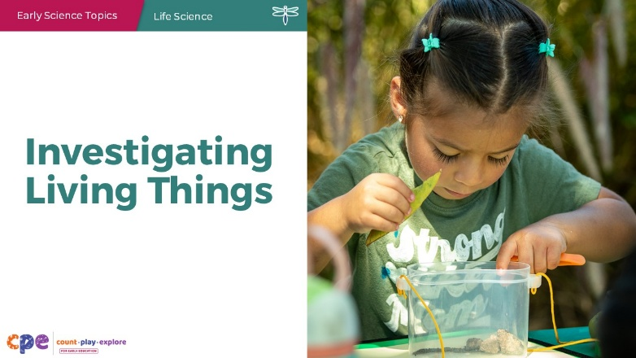

Talking Points
- Hello, and welcome everyone! Today, we will be exploring how to support children in investigating life science concepts and phenomena.

Facilitator Notes
- Adjust the talking points to reflect the session length and participant needs. If necessary, add introductory and “housekeeping” information.

Slide 2: Acknowledgments
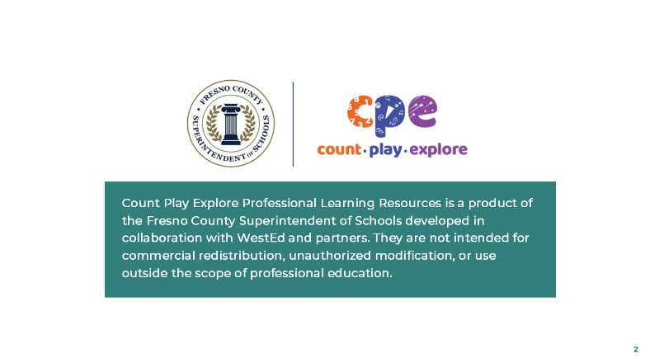

Talking Points
- The Count Play Explore Professional Learning Resources were made possible by Count Play Explore, an early math, science, and computer science initiative led by the Fresno County Superintendent of Schools, Early Care and Education Department. This initiative is generously funded by the California Department of Education and the California State Board of Education.
- These resources, developed by WestEd in collaboration with FCSS and AIMS Center for Math and Science Education, are intended to be used as a guide for implementing evidence-based strategies, promoting active learning, and encouraging developmentally appropriate practices in early education settings. They are not intended for commercial redistribution, unauthorized modification, or use outside the scope of professional education.

Slide 3: Session Goals
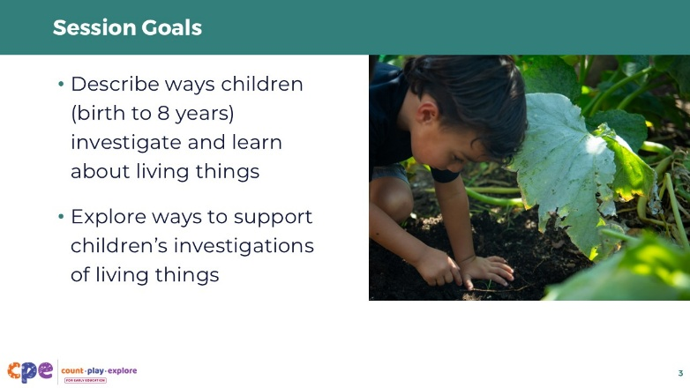

Talking Points
- In this session, we will
  - describe ways children (birth to 8 years) investigate and learn about living things, and
  - explore ways to support children’s investigations of living things.

Facilitator Notes
- Adjust slide content and talking points to reflect what you plan to address in your professional learning session.

Slide 4: Defining Life Science
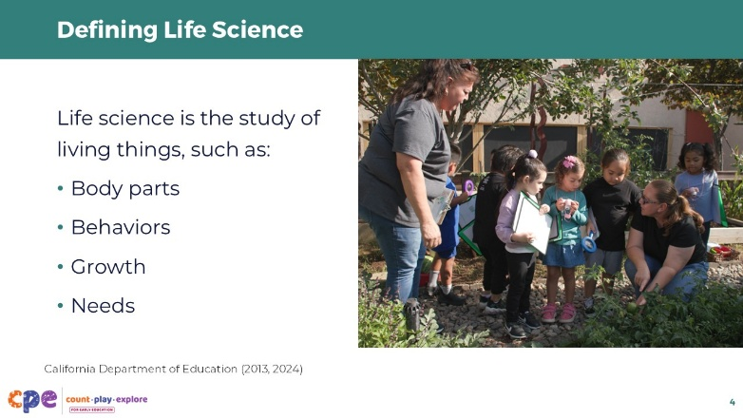

Talking Points
- Life science is the study of living things.
- When children investigate life science, they develop their understanding of animals (including humans) and plants. They may investigate their body parts, behaviors, growth, needs, and reproduction (California Department of Education, 2013, 2024)
- Children begin to understand the difference between living and non-living things in the preschool years (Margett & Witherington, 2011).
  - Living things are organisms that can grow, breathe, reproduce, and respond to stimuli (for example, people, animals, and plants). Non-living things are inanimate objects or materials that are not born, do not grow, and cannot reproduce (for example, metal and plastic materials; California Department of Education, 2024).

Slide 5: Is it living or non-living?
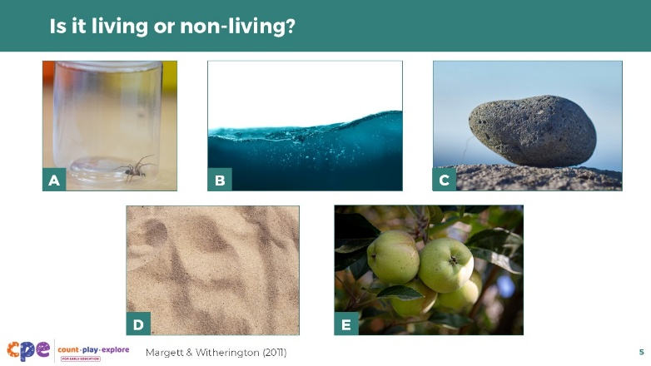
Time: 5 minutes

Talking Points
- Let’s think a little more about living and non-living things.
- Here are a few photos.
- On a piece of scratch paper, make notes on whether you think the different images are of living or non-living things. Think about why the thing is living or non-living.
- [Provide time for participants to review the photos and make notes. Encourage volunteers to share their answers and reasons why the thing is living or non-living. Use the talking points below to support your review.]
- Now we will review these photos.
  - The apple tree and spider are living. The spider can grow, reproduce, and breathe. The apple tree grows, uses water and nutrients, and can reproduce by making flowers and fruits.
  - Research shows that plants are difficult for children to categorize as living things (Margett & Witherington, 2011). This is because we can’t easily observe plants actively eating, moving, or breathing.
  - The sand, water, and rock are non-living things. These objects do not grow, reproduce, or breathe. Some of these distinctions might feel a little tricky. The rock, sand, and water are all natural items found in nature, but they are not living. Objects like this are part of Earth and Space science.

Facilitator Notes
- You might encourage participants to consider ways to support children in understanding how plants are living things. For example:
  - Sprouting seeds in a bag and taking photos of the changes daily. This will allow children to actively notice how the plant has grown.
  - Placing celery stalks in food coloring and noticing how the celery draws water up into itself—representing a living thing “eating” or getting nutrients.

Slide 6: Life Science and Me
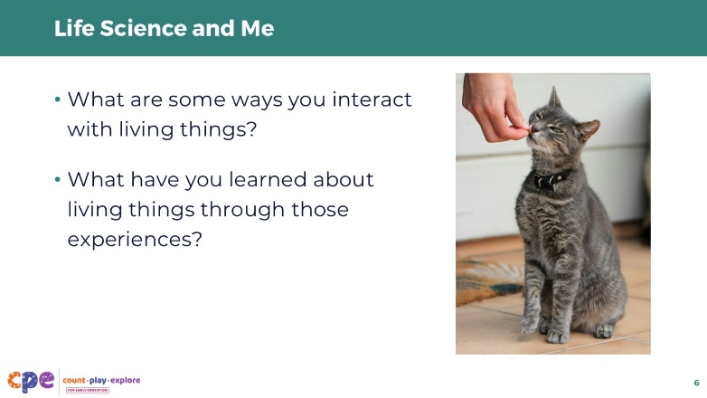
Time: 5 minutes

Talking Points
- Life science is a part of our lives. However, we all might experience life science in different ways.
  - For example, if you mow your grass, you might notice how quickly grass grows compared to other plants. This experience might help you learn about the concepts of how living things grow and change.
  - Or, if you have pets at home, you might learn about the needs of living things as you explore what and how to feed them.
  - If you walk in the park, you might notice the way different animals use trees for homes—birds, squirrels, and insects. This experience might help you learn about different habitats that living things need to thrive.
- Think about your own experiences with living things.
  - What are some living things you interact with? What are some ways you interact with these living things? What have you learned about living things through those experiences?
- [Encourage participants to discuss in their table groups. Then, invite a few volunteers to share with the larger group.]

Slide 7: Children Investigate Living Things
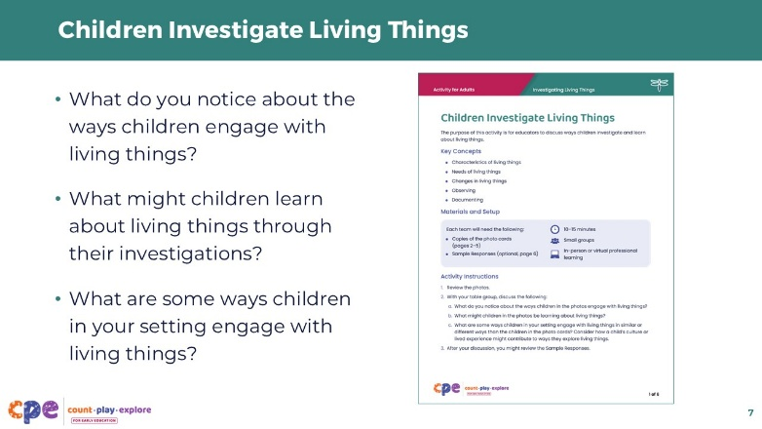
Time: 5 minutes
Materials: Children Investigate Living Things handout

Talking Points
- Let’s start our session by observing a few photos that show different ways children might investigate living things.
- [Hand out photo cards from the Children Investigate Living Things handout.]
- Review these photos with your table group. Discuss the following questions with your group:
  - What do you notice about the ways children engage with living things?
  - What might children learn about living things through their investigations?
  - What are some ways children in your setting engage with living things?
- [Invite a few volunteers to share with the larger group. Use the “Sample Responses” in the Children Investigate Living Things handout to support a discussion.]

Slide 8: Investigating Living Things
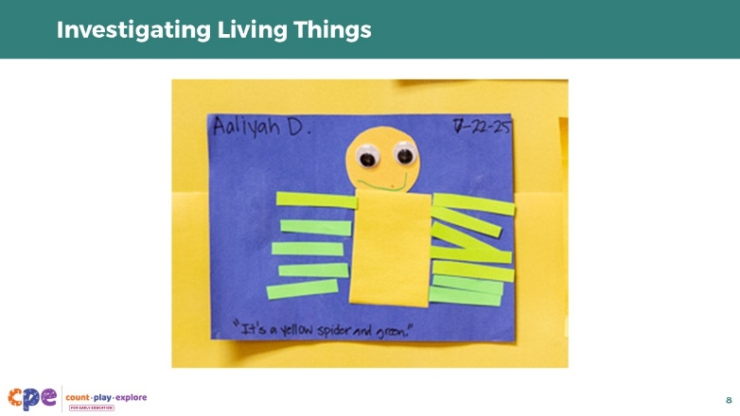
Materials: Parts, Purposes, and Complexities of Living Things handout (optional)

Talking Points
- We have established an understanding that children and adults experience and learn about life science all the time and across different contexts.
- Let’s take some time now to investigate living things.
- In this activity, we will investigate the different parts of living things.

Facilitator Notes
- You might use the Parts, Purposes, and Complexities of Living Things handout. However, slides 9—14 contain the same content as the handout.

Slide 9: Nature Walk
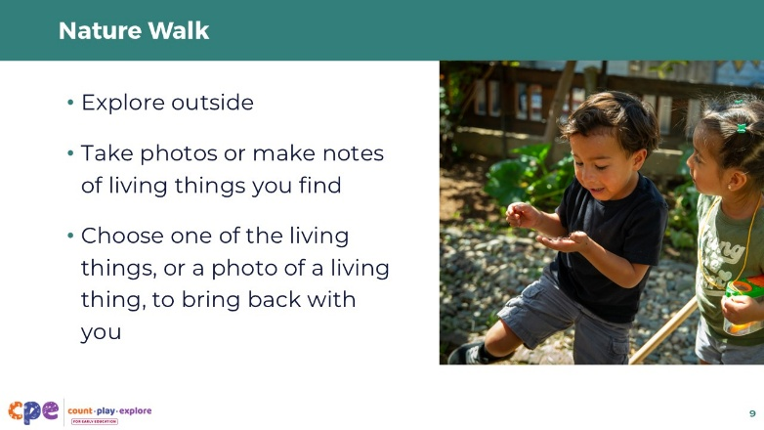
Time: 10–15 minutes
Materials: Parts, Purposes, and Complexities of Living Things handout (optional), small containers to collect samples of living things (optional)

Talking Points
- We will start by going on a nature walk in pairs to look for living things. For example, you might find a flower, a vine, or an ant.
- Make notes of some of the living things you find or use your phone to take a photo of the different living things you find.
- Keep in mind, we are looking for living things, not simply natural items. For example, I might find a rock on my nature walk. A rock is a natural item that is created from nature, but it is not living—it does not grow, reproduce, or breathe.
- Choose one of the living things—or a photo of the living thing—to bring back with you. If you bring back a piece of plant, try to gather more than just a leaf. For example, you might find a weed and bring back the entire weed including its roots, stem, leaves, and flower. The more parts of the living thing you can preserve, the better for this activity.
- Once you return to your tables, I’ll explain the next part of the investigation.
- [Support participants to choose partners.]
- Now, with your partner, take about 10 minutes to explore outside. Make notes or take photos of some of the living things you find on your nature walk. Then, choose one living thing to bring back with you. Remember to try to keep the living thing in one piece with multiple parts.

Facilitator Notes
- If participants are not able to go on a nature walk (for example, due to time constraints, weather, mobility needs, or location), you might skip this slide and the following slide. Instead of relying on living things participants find on a nature walk, you might provide any of the following:
  - crickets and/or mealworms (purchased at a pet store)
  - potted plants (purchased at a garden center or nursery)
  - cut flowers (purchased at a grocery store)
  - other living things
- Support participants to form teams of two. For example:
  - Encourage educators who work with similar ages of children to form pairs. This might facilitate conversations and a shared perspective.
  - Intentionally pair educators working with children from different ages to form pairs. This might introduce new ideas and experiences.
- Provide clear time expectations for when participants need to return to the PL room. For example,
  - Ask participants to notice what time it is when they leave the learning setting and what time it will be when they should return to the learning setting.
  - Ask participants to set a 10-minute timer on their phones to alert them when they need to return to the session.

Slide 10: Share our Findings
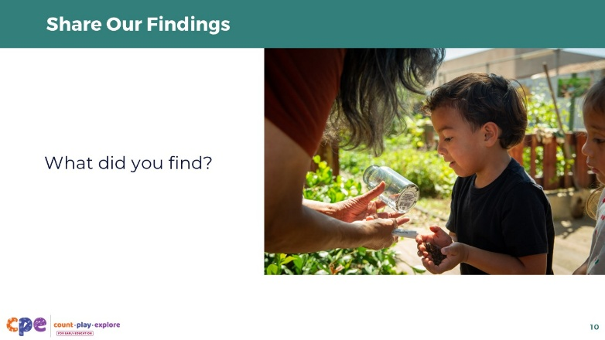
Time: 5 minutes
Materials: Parts, Purposes, and Complexities of Living Things handout (optional)

Talking Points
- [Once participants have returned to the session:]
- Welcome back everyone.
- I hope you all enjoyed a little time outside and found some interesting living things.
- Before we move further into our investigation, let’s share with others some of the living things we found.
- As you share your item, explain how you know it is living. What parts, behaviors, growth, or needs make this a living thing?
- [Encourage volunteers to share examples of the different living things they found on their nature walk in addition to the one item they brought back to the room.]
- Thank you all for sharing about the living things you found.
- The next part of our investigation will push our thinking a bit more.

Slide 11: Investigating Parts, Purposes, and Complexities
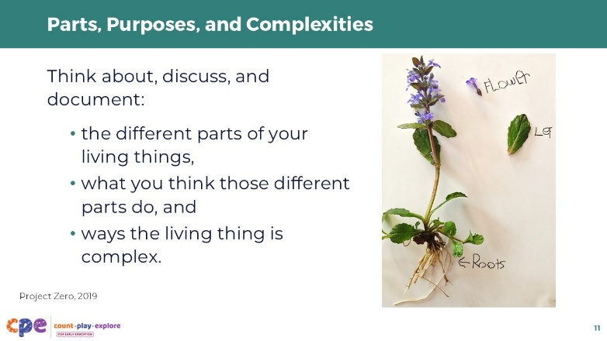
Time: 1 minute
Materials: Materials to document in different ways (for example, drawing paper, drawing materials, construction paper, glue, pipe cleaners, clay, paint), Parts, Purposes, and Complexities of Living Things handout (optional)

Talking Points
- We will use a thinking routine called Parts, Purposes, and Complexities (Project Zero, 2019) to further investigate the living things you found.
- You will be documenting its parts, the purposes of those different parts, and the ways those parts are complex.
- You might document in different ways. For example, you can make a chart, drawing or painting, list, diagram, or sculpture.

Facilitator Notes
- More information on the Parts, Purposes, and Complexities (Project Zero, 2019) thinking routine can be found on the Project Zero website.
- If participants do not go on a nature walk to find samples of living things, introduce the living things you are providing and support participants to choose one of the living things to use for this activity.
- Depending on your session goals and time allowances, consider providing ways for participants to document using technology. For example, creating a stop motion film or video recording.

Slide 12: Parts
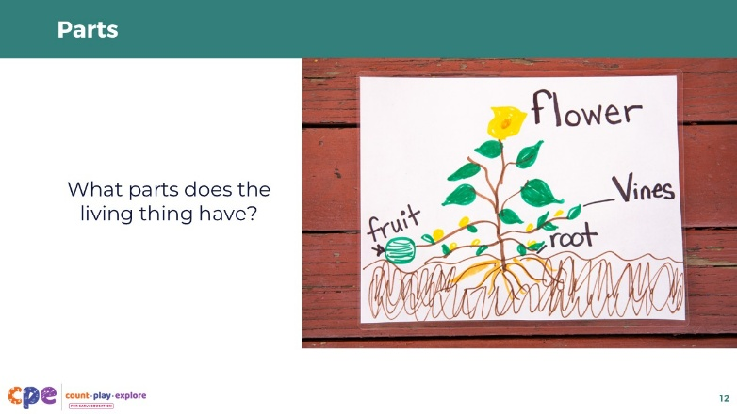
Time: 5–10 minutes
Materials: Paper and drawing materials, Parts, Purposes, and Complexities of Living Things handout (optional)

Talking Points
- We will start by observing and documenting the different parts of the living thing you have collected.
- Remember, you can document the parts of the living things in different ways. For example, you might draw pictures to represent the different parts, make a list or a chart, or create a diagram and label the parts.
- [Provide time for participants to record the different parts of their living thing.]
- With your table groups, share and discuss the different parts of the living thing you are investigating. You might notice similarities and differences among the parts of the different living things being investigated.

Facilitator Notes
- You might model this process for participants first. For example, you might have a flower. Explain that one of the parts of the flower is a stem, so you will draw a stem and write “stem.”
- As participants record the different parts of their living things, move around the room and provide support as needed. For example:
  - Ask participants about the different parts of their living things.
  - Notice the different ways participants are recording the parts of their living things. You might ask about why they chose a certain way to document.
- Observing and documenting are foundational skills to use when investigating living things. Explore the Observation and Investigation and Documentation and Communication suites for more information on ways to help educators support children to use these skills.

Slide 13: Purposes
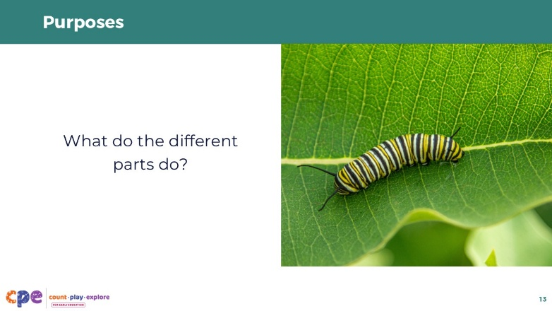
Time: 5–10 minutes
Materials: Paper and drawing materials, Parts, Purposes, and Complexities of Living Things handout (optional)

Talking Points
- Now, we will investigate further.
- With your partner, review the different parts of your living thing.
- Record the purpose of each part.
  - What does it do?
  - How does it support the living thing?
- If you brought back a plant, you might take apart the different parts of the plant to learn more about its parts and purposes.
- If you do not know the name or purpose of one of the parts, you might use the internet to do some research and learn more about your living thing.
- [Provide time for participants to record the different purposes of the parts of their living thing.]
- With another team at your table, share some of the different purposes of the parts of the living thing you are investigating.

Facilitator Notes
- You might model this process for participants. For example, using the flower example, you might explain that the stem of the flower holds the flower up off the ground. The stem also helps nutrients travel from the roots up to other parts of the plant.

Slide 14: Complexities
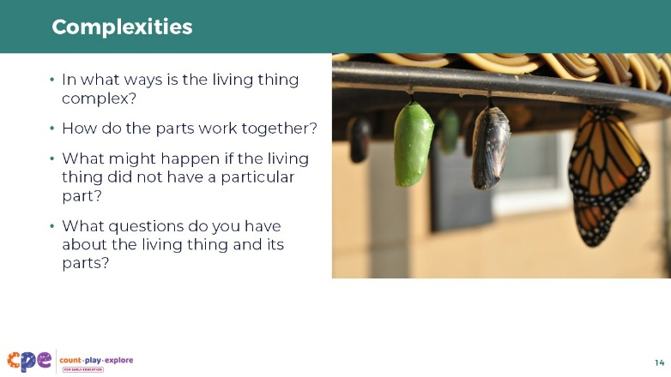
Time: 5–10 minutes
Materials: Paper and drawing materials, Parts, Purposes, and Complexities of Living Things handout (optional)

Talking Points
- Now, we will document ways the living thing is complex.
  - How do the parts work together?
  - What might happen if the living thing did not have a particular part?
  - What questions do you have about this living thing?
- [Provide time for participants to record ways the living thing is complex and any questions about the living thing they are investigating.]
- Turn and talk to another team at your table. Share some of the ways the living thing you are investigating is complex. What questions do you have about the living thing you are investigating?
- You might discuss different ways you can find out more about the living thing.
- [Provide time for participants to discuss the complexities of the living things.]

Slide 15: Gallery Tour
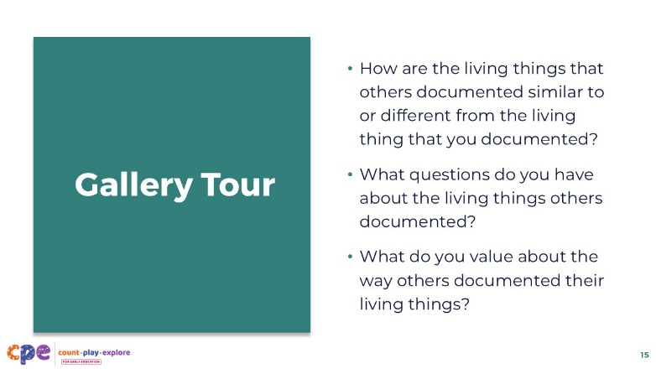

Talking Points
- Thank you for investigating the parts, purposes, and complexities of living things.
- Now we will take some time to appreciate the different parts, purposes, and complexities of living things that others investigated.
- Leave the documentation you created on your able for others to observe.
- We will move around the room and observe the way others have investigated living things. Take a pack of sticky notes and a pen with you. As you observe others’ work, leave a sticky note or two that
  - describes ways others’ living things are similar or different from yours,
  - poses a question about the living thing, or
  - expresses what you value about the way the living thing is documented.
- [Provide time for participants to move around the room and observe others’ investigations. Once everyone has finished their observations, encourage participants to review the sticky notes that were left for them. Invite a few volunteers to share about their observations or to share about the sticky notes that were left for them.]

Slide 16: Structure and Function
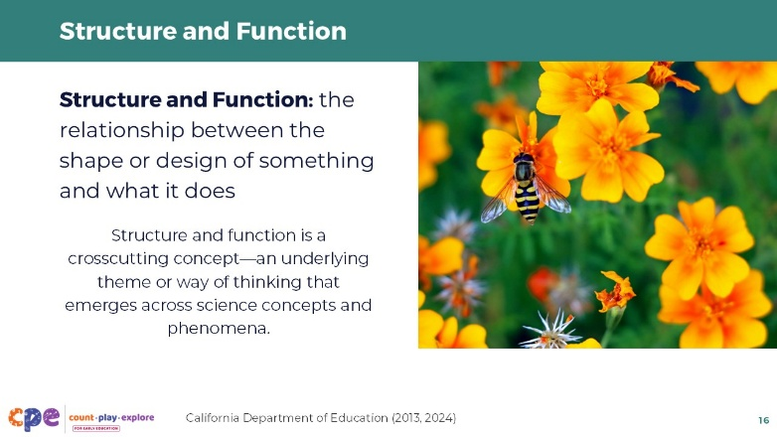

Talking Points
- Through your investigations of the parts, purposes, and complexities of living things, you might have noticed how the different shapes or characteristics of the living things relate to the way those parts function.
- This relationship between the way something is structured and functions is a crosscutting concept in science. For example:
  - The petals of a flower are colorful. They are colorful not just so they look pretty, but so they can attract pollinators. Without this structure and function relationship, flowers would not be able to reproduce.
  - A tortoise has a large, hard shell to protect it from predators. This is important because tortoises move too slowly to run away from danger and don’t have sharp claws or teeth to defend themselves.
- Crosscutting concepts are underlying themes or ways of thinking that emerge across science concepts and phenomena (California Department of Education, 2013, 2024).

Slide 17: Understanding Living Things
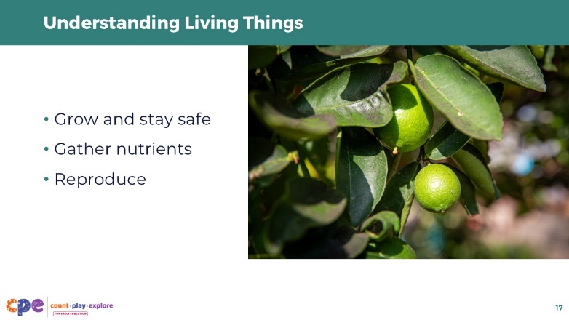

Talking Points
- You also investigated several life science concepts. Across all of the living things you investigated, you probably identified parts that supported the living thing to do the following:
  - grow and stay safe
  - gather nutrients
  - reproduce

Slide 18: Concepts and Phenomena in Life Science
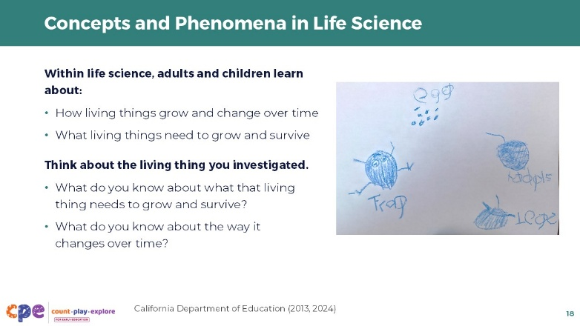
Time: 5 minutes

Talking Points
- Let’s think a little more about the range of concepts and phenomena that can be learned within life science.
- When investigating living things, adults and children learn about:
- How living things grow and change over time
  - For example, some organisms don’t just get bigger; they completely transform (such as a frog starts as a gill-breathing tadpole that lives underwater and matures into a lung-breathing adult that can hop on land).
- What living things need to survive
  - For example, plants need nutrients, just like people. However, they do not “eat” soil. They use nutrients from the soil to help make them healthy—similar to vitamins. They also use the process of photosynthesis to transform carbon dioxide from the air into sugars that help them grow.
- Think about the living thing you have collected today.
  - What do you know about what that living thing needs to grow and survive?
  - What do you know about the way it changes over time?
- [Encourage participants to discuss with their table groups and add ideas to their documentation they developed earlier. You might invite a few volunteers to share with the larger group.]

Facilitator Notes
- You might invite participants to use their smart phones to look up additional information related to the living thing they collected.

Slide 19: Concepts and Phenomena in Life Science (continued)
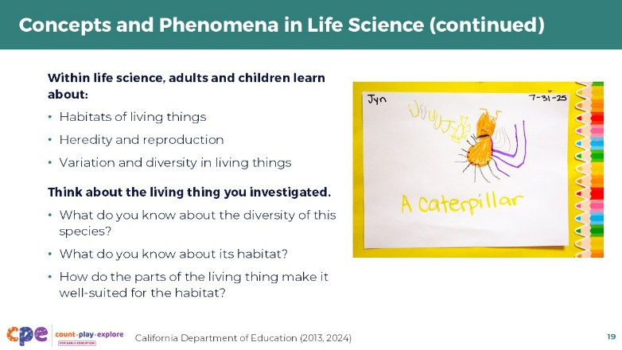
Time: 5 minutes

Talking Points
- Let’s consider a few more concepts that we might learn about when investigating life science.
- The habitats of living things.
  - A habitat is a home that provides food, water, and shelter. The size of that home depends on the size and needs of the creature living in it. For example, insects and spiders might live their entire lives on one tree. However, a large animal like a wolf might require hundreds of acres to hunt and provide for its pack. There are many different types of habitats that plants and animals call home.
  - An animal’s parts will match the habitat within which it lives. For example, fish have gills that allow them to get oxygen from water—so, their habitat is aquatic.
- Heredity and reproduction.
  - Living things reproduce to create offspring of their own kind, ensuring the survival of their species over time. For example, plants create and disperse seeds to create new plants.
  - We can observe similarities between parents and offspring because genetic traits are passed on—this is heredity. For example, a puppy might inherit its coat color and ear shape from its parents, while a plant inherits its flower color and leaf shape.
- Variation and diversity in living things
  - Children and adults learn about the characteristics of living things. For example, learning about their different parts and what they look like.
  - Noticing characteristics helps us understand similarities and differences. Even within a single species, variation can be great. For example, there are over 3,000 varieties of pear trees in the world. The fruits they produce range in color from purple to bright yellow, and in texture from buttery soft to crisp like an apple.
- Consider the living thing you collected and observed today.
  - What do you know about the diversity of this species?
  - What do you know about its habitat?
  - How do the parts of the living things make it well-suited for the habitat?
- [Encourage participants to discuss with their table groups and add their ideas to their documentation. You might invite a few volunteers to share with the larger group.]

Facilitator Notes
- You might invite participants to use their smart phones to look up additional information related to the living thing they collected.

Slide 20: Investigating Life Science Across the Ages
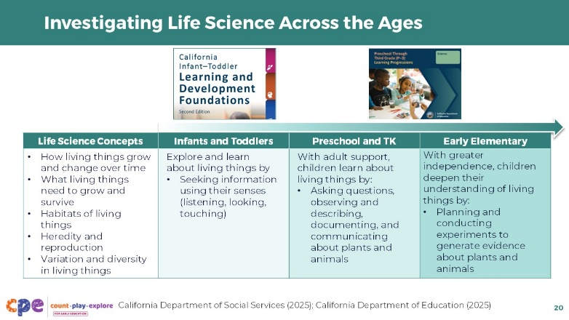
Time: 10 minutes
Materials: print copies of this slide for participants to review (optional)

Talking Points
- Let’s take a look at what children of different ages might learn about living things.
- Even very early on, children are learning about many different concepts in life science, including the needs, characteristics, growth, and habitats of living things.
- As children mature, they deepen their understanding of these different concepts using inquiry.
- Review the table. Consider the following questions:
  - What do you notice about the way children's inquiry skills in life science develop over time?
  - In what ways do children in your setting investigate life science concepts?
- [Provide time for participants to observe the table individually. Then, encourage participants to discuss what they notice about the way inquiry skills develop over time and share some examples of ways children in their settings investigate life science concepts.]

Facilitator Notes
- Consider printing this slide and providing copies for participants to review.
- Use the following to support a discussion:
  - Across the different ages, children are observing and exploring concepts in life science.
  - Infants and toddlers begin building these understandings by noticing and exploring living things. They might interact with different living things by touching, looking, and listening.
  - As children get older, they begin to apply more advanced inquiry skills as they investigate living things. For example, preschool or TK children might draw living things and describe the parts they include in their drawing.
  - In elementary school, children will further advance the way they explore these topics by planning and conducting experiments. They begin to document evidence to construct explanations.
- You might encourage participants to discuss ways they might support children of different ages to investigate the same living thing.
- Consider printing copies of relevant foundations and standards and encouraging participants to review life science concepts in more detail. We recommend the following documents and pages:
  - Infant–Toddler Learning and Development Foundations: Cognitive Development, Cause and Effect (pages 142—143); Approaches to Learning, Curiosity and Initiative (pages 85—86)
  - Preschool Through Third Grade Learning Progressions: Life Science (pages 24—36)
- Additional information on ways children develop an understanding of life science can be found in the following documents:
  - Preschool/Transitional Kindergarten Learning Foundations: Science (PTKLF; pages 50—64)
  - Next Generation Science Standards for California Public Schools, Kindergarten through Grade Twelve (CANGSS)

Slide 21: Observe: Investigating Living Things
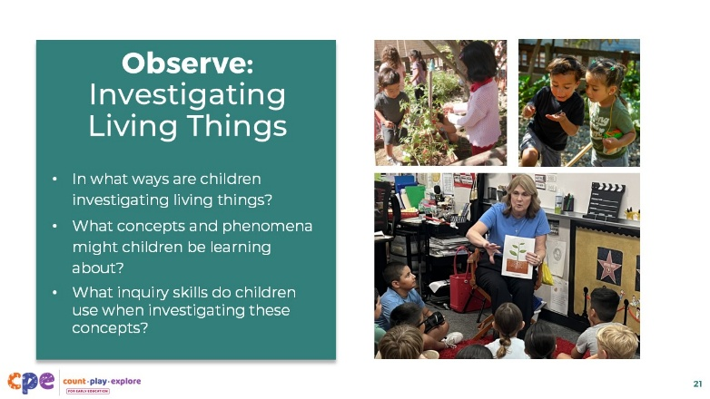
Time: 15 minutes (including the discussion on the following slide)
Materials: Video clip of children investigating living things

Talking Points
- Let’s notice some of these foundations and standards in action.
- We will observe a video showing children investigating living things.
- As you observe, consider the following questions:
  - In what ways are children investigating living things?
  - What concepts and phenomena might children be learning about?
  - What inquiry skills (for example, predicting, observing, testing ideas) do children use when investigating these concepts?
- You might record your observations on scratch paper.

Facilitator Notes
- Choose a video clip featuring children investigating living things. Consider playing two videos—one of the younger children and the elementary clip. The clips of younger children (toddlers and preschool) take place outdoors in a class garden. The elementary clip shows ways children can use models of living things in a classroom setting. Representing both indoor and outdoor inquiry experiences will provide a broad representation of the different ways to explore life science with children. You might also encourage participants to compare the ways children investigate across different ages. We provide the following videos:
  - Investigating Living Creatures (2–3 years)
  - Investigating Living Creatures (2–3 years) – Audio Descriptive Version
  - Investigating Life Science in the Garden (3–5 years)
  - Investigating Life Science in the Garden (3–5 years) – Audio Descriptive Version
  - Modeling Absorption in Plants (second–third grade)
  - Modeling Absorption in Plants (second–third grade) – Audio Descriptive Version
- If you only play one video, you might play the video more than once. The first time, invite participants to notice life science concepts and phenomena that the children are investigating. The second time, encourage participants to notice the inquiry skills children are using.

Slide 22: Discuss: Investigating Living Things
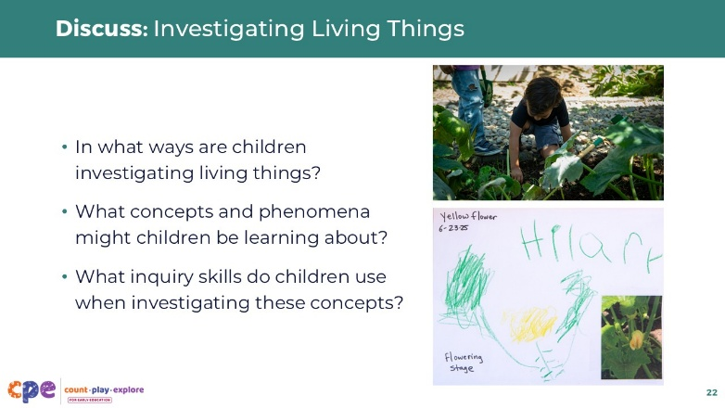
Time: 15 minutes (including observing the video on the previous slide)
Materials: Answer key for Observing Life Science handout(s) (one per video you choose to show)

Talking Points
- Let’s discuss what you observed:
  - In what ways are children investigating living things?
  - What concepts and phenomena might children be learning about?
  - What inquiry skills (for example, predicting, observing, testing ideas) do children use when investigating these concepts?
- [Support participants to share what they notice about ways children investigate living things. You might encourage table groups to discuss. Then, invite a few volunteers to share with the larger group.]

Facilitator Notes
- Use the Answer Key(s) for Investigating Living Things handouts for the videos you choose to show to support a discussion. Each answer key provides examples from the video related to the discussion questions for this slide. Select the Answer Key that matches the video you selected. Note: These handouts are designed to support facilitators only and are not intended to be used by participants.
  - Answer Key for Investigating Living Creatures (2–3 years)
  - Answer Key for Investigating Life Science in the Garden (3–5 years)
  - Answer Key for Modeling Absorption in Plants (second–third grade)
- Consider inviting participants to reflect on ways they might adapt a similar experience for the children in their settings.

Slide 23: Benefits of Interacting with Nature
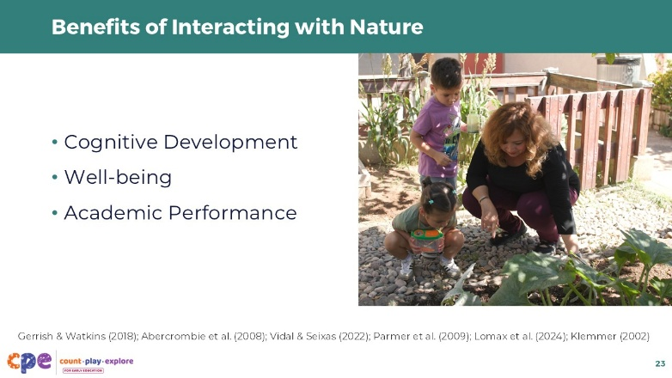

Talking Points
- [Note: the elementary clip does not show direct experiences in nature. Adjust the language on this slide if you only played the elementary clip].
- In the video observations, we noticed ways children learned about and investigated life science through direct experiences in nature.
- Engaging with the natural world has several benefits for children and adults. For example:
  - Exposure to green spaces can improve cognitive development such as executive functions (Dadvand et al., 2015).
  - Spending time in nature can reduce stress (Lomax et al., 2024) and improve well-being (Bratman et al, 2019).
- School gardens, or access to plants in the classroom, provide children with equitable opportunities to explore the natural world, even in urban spaces.
  - Having access to a garden in the learning setting is important because some children might have fewer opportunities to engage with the natural world in their homes or communities (Gerrish & Watkins, 2018).
  - School gardens have also been found to improve the health and wellness of children. For example, some school garden programs can increase the amount of fruits and vegetables that children eat—providing an authentic way to improve nutrition (Parmer et al., 2009).
  - School gardens can also improve children’s academic performance (Klemmer, 2002). This is because school gardens, and other direct experiences with the natural world, provide authentic and meaningful experiences for children to learn different concepts (for example, math and science concepts) through engaging first-hand learning.
- School gardens can be feasible for different spaces and budgets.
  - Vertical or container gardens, for example, provide creative ways to bring nature into any space.
  - Using recycled materials and developing community partnerships are ways to develop gardens at little to no cost.
  - Starting simple with a few potted plants in the classroom can also be great ways to build an indoor garden.

Slide 24: Connecting to Families
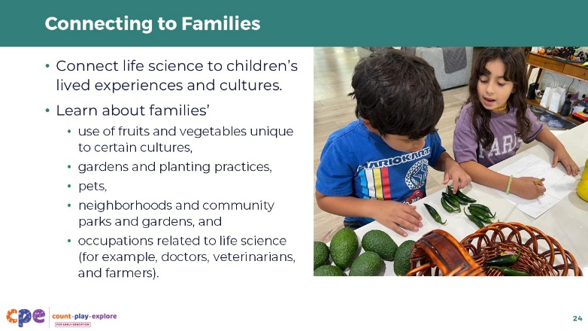

Talking Points
- Learning about life science and engaging with the natural world provide opportunities to connect to children’s lived experiences and cultures. Consider the diversity of life science opportunities that families might experience. For example:
  - fruits and vegetables meaningful to certain cultures
  - family gardens and planting practices
  - pets
  - neighborhoods and community parks and gardens
  - families’ occupations related to life science (for example, doctors, veterinarians, and farmers)
  - agriculture as a community industry
- Learning about the way families interact with the natural world can help you create meaningful investigations to support children’s understanding of living things.

Slide 25: Life Science Experiences
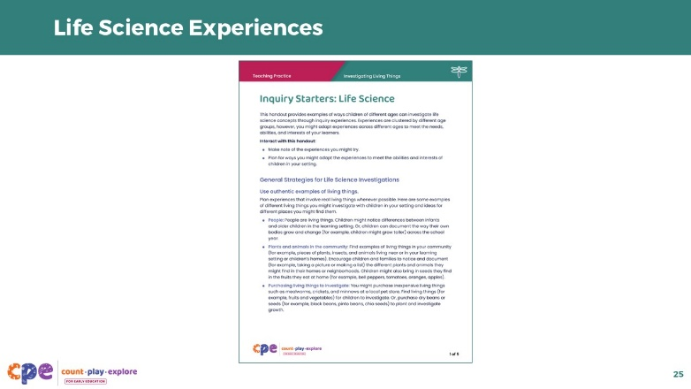
Time: 20 minutes
Materials: Inquiry Starters: Life Science handout

Talking Points
- In addition to using your direct access to the natural world, and building on families’ lived experiences, there are many other experiences you might provide for children to support them in learning about life science.
- We will review the Inquiry Starters: Life Science handout.
- In this handout, you will find some general ideas about how to provide life science experiences as well as a few ideas for specific activities and experiences.
- Review the handout. Draw a star next to an experience you might try in your setting. Draw a question mark next to an experience you are curious about. You might also make notes on ways to adapt a certain experience to meet the needs, abilities, and interests of the learners in your setting.
- [Provide time for participants to individually review the handout. Then, invite small groups to discuss the ideas they marked with a star and the ideas they marked with a question mark. You might invite a few volunteers to share with the larger group.]

Slide 26: Children’s Books Support Thinking about Life Science
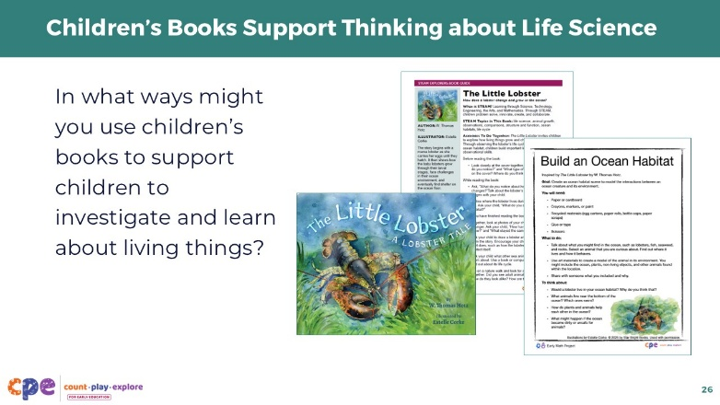
Time: 20 minutes
Materials: Children’s books featuring life science concepts, chart paper, markers

Talking Points
- Children’s books also provide opportunities to learn about life science.
- The Count Play Explore website offers Book Guides and Activities that you might use to support children’s understanding of life science. For example:
  - The Little Lobster by W. Thomas Hotz, explores the life cycle of lobsters. The Book Guide provides ideas on how to help children think about growth and change while reading. The related activity, Build an Ocean Habitat, describes ways to encourage children to create ocean habitats.
- I have brought in some of these books and book guides for us to review.
- I have placed different books and book guides around the room beside a sheet of chart paper. With a partner, you will move around the room to visit each book station. Review the book and book guide with your partner. Then, consider ways you might use the book and/or book guide to
  - introduce a life science topic or prompt a life science investigation,
  - expand children’s knowledge about a life science topic, or
  - build home to school connections through life science ideas.
- Record your ideas on the chart paper.
- Think about the interests, abilities, and lived experiences of the children in your setting when considering ways to use books to support learning about life science.
- [Provide time for participants to move around the room exploring books and making notes. You might invite volunteers to share, with the larger group, some of their ideas that were generated.]

Facilitator Notes
- There are many different books that educators might use to support children to investigate and learn about life science. Below are a few fiction and non-fiction books that you might share with participants. Links for related Book Guides and Activities are also included for selected books. You might print and share Count Play Explore’s Book Guides and Activities that support STEAM learning before, during, and after reading.
  - The Little Lobster by W. Thomas Hotz: STEAM Explorer’s Book Guide in English and Spanish; Build an Ocean Habitat Activity; Life Cycle Match Up Activity
  - Red Leaf, Yellow Leaf by Lois Ehlert: STEAM Explorer’s Book Guide in English and Spanish; Hug a Tree Activity; Leaf Match Activity
  - Actual Size by Steve Jenkins: STEAM Explorer’s Book Guide in English and Spanish; Chalk Animals Activity
  - Even an Ostrich Needs a Nest by Irene Kelly: STEAM Explorer’s Book Guide; Nest Making Activity
  - Up to My Knees by Grace Lin: STEAM Explorers Book Guide in English and Spanish; How Tall is a Sprout? Activity
  - Worm Weather by Jean Taft: STEAM Explorer’s Book Guide in English and Spanish
  - Chloe’s Community Garden by Valerie Bolling (expected release date: February 9, 2027)
- If you use other books, provide both fiction and non-fiction (informational text) books for educators to review.
- Other ways you might facilitate this experience include the following:
  - Asking participants to use sticky notes to record their ideas about ways they might use different books to support children’s understanding of life science concepts and phenomena. Educators can leave the sticky notes inside different books and then pass the books to another educator to add different ideas to the same book.
  - Encouraging educators to record the names of different books along with a few ideas about ways they might use them on an individual sheet of paper or index cards—one for each book (similar to recipe cards).
- You might invite participants to explore the CPE website for additional books and resources.
- Consider providing foundations and standards for participants to reference when considering what is appropriate for different ages.

Slide 27: Supporting Children to Investigate Living Things
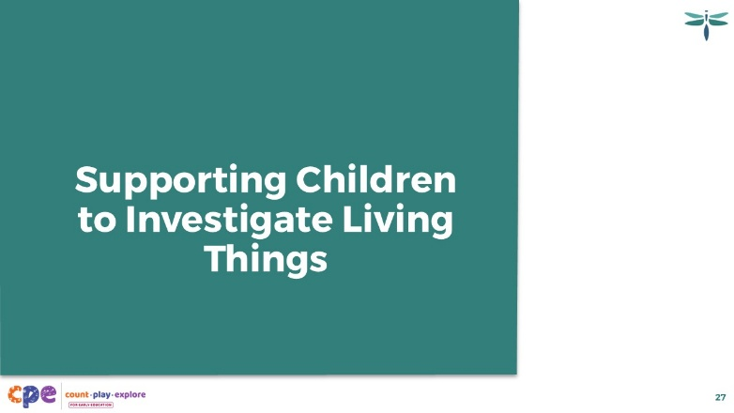

Talking Points
- We have observed and discussed ways that experiences in nature, like school gardens, and reading books can support children’s learning in life science.
- Now let’s think more about how educators can use different teaching practices to support children to investigate and learn about life science.

Slide 28: The M⁵ Early STEAM Approach
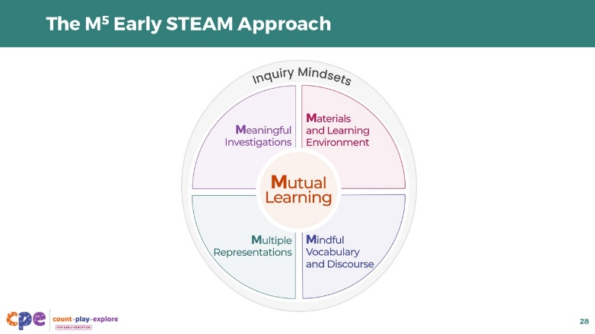
Time: 10-15 minutes
Materials: M⁵ Early STEAM Approach Overview handout

Talking Points
- We will use the M⁵ Early STEAM Approach as a framework for thinking about ways we can support children to investigate science concepts and phenomena.
- The M⁵ Approach features 5 effective teaching practices in STEAM, all within an inquiry mindset:
  - Mutual Learning
  - Meaningful Investigations
  - Materials and Learning Environment
  - Mindful Vocabulary and Discourse
  - Multiple Representations
- Let’s explore each M⁵ practice.

Facilitator Notes
- Consider your participants and their prior experiences with M⁵ Early STEAM Approach.
- For groups that have significant experience with M⁵, you might offer a few minutes for participants to share with a partner their areas of strength and what practices they are working on. Or you might use this slide to briefly revisit the M⁵ practices and move to the next slide.
- For groups that have less experience with M⁵, you might offer more time for participants to explore each practice. For example:
  - Provide time for participants to review the practices on their own. Invite them to make a square over practices that they have “squared away” (practices they understand and use), a circle over “what’s still going around in their heads” (practices they still have questions about), and a triangle over ideas that they will use in their settings.
  - Use a jigsaw approach. Assign each table group a different M⁵ practice to explore. Encourage participants to discuss examples of ways they have used, or ideas about ways they might use, each practice to support children to investigate and learn about life science.

Slide 29: Observe: Supporting Children to Investigate Living Things
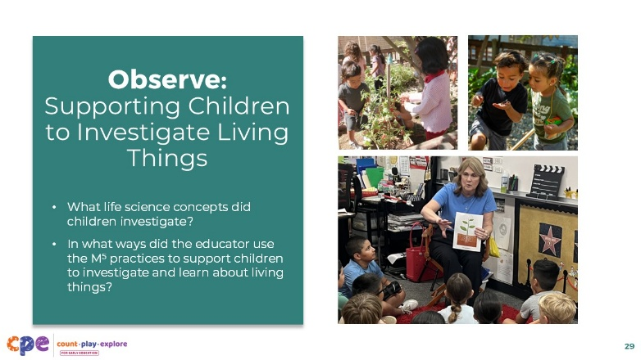
Time: 15 minutes (including the discussion on the following slide)
Materials: Video of children investigating living things

Talking Points
- We have discussed the M⁵ Early STEAM Approach. Let’s observe these practices in action.
- [Select a facilitation strategy from the Facilitator Notes.]
- We will observe a video clip of children investigating and learning about life science. As you observe, consider the following questions:
  - What life science concepts did children investigate?
  - In what ways did the educator use the M⁵ practices to support children to investigate and learn about living things?
- You might not observe each practice in the clip. If there is a practice you don’t observe, you might record some ideas about ways an educator could use the practice in the context of the video.

Facilitator Notes
- Select a video clip that features children investigating life science. We provide the following videos: [list clips] You might choose other videos.
  - Investigating Living Creatures (2–3 years)
  - Investigating Living Creatures (2–3 years) – Audio Descriptive Version
  - Investigating Life Science in the Garden (3–5 years)
  - Investigating Life Science in the Garden (3–5 years) – Audio Descriptive Version
  - Modeling Absorption in Plants (second–third grade)
  - Modeling Absorption in Plants (second–third grade) – Audio Descriptive Version
- If you are playing the same video that you used on Slide 21, you might skip or remove the first question about science concepts that children are investigating.
- Support participants to observe the video in a way that meets your session goals. For example:
  - You might play the video more than once and encourage participants to notice all of the M⁵ practices. Invite participants to share with their table group. Then, invite a few volunteers to share with the larger group.
  - Use a jigsaw approach. Assign table groups one of the M⁵ practices to focus on. Then, invite table groups to share about their assigned practice with the larger group.

Slide 30: Discuss: Supporting Children to Investigate Living Things
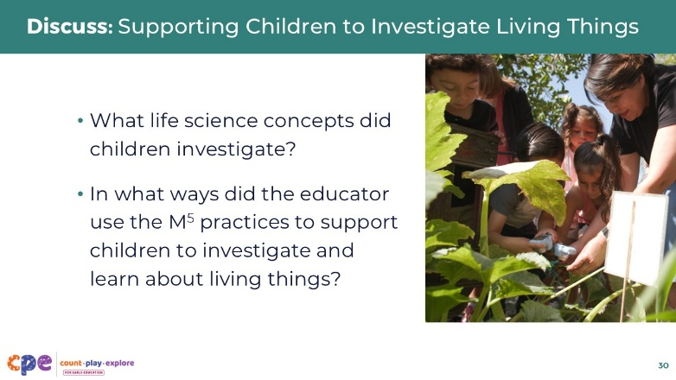
Time: 15 minutes (including observing the video on the previous slide)
Materials: Answer Key for Investigating Life Science handout

Talking Points
- Let’s discuss.
  - What life science concepts did children investigate?
  - In what ways did the educator use the M⁵ practices to support children to investigate and learn about living things?
- [Encourage volunteers to share examples of each M⁵ that they observed in the video.]

Facilitator Notes
- Use the Answer Key for Investigating Life Science to support a discussion. Select the handout that matches the video you have chosen to share.
- Consider expanding this discussion by encouraging participants to share ways they might further support children in the video.

Slide 31: Planning Life Science Investigations
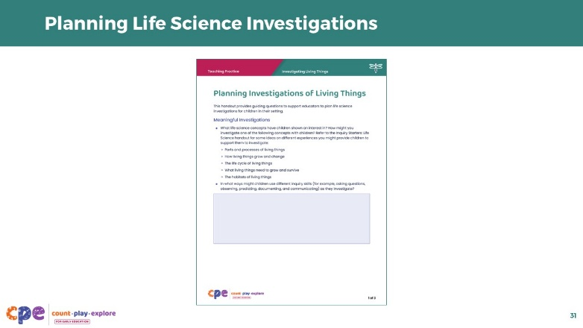
Time: 20-30 minutes
Materials: Planning Investigations About Living Things handout, Inquiry Starters: Life Science handout

Talking Points
- Now we will take some time to consider ways you can use what you learned today to support the children in your settings to investigate living things.
- We will use the Planning Investigations about Living Things handout to guide our planning process. You might use the Inquiry Starters: Life Science handout to generate some ideas for an experience you will plan for.
- First, think about what life science concept you might focus on. For example:
  - How living things grow and change over time
  - The life cycle of living things
  - What living things need to grow and survive
  - The habitats of living things
  - Variation and diversity in living things
- How will children investigate this concept? What living thing would they investigate (A plant? An insect?). What will they observe and document? Will they need to investigate over a few days or weeks?
- Then, move through each of the M⁵ practices. Consider ways you might use each practice to support children to investigate and learn about the life science concept you choose to focus on. You might reference foundations and standards to help focus your planning.
- [Provide time for participants to plan individually or in pairs.]
- [When participants finish planning, encourage them to share with others at their table groups.]

Facilitator Notes
- Move around the room to support participants. You might ask questions about their plans and provide suggestions as needed.
- Consider providing participants with copies of the relevant foundations or standards to support their planning or use the table on slide 20 as an optional reference point to support participants.

Slide 32: Apply to Your Setting
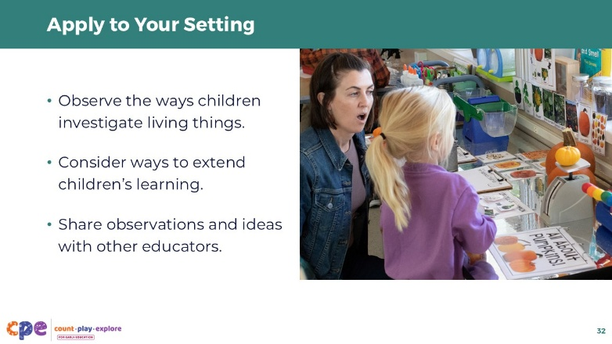

Talking Points
- When you return to your learning setting, try your plans with the children in your setting.
- Observe children and notice
  - understandings children are developing about living things,
  - questions children have about living things, and
  - ways children used inquiry skills to learn about living things.
- Reflect on these notes and consider ways you might extend children’s learning through related and ongoing experiences.
- You might share your observations and ideas with a colleague. Having a thought partner is an important way to continue our learning as educators.

Facilitator Notes
- Providing ongoing support and opportunities for collaborative reflection are critical components of effective professional learning (Darling-Hammond et al., 2017). Consider ways you can support participants to apply what they learned in this session to their learning settings and support collaborative reflection. For example:
  - Encourage participants to share photos and anecdotes of ways they are supporting children to observe and investigate over time. You might use digital platforms such as Padlet or a shared Google Drive. You can provide feedback to individual participants and encourage others to make comments and suggestions as a way to build community.
- Encourage educators to keep a journal to document ways they are supporting children to observe and investigate. They can share and discuss their journal entries during in-person meetings.

Slide 33: Reflection
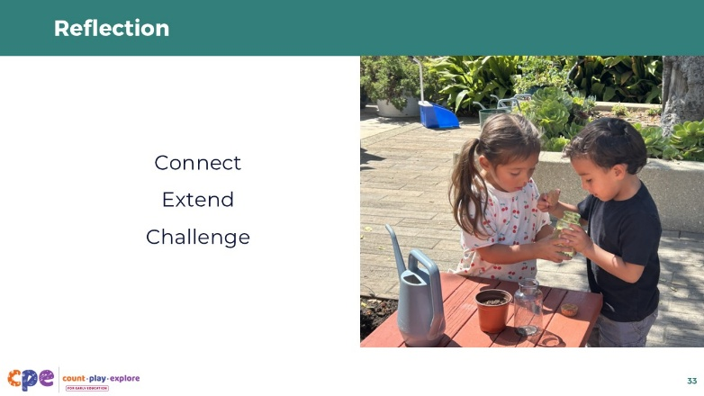
Time: 5 minutes

Talking Points
- Consider your experiences today.
- We explored ways children investigate living things and ways educators can support their investigations. We also planned ways we might investigate living things with the children in our learning settings.
- Take a moment to reflect.
- Consider the following:
  - In what ways does the content from our session today CONNECT with what you already do?
  - In what ways does the content from our session today EXTEND what you already do?
  - In what ways does the content from our session today CHALLENGE what you already do?
- [Encourage participants to reflect individually. Then, invite a few volunteers to share with the larger group.]

Slide 34: Thank you!
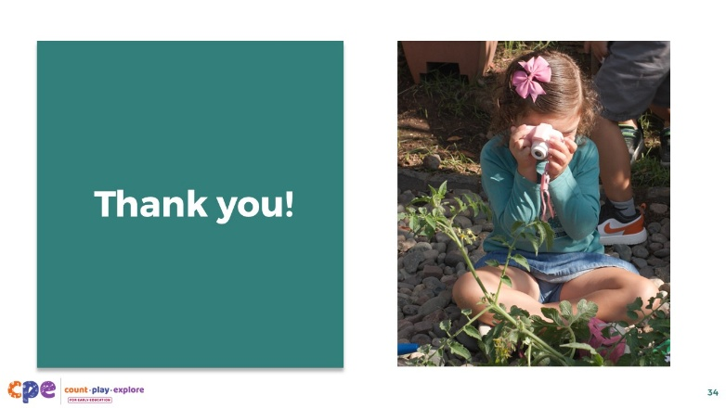

Talking Points
- Thank you for exploring living things with me today.

Facilitator Notes
- Consider any additional next steps for participants that will support them to apply what they have learned to their settings.

