Playful and Creative Coding
Use this facilitator guide with the slides “Playful and Creative Coding.” This facilitator guide and set of slides provide descriptions of how children from preschool to third grade develop an understanding of computational thinking (CT) skills through playful computer science (CS) experiences and ways educators can support them in CT and CS learning. Facilitators can find talking points and guidance for activities and group discussions in this guide. The text in the guide is also located in the notes portion of the slides.

Session at-a-Glance
Slide numbers | Overview of content | Approximate time (in minutes)
1–3 | Introduction and session goals | 5–10
4–10 | Engage in playful and creative coding  - Defining CT and CS  - Activities for adults | 50–60
11–20 | Explore strategies to support children’s CS learning  - Benefits of early CS exposure  - Video observation  - Connection to CS standards  - Integrating CS with other areas | 20–30
21–24 | Learn about CS resources for early childhood settings  - Resources for children  - Resources for educators and families  - Closing reflection | 15–20

To Prepare for Your Session
- Before your session, carefully review all handouts and prepare the necessary materials. Throughout the facilitator guide, we offer options for facilitation approaches. Select a facilitation method that works best for your session length and format, group size, and participant needs.
- Consider using photos, videos, or stories from the learning settings where educators work within this session. Making the information more personal for participants can create a greater connection to the content and foster feelings of belonging in STEAM.
- You might also review the Computational Thinking and Computer Science in Early Childhood research brief for a more in-depth understanding of this session topic.
- To support educators’ deeper understanding of CT, consider facilitating a session using the Computational Thinking suite.

Materials Needed
- Scratch paper, chart paper, and writing tools
- Embodied Movement handout, directional cards, tape, paper, writing tools, assorted objects (that could be used as obstacles for a maze)
- Movement with Bee-Bots handout
  - Option 1: Bee-Bot robots, large 5’x6’ grid, paper, writing tools
  - Option 2: Computers with Wi-Fi access for Bee-Bot online emulator, paper, writing tools
- Coding Resources for Children handout
- Coding Resources for Educators and Families handout

Slide 1: Playful and Creative Coding
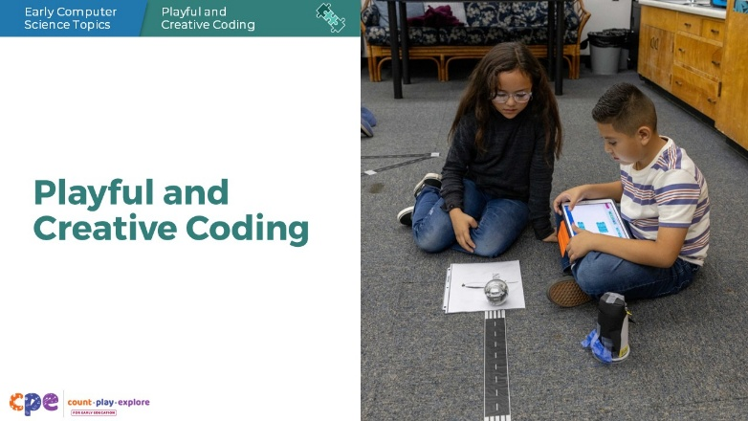

Talking Points
- Today, we will engage in playful and creative coding experiences and explore ways to support young children’s computational thinking (CT) and computer science (CS) learning.
Facilitator Notes
- Adjust talking points to reflect your session length and participant needs. If necessary, add introductory and “housekeeping” information.
- Consider participants’ knowledge of and experiences with CT and CS. For example, you might introduce a poll to learn about participants’ prior knowledge and experiences with this session topic. Tailor the session content and talking points based on the information you learn.
- If this session is participants’ first exposure to CT or CS, acknowledge any thoughts and feelings that participants may share about learning something new. If participants have prior experiences with CT or CS, acknowledge the value that their prior experiences and knowledge might add to the session.

Slide 2: Acknowledgments
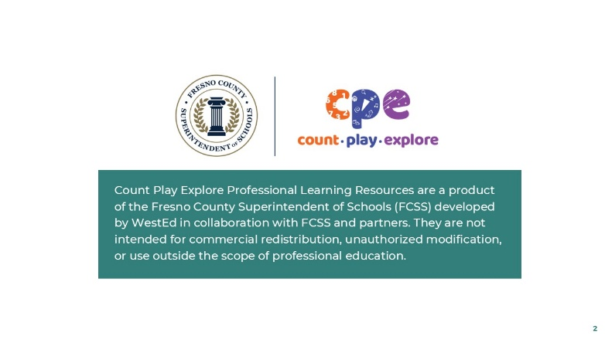

Talking Points
The Count Play Explore Professional Learning Resources were made possible by Count Play Explore, an early math, science, and computer science initiative led by the Fresno County Superintendent of Schools (FCSS), Early Care and Education Department. This initiative is generously funded by the California Department of Education and the California State Board of Education. These resources, developed by WestEd in collaboration with FCSS and the AIMS Center for Math and Science Education, are intended to be used as a guide for implementing evidence-based strategies, promoting active learning, and encouraging developmentally appropriate practices in early education settings. They are not intended for commercial redistribution, unauthorized modification, or use outside the scope of professional education.

Slide 3: Session Goals
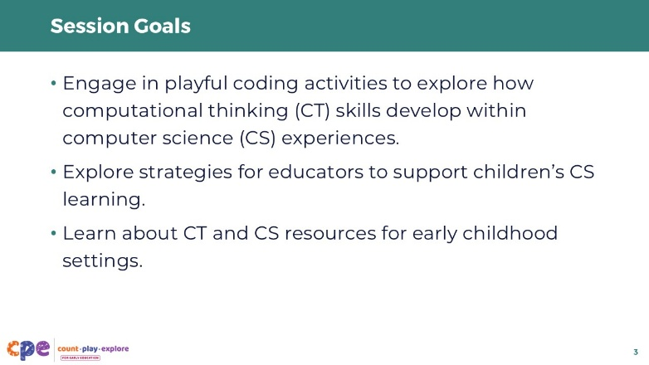

Talking Points
- In this session, we will:
  - engage in playful coding activities to explore how computational thinking (CT) skills develop within computer science (CS) experiences,
  - explore strategies for educators to support children’s CS learning, and
  - learn about CT and CS resources for early childhood settings.

Slide 4: Defining CT and CS
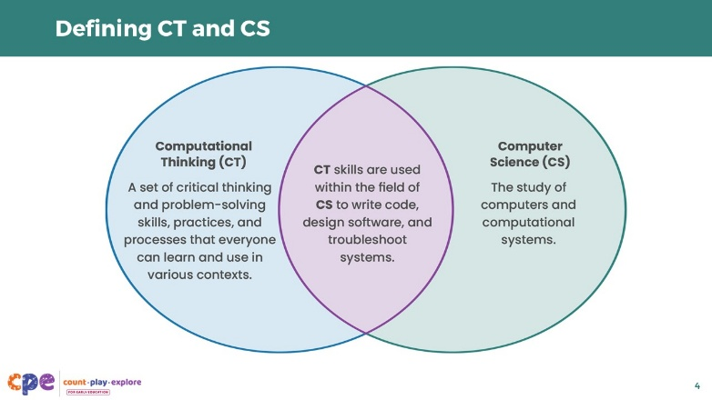

Talking Points
- Let’s begin by reviewing the terms “computational thinking” and “computer science,” or CT and CS for short.
- Computational Thinking (CT) is a set of critical thinking and problem-solving skills, practices, and processes that everyone, including computer scientists, can learn and use in various contexts.
- Computer science (CS) is the study of computers and computational systems. Computer scientists are people who use technology to solve real-world problems. They perform a variety of tasks, such as writing and running computer code, developing and testing software, and troubleshooting and improving computer systems.
- CT skills are used regularly within the broader field of CS to write code, design software, and troubleshoot systems. However, CT skills are also used outside the context of coding, as part of everyday life. We will explore both CT and CS in this session.

Facilitator Notes
- To support participants’ deeper understanding of CT, consider facilitating a session using the Computational Thinking suite.

Slide 5: Play: Embodied Movement
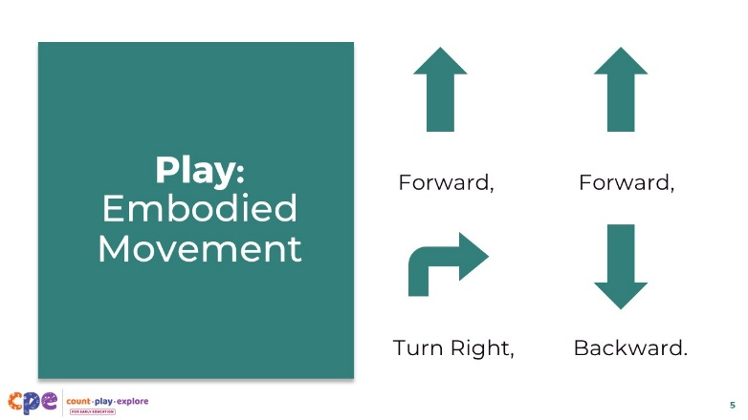
Materials: Embodied Movement handout, directional cards (included in the handout), tape, paper, writing tools, assorted objects (that could be used as obstacles for a maze)
Time: 20 minutes (including the next slide)

Talking Points
- An algorithm is a set of step-by-step instructions required to solve a problem or complete a task.
- Observe this algorithm on the slide of directional arrows that read “Forward, Forward, Turn Right, Backward.” Can you act out this algorithm with your body? For instance, you might point, move your arms, or turn your torso.
- [Provide time for participants to act out the movements.]
- Now you will create your own algorithms in small groups.
- [Provide activity handout and review the Round 1 instructions. After some time of playing Round 1, regroup participants and invite them to play Round 2.]

Facilitator Notes
- Model the algorithm on the slide as a whole group. Then invite participants to use the handout to work in small groups or pairs to create and act out their own algorithms.
- Walk around and check in with participants as they are doing the activities. Use CT language to model how the activity supports algorithmic thinking. For example, you might ask, “What are the steps of your algorithm? What happens first, second, third, and so on?” or make observations such as, “Your algorithm includes a repeat loop!”

Slide 6: Reflect: Embodied Movement
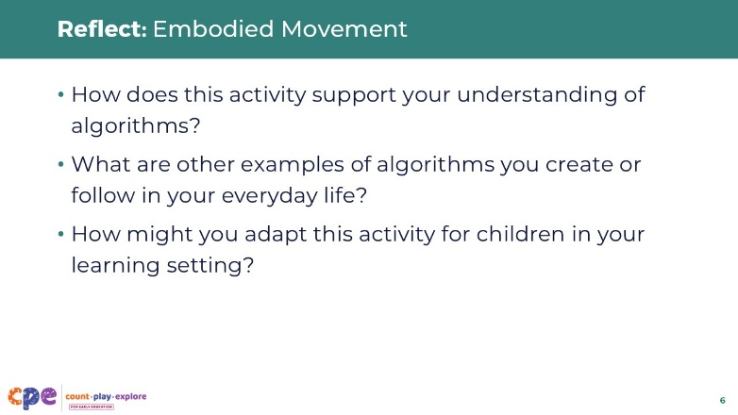
Materials: Embodied Movement handout
Time: 20 minutes (including the previous slide)

Talking Points
- In pairs or small groups, take a moment to reflect on this activity:
  - How does this activity support your understanding of algorithms?
  - What are other examples of algorithms you create or follow in your everyday life?
  - How might you adapt this activity for children in your learning setting?

Facilitator Notes
- Invite participants to share their reflections with the larger group.
- The purpose of this activity is for participants to practice creating and following step-by-step instructions, which is a foundational CT skill (algorithms and sequencing) needed for coding. Making connections to algorithms in participants’ everyday lives can support participants’ understanding of CT as a broad set of skills with many real-world applications.
- Use the notes below to facilitate a discussion.
- How does this activity support your understanding of algorithms?
  - The activity encouraged me to use a set of steps to complete a goal.
- What are other examples of algorithms you create or follow in your everyday life?
  - Examples might include following a recipe, learning a workout routine, tying shoes, and other daily routines that require a step-by-step process.
- How might you adapt this activity for children in your learning setting?
  - Children might work in pairs to get from point A to point B or to complete a task. One child can give a set of directions and the other child can follow those directions.

Slide 7: Play: Movement with Bee-Bots
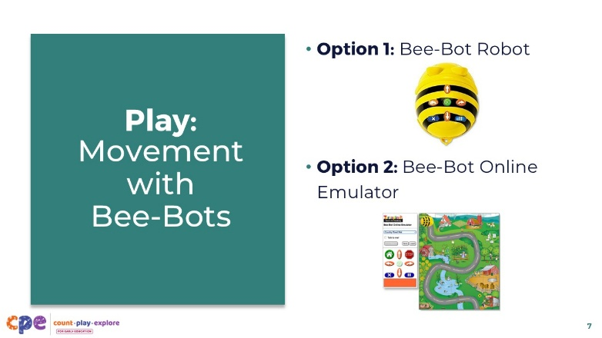
Materials: Movement with Bee-Bots handout (Option 1: Bee-Bot robots, large 5’x6’ grid, paper, writing tools; Option 2: Computers with Wi-Fi access for Bee-Bot online emulator, paper, writing tools)
Time: 20 minutes (including either Option 1 or Option 2)

Talking Points
- In the previous activity, we embodied the roles of being the “programmer” who creates algorithms and the “computer” that follows algorithms. Now we will act as programmers for an actual computer: the Bee-Bot robot!
- Bee-Bot is a robot that can move forward or backward and turn right or left. To make the robot do anything, we have to code or program it. Coding or programming is the practice of developing a set of instructions (or code) that a computer can understand and execute.

Facilitator Notes
- There are two options for engaging in this plugged activity: the Bee-Bot robot (~$100) or the screen-based Bee-Bot online emulator (free and available on all devices). Depending on your session format, group size, and agency resources, you might choose to use the robot, the screen-based online emulator, or both. Adapt the slides to reflect the option you select for this activity.
- Model the activity you choose as a whole group. Then invite participants to engage in the activity in small groups or pairs.

Slide 8: Option 1: Bee-Bot Robot
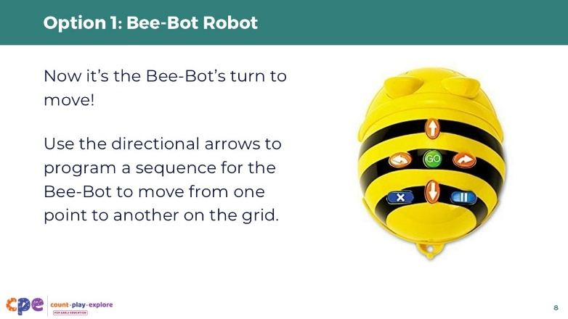
Materials: Movement with Bee-Bots handout, Bee-Bot robots, large 5’x6’ grid, paper, writing tools
Time: 20 minutes

Talking Points
- [Show participants the Bee-Bot robot. Demonstrate how to turn it on and program a sequence of actions using the directional arrow buttons.]
- Use the directional arrows to program a sequence for the Bee-Bot to move from one point to another on the grid.

Facilitator Notes
- Invite participants to program the Bee-Bot to navigate from one point to another.
  - For example, you might place objects in various spots on a grid and invite participants to program the Bee-Bot to navigate from one object to another object.
- Provide time for participants to freely explore the robot and create their own mazes and challenges.
  - For example, the grid might include obstacles such as lakes and bridges, and the robot must pass around or through the obstacles to get to its final destination. To support participants with designing grids for this activity, you might offer examples from the Bee-Bot online emulator (on next slide).
- Consider inviting participants to reflect on their own or children’s lived experiences when creating their own mazes and challenges. This activity can be an opportunity to make culturally relevant connections to personal experiences and communities, such as a local market or community garden.
  - For example, you might construct a maze for Bee-Bot to navigate from the school to the local zoo or showcase the path of a bee pollinating poppy flowers.
- Walk around and check in with participants as they are doing the activity. Use CT language to model how the activity supports algorithmic thinking. For example, you might ask, “What steps did your Bee-Bot take to navigate this maze? How might you represent this algorithm using arrows and other symbols?”

Slide 9: Option 2: Bee-Bot Online Emulator
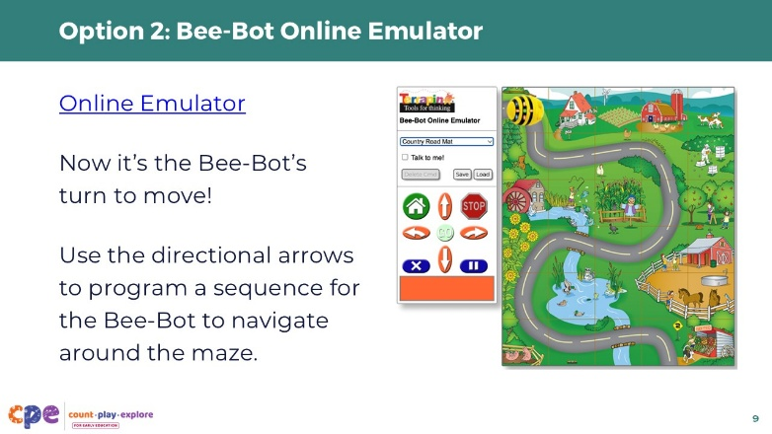
Materials: Movement with Bee-Bots handout, computers with Wi-Fi access for the Bee-Bot online emulator, paper, writing tools
Time: 20 minutes

Talking Points
- [Show participants the Bee-Bot online emulator. Demonstrate how to program a sequence of actions using the directional arrow buttons. Also demonstrate how to toggle between the various mats.]
- Use the directional arrows to program a sequence for the Bee-Bot to navigate around the maze.

Facilitator Notes
- Invite participants to program the Bee-Bot to navigate from one point to another on the Alphabet Mat.
- Provide time for participants to freely explore the online emulator and the various mats.
- Move around the room and check in with participants as they are doing the activity. Use CT language to model how the activity supports algorithmic thinking. For example, you might ask, “What steps did your Bee-Bot take to navigate this maze? How might you represent this algorithm using arrows and other symbols?”

Slide 10: Reflect: Movement with Bee-Bots
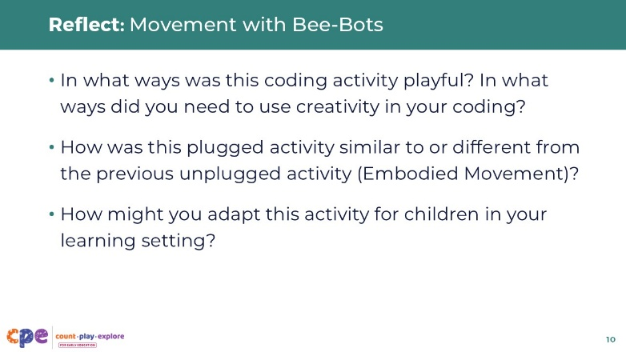
Materials: Movement with Bee-Bots handout
Time: 20 minutes (including the previous Option 1 or Option 2 slides)
Talking Points
- In pairs or small groups, take a moment to reflect:
  - In what ways was this coding activity playful? In what ways did you need to use creativity in your coding?
  - How was this plugged activity similar to or different from the previous unplugged activity (Embodied Movement)?
  - How might you adapt this activity for children in your learning setting?

Facilitator Notes
- Invite participants to share their reflections with the larger group.
- The purpose of this activity is for participants to experience a playful coding experience similar to the unplugged Embodied Movement activity.
- Explain how the activities were similar. For example:
  - Both activities involved creating and following a set of instructions to make something move from one location to another.
- Explain to participants how the two activities support CT and CS learning. For example:
  - In the Embodied Movement activity, participants created and followed algorithms to model the roles of programmers and computers. In the Movement with Bee-Bots activity, participants acted as programmers for the Bee-Bot. The Bee-Bot robot or online emulator was the computer that followed instructions exactly as given.
- Make connections to how you might use this robot to do similar activities with children ages three to eight.
  - For example, an educator might support a group of preschool children to count the number of grid steps between a Bee-Bot robot and its hive. Then, children work together to program the Bee-Bot.

Slide 11: Supporting Children’s CT and CS Learning
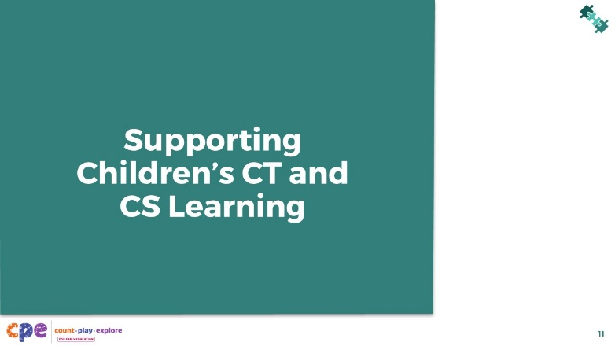

Talking Points
- Just as you experienced unplugged and plugged experiences in the previous activities, you can also engage children in unplugged and plugged experiences to support their CT and CS learning.
- Unplugged CT experiences can happen as part of everyday life, through activities like sorting laundry, following a recipe, or giving step-by-step directions. Through plugged CS experiences, children can further develop their CT skills while also learning the basics of coding.
- We will now explore examples of how to support children’s CT and CS learning.

Facilitator Notes
- To support participants’ deeper understanding of key CT skills in early childhood, consider facilitating a session using the Computational Thinking suite.
- Educators might have different feelings about using screens in their learning settings. For very young children, screen-free, "unplugged" experiences are often the most developmentally appropriate starting point. Educators might introduce meaningful and active plugged experiences when children are ready. It might be helpful to remind educators that meaningful and active plugged experiences allow children to use screens in ways that support learning and development which is different than using screens for passive entertainment.

Slide 12: Unplugged Examples of Algorithms
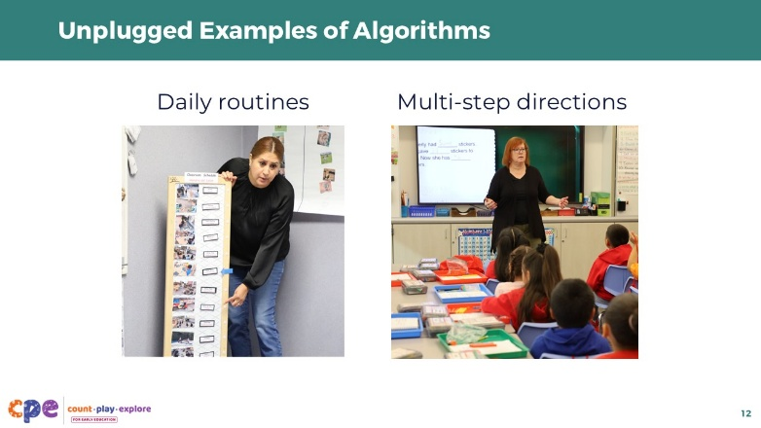

Talking Points
- Algorithmic thinking was a key CT skill that we engaged in as adults during the two activities earlier in this session. How might young children engage in algorithmic thinking as part of their everyday life?
- Daily routines are one way that young children experience algorithms and sequencing. When children follow a step-by-step routine, such as getting ready in the morning or following a daily schedule at school, they are learning that order matters.
- As children develop, they can engage in algorithms and sequencing in more complex ways. For instance, early elementary school children may follow multi-step instructions, ensuring that each step is completed in the correct order. They may also begin to create their own simple algorithms, such as describing the steps needed to solve a math problem.

Slide 13: Plugged Examples of Algorithms
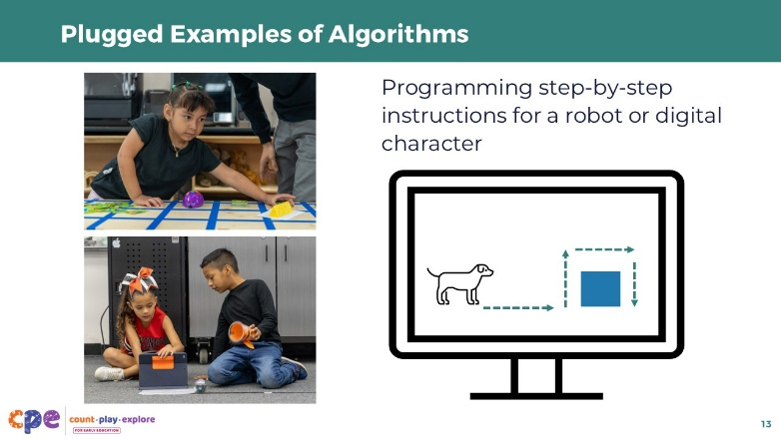

Talking Points
- Children can also use algorithmic thinking during plugged experiences—experiences utilizing technology.
- For example, children might use algorithms when programming a robot or digital character to move toward a target. They might create a step-by-step set of instructions, such as forward, forward, forward, turn right, forward, forward, turn right.
- Children might use different types of commands when creating an algorithm for a robot or digital character to follow. Commands might include different types of movement (for example, jump, spin), different speeds of movement (for example, slow, fast), different directions of movement (for example, left turn, right turn, 90-degree turn, 180-degree turn), or other types of behaviors (for example, making a sound).

Slide 14: Benefits of Early CS Exposure
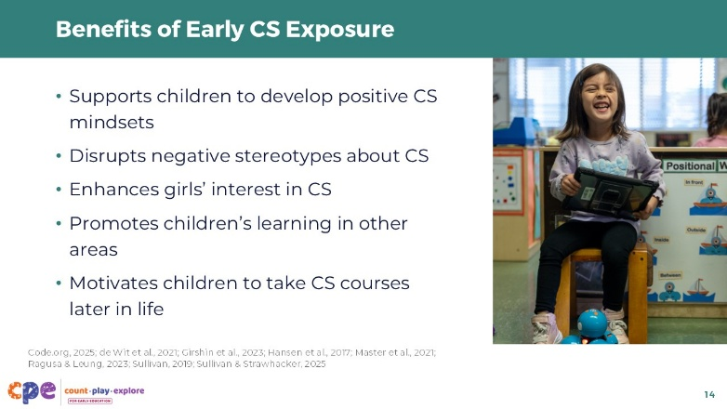

Talking Points
- Although children develop CT skills (like algorithmic thinking) through everyday learning experiences, there are benefits to targeted exposure to CS learning experiences (Sullivan & Strawhacker, 2025).
- Early exposure to CS can support children to develop positive mindsets about computing.
  - For example, a study with elementary children ages seven to ten found that participation in a robotics and coding afterschool program increased children’s understanding of CS and robotics, and it increased their motivation to pursue a CS-related career, such as engineering and software programming (Ragusa & Leung, 2023).
- Early exposure to CS can also disrupt negative stereotypes children may hold about who computer scientists are and what they do (Hansen et al., 2017; de Wit et al., 2021; Master et al., 2021).
  - For example, many studies have found that positive experiences with programmable robots can increase girls’ interest in CS, which can help promote gender equality in STEM fields (Girshin et al., 2023; Sullivan, 2019).
- Early exposure to CS has also been shown to have additional benefits for children’s academic success and career opportunities later in life. Studies show that children who study CS in school perform better in other subjects such as math, reading, and science; excel at problem-solving; and are more likely to attend college and pursue CS-related studies (Code.org, 2025).

Facilitator Notes
- Educators might have different feelings about the use of screens in their learning settings. You might acknowledge and validate these different feelings.

Slide 15: California Computer Science Standards
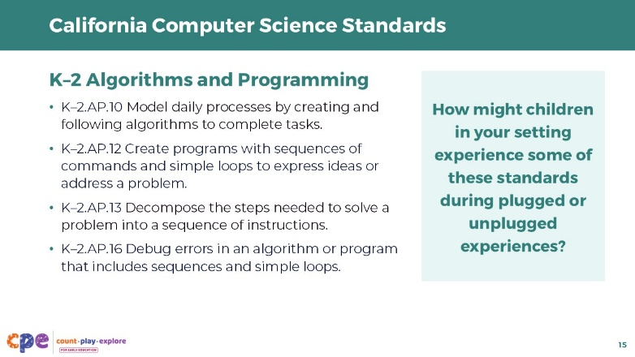

Talking Points
- This slide shares a few of the California K-12 Computer Science Standards related to algorithms and programming.
- How might children in your setting experience some of these standards during plugged or unplugged experiences?
- [Provide time for participants to reflect independently or in pairs and then share their reflections with the larger group.]

Facilitator Notes
- Invite participants to reflect on the prompt individually or in pairs. Then invite volunteers to share their reflections with the larger group. Here are some possible responses that you might use to support a discussion:
  - Children might create a set of instructions for how they get ready for lunch.
  - Children might decompose the steps needed to solve a problem. For example, making a plan for how to fix the bird feeder or planning ways to start a garden.
- The standards listed in this slide are condensed. You might consider providing participants with copies of the California K-12 Computer Science Standards. Consider whether electronic or printed copies will be more useful for your participants.

Slide 16: Observe: Integrating CS in Play (3–5 years)
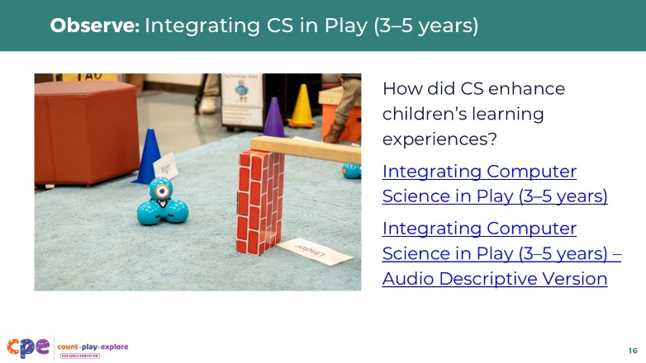
Materials: Integrating Computer Science in Play (3–5 years), Integrating Computer Science in Play – Audio Descriptive Version video clip

Talking Points
- Let’s observe some additional examples of how children engage in CS in a learning setting.
- Observe this video of preschool educators sharing examples of integrated CS lessons.
- Notice ways CS enhances children’s learning.
- [Play the video.]
- In each of these examples, how did CS enhance children’s learning experiences?
- [Invite participants to reflect on the prompt individually or in pairs. Then invite volunteers to share their reflections with the larger group. Use the Facilitator Notes to support a discussion.]

Facilitator Notes
- Use the notes below to support a discussion:
  - In the first example, an educator discusses a literacy activity with the Sphero Dash and Dot robots. Children use tablets to program the robots to navigate to different letters. CS enhances children’s learning by providing a playful way to learn letters and develop spatial thinking skills as they move the robot in different directions.
  - In the second example, an educator facilitates a water table activity with the Sphero BOLT robot. This CS experience enhances children’s learning by providing a playful way to develop spatial thinking skills.

Slide 17: Observe: Coding Pathways to the Zoo (second–third grade)
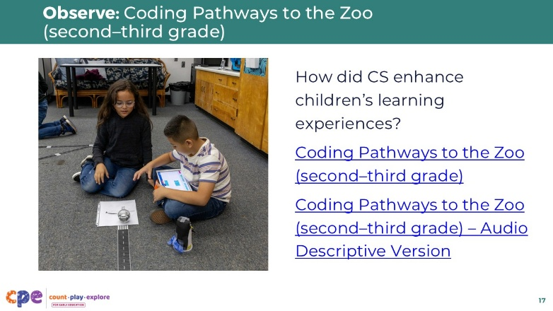
Materials: Coding Pathways to the Zoo (second–third grade), Coding Pathways to the Zoo (second–third grade) – Audio Descriptive Version video clip

Talking Points
- Now let’s observe this video of a third-grade classroom. In this example, the educator discusses a maze activity with the Sphero BOLT robots.
- Children decorate their robot as an animal and work together in pairs to program their animal to navigate through a maze to get to their final destination: the zoo!
- Notice how children develop, test, debug, and retest their program to get their animal to follow the maze path as closely as possible.
- [Play the video.]
- In this example, how does CS enhance children’s learning experiences?
- [Provide time for participants to reflect independently or in pairs and then share their reflections with the larger group. Use the Facilitator Notes to support a discussion.]

Facilitator Notes
- Use the notes below to support a discussion:
- CS enhances children’s learning experiences in the following ways:
  - Children use math. They manipulate the time (in seconds) that the robot moves forward. They also explore changes in angles to change the direction the robot will turn.
  - Children use art when developing their model animals.
  - Children use knowledge of life science when they create their model animals. They consider the different characteristics of different animals they might find in a zoo.
  - Children use technology. They use tablets to program their robots.
  - The experience supports children’s approaches to learning skills—children use persistence as they debug and retest their programs.
  - The experience also supports children’s social and emotional skills—they work collaboratively, communicating with each other about ways to improve their programs.

Slide 18: Strategies to Support CS Learning
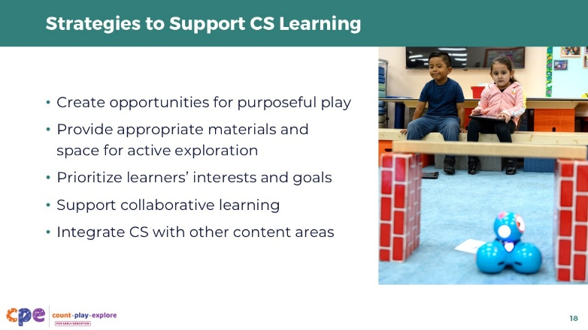

Talking Points
- As the video examples help illustrate, educators can use a variety of strategies to integrate CS into their teaching practice and support children’s learning. For example, educators can intentionally:
  - create opportunities for purposeful play,
  - provide appropriate materials and space for active exploration,
  - prioritize learners’ interests and goals,
  - support collaborative learning, and
  - integrate CS with other content areas.
- In the videos we just observed, which strategies did you notice educators using to support children’s CS learning?
- [Provide time for participants to reflect independently or in pairs and then share their reflections with the larger group. Use the Facilitator Notes to support a discussion.]

Facilitator Notes
- You might replay the videos from the previous slides to help participants notice and reflect on the strategies.
  - Integrating Computer Science in Play (3–5 years)
  - Integrating Computer Science in Play – Audio Descriptive Version
  - Coding Pathways to the Zoo (second–third grade)
  - Coding Pathways to the Zoo (second–third grade) – Audio Descriptive Version
- Use the points below to support a discussion:
- In the video “Integrating Computer Science in Play (3–5 years),” educators use the following strategies to support CS learning:
  - Create opportunities for purposeful play: In both clips, the educators support children to playfully navigate the robots. Children choose which target to seek out and are invited to playfully find ways to navigate their robot toward different targets.
  - Provide materials and open space for exploration: For example, in the first clip, the educator provides blocks and cones to allow children to create pathways to move the robot on. In the second clip, the educator provides a large tub of water with obstacles to invite the children to explore movement in different ways.
  - Integrate CS with other domains: The educator in the first clip provides letter cards to act as targets for children to guide their robots toward. The integration of letters into this CS experience supports literacy.
- In the video “Coding Pathways to the Zoo (second–third grade)” the educator used the following strategies to support learning:
  - Create opportunities for purposeful play: The educator creates a playful context—navigating animals to the zoo—to support children to use coding in a playful way.
  - Provide appropriate materials and space for active exploration: The educator uses “road tape” on the floor to create visual guidelines for how the robots are intended to move. The educator also provides ample space for children to work so they do not crowd each other or accidentally move their robots into one another.
  - Prioritize learners’ interests and goals: The children are invited to represent an animal of their choice for their coding experience.
  - Support collaborative learning: The educator organizes children into pairs. Children are able to troubleshoot together—building communication and cooperation skills.
  - Integrate CS with other content areas: The educator supports children’s engagement with the arts when they create their representations of different animals. The educator also supports children’s development of math skills, including spatial thinking, geometry (angles), and measurement (time). Additionally, the educator supports children’s thinking about life science concepts by supporting children to consider the different attributes of different animals as they develop their models.

Slide 19: Coding Supports Math and Science Learning
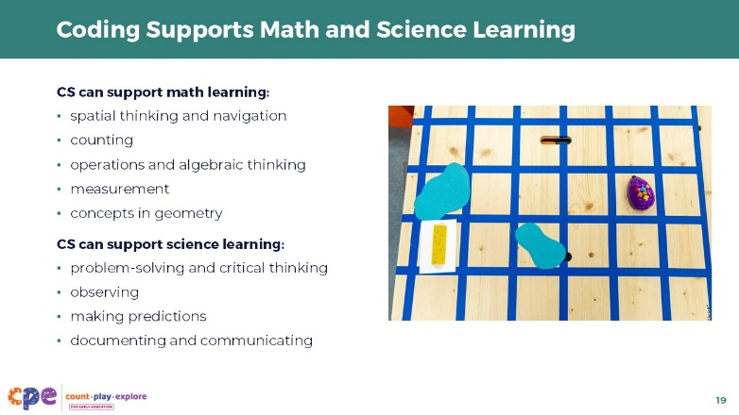

Talking Points
- As we observed in the videos, CS is an effective way to support math and science learning.
- CS provides opportunities to support many different math concepts. For example, CS can support children’s understanding of:
  - spatial thinking and navigation,
  - counting,
  - operations and algebraic thinking,
  - measurement, and
  - concepts in geometry.
- Similarly, CS can support science learning. CS can be used to explore and represent many different concepts and phenomena across the science disciplines. Moreover, CS can also provide opportunities for children to use science practices. For example:
  - problem solving and critical thinking
  - observing
  - making predictions
  - documenting and communicating

Facilitator Notes
- You might encourage participants to think about the different math and science skills they used during their Bee-Bot activity. Examples of math and science connections that participants might share include:
  - spatial thinking and navigation,
  - counting the number of steps,
  - problem-solving and critical thinking,
  - measuring how far the Bee-Bot moves,
  - observing the movements of the Bee-Bot,
  - recognizing shapes and sizes (using the Bee-Bot online emulator),
  - considering the life cycle of a butterfly (using the Bee-Bot online emulator), and
  - identifying plants and animals (using the Bee-Bot online emulator).

Slide 20: How might CS be integrated with other areas?
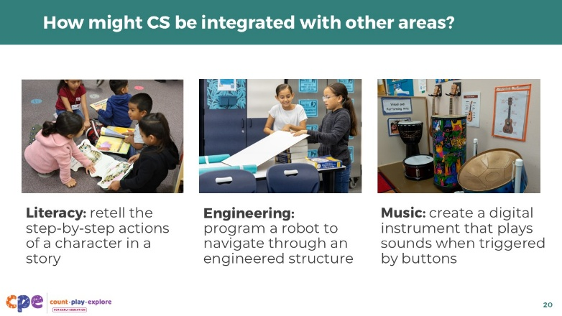

Talking Points
- Not only can CS support learning and development in math and science, but it can also support learning in other domains.
- Here are some additional examples of playful and creative coding activities that can support learning in other areas:
  - Literacy: Retelling a story (what happens first, second, third, and so on) involves the CT skill of algorithms and sequencing. Children might retell a story in their home language and then program robots to act out a character’s actions in the story.
  - Engineering: Assembling blocks in different ways to create different kinds of structures involves the CT skill of decomposition and modularity. Children might program a robot to navigate through a bridge or over a ramp constructed from blocks.
  - Music: Musical notes are abstract symbols that represent sounds (abstraction and representation). Children might use a coding application to create a digital instrument that plays different sounds when triggered by different buttons.
- What are other examples of how CS can be integrated into other areas of learning and development?

Facilitator Notes
- Invite participants to share their own examples in small groups. Their examples could come from other areas of learning and development, such as approaches to learning, technology, social and emotional development, social studies, and so on.

Slide 21: Coding Resources for Children
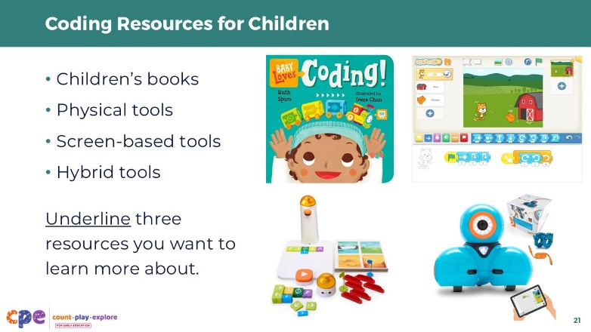
Materials: Coding Resources for Children handout

Talking Points
- There are many unplugged and plugged resources to support children’s CS learning.
- Unplugged resources include children’s books. Books offer an opportunity for children of all ages to learn about coding without using any technology.
- Plugged resources include physical tools, screen-based tools, and hybrid tools. These resources provide children with opportunities to engage in coding using technology such as robots, computers, and tablets.
- [Provide participants with the handout.]
- Take a moment to review the handout. Underline three resources you want to explore further in the next week or month. For instance, you might explore a children’s book at your local library, observe videos related to a robotics kit, or try out a new coding application.

Facilitator Notes
- Acknowledge that this handout is not exhaustive. Provide guidance on how to choose appropriate resources for participants’ learning settings, depending on factors such as:
  - type of interface (physical, screen-based, or hybrid),
  - price point, and
  - recommended ages and developmental appropriateness

Slide 22: Coding Resources for Educators and Families
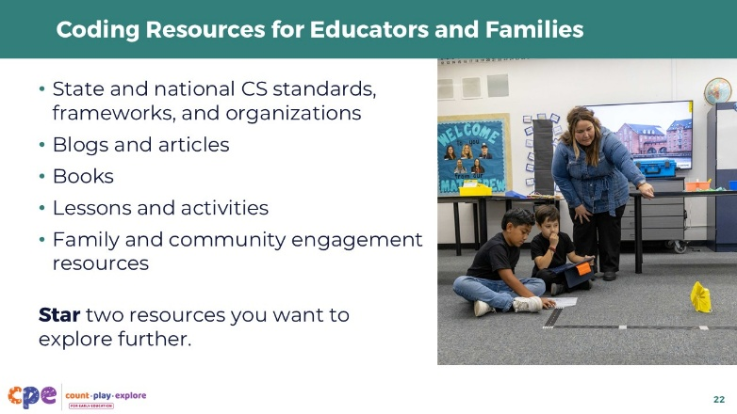
Materials: Coding Resources for Educators and Families handout

Talking Points
- In addition to resources for children, there are also various resources that educators and families might use to support their own learning or children’s CS learning:
  - state and national CS standards, frameworks, and organizations
  - blogs and articles about CT and CS in early childhood
  - books for adults
  - curricular lessons and activities
  - family and community engagement resources
- [Provide participants with the handout.]
- Take a moment to review the handout. Star two resources you want to explore further in the next week or month. For instance, you might preview a few lessons from a coding curriculum or read an article about coding in preschool settings.

Facilitator Notes
- Acknowledge that this handout is not exhaustive.

Slide 23: Reflect: CS Learning
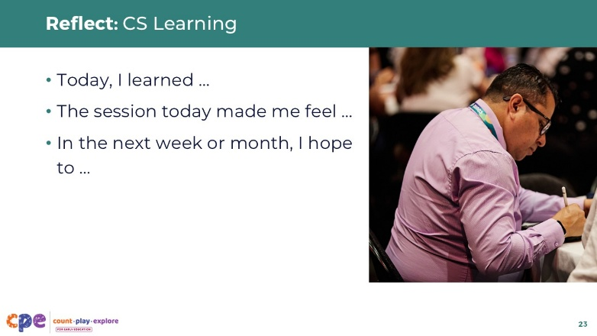

Talking Points
- Individually on a sticky note or in a journal, reflect on your learning from this session.
- Fill in these sentence starters:
  - Today, I learned …
  - The session today made me feel …
  - In the next week or month, I hope to …

Facilitator Notes
- Participants may experience a range of emotions in this session, especially if it’s their first introduction to coding. Remind participants that it is okay to feel uncomfortable or nervous about CS. Just as they encourage children to adopt a growth mindset, it’s important for participants to remember that they can also develop their skills over time with continued practice and persistence. Acknowledge that educators’ attitudes and beliefs about CS learning can affect the way they support children’s CS learning.
- Encourage participants to share their reflections in small groups or pairs. Then, invite volunteers to share with the larger group.

Slide 24: Thank You!


Talking Points
- Thank you for exploring computer science with me today!
- I hope you enjoy learning more about computer science with the children in your learning settings.

Facilitator Notes
- Providing ongoing support and opportunities for collaborative reflection are critical components of effective professional learning (Darling-Hammond et al., 2017). Consider ways you can support participants to apply what they learned in this session to their learning settings and support collaborative reflection. For example:
  - Encourage participants to share photos and anecdotes of ways they are supporting children’s CS learning. You might use digital platforms such as Padlet or a shared Google Drive. You can provide feedback to individual participants and encourage others to make comments and suggestions as a way to build community.
  - Encourage educators to keep a journal to document ways they are supporting children’s CS learning. They can share and discuss their journal entries during in-person meetings.

