Computational Thinking
Use this facilitator guide with the slides “Computational Thinking.” This facilitator guide and set of slides provide descriptions of how children from birth to age eight develop an understanding of computational thinking (CT) and ways educators can support them in CT. Facilitators can find talking points and guidance for activities and group discussions in this guide. The text in the guide is also located in the notes portion of the slides.

Session at-a-Glance
Slide numbers | Overview of content | Approximate time (in minutes)
1–5 | Introduction, session goals, and opening icebreaker | 15–20
6–16 | Define computational thinking  - Activity for adults  - Video observation  - Defining CT | 20–30
17–22 | Explore key CT skills in early childhood  - Explore key CT skills  - Children’s development of CT skills | 40–50
23–29 | Identify teaching practices to support children’s CT skills  - Video observation  - Integrating CT into play and everyday routines  - CT in your teaching practice | 15–20
The times are approximate and may vary based on session goals, group size, and participants’ previous experience and familiarity with the content.

To Prepare for Your Session
- Before your session, carefully review all handouts and prepare the necessary materials. You might also review the Computational Thinking and Computer Science in Early Childhood research brief, which is provided as part of this suite’s materials, for a more in-depth understanding of this session topic.
- Throughout the facilitator guide, we offer options for facilitation approaches. Select a facilitation method that works best for your session length and format, group size, and participant needs.
- Consider using photos, videos, or stories from the learning settings where educators work within this session. Making the information more personal for participants can create a greater connection to the content and foster feelings of belonging in STEAM.
- To support educators’ deeper understanding of CT in the context of computer science, consider facilitating a session using the Playful and Creative Coding suite.

Materials Needed
- Scratch paper, chart paper, and writing tools
- Computational Thinking Skills handout, arts and crafts materials (such as markers, colored paper, scissors, recycled materials, modeling clay, and so on)

Slide 1: Computational Thinking
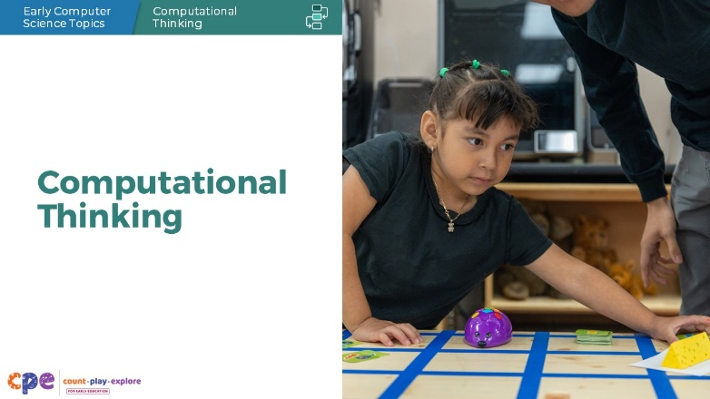

Talking Points
- In this session, we will explore foundational skills of computational thinking (CT) in children from birth to age eight. We will also focus on ways we can support children to develop and use CT.

Facilitator Notes
- Adjust talking points to reflect your session length and participant needs. If necessary, add introductory and “housekeeping” information.
- Consider participants’ knowledge of and experiences with CT. For example, you might introduce a poll to learn about participants’ prior knowledge and experiences with this session topic. Tailor the session content and talking points based on the information you learn.
- If this session is participants’ first exposure to CT, acknowledge any thoughts and feelings that participants may share about learning something new. If participants have had prior experiences with CT, acknowledge the value that their prior experiences and knowledge might add to the session.

Slide 2: Acknowledgments
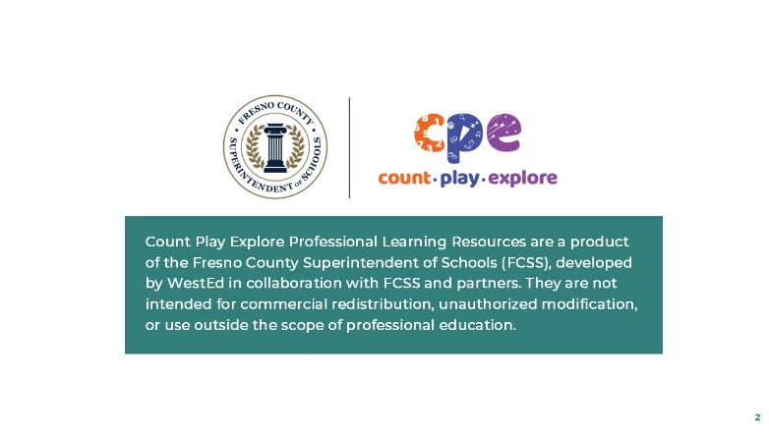

Talking Points
The Count Play Explore Professional Learning Resources were made possible by Count Play Explore, an early math, science, and computer science initiative led by the Fresno County Superintendent of Schools (FCSS), Early Care and Education Department. This initiative is generously funded by the California Department of Education and the California State Board of Education. These resources, developed by WestEd in collaboration with FCSS and the AIMS Center for Math and Science Education, are intended to be used as a guide for implementing evidence-based strategies, promoting active learning, and encouraging developmentally appropriate practices in early education settings. They are not intended for commercial redistribution, unauthorized modification, or use outside the scope of professional education.

Slide 3: Session Goals
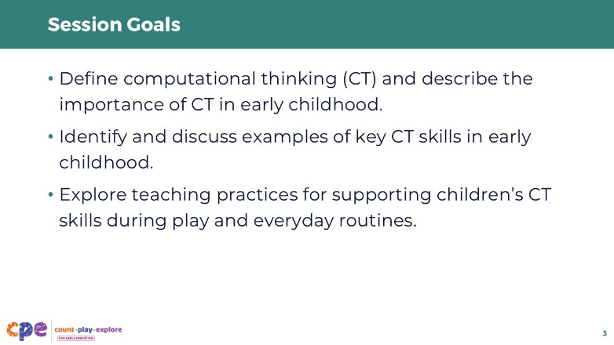

Talking Points
- In this session, we will:
  - define computational thinking (CT) and describe the importance of CT in early childhood,
  - identify and discuss examples of key CT skills in early childhood, and
  - explore teaching practices for supporting children’s CT skills during play and everyday routines.

Slide 4: Explore: If-Then Icebreaker
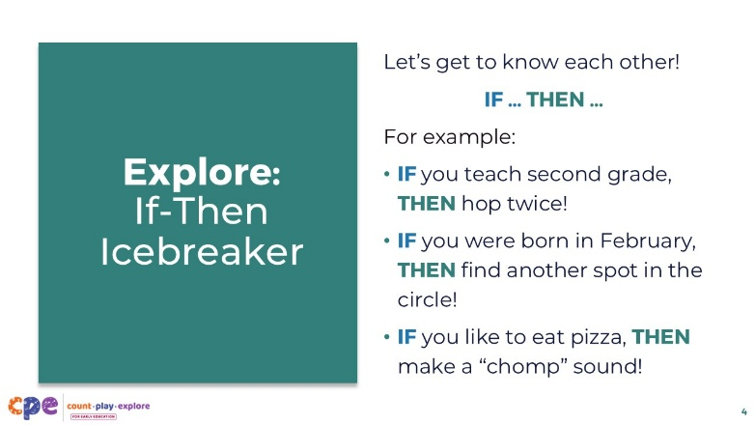
Time: 10 minutes (or as many rounds as there is time for)

Talking Points
- Let’s play a game to get to know each other!
- Gather around in a circle, except for one person who will be in the center of the circle.
- The center person makes an if-then statement like, “If you teach second grade, then hop twice!” Everyone around the circle who teaches second grade must then follow the instructions and hop twice.
- To switch out the person in the center, that person can make moving around the circle as part of the instructions. For example, the center person might say, “If you were born in February, then find another spot in the circle!” All those born in February leave their spot in the circle and find another spot, including the center person. The last person without a spot in the circle comes to the center.

Facilitator Notes
- Consider providing examples of if-then statements for participants to draw from. For example:
  - If you teach [grade level], then [do this action]!
  - If you were born in [month], then [do this action]!
  - If you like to eat [type of food], then [do this action]!
  - If you like to [hobby], then [do this action]!
- To modify this activity for adults with limited mobility, consider other ways for participants to get to know each other while practicing if-then statements. For example:
  - If you teach [grade level], then make a “quack” sound like a duck!
  - If you were born in [month], then raise your hand!
- This is an adult icebreaker activity but could also be adapted for early elementary settings. The activity is done whole-group (with group sizes up to 40 participants). For groups larger than 40 participants, split into smaller groups.

Slide 5: Reflect: If-Then Icebreaker
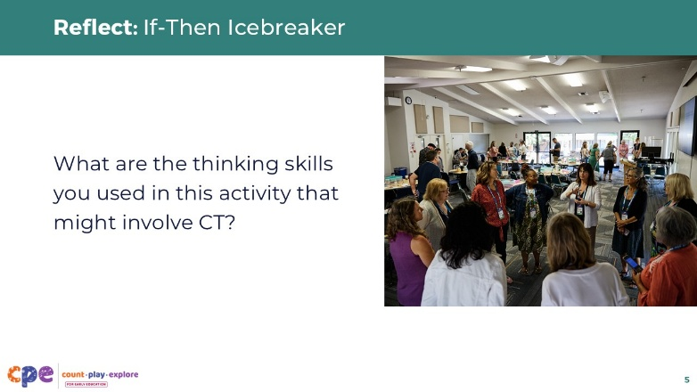
Time: 10 minutes (including the previous slide)

Talking Points
- Take a minute to independently reflect on how this icebreaker might relate to CT:
  - What are the thinking skills you used in this activity that might involve CT?
- [Provide time for participants to reflect individually on a sticky note or in a reflection journal. After a couple of minutes, invite participants to share their reflections with a partner.]
- In this session, you will learn more about how you used multiple CT skills when participating in this game and how children practice these CT skills during similar experiences. For example, you used conditional logic to make if-then statements.

Facilitator Notes
- The purpose of this reflection is for participants to draw upon any prior knowledge about CT. Consider how you might create a safe space for all participants, regardless of their prior knowledge or background with CT or computer science, to engage in this reflection. For instance, you might explicitly acknowledge that it’s OK if this activity did not surface any reflections related to CT and that we will explore CT skills in greater detail later in this session.

Slide 6: CT Makes Me Think of …
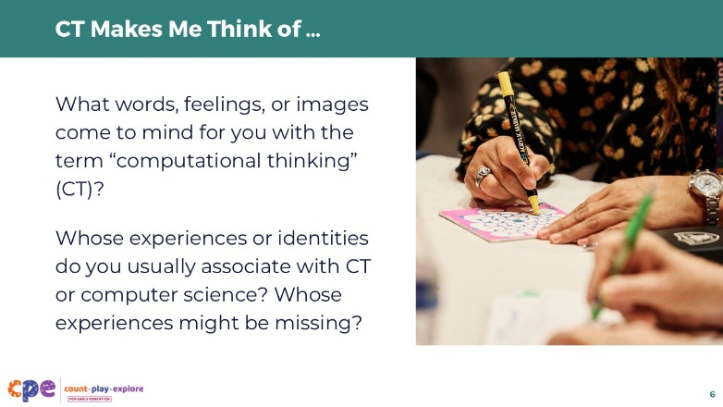

Talking Points
- What words, feelings, or images come to mind for you with the term “computational thinking?” Whose experiences or identities do you usually associate with CT or computer science? Whose experiences might be missing?
- Record your reflections independently on a sticky note or in a reflection journal.
- [Provide time for participants to reflect individually on a sticky note or in a reflection journal. After a couple of minutes, invite participants to share with their table group.]
- What words, feelings, images, experiences, and identities emerged in your table discussions? How were your reflections similar to or different from others’ reflections?

Facilitator Notes
- These reflection prompts may elicit a range of thoughts and emotions from participants. They can also support facilitators in gently surfacing implicit biases and stereotypes related to CT and computer science, which may be connected to individuals’ identities and sense of belonging in STEAM. Encourage participants to engage in independent reflection before sharing their reflection with others.
- For longer sessions with a large group of participants, consider doing this reflection as a word cloud activity to display participants’ responses in real time (using a free word cloud generator such as Mentimeter or Poll Everywhere).
- You might also facilitate this reflection as a gallery walk activity. Post the reflection questions on chart paper and then invite participants to record their reflections on sticky notes and post them on the chart paper. Invite participants to review and react to others’ reflections using stickers or writing tools.

Slide 7: Play: True or False?
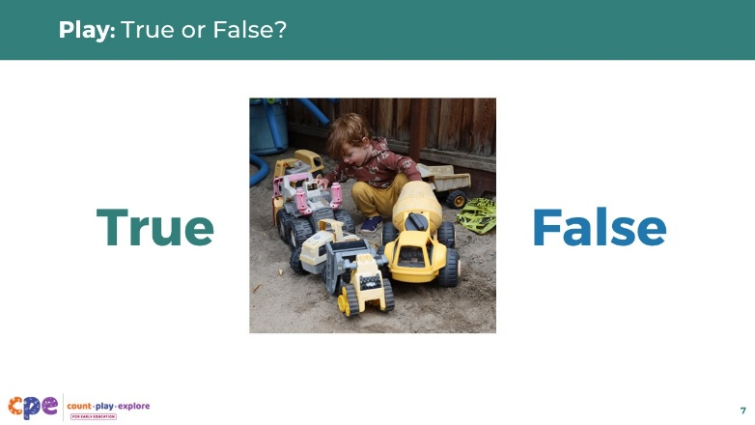

Talking Points
- Let’s explore what CT actually is and isn’t.
- Review each of the following statements about CT, some of which represent what CT is and some of which do not. Consider whether each statement is true or false.

Facilitator Notes
- There are different ways to invite participants to indicate their answer to each statement as “True” or “False.” For example, you might ask participants to raise their hand for each answer, wave a green-colored paper for “True” and a red-colored paper for “False,” or respond to a virtual poll. An anonymous poll might encourage participants who may not have prior CT knowledge or experience to feel more comfortable participating in this activity.

Slide 8: True or False? #1
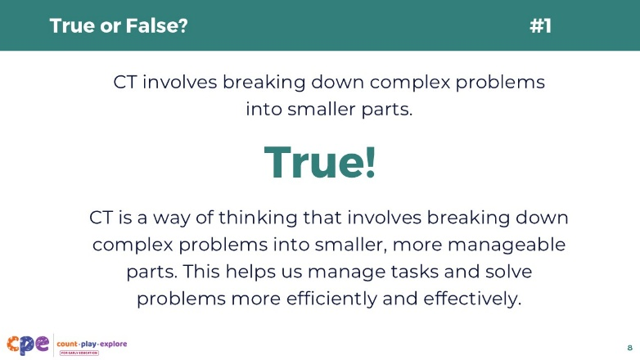
This slide contains animation. See instructions in the Talking Points.

Talking Points
- True or false? “CT involves breaking down complex problems into smaller parts.”
- [Pause to allow participants time to think about the statement and respond.]
- [Click: The following text will appear on the screen:] True!
- CT is a way of thinking that involves breaking down complex problems into smaller, more manageable parts. This helps us manage tasks and solve problems more efficiently and effectively.

Slide 9: True or False? #2
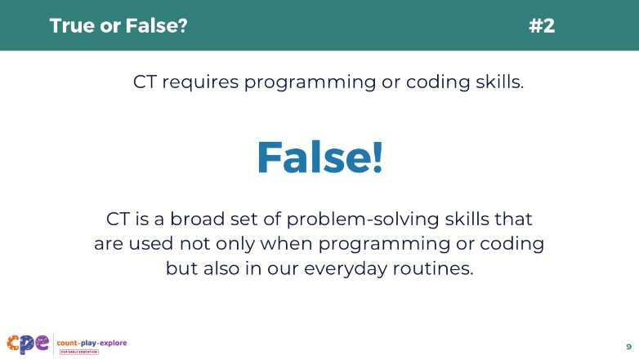
This slide contains animation. See instructions in the Talking Points.

Talking Points
- True or false? “CT requires programming or coding skills.”
- [Pause to allow participants time to think about the statement and respond.]
- [Click: The following text will appear on the screen:] FALSE!
- CT is a broad set of problem-solving skills that are used not only when programming or coding, but also in our everyday routines.

Slide 10: True or False? #3
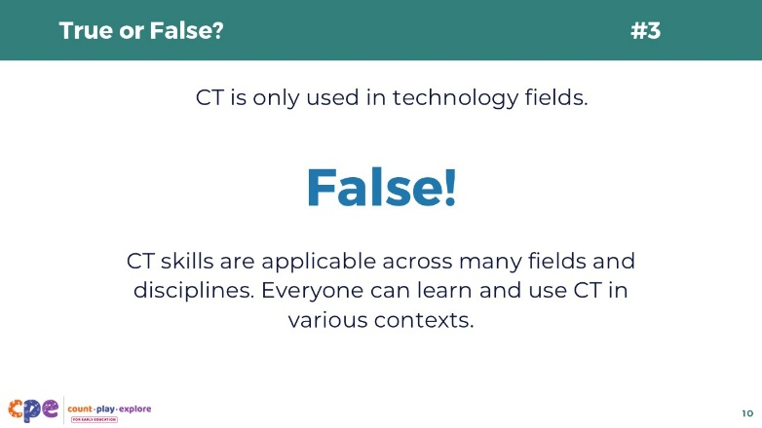
This slide contains animation. See instructions in the Talking Points.

Talking Points
- True or false? “CT is only used in technology fields.”
- [Pause to allow participants time to think about the statement and respond.]
- [Click: The following text will appear on the screen:] FALSE!
- CT skills are applicable across many fields and disciplines. People of all ages, cultural backgrounds, languages, and abilities can learn and use CT in various contexts.

Slide 11: True or False? #4
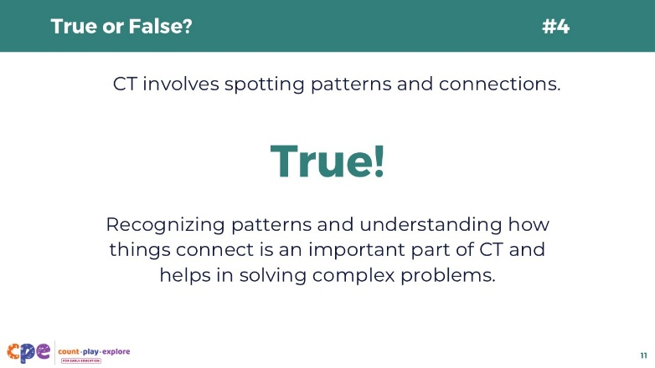
This slide contains animation. See instructions in the Talking Points.

Talking Points
- True or false? “CT involves spotting patterns and connections.”
- [Pause to allow participants time to think about the statement and respond.]
- [Click: The following text will appear on the screen:] TRUE!
- Recognizing patterns and understanding how things connect is an important part of CT and helps in solving complex problems.

Slide 12: True or False? #5
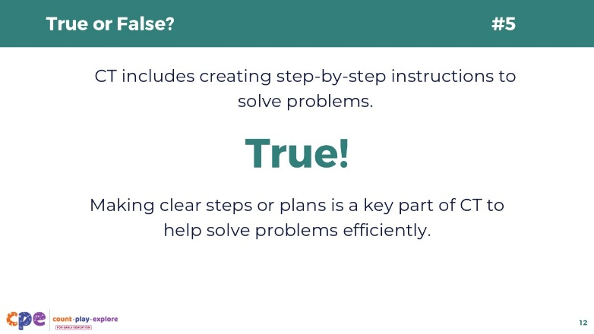
This slide contains animation. See instructions in the Talking Points.

Talking Points
- True or false? “CT includes creating step-by-step instructions to solve problems.”
- [Pause to allow participants time to think about the statement and respond.]
- [Click: The following text will appear on the screen:] TRUE!
- Making clear steps or plans is a key part of CT to help solve problems efficiently.

Slide 13: True or False? #6
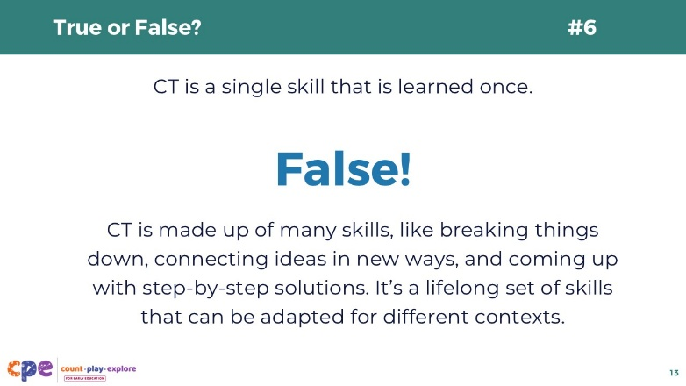
This slide contains animation. See instructions in the Talking Points.

Talking Points
- True or false? “CT is a single skill that is learned once.”
- [Pause to allow participants time to think about the statement and respond.]
- [Click: The following text will appear on the screen:] FALSE!
- CT is made up of many skills like breaking things down, connecting ideas in new ways, and coming up with step-by-step solutions. It’s a lifelong set of skills that can be adapted for different contexts.

Slide 14: Observe: Cracking the Code
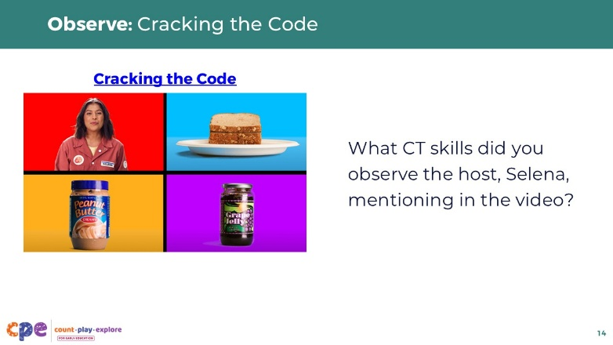
Time: 5 minutes
Materials: “I’m Ready!” video, Cracking the Code, Cracking the Code – Audio Descriptive Version

Talking Points
- As you might have noticed from the statements we just covered, CT is a broad set of skills used in everyday life.
- It can be as simple as how we come up with special handshakes. Let’s observe an example in this video.
- We will observe an “I’m Ready!” video from the Count Play Explore website called “Cracking the Code.” You will observe a child and his father creating a special handshake. Notice how they use symbols to represent the different actions of the handshake.
- [Play the video.]
- What CT skills did you observe the host, Selena, mentioning in the video clip?
- [Provide time for participants to reflect and then share their reflections.]
- In the video, Selena mentions multiple CT skills: sequencing, representation, and loops. We will learn more about these CT skills later in this session.

Facilitator Notes
- Encourage participants to share in small groups or pairs. Then, invite volunteers to share with the larger group.

Slide 15: Defining CT
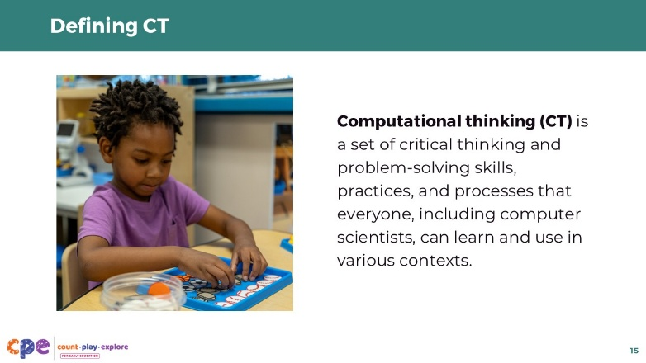

Talking Points
- So far, we have discussed what CT involves and might look like. Let’s explore the definition of CT.
- Computational thinking is a set of critical thinking and problem-solving skills, practices, and processes that everyone, including computer scientists, can learn and use in various contexts.
- CT skills are used regularly within the broader field of computer science to write code, design software, and troubleshoot systems. However, CT skills are also used outside the context of coding, as part of everyday life.

Facilitator Notes
- For more activities and resources related to CT and coding, you might offer a follow-up session for participants using the Playful and Creative Coding suite.

Slide 16: We Are All Computational Thinkers!
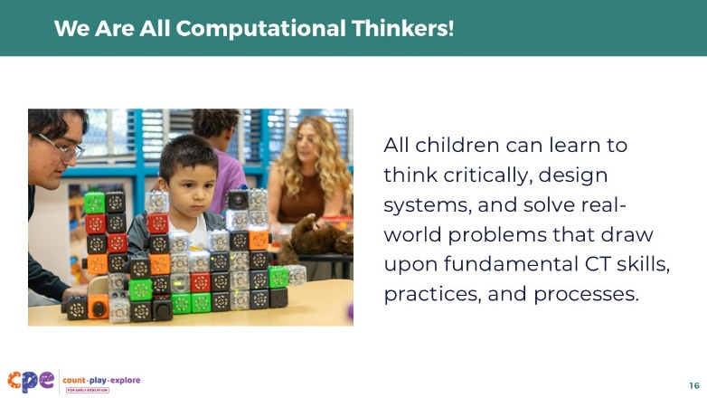

Talking Points
- Although children of different ages and ability levels may use CT skills at varying levels of complexity, it’s important to remember that we are all computational thinkers.
- All children can learn to think critically, design systems, and solve real-world problems that draw upon fundamental CT skills, practices, and processes.

Slide 17: Key CT Skills in Early Childhood
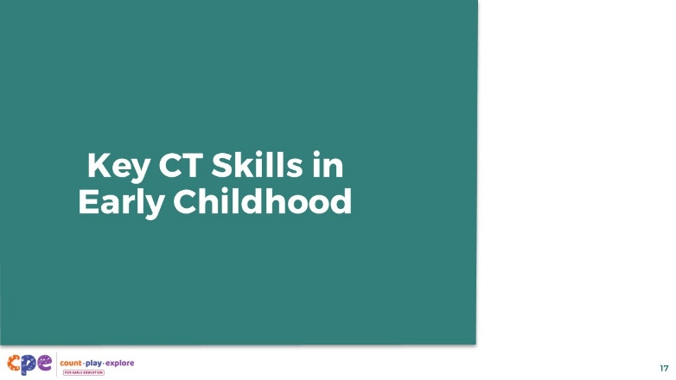

Talking Points
- Now that we’ve explored what CT is, let’s dive deeper into specific CT skills that young children can learn and develop.

Slide 18: Six Key CT Skills
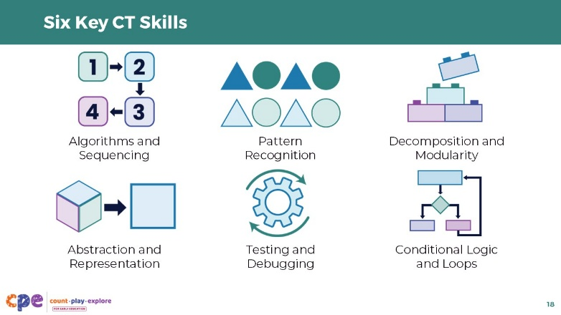
Materials: Computational Thinking Skills in Early Childhood handout

Talking Points
- There are different frameworks in the field to describe key CT skills in early childhood. Although the frameworks differ in their language and scope, they all target similar CT skills.
- [Provide copies of the Computational Thinking Skills in Early Childhood handout to participants.]
- In this session, we will focus on these six key CT skills that young children can learn and develop:
  - Algorithms and Sequencing
  - Pattern Recognition
  - Decomposition and Modularity
  - Abstraction and Representation
  - Testing and Debugging
  - Conditional Logic and Loops

Slide 19: Explore: CT Jigsaw
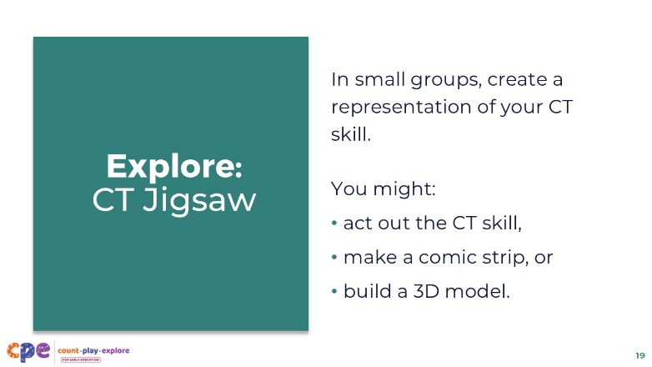
Time: 40 minutes (including the next slide)
Materials: Computational Thinking Skills in Early Childhood handout, arts and crafts materials (such as anchor charts, markers, colored paper, scissors, recycled materials, modeling clay, and so on)

Talking Points
- Let’s explore these six CT skills further!
- We will divide into six small groups. Each small group will be assigned one of the six CT skills to review in the handout and then create a representation of the CT skill. For example, you might:
  - act out the CT skill,
  - make a comic strip, or
  - build a 3D model.

Facilitator Notes
- Invite participants to use the handout to learn more about their assigned CT skill.
- Encourage participants to be creative with their representations. To inspire participants’ thinking, offer them guidance to consider how children or adults might use this CT skill in their everyday lives.
- Note that many of the CT skills are comprised of two related skills (for example, algorithms and sequencing, decomposition and modularity). Encourage participants to address both aspects of the CT skill in their representations. For example, participants might display the algorithm, or steps, for a recipe while also demonstrating sequencing by acting out the order in which the steps are carried out.
- Depending on the group size and session format, consider assigning each small group more than one CT skill:
  - For example, if there are three small groups, each small group can be assigned two of the six CT skills.
  - For large groups, assign multiple groups to the same CT skill. Encourage groups to create different kinds of representations for the same skill.

Slide 20: Share: CT Jigsaw
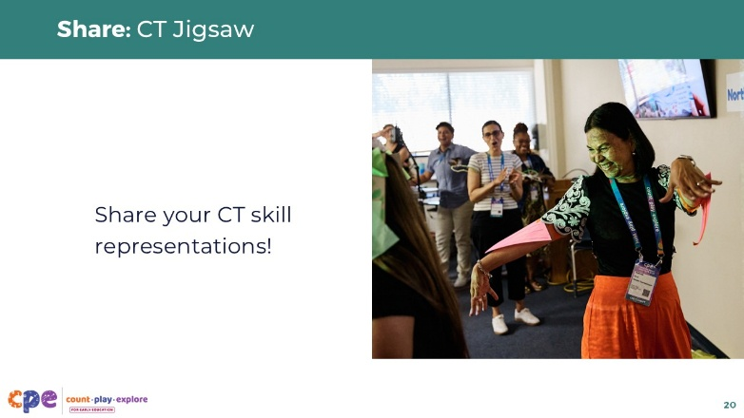
Time: 40 minutes (including the previous slide)
Materials: Computational Thinking Skills in Early Childhood handout

Talking Points
- Now it’s time to share! Each small group will share their CT skill with the larger group.
- [Select a strategy from the facilitator notes to support participants to share their CT skills with the larger group.]

Facilitator Notes
- Provide enough time for participants to react to each other’s representations and ask questions to learn more about the CT skills. For example:
  - How does your representation display your CT skill?
  - What prior lived experiences inspired your representation?
- Depending on the group size and session format, consider providing a virtual tool (for example, Padlet, Google Slides) for participants to share their representations.
- Another option for the share-out is a gallery walk, where participants move around the room to observe each group’s CT skill representation.

Slide 21: Reflect: CT Skills
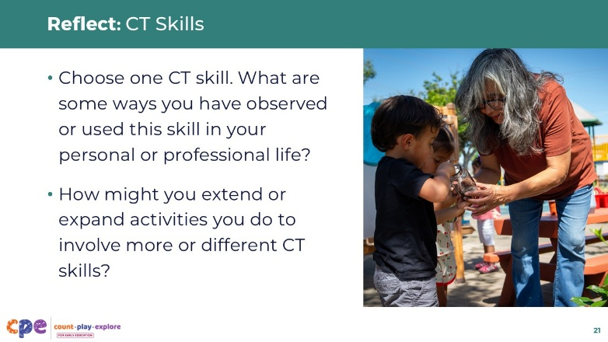

Talking Points
- Your representations showed how CT skills can appear in all aspects of our lives. For instance, pattern recognition is involved in jewelry making, and testing and debugging are involved in baking.
- CT skills may show up differently across cultures:
  - For example, some cultures have unique storytelling traditions and repeated narrative structures that serve as great examples of sequencing and patterns.
  - Artistic traditions such as weaving, beadwork, music, and dance are also examples of everyday activities that involve a variety of CT skills.
- Let’s dive deeper into how CT may be present in our everyday lives.
- Individually on a sticky note or in your journal, take a moment to reflect:
  - Choose one CT skill.
  - What are some ways you have observed or used this skill in your personal or professional life?
  - How might you extend or expand activities you do to involve more or different CT skills?
- [Encourage participants to share their reflections in small groups or pairs. Then, invite volunteers to share with the larger group.]

Facilitator Notes
- Consider providing cultural examples from your or your participants’ lived experiences and backgrounds (for example, home routines, cultural traditions, and community experiences) to illustrate how many everyday activities involve CT skills:
  - For example, describe your favorite holiday of the year and the steps you take to prepare for and celebrate this holiday with loved ones.
  - You might also share a favorite meal from this holiday and its recipe for how to make it.
- To extend or expand activities to involve more CT skills, you might explicitly break complex tasks into smaller tasks (decomposition) that are represented visually (representation) or with written instructions (algorithms):
  - For example, to share how to make your favorite meal, you might write down the step-by-step recipe and include pictures or icons for each step.

Slide 22: How Children Develop CT Skills
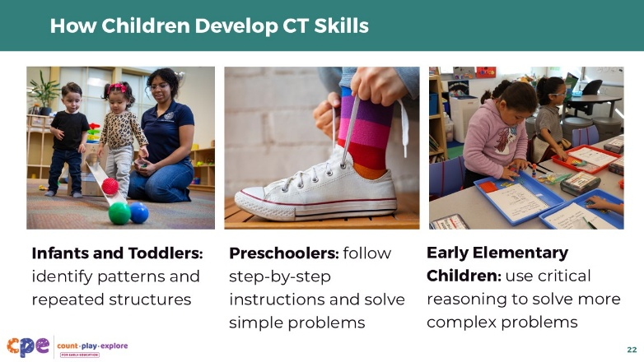

Talking Points
- The development of CT begins early in life as children explore their environment and make sense of the world around them.
- Infants and toddlers begin to identify patterns and repeated structures (for example, a daily bedtime routine) and think in a conditional way (for example, “If I push a button, then it will make a noise”).
- As children develop, they engage in critical thinking and reasoning as part of their everyday routines and play.
- Preschoolers may begin to follow step-by-step instructions and solve simple problems:
  - For example, four-year-olds may sing a song to remember the steps for tying their shoelaces.
- Early elementary school children learn to solve more complex problems and follow multistep instructions to complete tasks:
  - For example, they may follow an algorithm, or a step-by-step process, to add and subtract numbers.

Slide 23: Supporting Children’s CT Skills
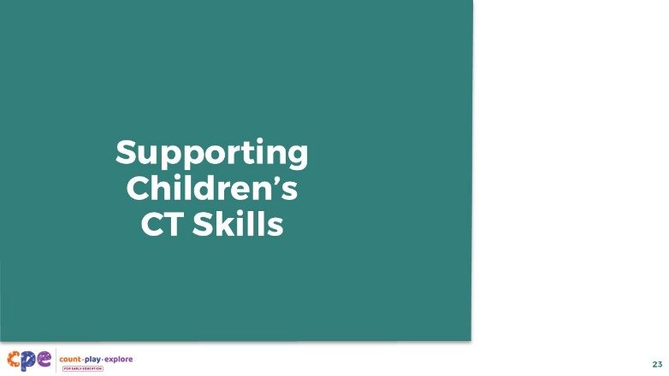

Talking Points
- Just like you experience CT in many aspects of your daily life, children have opportunities to engage in CT early in their development.
- Let’s explore some ways to support children’s CT skills.

Slide 24: Unplugged and Plugged CT
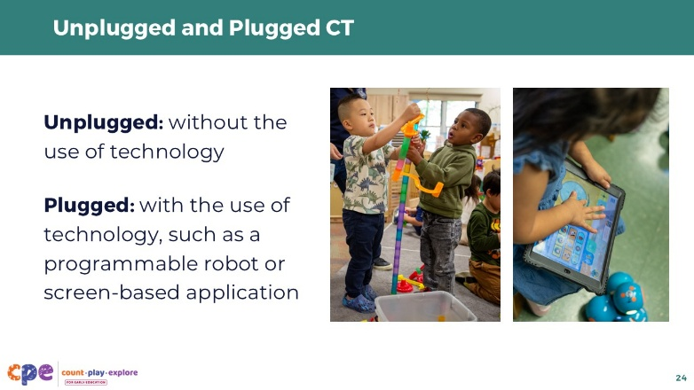

Talking Points
- Children can build foundational CT skills through active learning experiences. Especially for the youngest learners, these experiences are often unplugged (meaning that they do not involve the use of technology).
- As children develop, they continue to explore CT skills in active, unplugged ways. They may also have opportunities to engage in plugged activities.
- Plugged activities involve some type of technology, such as a programmable robot or coding application, that engages children in CT learning in the context of a computer science experience.

Facilitator Notes
- Educators might have different feelings about using technology and screens in their learning setting. It is important to note that plugged activities should be meaningful, developmentally appropriate, and not replace interactions between children, educators, and their peers. Educators can be selective on what plugged activities can complement unplugged and embodied computational thinking activities.

Slide 25: Observe: CT in Early Childhood
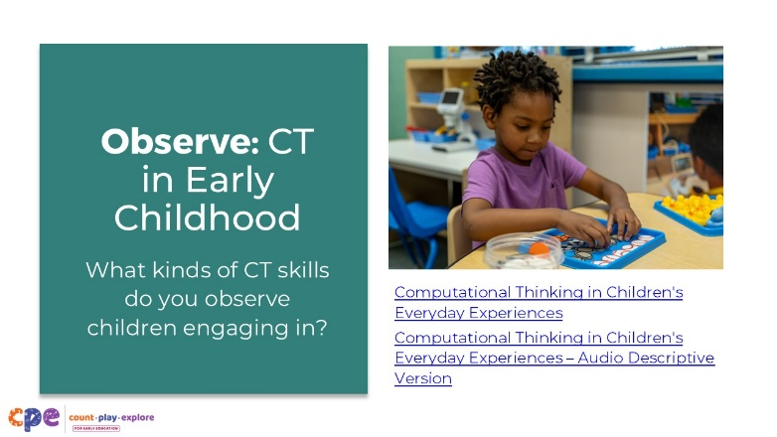
Time: 10 minutes
Materials: Computational Thinking in Children’s Everyday Experiences, Computational Thinking in Children's Everyday Experiences – Audio Descriptive Version video clip

Talking Points
- When we recognize CT as part of everyday routines and play, we can effectively integrate CT into our teaching practice.
- Observe this video of children engaged in everyday routines and playful learning experiences.
- Notice the kinds of CT skills children might be using in these unplugged experiences.
- [Play the video. Use the discussion points in the Facilitator Notes to support a discussion.]

Facilitator Notes
- Support participants to notice and discuss the kinds of CT skills they observe children engaging with in the video. For example:
  - Invite participants to reflect independently or in pairs and then share their observations with the larger group.
  - Assign each table a different clip to focus on. When the video is finished, encourage each table to discuss and then share with the larger group.
- Use the notes below to support a discussion:
  - Conditional Logic (4–5 years): In this first clip, the educator supports a child to use conditional logic when building a block structure. She asks, “What would have happened if … ?” The child uses conditional logic (if-then) to predict what would have happened if he had placed one block on the structure instead of two at the same time. Using this conditional logic, the child chooses to place two blocks at the same time to help the structure remain balanced.
  - Pattern Recognition (8–18 months): In this clip, the educator uses language and movement to label a pattern and call the child’s attention to the pattern she is engaged in while playing with the bead maze. The educator describes the movement, saying “Up, down, up down,” while moving the beads up and down on the structure. The educator also creates patterns with the tone of her voice. She uses a higher pitch when saying up and a lower pitch when saying down. She repeats this pattern of sounds. The child mimics this sound pattern. These are examples of repeating patterns using an ABAB structure.
  - Sequencing (18–36 months): In this clip, the educator describes and children respond to their daily routine as a sequence of activities. She uses a vertical chart and an arrow to show the sequence of activities—children can visually observe and repeat what comes first, next, and after.
  - Debugging (second—third grade): In this clip, the children are constructing a car. They notice that one of their wheel sets is not spinning. Their educator supports the children to notice the problem by comparing the wheel that is not working correctly to the wheel that is working correctly. The children notice the problem—the “bug”—and make adjustments to their design to fix it.

Slide 26: Supporting CT Through Play
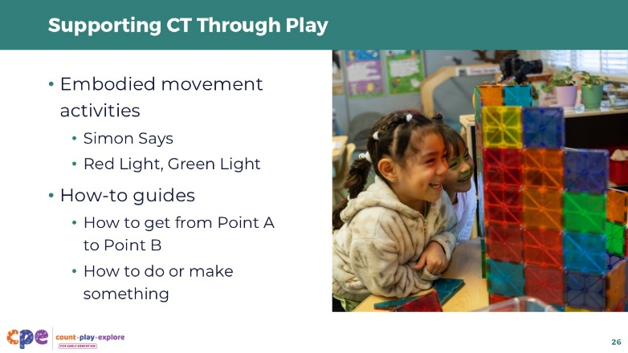

Talking Points
- We observed a few different ways that children might use CT skills through their everyday experiences and routines.
- Now, let’s consider ways educators can support CT skills through play.
- Here are some examples of ways to integrate CT skills into embodied movement activities and how-to guides.
- Engage children in embodied movement activities such as Simon Says and Red Light, Green Light:
  - Games like these offer opportunities for children to engage in sequencing, conditional logic, and loops. For example, the rules for Red Light, Green Light can be modeled as if-then statements: “If I say, ‘Green Light,’ then you move. If I say, ‘Red Light,’ then you freeze!”
- Another playful way to engage children in CT skills is through how-to guides. Children can use different communication methods to describe how to get from Point A to Point B or how to do or make something. For example:
  - Children can follow step-by-step instructions for washing their hands, watering plants in their school garden, or following a recipe.
  - Children can model the actions of the steps, draw illustrations, record a video, or use language to communicate the instructions.
  - Educators or children’s peers might follow children’s instructions exactly as provided to illustrate the importance of providing clear, step-by-step instructions.

Slide 27: Integrating CT into Everyday Routines
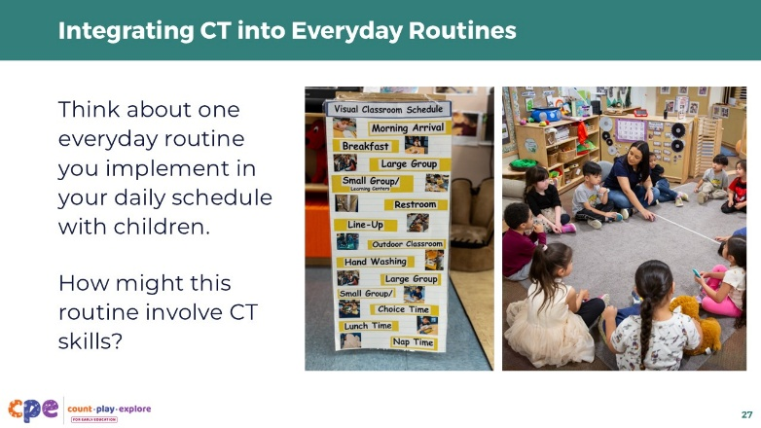

Talking Points
- Educators can also integrate CT into everyday routines.
- Think about one everyday routine you implement in your daily schedule with young children. For example:
  - morning routine
  - transition between activities
  - mealtime
  - naptime
  - storytime
  - protocols for class discussions or documenting observations
- How might this routine involve CT skills? Share your ideas with a partner.
- [Provide time for participants to share and discuss their ideas in pairs. Then, invite a few volunteers to share with the larger group. Use the Facilitator Notes to support a discussion.]

Facilitator Notes
- Examples of everyday routines involving CT skills that participants might share include:
  - sequencing: following step-by-step instructions (for example, “First, we will put on our shoes and jackets. Second, we will line up by the door. Third, we will walk outside.”)
  - conditional logic: cause and effect (for example, “If it’s raining outside, then we will have recess indoors.”)
  - pattern recognition: singing repetitive songs (for example, “The wheels on the bus go round and round, round and round, round and round … ”)
  - abstraction: identifying key details of complex objects (for example, “These socks are big, and these other ones are small.”)
- Children’s everyday routines may be influenced by their cultural backgrounds and family experiences. Encourage participants to consider children’s unique backgrounds and contexts when reflecting on everyday routines.
- As an additional reflection, encourage participants to consider how they might modify their routines to integrate CT more intentionally in their teaching practice:
  - For instance, to transition between activities, participants might introduce a song or visual symbol that represents the activity children will do next.

Slide 28: Reflect: CT in Your Teaching Practice
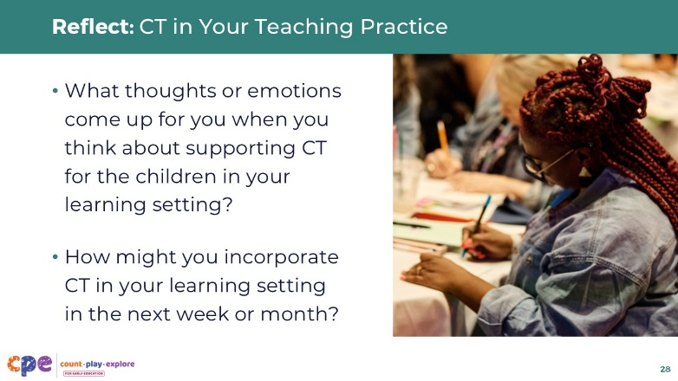

Talking Points
- Thank you for exploring CT skills with me today.
- Before we close our session, let’s take a moment to reflect.
- In pairs or small groups, reflect on your role as educators who help shape children’s early CT experiences and mindsets. Discuss the following questions:
  - What thoughts or emotions come up for you when you think about supporting CT for the children in your learning setting?
  - How might you incorporate CT in your learning setting in the next week or month?
- Consider children’s cultural backgrounds, language, and family experiences when reflecting on ways to incorporate CT in your learning setting.
- Record your ideas on a sticky note or in your journal to take back to your learning setting.
- [Provide time for participants to jot down their ideas. Then, invite volunteers to share their reflections with the larger group.]

Facilitator Notes
- Providing ongoing support and opportunities for collaborative reflection are critical components of effective professional learning (Darling-Hammond et al., 2017). Consider ways you can support participants to apply what they learned in this session to their learning setting and support collaborative reflection. For example:
  - Encourage participants to share photos and anecdotes of ways they are supporting children’s CT skills. You might use digital platforms such as Padlet or a shared Google Drive. You can provide feedback to individual participants and encourage others to make comments and suggestions as a way to build community.
  - Encourage educators to keep a journal to document ways they are supporting children’s CT skills. They can share and discuss their journal entries during in-person meetings.

Slide 29: Thank You!
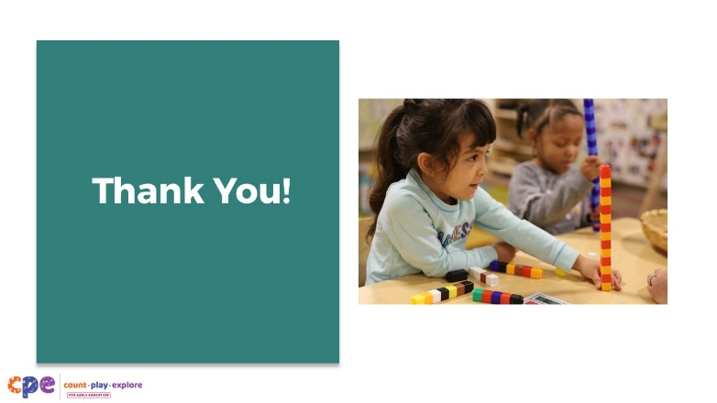

Talking Points
- Thank you for your time and attention as we explored CT today.

Facilitator Notes
- Based on participants’ interests and needs, consider offering a follow-up session to extend participants’ exploration of CT skills through coding. Use the Playful and Creative Coding suite.

