Investigating Force and Motion
Use this facilitator guide with the slides “Investigating Force and Motion.” This facilitator guide and set of slides provide descriptions of ways children, birth to eight years, learn about force and motion and ways educators can support children in investigating concepts and phenomena related to force and motion. Facilitators can find talking points and guidance for activities, handouts, and group discussions in this guide. The text is also located in the notes portion of the slides.

Session At-a-Glance
Slide numbers | Overview of content | Approximate time (in minutes)
1–3 | Introduction and Session Goals | 5
4–13 | Exploring force and motion  - Activity for adults  - Developmental progressions  - Video observation | 45–60
14–22 | Supporting children in investigating force and motion  - Observing and discussing M⁵ Early STEAM Approach  - Planning for children’s investigations of force and motion | 45
23–25 | Reflection and Conclusion | 10
The times are approximate and may vary based on session goals, group size, and participants’ previous experience and familiarity with the content.

To Prepare for Your Session
- Before your session, carefully review all handouts and prepare the necessary materials. Experiment with the materials you have selected (for example, balls and ramps) in ways that are similar to how participants will use them. It is important to confirm that the materials will function in a way that allows participants to benefit most from the experience. For example, do you have enough ramps? Are the balls an appropriate size to fit on the ramps?
- Throughout the facilitator guide, we offer options for facilitation approaches. Select the facilitation approach that works best for your session length and format, group size, and participant needs.
- Consider using photos, videos, or stories from the learning settings where educators work within the session. Making the information more personal for participants can create a greater connection to the content and foster feelings of belonging in STEAM.

Materials Needed
- Chart paper, scratch paper, and writing tools
- Different balls, multiple ramps (five to six) per group, blocks, books, or stackable objects to create elevation for ramps, nonslip shelf liner cut into 2-inch squares (optional). You might use different kinds of ramps, including recycled materials (for example, pieces of cardboard or paper-towel tubes), or invite participants to bring their own ramp pieces from home.
- Investigating Ramps and Rollers handout
- M⁵ Early STEAM Approach Overview handout
- Inquiry Starters: Force and Motion handout
- Planning Investigations About Force and Motion handout
- Videos and video answer keys listed throughout this facilitator guide
- Copies of pages from the following documents (optional):
  - California Infant–Toddler Learning and Development Foundations: Cognitive Development: Cause and Effect (pages 142–143); Approaches to Learning: Curiosity and Initiative (pages 85–86)
  - Preschool Through Third Grade (P-3) Learning Progressions: Physical Science (pages 41, 45–51)

Slide 1: Investigating Force and Motion
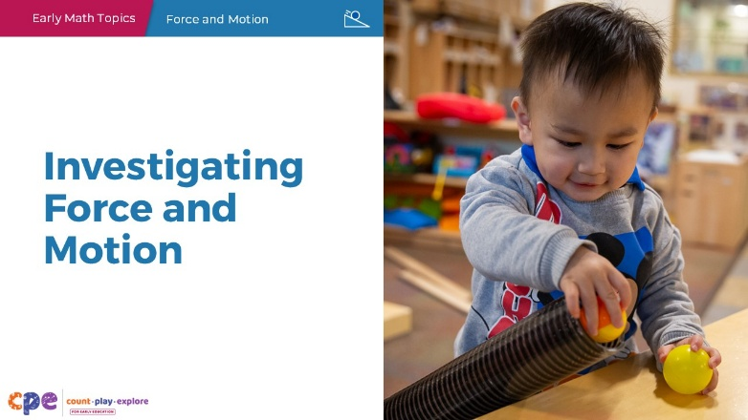

Talking Points
- Hello, and welcome everyone! Today, we will be exploring the physical science concepts of force and motion, or how things move.

Facilitator Notes
- Adjust the talking points to reflect the session length and participant needs. If necessary, add introductory and “housekeeping” information.

Slide 2: Acknowledgments
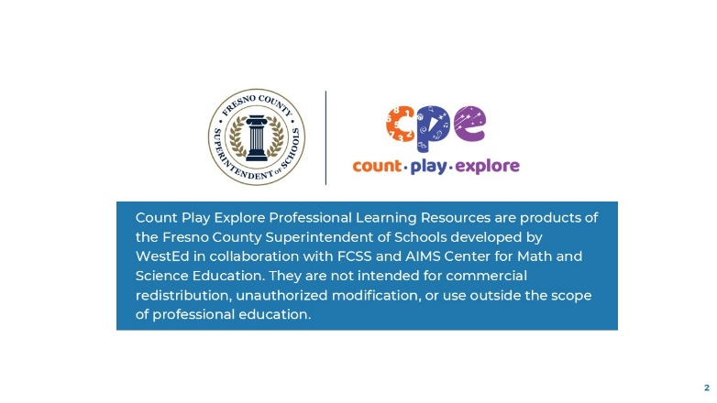

Talking Points
- The Count Play Explore Professional Learning Resources were made possible by Count Play Explore, an early math, science, and computer science initiative led by the Fresno County Superintendent of Schools, Early Care and Education Department. This initiative is generously funded by the California Department of Education and the California State Board of Education.
- These resources, developed by WestEd in collaboration with FCSS and AIMS Center for Math and Science Education, are intended to be used as a guide for implementing evidence-based strategies, promoting active learning, and encouraging developmentally appropriate practices in early education settings. They are not intended for commercial redistribution, unauthorized modification, or use outside the scope of professional education.

Slide 3: Session Goals
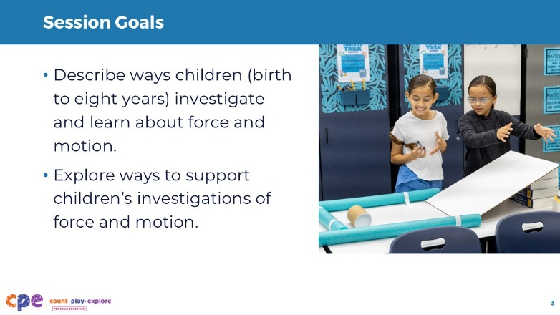

Talking Points
- In this session, we will:
  - describe ways children (birth to eight years) investigate and learn about force and motion and
  - explore ways to support children’s investigations of force and motion.

Facilitator Notes
- Adjust slide content and talking points to reflect what you plan to address in your professional learning session.

Slide 4: Physical Science
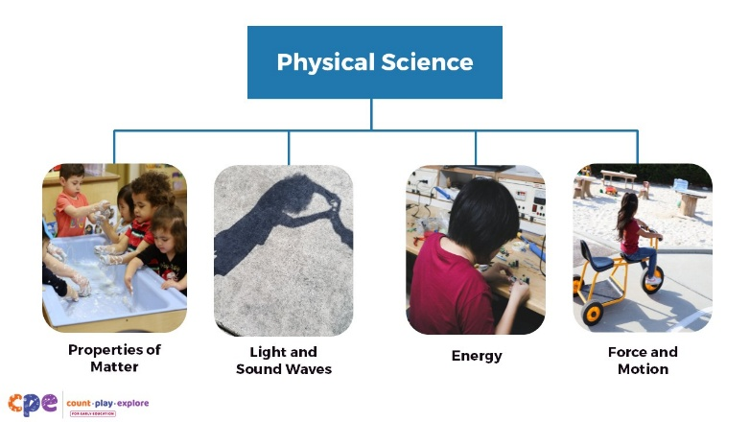

Talking Points
- The concepts of force and motion are parts of a broader category of science learning—physical science.
- As children explore physical science, they learn to investigate, describe, and explain the characteristics and changes in matter and materials, force and motion, light and sound waves, and energy through hands-on inquiry (California Department of Education 2013, 2016).
- Today, we will be focusing on force and motion.

Slide 5: Force and Motion in My Life
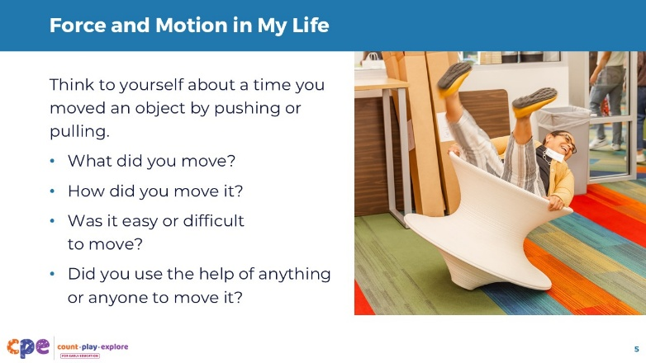
Time: 5 minutes

Talking Points
- Let’s start by connecting the concepts of force and motion to our own lives.
- Think to yourself about a time when you moved an object by pushing or pulling. Consider the following questions:
  - What did you move?
  - How did you move it?
  - Was it easy or difficult to move?
  - Did you use the help of anything or anyone to move it?
- [Provide time for participants to think independently.]
- Now turn and talk to a partner. Share about your experience moving something.
- [Provide time for participants to discuss with a partner. Then, invite a few volunteers to share with the larger group.]

Slide 6: Forces cause things to move.
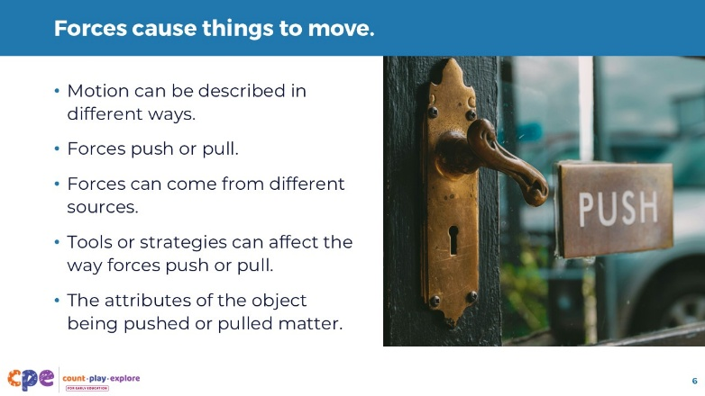

Talking Points
- Thank you for sharing your experiences with motion.
- Across your examples, you shared ways we might describe motion. You might have experienced differences in the speed (for example, fast or slow), direction (for example, up or down, forward or backward, left or right), or distance (for example, far or near). You also discussed how forces—pushing or pulling—caused an object to move.
- [You might replace some of the examples provided below with the examples participants share.]
- There are many sources of force. For example, energy from our muscles can create a force to push or pull; energy from a combustion engine creates a force to push the pistons in an engine, making a car move; the wind can be a force that pushes a sailboat or a kite; and gravity is a force that can cause something to roll down a hill.
- Some of you used tools or strategies that might facilitate the way forces push or pull. For example, wheels can help something roll instead of slide, a system of pulleys can distribute weight and may require less force to move an object, teamwork—when multiple people combine their force—can also make it easier to move something.
- You all discussed moving different types of objects. Different objects require different forces. Some objects might be very heavy and require a great amount of force. Other objects might be lighter and require less force.
- There are many different variables that can affect the way forces create motion.

Facilitator Notes
- Revise the points on this slide to reflect what participants have shared about their experiences with motion. Elevate the following points:
  - different types of motion
  - sources of force
  - tools or strategies used
  - different types of objects that were moved

Slide 7: Force and Motion in Play and Daily Experiences
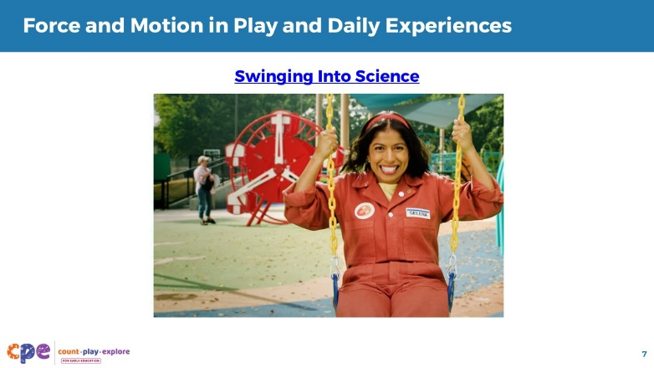
Time: 5 minutes
Materials: “I’m Ready!” video, “Swinging Into Science”

Talking Points
- Let’s consider ways children might explore force and motion through play and daily experiences.
- We will observe an “I’m Ready!” video from the Count Play Explore website called “Swinging Into Science.”
- As you observe, notice ways children in the video explore different concepts related to force and motion.
- [Play the video. Then, invite volunteers to share ways children explore different concepts related to force and motion with the larger group.]

Facilitator Notes
- The “I’m Ready!” video “Swinging Into Science” provides examples of elementary-aged children experiencing force and motion on the playground. Consider inviting participants to provide other ways children might experience force and motion across different ages. For example, children experience force and motion when they:
  - push or pull toys or objects
  - roll objects down ramps or across the floor
  - throw, bounce, or kick objects and notice how they move

Slide 8: Exploring force and motion is important.
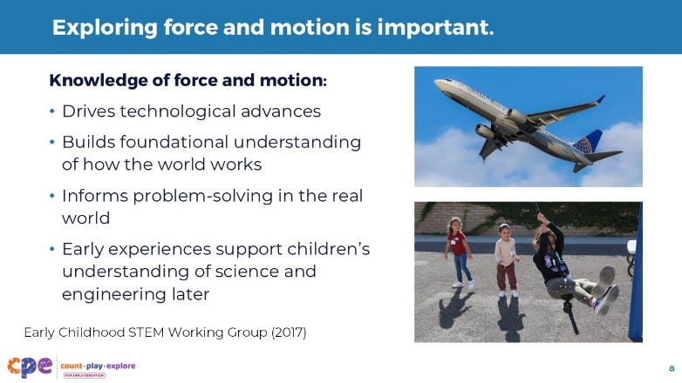

Talking Points
- Exploring force and motion is important.
- Scientists and engineers use their knowledge of force and motion to contribute to our society in meaningful ways. For example:
  - Transportation, aeronautics, and space exploration: Knowledge of force and motion was critical in the development of cars, trains, planes, satellites, and spacecrafts.
  - Buildings and bridges: Engineers study how forces affect buildings that don’t move. This helps them design safe bridges and tall buildings that won’t collapse or lean.
- When young children investigate force and motion, they learn how the world works and discover ways they can change it. Similar to scientists and engineers, children can use their developing understanding of forces like pushing and pulling to solve problems in the real world. For example, children might push a basket of toys, pull a wagon, or push the pedal of their tricycle to cause it to move.
- Further, early experiences with force and motion can support children’s understanding of science and engineering in their later years in school (Early Childhood STEM Working Group, 2017).

Slide 9: Investigating Ramps and Rollers
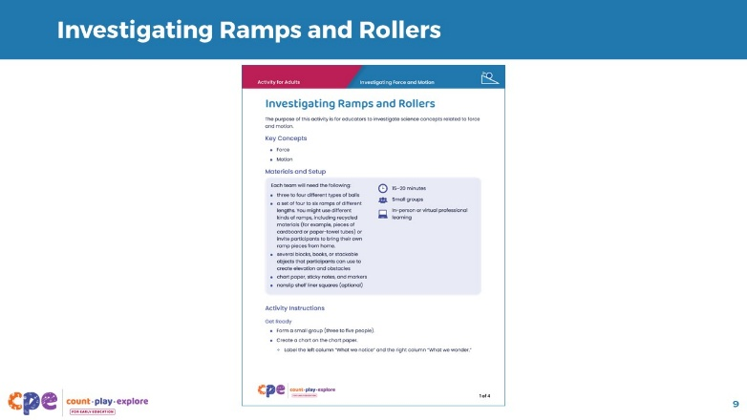
Time: 20–30 minutes (including the discussion on the following slide)
Materials: Each group will need the following: Investigating Ramps and Rollers handout; a set of four to six ramps of different lengths; three to four different types of balls; several blocks, books, or stackable objects that participants can use to create elevation and obstacles; nonslip shelf liner squares (optional); chart paper; sticky notes; and markers.

Talking Points
- Let’s explore more about how things move using ramps and rollers.
- We will use the Investigating Ramps and Rollers handout to guide our experience.
- [Review the handout with participants. Provide time (about 15–20 minutes) for them to investigate.]

Facilitator Notes
- Consider ways to group participants into teams of three to five. For example:
  - Encourage teaching teams or grade-level teams to work together.
  - Create random groups by assigning numbers to each participant. Then, encourage each number to form a group (for example, all the 4s will work as a team).
- You might use open-ended prompts or questions to support participants as they build. For example,
  - “Tell me about your structure.”
  - “I wonder what would happen if you …”
- If participants finish early, encourage them to extend their investigations. For example, invite participants to find a way to get the ball to turn in the opposite direction.
- If you are facilitating this activity virtually, consider the following:
  - Encourage participants to gather necessary materials before the session begins. They can use materials available in their settings (for example, books or recycled cardboard boxes can be used as ramps).
  - Participants can plan, build, and redesign as needed individually or in teams from their remote location.
  - Participants can share their designs by moving their cameras to a location that makes their ramp structures visible to others attending the virtual session. You might also use a digital platform (for example, Padlet) as a space for participants to post photos or videos of their ramp structures.
  - Depending on the number of participants, you might use breakout rooms to facilitate sharing.
- The handout includes discussion and reflection prompts. The same prompts are provided in the following slides. You might let participants know that they should use the time provided to investigate and that more time will be provided afterward for reflection and discussion.

Slide 10: Reflect and Discuss
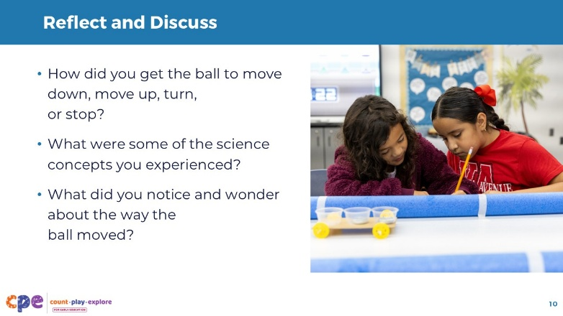
Time: 20–30 minutes (including the investigation on the previous slide and additional discussion on the following slide)

Talking Points
- [Select a facilitation strategy from the Facilitator Notes. Adapt the talking points as needed.]
- Now, we will take some time to share your investigations and some of the ideas you documented on your notice/wonder chart.
- Each team will present their structures. As you share, explain the following:
  - How did you get the ball to move down, move up, turn, and stop?
  - What were some of the science concepts you experienced? Review “The Science of Force and Motion” section in the activity handout.
  - What did you notice and wonder about the way the ball moved?

Facilitator Notes
- Support participants in sharing their investigations with others. For example:
  - Invite neighboring groups to share with each other.
  - Encourage participants to go on a gallery walk. Groups will move around the room, observing different structures and notes that teams developed. Then, you might ask a few volunteers to share their observations during the gallery walk.

Slide 11: Connecting to Your Learning Setting
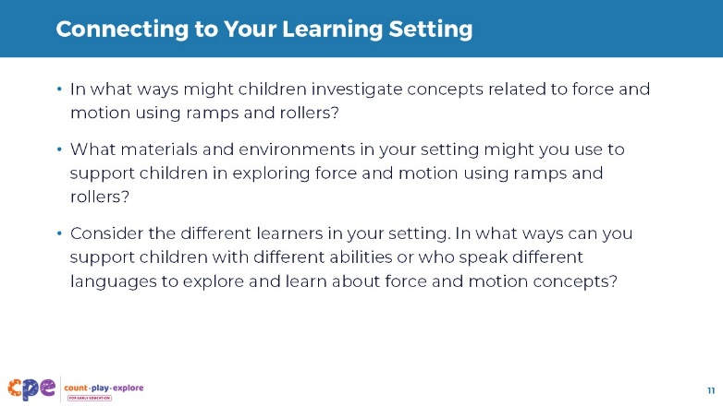
Time: 20–30 minutes (including the investigation and discussion on the previous slides)

Talking Points
- Experiences like the ones you engaged in can support children of different ages to investigate and learn about force and motion.
- In your table groups, discuss ways children in your setting might investigate similar concepts. Consider the following:
  - In what ways might children investigate concepts related to force and motion using ramps and rollers?
  - What materials and environments in your setting might you use to support children to explore force and motion using ramps and rollers?
  - Consider the different learners in your setting. In what ways can you support children with different abilities to explore and learn about force and motion concepts?
  - How might you support children who speak different languages to explore and learn about force and motion concepts?
- [After table groups have discussed, invite a few volunteers to share with the larger group.]

Slide 12: Investigating Force and Motion Across Ages
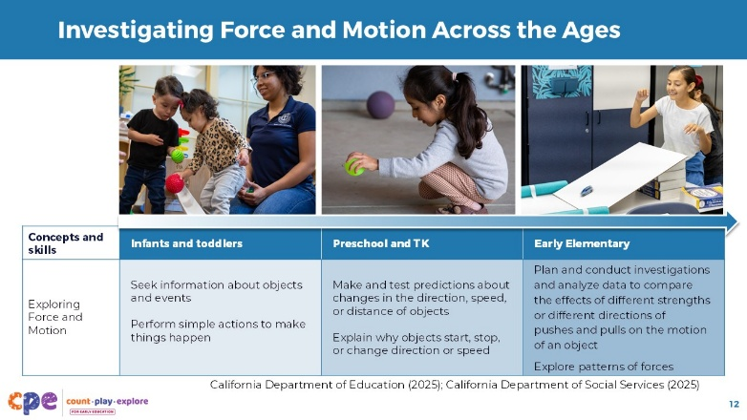
Time: 10 minutes
Materials: Copies of foundations and standards (optional; refer to the facilitator notes for links to the documents and pages to focus on)

Talking Points
- Let’s explore in more detail ways children develop an understanding of force and motion across ages.
- Observe the table on the slide.
- With your table group, discuss:
  - what you notice about ways children explore and learn about force and motion over time and
  - ways you might have experienced some of these concepts and skills in the activity you did with ramps and balls.
- [Move around the room to support group discussions. You might invite a few volunteers to share with the larger group.]

Facilitator Notes
- For a more in-depth review of foundations and standards, print and support participants to examine and discuss the following documents:
  - Preschool Through Third Grade (P-3) Learning Progressions: Science: Force and motion Learning Progression, page 41; in-practice examples, pages 45—51
  - California Infant–Toddler Learning and Development Foundations: Approaches to Learning: Curiosity and Initiative (pages 85—86); Cognitive Development: Cause and Effect (pages 142—143)
- Additional information on ways children learn about force and motion and other physical science concepts can be found in the following documents:
  - California Preschool/Transitional Kindergarten Learning Foundations
  - Next Generation Science Standards for California Public Schools, Kindergarten through Grade Twelve (CA NGSS)
- You might notice that some grades and ages do not have specific standards or foundations related to force and motion. However, children are continuing to explore and build their understanding of these concepts over time.

Slide 13: Observe: Children Exploring Force and Motion
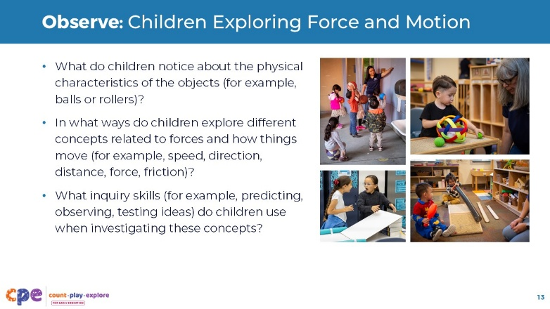
Time: 10–15 minutes (including the discussion on the following slide)
Materials: Video clip of children investigating how things move

Talking Points
- Now we will observe a video showing children investigating how things move.
- As you observe, consider the following questions:
  - What do children notice about the physical characteristics of the objects (for example, balls or other objects that roll)? In what ways do children communicate what they notice?
  - In what ways do children explore different concepts related to forces and how things move (for example, speed, direction, distance, force, friction)?
  - What inquiry skills (for example, predicting, observing, testing ideas) do children use when investigating these concepts?
- You might record your observations on scratch paper.

Facilitator Notes
- Choose a video clip featuring children investigating how things move. We provide the following videos:
  - Exploring Balls (8–18 Months)
  - Exploring Balls (8–18 Months) - Audio Descriptive Version
  - Investigating Rolling (18–36 Months)
  - Investigating Rolling (18–36 Months) - Audio Descriptive Version
  - Bouncing Balls (3–5 Years)
  - Bouncing Balls (3–5 Years) - Audio Descriptive Version
  - Investigating Force (second–third grade)
  - Investigating Force (second–third grade) - Audio Descriptive Version
- You might use more than one video and encourage participants to compare the ways children investigate across different ages. Support participants to discuss how skills and concepts develop over time.

Slide 14: Discuss: Children Exploring Force and Motion
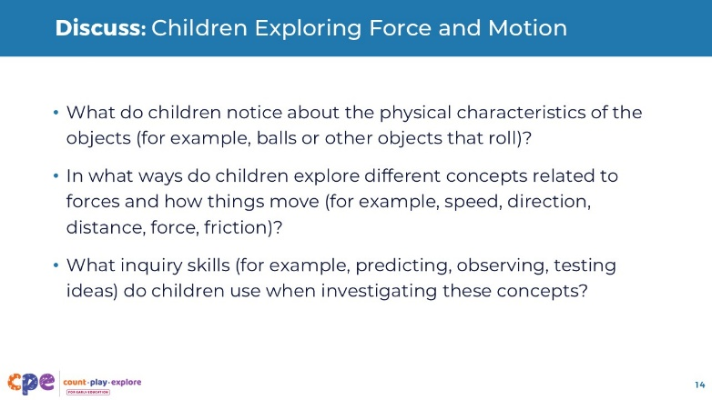
Time: 15 minutes (including observing the video on the previous slide)
Materials: Answer Key handout (one per video you choose to show)

Talking Points
- Let’s discuss what you observed:
  - What do the children notice about the characteristics of the objects (for example, balls or rollers) and how they move? In what ways do children communicate what they notice?
  - In what ways do children experience or investigate different physical science concepts (for example, speed, direction, distance, force, friction)?
  - What inquiry skills (for example, predicting, observing, testing ideas) do the children use when investigating these concepts?

Facilitator Notes
- Support participants to share what they notice about ways children investigate how things move. You might encourage table groups to discuss. Then, invite a few volunteers to share with the larger group.
- Use the Answer Key handout for the videos you choose to show to support a discussion. Each answer key provides examples from the video related to the discussion questions for this slide. Select the Answer Key that matches the video you select. Note: These handouts are designed to support facilitators only and are not intended to be used by participants.
  - Answer Key for Exploring Balls (8–18 months)
  - Answer Key for Investigating Rolling (18–36 months)
  - Answer Key for Bouncing Balls (3–5 years)
  - Answer Key for Investigating Force (second–third grade)
- Consider inviting participants to reflect on ways they might adapt a similar experience for the children in their settings.

Slide 15: Supporting Children in Investigating How Things Move
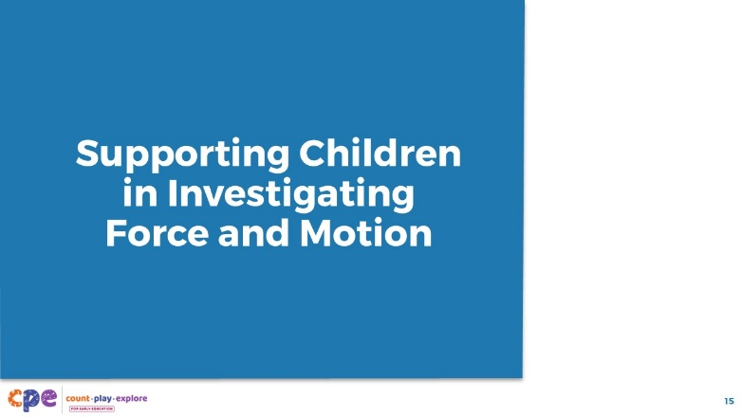

Talking Points
- We have noticed ways children can investigate how things move. We also discussed ways children use different inquiry skills as they investigate.
- Let’s shift our attention now to ways educators can support children in investigating force and motion.

Slide 16: Observe: Supporting Children in Investigating Force and Motion
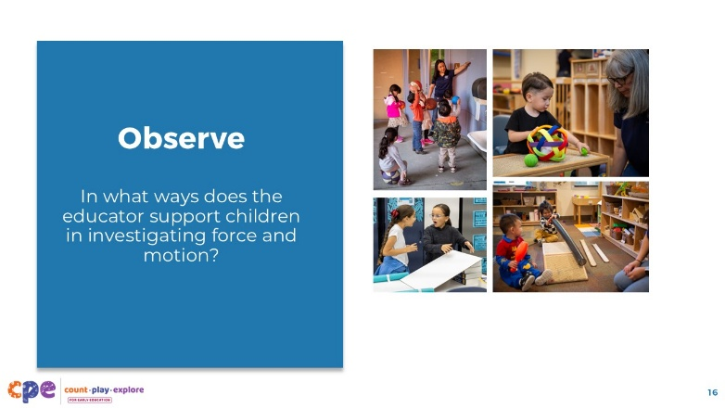
Time: 10–15 minutes (including discussion on the following slide)
Materials: Sticky notes, video of children exploring force and motion

Talking Points
- We will observe a video of children investigating force and motion.
- As you observe, notice ways educators support children to investigate and learn about force and motion.
- Use different sticky notes to record various teaching practices that you observe. We will be sorting these notes later in our session.
- [Play the video.]

Facilitator Notes
- Choose a video clip featuring children investigating force and motion. We provide the following videos:
  - Exploring Balls (8–18 Months)
  - Exploring Balls (8–18 Months) - Audio Descriptive Version
  - Investigating Rolling (18–36 Months)
  - Investigating Rolling (18–36 Months) - Audio Descriptive Version
  - Bouncing Balls (3–5 Years)
  - Bouncing Balls (3–5 Years) - Audio Descriptive Version
  - Investigating Force (second–third grade)
  - Investigating Force (second–third grade) - Audio Descriptive Version
- If you play the same video that you used earlier in the session, be sure to explain to participants that they have already observed this video. The first viewing was focused on ways children were investigating. During this viewing, they will be observing the educator.

Slide 17: Discuss: Supporting Children in Investigating Force and Motion
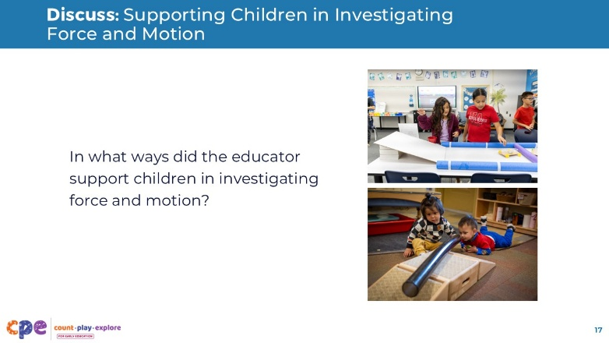
Time: 10–15 minutes (including observing the video on the previous slide)

Talking Points
- Let’s discuss what you noticed.
  - In what ways did the educator support children to investigate how things move?
- [Encourage participants to share with the larger group.]

Facilitator Notes
- Participants will share more about their observations on the next slide when they sort what they noticed into the M⁵ Early STEAM Approach categories.

Slide 18: The M⁵ Early STEAM Approach
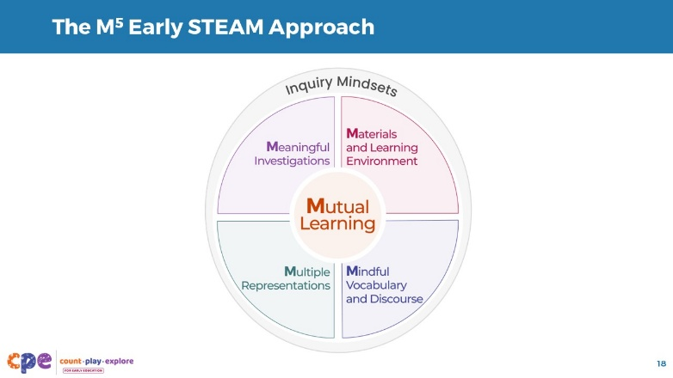
Time: 10–15 minutes
Materials: Chart paper, markers, sticky notes, M⁵ Early STEAM Approach Overview handout, Answer Key handout

Talking Points
- You all provided different examples of ways educators supported children to investigate how things move.
- We can use the M⁵ Early STEAM Approach as a framework for thinking about ways educators support children to learn about science concepts and phenomena.
- The M⁵ Early STEAM Approach consists of five effective teaching practices that are enacted within the frame of an educator’s inquiry mindset. The five teaching practices are:
  - Mutual Learning
  - Meaningful Investigations
  - Materials and Learning Environment
  - Mindful Vocabulary and Discourse
  - Multiple Representations
- You will explore the M⁵ Early STEAM Approach with your teams.
- Use the M⁵ Early STEAM Approach Overview handout to learn more about each M⁵ practice to support your sorting process.
- Create six sections on your chart paper. Label one Inquiry Mindsets and the other five with the remaining M⁵ teaching practices: Mutual Learning, Meaningful Investigations, Materials and Learning Environment, Mindful Vocabulary and Discourse, and Multiple Representations.
- With your team, sort the different examples you recorded on sticky notes from the video observation into each of the M⁵ categories on your chart paper. For example, you might have recorded on your sticky note that the educator modeled science language. You would place this sticky note in the “Mindful Vocabulary and Discourse” category on your chart paper.
- You might find that a specific example applies to more than one M⁵ practice. This is because the M⁵ practices complement each other. If this happens, choose the practice that you think best fits your sticky note example.
- You might add new sticky notes with different ideas about the ways educators can support children to investigate how things move.
- If one of the M⁵ teaching practices is not observed in the video clip, consider ways educators might use this practice within the context of the video.
- [Provide time for participants to sort their sticky notes. Then, invite a few volunteers to share examples for each M⁵ practice.]
- Thank you for exploring the M⁵ Early STEAM Approach.

Facilitator Notes
- Consider playing the video again for participants to add to their M⁵ charts.
- You might create a chart of your own to model how to set up the activity for participants. Or create multiple labeled charts in advance for participants to use.
- Instead of the sorting activity, you might review the M⁵ practices featured in the video by using the Answer Key handout. Note: These handouts are designed to support facilitators only and are not intended to be used by participants.
  - Answer Key for Exploring Balls (8–18 months)
  - Answer Key for Investigating Rolling (18–36 months)
  - Answer Key for Bouncing Balls (3–5 years)
  - Answer Key for Investigating Force (second–third grade)

Slide 19: Investigating Force and Motion: Brainstorming
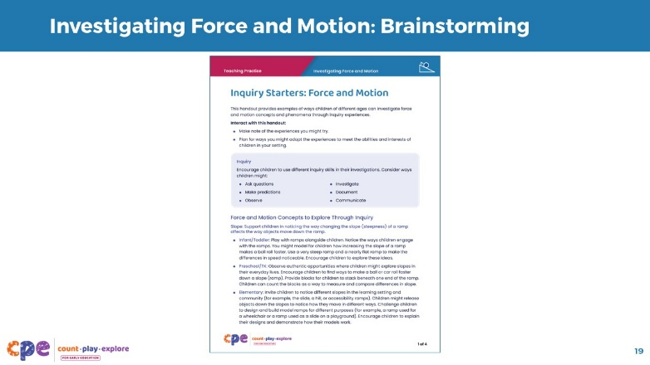
Time: 15–20 minutes
Materials: Inquiry Starters: Force and Motion handout

Talking Points
- Let’s apply what we have been exploring to your settings.
- Review the Inquiry Starters: Force and Motion handout for ideas about ways children might investigate force and motion.
- As you review, circle ideas that you might like to try and add your own ideas that relate more closely to the children in your setting.
- You might review foundations and standards or think about the developmental progression to choose concepts that are appropriate for the children in your setting.
- [Provide time for participants to individually review the handout. Then, invite participants in table groups to share with each other.]

Slide 20: Investigating Force and Motion: Planning
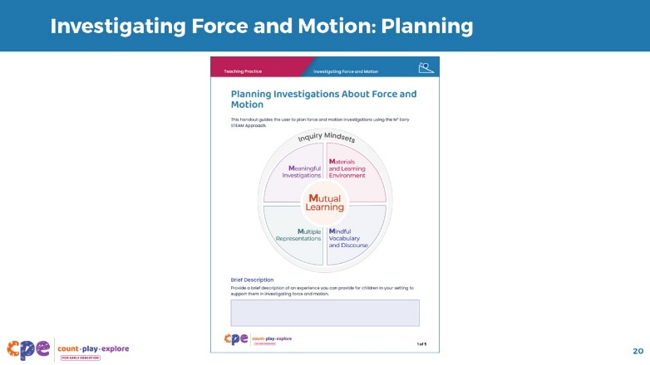
Time: 15–20 minutes
Materials: Planning Investigations About Force and Motion handout

Talking Points
- Now, choose one inquiry to plan out more thoroughly. Use the Planning Investigations About Force and Motion handout.
- [Select a facilitation strategy to support participants in planning ways for children in their setting to investigate how things move.]

Facilitator Notes
- Consider different ways to support participants in planning. For example:
  - Encourage educators working with children of the same age or grade to plan together.
  - Invite participants to find a partner to plan with. Partners might discuss their ideas with each other as they plan.
- The CA NGSS do not include standards for force and motion for first and second grades. If you have educators teaching children in these grades, you might:
  - Explain that, although standards do not explicitly address concepts related to force and motion in these grades, children are still learning and developing understanding related to force and motion. Educators can draw from children’s everyday experiences of force and motion to explore these concepts in first and second grades. Children will revisit and deepen these ideas in third grade.

Slide 21: Sharing Plans
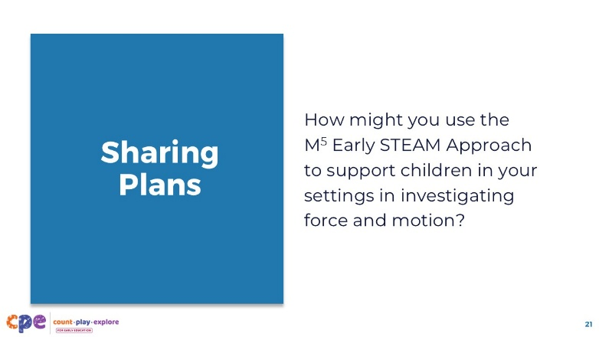

Talking Points
- Thank you all for taking the time to begin planning for ways children in your setting can investigate force and motion.
- Now, we will share our plans with others.
- Turn and talk to a partner. Share your plans for ways children in your setting can investigate force and motion. Consider what parts of the investigation you are most excited about and what parts of the investigation you have questions about.

Facilitator Notes
- You might invite participants to workshop ideas with each other. For example, invite partners to provide the following feedback for each other after the ideas are shared:
  - I value the way you have …
  - I wonder about ...
  - One suggestion I have is to …

Slide 22: Apply to Your Setting
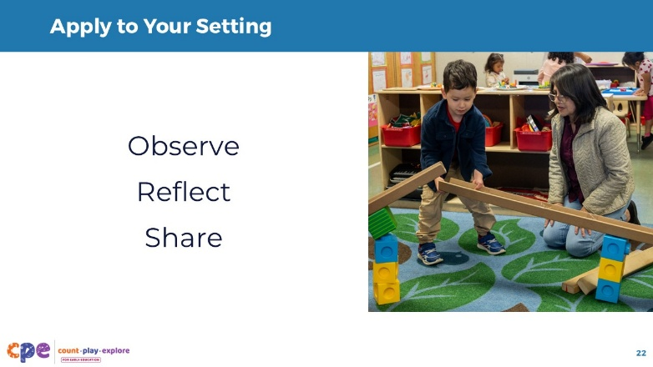

Talking Points
- When you return to your learning setting, try your plans with the children in your setting.
- As children investigate how things move:
  - Observe children and notice ways they use inquiry skills and develop understanding about force and motion.
  - Reflect on your observations of children and consider ways you might extend their learning through related and ongoing experiences. Think about ways you might connect to their everyday lives and lived experiences.
  - Share your observations and ideas with a colleague. Having a thought partner is an important way to continue learning as educators.

Facilitator Notes
- Provide ongoing support for participants after this session by offering opportunities to learn how others are exploring physical science in their settings. You might create a shared Google Document or create a Padlet as a digital space to share images and stories.
- Facilitate a community of practice where participants can share how they are exploring physical science in their learning settings.

Slide 23: Relevant CPE Resources
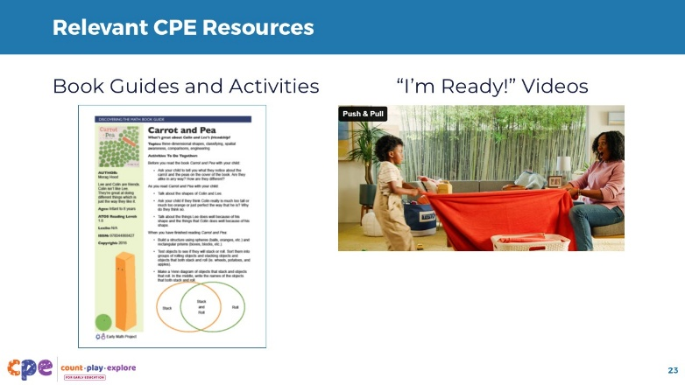

Talking Points
- Here are some additional resources related to force and motion.
- You might review Count Play Explore’s Book Guides and Activities that support STEAM learning before, during, and after reading. For example:
  - the Discovering the Math Book Guide and related activity for Carrot and Pea: An Unlikely Friendship by Morag Hood, which is a story about how peas and carrots move differently because of their shapes
- The Book Guides and related Activities can extend children’s learning to other topics and support you in making connections to other learning domains.
- Consider sharing the Count Play Explore “I’m Ready!” videos as a way to help families understand ways to investigate physical science with their children. For example:
  - “Swinging Into Science” (which we observed earlier in the session)
  - “Push and Pull” (appropriate for infants and toddlers)

Facilitator Notes
- You might show participants how to access the Count Play Explore website and navigate to the featured materials: https://countplayexplore.org/.
- Consider playing one of the videos or reviewing one of the Book Guides with participants. Engage them in a brief discussion about ways they might use these resources in their learning settings. Below are links to the Book Guides, Activities, and videos.
  - Carrot and Pea: An Unlikely Friendship by Morag Hood: Discovering the Math Book Guide in English and Spanish, Ramp and Roll activity, What Rolls? activity
  - “I’m Ready!” video: “Swinging Into Science”
  - “I’m Ready!” video: “Push and Pull”

Slide 24: Reflection
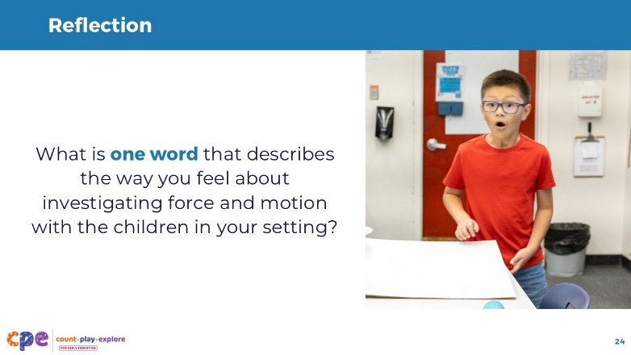
Time: 5 minutes

Talking Points
- Consider your experiences today.
- We explored ways children investigate force and motion, and we were able to experience force and motion ourselves. We also planned for ways we might investigate forces with the children in our learning settings.
- Take a moment to reflect on your feelings about investigating force and motion with the children in your setting.
- Choose one word that describes how you feel.
- [Invite participants to share with a partner or table group the word that they chose and why they chose that word. Then, invite a few volunteers to share with the larger group.]

Facilitator Notes
- Consider using a digital word cloud generator (for example, Slido®, Vevox®, Mentimeter®, or StreamAlive™). This way, participants can see the variety of feelings that are expressed across the professional learning session.

Slide 25: Thank you!
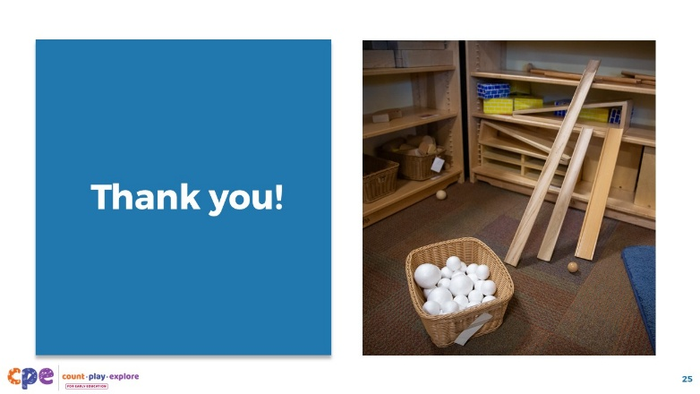

Talking Points
- Thank you all for your time and attention today.

