Observation and Investigation
Use this facilitator guide with the slides “Observation and Investigation.” This facilitator guide and set of slides provides descriptions of how children, birth to eight years, observe and investigate and ways educators can support them to observe and investigate. Facilitators can find talking points, guidance for activities, and group discussions in this guide. The same text is also located in the notes portion of the slides.

Session At-a-Glance
Slide numbers | Overview of content | Approximate time (in minutes)
1–3 | Introduction and Session Goals | 5
4–17 | Exploring observation and investigation  - Activity for adults  - Define ways children observe and investigate  - Video observation | 45–75
18–19 | Supporting children to observe and investigate  - Explore developmental progressions of inquiry skills | 15–20
20-21 | Reflection | 5
The times are approximate and may vary based on session goals, group size, and participants’ previous experience and familiarity with the content.

To Prepare for Your Session
- Before your session, carefully review all handouts and prepare the necessary materials. Throughout the facilitator guide, we offer options for facilitation approaches. Select the facilitation approach that works best for your session length and format, group size, and participant needs.
- Consider using photos, videos, or stories from the learning settings where educators work within this session. Making the information more personal for participants can create a greater connection to the content and foster feelings of belonging in STEAM.

Materials Needed
- Chart paper, scratch paper, and writing tools
- Observing and Describing an Orange activity: oranges (or other fruit or object of choice), measuring tape, balance scales, magnifying glasses
- Developmental Progression of Inquiry Skills handout
- Supporting Children to Observe and Investigate handout

Slide 1: Observation and Investigation
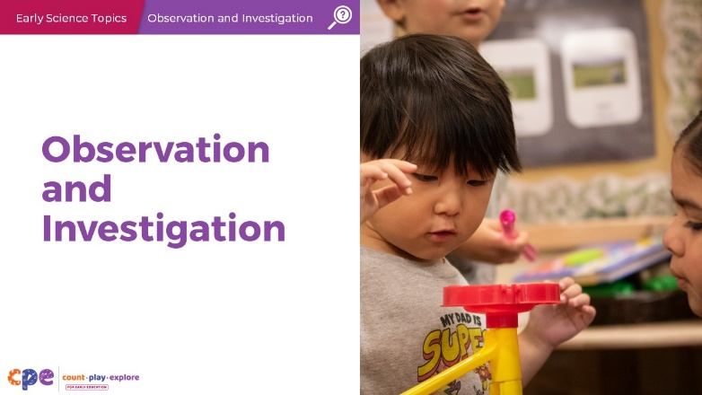

Talking Points
- Today, we will be exploring ways that children (birth to eight years) observe and investigate to learn about science concepts and phenomena. By phenomena, we mean observable events that involve science concepts, such as a seed sprouting, paint mixing to form a new color, or a ball rolling into a block structure causing it to topple over.

Facilitator Notes
- Adjust talking points to reflect your session length and participant needs. If necessary, add introductory and “housekeeping” information.

Slide 2: Acknowledgments
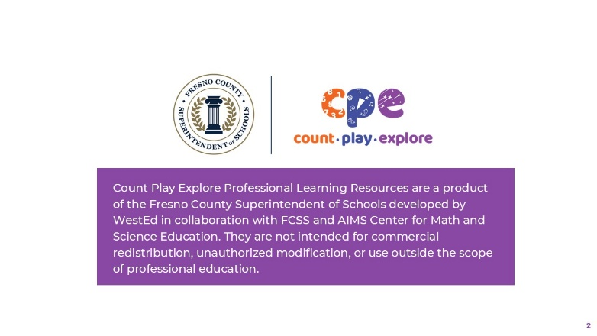

Talking Points
The Count Play Explore Professional Learning Resources were made possible by Count Play Explore, an early math, science, and computer science initiative led by the Fresno County Superintendent of Schools (FCSS), Early Care and Education Department. This initiative is generously funded by the California Department of Education and the California State Board of Education. These resources, developed by WestEd in collaboration with FCSS and AIMS Center for Math and Science Education, are intended to be used as a guide for implementing evidence-based strategies, promoting active learning, and encouraging developmentally appropriate practices in early education settings. They are not intended for commercial redistribution, unauthorized modification, or use outside the scope of professional education.

Slide 3: Session Goals
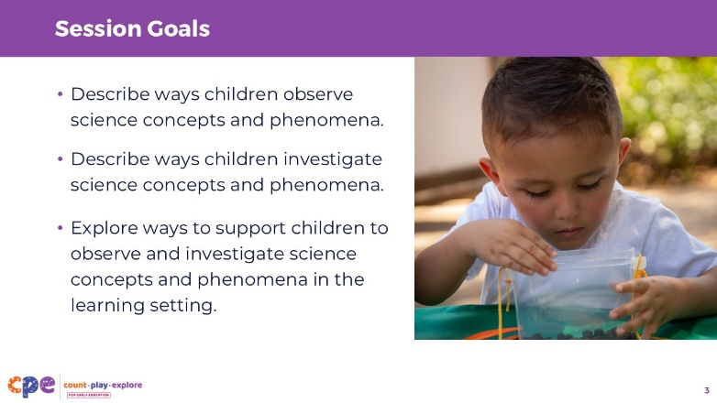

Talking Points
- In this session, we will:
  - describe ways children observe science concepts and phenomena,
  - describe ways children investigate science concepts and phenomena, and
  - explore ways to support children to observe and investigate science concepts and phenomena in their learning settings.

Facilitator Notes
- Adjust slide content and talking points to reflect what you plan to address in your professional learning session.

Slide 4: Explore: Observing and Investigating
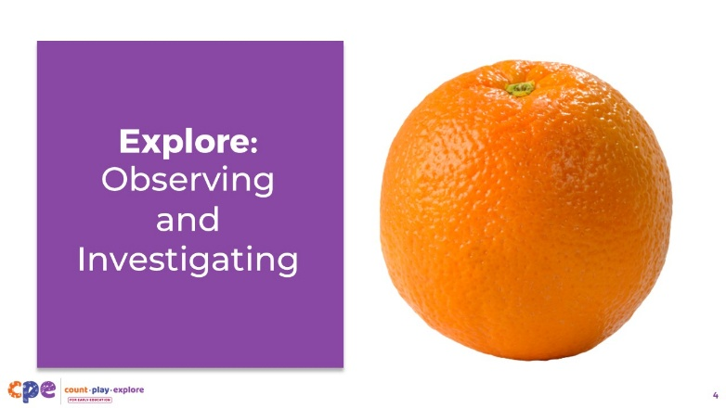
Materials: An orange for each participant
Time: 15 minutes (including the investigation and discussion on slides 5 and 6)

Talking Points
- Let’s experience observing and investigating with an everyday object—an orange.
- Consider the orange. Think about any personal or cultural connections you might have with this object; for example, traditions, cooking, or gardening.
- Turn and talk to a partner about any connections or memories you might have with the orange.
- [Provide time for participants to turn and talk to a partner about connections or memories they might have with the orange.]
- Take a moment to observe the outside of the orange. What do you notice?
- [Provide a few minutes for participants to observe the orange. Encourage participants to share what they notice.]

Facilitator Notes
- Adapt this experience to meet your needs and the needs of participants. For example:
  - Use different kinds of fruits or different kinds of oranges to encourage participants to compare.
  - Instead of an orange, you can use a different object that is more accessible to you (for example, food or nonfood items, including assorted cut flowers, plants, pinecones, or shells).
  - Encourage participants to bring their favorite fruit, snack, or meaningful object from home.

Slide 5: Explore: Observing and Investigating (continued)
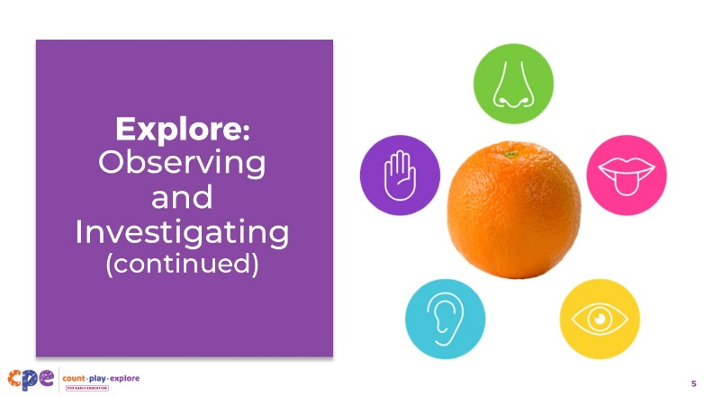
Materials: An orange for each participant, chart paper, measuring tape, balance scales, magnifying glasses
Time: 15 minutes (including slides 4 and 6)

Talking Points
- Now, let’s observe the outside of the orange again, but this time we will use all our senses. You might use the tools at your table to observe in different ways.
- Use the chart paper at your table to document, as a group, what you notice about the different attributes of the outside of the orange. For example:
  - Use your sense of touch to observe the weight, temperature, and texture.
  - Use your sense of sight to observe the size, shape, color, luster (how shiny or dull something is), and the opacity (the ability to see light through the object).
  - Consider what attributes you might observe using your sense of hearing, smell, and taste.
  - [Provide time for participants to observe the orange again, adding descriptive language to their chart paper. Encourage participants to share what they observed about the orange with the larger group.]

Facilitator Notes
- Consider inviting participants to open the orange and add descriptions to their chart paper. It is important to be thoughtful when using food items in a learning experience. Encourage participants to handle their oranges in a hygienic way (for example, washing their hands, rinsing the orange, using gloves to handle the orange, and using a plate) so that they can enjoy their orange as a snack after their investigation.

Slide 6: What do you wonder?
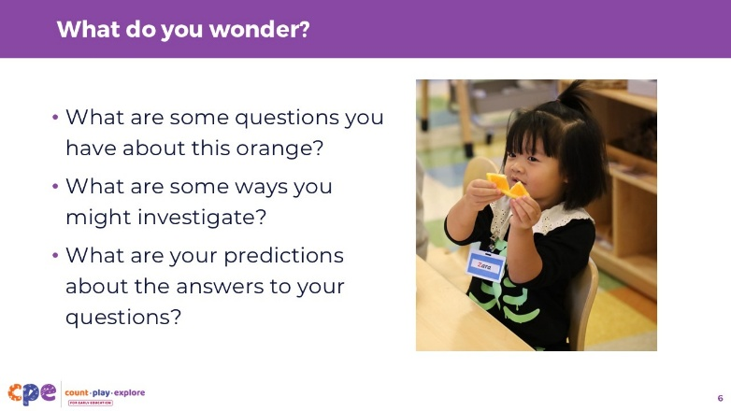
Materials: An orange for each participant, chart paper
Time: 15 minutes (including the previous slides)

Talking Points
- We have had some time to carefully observe and describe this orange. When we observe carefully and intentionally, it might inspire questions (Tishman, 2017).
- What are some questions you have about this orange?
  - [Encourage participants to add questions to their chart paper.]
  - [Invite participants to share their questions with the larger group.]
- What are some ways you might investigate?
- What are your predictions about the answers to your questions?
  - [Encourage participants to investigate their questions and explore their predictions.]

Facilitator Notes
- Here are some examples of questions participants might have and ways they might investigate. You can contribute some of these ideas to the discussion.
  - Where does the orange come from? Participants might observe the sticker on the orange to find where it was grown.
  - What is inside the orange? Participants might cut open the orange to find out.
  - What do the pores do? Participants might further investigate the rind and notice that, when squeezed, the pores excrete oil. They might observe different fruits (some with a rind and others without) to build their understanding of the structure and function of different peels or rinds.
  - Are all oranges the same? Participants might investigate different kinds of oranges.
  - Why do some oranges taste sweet and others sour? Participants might explore the taste of different oranges and notice relationships between their appearance (size and color) and their taste.

Slide 7: Reflect: Observing and Investigating
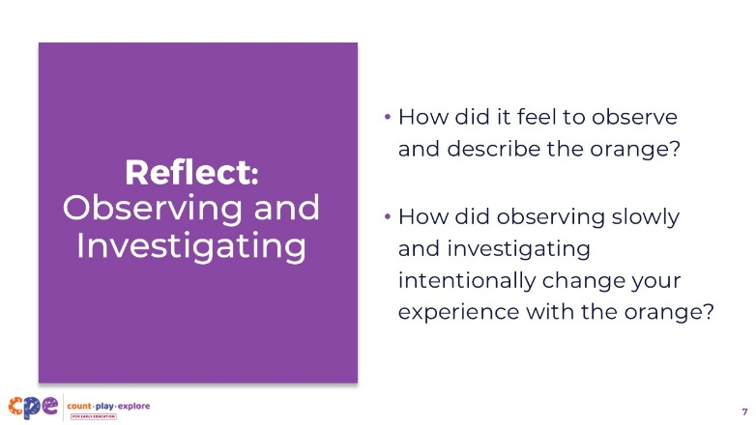
Time: 3–5 minutes

Talking Points
- Let’s take a moment to reflect on this experience.
- Most of us have eaten an orange before. Today, we slowly and intentionally observed and described various parts of an orange.
- How did it feel to observe and describe the orange?
- How did observing slowly and investigating intentionally change your experience with the orange?
- [Provide time for participants to reflect. You might encourage participants to share with their table group and then share with the larger group.]

Facilitator Notes
- You might invite participants to think about ways they might engage the children in their learning settings in a similar experience of observation and investigation.

Slide 8: Science and Engineering Practices
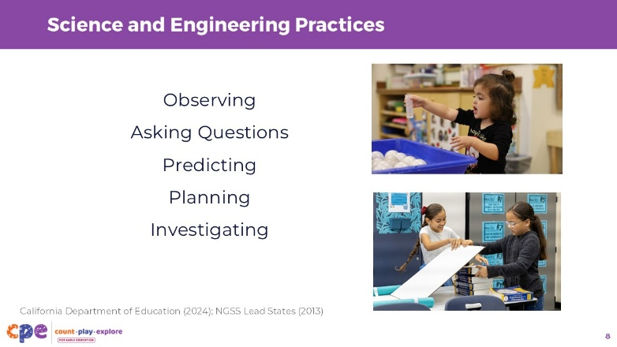
Time: 3—5 minutes

Talking Points
- In this experience, you used different skills to observe and investigate.
- Review the list of inquiry skills displayed on the screen.
- What are some ways you used these different skills while observing and describing the orange?
- [Invite volunteers to share with the larger group.]
- [Use the notes below to support a discussion about the different inquiry skills participants used when observing and describing the orange.]
  - You made observations using multiple senses.
  - You used observation and measurement tools to observe.
  - You asked questions about what you noticed.
  - You made predictions and then planned for ways to test your predictions by investigating.
- These skills are called science and engineering practices—the ways we notice and explore science concepts and phenomena all around us.
- We are already using many of these inquiry skills within our everyday experiences, cultures, and communities—just like we did with a common fruit like an orange.
- Furthermore, we can all—adults and children—grow in our abilities to use these skills.
- The more we observe and investigate, the more questions might surface.
- This process of observing, wondering, and investigating can work as a cycle—new discoveries might lead to new questions. As educators, we stay open to following children’s leads and supporting them as they observe, wonder, and investigate.

Slide 9: Observation
This slide contains animation. See instructions in the Talking Points.
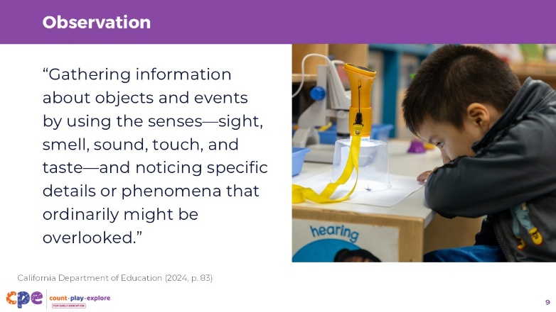
Time: 5 minutes

Talking Points
- Let’s take a moment to focus on the practice of observing.
- Consider for a moment how you might define observation.
- Turn and talk to a partner to share your definition of observation.
- [You might invite volunteers to share with the larger group. Then, make connections to what participants share with the definition that appears on the slide.]
- [Click]Observation means “gathering information about objects and events by using the senses—sight, smell, sound, touch, and taste—and noticing specific details or phenomena that ordinarily might be overlooked” (California Department of Education, 2024, p. 83).
- This is just what you did when we slowed down and thoughtfully observed the orange.
- Consider ways you notice children in your setting observing. Turn and talk to a partner to share about the ways children in your setting engage in observation. [Provide time for participants to turn and talk to a partner. You might invite volunteers to share with the larger group.]

Facilitator Notes
- The definition of observation presented on this slide is a glossary term in the Preschool/Transitional Kindergarten Learning Foundations (California Department of Education, 2024). Similar descriptions of observation can be found in Appendix F – Science and Engineering Practices in the Next Generation Science Standards (NGSS Lead States, 2013).

Slide 10: Observation in Action
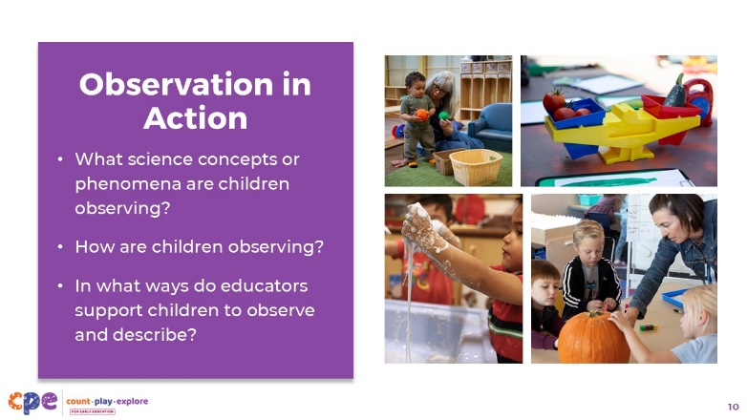
Materials: Children’s Observations Across Ages, Children’s Observations Across Ages - Audio Descriptive Version video, writing tools, scratch paper
Time: 10–15 minutes (including discussion on the following slide)

Talking Points
- Now we will notice ways children use observation to learn about their world and make sense of science concepts and phenomena.
- We will watch a video that shows clips of children from eighteen months to five years old observing to learn about science concepts and phenomena.
- All the clips in this video are small parts of larger investigations or studies that educators and children have been exploring over a period of time.
- As you observe the video, notice the following:
  - What science concepts or phenomena are children observing? By phenomena, we mean observable events.
  - How are children observing?
  - In what ways do educators support children to observe and describe?
- You might record what you notice on scratch paper.
- [Play the video.]

Facilitator Notes
- The video Children’s Observations across Ages includes short excerpts of children observing science concepts and phenomena. You might choose to play extended versions of these interactions:
  - Exploring Balls (8–18 months)
  - Exploring Balls (8–18 months) - Audio Descriptive Version
  - Observing and Investigating Goop (18–36 months)
  - Observing and Investigating Goop (18–36 months) - Audio Descriptive Version
  - Observing Pumpkins Inside and Out (4–5 years)
  - Observing Pumpkins Inside and Out (4–5 years) - Audio Descriptive Version
  - Investigating a Spider (3—5 years)
  - Investigating a Spider (3—5 years) – Audio Descriptive Version
  - Documenting and Communicating in the Garden (3—5 years)
  - Documenting and Communicating in the Garden (3—5 years) – Audio Descriptive Version

Slide 11: Discuss: Observation in Action
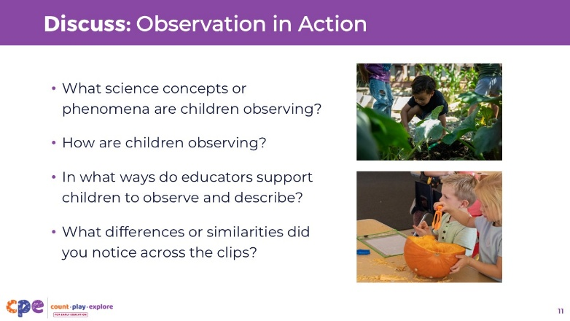
Time: 10–15 minutes (including playing the video on the previous slide)

Talking Points
- Let’s discuss what you noticed.
- Share what you noticed about the following:
  - What science concepts or phenomena are children observing?
  - How are children observing?
  - In what ways do educators support children to observe and describe?
  - What differences or similarities did you notice across the clips?
- [Encourage participants to share what they noticed with their table groups or with the larger group.]

Slide 12: What and how do children observe?
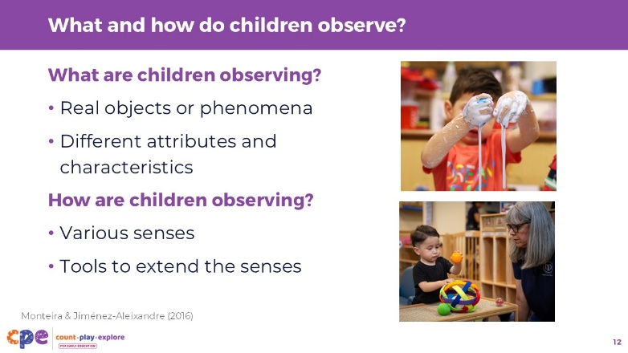

Talking Points
- Thank you all for sharing what you noticed about how children observe science concepts and phenomena and ways that educators support them to do so.
- Here are some key points to take away from the video observation.
- [Adjust talking points to complement the discussion on the previous slide.]
- What are children observing?
  - They are observing real objects and phenomena! For example, they notice the shape and texture of balls, the way the balls move, the growth of the zucchinis, the legs of a spider, and the way the goop moves.
  - Observation of science concepts and phenomena is most effective when children are provided with real objects that they can directly experience (Monteira & Jiménez-Aleixandre, 2016). In the video, we noticed children observing real balls, real goop, real vegetables, and even a real spider.
  - We also noticed children observing different attributes of objects. They were able to use many of their senses to notice shape, size, weight, texture, and even smell.
- How are children observing?
  - Children are observing by touching, smelling, moving, turning, looking—they are using their senses. Being able to move and manipulate objects supports children to observe in different ways.
  - Older children also used descriptive language to communicate what they are observing. For example, the children in the garden talk about how big the zucchini is, and the toddlers exploring goop describe the texture as being “squishy.”
  - We also noticed the use of tools in some of the clips. Tools can help extend children’s observations. For example, we noticed children using measuring tools to enhance their abilities to observe size and weight. We also saw children using digital microscopes to enhance their ability to notice the shape and structure of the spider.

Slide 13: Supporting Children to Observe and Describe
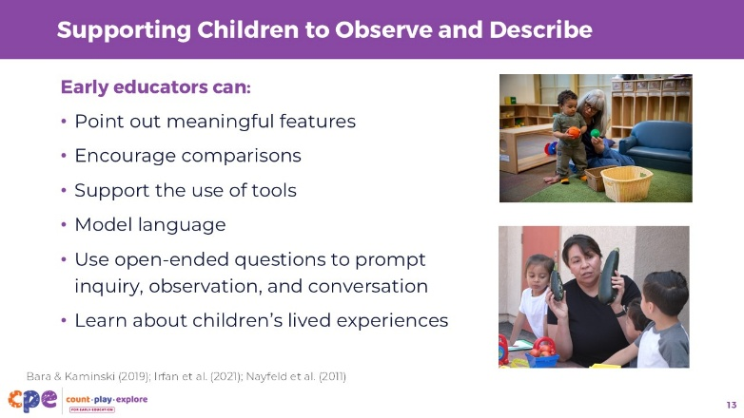

Talking Points
- Early educators can support children to observe and describe in different ways. In the video, we observed educators using similar strategies with children across different ages.
- Here are a few ways educators can support children to observe and describe.
  - Point out meaningful features: We noticed educators pointing out meaningful features of the objects children were exploring. Meaningful features are the parts of an object or phenomenon that provide information on what the object does or how it works. For example, in the infant classroom, educators were helping children notice differences in texture and sound. When observing the spider, the educator encouraged children to observe the number of legs the spider has.
  - Encourage comparisons: Educators supported children to compare. For example, the infants were encouraged to compare a ball that made a sound and one that did not make a sound. Children exploring in the garden compared the different sizes of the zucchinis.
  - Support the use of tools: We also noticed educators supporting children to use tools. When using the measuring tape, an educator supported children to read the numbers. When using the digital microscope, the educator supported children in focusing the instrument. Children will often need support in learning how to use a tool before they can use it effectively (Nayfeld et al., 2011). Supporting children to use different tools to enhance observations can also support learning in other domains. For example, using measuring tools can provide opportunities to develop math knowledge and skills.
  - Model language: Educators also provided language for children. Educators were pairing new vocabulary—descriptive language—to the real objects and phenomena that children were investigating. Pairing new vocabulary with tangible objects and real events is an effective way to build vocabulary (Bara & Kaminski, 2019; Irfan et al., 2021). Educators can provide language for children in English or in the child’s home language.
  - Use open-ended questions: We noticed educators using open-ended questions or language to prompt inquiry, observation, and conversation. For example, using prompts like, “What do you notice about …?” can support children to observe specific parts of an object. Using open-ended questions also supports critical thinking and language development.
  - Learn about children’s home lives and experiences: Although not explicit in the video, educators were likely building on their knowledge of children’s prior knowledge and experiences. Children’s cultural backgrounds and home experiences influence what they notice, depending on familiarity and past experiences with what is being observed. It is important for educators to draw on that existing knowledge to support children’s observations.

Slide 14: Investigation
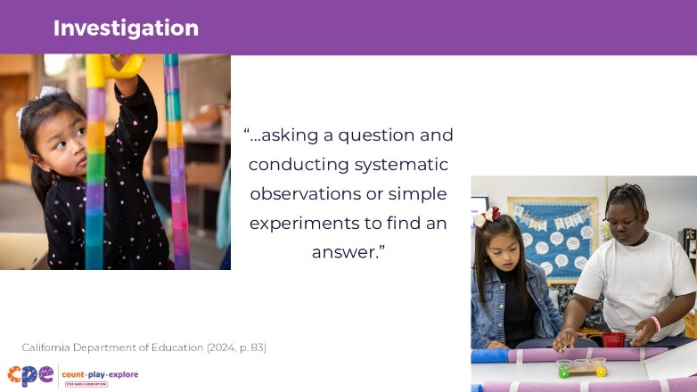

Talking Points
- We focused the first part of our session on observation. Observation is part of how we investigate.
- Investigation is a process of scientific inquiry. It involves “asking a question and conducting systematic observations or simple experiments to find an answer” (California Department of Education, 2024, p. 83).
- As the definition explains, investigations involve observations of objects or phenomena to answer a question.

Facilitator Notes
- The definition of investigation presented on this slide is a glossary term in the Preschool/TK Learning Foundations. Similar descriptions of investigation can be found in the Next Generation Science Standards, Appendix F (NGSS Lead States, 2013).

Slide 15: Experimentation
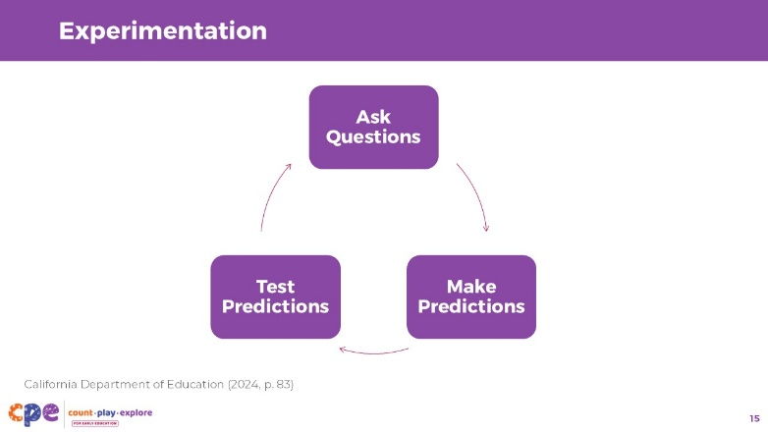

Talking Points
- Investigation can also involve experimentation. Experimentation is “the process of testing a hypothesis by observing how different actions lead to different outcomes to learn about how something in the world works” (California Department of Education, 2024, p. 83).
  - Through this process, children might ask questions, make predictions, and test their ideas.

Facilitator Notes
- The definition of experimentation presented in the talking points is a glossary term in the Preschool/TK Learning Foundations. Similar descriptions of experimentation can be found in the Next Generation Science Standards, Appendix F (NGSS Lead States, 2013).

Slide 16: Investigation in Action
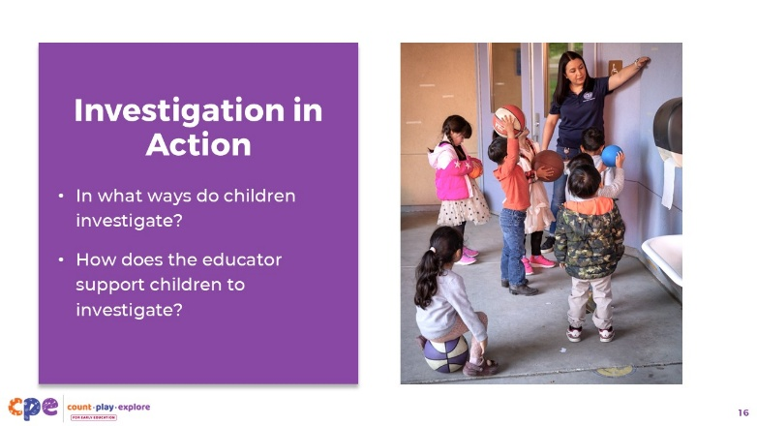
Materials: Bouncing Balls (3—5 years), Bouncing Balls (3—5 years) - Audio Descriptive Version video, writing tools, scratch paper
Time: 10–15 minutes (including discussion on the following slide)

Talking Points
- Now we will observe a video to notice ways children investigate.
- In this video, you will notice children investigating balls bouncing. This part of their investigation occurred within a broader study on balls. Children investigated many different types of balls and explored them in many ways—they rolled them, kicked them, threw them, played games with them, and tested them down ramps and slides. They were learning about force and motion concepts in physical science.
- We will watch a short clip that shows one way children investigated balls through bouncing.
- As you observe the clip, notice:
  - ways children investigate (for example, observing, predicting, and testing predictions); and
  - ways the educator supports children to investigate.
- You might take notes on scratch paper.

Facilitator Notes
- You might use other videos showing children investigating. For example:
  - Exploring Balls (8–18 months)
  - Exploring Balls (8–18 months) - Audio Descriptive Version
  - Observing and Investigating Goop (18–36 months)
  - Observing and Investigating Goop (18–36 months) - Audio Descriptive Version
  - Observing Pumpkins Inside and Out (4–5 years)
  - Observing Pumpkins Inside and Out (4–5 years) - Audio Descriptive Version

Slide 17: Discuss: Investigation in Action
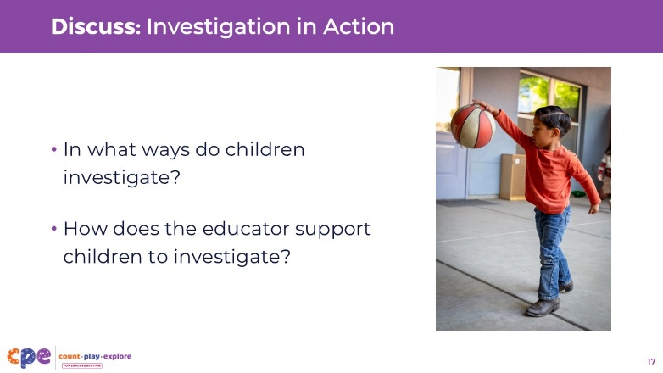
Time: 10–15 minutes (including observing the video on the previous slide)

Talking Points
- In small groups, let’s discuss what you noticed.
- In what ways do children investigate? For example, how do they do the following:
  - Observe attributes of the balls
  - Ask questions or show curiosity
  - Make predictions
  - Test their ideas
- In what ways does the educator support children to investigate?
- [Encourage participants to discuss in small groups and then facilitate a large group discussion.]
- [Review the Facilitator Notes for sample answers to support a discussion.]

Facilitator Notes
- Here are some sample responses to support a discussion about the video “Bouncing Balls (3–5 years)”:
- In what ways did children investigate?
  - Children observed the texture and size of the balls. They also observed the way the balls bounced—some bounced higher than others.
  - Children were curious about why some balls bounced higher than others.
  - Children made predictions and experimented by bouncing different balls and noticing how high the different balls bounced.
- How did the educator support children to investigate?
  - Encouraged children to observe the balls in a playful way—free exploration (the children bounced the balls and started to notice differences in how they moved)
  - Supported children to observe certain attributes of the balls—noticing the different textures, materials, sizes, and ways they moved
  - Limited the balls that were tested to three balls, which allowed children to focus on the different characteristics of the balls and compare the differences in height more easily
  - Wondered alongside children why some balls bounced higher than others
  - Encouraged children to predict how high the ball will bounce
  - Introduced a way to measure and compare how high the balls bounced—placing tape on the wall at different heights
  - Used open-ended questions to encourage children to consider why some balls bounced higher than others

Slide 18: Ways Children Observe and Investigate
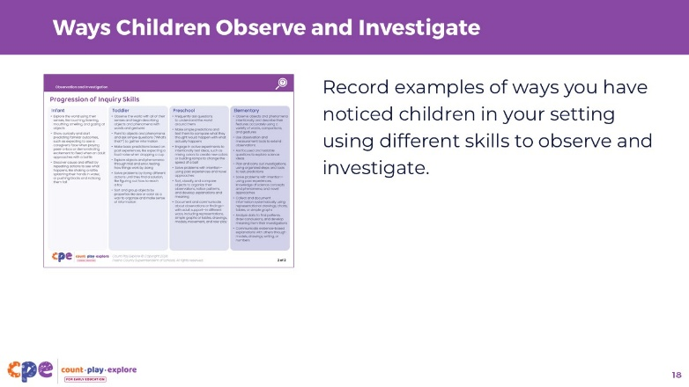
Materials: Developmental Progression of Inquiry Skills handout
Time: 5–10 minutes

Talking Points
- We have observed examples of ways children of different ages use inquiry skills to observe and investigate. Let’s take a closer look at the progression of inquiry skills.
- [Provide participants copies of the Developmental Progression of Inquiry Skills handout.]
- The handout describes ways children across ages use different skills to engage in inquiry.
- Review the handout. Record examples on the handout or scratch paper of ways you have noticed children in your setting using these skills to observe and investigate.
  - Consider the different ages and abilities of the children in your care. You might find yourself connecting with descriptions of children from age groups that are older or younger than the age groups of the children in your learning setting. Development is dynamic—it changes and varies based on children’s prior knowledge, cultural backgrounds, and lived experiences.
- [Provide time for participants to review the handout and record examples of ways they have noticed children in their setting using the skills described in the handout.]
- [Encourage participants to share (with the larger group or in their table groups) ways they have noticed children in their settings using different skills to observe and investigate.]
- Thank you for sharing ways children in your setting observe and investigate.

Facilitator Notes
- Refer to foundations, standards, and other resources focusing on science for more information on ways children of different ages and abilities observe and investigate. For example:
  - California Infant/Toddler Learning and Development Foundations
  - California Preschool/Transitional Kindergarten Learning Foundations
  - California Next Generation Science Standards
  - Preschool Through Third Grade (P-3) Learning Progressions
  - Consider inviting participants to share skills they have not observed in their settings. They might wonder why this is and consider ways to foster engagement in these skills.

Slide 19: Supporting Children to Observe and Investigate
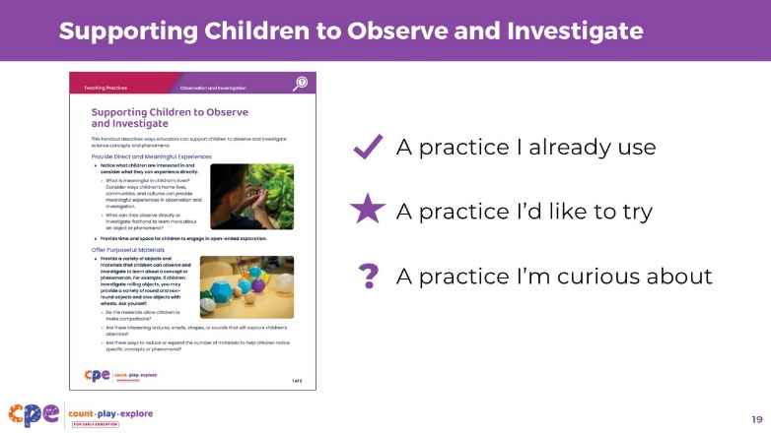
Materials: Supporting Children to Observe and Investigate handout
Time: 10–15 minutes

Talking Points
- We have focused on ways children observe and investigate. Now let’s consider ways educators can support children to observe and investigate.
- [Provide participants copies of the Supporting Children to Observe and Investigate handout.]
- This handout provides strategies educators can use to support children to observe and investigate. Some of these strategies we have already discussed as we reflected on video clips. Other strategies might be new.
- Take some time to review the handout.
  - Place a check mark next to a practice you already use in your learning setting.
  - Place a star next to a practice you would like to try.
  - Place a question mark next to a practice you are curious about.
  - [Provide time for participants to read and make notes on the handout.]
- Find a partner near you. Discuss the following with your partner:
  - The practice you already use in your setting: Give an example of how you use it and how children respond.
  - The practice you would like to try in your setting: Explain why you think this would be a good practice to try and how you might try it out.
  - The practice you are curious about: Explain what makes you curious about this practice and what questions you have about it.
- [Move around the room as participants discuss with their partner. Provide support as needed. After participants have discussed with their partners, you might invite a few volunteers to share their ideas with the larger group.]

Slide 20: Reflect
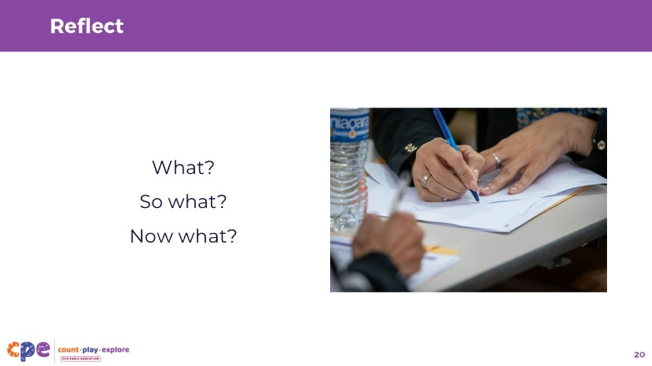
Time: 5 minutes

Talking Points
- Consider the experiences we had together today and ask yourself the following questions:
  - What? What was one of the experiences you valued most?
  - So what? Why was this experience meaningful?
  - Now what? How might you use what you learned in your setting?
- Take a moment to consider these questions on your own. Record your answers to the reflection questions on a piece of scratch paper. Then, turn and talk to a partner.
- [You might invite volunteers to share with the larger group.]

Slide 21: Applying to Your Learning Setting
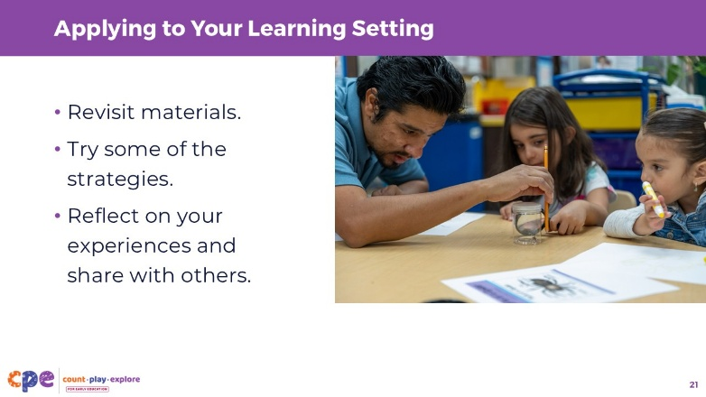

Talking Points
- When you return to your learning settings, revisit some of the materials we explored today, including the handout Supporting Children to Observe and Investigate.
- Try some of the strategies with the children in your setting.
- Reflect on your experiences and share with others in your learning community.

Facilitator Notes
- Providing ongoing support and opportunities for collaborative reflection are critical components of effective professional learning (Darling-Hammond et al., 2017). Consider ways you can support participants in applying what they learned in this session to their learning settings and supporting collaborative reflection. For example:
  - Encourage participants to share photos and anecdotes of ways they are supporting children to observe and investigate over time. You might use digital platforms such as Padlet or a shared Google Drive. You can provide feedback to individual participants and encourage others to make comments and suggestions as a way to build community.
  - Encourage educators to keep a journal to document ways they are supporting children to observe and investigate. They can share and discuss their journal entries during in-person meetings.

Slide 22: Additional Resources
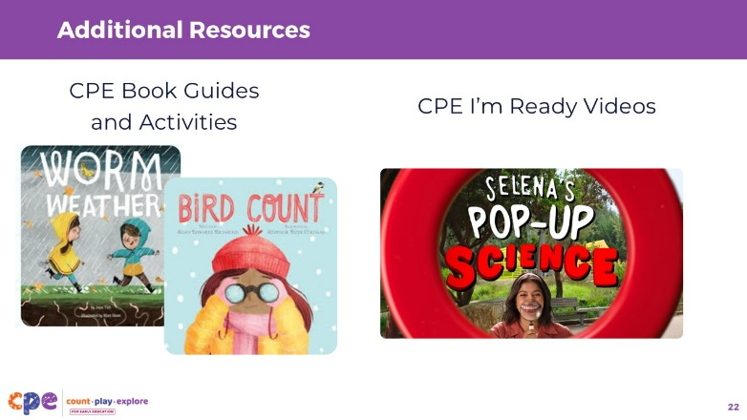

Talking Points
- As you explore observing and investigating with the children in your setting, you might use additional Count Play Explore (CPE) resources to further your investigations.
- Explore the CPE Book Guides and activities. There are many books and book guides that you might use to springboard into new observations and investigations. For example:
  - Worm Weather, by Jean Taft, might spark an interest in noticing the weather, exploring outside during a rainy day, or observing how worms and other wildlife experience the rain.
  - Bird Count, by Susan Edwards Richmond, can encourage children to observe and investigate the birds in their neighborhoods. Children might use tools, like binoculars, to observe birds more closely, or notice the different sounds birds make.
- Share CPE “I’m Ready!” videos. Consider sharing the video “Magic of Magnification” with families. This might encourage families to observe and investigate with their children in their homes, communities, and neighborhoods.

Facilitator Notes
- Count Play Explore Book Guides, activities, and “I’m Ready!” videos are available in English and Spanish through the Count Play Explore website.
- You might provide time in your session for participants to explore the Count Play Explore website materials and to consider ways they might use these resources to support children to observe and investigate.

Slide 23: Thank you!
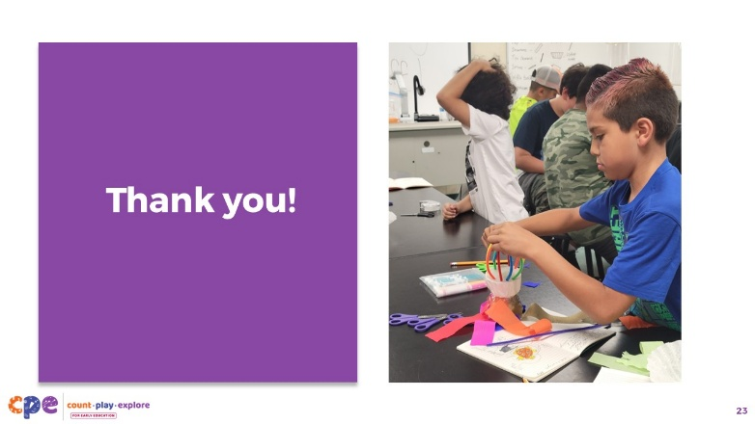

Talking Points
- Thank you for sharing your thoughts and ideas today.

