Math Mindsets Matter: Birth–8 years
Facilitator Guide
Use this facilitator guide with the slides “Math Mindsets Matter.” This set of slides can be used with educators working with children from birth to eight years old. Facilitators can find talking points and guidance for activities and group discussions in this guide. The text in the guide is also located in the notes portion of the slides. Adapt this facilitator guide based on your group size, session length and format, and participants’ needs.

Session At-a-Glance
Slide numbers | Overview of content | Approximate time (in minutes)
1-4 | Introduction & Session Goals  - Reflection | 15-20
5-11 | Reflect on lived experiences, thoughts, and feelings related to math  - Define math mindset  - How math mindsets develop and why they’re important  - Video reflection | 20-30
12-28 | Identify strategies to build positive math mindsets  - Engage in playful math experiences  - Activity for adults  - Recognize that math is for everyone  - Acknowledge your feelings about math  - Notice that math is everywhere  - Video reflection  - Resources to support positive math mindsets  - Closing reflection | 60-75
The times are approximate and may vary based on session goals, group size, and participants’ previous experience and familiarity with the content.

To Prepare for Your Session
- Adjust talking points to reflect your session length and participant needs. If necessary, add introductory and “housekeeping” information.
- Before your session, carefully review all handouts and prepare the necessary materials. Select a facilitation method that works best for your session length and format, group size, and participant needs.
- Before presenting a session on math mindsets, you may want to first explore the Mindsets About Math module to reflect on your own math mindset.

Materials Needed
- Paper, chart paper, and writing tools
- Dear Math handout
- Playing with Patterns handout, crayons, colored pencils, or markers (optional)

SLIDE 1: Math Mindsets Matter

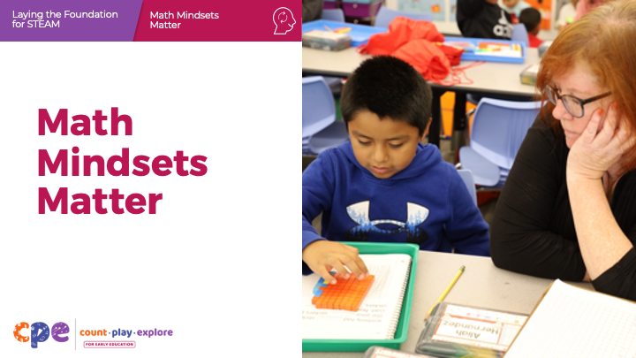

Talking Points
- Welcome! Today, we will explore your feelings and thoughts about math. The term “math mindset” can describe your feelings and thoughts about math. We will also reflect on the ways your math mindset impacts you and the children and families you work with.

Facilitator Notes
- Adjust talking points to include relevant introductions, “housekeeping,” and other information that’s important for your participants to know.
- Before presenting a session on math mindsets, you may want to first explore the Mindsets About Math module to reflect on your own math mindset.

SLIDE 2: Acknowledgments

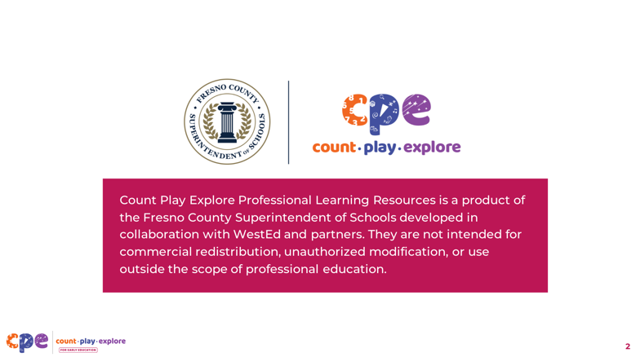

Talking Points

The Count Play Explore Professional Learning Resources were made possible by Count Play Explore, an early math, science, and computer science initiative led by the Fresno County Superintendent of Schools, Early Care and Education Department. This initiative is generously funded by the California Department of Education and the California State Board of Education. These resources, developed by WestEd in collaboration with FCSS and AIMS Center for Math and Science Education, are intended to be used as a guide for implementing evidence-based strategies, promoting active learning, and encouraging developmentally appropriate practices in early education settings. They are not intended for commercial redistribution, unauthorized modification, or use outside the scope of professional education.

SLIDE 3: Session Goals

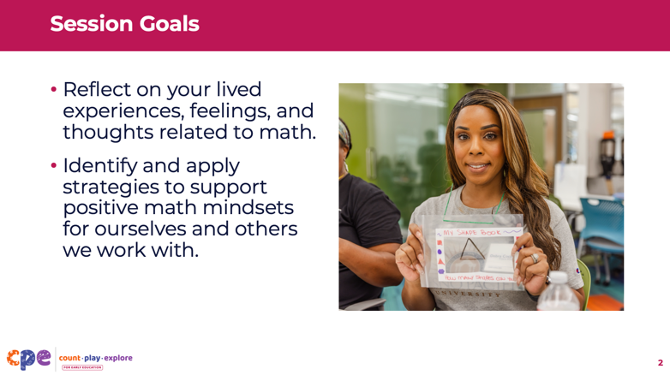

Talking Points
- First, we will discuss how our feelings and thoughts about math develop early in life and why they matter.
- Then, we will explore strategies for promoting a positive math mindset. For example, we will engage in a playful math activity and practice using growth mindset language to express our feelings and thoughts about math. We will also focus on how our math mindsets can impact the way others feel and think about math.

Facilitator Notes
- Adjust the slide content and talking points to reflect your session topics and participant needs.

SLIDE 4: Reflect: Dear Math (Part 1)
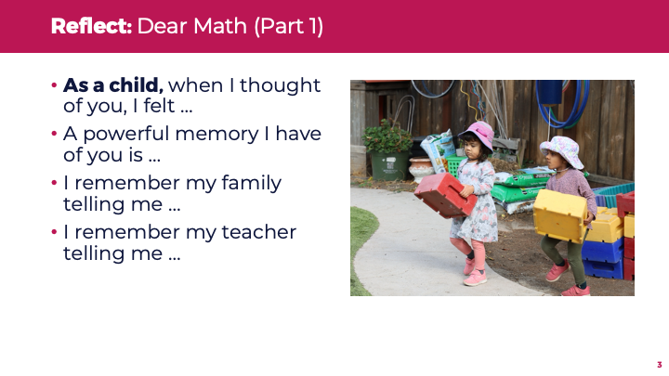
Time: 5–10 minutes
Materials: Dear Math handout, paper, pens

Talking Points
- Take out the Dear Math handout. [Refer to the handout for activity instructions.]
- During our time together, we will draft a letter to math. Right now, focus on the first part of the letter, which addresses your past experiences with math.

Facilitator Notes
- Before your session, carefully review the handout and prepare the necessary materials. Participants will also work on their letters to math in later slides.
- For longer sessions, invite participants to work on the first part of the letter. Then, consider discussing the first question in the “Reflect and Discuss” section of the handout: (1) What are your early memories of math?

SLIDE 5: Your Math Mindset Matters!

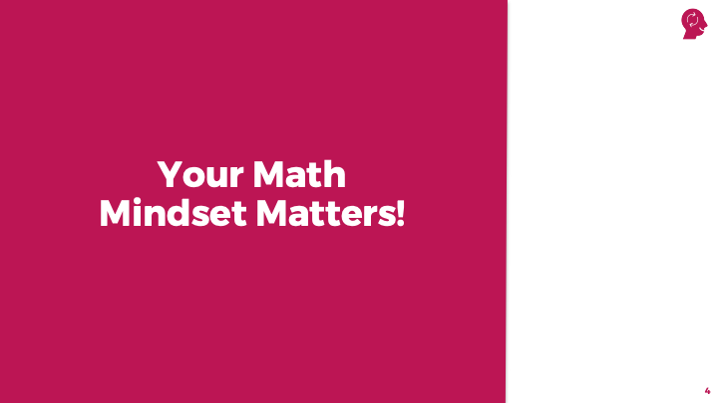

Talking Points
- Intentional reflection on your feelings and thoughts about math can promote impactful, meaningful learning for yourself, other adults, and children. For this first part of our session, we will take a deeper dive into our own thoughts and feelings about math.

SLIDE 6: Math Mindsets

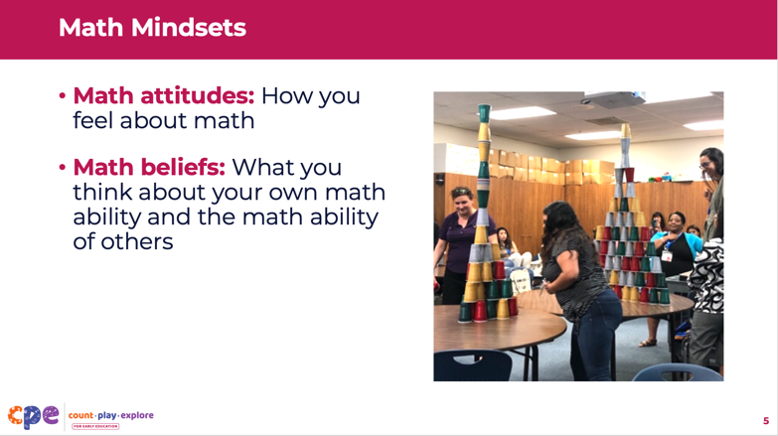

Talking Points
- Everyone has a math mindset. Math mindsets are made up of:
  - Math attitudes: How someone feels about math
  - Math beliefs: What someone thinks of their own math ability and the math ability of others

Facilitator Notes
- Math mindsets matter! This principle is key to the “Count Play Explore” approach to professional learning.

SLIDE 7: Math Mindsets Develop Early in Life

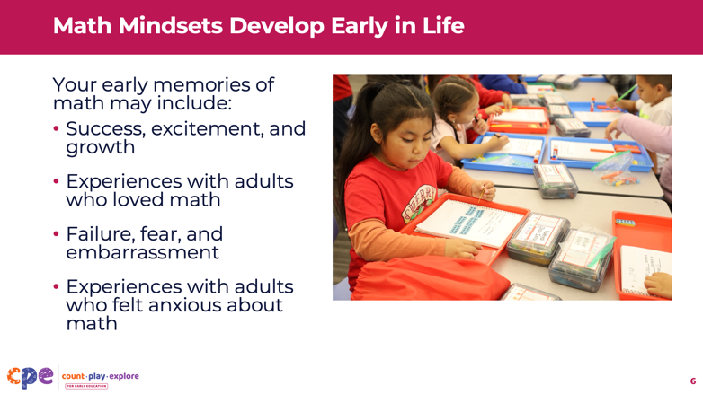

Talking Points
- Your math mindset is shaped by your environment and lived experiences. From birth, you probably have experienced math through daily routines, play, or math activities at home and school. You may have received messages—directly or indirectly—from others about how they feel and think about math.
- Your early memories of math may include:
  - Success, excitement, and growth
  - Experiences with adults who loved math
  - Failure, fear, and embarrassment
  - Experiences with adults who felt anxious or unenthusiastic about math

SLIDE 8: Why Adults’ Mindsets Are Important

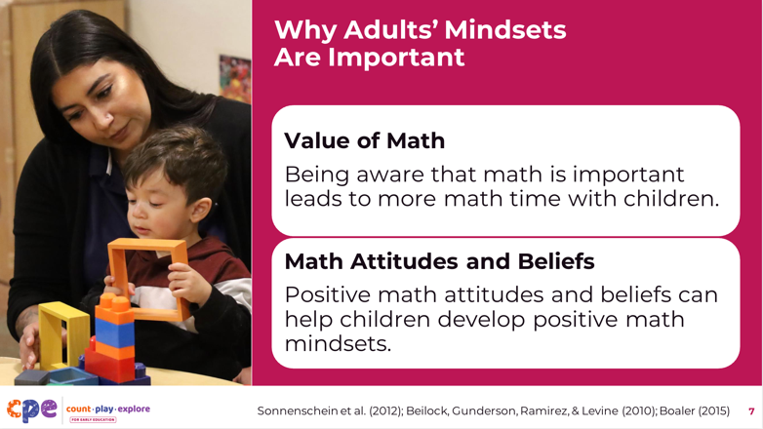

Talking Points
- Research shows that adults’ math mindsets play an important role in children’s early math experiences.
  - Value of math: Adults who are more aware of the importance of math in early childhood tend to spend more math time with children (Sonnenschein et al., 2012).
  - Math attitudes and beliefs: Adults who have more positive math feelings and beliefs can support children to also develop positive math feelings and beliefs (Beilock et al., 2010; Boaler, 2015).
- When adults use positive language about math, they send the message that math is for everyone. Math is for every child—of any background, gender, race, culture, ethnicity, ability, language, or socioeconomic status (Boaler, 2015).

Facilitator Notes
- Math is for everyone! This principle is also key to the “Count Play Explore” approach to professional learning.

SLIDE 9: Observe: Educators’ Math Memories

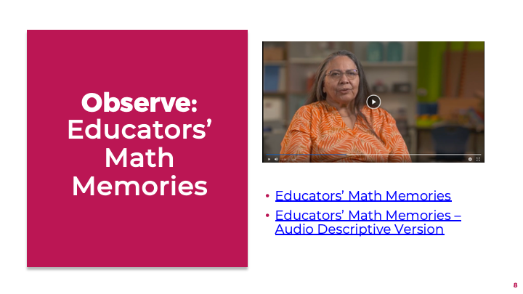
Time: 8–15 minutes (including the discussion on the next slide)
Materials: Link to video:
- Educators’ Math Memories
- Educators’ Math Memories – Audio Descriptive Version

Talking Points
- Let’s observe a video about two early childhood professionals’ math memories. After the video, we will make connections to our feelings and thoughts about math. We will also explore how our math mindsets develop very early in life and why they matter for our work with children and families.
Facilitator Notes
- For shorter sessions, you might skip this activity.
- For longer sessions, invite participants to discuss the video with partners first and then in small groups. Finally, invite participants to share their observations with the whole group.

SLIDE 10: Discuss: Educators’ Math Memories

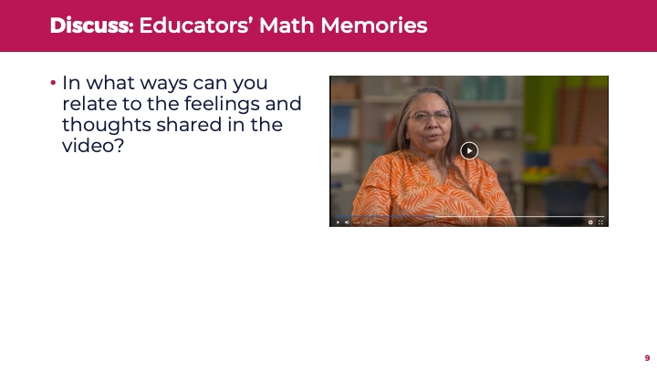
Time: 8–15 minutes (including the previous slide)

Talking Points
- Discuss in small groups: In what ways can you relate to the feelings and thoughts shared in the video?

Facilitator Notes
- For shorter sessions, you might skip this activity.
- For longer sessions, invite participants to discuss the video with partners first and then in small groups. Finally, invite participants to share their observations with the whole group.

SLIDE 11: Math Mindsets Can Change

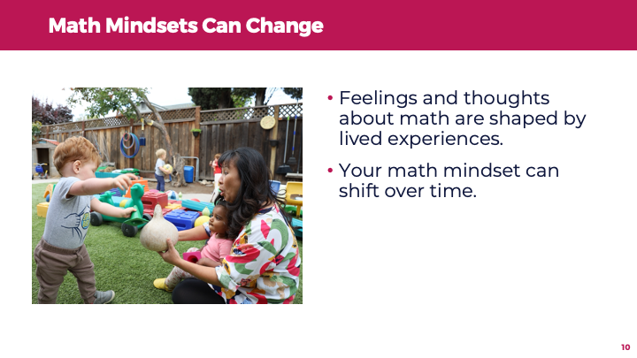

Talking Points
- Your feelings and thoughts about math are shaped by your lived experiences. As such, even adults can change their math mindsets.
- Reflecting on your math experiences and recognizing ways your mindset can impact others will help you support children to develop positive math mindsets.

SLIDE 12: Promoting a Positive Math Mindset

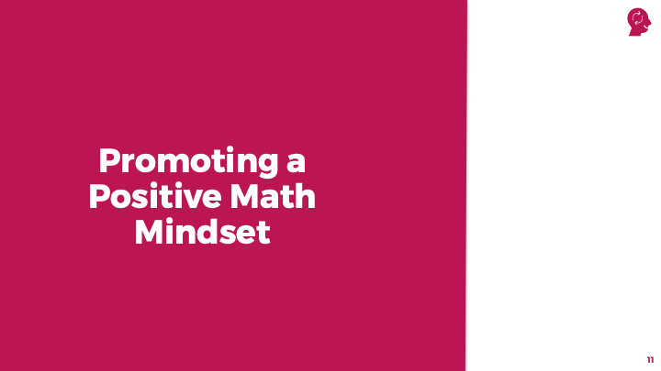

Talking Points
- Your attitudes and beliefs about math impact the way you engage children and families around math. New experiences with math can shift the way you think and feel about math. Next, we’ll explore how to promote a positive math mindset in those you work with.

SLIDE 13: Engage in Playful Math Experiences

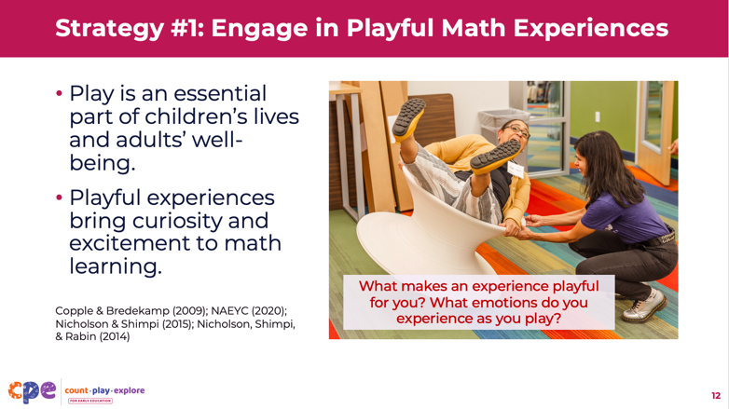
Time: 5–10 minutes (including debrief on this slide)

Talking Points
- We know that play is an essential part of young children’s lives. As children play, they explore math concepts, solve problems, and make meaningful discoveries. They also develop language and communication skills, build relationships, and process feelings (Copple & Bredekamp, 2009; National Association for the Education of Young Children, 2020).
- Play is also an important part of adults’ well-being. During play, adults experience joy, productivity, self-confidence, imagination, and empowerment (Nicholson & Shimpi, 2015; Nicholson et al., 2014).
- Engaging in playful math experiences brings curiosity and excitement to math learning. Play can promote positive math thinking!
- Take a couple minutes to reflect. Think about the ways that you play:
  - What makes an experience playful for you?
  - What emotions do you experience as you play?
- [After offering a few minutes for participants to reflect on their own, invite participants to share some of their reflections.] Let’s discuss what you reflected on when it comes to play.
- When math experiences are playful, you may feel more comfortable exploring math. For example, you may be more willing to experiment to solve problems and learn from mistakes. This active, joyful engagement with math can lead to more positive feelings and thoughts about math.

Facilitator Notes
- Math is playful! This principle is also key to the “Count Play Explore” approach to early math learning.
- Select a strategy for sharing reflections based on group size and session length. For shorter sessions, invite participants to discuss in pairs or small groups. For longer sessions, invite participants into a deeper discussion on how these playful experiences might impact their math interactions with children and families.

SLIDE 14: Playing with Patterns


Time: 10–15 minutes (including the discussion on the next slide)
Materials: Playing with Patterns handout, paper and crayons, coloring pencils, or markers

Talking Points
- Take out the Playing with Patterns handout. This activity offers a chance to playfully engage with math by observing the environment around us. [Refer to the handout for activity instructions.]

Facilitator Notes
- Math is playful! And math is everywhere! These principles are key to the “Count Play Explore” approach to professional learning. This activity invites adults to explore the math around them in a playful way.
- Before your session, carefully review the handout and prepare the necessary materials.

SLIDE 15: Discuss: Playing with Patterns
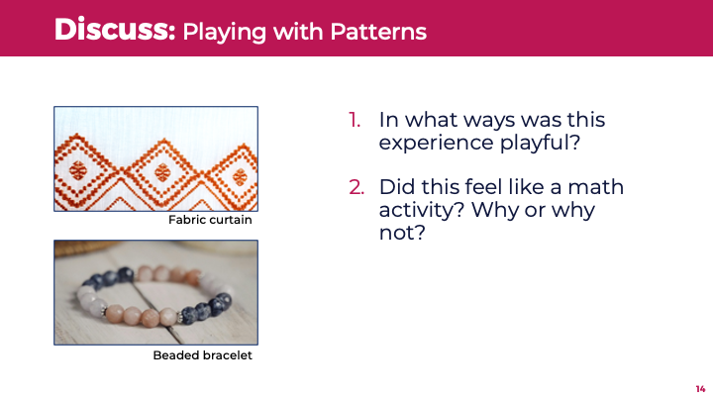
Time: 10–15 minutes (including the previous slide)
Materials: Playing with Patterns handout, paper and crayons, coloring pencils, or markers

Talking Points
- Take a moment to reflect on this activity. Discuss the following questions with a partner:
  - In what ways was this experience playful?
  - Did this experience feel like a math activity? Why or why not?
- [After some time for discussion, invite participants to share their thoughts about this activity.]

Facilitator Notes
- Adjust the discussion based on your group size, session length and format, and participant needs. For smaller groups, consider doing the reflection as a large group. For shorter sessions, invite participants to share in pairs or small groups. For longer sessions, invite participants to share with the large group the patterns they chose and the symbols they used to represent patterns.

SLIDE 16: Recognize That Math is for Everyone

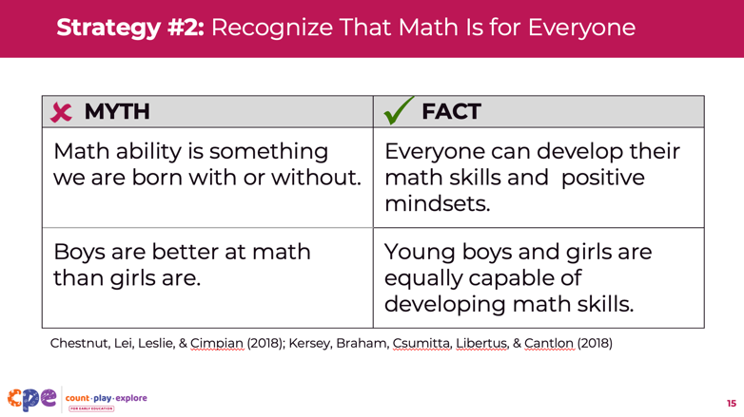

Talking Points
- Implicit biases are unconscious attitudes and beliefs we form without consciously knowing it. These biases can affect math expectations, decisions, and interactions. They can also lead to behaviors that reinforce stereotypes.
- Stereotypes are often based on biases about gender, race, culture, ethnicity, language, socioeconomic status, ability, and other factors. Stereotypes can influence our feelings and thoughts about math throughout life.
- Stereotypes can lead to math myths that can harm you and the children and families you work with.
  - A common math myth: “Math ability is something we are born with or without; some groups of people are likely to be better or worse at math.” The fact: Everyone can develop their math skills and positive mindsets. All children are born with the capacity to learn math (Chestnut et al., 2018).
  - Another math myth: “Boys are better at math than girls are.” The fact: Research conducted with children ages six months to eight years shows that boys and girls are equally capable of developing math skills (Kersey et al., 2018).

Facilitator Notes
- Math is for everyone! This principle is key to the “Count Play Explore” approach to early math learning.
- For longer sessions, consider inviting participants to discuss how each math myth can harm adults and children. They might also discuss how the math facts add to their understanding of math mindsets.

SLIDE 17: Disrupting Math Stereotypes
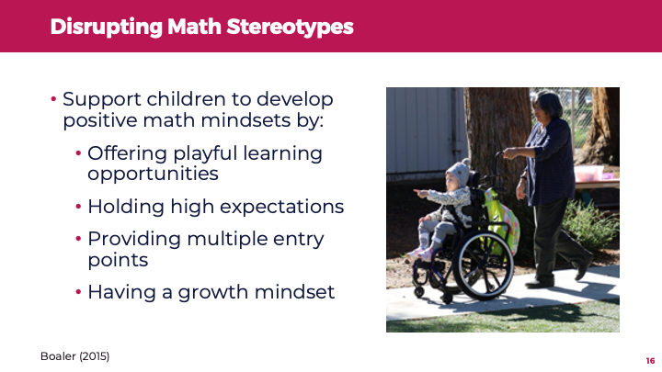

Talking Points
- As educators, you can disrupt or interrupt math stereotypes. Math is for everyone! Support all children to develop positive math mindsets by doing the following:
  - Offer playful learning opportunities to all children. For example, invite boys to the dramatic play center or girls to the block area.
  - Hold high expectations for all children, regardless of background (age, race, ethnicity, language, gender, and ability).
  - Offer meaningful learning experiences with different entry points to build on the strengths and meet the needs of all children, including children who have disabilities or delays.
  - Use growth mindset language with all children you work with.
- These practices reinforce everyone’s ability to learn math and develop positive math mindsets. Next, we will explore ways to use these practices.

Facilitator Notes
- Math is for everyone! This principle is key to the “Count Play Explore” approach to professional learning.

SLIDE 18: Growth and Fixed Mindsets
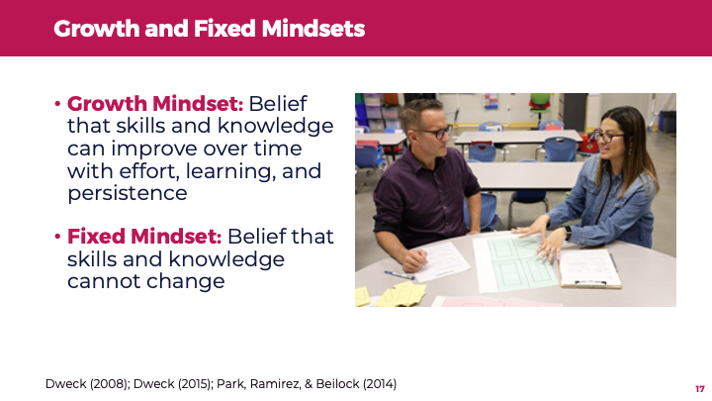

Talking Points
- Having a positive math mindset is often related to having a growth mindset. Someone with a growth mindset believes that an individual’s skills and knowledge can improve over time with effort and practice (Dweck, 2008, 2015; Park et al., 2014).
- Someone with a fixed mindset may believe that an individual’s skills and knowledge cannot change.

SLIDE 19: Explore: Practice Growth Mindset Language (optional)
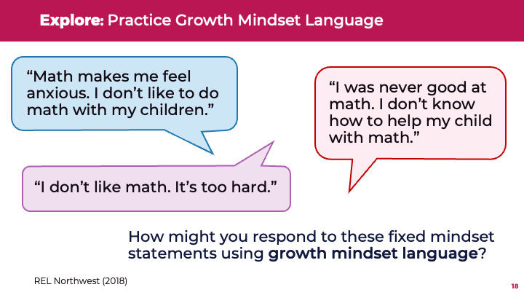

Talking Points
- Using growth mindset language and communication about math can be a powerful tool for promoting positive math mindsets (REL Northwest, 2018). You might be familiar with fixed mindset statements like:
  - “Math makes me feel anxious. I don’t like to do math with my child.”
  - “I was never good at math. I don’t know how to help my child with math.”
  - “I don’t like math. It’s too hard.”
- Let’s take some time to practice responding to these fixed mindset statements using a growth mindset perspective. For example:
  - Consider the statement “I was never good at math. I don’t know how to help my child with math.”
  - Using growth mindset language, you might reframe this statement as “You are probably already doing math with your child during everyday interactions and routines. Let’s discuss how you might playfully support your child with the math all around us!”

Facilitator Notes
- Adjust the discussion based on your group size, session length and format, and participant needs. For smaller group sizes, invite participants to reflect on their own and then share with the group ways they might respond to these fixed mindset statements. For larger groups, invite participants to practice in small groups first and then share out their reflections with the full group.
- Offer additional examples of growth mindset statements:
  - “You are probably already doing math with your child during everyday interactions and routines. Let’s discuss how you might playfully support your child with the math all around us!”
  - “Everyone can strengthen their math skills. I can connect you with family math resources.”
  - “Many adults feel anxious about math. You are not alone. But you can build your math confidence.”
  - “Identifying your worrisome feelings can help you move toward more positive thinking about math.”
  - “Your positive view of math can help your children enjoy math.”

SLIDE 20: Pause, Notice, and Name Your Feelings About Math
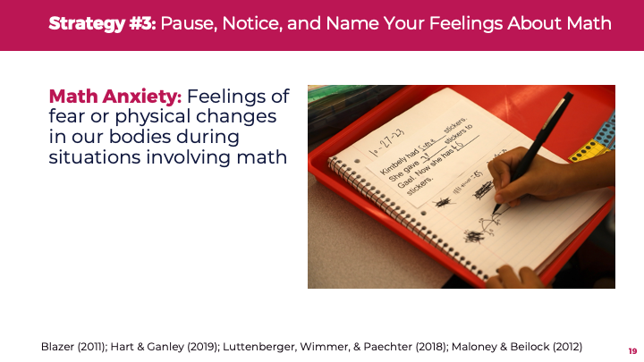

Talking Points
- Past and present experiences with math can surface many emotions, including anxiety. Math anxiety involves feelings of fear, worry, or uneasiness about math. It also may involve physical changes in our bodies. For example, we may experience an increased heart rate or sweating in situations related to math (Luttenberger et al., 2018).
- Did you know that 93 percent of adults experience math anxiety? Many adults believe their math anxiety is related to having a math-anxious parent or teacher. Even so, the way we feel and think about math can change over time (Hart & Ganley, 2019; Maloney & Beilock, 2012).
- Pause, notice, and name your feelings about math. Focus on understanding the source of your feelings. If you are feeling frustrated or worried about a situation that involves math, you might take a break and consider the source of your feelings. You can reach out to others for help. You might find professional learning resources to help you approach math in a more positive way.

Facilitator Notes
- Participants may want to share an emotional experience with math, either positive or negative.

SLIDE 21: Reflect on Math Strengths and Opportunities for Growth
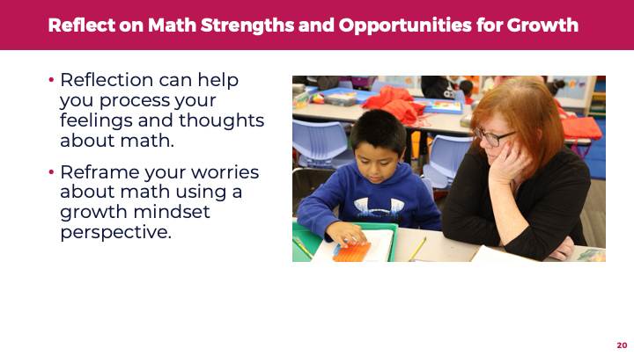

Talking Points
- Reflection can help you process your feelings and thoughts about math. For example, you might notice how your math-related feelings influence the activities you engage in or learning experiences you offer to children. You can reframe your worries about math using a growth mindset perspective, which can help you recognize that math is for everyone.

Facilitator Notes
- Math is for everyone! This principle is key to the “Count Play Explore” approach to professional learning.

SLIDE 22: Reflect: Dear Math (Part 2)
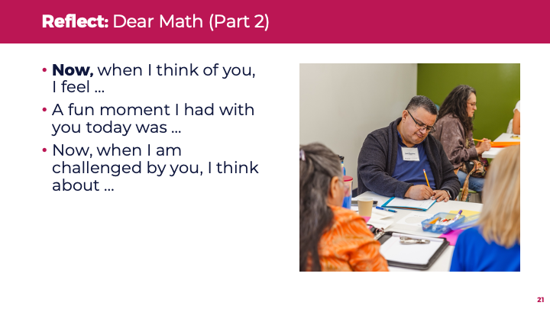
Time: 5–10 minutes
Materials: Dear Math handout, paper, pens

Talking Points
- Take out your Dear Math handout. We will reflect on strengths and areas for growth for your math mindset. [Refer to the handout for activity instructions.]
- Let’s focus on the second part of the letter—your current experiences with math.

Facilitator Notes
- Before your session, carefully review the handout and prepare the necessary materials. If participants began drafting their letters in Part 1, then continue the letters now.
- For longer sessions, invite participants to work on the second part of the letter. Then, discuss the second and third questions on the “Reflect and Discuss” section of the handout: (2) What are your current strengths related to your math mindset? and (3) What are your current areas for growth for your math mindset?

SLIDE 23: Notice That Math Is Everywhere
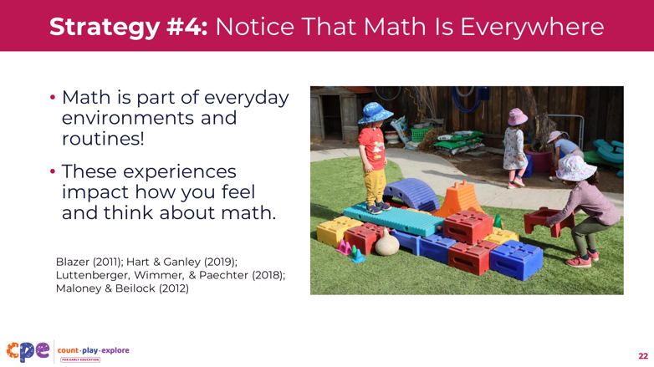

Talking Points
- Math is everywhere. It is part of our everyday experiences. For example:
  - When cooking, you use measuring spoons and cups to measure ingredients. You might also estimate ingredients by including a “pinch of this” or a “few handfuls of that.”
  - At work, you gather data from different people before making a decision.
  - When shopping, you count the amount of money you need to spend on things.
- In each of these examples, you are using math. Experiences with math in everyday environments and routines can impact how you feel and think about math.

Facilitator Notes
- Math is everywhere! This principle is also key to the “Count Play Explore” approach to professional learning.
- Adjust the discussion based on your group size, session length and format, and participant needs. For shorter sessions, invite participants to share (in pairs or together as a whole group) one way they have used math today. For longer sessions, invite participants to discuss some ways they use math in their everyday lives.

SLIDE 24: Observe: Wide World of Math: Cry Daddy

Time: 10–15 minutes (including the discussion on the next slide)
Materials:
- Wide World of Math: Cry Daddy video [1:49]
- Wide World of Math: Cry Daddy video – Audio Descriptive Version [2:10]

Talking Points
- In this video, dad Chet Kingston discusses his feelings and thoughts about math.
- As you observe the video, consider:
  - Math myths or stereotypes that may have influenced Chet’s experiences
  - Experiences that may have changed Chet’s math mindset
  - Ways Chet’s story might impact the way you approach early math with children and families
- After the video, we will discuss what you noticed.

SLIDE 25: Discuss: Wide World of Math: Cry Daddy
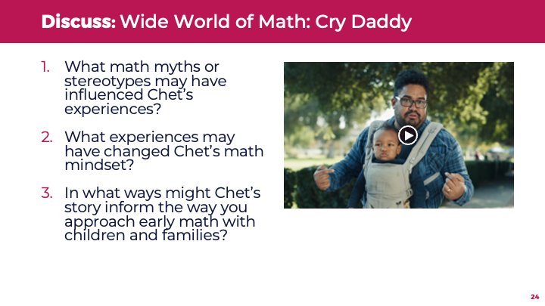
Time: 10–15 minutes (including the previous slide)
Materials:
- Wide World of Math: Cry Daddy video [1:49]
- Wide World of Math: Cry Daddy video – Audio Descriptive Version [2:10]

Talking Points
- Let’s discuss what you noticed about the following:
  - What math myths or stereotypes may have influenced Chet’s experiences?
  - What experiences may have changed Chet’s math mindset?
  - In what ways might Chet’s story inform the way you approach early math with children and families?
- [Use the facilitator notes that best fit your group’s needs.]
- [After discussion:] Thank you for sharing. This video highlights how everyday math experiences can help change math mindsets. Here are some takeaways from the video:
  - Early in the video, Chet cries and feels anxious and overwhelmed about math. He wonders how to teach his child math when he wasn’t good at it as a child. He may have been influenced by stereotypes about who can or cannot do math.
  - Later in the video, Chet shares more positive feelings about math. He notices that math opportunities are everywhere: at home, at the beach, and on the street. He uses growth mindset language to describe his math abilities.
  - At the end of the video, Chet feels less anxious and more confident about math. He calls himself a “mathlete” and supports other families to be less fearful of math.

Facilitator Notes
- Adjust the discussion based on your group size, session length and format, and participant needs.
- Consider the following adaptations based on session length and group size:
  - For shorter sessions, assign each table one of the questions to discuss. Then, invite tables to share what they noticed with the whole group. Make connections to participants’ observations and key takeaways described in the talking points.
  - For longer sessions, offer time for participants to share their observations in pairs or at their tables. Then, invite each table to share their observations. Make connections to participants’ observations and key takeaways described in the talking points.

SLIDE 26: Supporting Children’s Positive Math Mindsets
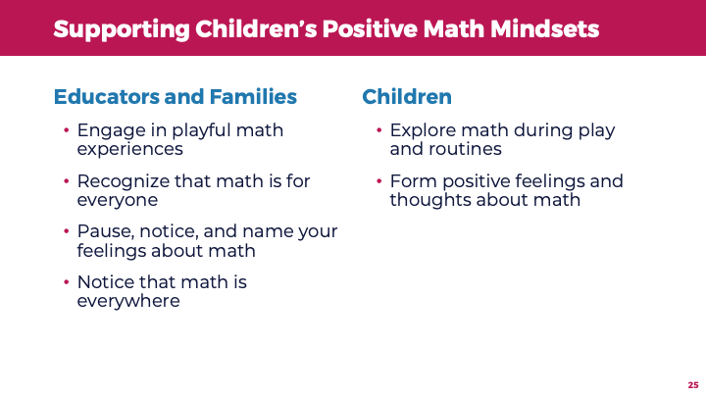
Talking Points
- Educators and families likely already engage children in math as part of daily routines and activities. By recognizing how math is everywhere and math is for everyone, you can develop your own positive math mindset and support positive math mindsets in others, including children.
- Your math mindset influences the amount of time you spend engaging with children in math. It also influences the types of math learning experiences you offer to children.

SLIDE 27: Additional Resources
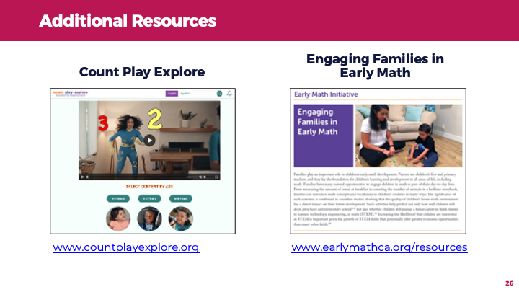
Time: 5–15 minutes (including navigating the website)

Talking Points
- The Count Play Explore website offers early math learning resources, in English and Spanish, for children and families. For example, it includes:
  - “I’m Ready” videos for families: The videos provide playful and fun examples for families to experience math in their everyday routines and environments.
  - Discovering the Math: Book Guides for families and educators to use with children: The book guides provide strategies on how to implement math while reading and provide information on how to support the math topics in daily activities and routines.
  - Math activities: Families and educators can use these activities with children from birth to eight years old.
- You might also review the research brief “Engaging Families in Early Math.” It offers in-depth information on families’ important role in children’s early math development.
- Let’s take some time to explore one of these resources. Consider how you might use this resource in your work in the next week or month.

Facilitator Notes
- Provide the website URL of Count Play Explore.
- Navigate the Count Play Explore website on-screen to show participants how they can select a book and access the Discovering the Math Book Guides and related activities. You might invite participants to share how they might use these materials with families.
- Consider reading the research brief “Engaging Families in Early Math” before the session. The brief provides useful information you can share with participants about families’ important role in children’s early math development.
- Consider the following adaptations based on session length and group size:
  - For shorter sessions, consider providing educators with some time to explore one of the resources. In pairs or small groups, invite them to share what they explored and how they might use this resource in the next week or month. Then, encourage a few participants to share their ideas with the whole group.
  - For longer sessions, consider providing educators with the research brief. Divide the brief into sections. Invite each table to review one section. Then, allow time for each table to share key points from each section with the large group.

SLIDE 28: Reflect: Dear Math (Part 3)
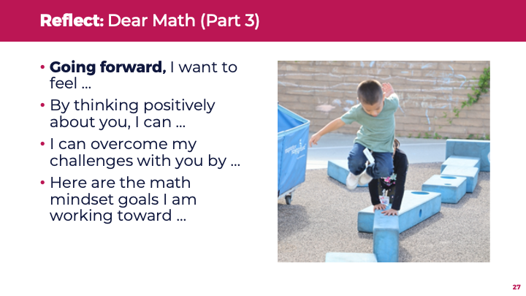
Time: 5–10 minutes

Materials: Dear Math handout, paper, pens

Talking Points
- In this session, we explored our own math mindsets. We also discussed why math mindsets matter, strategies for promoting positive math mindsets, and ways to support children to develop positive math mindsets.
- Take a few minutes to think about our session. Now, take out the Dear Math handout. [Refer to the handout for activity instructions.]
- Let’s focus on the third and final part of the letter, your math mindset goals. [Allow three to five minutes for participants to finish their letters to math.]
- With a partner, share something you will do as a result of this session. [Allow three to five minutes for participants to share with partners.]
- Thank you for your time, attention, and participation. I hope this session has had a positive impact on your math mindset and has offered some ideas on how to promote others’ positive math mindsets.

Facilitator Notes
- Before your session, carefully review the handout and prepare the necessary materials. If participants began drafting their letters in Parts 1 and 2, then continue the letters now.
- Adjust the closing discussion based on your group size, session length and format, and participant needs.
- For longer sessions, invite participants to discuss their goals in small groups. Then, consider discussing the fourth question on the “Reflect and Discuss” section of the handout: (4) Going forward, what are some ways you will maintain or strengthen your positive math mindset? Offer time for some participants to share their goals with the whole group.

