Geometry: Preschool, Transitional Kindergarten, and Kindergarten (PPT 2b)
Use this facilitator guide with the slides “Geometry: Preschool, Transitional Kindergarten, and Kindergarten.” This facilitator guide and set of slides provides descriptions of how infants and toddlers develop an understanding of shapes and ways educators can support them as they develop an early understanding of shapes. Facilitators can find talking points and guidance for activities and group discussions in this guide. The text in the guide is also located in the notes portion of the slides.

Session at-a-Glance
Slide numbers | Overview of content | Approximate time (in minutes)
1—4 | Introduction, session goals, and reflection activity | 15
5-18 | How children develop an understanding of shapes:  - California learning foundations and standards  - Classifying shapes  - Naming shapes  - Learning about the attributes of shapes  - Composing and decomposing shapes  - Video observation | 30-40
19—25 | How to support children in develop an understanding of shapes:  - Observing and discussing M⁵  - Activity for children | 45-75
26 | Reflection activity | 5
The times are approximate and may vary based on session goals, group size, and participants’ previous experience and familiarity with the content.

To Prepare for Your Session
- Before your session, carefully review all handouts and prepare the necessary materials. Throughout the facilitator guide, we offer options for facilitation approaches. Select a facilitation method that works best for your session length and format, group size, and participant needs.
- Consider using photos, videos, or stories from the learning settings where educators work within this session. Making the information more personal for participants can create a greater connection to the content and foster feelings of belonging in Math.
- As you plan your professional learning session, consider the content in each of the PPTs in this suite of resources:
  - PPT 1 “Introduction to Geometry: Birth–8 Years” describes foundational information about children’s geometry learning from birth to eight years old. This introductory session also includes opportunities for participants to use geometry skills.
  - PPT 2a “Geometry: Infants and Toddlers” describes infants’ and toddlers’ early geometry learning and ideas on how to support it.
  - PPT 2b “Geometry: Preschool, Transitional Kindergarten, and Kindergarten” describes the development of geometry learning for children in preschool, TK, and K and ideas on how to support it.
  - PPT 2c “Geometry: Early Elementary” describes the development of geometry learning for children in first and second grade and ideas on how to support it.
- We encourage you to offer the content in PPT 1 before, or in combination with, content in one of the age-specific slide decks (PPT 2a, PPT 2b, or PPT 2c). Together, PPT 1 and one of the age-specific slide decks make up a three-hour professional learning session.
- You might inform participants that we will use “TK” to refer to transitional kindergarten and “K” for kindergarten.

Materials Needed
- Scratch paper, chart paper, T-Charts, and writing tools
- M⁵ Early Math Approach Overview handout
- Observing M⁵ in Action: Shapes handout, Answer Key for Observing M⁵ in Action: Shapes handout, preschool, TK or K shapes video clip
- Using M⁵ to Support Learning About Shapes and Space handout
- Shape Viewfinder handout

SLIDE 1: Geometry: Preschool, Transitional Kindergarten, and Kindergarten

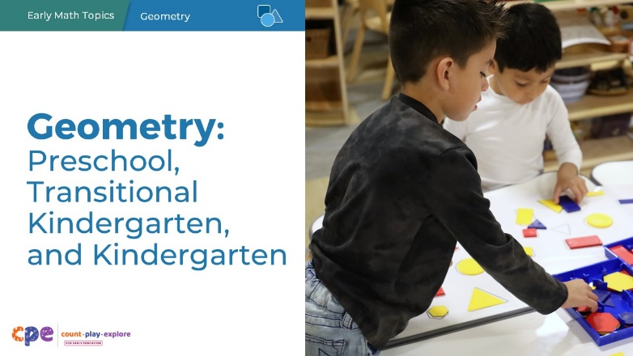

Talking Points
- In this session, we will explore how children in preschool, transitional kindergarten, and kindergarten learn about shapes. We will also focus on ways we can support children in preschool, transitional kindergarten, and kindergarten to learn about shapes.
- We will use “TK” to refer to transitional kindergarten and “K” for kindergarten.

Facilitator Notes
- Adjust talking points to reflect your session length and participant needs. If necessary, add introductory and “housekeeping” information.

SLIDE 2: Acknowledgments
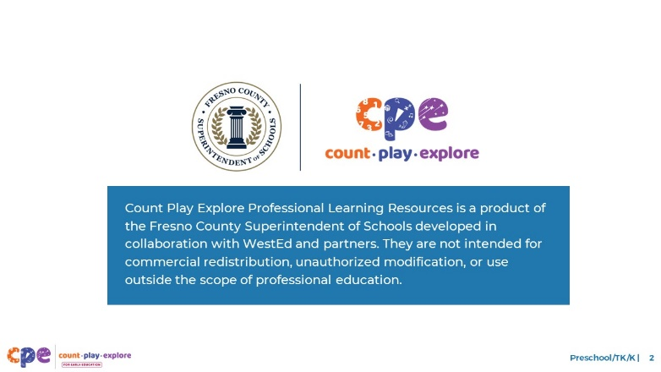

Talking Points
The Count Play Explore Professional Learning Resources were made possible by Count Play Explore, an early math, science, and computer science initiative led by the Fresno County Superintendent of Schools, Early Care and Education Department. This initiative is generously funded by the California Department of Education and the California State Board of Education. These resources, developed by WestEd in collaboration with FCSS and AIMS Center for Math and Science Education, are intended to be used as a guide for implementing evidence-based strategies, promoting active learning, and encouraging developmentally appropriate practices in early education settings. They are not intended for commercial redistribution, unauthorized modification, or use outside the scope of professional education.

SLIDE 3: Session Goals

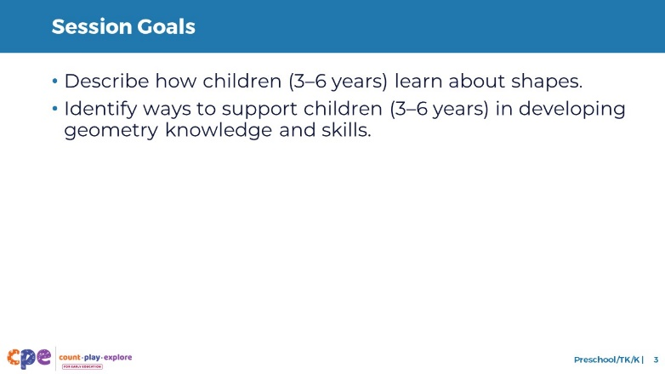

Talking Points
- First, we will review how children in preschool, TK, and K learn about shapes.
- Next, we will explore some ways that educators and families can support preschool-aged, TK-aged, and K-aged children to develop geometry knowledge and skills.
- Throughout our session, we will take time to reflect on our current practices. We will also think about how we might use information from this session in our work.

Facilitator Notes
- Adjust talking points to reflect your session length and participant needs.

SLIDE 4: Reflect: Exploring and Learning About Shapes
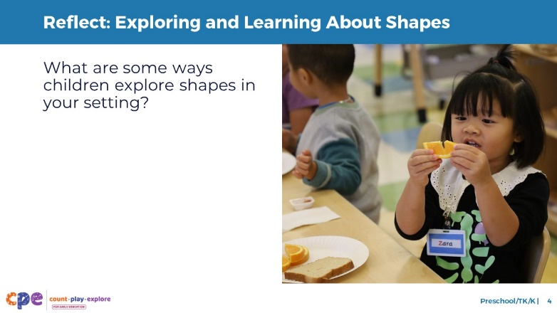
Time: 7–15 minutes (including debrief)
Materials: Markers, one or more T-Charts with one column labeled “preschool/TK” and one “K”

Talking Points
- Children in preschool, TK, and K explore and learn about shapes every day!
- Take a couple minutes to think about your learning setting and some ways that children explore shapes.
  - How might children’s home environments and cultural backgrounds impact the ways children explore shapes in your setting?
  - Consider different areas of the learning setting or times of the day, for example, inside, outside, during choice time, or during free play.
- [Allow participants a few minutes to reflect before inviting them to share their reflections.]

Facilitator Notes
- Adjust the way you debrief participant reflections based on group size, session length and format, and participants’ needs. Charting reflections using a T-Chart will help participants connect their current practices to session content. You can use the following options for charting participant reflections:
  - Invite participants to share their reflections with the whole group. As they share, chart their reflections in the appropriate column.
  - Provide markers and a T-Chart to each table. Ask each table to choose a recorder and reporter. Allow time for participants to share their examples with their table group and for the recorder to chart their reflections in the appropriate column. Then, encourage the reporter from each table to share one or two reflections from their table’s chart.
- If you have not presented content from PPT 1 “Introduction to Geometry: Birth–8 Years” before engaging in this session, consider presenting the “Pull-Up Polyhedra” activity in slide 6 of PPT 1 at this point in your session. This will allow participants to engage in a playful, hands-on activity about two- and three-dimensional shapes.

SLIDE 5: Learning About Shapes

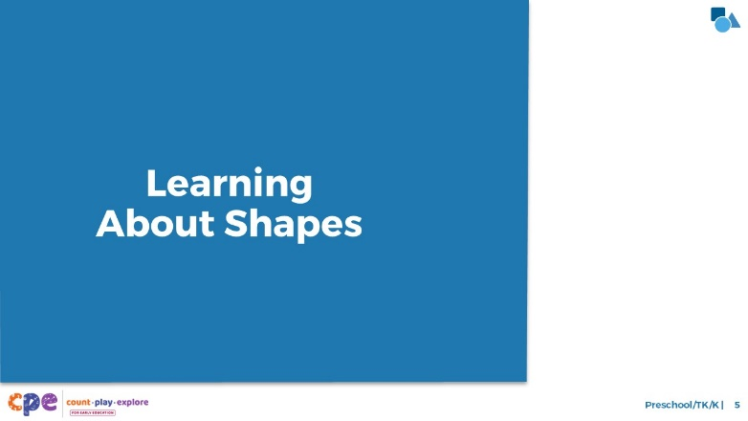

Talking Points
- Wow! The children in your settings are exploring and learning about shapes in a lot of different ways! Let’s examine what children in preschool, TK, and K learn about shapes.

SLIDE 6: The California Preschool/TK Learning Foundations

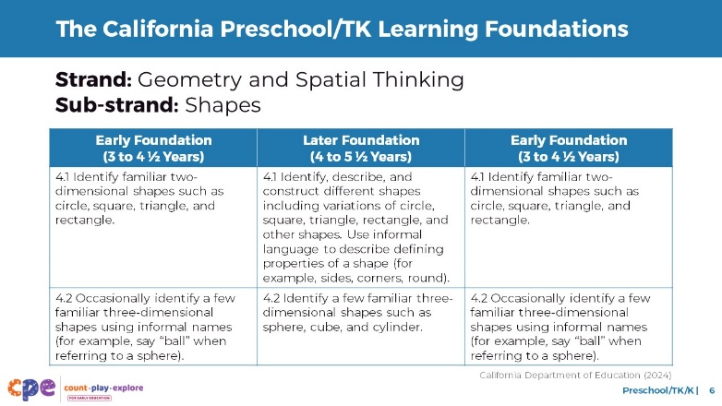

Talking Points
- Let’s review how geometry is represented in the Preschool/Transitional Kindergarten Learning Foundations (PTKLF; California Department of Education, 2024). The recently revised PTKLF were designed to align with expectations stated in the California Common Core Kindergarten Math standards.
- Four standards in the “Geometry and Spatial Thinking” strand describe what children learn about geometry in preschool/TK. These standards are part of the “Shapes” sub-strand.
- The first two foundations describe children’s ability to:
  - Identify and describe a variety of two-dimensional shapes
  - Identify a few three-dimensional shapes

Facilitator Notes
- Slides 6, 7, and 8 make connections to foundations and standards for geometry.
- The PTKLF addresses children aged 3–5, this includes both children in preschool and TK.
- The foundations and standards listed in some of the slides are condensed. You might consider providing participants with copies of the relevant California Preschool/TK Foundations Toddler Learning Foundations or the California Common Core State Standards. Consider whether electronic or printed copies will be more useful for your participants.

SLIDE 7: The California Preschool/TK Learning Foundations, continued

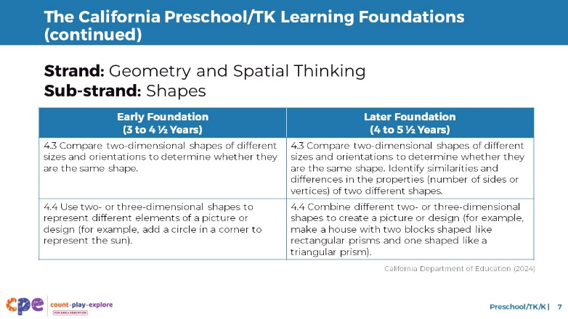

Talking Points
- The next two foundations describe children’s ability to:
  - Compare two-dimensional shapes to determine if they are the same
  - Combine two- or three-dimensional shapes to create pictures or designs.

SLIDE 8: The California Common Core – Kindergarten

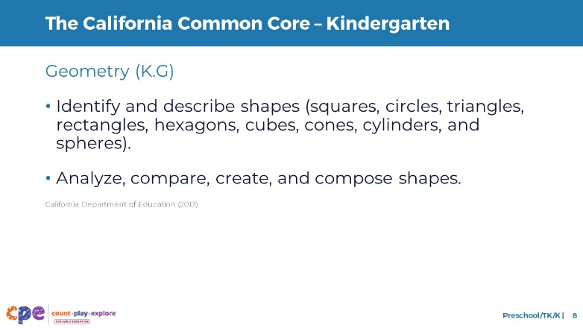

Talking Points
- Let’s review how geometry learning is represented in the California Common Core State Standards.
- Two kindergarten standards describe how children learn about shapes:
  - One standard describes children’s ability to identify and describe a variety of two- and three-dimensional shapes.
  - The other standard describes children’s understanding of shape attributes and their ability to compose and decompose shapes.

SLIDE 9: Five Components of Learning About Shapes

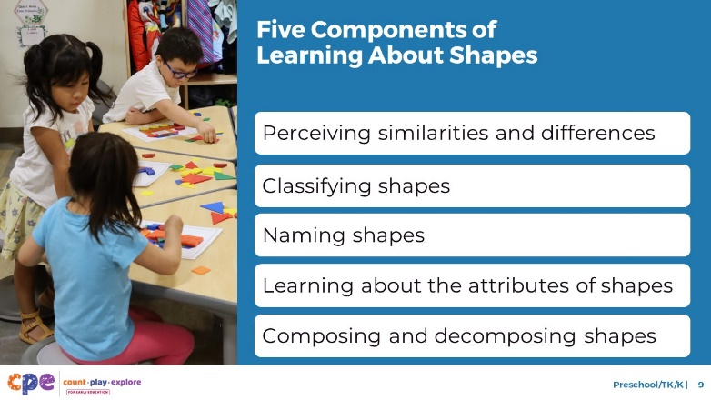

Talking Points
- There are five components of learning about shapes in early childhood:
  - Perceiving similarities and differences
  - Classifying shapes
  - Naming shapes
  - Learning about the attributes of shapes
  - Composing and decomposing shapes
- In this session, we will focus on the concepts most relevant for children in preschool, TK, and K. These concepts include classifying shapes, learning about shape attributes, naming shapes, and composing and decomposing shapes.

SLIDE 10: Classifying Shapes

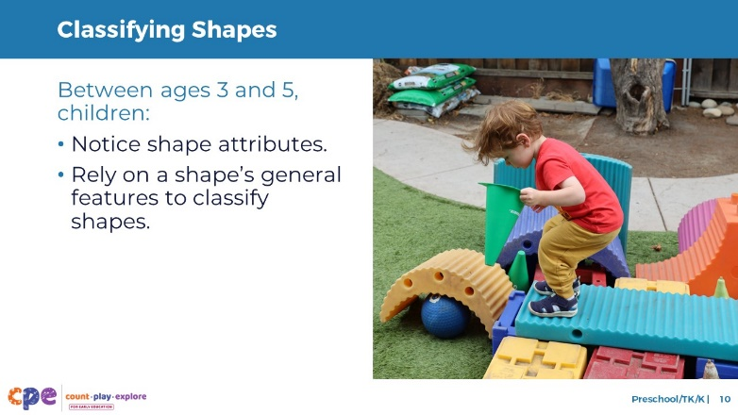

Talking Points
- During infancy and toddlerhood, children develop the ability to perceive similarities and differences between objects. They also begin to match and classify a variety of shapes.
- When infants and toddlers classify shapes, they tend to focus on a shape’s general features. For example, they may notice if a shape is “round” or “pointy.”
- Children’s strategies for classifying shapes change over time. Starting at around age three and continuing into kindergarten, children begin to pay attention to a shape’s attributes. For example, they may notice how many sides a shape has.
- However, they do not use their understanding of a shape’s attributes consistently to classify shapes. Most preschoolers continue to rely on a shape’s general features when classifying shapes. For this reason, children’s familiarity with a shape and how much experience they have with it can impact their ability to classify shapes.
- Let’s explore this idea more in the next few slides.

SLIDE 11: Classifying Shapes: Is it a triangle?
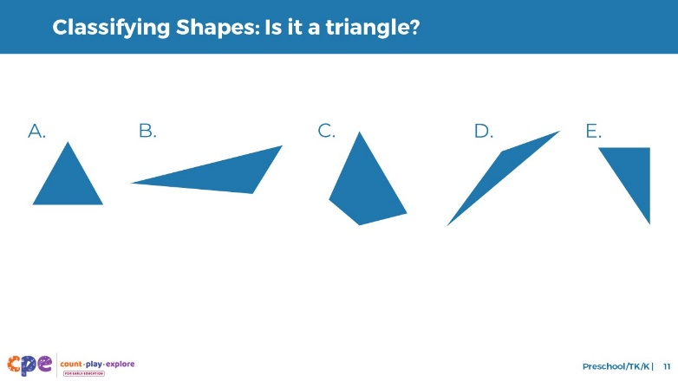
Time: 7–10 minutes

Talking Points
- Observe these five shapes. With the person next to you, identify whether each shape is a triangle. Then, explain why it is or isn’t a triangle.
- [Offer five to seven minutes for participants to discuss the shapes and why the shapes are or are not triangles.]
- [Select participants to share their answers. After participants describe each of the shapes, use the following talking points to debrief.]
- During this activity, you might have noticed that triangles can have a lot of variation. The sides of the triangles can be different lengths. Triangles can have different angles, and triangles can be oriented in different ways. For example:
  - A point might be on the bottom or at the top.
  - You also might have noticed that one shape looked similar to a triangle but was not a triangle.
- When you explained why something was or was not a triangle, you described the number of sides or corners the shape had. [Make connections to specific answers from participants.]
- Let’s think about how children in preschool, TK, and K might classify these shapes.

Facilitator Notes
- Adjust the way you facilitate this activity based on group size, session length and format, and participants’ needs.
  - For smaller groups, you might invite participants to share their answers and thinking with the whole group.
  - For larger groups, consider offering time for participants to share their observations in pairs or at their tables. Then, invite each pair or table to share their answer for one of the triangles with the whole group.
- Answer key:
  - Shapes A, B, D, and E are all triangles because they have three sides and three corners.
  - Shape C is not a triangle because it has four sides and four corners.

SLIDE 12: Classifying Shapes: Typical and Atypical Shapes

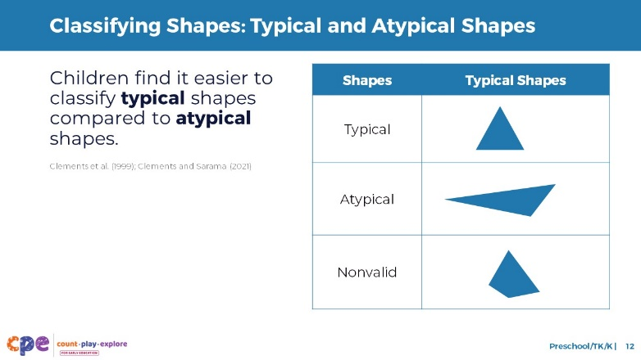

Talking Points
- Between the ages of three and five, children are likely to continue to use a shape’s general features to classify it.
- Preschoolers find it easier to classify typical shapes (Clements et al., 1999; Clements and Sarama, 2021).
  - Children observe typical shapes in their everyday environments. [Point to the typical triangle on the slide.] An example of a typical shape is an equilateral triangle, which has three sides of the same length. Most children’s books or toys show typical versions of shapes.
  - Children are much less likely to experience atypical shapes. [Point to the atypical triangle on the slide.] An example of an atypical triangle is a scalene triangle or a triangle with a point facing downward. We call these atypical shapes because children do not observe these versions frequently.
- As mentioned earlier, preschoolers tend to focus on general features of shapes. This focus means that preschoolers may incorrectly classify nonvalid shapes like this one. [Point to the nonvalid triangle on the slide.] An example of a nonvalid triangle is a shape that looks like a triangle—for example, by having a point at the top—but has more than three sides.
  - When children encounter a nonvalid triangle, they might notice that the shape has a point at the top and conclude that it is a triangle. However, they may not notice that the shape has four sides.
- By the time children enter kindergarten, they become more familiar with a shape’s attributes and will use this information more consistently when classifying shapes.
- Next, we will discuss what children in preschool, TK, and K learn about shape attributes. We will also explore how this knowledge helps with their classification.

SLIDE 13: Learning About Shape Attributes

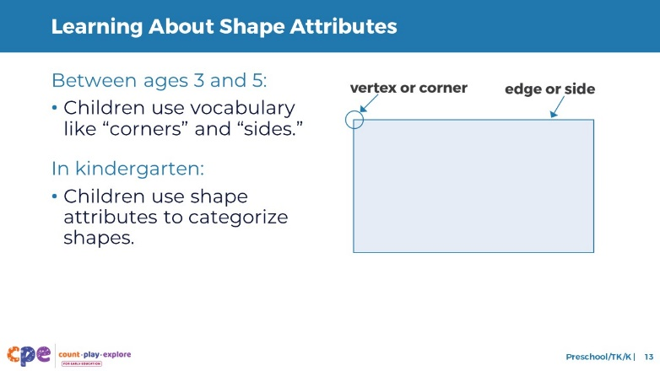

Talking Points
- Between ages three and five, children begin to use vocabulary such as “corners” or “sides” to describe shape attributes. When prompted, they might count a shape’s corners and sides.
- Over time, children learn that noticing attributes is the most accurate way to identify and classify shapes. By kindergarten, they use attributes more consistently to classify shapes.
- Kindergartners also use their understanding of attributes to communicate about a shape’s similarities and differences. For example:
  - They might explain that triangles are different from squares because triangles have three corners and squares have four corners.

SLIDE 14: Naming Two-Dimensional Shapes

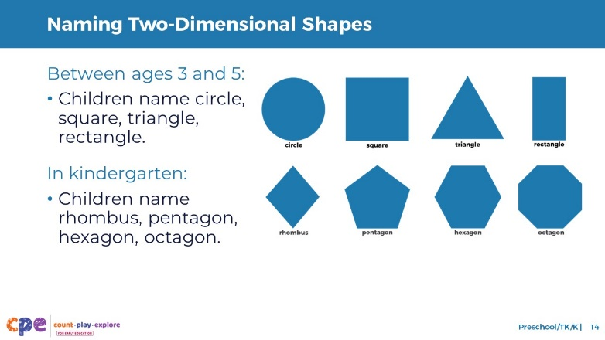

Talking Points
- Between ages three and five, children expand their shape vocabulary. They know shape names such as circle, square, triangle, and rectangle. They may even learn the names of more complex two-dimensional shapes such as rhombus or trapezoid.
- In kindergarten, children may learn the names of shapes such as rhombus, pentagon, hexagon, and octagon.

Facilitator Notes
- For more information about common two- and three-dimensional shapes and their names, review slide 16 and 18 of PPT 1 “Introduction to Geometry: Birth–8 Years.”

SLIDE 15: Naming Three-Dimensional Shapes

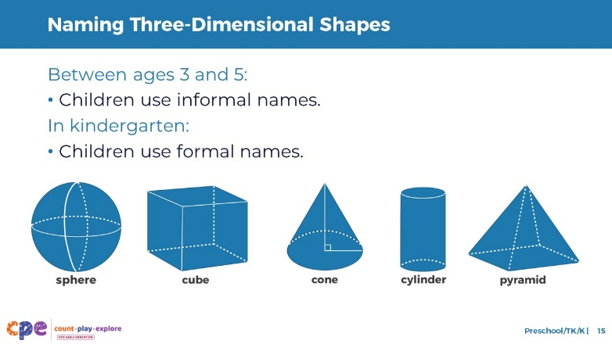

Talking Points
- Children in preschool and TK also begin to identify three-dimensional shapes such as spheres, cubes, and cones. Many children continue to use informal names like “ball” for a sphere or “box” for a cube. Children use these informal names because adults often use them to describe three-dimensional objects, and these names make the most sense in many contexts. For example:
  - When playing basketball, children are more likely to communicate “throw the ball” than “throw the sphere.”
- Kindergartners may begin to use or understand formal names for a wider variety of three-dimensional shapes such as cylinders or pyramids.
- It is important for children to develop an understanding of and use formal shape vocabulary in early elementary school. However, in preschool, TK, and K, it is appropriate for children to continue to use informal names for three-dimensional shapes.

SLIDE 16: Composing and Decomposing Shapes
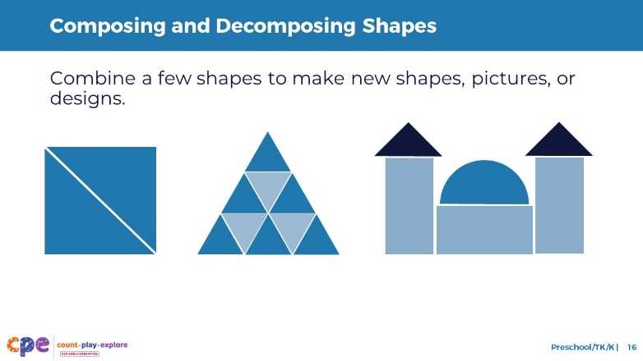
Time: 7–10 minutes

Talking Points
- Composing and decomposing shapes is the ability to combine or take apart shapes to create new shapes, pictures, or designs.
- Between ages three and five, children begin to explore composing and decomposing shapes when building or making art. For example:
  - When building, children might combine two triangles to make a square. Or they might cut paper shapes like a circle into two semi-circles.
- By kindergarten, children combine shapes to create simple pictures. For example:
  - They might put a triangle on top of a square to make a house.
- Children’s composition and decomposition skills in preschool, TK, and K build the foundation for understanding shape partitioning—or how shapes can be divided—in early elementary school.
- In table groups, take a moment to reflect on the ways children in your setting already explore composing and decomposing shapes. What types of materials do children use when composing and decomposing shapes?
- [Provide participants with five to seven minutes to discuss ideas in their table groups.]

Facilitator Notes
- For longer sessions, consider offering some time for hands-on exploration of composing and decomposing shapes. Provide participants with blocks, tangrams, or shape cutouts. Invite participants to compose new shapes, pictures, or designs. For example, you might challenge them to make an animal using tangrams or a bridge with blocks.

SLIDE 17: Observe: Learning About Shapes
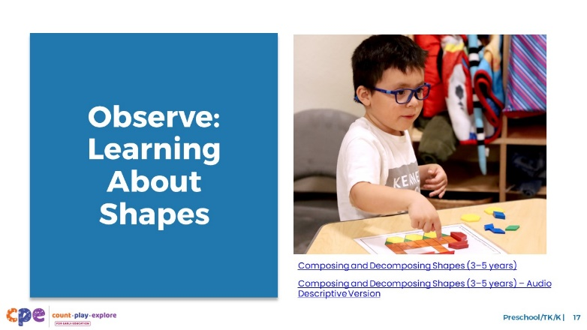
Time: 10–20 minutes (including debrief)
Materials: Preschool, TK, or K shape video [before your session, select a video to show]

Talking Points
- Now we will observe a video. As you observe the video, think about ways children are showing that they are:
  - Classifying shapes
  - Learning about the attributes of shapes
  - Naming shapes
  - Composing and decomposing shapes
- Consider how the interests, cultures and lived experiences, languages, abilities, and emerging skills of the children in this video might have affected how they learned about and explored shapes.
- You might record your observations. After the video, we will discuss what you noticed.
Facilitator Notes
- Choose a video that shows children learning about shapes.
- We provide the following videos (you may use other videos):
  - Naming Three-Dimensional Shapes (3–5 years)
  - Naming Three-Dimensional Shapes (3–5 years) – Audio Descriptive Version
  - Composing and Decomposing Shapes (3–5 years)
  - Composing and Decomposing Shapes (3–5 years) – Audio Descriptive Version
- Note: Discussion points are provided for the videos in the Facilitator Notes on the next slide.
- If a component is not observed in the video, you might invite participants to:
  - Think about ways that children might develop knowledge and skills related to that component
  - Explain how educators might support children to develop the knowledge and skills related to that component
- Consider playing the video more than once. The first time, invite the participants to just become familiar with the video. Then, invite the participants to observe specific ways children show their understanding of the components of shape learning.

SLIDE 18: Discuss: Learning About Shapes
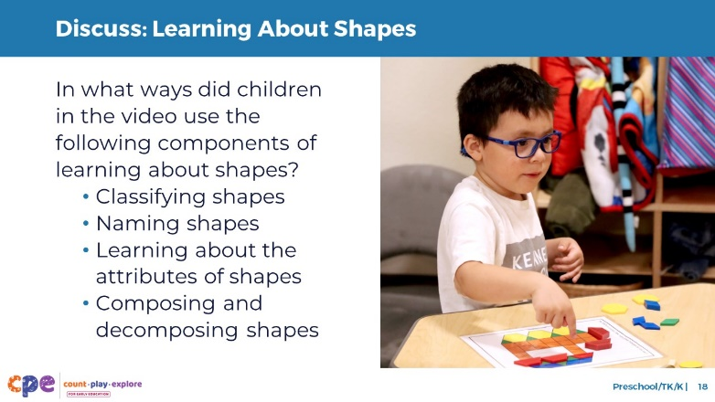
Time: 10–20 minutes (including the video observation on the previous slide)

Talking Points
- Let’s discuss what you noticed.
- In what ways did children in the video demonstrate that they were:
  - Classifying shapes
  - Learning about the attributes of shapes
  - Naming shapes
  - Composing and decomposing shapes

Facilitator Notes
- Adjust the debrief based on your group size, session length and format, and participant needs. Consider charting participants’ observations to visually provide ways children develop an understanding of shapes.
- Consider using the following adaptations based on session length:
  - For shorter sessions, invite participants to share, with the large group, what they noticed about ways children in preschool, TK, and K showed their understanding of shapes.
  - For longer sessions, offer time for participants to share their observations in pairs or at their tables. Then, invite each table to share their observations.
- Here are some examples of how children in the video “Naming Three-Dimensional Shapes” classified shapes and named shapes:
  - Classifying shapes: As they were learning the names of the three-dimensional shapes, some children used the names or made comparisons to similar two-dimensional shapes. For example, one child said “square” instead of “cube.” One child also noticed how the sphere looked like a scoop of ice cream. These observations allowed children to classify these shapes and learn what makes three-dimensional shapes different from two-dimensional shapes.
  - Naming shapes: Children repeated the names of three-dimensional shapes after the educator introduced them, such as sphere, cube, pyramid, and cone. Children then named the correct shape that was missing when they played their game.
- Here are some examples of how children in the video “Composing and Decomposing Shapes” named shapes, and composed and decomposed shapes:
  - Naming shapes: Children were naming some of the shapes as they were looking for them. One child said, “I need three orange squares.”
  - Composing and decomposing shapes: Through the activity, children were composing pictures out of shapes.

SLIDE 19: Supporting Shape Learning

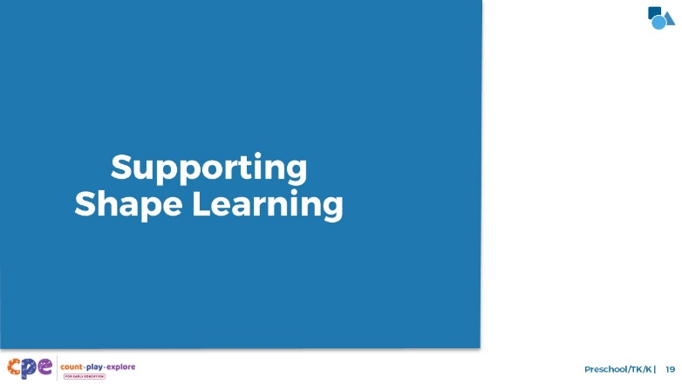

Talking Points
- We explored five components of shape learning. We also observed some ways children in preschool, TK, and K classify shapes, learn about shape attributes, name shapes, and compose and decompose shapes. Now, let’s discuss ways we can support children to learn about shapes—in our learning settings and at home.
- Historically, inequities in our educational system have impacted Children of Color, multilingual learners, and children with disabilities. For example, Children of Color, multilingual learners, and children with disabilities have had unequal access to rigorous learning opportunities. We must work to ensure that every child—of any background, race, culture, ethnicity, language, gender, ability, or socioeconomic status—has equitable opportunities to engage in high-quality geometry learning environments and experiences.

SLIDE 20: Explore: M⁵ Early Math Approach
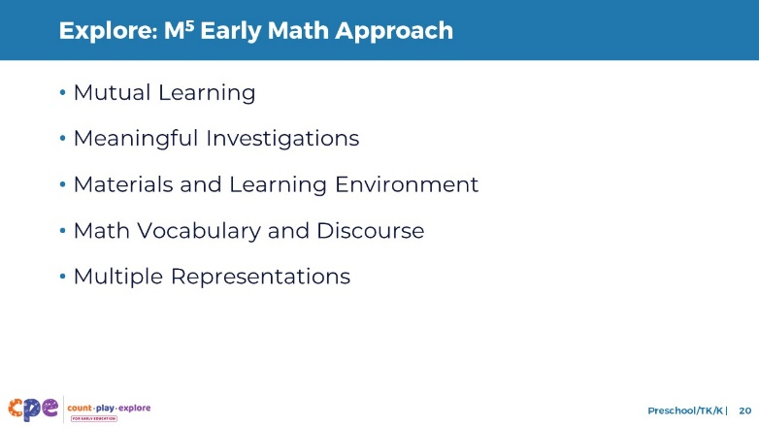
Time: 15 minutes
Materials: M⁵ Overview handout

Talking Points
- Count Play Explore often uses the M⁵ (pronounced: M to the fifth) Early Math Approach to refer to five core early math teaching practices:
  - Mutual Learning
  - Meaningful Investigations
  - Materials and Learning Environment
  - Math Vocabulary and Discourse
  - Multiple Representations
- Let’s explore the M⁵ practices. Then, we will observe M⁵ in action.

Facilitator Notes
- Consider your participants and their prior experiences with M⁵.
  - For groups that have significant experience with M⁵, you might offer a few minutes for participants to share with a partner their areas of strength and what practices they are working on. Or you might use this slide to briefly revisit the M⁵ practices and move to the next slide.
  - For groups that have less experience with M⁵, you might offer more time for participants to explore each practice. For example, you might allow time for them to review the practices in the handout on their own. Invite them to make or imagine a square over practices that they have “squared away” (practices they understand and use), a circle over “what’s still going around in their heads” (practices they still have questions about), and a triangle over three ideas that they will use in their settings. For more ideas on how to provide a more comprehensive review, visit the M⁵ Early Math Approach suite of resources.

SLIDE 21: Observe: M⁵ in Action
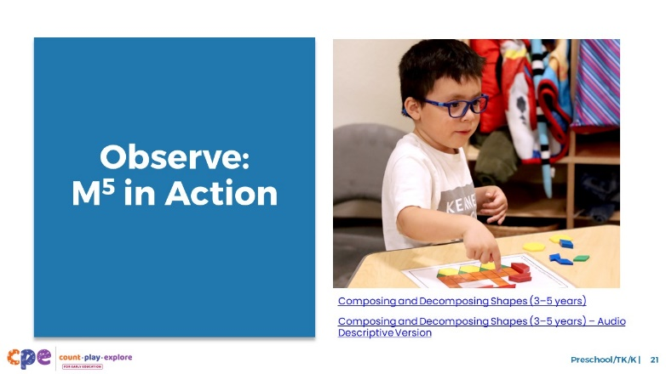
Time: 5–7 minutes (not including debrief)
Materials: Observing M⁵ in Action: Shapes handout; preschool, TK, or K shapes video; chart paper; markers

Talking Points
- We observed how young children learn about shapes. Then, we explored the M⁵ Early Math Approach. Now, we are going to observe a video showing M⁵ practices that support children’s shape learning. [Choose a strategy for facilitating this observation and debrief. Adapt the talking points to reflect this strategy.]

Facilitator Notes
- Choose a preschool, TK, or K video that shows children exploring shapes. This video may be the same one you used for observing children learning about shapes.
- We provide the following videos (you may use other videos):
  - Composing and Decomposing Shapes (3–5 years)
  - Composing and Decomposing Shapes (3–5 years) – Audio Descriptive Version
  - Naming Three-Dimensional Shapes (3–5 years)
  - Naming Three-Dimensional Shapes (3–5 years) – Audio Descriptive Version
  - Note: An answer key is provided for the video “Composing and Decomposing Shapes (3–5 years)” in the Facilitator Notes on the next slide.
- Invite participants to take out the Observing M⁵ in Action: Shapes handout.
- For larger groups and longer sessions, use a jigsaw approach. Before playing the video, assign each table one practice to focus on during the video. [If there are more than five tables, assign more than one table to focus on each practice.]
- For smaller groups and shorter sessions, consider showing the video two to three times, inviting participants to focus on specific practices each time. Encourage them to record observations on the handout.

SLIDE 22: Discuss: M⁵ in Action
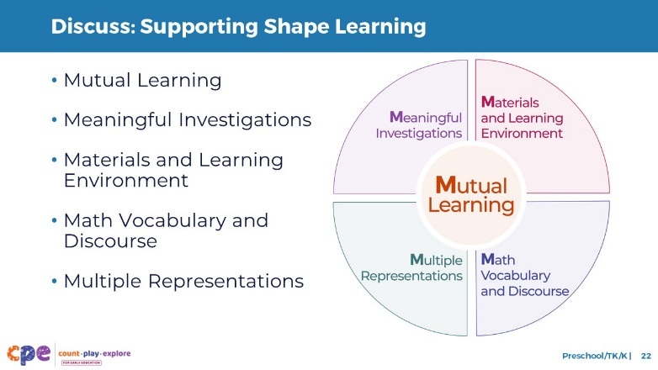
Time: 20–30 minutes (varies based on session goals)
Materials: Observing M⁵ in Action: Shapes handout; preschool, TK, or K shapes video; chart paper; markers

Talking Points
- Let’s unpack your observations of each M⁵ practice. How did the educator use M⁵ to support children’s learning about shapes?

Facilitator Notes
- Use the Answer Key for Observing M⁵ in Action: Shapes handout for examples of ways M⁵ was used in the video “Composing and Decomposing Shapes (3–5 years).”
- For larger groups or longer sessions: After observing the video, ask each table to discuss what they noticed about their assigned practice. Then, invite each table to share their observations with the larger group. As each table shares, paraphrase, affirm, and add to their responses as needed. Consider charting each table’s observations to make practices visible.
- For smaller groups or shorter sessions: Invite participants to share their observations with the whole group. Chart their observations to make the practices visible. As participants share, paraphrase, affirm, and add to their responses as needed. Consider inviting participants to share something they learned with someone from another table. For example, you might ask them to find someone with similar shoes, move to meet them, and share something they learned with that person.

SLIDE 23: Explore: Using M⁵ to Support Learning About Shapes
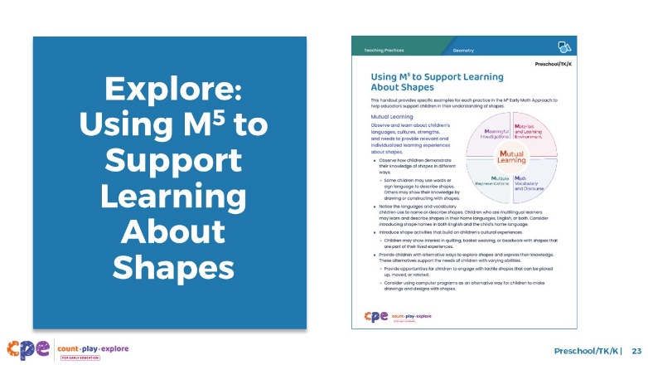
Time: 15–30 minutes (including debrief on the next slide)
Materials: Using M⁵ to Support Learning About Shapes handout, chart paper, markers

Talking Points
- We have discussed the M⁵ Early Math Approach and observed some ways the practices might be used to support children’s geometry learning. Let’s consider other ways for using M⁵ to support children’s learning about shapes.
- Take out Using M⁵ to Support Learning About Shapes. Review the ideas on how to use M⁵ to support children’s geometry learning.

Facilitator Notes
- Provide five to seven minutes for participants to review the handout.
- While participants review the handout, post one chart for each of the five M⁵ Early Math practices around the room. Label them with the following headers: Mutual Learning, Meaningful Investigations, Materials and Learning Environment, Math Vocabulary and Discourse, Multiple Representations. Divide each chart into two columns. Label one column “Preschool/TK” and the other “K.” For larger groups, create and post more than one chart per M⁵ practice. Leave markers near each chart. Use talking points and facilitator notes on the next slide to guide the debrief.

SLIDE 24: Discuss: Using M⁵ to Support Learning About Shapes
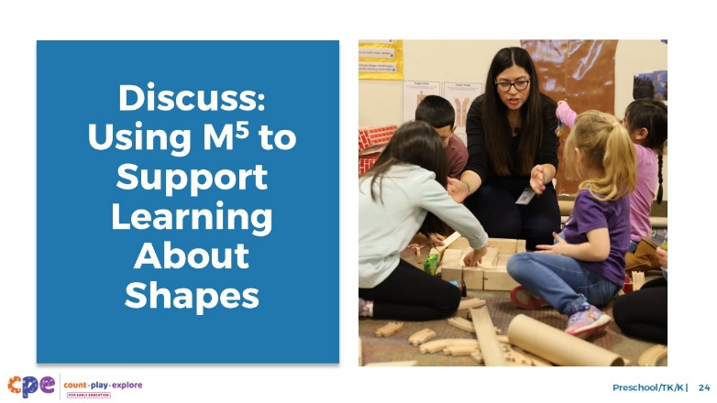
Time: 15–30 minutes (including review of the handout on the previous slide)
Materials: Using M⁵ to Support Learning About Shapes handout; chart paper; markers

Talking Points
- You reviewed some ideas on ways to support children’s shape learning using the M⁵ Early Math Approach. Next, let’s reflect on ways we can continue to support children’s shape learning. We might think about strategies we already use as well as strategies that we want to try.
  - We will form small groups that will travel from chart to chart together. [Provide directions on how to form groups. The facilitator notes offer some suggestions.]
  - When you arrive at the chart, identify and chart something you would like to try. For example, on the Materials and Learning Environment chart, you might want to try using recycled materials like boxes and tubes so children can construct something with three-dimensional shapes.
  - I will signal groups when it’s time to move to the next chart. Leave the marker at the chart for the next group to use. Move clockwise to the next chart. When you arrive, review the ideas suggested by the previous groups. Identify and chart additional ideas.
  - The last group at each chart will share with the whole group two to three ideas that they found most interesting or valuable.
  - Reflect on the diversity of early learners in your setting. Consider children’s interests, languages, cultures and lived experiences, abilities, and emerging skills during the discussion.
- [After the carousel concludes:] You might share the ideas you want to try with your coach and revisit this handout as you plan learning experiences throughout the year.

Facilitator Notes
- Select a strategy for forming small groups. Some ideas include numbering off at tables, numbering off in the whole group, or moving in table groups.
- Consider modeling what to do at charts.
- When considering the time allotted for this activity, leave at least five minutes at the end for the whole group to share. The remaining time should be divided into the number of charts. For example, if you have 25 minutes total, allow 20 minutes for the main carousel and 5 minutes for the debrief. If there is one chart for each M⁵ practice, the time allotted at each chart is four minutes (20/5 = 4).
- After the carousel concludes, invite participants to return to their seats.

SLIDE 25: Explore: Activity to Learn About Shapes
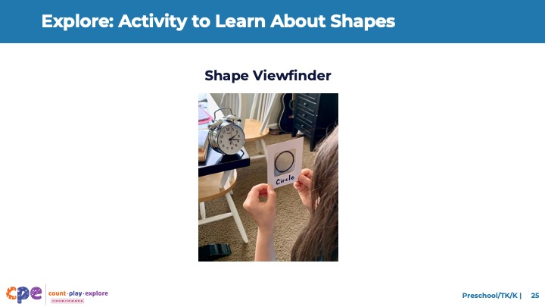
Time: 10–15 minutes
Materials: Shape Viewfinder handout

Talking Points
- We reviewed a variety of ways that you can support children’s shape learning using M⁵. Next, we will read and discuss one activity that allows children to explore and learn about shapes in playful, hands-on ways.
- Take out the Shape Viewfinder activity handout.
- This activity handout includes instructions for setting up the activity. It also includes ideas on how to support children’s learning using the M⁵ Early Math Approach.
- Read the handout with a partner. Then, discuss how you might use this activity in your settings. Consider the following questions:
  - Think about the children in your setting. In what ways might you modify this activity to respond to their languages, cultures, strengths, and needs?
  - What vocabulary might you introduce through this activity?

Facilitator Notes
- Provide 5–10 minutes for participants to read and discuss the handout with a partner.
- For longer sessions, offer time for participants to share, with their tables, how they might use the activity they reviewed.
- For longer sessions, consider offering time for participants to do the activity. Be sure to prepare and bring the necessary materials. Encourage participants to discuss what they notice as they engage in the activity.

SLIDE 26: Reflect: Learn, Wonder, Do
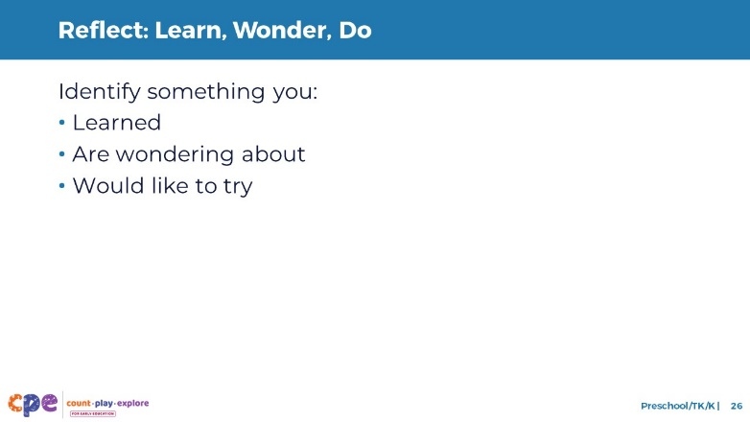
Time: 5 minutes

Talking Points
- Take a few minutes to think about our session.
- Consider the following questions:
  - What is something you learned?
  - What is a wonder you still have?
  - What is something you want to try in your learning setting?
- [Allow two to three minutes for participants to think. You might invite participants to share their reflections with a partner.]
- Thank you for your time, attention, and engagement. It’s been wonderful working with you.

Facilitator Notes
- For longer sessions, consider asking participants to share their reflections with the larger group.
- As participants discuss their reflections, note the questions that they still have and the things they would like to try. These reflections may inform the topics of future trainings, coaching, or communities of practice.

