Introduction to Geometry: Birth–8 Years (PPT 1)
Use this facilitator guide with the slides “Introduction to Geometry: Birth–8 Years.” This facilitator guide and set of slides provides an overview of the development of key concepts and skills in geometry for children from birth to eight years old. When planning a professional learning session on geometry, facilitators can use these slides as an introduction, or in combination with the age-specific slide decks. Facilitators can find talking points and guidance for activities and group discussions in this guide. The text in the guide is also located in the notes portion of the slides.

Session at-a-Glance
Slide numbers | Overview of content | Approximate time (in minutes)
1—4 | Introduction, Session Goals, and reflecting on mindsets about geometry | 5
5-9 | Exploring geometry  - Defining geometry  - Activity for adults | 30-60
10—21 | Overview of how children develop an understanding of geometry  - Perceiving similarities and differences  - Classifying shapes  - Naming shapes  - Learning about the attributes of shapes  - Composing and decomposing shapes | 25-35
The times are approximate and may vary based on session goals, group size, and participants’ previous experience and familiarity with the content.

To Prepare for Your Session
- Before your session, carefully review all handouts and prepare the necessary materials. Throughout the facilitator guide, we offer options for facilitation approaches. Select a facilitation method that works best for your session length and format, group size, and participant needs.
- Consider using photos, videos, or stories from the learning settings where educators work within this session. Making the information more personal for participants can create a greater connection to the content and foster feelings of belonging in Math.
- As you plan your professional learning session, consider the content in each of the PPTs in this suite of resources:
  - PPT 1 “Introduction to Geometry: Birth–8 Years” describes foundational information about children’s geometry learning from birth to eight years old. This introductory session also includes opportunities for participants to use geometry skills.
  - PPT 2a “Geometry: Infants and Toddlers” describes infants’ and toddlers’ early geometry learning and ideas on how to support it.
  - PPT 2b “Geometry: Preschool, Transitional Kindergarten, and Kindergarten” describes the development of geometry learning for children in preschool, TK, and K and ideas on how to support it.
  - PPT 2c “Geometry: Early Elementary” describes the development of geometry learning for children in first and second grade and ideas on how to support it.
- We encourage you to offer the content in PPT 1 before, or in combination with, content in one of the age-specific slide decks (PPT 2a, PPT 2b, or PPT 2c). Together, PPT 1 and one of the age-specific slide decks make up a three-hour professional learning session.
- You might inform participants that we will use “TK” to refer to transitional kindergarten and “K” for kindergarten.

Materials Needed
- Scratch paper, chart paper, sticky notes, and writing tools
- Pull-Up Polyhedra handout, templates, scissors, single-hole punch, and yarn or string

SLIDE 1: Introduction to Geometry: Birth–8 Years
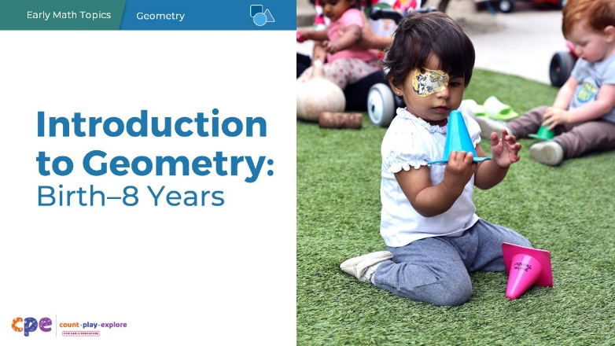
Materials (optional): Markers, sticky notes, chart paper

Talking Points
- Welcome to the wonderful world of geometry! Thank you for making time to work together today. I look forward to exploring children’s geometry learning with you!
- We will use “TK” to refer to transitional kindergarten and “K” for kindergarten.

Facilitator Notes
- Consider providing sticky notes and markers on tables. Invite participants to draw shapes (one per sticky note) until the session starts. Encourage them to draw as many different shapes as they can think of. Participants will classify them when we discuss typical and atypical shapes later in the session. (You may want to include these instructions on chart paper.) Invite individuals who may not be able to use their hands to draw to work with a partner.
- Adjust talking points to include relevant introductions, “housekeeping,” and other information that participants should know.

SLIDE 2: Acknowledgments
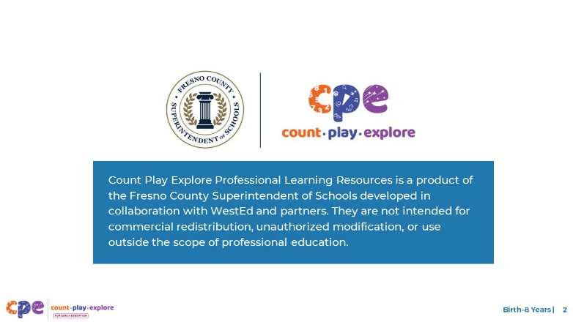

Talking Points
The Count Play Explore Professional Learning Resources were made possible by Count Play Explore, an early math, science, and computer science initiative led by the Fresno County Superintendent of Schools, Early Care and Education Department. This initiative is generously funded by the California Department of Education and the California State Board of Education. These resources, developed by WestEd in collaboration with FCSS and AIMS Center for Math and Science Education, are intended to be used as a guide for implementing evidence-based strategies, promoting active learning, and encouraging developmentally appropriate practices in early education settings. They are not intended for commercial redistribution, unauthorized modification, or use outside the scope of professional education.

SLIDE 3: Session Goals

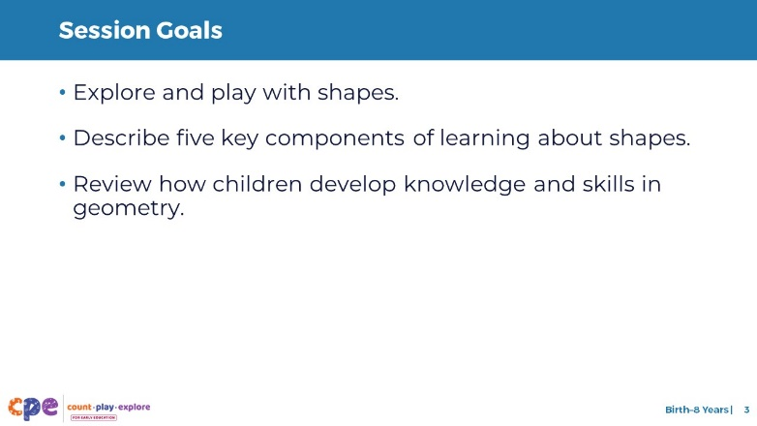

Talking Points
- In this session, we will start by exploring and playing with shapes.
- Next, we will describe five key components of learning about shapes.
- We will also review the ways children develop knowledge and skills in geometry.
- The ways we will learn together are similar to the ways children learn. We will play, observe, explore, and reflect.

Facilitator Notes
- Adjust slide content and talking points to reflect what you plan to address in this session.
- If you are planning to present PPT 2a (for infants and toddlers), PPT 2b (for preschool, TK, and K), or PPT 2c (for early elementary children) in the same session, you may want to include any adjustments in the slide content and talking points.

SLIDE 4: Reflect: Mindsets About Geometry
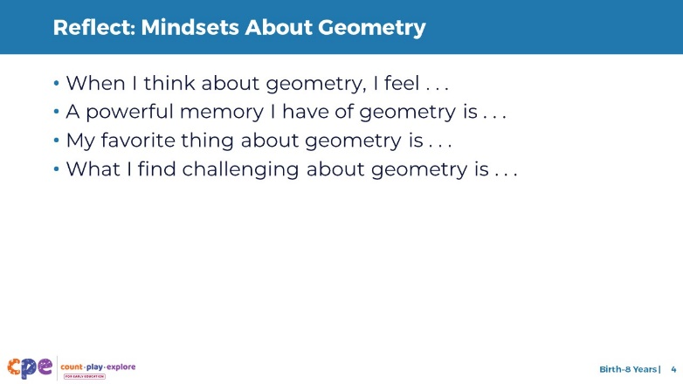
Materials (optional): Markers, sticky notes
Time: 5 minutes

Talking Points
- Each of us has thoughts and feelings—or mindsets—about geometry. We bring those mindsets to our settings. They can affect how we support children to learn geometry.
- Let’s take a moment to consider our geometry mindsets. Respond to one of the following prompts to surface your geometry mindset:
  - When I think about geometry, I feel . . .
  - A powerful memory I have of geometry is . . .
  - My favorite thing about geometry is . . .
  - What I find challenging about geometry is . . .
- Record what comes to mind on sticky notes.
- [After participants have recorded their thoughts:] This activity may have surfaced a variety of thoughts and feelings. Whatever your thoughts and feelings, I hope that engaging in today’s session will promote positive thoughts and feelings about geometry.

Facilitator Notes
- Math mindsets matter! This principle is key to the Count, Play, Explore professional learning approach. If you are interested in providing professional learning on math mindsets, consider reviewing the resources in the Math Mindsets Matter suite of resources.
- Invite participants to individually complete their reflection using one of the prompts. The goal is for them to surface their thoughts and feelings related to geometry.
- Consider your group size and dynamics. If appropriate, you might offer an opportunity for participants to share some of their thoughts. Encourage participants to reflect on what they notice about the experiences shared by others and how these experiences may impact the children and families they work with.

SLIDE 5: Geometry: An Overview

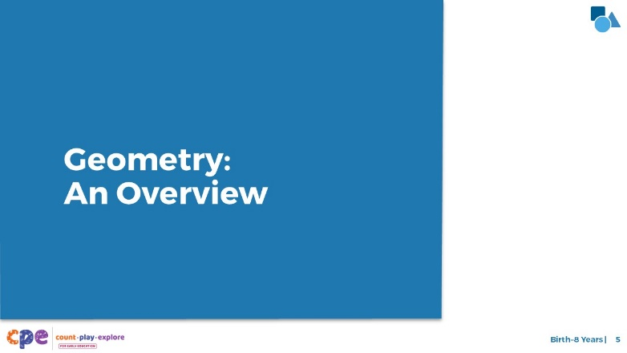

Talking Points
- Before we review what children learn about shapes, let’s begin with a shared understanding of geometry learning for young children.

SLIDE 6: Geometry Defined

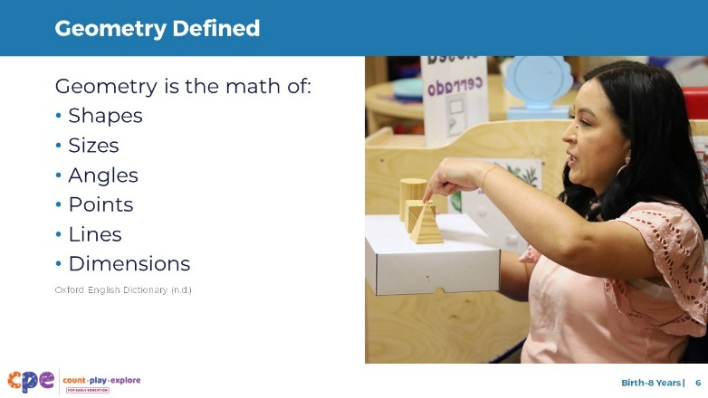

Talking Points
- Geometry is the math of shapes, sizes, angles, points, lines, and dimensions (Oxford English Dictionary, n.d.). In early childhood, most children’s geometry learning is about two-dimensional and three-dimensional shapes and sizes. Older children will focus more on concepts such as angles or lines.
- Throughout this session, we will use the word “shape” interchangeably with geometry.

SLIDE 7: Geometry Is Everywhere!

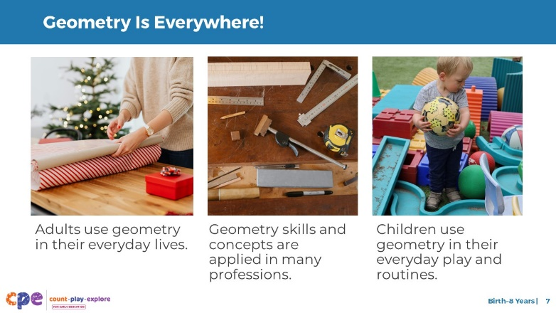

Talking Points
- Geometry plays a key role in the lives of children and adults. That is why it is important for us to help children develop their geometry understanding and skills.
- We use geometry every day. For example, we use geometry when we do the following:
  - Wrap a gift—when we wrap a gift, we must consider its shape. We also think about the dimensions of the wrapping paper needed to cover it.
  - Play sports—when we throw a ball or swing a bat, we need to consider lines and angles.
  - Cook—when creating a dish such as homemade tortillas, we need to consider symmetry and size when rolling and shaping the dough.
- Many professionals use geometry.
  - When designing spaces, architects, engineers, and designers use geometry concepts like length, angles, area, and shapes.
  - Carpenters use geometry to identify and cut angles out of wood so that pieces fit together correctly.
  - Medical professionals use geometric imaging, like an MRI, to analyze scans or make diagnoses.
- Children also use geometry in their everyday routines and interactions.
  - When children engage in art, they often use shapes as part of their creations. For example, children often draw stick figures using a circle for a head and lines for the arms and legs.
  - Children may notice and describe the shapes in their neighborhood, using English, their home language, or both. For example, a child whose home language is Spanish might notice that a house on their walk to the playground has a window that is a “círculo” (circle).
- Let’s play with some shapes now!

Facilitator Notes
- Math is everywhere! This principle is also key to the Count Play Explore approach to professional development.
- With this slide, you help participants recognize how geometry is an integral part of their lives.
- For longer sessions, after noting that geometry is part of their everyday routines, invite participants to identify how they use or observe geometry in their everyday lives. You may ask participants to describe some ways they have observed children engaging with geometry. Then, use the text on screen and the talking points to connect participants’ observations with key points.

SLIDE 8: Play: Pull-Up Polyhedra
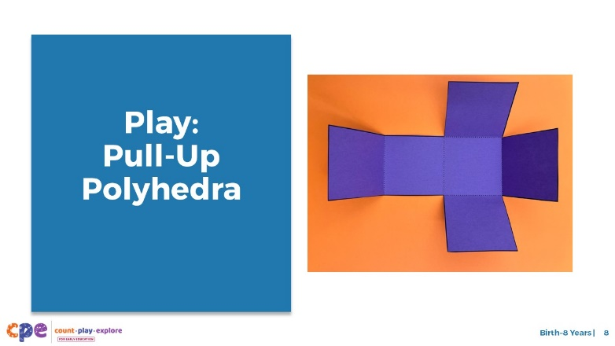
Time: 30–60 minutes (including the reflection and debrief on the next slide)
Materials: Pull-Up Polyhedra handout, templates, scissors, single-hole punch, and yarn or string

Talking Points
- Polyhedra [pronounced: pol-ee-hee-druh] are three-dimensional shapes with flat faces, straight edges, and corners. A cardboard box is an example of a polyhedron. We interact with polyhedra every day. What are some examples of polyhedra in your everyday lives?
- In this activity, we will use our knowledge of shapes to make three-dimensional shapes using shape nets. A net is what a three-dimensional shape would look like when opened and laid flat.
- Take out the Pull-Up Polyhedra handout. [Review the handout with participants and provide support as needed. As participants create their polyhedra, move around the room.]

Facilitator Notes
- Math is playful! This principle is also key to the Count Play Explore professional development approach. This activity invites adults to learn about two-dimensional and three-dimensional objects through play.
- Polyhedra [pronounced: pol-ee-hee-druh] is the plural of polyhedron [pronounced: pol-ee-hee-druhn].
- Before your session, carefully review the handout and prepare the necessary materials. Select a facilitation method that works best for your session length and format, group size, and participant needs.
- This activity has three shape nets for participants to explore. Encourage participants to start with the “Cube Net – Cross” since it provides the most scaffolding. If time allows, ask participants to explore one or both of the other shape nets (Tetrahedron Net or Cube Net – Staircase).

SLIDE 9: Discuss: Pull-Up Polyhedra
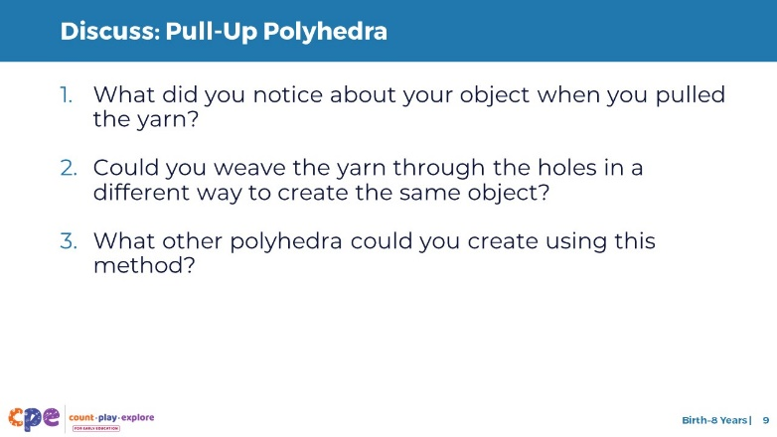
Time: 30–60 minutes (including the activity on the previous slide)
Materials: Pull-Up Polyhedra handout, templates, scissors, single-hole punch, and yarn or string

Talking Points
- Let’s take some time to discuss this activity. At your table, discuss the following questions:
  - What did you notice about your object when you pulled the yarn?
  - Could you weave the yarn through the holes in a different way to create the same object?
  - What other polyhedra could you create using this method?
- [After some time for small group discussion, invite participants to share their thoughts about this activity and geometry learning.]
- In this playful activity, we used our knowledge of shapes and spatial thinking to create polyhedra. I hope this experience helped surface positive thoughts and feelings about geometry.

Facilitator Notes
- Adjust the way participants reflect (for example, in pairs or at tables) based on your group size, session length and format, and participant needs.
- Allow time for participants to share their experiences with the whole group and summarize the purpose of this activity.

SLIDE 10: Learning About Shapes

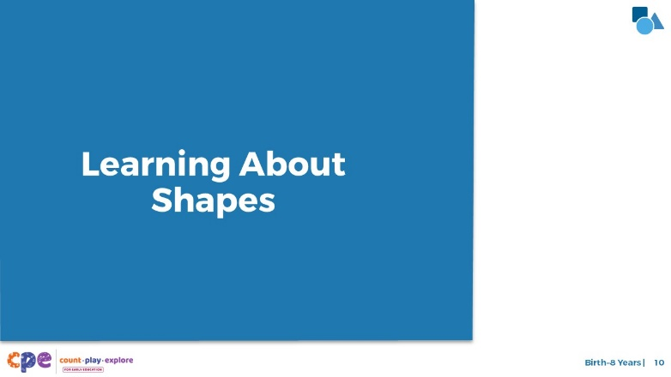

Talking Points
- In the last activity, we played with two-dimensional and three-dimensional shapes. Now, let’s discuss how young children learn about shapes.

SLIDE 11: Five Components of Learning About Shapes

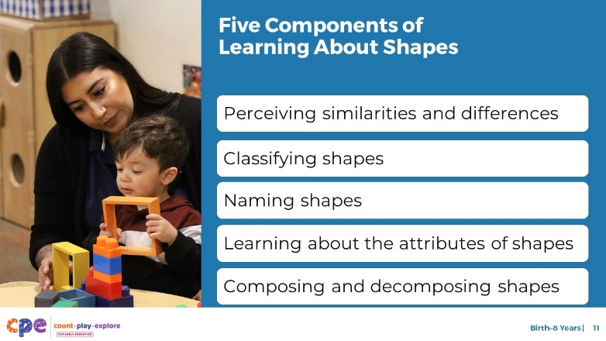

Talking Points
- In the next few slides, we will describe five important components of children’s shape learning:
  - Notice similarities and differences between two-dimensional and three-dimensional shapes in their environment
  - Classify shapes based on similarities and differences
  - Name shapes in English, their home languages, or both
  - Understand that shapes have different attributes and use these attributes to identify shapes
  - Compose and decompose shapes

Facilitator Notes
- For a more in-depth understanding of how children learn about shapes, consider reading the research brief Shapes and Spatial Reasoning: The Development of Geometry Knowledge from Infancy Through the Early School Years.

SLIDE 12: Perceiving Similarities and Differences

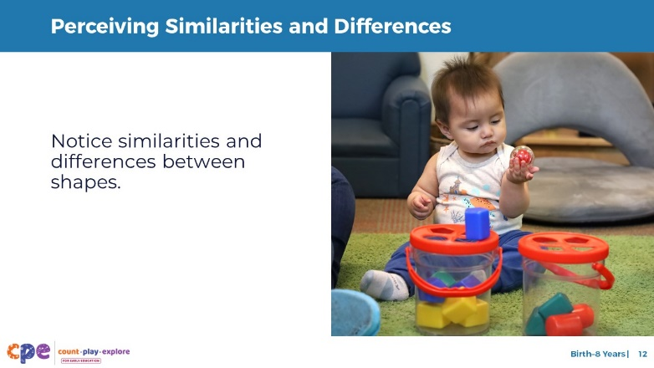

Talking Points
- Perceiving similarities and differences describes the ability to notice similarities and differences in object attributes, such as shape, size, color, and texture. Children might do this by touching, mouthing, and looking at objects.
- When children first notice similarities and differences between shapes, they can see or feel that two shapes are different. However, they do not understand how these shapes are similar or different. Children develop a deeper understanding of what makes shapes similar or different as they learn to classify shapes and learn about a shape’s attributes.

SLIDE 13: Classifying Shapes

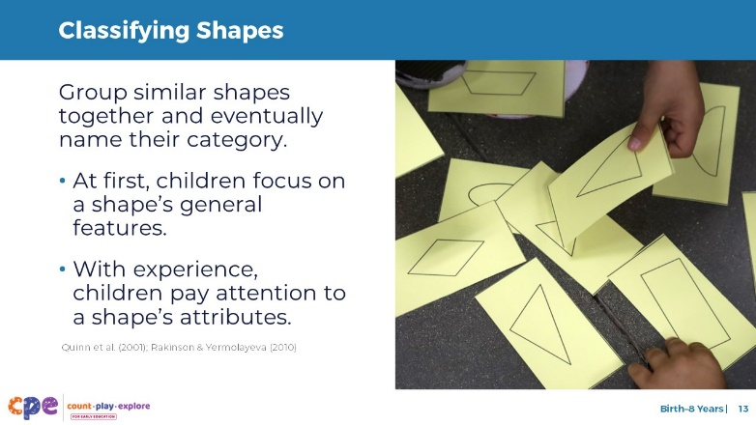

Talking Points
- Classifying shapes is grouping shapes together based on similarities.
- Once children notice how objects are similar and different, they naturally begin to group similar objects into categories.
- From research, we know that in their first year, infants form categories for many different types of familiar objects (Quinn et al., 2001; Rakinson & Yermolayeva, 2010). These categories range from furniture to animals and basic shapes like circles and squares.
- As children are exposed to more objects, they classify objects more precisely. For shapes, they group similar shapes together more accurately (for example, many different types of triangles). They also know when something belongs to a different shape category (for example, a trapezoid is different from a square).
- Children’s strategies for classifying shapes change over time:
  - When children first begin to classify shapes, they tend to focus on a shape’s general features. For example, they focus on how “round” or “pointy” a shape is.
  - When older children classify shapes, they also pay attention to a shape’s attributes. For example, they notice how many sides a shape has.
- Some shape classifications are easier for children than other classifications. Let’s discuss this in more detail.

SLIDE 14: Classifying Shapes: Variations in Shapes
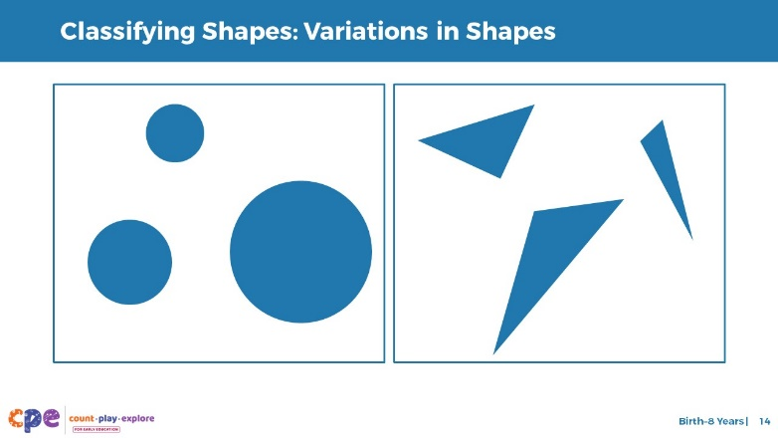

Talking Points
- The focus on general features, such as “round” or “pointy,” makes some shapes easier to classify than others:
  - For example, when children observe three differently sized circles—like the ones on this slide—they easily recognize that all three circles are part of the same group. Although each circle is a different size, in all other ways these three shapes are the same.
  - Imagine children observing the three triangles on the slide. It will be more difficult for them to identify these shapes as part of the same shape group. All three shapes have different sides and angles. They are also oriented in different ways—sometimes a point is on the bottom, sometimes at the top.
  - Younger children can classify shapes that do not vary much, like circles or squares. Older children can more accurately classify shapes that have more variation, like triangles.

SLIDE 15: Classifying Shapes: Typical and Atypical Shapes

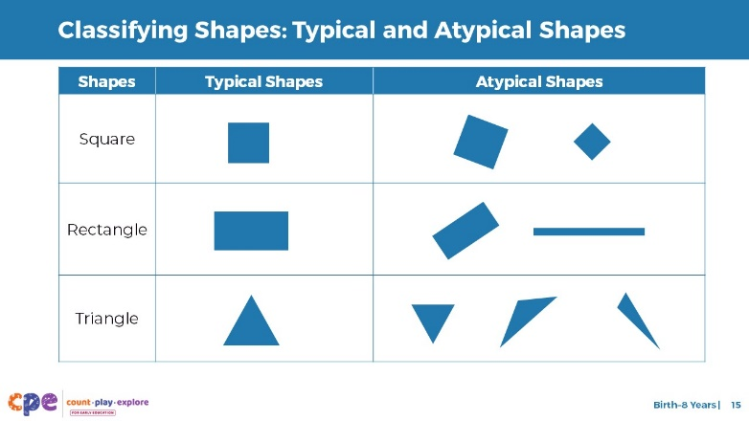

Talking Points
- Children’s exposure to different types of shapes can impact their ability to classify shapes.
- When adults draw attention to shapes in children’s environments or activities, the shapes are usually typical shapes.
  - [Point to each shape in the left column.] Squares with one side on the bottom, rectangles with one side on the bottom, and equilateral triangles are all typical shapes.
  - Most children’s books or toys show typical versions of shapes.
- Atypical shapes are much less likely to be highlighted in children’s environments or activities. Some examples of atypical shapes include a square presented with a point at the top, a long skinny rectangle, a scalene triangle, or a triangle with the point down. We call these atypical shapes because these shapes are not often highlighted in children’s books, toys, or activities.
- Because children are more familiar with typical shapes, it is easier for them to classify typical shapes.
- Young children are able to notice the differences between shapes, regardless of whether they are typical or atypical shapes. For example, they will notice that one shape is long and skinny and another has a point at the bottom. However, because young children have had less exposure to atypical versions of a shape, they are not yet accurately classifying all shapes into the correct shape category. For example, they may not think of these atypical triangles on the slide as being in the same shape category as the typical triangle. Adults play an important role in highlighting both typical and atypical shapes for children so that children can learn to classify all types of shapes accurately.
- Note: The concept of classifying is very similar to categorizing and sorting. You may notice that curricula and state standards use a mix of these terms. For this session, we will use “classifying.”

Facilitator Notes
- If participants drew shapes on sticky notes for slide 1, invite them to classify their shapes into typical and atypical shapes.

SLIDE 16: Naming Two-Dimensional Shapes

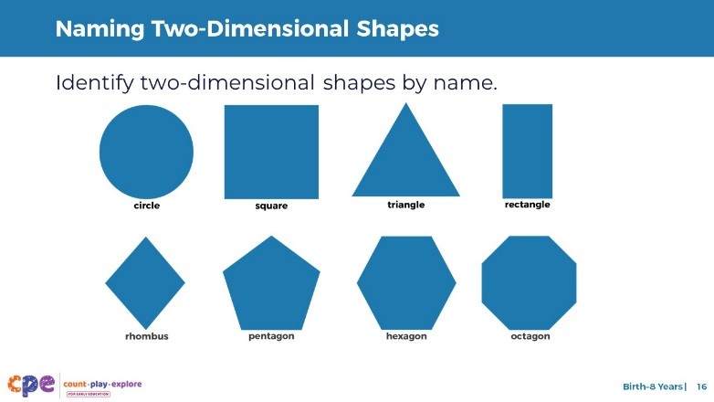

Talking Points
- Around the same time that children learn to classify shapes, they also learn to identify or name shapes in English, their home language, or both. Children tend to learn two-dimensional shape names before three-dimensional shape names.
- This slide shows some examples of two-dimensional shapes, for example, circle, square, triangle, rectangle, rhombus, pentagon, hexagon, and octagon.
- Identifying and naming are different but related skills. Identifying a shape is the ability to recognize the name of a shape, for example, by pointing to the correct shape when someone asks, “Where is the triangle?” Naming a shape is the ability to label a shape using vocabulary. Naming could be spoken, written, or signed.
- The component of naming shapes, as described here, can take different forms based on children’s preferences and abilities. Some children may demonstrate their knowledge of shape names by using vocabulary. Other children may choose to demonstrate their understanding through gestures.

SLIDE 17: Quadrilateral Shape Family
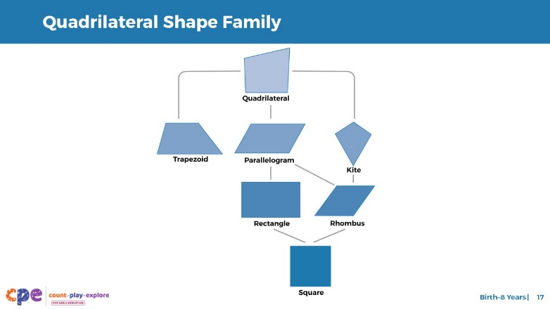
Time: 5–7 minutes

Talking Points
- Additionally, some shapes can be described as being part of a group of similar shapes.
- Observe the quadrilaterals on this slide. A quadrilateral is a shape that has four sides (or edges) and four corners (or vertices). These shapes are all examples of quadrilaterals. You may notice that these shapes not only have some things in common with each other but also have differences.
- Think about how these shapes are similar and different from one another. For each shape, consider the length of each of its sides and the angles of each corner. Develop a definition for each shape on the slide.
- [After participants develop definitions, debrief by asking participants to share their definitions. If necessary, use the answer key in the facilitator notes to ensure accuracy of definitions.]

Facilitator Notes
- Allow participants a few minutes to develop definitions independently. Then, consider one of the following ways to debrief this activity:
  - For shorter sessions: Review the correct definitions with the whole group. Invite participants to ask any questions they might have.
  - For longer sessions: Invite participants to discuss their answers with their table group. If participants drew shapes on sticky notes for slide 1, consider inviting them to reclassify their quadrilateral shapes by shape name. Then, review the correct definitions with the whole group.
- Answer key:
  - Quadrilateral: four sides and four corners
  - Trapezoid: one pair of parallel sides
  - Parallelogram: opposite sides that are parallel and two pairs of equal-length sides
    - Rectangle: a specific type of parallelogram—in addition to all the properties of a parallelogram, all its angles are 90 degrees
    - Square: a specific type of rectangle—in addition to all the properties of a rectangle, all four of its sides are equal in length
  - Kite: two pairs of equal-length sides
  - Rhombus: part of the kite and parallelogram families
    - The opposite sides are parallel, and the sides are equal in length. It also has two opposing pairs of equal angles, which means that a square is a specific type of rhombus.

SLIDE 18: Naming Three-Dimensional Shapes

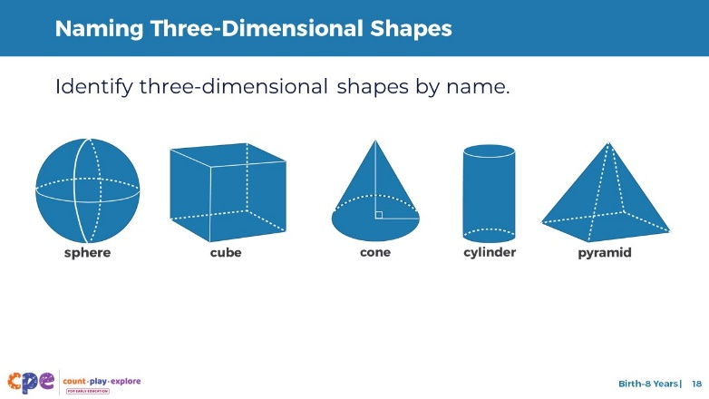

Talking Points
- This slide shows some of the most common three-dimensional shapes children learn to identify or name, including sphere, cube, cone, cylinder and pyramid.
- The vocabulary adults use to identify or name shapes affects how children identify or name them. As adults, we often use informal names to describe three-dimensional shapes, and children will often do the same. For example, adults and children may say “ball” instead of “sphere,” or “box” instead of “cube.” This is more common in some contexts than in others. For example, it would be strange to call a “ball” a “sphere” when playing soccer.
- Adults and children also often use the names of two-dimensional shapes to refer to three-dimensional shapes. For example, adults and children may say “triangle” when they mean “pyramid.”
- To encourage children to learn three-dimensional shape names, adults will need to be consistent about using this vocabulary with children.
- We’ve discussed three components of shape learning—perceiving similarities and differences, classifying shapes, and naming shapes.
  - Identify something that was new to you. Connect with someone who is not sitting at your table. When I give the signal, get up and move to that person. Share what you learned. Listen to your partner, and then move to someone else who is looking for a partner. When I give the signal, return to your table.

Facilitator Notes
- Optional activity: Ask participants to notice what two-dimensional shapes they observe in these three-dimensional shapes. For example, the cube is made of six squares.

SLIDE 19: What Are Shape Attributes?

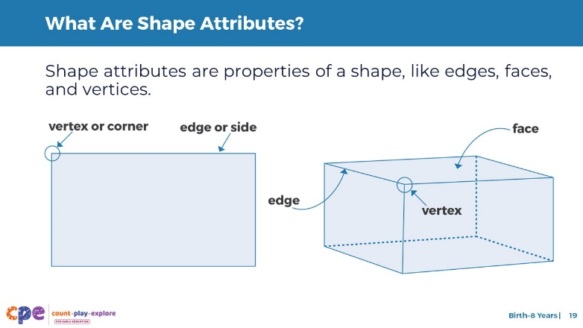

Talking Points
- When older children classify shapes, they pay attention to a shape’s attributes. Shape attributes are properties of a shape like the number of sides or corners.
- Two-dimensional shapes have two types of attributes: edges (sides of the shape) and vertices (points where two edges meet).
  - Edges and vertices are defining attributes of a two-dimensional shape. The number and types of edges and vertices determine what shape it is.
  - For example, a triangle has three edges and three vertices.
- Three-dimensional shapes have three attributes: edges, vertices, and faces.
  - Faces are the flat surfaces on a three-dimensional shape.
  - Edges, faces, and vertices are defining attributes of a three-dimensional shape. The number and types of edges, faces, and vertices determine what shape it is.
  - For example, a cube has 12 edges, 6 faces, and 8 vertices.
- The language adults use for these attributes affects children’s vocabulary. As adults, we often use informal names for these attributes, and children will often do the same. For example, many adults and children use the word “sides” to refer to “edges” and “points” or “corners” to refer to “vertices.” Consider using both informal and formal names for these attributes to help children understand that these words mean the same thing.

Facilitator Notes
- As you describe and define shape attributes, point to the slide to help make connections between vocabulary and the parts of the image.

SLIDE 20: Learning About the Attributes of Shapes

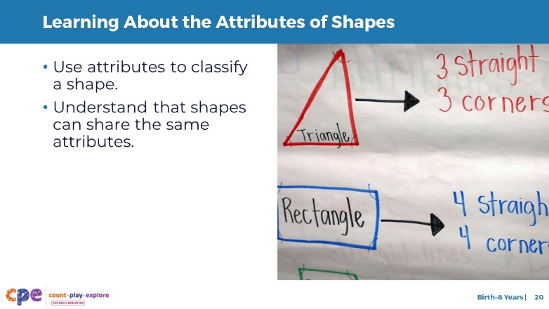

Talking Points
- Let’s explore how children use what they know about attributes to classify shapes.
- By the time children start preschool, they notice that shapes have attributes, such as “corners” or “sides.”
- Even after children first notice a shape’s attributes, they continue to use a shape’s general features to decide what shape something is.
  - For example, a child might observe a square with one point facing up and identify it as a triangle because it looks “pointy.” However, if you asked the child to count the number of sides and edges, they might realize the shape is a square.
- Over time, children learn that using attributes is the most accurate way to identify and classify shapes. Eventually, they will pay less attention to a shape’s general features and use attributes more consistently.
- As children enter elementary school, they also understand that multiple shapes can share the same attributes. For example, they realize that squares and rectangles both have four sides and are quadrilaterals.

SLIDE 21: Composing and Decomposing Shapes

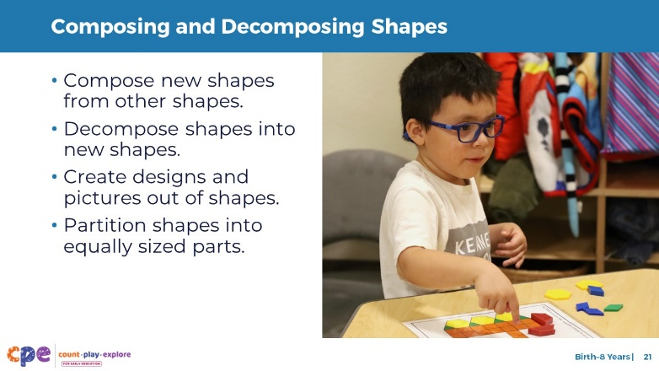

Talking Points
- As children become more familiar with shapes, they begin to explore composing and decomposing shapes. Children often do this while building structures or engaging in art with shapes.
- At first, children focus on composing and decomposing individual shapes. For example:
  - Children may put two triangles together to make a square or cut a square piece of play dough into two triangles.
- Eventually, children will make more complex pictures and designs. For example:
  - They might create an apartment building out of a long rectangular tile with small circular tiles for windows.
- This exploration of composing and decomposing shapes helps children understand that shapes can be divided into smaller parts. Knowing that shapes can be divided into smaller parts is the foundation for understanding geometric area and fractions. For example:
  - In early elementary school, children learn to divide a circle into four equal parts. They also learn to describe these equal parts using vocabulary like halves, thirds, and quarters.

SLIDE 22: Overview of Children’s Knowledge of Shapes

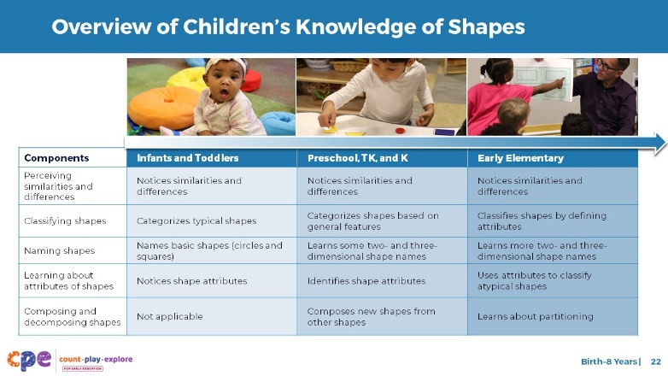

Talking Points
- We’ve discussed five components of shape learning in early childhood. Let’s take a moment to think about how children’s learning about shapes develops and becomes more complex over time.
- This slide shows you what children at three points of development know about shapes, using the five components.
  - Infants and toddlers start by noticing how objects are the same or different. With support from adults, toddlers may learn to identify or name a few common shapes.
  - Children in preschool, transitional kindergarten, and kindergarten build on these skills. They learn to classify and identify or name a greater variety of two-dimensional and three-dimensional shapes. They also learn about shape attributes.
  - In early elementary school, children continue to learn about shape attributes and how these attributes help them classify shapes. They also develop the ability to compose and decompose shapes and think about concepts like quarter, third, and half.
- [If presenting PPT 2a, PPT 2b, or PPT 2c:] We hope that you have a better understanding of the components of shape learning. Next, we will examine what [insert relevant age group: infants and toddlers; children in preschool, transitional kindergarten, and kindergarten; early elementary children] learn about shapes and ways to support their geometry learning.

Facilitator Notes
- Optional activity: Instead of using this slide, consider using the content as a puzzle activity for participants. For example, you might enlarge and print the developmental progression. Then, cut the table cells into pieces. Provide a puzzle for each table or pairs of participants. Invite participants to place the knowledge and skills in each cell under the correct age group and component.

