Geometry: Infants and Toddlers (PPT 2a)
Use this facilitator guide with the slides “Geometry: Infants and Toddlers.” This facilitator guide and set of slides provides descriptions of how infants and toddlers develop an understanding of shapes and ways educators can support them as they develop an early understanding of shapes. Facilitators can find talking points and guidance for activities and group discussions in this guide. The text in the guide is also located in the notes portion of the slides.

Session at-a-Glance
Slide numbers | Overview of content | Approximate time (in minutes)
1—4 | Introduction, session goals, and reflection activity | 15
5-15 | How children develop an understanding of shapes:  - California Infant/Toddler Learning and Development Foundations  - Perceiving similarities and differences  - Classifying shapes  - Video observation | 20-30
16—22 | How to support children in develop an understanding of shapes:  - Daily opportunities to explore shapes  - Observing and discussing M⁵ | 45-75
23 | Reflection activity | 5
The times are approximate and may vary based on session goals, group size, and participants’ previous experience and familiarity with the content.

To Prepare for Your Session
- Before your session, carefully review all handouts and prepare the necessary materials. Throughout the facilitator guide, we offer options for facilitation approaches. Select a facilitation method that works best for your session length and format, group size, and participant needs.
- Consider using photos, videos, or stories from the learning settings where educators work within this session. Making the information more personal for participants can create a greater connection to the content and foster feelings of belonging in Math.
- As you plan your professional learning session, consider the content in each of the PPTs in this suite of resources:
  - PPT 1 “Introduction to Geometry: Birth–8 Years” describes foundational information about children’s geometry learning from birth to eight years old. This introductory session also includes opportunities for participants to use geometry skills.
  - PPT 2a “Geometry: Infants and Toddlers” describes infants’ and toddlers’ early geometry learning and ideas on how to support it.
  - PPT 2b “Geometry: Preschool, Transitional Kindergarten, and Kindergarten” describes the development of geometry learning for children in preschool, TK, and K and ideas on how to support it.
  - PPT 2c “Geometry: Early Elementary” describes the development of geometry learning for children in first and second grade and ideas on how to support it.
- We encourage you to offer the content in PPT 1 before, or in combination with, content in one of the age-specific slide decks (PPT 2a, PPT 2b, or PPT 2c). Together, PPT 1 and one of the age-specific slide decks make up a three-hour professional learning session.
- You might inform participants that we will use “TK” to refer to transitional kindergarten and “K” for kindergarten.

Materials Needed
- Scratch paper, chart paper, T-Charts, and writing tools
- Daily Opportunities to Explore Shapes handout
- M⁵ Early Math Approach Overview handout
- Observing M⁵ in Action: Shapes handout, Answer Key for Observing M⁵ in Action: Shapes handout, infant or toddler shapes video clip
- Using M⁵ to Support Learning About Shapes and Space handout

SLIDE 1: Geometry: Infants and Toddlers

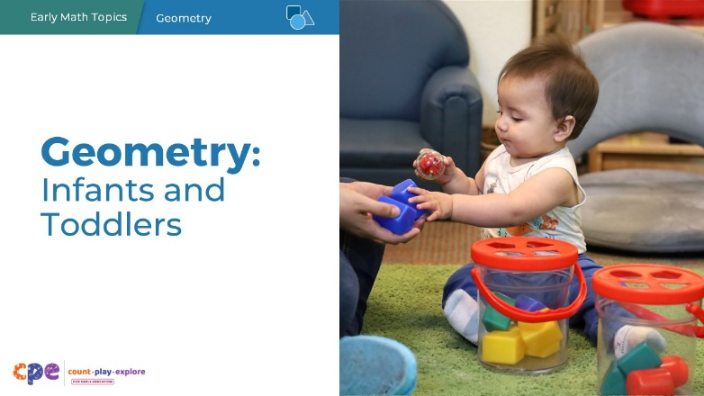

Talking Points
- In this session, we will explore how infants and toddlers learn about shapes. We will also focus on ways we can support infants and toddlers to learn about shapes.

Facilitator Notes
- Adjust talking points to reflect your session length and participant needs. If necessary, add introductory and “housekeeping” information.

SLIDE 2: Acknowledgments
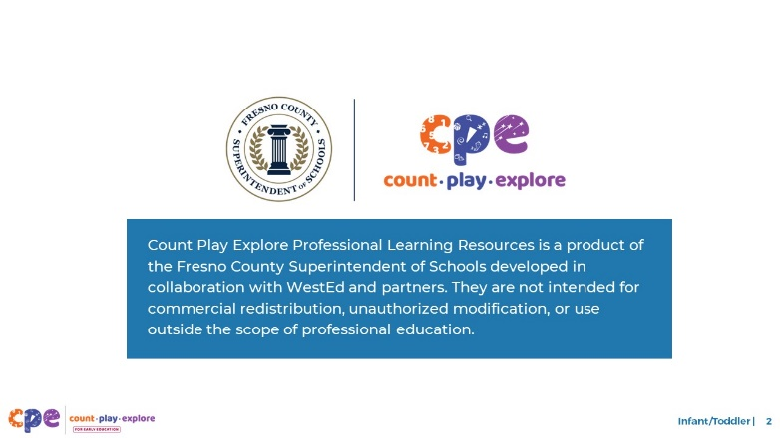

Talking Points
The Count Play Explore Professional Learning Resources were made possible by Count Play Explore, an early math, science, and computer science initiative led by the Fresno County Superintendent of Schools, Early Care and Education Department. This initiative is generously funded by the California Department of Education and the California State Board of Education. These resources, developed by WestEd in collaboration with FCSS and AIMS Center for Math and Science Education, are intended to be used as a guide for implementing evidence-based strategies, promoting active learning, and encouraging developmentally appropriate practices in early education settings. They are not intended for commercial redistribution, unauthorized modification, or use outside the scope of professional education.

SLIDE 3: Session Goals

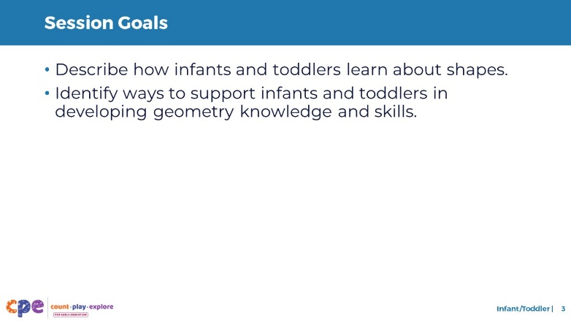

Talking Points
- First, we will review how infants and toddlers learn about shapes.
- Next, we will explore some ways that educators and families can support infants’ and toddlers’ geometry learning and development.
- Throughout our session, we will take time to reflect on our current practices. We will also think about how we might use information from this session in our work.

Facilitator Notes
- Adjust talking points to reflect your session length and participant needs.

SLIDE 4: Reflect: How Infants and Toddlers Explore Shapes
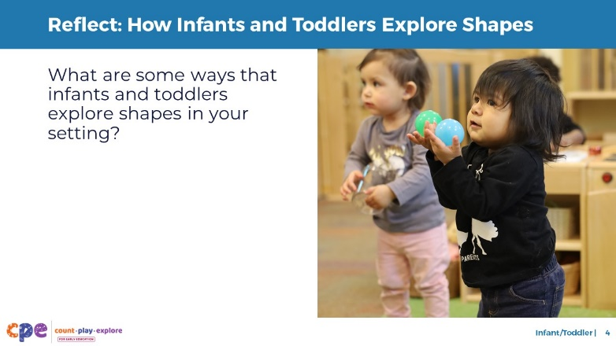
Time: 7–15 minutes (including debrief)
Materials: T-Charts with one column labeled “Infants” and one “Toddlers,” markers

Talking Points
- Infants and toddlers are exploring and learning about shapes every day.
- Take a couple minutes to think about your learning setting and some ways that infants and toddlers explore shapes.
- [Allow participants a few minutes to reflect before inviting them to share their reflections.]

Facilitator Notes
- Adjust the way you debrief participant reflections based on group size, session length and format, and participants’ needs. Charting reflections using a T-Chart will help participants connect their current practices to session content. You can use the following options for charting participant reflections:
  - Invite participants to share their reflections with the whole group. As they share, chart their reflections in the appropriate column.
  - Provide markers and chart paper to each table. Ask each table to choose a recorder and reporter. Allow time for participants to share and chart their reflections at their tables. Then, encourage the reporter from each table to share one to two reflections from their table’s chart.
- If you have not presented content from PPT 1 “Introduction to Geometry: Birth–8 Years” before engaging in this session, consider presenting the “Pull-Up Polyhedra” activity in slide 8 of PPT 1 at this point in your session. This will allow participants to engage in a playful, hands-on activity about two- and three-dimensional shapes.

SLIDE 5: Learning About Shapes

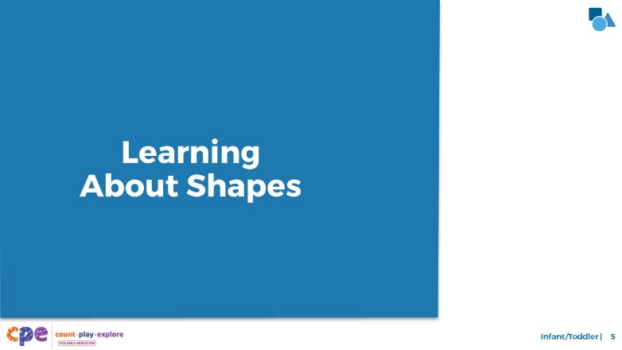

Talking Points
- The children in your settings are exploring shapes in a lot of different ways! Let’s examine what infants and toddlers learn about shapes through these explorations.

SLIDE 6: The California Infant/Toddler Learning and Development Foundations
Subtitle: Foundation: Classification

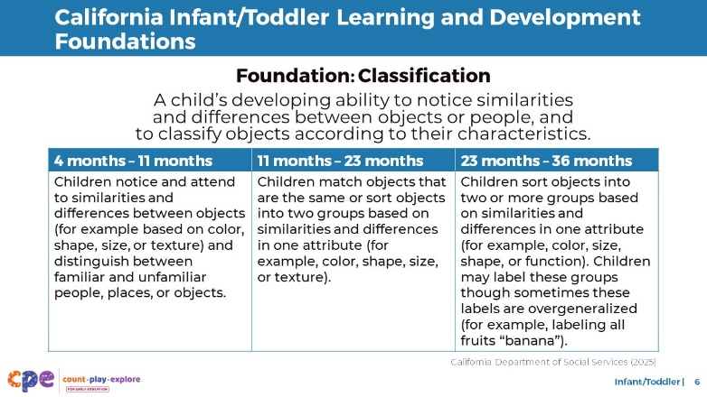

Talking Points
- Before we get started, let’s review some relevant foundations from the California Infant/Toddler Learning and Development Foundations (California Department of Social Services, 2025).
- Two relevant foundations touch on concepts related to shape learning:
  - Classification
  - Spatial Relationships
- The foundation on classification describes how children explore objects and notice similarities and differences in the attributes of these objects. Although this foundation does not specifically address shape learning, it describes more generally how infants and toddlers develop skills from our first two components:
  - Perceiving similarities and differences
  - Classifying shapes

Facilitator Notes
- Slides 6 and 7 make connections between the components and relevant foundations.
- You may want to provide participants with copies of the relevant California Infant/Toddler Learning and Development Foundations. Consider whether electronic or printed copies will be more useful for your participants.

SLIDE 7: The California Infant/Toddler Learning and Development Foundations
Subtitle: Foundation: Spatial Thinking

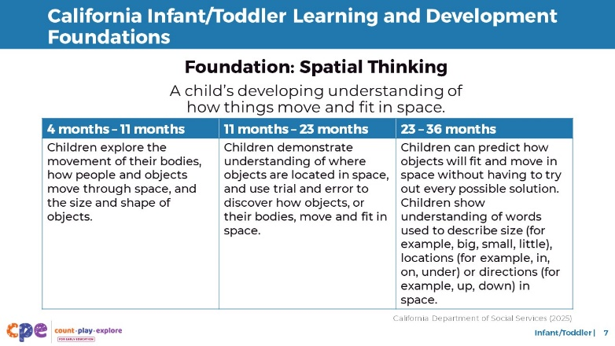

Talking Points
- Children’s understanding of spatial relationships is closely related to their understanding of shapes. As children explore object properties (like their shape), they also learn how these objects fit and move through space.
- This relationship is shown in the foundation on spatial relationships, which describes how children explore the size and shape of objects as they move through space.

SLIDE 8: Five Components of Learning About Shapes

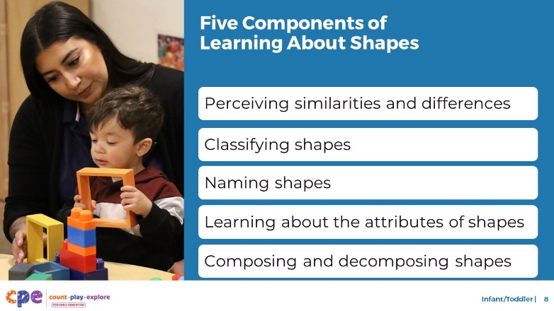

Talking Points
- There are five components of learning about shapes in early childhood:
  - Perceiving similarities and differences
  - Classifying shapes
  - Naming shapes
  - Learning about the attributes of shapes
  - Composing and decomposing shapes
- In this session, we focus on the concepts most relevant for infants and toddlers. For infants we will discuss two components: perceiving similarities and differences and classifying shapes. For toddlers, we will discuss the first four components: perceiving similarities and differences, classifying shapes, naming shapes, and noticing shape attributes.

SLIDE 9: Perceiving Similarities and Differences

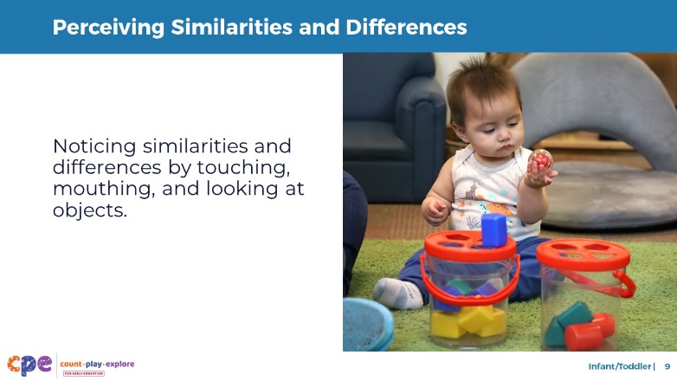

Talking Points
- From a very young age, infants explore objects and notice—or perceive—similarities and differences between objects.
  - By touching, mouthing, and looking at objects, very young infants learn that objects can have different properties, including shape, size, color, and texture.
  - Early interest in and exploration of objects’ properties help infants begin noticing similarities and differences between shapes.
- Noticing similarities or differences between shapes is natural for infants. They do this in the same way that they see or feel the differences between any two objects, like a book and a plate.
- When infants first notice similarities and differences between shapes, they can see or feel that two shapes are different. However, they do not understand how these shapes are similar or different. Toddlers develop a deeper understanding of what makes shapes similar or different as they learn to classify shapes.

Facilitator Notes
- Make connections to participants’ reflections on the ways infants in their settings explore shapes and ways infants learn to perceive similarities and differences.

SLIDE 10: Classifying Shapes: Infants

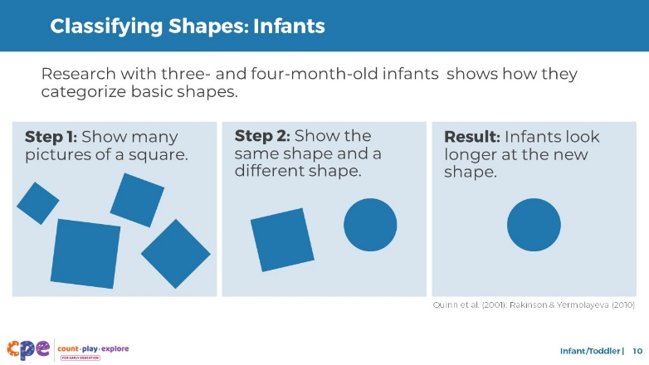

Talking Points
- Once infants notice how objects are similar and different, they naturally begin to group similar objects into categories.
- From research, we know that in their first year, infants form categories for many different types of familiar objects (Quinn et al., 2001; Rakinson & Yermolayeva, 2010). These categories range from furniture to animals and basic shapes like circles and squares.
- Research has found that three- and four-month-olds can classify a few basic shapes like circles and squares (Quinn et al., 2001).
  - In one study, young infants were presented with many types of the same shape. For example, they were shown different squares. [Point to step 1 on the slide.] Then, infants were shown a new picture of the same shape (a new square) and a new picture of a different shape (a circle). [Point to step 2 on the slide.]
  - The researchers found that infants three to four months old, but not newborns, looked much longer at the new shape category (the circle) than the same shape category.
  - This finding suggests that, after only a few months of experience with shapes in their environment, infants already notice the similarities and differences between shapes. They can then use that information to group similar shapes together in a category.
- A note about the word “classifying.” The concept of classifying is very similar to that of categorizing and sorting. You may notice that curricula and state standards use a mix of these terms. For our purposes we will use “classifying.”

SLIDE 11: Classifying Shapes: Toddlers

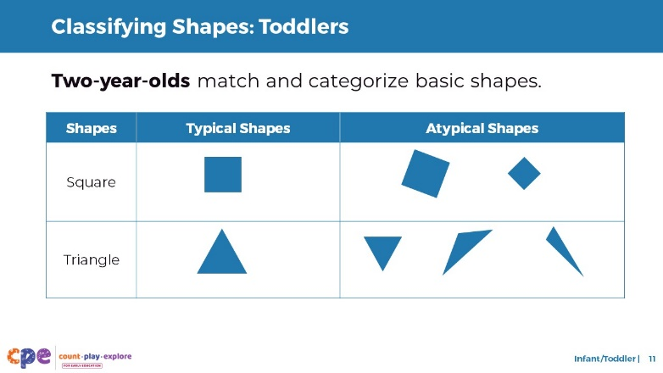

Talking Points
- The ability to classify steadily improves as infants are exposed to more shapes and develop a stronger understanding of how shapes are similar or different.
- By two years old, children can match and classify a variety of shapes. For example, when toddlers put shapes in the right holes in a shape sorter, they are showing their ability to match shapes. When toddlers choose to only play with a certain type of shape block, they are demonstrating their understanding of shape categories.
- It is easier for young children to classify typical shapes than atypical shapes. It’s also easier for them to classify shapes that don’t have many variations, like circles and squares. It’s more difficult for toddlers to classify triangles because there are many types of triangles. You may, therefore, notice that toddlers are able to classify equilateral triangles but may not classify scalene or right-angled triangles as triangles.

Facilitator Notes
- Make connections to participants’ reflections on the ways infants and toddlers in their settings explore shapes and learn to classify shapes.

SLIDE 12: Naming Shapes

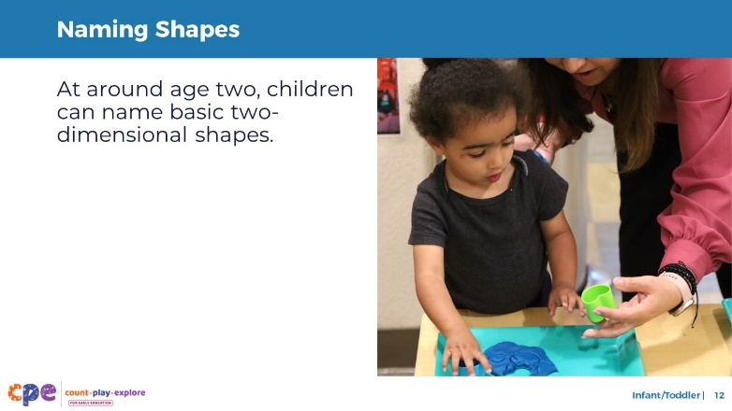

Talking Points
- As toddlers begin to perceive similarities and differences, classify shapes, and develop their language skills, they also learn to name these shape categories. Toddlers begin to name and identify basic two-dimensional shapes, like circles and squares. Sometimes, they can also name or identify triangles or rectangles.
  - When we say “identify,” we mean that children can indicate the right shape when someone else uses the shape vocabulary. For example, a child points to a square when someone asks, “Where is the square?”
- Toddlers may also begin to use informal names for three-dimensional shapes. For example, they may say “ball” for a sphere or “box” for a cube.
- Next, we will observe infants and toddlers learning about shapes.

Facilitator Notes
- Make connections to participants’ reflections on the ways infants in their settings explore shapes and ways toddlers learn to name shapes.

SLIDE 13: Noticing Shape Attributes

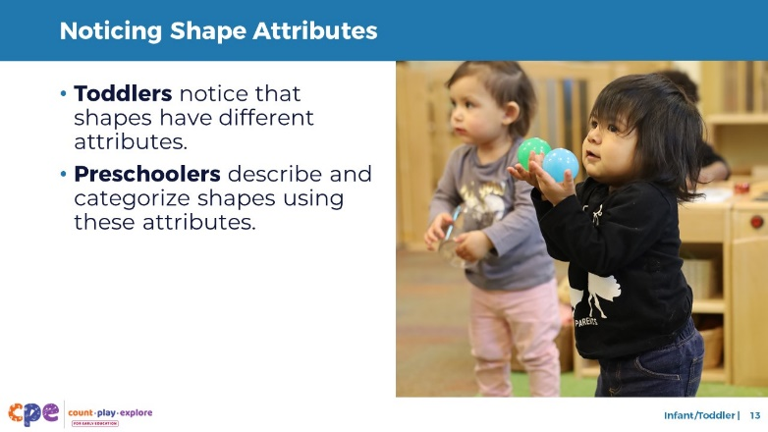

Talking Points
- As toddlers continue to perceive similarities and differences between shapes, they also notice how shapes have different attributes. Shape attributes are properties of a shape, like the number of sides or corners.
- At this age, children will notice that some shapes are round, while others have flat sides and are pointy. Infants and toddlers may pay attention to these attributes by touching the corner of a shape, for example.
- It is generally not until preschool that children will begin to use or respond to vocabulary like “corners” or “sides” to describe these attributes.
- Note: In mathematics, the formal name for “side” is “edge” and the formal name for “corner” is “vertex.” It is not until early elementary school that children would be expected to know these terms.

SLIDE 14: Observe: Learning About Shapes
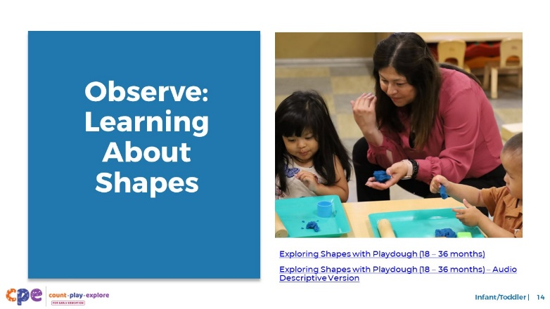
Time: 10–20 minutes (including debrief)
Materials: Infant or toddler shapes video

Talking Points
- Now we will observe a video. As you observe the video, think about ways children are showing that they are:
  - Perceiving similarities and differences
  - Naming shapes
- Consider how the interests, cultures and lived experiences, languages, abilities, and emerging skills of the children in this video might have affected how they learned about and explored shapes.
- You might record your observations. After the video, we will discuss what you noticed.

Facilitator Notes
- Choose a video that shows children learning about shapes.
- We provide the following video (you may use other videos):
  - “Exploring Shapes with Play Dough (18 – 36 months)”
  - “Exploring Shapes with Play Dough (18 – 36 months) – Audio Descriptive Version”
- Note: Discussion points are provided for this video in the Facilitator Notes on the next slide.
- If a component is not observed in the video, you might invite participants to:
  - Think about ways that children might develop knowledge and skills related to that component
  - Explain how educators might support children to develop the knowledge and skills related to that component
- Consider playing the video more than once. The first time, invite the participants to just become familiar with the video. Then, invite the participants to observe specific ways children show their understanding of the components of shape learning.

SLIDE 15: Discuss: Learning About Shapes
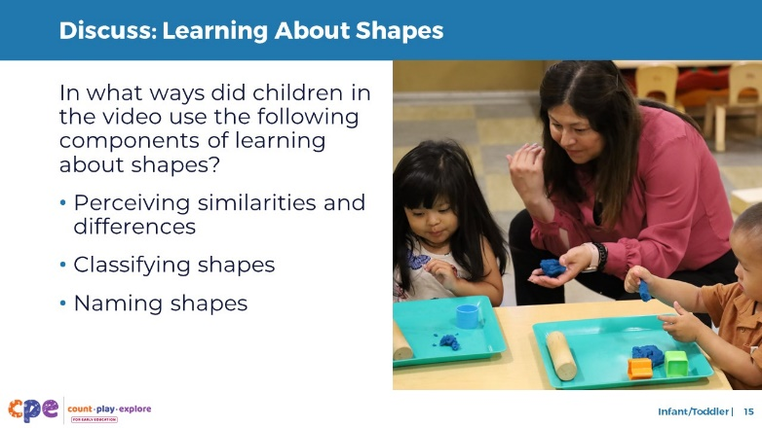
Time: 10–20 minutes (including the video observation on the previous slide)

Talking Points
- Let’s discuss what you noticed.
- In what ways did children in the video demonstrate that they were:
  - Perceiving similarities and differences
  - Naming shapes

Facilitator Notes
- Adjust the debrief based on your group size, session length and format, and participant needs. Consider charting participants’ observations to visually provide ways children develop an understanding of shapes.
- Consider using the following adaptations based on session length:
  - For shorter sessions, invite participants to share, with the large group, what they noticed about ways infants and toddlers showed their understanding of shapes.
  - For longer sessions, offer time for participants to share their observations in pairs or at their tables. Then, invite each table to share their observations.
- Here are some examples of how children in the video perceived similarities and differences and named shapes:
  - Perceiving similarities and differences: The children explored the similarities and differences of shapes when stamping different shapes in play dough. Children touched the shape stampers, which allowed them to notice the attributes of the shapes and how they are similar and different.
  - Naming shapes: One child said “shape” when pressing down a triangle shape. Another child said “circle” when making a circle shape.

SLIDE 16: Supporting Shape Learning

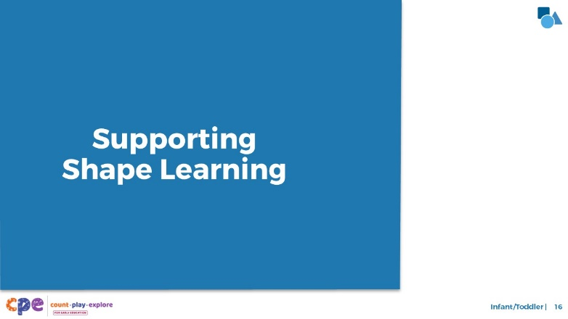

Talking Points
- We explored four components of shape learning. We also observed some ways infants and toddlers perceive similarities and differences, classify shapes, and name shapes. Now, let’s discuss ways we can support children to learn about shapes—in our learning settings and at home.
- Historically, inequities in our educational system have impacted Children of Color, multilingual learners, and children with disabilities. For example, Children of Color, multilingual learners, and children with disabilities have had unequal access to rigorous learning opportunities. We must work to ensure that every child—of any background, race, culture, ethnicity, language, gender, ability, or socioeconomic status—has equitable opportunities to engage in high-quality geometry learning environments and experiences.

SLIDE 17: Explore: Daily Opportunities to Explore Shapes
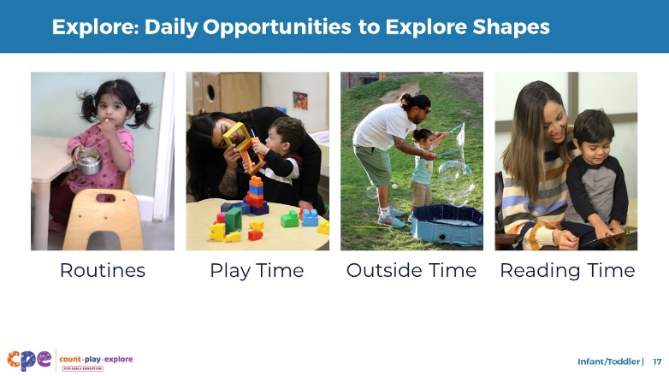
Time: 5–10 minutes
Materials: Daily Opportunities to Explore Shapes handout

Talking Points
- Let’s review how infants and toddlers can learn about shapes through daily routines at home, in their communities, and in early learning and care settings.
- Take out and review Daily Opportunities to Explore Shapes. This handout offers some ideas on how to support infants’ and toddlers’ shape learning through daily routines.
- With a partner, discuss ways you might use the ideas in this handout with families. Consider ways to help families notice the ideas they already use and identify other ways that they want to support their infants’ and toddlers’ shape learning.

Facilitator Notes
- Provide 5–10 minutes for participants to review and discuss the handout.
- For longer sessions, invite participants to share, with the larger group, how they might use these ideas.

SLIDE 18: Explore: M⁵ Early Math Approach
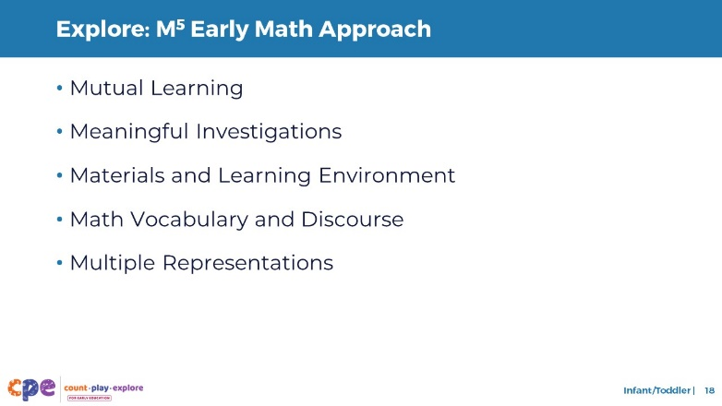
Time: 15 minutes
Materials: M⁵ Overview handout

Talking Points
- Count Play Explore often uses the M⁵ (pronounced: M to the fifth) Early Math Approach to refer to five core early math teaching practices:
  - Mutual Learning
  - Meaningful Investigations
  - Materials and Learning Environment
  - Math Vocabulary and Discourse
  - Multiple Representations
- Let’s explore the M⁵ practices. Then, we will observe M⁵ in action.

Facilitator Notes
- Consider your participants and their prior experiences with M⁵.
  - For groups that have significant experience with M⁵, you might offer a few minutes for participants to share with a partner their areas of strength and what practices they are working on. Or you might use this slide to briefly revisit the M⁵ practices and move to the next slide.
  - For groups that have less experience with M⁵, you might offer more time for participants to explore each practice. For example, you might allow time for them to review the practices in the handout on their own. Invite them to make a square over practices that they have “squared away” (practices they understand and use), a circle over “what’s still going around in their heads” (practices they still have questions about), and a triangle over three ideas that they will use in their settings. For more ideas on how to provide a more comprehensive review, visit the M⁵ Early Math Approach suite of resources.

SLIDE 19: Observe: Supporting Shape Learning
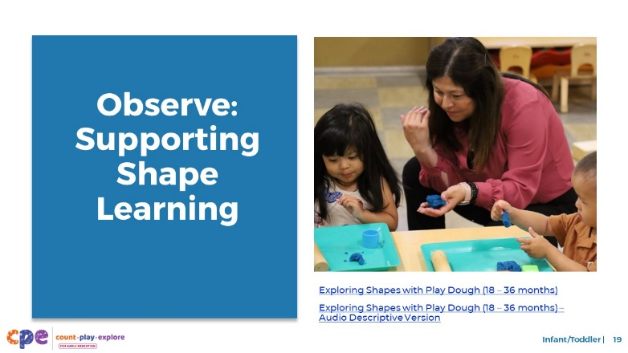
Time: 5–7 minutes (not including debrief)
Materials: Observing M⁵ in Action: Shapes handout, infant or toddler shapes video, chart paper, markers

Talking Points
- We observed what infants and toddlers learn about shapes. Then, we explored the M⁵ Early Math Approach. Now, we are going to observe a video with M⁵ practices. [Choose a strategy for facilitating this observation and debrief. Adapt the talking points to reflect this strategy.]

Facilitator Notes
- Choose an infant and toddler video that shows children exploring shapes. This may be the same video used for observing children learning about shapes.
- We provide the following video (you may use other videos):
  - “Exploring Shapes with Play Dough (18 – 36 months)”
  - “Exploring Shapes with Play Dough (18 – 36 months) – Audio Descriptive Version”
- Note: An answer key is provided for this video in the Facilitator Notes on the next slide.
- Invite participants to take out the Observing M⁵ in Action: Shapes handout.
- For larger groups and longer sessions, use a jigsaw approach. Before playing the video, assign each table one practice to focus on during the video. [If there are more than five tables, assign more than one table to focus on each practice.]
- For smaller groups and shorter sessions, consider showing the video two to three times, inviting participants to focus on specific practices each time. Encourage them to record observations on the handout.

SLIDE 20: Discuss: Supporting Shape Learning
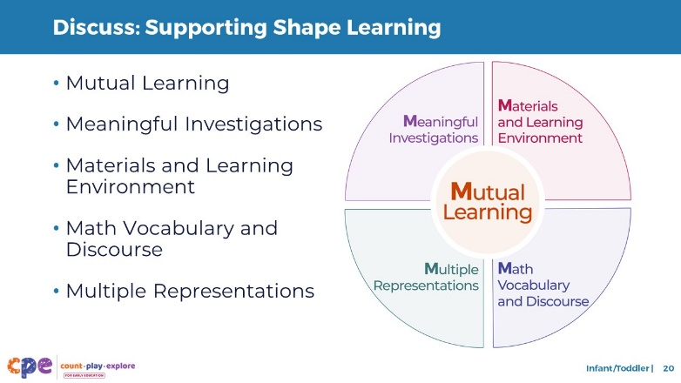
Time: 20–30 minutes (varies based on session goals)

Talking Points
- Let’s unpack your observations of each M⁵ practice. How did the educator use M⁵ to support children’s learning about shapes?

Facilitator Notes
- Use the Answer Key for Observing M⁵ in Action: Shapes handout for examples of ways M⁵ was used in the video “Exploring Shapes with Play Dough (18 – 36 months).”
- For larger groups or longer sessions: After observing the video, ask each table group to discuss what they noticed about their assigned practice. Then, invite each group to share their observations with the larger group. As each group shares, paraphrase, affirm, and add to their responses as needed. Consider charting each group’s observations to make practices visible.
- For smaller groups or shorter sessions: Invite participants to share their observations with the whole group. Chart their observations to make the practices visible. As participants share, paraphrase, affirm, and add to their responses as needed. Consider inviting participants to share something they learned with someone from another table. For example, you might ask them to find someone with similar shoes, move to meet them, and share something they learned with that person.

SLIDE 21: Explore: Using M⁵ to Support Learning About Shapes and Space
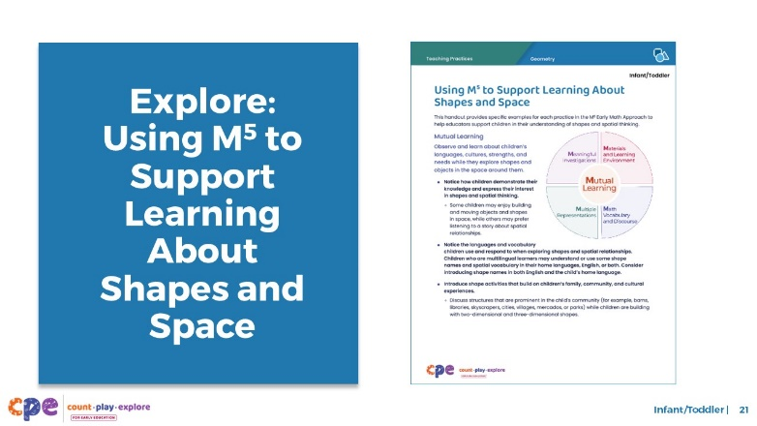
Time: 15–30 minutes (including debrief on the next slide)
Materials: Using M⁵ to Support Learning About Shapes and Space handout, chart paper, markers

Talking Points
- We discussed the M⁵ Early Math Approach and observed some ways the practices might be used to support infants’ and toddlers’ shape learning. Let’s consider other ways for using M⁵ to support infants’ and toddlers’ shape learning.
- Take out the Using M⁵ to Support Learning About Shapes and Space handout. Review the ideas on how to use M⁵ to support infants’ and toddlers’ geometry learning.

Facilitator Notes
- This document was also used in the suite of resources on Spatial Thinking. This resource refers to a broader concept of geometry that includes both shapes and spatial thinking.
- Provide five to seven minutes for participants to review the handout.
- While participants review the handout, post one chart for each of the five M⁵ practices around the room. Label them with the following headers: Mutual Learning, Meaningful Investigations, Materials and Learning Environment, Math Vocabulary and Discourse, Multiple Representations. Divide each chart into two columns. Label one column “Infants” and the other “Toddlers.” For larger groups, create and post more than one chart per M⁵ practice. Leave markers near each chart. Use talking points and facilitator notes on the next slide to guide the debrief.

SLIDE 22: Discuss: Using M⁵ to Support Learning About Shapes and Space
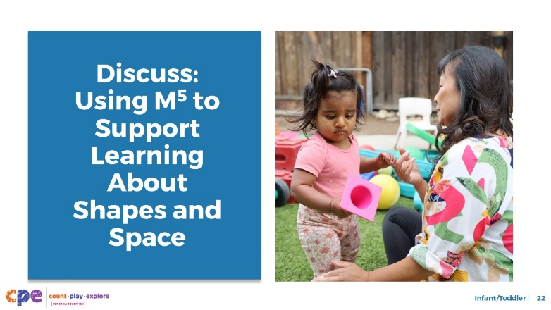
Time: 15–30 minutes (including review of the handout from the previous slide)
Materials: Using M⁵ to Support Learning About Shapes and Space handout, chart paper, markers

Talking Points
- You reviewed some ideas on ways to support infants’ and toddlers’ shape learning using the M⁵ Early Math Approach. Next, let’s reflect on ways we can continue to support infants’ and toddlers’ shape learning. This reflection might include strategies we already use as well as strategies that we want to try.
  - We will form small groups that will travel from chart to chart together. [Provide directions on how to form groups. The facilitator notes offer some suggestions.]
  - When you arrive at the chart, identify and chart something you would like to try. For example, on the Math Vocabulary and Discourse chart, you might identify mealtime routines as a way to use math language to describe the shapes of food.
  - I will signal groups when it’s time to move to the next chart. Leave the marker at the chart for the next group to use. Move clockwise to the next chart. When you arrive, review the ideas suggested by the previous groups. Identify and chart additional ideas.
  - The last group at each chart will share with the whole group two to three ideas that they found most interesting or valuable.
  - Reflect on the diversity of early learners in your setting. Consider children’s interests, languages, cultures and lived experiences, abilities, and emerging skills during the discussion.
- [After the carousel concludes:] You might share the ideas you want to try with your coach and revisit this handout as you plan learning experiences throughout the year.

Facilitator Notes
- Select a strategy for forming small groups. Some ideas include numbering off at tables, numbering off in the whole group, or moving in table groups.
- Consider modeling what to do at the charts.
- When considering the time allotted for this activity, leave at least five minutes at the end for the whole group to share. The remaining time should be divided into the number of charts. For example, if you have 25 minutes total, allow 20 minutes for the carousel and 5 minutes for the debrief. If there is one chart for each M⁵ practice, the time allotted at each chart is four minutes (20/5 = 4).
- After the carousel concludes, invite participants to return to their seats.

SLIDE 23: Reflect: Learn, Wonder, Do
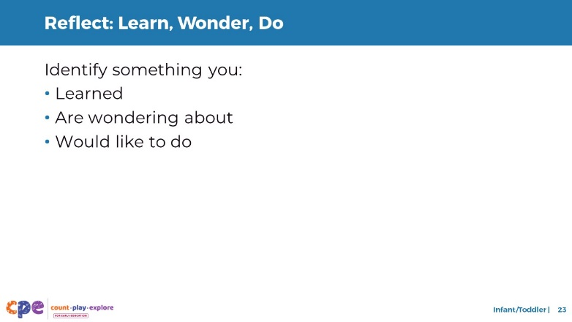
Time: 5 minutes

Talking Points
- Take a few minutes to think about our session.
- Consider the following questions:
  - What is something you learned?
  - What is a wonder you still have?
  - What is something you want to try ins your learning setting?
- [Allow two to three minutes for participants to think. You might invite participants to share with a partner.]
- Thank you for your time, attention, and engagement. It’s been wonderful working with you.

Facilitator Notes
- For longer sessions, consider asking participants to share some of their reflections with the larger group.
- As participants discuss their reflections, note the questions that they still have and the things they would like to try. These reflections may inform the topics of future trainings, coaching, or communities of practice.

