Documentation and Communication
Use this facilitator guide with the slides “Documentation and Communication.” This facilitator guide and set of slides provides descriptions of ways children, birth to age eight, document and communicate and ways educators can support them to document and communicate. Facilitators can find talking points, guidance for activities and handouts, and group discussions in this guide. The same text is also located in the notes portion of the slides.

Session At-a-Glance
Slide numbers | Overview of content | Approximate time (in minutes)
1–3 | Introduction & Session Goals | 5
4–14 | Exploring documentation and communication  - Activity for adults  - Video observation  - Exploring developmental progressions of inquiry skills | 30–40
15–20 | Exploring ways to support children to document and communicate  - Various ways children document  - Video observation | 25–35
21 | Reflection | 5
The times are approximate and may vary based on session goals, group size, and participants’ previous experience and familiarity with the content.

To Prepare for Your Session
- Before your session, carefully review all handouts and prepare the necessary materials. Throughout the facilitator guide, we offer options for facilitation approaches. Select the facilitation approach that works best for your session length and format, group size, and participant needs.
- Consider using photos, videos, or stories from the learning settings where educators work within this session. Making the information more personal for participants can create a greater connection to the content and foster feelings of belonging in STEAM.

Materials Needed
- Scratch paper, chart paper, and writing tools
- Developmental Progression of Inquiry Skills handout
- Documenting and Communicating in Science Inquiry handout, a set of inquiry cards for each participant (page 3 of the handout), scratch paper, graph paper, drawing tools (for example, pencils, markers, crayons), clay or other craft materials that participants might use to create representations
- Various Ways Children Document handout
- Supporting Children to Document and Communicate handout

Slide 1: Documentation and Communication
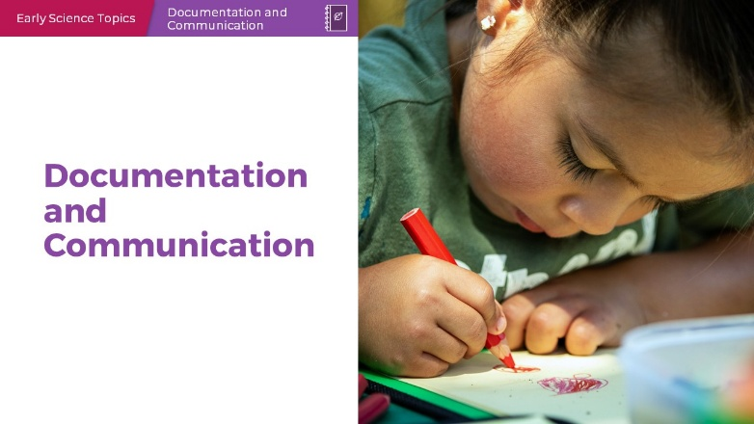

Talking Points
- Today, we will be exploring ways that children (birth to age eight) document and communicate as part of science investigations.

Facilitator Notes
- Adjust Talking Points to reflect your session length and participant needs. If necessary, add introductory and “housekeeping” information.

Slide 2: Acknowledgments
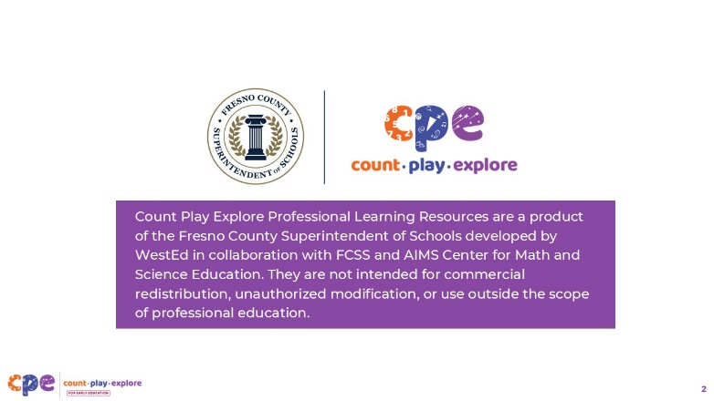

Talking Points
The Count Play Explore Professional Learning Resources were made possible by Count Play Explore, an early math, science, and computer science initiative led by the Fresno County Superintendent of Schools, Early Care and Education Department. This initiative is generously funded by the California Department of Education and the California State Board of Education. These resources, developed by WestEd in collaboration with FCSS and AIMS Center for Math and Science Education, are intended to be used as a guide for implementing evidence-based strategies, promoting active learning, and encouraging developmentally appropriate practices in early education settings. They are not intended for commercial redistribution, unauthorized modification, or use outside the scope of professional education.

Slide 3: Session Goals
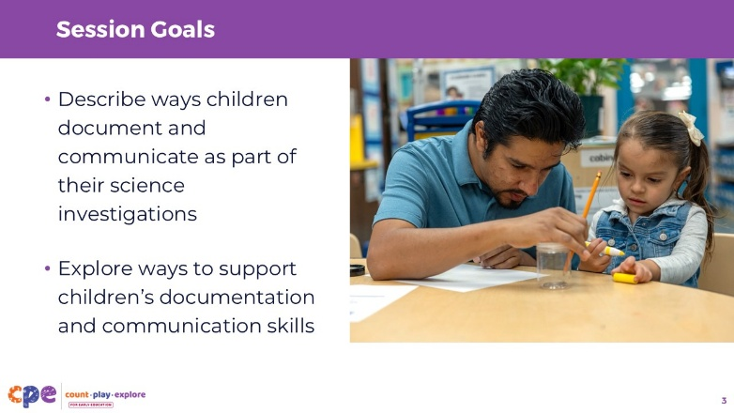

Talking Points
- In this session, we will:
- describe ways children document and communicate as part of their science investigations, and
- explore ways to support children’s documentation and communication skills.

Facilitator Notes
- Adjust slide content and Talking Points to reflect what you plan to address in your professional learning session.
- Depending on your group of participants, you might discuss the developmental appropriateness of documenting with infants. Even if infants are not physically documenting themselves, there are ways educators might model this skill for children. For example, educators can:
  - read out loud as they write down (document) what a child is observing (such as, “Oscar noticed that the blue ball rolled farther than the yellow ball”).
  - describe what they are drawing and how they are drawing it (such as, “I’m drawing the petal of this flower. It is red and oval-shaped like this”).
- This mindset might be important to establish before exploring the content in this suite.

Slide 4: Documentation and Communication in Science
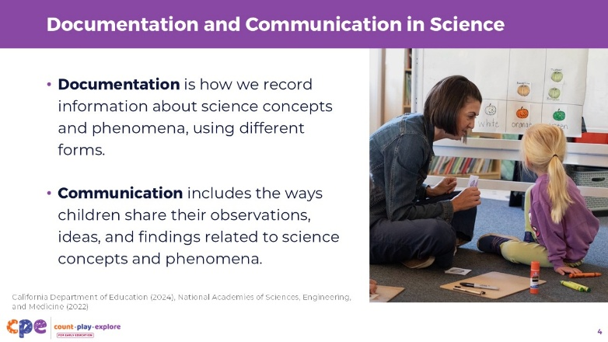

Talking Points
- Documentation is how we record information about science concepts and phenomena, using different forms.
- In early childhood settings, examples of documentation may include “… drawings, photographs, written transcripts, charts, journals, models, and constructions” (California Department of Education, 2024, p. 82).
- Communication includes the ways children share their observations, ideas, and findings related to science concepts and phenomena (California Department of Education, 2024; National Academies of Sciences, Engineering, and Medicine, 2022). When we say phenomena, we mean observable events that involve science concepts such as a seed sprouting, paint mixing to form a new color, or a ball rolling into a block structure causing it to topple over. [You might use different examples of phenomena that are relevant to your local communities that children and educators are familiar with.]
- Documentation might be one way children communicate (for example, drawing pictures to show the steps in an investigation) (California Department of Education, 2024; National Academies of Sciences, Engineering, and Medicine, 2022).
Facilitator Notes
- The definitions of documentation and communication presented on this slide are glossary terms in the California Preschool/Transitional Kindergarten Learning Foundations. Similar descriptions of documentation and communication can be found in the Next Generation Science Standards, Appendix F (NGSS Lead States, 2013).

Slide 5: Explore: Documentation and Communication in Science Inquiry
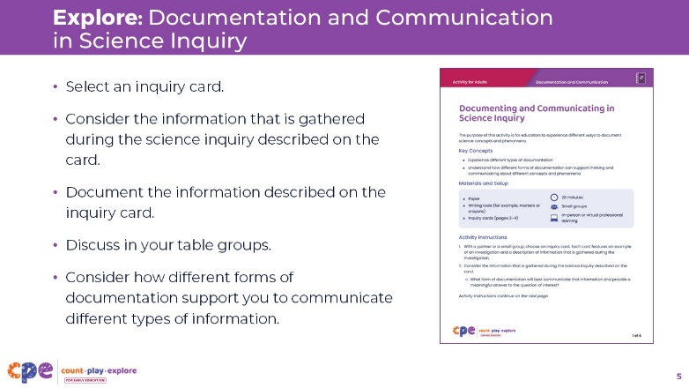
Materials: Documenting and Communicating in Science Inquiry handout, a set of inquiry cards for each participant (page 3 of the handout), paper, graph paper, drawing tools (for example, pencils, markers, crayons), and clay or other craft materials that participants might use to create representations
Time: 15–20 minutes (including discussion on the following slide)

Talking Points
- [Review the handout prior to engaging in this experience to prepare materials and decide how to facilitate the activity.]
- Let’s experience documenting and communicating in inquiry experiences.
- [Review the instructions on the activity handout with participants.]
- [Provide time for participants to complete the activity and discuss their documentation with each other. Move around the room offering support and asking questions as needed.]

Facilitator Notes
- Inquiry scenarios are provided in the handout. However, you might create more or different inquiry scenarios to represent science concepts and phenomena that are familiar to the educators you work with or that reflect your local community and natural environment.

Slide 6: Discuss: Documentation and Communication in Inquiry
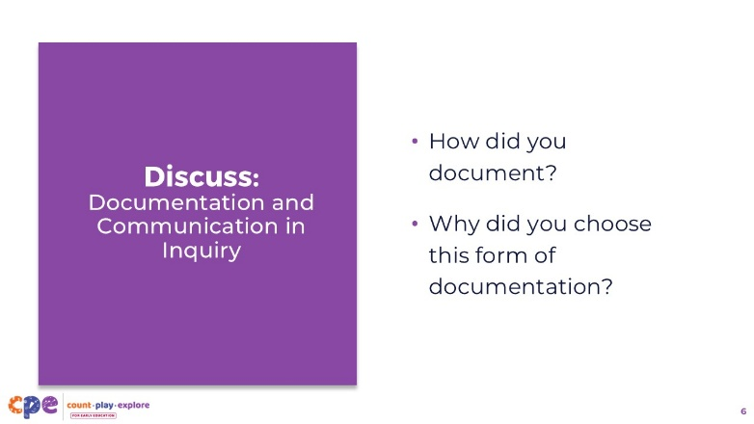
Materials: Documenting and Communicating in Science Inquiry handout
Time: 15–20 minutes (including discussion on the previous slide)

Talking Points
- Let’s discuss ways you documented and communicated about information from different science inquiries.
- [Review the Facilitator Notes for ways you might support a discussion.]

Facilitator Notes
- Review each inquiry card from the Documenting and Communicating in Science Inquiry handout. Invite participants to share ways they documented and why they chose that form of documentation for each inquiry card. Encourage participants to consider ways their documentation supports them to communicate.
- Invite participants to explore others’ documentation in a gallery walk. After the gallery walk, invite a few volunteers to share with the larger group what they noticed about the different ways others documented and communicated.

Slide 7: Reflect on Your Setting
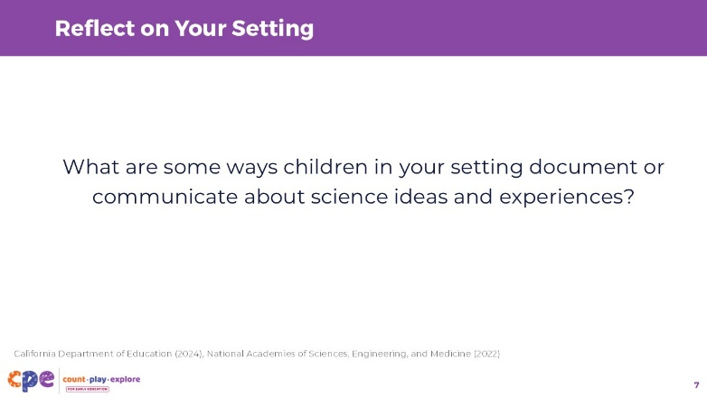
Time: 5 minutes

Talking Points
- You all explored ways to document and communicate. Consider the children in your learning setting. What are some ways children in your setting document or communicate about science ideas and experiences?
- [For infant and toddler educators, you might ask: What are some ways you help infants and toddlers document their ideas and observations?]
- Turn and discuss with a partner some examples of ways science is documented and communicated in your setting.
- [Provide time for participants to discuss ways children in their settings document and communicate science ideas. You might encourage volunteers to share with the larger group.]
- Thank you for discussing ways you and the children in your setting document and communicate. We will explore more about the different ways children document and communicate about their science ideas and experiences.

Facilitator Notes
- Prior to the session, you might invite participants to bring a photo of science documentation or communication from their learning setting. Participants might share their examples with others at their table group.

Slide 8: Educators document, too!
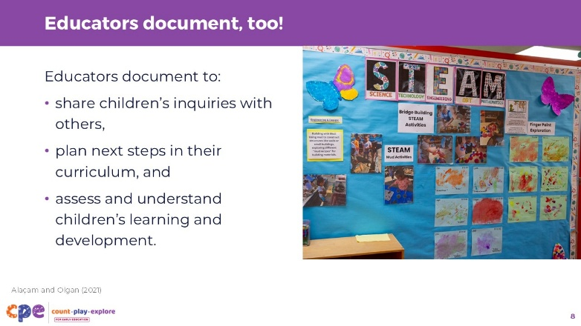

Talking Points
- Educators also engage in the practice of documentation.
- For example, educators might photograph the way their children are exploring, write dictations documenting what children say, or record other observations to document the learning and development of children in their setting.
- Both educators and children can document meaningful information in different ways and use that information to build understanding.
- Educators document to:
  - share children’s inquiries with others (for example, with children, their families, and other educators),
  - plan next steps in their curriculum, and
  - assess and understand children’s learning and development (Alaçam & Olgan, 2021).

Slide 9: Observe: Investigating a Spider
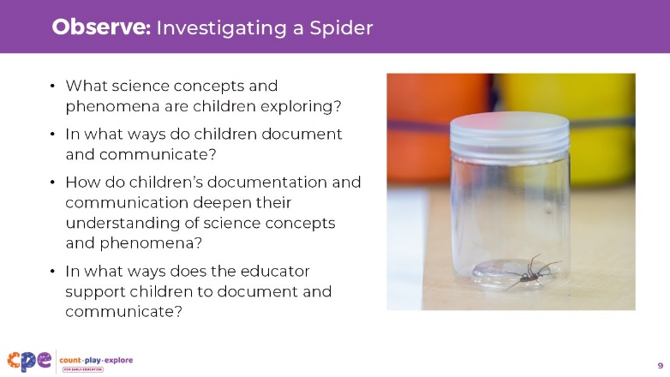
Materials: Investigating a Spider (3—5 years), Investigating a Spider (3—5 years) – Audio Descriptive Version video clip, writing tools, scratch paper
Time: 15–20 minutes (including discussion on the following slides)

Talking Points
- You experienced documenting and communicating and reflected on ways documentation and communication happen in your settings.
- Now we will observe the ways children document and communicate as they investigate a spider and ways their educator supports them to do so.
- As you observe the video, notice the following:
  - What science concepts and phenomena are children exploring?
  - In what ways do children document and communicate?
  - How do children’s documentation and communication deepen their understanding of science concepts and phenomena?
  - In what ways does the educator support children to document and communicate?
- In the spirit of documentation, you might record, or document, what you notice on scratch paper.
- [Play the video.]

Facilitator Notes
- This video offers rich examples of ways children document and communicate and ways their educator supports them to do so. You might use it in different ways to allow participants to think more critically about the video. For example:
  - Play the video twice. For the first viewing, encourage participants to notice what the children are learning about and how they communicate and document. For the second viewing, invite participants to notice how the educator supports children to document and communicate.
  - Use a jigsaw approach. Assign different table groups different questions to pay attention to as they view the video, followed by a large group share-out

Slide 10: Discuss: Investigating a Spider
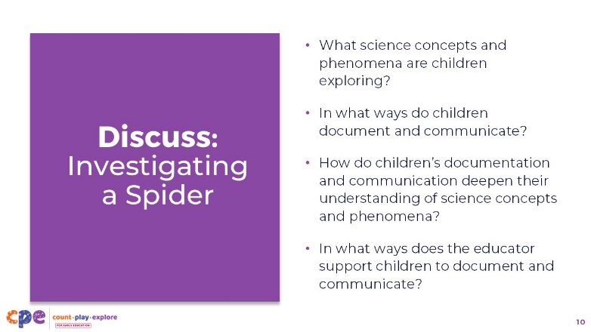
Time: 15–20 minutes (including observing the video on the previous slide)

Talking Points
- Let’s discuss what you noticed.
- With your table groups, share what you noticed about the following:
  - What science concepts and phenomena are children exploring?
  - In what ways do children document and communicate?
  - How do children’s documentation and communication deepen their understanding of science concepts and phenomena?
  - In what ways does the educator support children to document and communicate?
- [Encourage participants to share what they noticed with their table groups. Then, facilitate a discussion with the larger group.]
- [Use the sample responses in the Facilitator Notes to support a discussion.]

Facilitator Notes
- The following are sample responses to support a discussion.
- What science concepts and phenomena are children exploring?
  - Children are exploring life science concepts. They are investigating the characteristics of living things. For example, they are documenting and communicating about the body parts of a spider and how it moves.
- In what ways do children document and communicate?
  - Children document the spider by creating a representational drawing.
  - Children communicate by discussing with peers during a think-pair-share routine in circle time and explaining their drawings to their educator.
- How do children’s documentation and communication deepen their understanding of science concepts and phenomena?
  - By drawing the spider, children are able to focus on the individual body parts (for example, the legs, fangs, thorax).
  - By communicating about the spider, children are able to use new vocabulary about the parts of the spider and consolidate their ideas in a meaningful way.
- In what ways does the educator support children to document and communicate?
  - Finding the spider was a spontaneous occurrence. The educator restructured his plans for the day to allow children to investigate the spider in a meaningful way.
  - The educator supports children to document and communicate by first providing time for children to observe, wonder about, and discuss the spider. This time to notice allows children to gain familiarity with the spider, draw on their prior knowledge and past experiences, and notice different attributes of the spider.
  - The educator helps children notice different body parts of the spider by providing children with tools (for example, the digital microscope) and a diagram of a spider to allow them to view it more easily. He also provides the names of these body parts—helping make them distinct and identifiable.
  - The educator also provides time for children to discuss the spider with peers—supporting children to draw on past experiences.
  - The educator supports children to draw the spider by helping them notice specific shapes that they might use in their drawings (for example, “It looks like a circle so you can start with a circle.”).
  - The educator supports children to communicate about the spider by inviting them to explain their drawings. He then adds dictation to their drawings.
  - The educator discusses ways he supports multilingual learners. For example, he says he writes down what children say in the language they are using and gets support from other educators who speak the child’s home language.

Slide 11: Why are documentation and communication important?
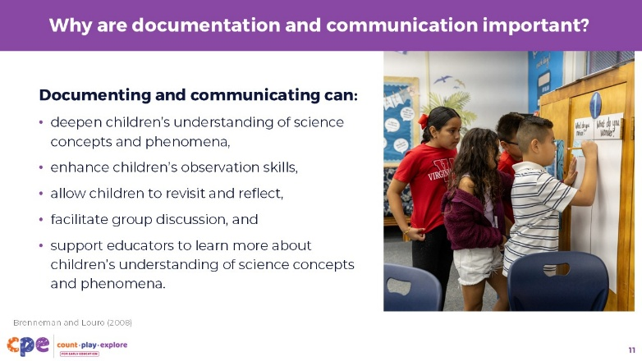

Talking Points
- Documentation is an important way for children to make sense of science concepts and phenomena and to show their understanding (Brenneman & Louro, 2008). When children communicate about science concepts and phenomena, it allows them to consolidate their ideas and use new vocabulary in a meaningful context.
  - Documentation and communication provide a space for children to step out of the action, organize their ideas, and make meaning of observed science concepts and phenomena.
- The process of documenting can enhance children’s observation skills (Brenneman & Louro, 2008).
  - When educators provide children with guidance for what to document (for example, the way the plant has grown), they help children pay attention to more detail and notice with a purpose.
- Documenting can also allow children to revisit and reflect on an experience. It can support them to make connections between current and previous experiences, find patterns, and make comparisons.
- Documenting can support communication in group discussions.
  - Educators might encourage children to share their documentation with others. Using documentation provides a tangible way for children to communicate their ideas and a reference point to support their thinking.
  - Finally, documentation and communication are powerful ways for educators to learn more about what children know and think about science concepts and phenomena.

Slide 12: Using Different Skills
This slide contains animation. See instructions in the Talking Points.
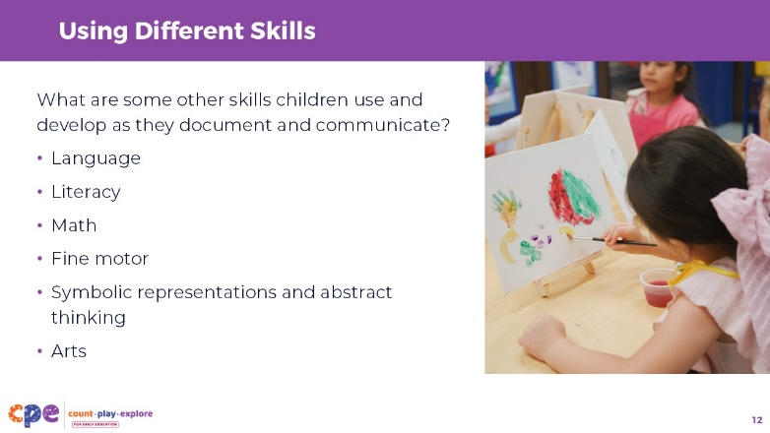

Talking Points
- When children document and communicate, they also build skills in domains outside of science.
- What are some other skills children use and develop when they document and communicate during science investigations?
- [Encourage participants to discuss other skills children might learn as they document and communicate. Use the following talking points to summarize and add to what participants share.]
- Here are some skills and understanding children develop as they learn to document and communicate during science investigations:
  - [Click] Language skills. For example, children will develop their vocabulary (for example, spinneret, thorax) and expressive language abilities.
  - [Click] Early literacy. Some documentation provides opportunities to support early literacy skills such as writing—and this too, like drawing, develops through stages. Children might dictate information to an adult to write for them as a way to scaffold early literacy skills. Educators can support children to write in ways that are developmentally appropriate (for example, using inventive spelling).
  - [Click] Math knowledge and skill. For example, children count the legs of a spider they are drawing or measure the lengths their balls travel, documenting these distances to compare different ramp structures.
  - [Click] Fine motor skills. Children will develop fine motor skills as they hold and use writing tools to document their observations.
  - [Click] Understanding of symbolic representations and abstract thinking. For example, children will develop an understanding that each tally mark represents one occurrence—a form of symbolic representation that children learn as they use tally marks during science investigations.
  - [Click] The arts. Children begin learning to draw using scribbles in infancy and toddlerhood. They progress to pre-schematic representations in preschool, and in early elementary school, they are able to represent more realistic representations with greater attention to detail (Lowenfeld, 1957). Encouraging children to create representational drawings of science concepts and phenomena can support the development of these skills.

Slide 13: The Development of Documentation and Communication Skills
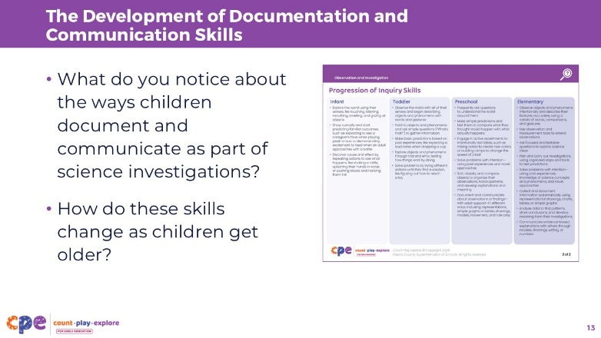
Materials: Developmental Progression of Inquiry Skills handout
Time: 5–10 minutes

Talking Points
- Let’s consider ways children of different ages document and communicate.
- We will review the Developmental Progression of Inquiry Skills handout. This handout includes a table that describes the ways infants, toddlers, preschool-aged children, and elementary-aged children develop and use inquiry skills. In the California Preschool/Transitional Kindergarten Learning Foundations and the Next Generation Science Standards for California Public Schools, Kindergarten through Grade Twelve, these inquiry skills are called science and engineering practices.
- Science and engineering practices are what children do to develop an understanding of science concepts and phenomena in their world.
- In this table, you will notice other science and engineering practices related to observation and investigation, in addition to practices specific to documentation and communication. This is because documentation and communication do not happen in isolation. Documenting and communicating are just two of many other ways that children investigate their world, gather information, and build an understanding of science concepts and phenomena.
- As you review the Developmental Progression of Inquiry Skills handout:
  - Circle the practices (skills) that are related to documenting and communicating.
- [Provide time for participants to review the handout.]
- What do you notice about the ways children document and communicate as part of science investigations? How do these skills change as children get older?
- [Review the Facilitator Notes for sample responses to support a discussion.]

Facilitator Notes
- You might have individuals review the table and then share what they notice in their small groups or in the larger group. Alternatively, you might assign different groups different ages to focus on. Groups can share what they notice about ways children document and communicate. Then, groups might work together to explore ways these skills change as children get older.
- Infant:
  - Infants communicate with caregivers through gestures and expressions. Educators can model documenting and communicating for children. For example, educators can model documenting and communicating for younger children by taking photos and discussing photos with children, sorting objects and discussing why objects are placed in different groups, and talking about drawings using language to label the different parts of an image.
- Toddler:
  - Toddlers might begin to document by sorting and grouping objects by properties like size or color as a way to organize and make sense of information. Early sorting experiences with objects establishes a foundation to support children to document using symbolic representations (for example, drawing or generating charts and graphs) as they get older.
- Preschool:
  - Sort, classify, and compare objects to organize their observations, notice patterns, and develop explanations and meaning.
  - Document observations or findings with adult support and use representations, including drawings, models, movement, role-play, and other methods, to communicate their understanding of science concepts and phenomena.
  - Communicate their findings and ideas to others in different ways (for example, describing a drawing, discussing an observation with peers, gesturing).
- Early Elementary:
  - Collect and document information systematically using representational drawings, charts, tables, or simple graphs.
  - Analyze data to find patterns, draw conclusions, and develop meaning from their investigations.
  - Communicate evidence-based explanations with others through models, drawings, writing, or numbers.
- As children get older, the ways they document and communicate become more advanced. Children start with very tangible experiences of sorting and progress to more symbolic, abstract representations of documentation as they get older (for example, using tally marks or creating bar graphs).

Slide 14: Different Ways Children Document and Communicate
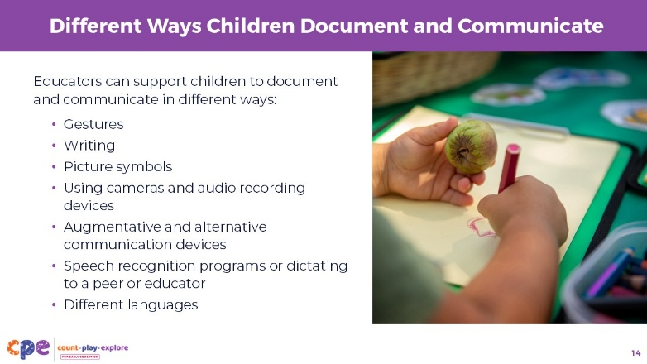

Talking Points
- Children document and communicate in different ways. For example:
  - Children might use gestures, writing, picture symbols, cameras, audio recording devices, or augmentative and alternative communication devices to document and communicate during science investigations.
- Children with motor impairments might use computers, eye trackers, or speech recognition programs, or dictate to a peer or educator as ways to document and communicate during science investigations.
- Children might communicate using different languages. It is important to support children to communicate in the way that is most effective for them. Supporting the use of the home language allows children to draw on all of their knowledge and prior experiences to develop a more complex understanding of science concepts and phenomena.

Slide 15: Various Ways Children Document
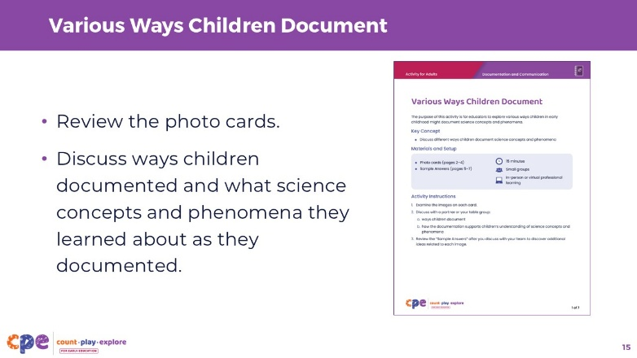
Materials: Various Ways Children Document handout
Time: 15 minutes

Talking Points
- You have experienced different ways to document in science inquiries and have observed a video showing children documenting and communicating.
- Now we will examine some examples of different ways children document science concepts and phenomena.
- [Distribute the photo cards from the Various Ways Children Document handout.]
- [Review the instructions with participants. As participants examine each photo, move around the room and support participants as needed.]
- [After participants have reviewed and discussed the photo cards, you might invite different groups to share about each photo.]
- [Use the “Sample Answers” in the handout to support a discussion.]

Facilitator Notes
- You might use a jigsaw approach—assigning different table groups different images to discuss. Invite each table group to share their ideas about the documentation.
- The handout includes information related to representational drawings, charts and graphs, and taking photographs. More information on ways children develop skills to collect, represent, and interpret data can be found in the Early Math Topic suite, “Collecting, Representing, and Interpreting Data: Preschool through Early Elementary.”

Slide 16: Observe: Documentation and Communication in Action
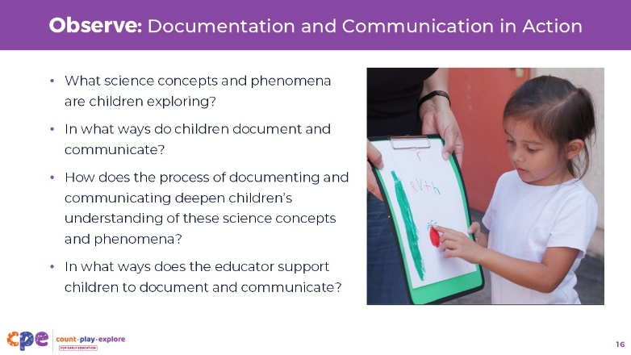
Materials: video clip of children documenting and communicating in a science investigation, writing tools, scratch paper
Time: 15 minutes (including the discussion on the following slides)

Talking Points
- Now, we will notice ways children document and communicate as they investigate science concepts and phenomena.
- As you observe the video, notice the following:
  - What science concepts and phenomena are children exploring?
  - In what ways do children document and communicate?
  - How does the process of documenting and communicating deepen children’s understanding of these science concepts and phenomena?
  - In what ways does the educator support children to document and communicate?
- You might record what you notice on scratch paper.
- [Select and play a video.]

Facilitator Notes
- Choose a video clip that shows children documenting and communicating in a science investigation.
- We provide the following videos (you may use other videos):
  - Documenting and Communicating in the Garden (3-5 Years)
  - Documenting and Communicating in the Garden (3-5 Years) – Audio Descriptive Version
  - Documenting and Communicating about Force (second-third grade)
  - Documenting and Communicating about Force (second-third grade) – Audio Descriptive Version
- Note: Discussion points are provided for the videos on the next slide.
- The videos featured on this slide are rich in examples of ways children document and communicate and ways an educator supports them to do so. You might want to help participants focus on a few of the prompting questions at a time to allow them to think more critically about the video. For example:
  - Explain that you will play the video twice. The first time, encourage participants to notice what the children are doing and learning about. The second time you play the video, encourage participants to notice ways the educator supports children to document and communicate.
  - Use a jigsaw approach—assign different table groups different prompting questions to pay attention to as they view the video.

Slide 17: Discuss: Documentation and Communication in Action
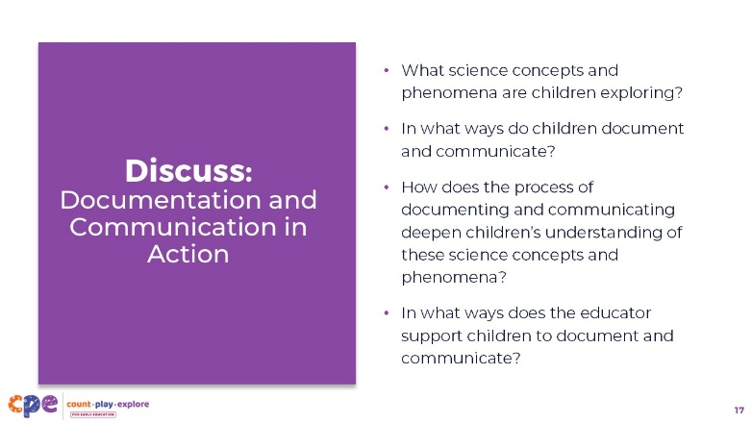
Time: 15 minutes (including observing the video on the previous slide)

Talking Points
- Let’s discuss what you noticed.
- With your table groups, share what you noticed about the following:
  - What science concepts and phenomena are children exploring?
  - In what ways do children document and communicate?
  - How does the process of documenting and communicating deepen children’s understanding of these science concepts and phenomena?
  - In what ways does the educator support children to document and communicate?
  - What other ways might you support children to document and communicate in this context?
- [Encourage participants to share what they noticed with their table groups. Then, facilitate a discussion with the larger group.]
- [Use the sample responses in the Facilitator Notes to support a discussion.]

Facilitator Notes
- The following are sample responses to support a discussion about the video clip, Documenting and Communicating in the Garden (3–5 Years).
- What science concepts and phenomena are children exploring?
  - Children are exploring concepts related to life science: the characteristics of living things and how things grow and change.
  - Children are also using math knowledge and skills as they measure and record the lengths of the vegetables.
- In what ways do children document and communicate?
  - Children document by taking photos and creating representational drawings.
  - They observe the vegetables’ lengths using a measuring tape and document the lengths on their drawings.
  - Children communicate by presenting their drawings to their peers. They explain what they drew and why they drew it in a particular way.
- How does the process of documenting and communicating deepen children’s understanding of these science concepts and phenomena?
  - Their observations help them notice details about the characteristics of living things (for example, differences in size, color, and shape among various vegetables). They are also noticing how living things grow and change (for example, one of the zucchinis grew very large and the other was smaller).
- In what ways does the educator support children to document and communicate?
  - The educator supports children to document by first helping children observe the vegetables and compare their sizes.
  - The educator also provides children with measuring tools (for example, a balance scale and measuring tape) as a way for them to extend their senses and notice the size and weight of the vegetables.
  - The educator provides cameras for children to document the way the vegetables look.
  - The educator supports children to communicate about the vegetables by providing time and space for each child to share their documentation.
  - The educator encourages children to explain their documentation to other children by asking questions such as, “I see a number here. What number is that … was that the small zucchini or the large one?” and “What did you document?”
- The following are sample responses to support a discussion about the video clip, Documenting and Communicating about Force (second–third Grade).
- What science concepts and phenomena are children exploring?
  - Children are exploring concepts related to forces and how things move. They are investigating the effect of weight on the movement of objects down a ramp.
- In what ways do children document and communicate?
  - Children document by writing down what they notice and wonder about the way adding weights to cars affects how they move.
  - Children communicate with each other by discussing their ideas verbally as they work in collaborative teams.
  - Children also communicate with each other and their educator through a discussion after they experiment. Through this whole group discussion, children are able to compare ideas and think more deeply about what they noticed.
- How does the process of documenting and communicating deepen children’s understanding of these science concepts and phenomena?
  - Children’s ideas about the effects of weight on the movement of cars down a ramp were deepened when they were encouraged to share their observations with other teams. This communication allowed children to compare observations and consider different perspectives and experiences.
  - Writing what they notice and what they wonder about the investigation also supported children’s thinking about the physical concepts in their investigation. Children needed to organize their ideas and consolidate their understandings before writing down their observations and questions on the sticky notes.
- In what ways does the educator support children to document and communicate?
  - The educator supports children to document by clearly explaining the “What do you wonder? What do you notice?” routine and integrating it into the investigation.
  - The educator supports children to communicate by organizing the children into collaborative groups. In collaborative groups, children are more likely to share ideas and plans with their teammates.
  - The educator discusses ways she uses sentence frames to support children to communicate their ideas, even when their ideas might differ. She explains how it is important to create a culture wherein children are comfortable sharing their ideas with each other and that this is a process that builds over time.

Slide 18: Communicating Science Ideas
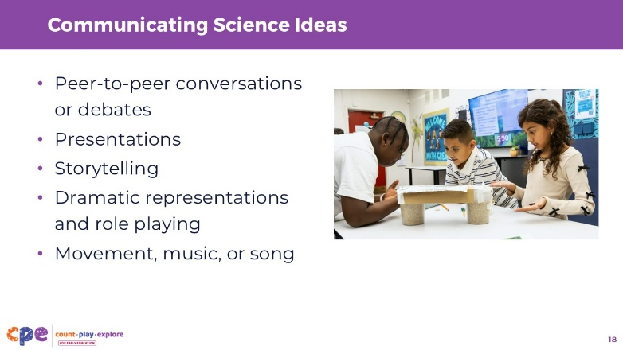

Talking Points
- In the video, we observed children communicating their ideas about science concepts and phenomena.
- There are many ways children can share their ideas about science concepts and phenomena. For example, children can communicate through:
  - peer-to-peer conversations or debates;
  - presentations;
  - storytelling;
  - dramatic representations and role playing; and
  - movement, music, or song.
- Educators might use routines to encourage children to communicate (for example, using a think-pair-share routine). Using routines repeatedly, over time, helps children get comfortable with the process. Once they know how to communicate in a different way, they can begin to express their ideas more fluidly.
- Educators can provide different types of supports and tools that can help children with varied abilities to communicate their understanding in ways that meet their strengths and needs.

Slide 19: Supporting Children to Document and Communicate
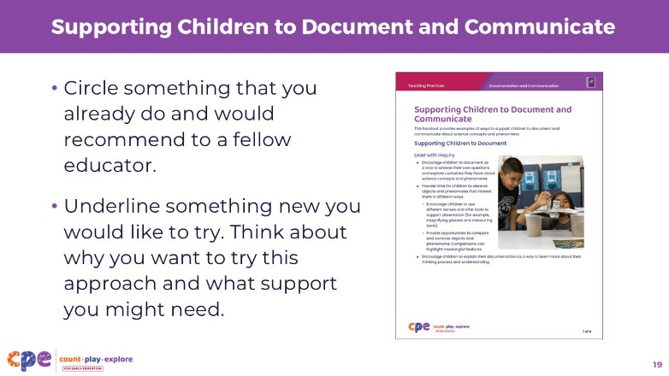
Materials: Supporting Children to Document and Communicate handout
Time: 15-20 minutes

Talking Points
- We have discussed many different ways children can document and communicate about science concepts and phenomena. We have also discussed and viewed examples of ways educators can support children to document and communicate.
- Now we will review a handout that summarizes ways educators can support children to document and communicate.
- Circle something that you already do and would recommend to a fellow educator.
- Underline something new you would like to try. Think about why you want to try this approach and what support you might need.
- [Provide time for participants to review and mark up the handout.]
- Turn to a partner at your table. Discuss the following:
  - Something that you already do in your learning setting and would recommend to another educator. Explain why you would recommend this approach.
  - Something new you would like to try. Explain why you would like to try this and what support you might need to do so effectively.
- [Provide time for participants to discuss with a partner. You might invite a few volunteers to share with the larger group.]

Facilitator Notes
- You might more thoroughly explore some of the strategies provided in the Supporting Children to Document and Communicate handout. For example:
  - Consider observing and discussing the Think-Pair-Share with Peers (3–5 years), Think-Pair-Share with Peers (3–5 years) - Audio Descriptive Version video clip. In this video, educator Diego explains ways he teaches his preschool children to use the think-pair-share routine to communicate their ideas about science concepts and phenomena.
  - Provide participants with copies of the routines and protocols that were listed in the handout. Encourage participants to review the protocols and consider ways they might adapt them to use in their own settings.

Slide 20: Additional Resources
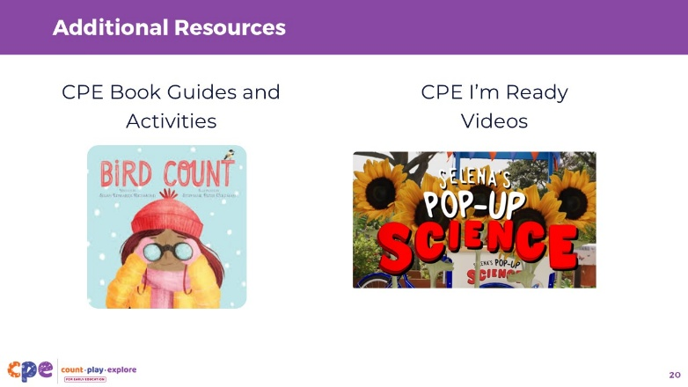

Talking Points
- As you document with children and support them to communicate, you might use additional Count Play Explore (CPE) resources to further your investigations.
- Explore the CPE Book Guides and activities. There are many books and book guides that you might use to invite children to document and communicate about science concepts and phenomena. For example:
  - Bird Count, by Susan Edwards Richmond, can encourage children to document and communicate about the birds in their neighborhoods. Children might use tally marks to record the number of different birds they find. Or children might create representations (for example, drawings or paintings) to communicate about the different characteristics of the birds they find.
- Share CPE “I’m Ready!” videos with families. For example, the video “Secret Life of Sunflowers” explores ways families can document and communicate about the growth of plants.
Facilitator Notes
- Count Play Explore Book Guides, activities, and “I’m Ready!” videos are available in English and Spanish through the Count Play Explore website.
- You might provide time in your session for participants to explore the Count Play Explore website materials and to consider ways they might use these resources to support children to document and communicate about science concepts and phenomena.

Slide 21: Reflection
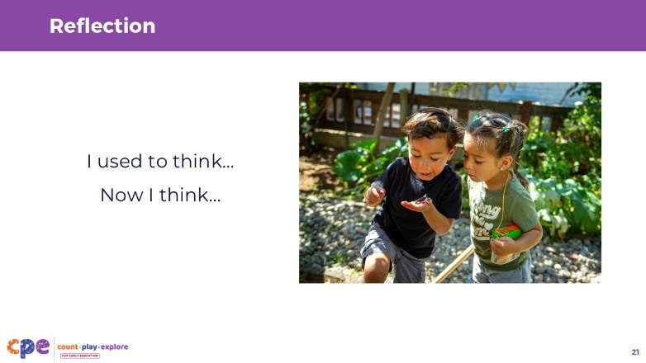
Materials: Scratch paper and writing tools
Time: 5 minutes

Talking Points
- Thank you for exploring ways that children document and communicate in science investigations and ways educators can support them to do so.
- Take a moment to reflect on our session today. Consider the different videos we observed, the activities we engaged in, and the handouts we discussed.
- [Provide about a minute for participants to consider their experiences during the session.]
- On a piece of scratch paper, record what you used to think about documenting and communicating.
- Then, record what you now think about documenting and communicating.
- [Provide 2-3 minutes for participants to reflect and record their ideas. You might invite volunteers to share with the larger group.]
- As you return to your learning settings, consider:
  - ways you might challenge yourself to explore different approaches to support children to document and communicate, and
  - ways you might adjust your practice to support all children to document and communicate in ways that build on children’s individual strengths.
- You might find a colleague to work with and share ways you are building these skills for yourself and for the children in your setting.

Facilitator Notes
- Providing ongoing support and opportunities for collaborative reflection are critical components of effective professional learning (Darling-Hammond et al., 2017).
- Consider ways you can support participants to apply what they learned in this session to their learning settings and support collaborative reflection. For example, encourage participants to share photos and anecdotes of ways they are supporting children to document and communicate in science investigations.
  - You might use digital platforms such as Padlet or a shared Google Drive. You can provide feedback to individual participants and encourage others to make comments and suggestions as a way to build community.
  - Encourage educators to keep a journal to record ways they are supporting children to document and communicate. They can share and discuss their journal entries during in-person meetings.

Slide 22: Thank You!


Talking Points
- Thank you all for your time and attention today.
- I hope you enjoy exploring ways to support children to document and communicate in science inquiries.

