Collecting, Representing, and Interpreting Data: Preschool Through Early Elementary
Use this facilitator guide with the slide deck titled “Collecting, Representing, and Interpreting Data: Preschool Through Early Elementary.” This set of slides provides an overview of how children develop an understanding of data collection, representation, and interpretation starting in preschool into the early elementary years. Facilitators can find talking points and guidance for activities and group discussions in this guide. The text in the guide is also located in the notes portion of the slides. Adapt this facilitator guide based on your group size, session length and format, and participants’ needs.

Session At-a-Glance
Slide Numbers | Overview of Content | Approximate time (in minutes)
1-3 | Introduction & session goals | 5
4-11 | Introducing data:  - Adult activity  - Defining data  - Data is everywhere | 30-40
12-27 | How children develop an understanding of data:  California learning foundations and  Standards  - Sort and classify data  - Collect and represent data  - Interpret data  - Video observation | 30-45
28-33 | How to support children in collecting and representing data:  - Observing and Discussing M⁵ | 45-60
34 | Closing reflection activity | 5-10

To Prepare for Your Session
- Before your session, carefully review all handouts and prepare the necessary materials. Select a facilitation method that works best for your session length and format, group size, and participants’ needs.

Materials Needed
- Scratch paper, chart paper, and writing tools
  - Using Data to Tell Our Story handout, paper, chart paper, markers, stickers
  - M⁵ Overview handout
  - Observing M⁵ in Action: Data handout
  - Using M⁵ to Support Learning About Data handout

Slide 1: Collecting, Representing, and Interpreting Data: Preschool Through Early Elementary
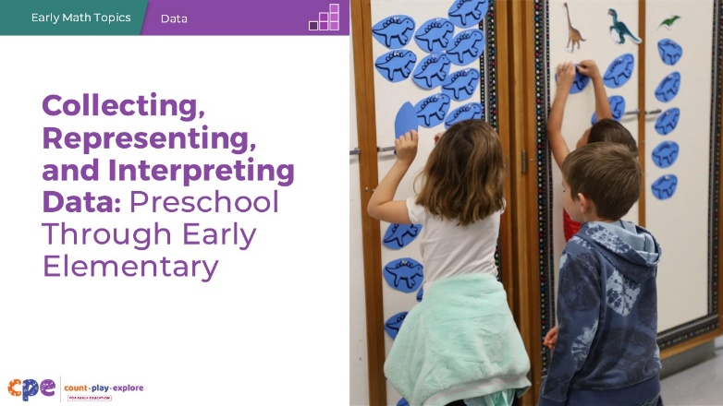

Talking Points
- Welcome! Today, we will explore how young children learn to collect, represent, and interpret data.

Facilitator Notes
- Adjust talking points to include relevant introductions, “housekeeping,” and other important information for your participants.
- You might share with participants that, in this session, we might use “TK” to refer to transitional kindergarten and “K” for kindergarten.

Slide 2: Acknowledgments
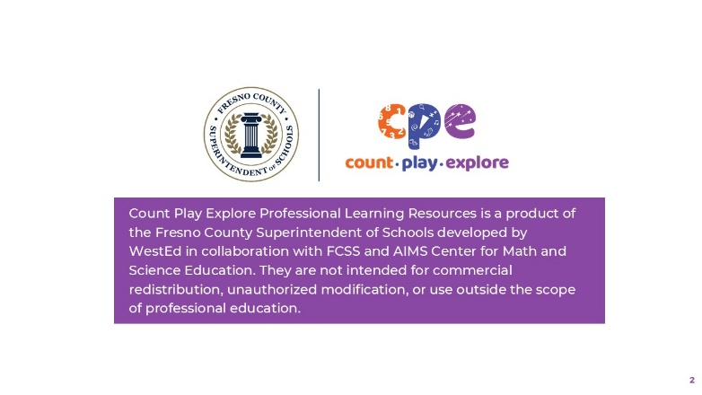

Talking Points
The Count Play Explore Professional Learning Resources were made possible by Count Play Explore, an early math, science, and computer science initiative led by the Fresno County Superintendent of Schools (FCSS), Early Care and Education Department. This initiative is generously funded by the California Department of Education and the California State Board of Education. These resources, developed by WestEd in collaboration with FCSS and the AIMS Center for Math and Science Education, are intended to be used as a guide for implementing evidence-based strategies, promoting active learning, and encouraging developmentally appropriate practices in early education settings. They are not intended for commercial redistribution, unauthorized modification, or use outside the scope of professional education.

Slide 3: Session Goals
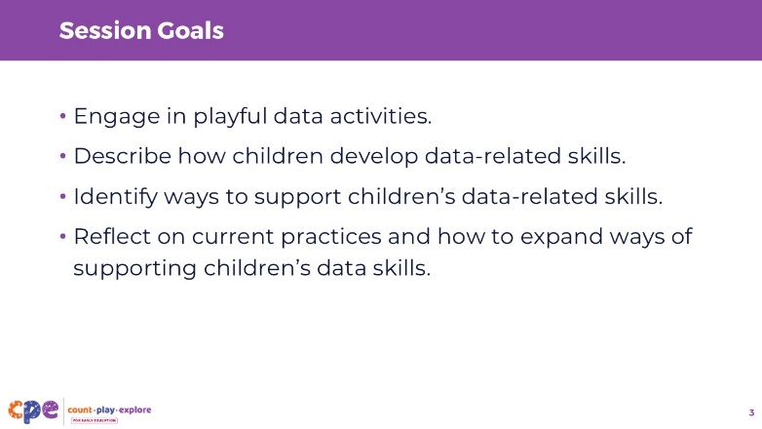

Talking Points
- In this session, we will start by engaging in playful data collection and representation activities.
- Next, we will describe how children learn to collect, represent, and interpret data.
- Then, we will identify ways educators can support children in data collection, representation, and interpretation.
- Throughout the session, we will reflect on our current practices. We will also think about how we might use information from this session in our work.

Facilitator Notes
- Adjust slide content and talking points to reflect what you plan to address in your professional learning session.

Slide 4: Play: Using Data to Tell Our Story
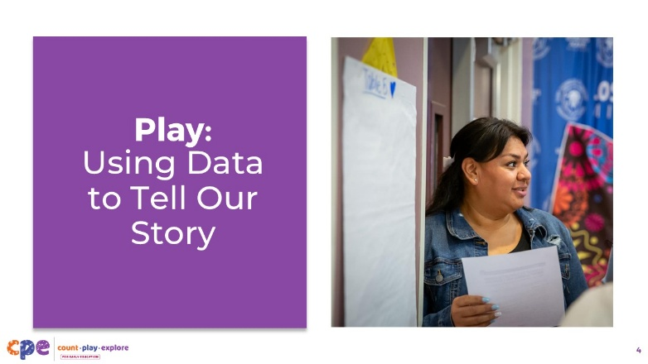
Time: 20–30 minutes (including debrief on the next slide)
Materials: Using Data to Tell Our Story handout, paper, chart paper, markers, stickers

Talking Points
- Let’s begin our session with a data activity so that you can experience all steps of the data collection and representation process.
- Take out the Using Data to Tell Our Story handout. [Review the handout with participants and provide support as needed. Provide guidance on how participants might pair up or create small groups to engage in the activity.]

Facilitator Notes
- Math is playful. This principle is key to the Count Play Explore professional development approach. This activity invites adults to explore data through play.
- Before your session, carefully review the handout and prepare the necessary materials. Select a facilitation method that works best for your session length and format, group size, and participants’ needs.

Slide 5: Discuss: Using Data to Tell Our Story
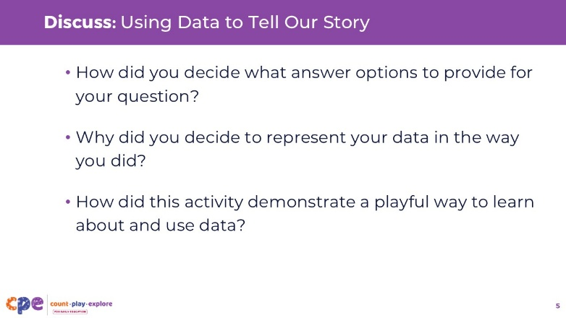
Time: 20–30 minutes (including the activity on the previous slide)
Materials: Using Data to Tell Our Story handout, clipboards with paper, chart paper, colored markers, connecting cubes

Talking Points
- Let’s take some time to discuss how you engaged in the data analysis process through this activity.
  - How did you decide what answer options to provide for your question?
  - Why did you decide to represent your data in the way you did?
  - After going through your own experience of collecting data, how did this activity demonstrate a playful way to learn about and use data?
- Based on the data you have collected, we can consider how we might use that information to plan next steps.
  - [Adapt the examples based on the data collected by educators. For example, you might say, “Knowing that many of you feel nervous about supporting children in data collection, I might slow down the content that I present today and leave more time for questions.” Or, “Knowing many of you enjoy story time, we will take some time today to brainstorm books you might read during story time that allow children to learn about data.”]

Facilitator Notes
- Consider making connections to this activity throughout the session, drawing from participants’ reflections and experiences.

Slide 6: Data: An Overview
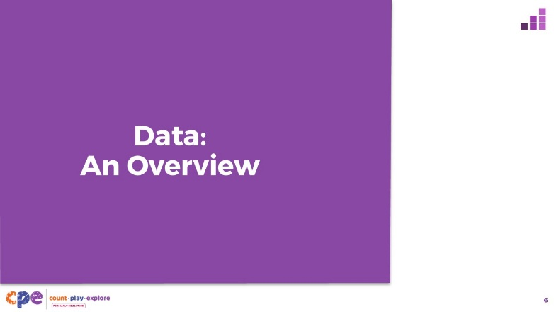

Talking Points
- Before we review how children develop an understanding of data, let’s begin by defining “data.”

Slide 7: What is Data?
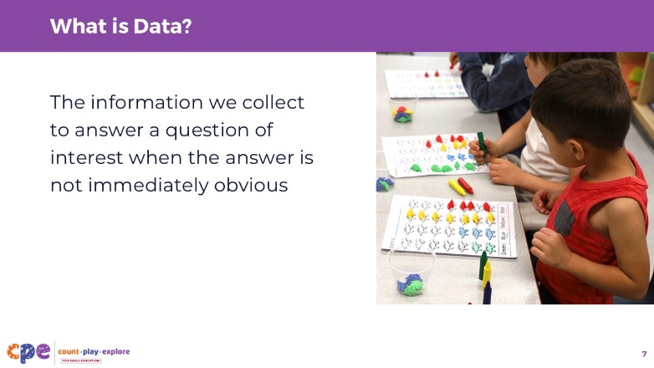

Talking Points
- Data is the information we collect to answer a question of interest when the answer is not immediately obvious.
- It involves important math skills such as sorting, counting, quantifying, comparing, and graphing. Data collection is also an important tool in science and computer science.
- Collecting data happens every day in formal and informal ways. It can resemble more formal methods like surveys and interviews or informal ways such as collecting advice through storytelling, and careful noticing of how your body feels throughout the day. Different cultures collect and use data in different ways. For example, some cultures collect data by using the position of the stars for navigating.
- Our focus in this session is on formalized ways of collecting quantifiable data.

Slide 8: Data is Everywhere!
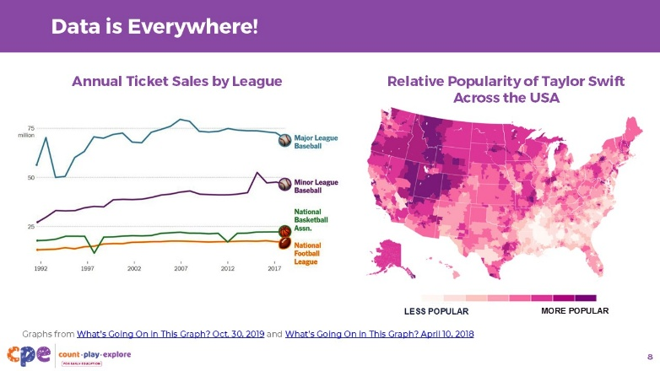

Talking Points
- Data plays an important role in our everyday lives (for example when we look at the weather, follow sports, or listen to music).
- We apply data collection, representation, and interpretation skills in different fields, including science, social studies, economy, and education.
- Let’s review some graphs together.

Slide 9: Average High and Low Temperature in Fresno, CA
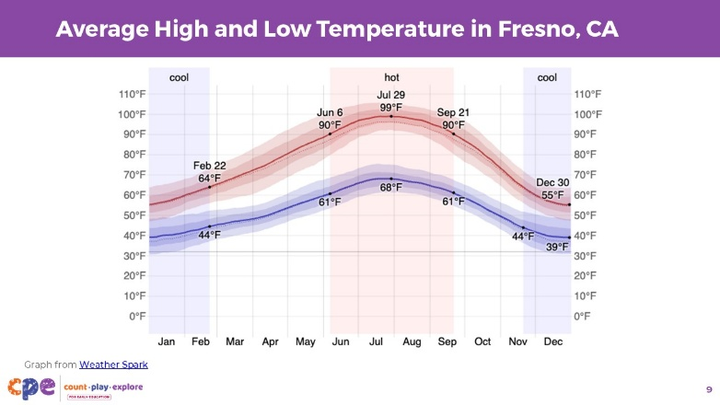

Talking Points
- Let’s observe a graph showing us the average temperature in Fresno, California, by month.
- What does this graph tell us? What month was the hottest? What month was the coolest? How much hotter was the hottest month compared to the coolest month?

Facilitator Notes
- We have provided you with an example graph. Consider changing out the graph to represent a topic that is important to your participants or that demonstrates a theme that is particularly salient at the time you are doing this session.
- Consider using a graph from the following websites:
  - Slow Reveal Graphs
  - Over 75 New York Times Graphs for Students to Analyze

Slide 10: Data as Part of Everyday Routines and Projects
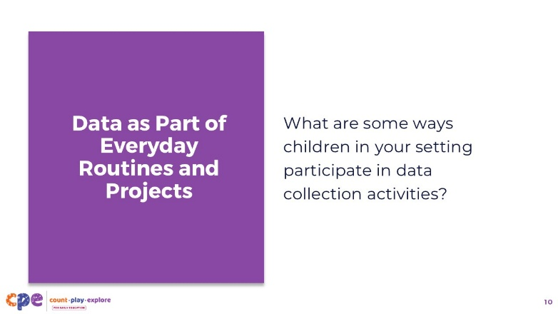

Talking Points
- Now let’s consider how young children engage in data collection and interpretation.
- [Ask participants to discuss the following question:] What are some ways children in your setting participate in data collection activities?
- [Provide time for participants to share their examples. As you discuss the points below, make connections to the examples provided by participants.]
- Children participate in data collection and representation activities as part of everyday routines.
  - For example, children may take part in a “Question of the Day.” The “Question of the Day” is a daily question that is posted in the classroom for children to answer as part of their morning routine. This may include questions like “What is your favorite pet?” “Do you have brown eyes?” or “What do you like to do with your family?”
- Data collection and representation activities can also happen as part of project-based work.
  - For example, as part of a project or unit on transportation, children may collect data on which modes of transportation children take to school.
- Data collection activities also allow educators to survey children in the classroom to make a collective decision or solve a problem.
  - For example, children may vote on what they should name their classroom pet or decide on a way to work together.
  - Data collection can connect to children’s cultural background or relate to their lived experiences at home or in their community.
  - For example, children may vote on their favorite family activity or their favorite home meal.

Facilitator Notes
- Adjust the way you organize the activity based on group size, session length and format, and participants’ needs. For example:
  - For small groups, you might invite participants to share their examples directly with the larger group.
  - For larger groups, you might invite participants to work with a partner and share with the larger group.

Slide 11: Data as Part of Scientific Investigations
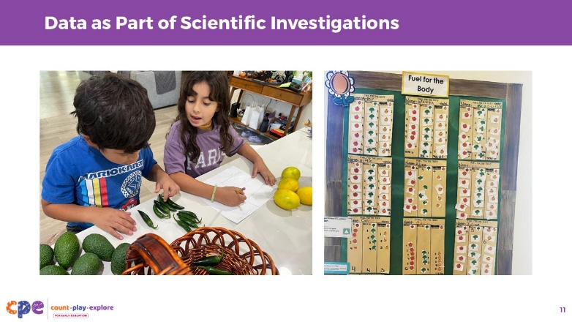

Talking Points
- STEAM investigations—investigations using science, technology, engineering, art, and math to construct meaning about the world—provide a rich context for children to engage in data collection and representation.
- Supporting children to collect data as part of a scientific investigation allows children to answer questions of interest with greater precision and accuracy. For example, data collection and representation allows children to answer questions such as:
  - Did we collect more avocados, lemons, or jalapenos in our garden?
  - Which car rolls farthest down the ramp?
  - Do we see more bees or butterflies in our flower bed?
  - Which month is the hottest? Which month is the coldest?
  - Which of the bridges we built can hold the most weight?

Slide 12: Learning About Data
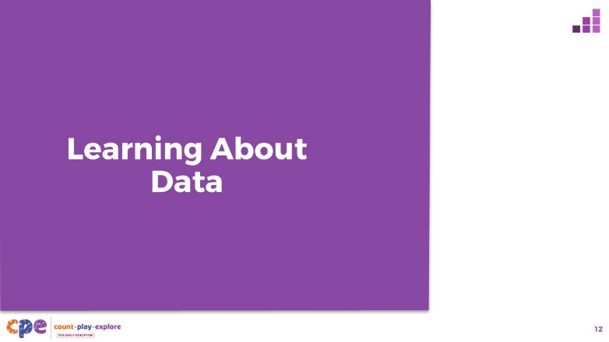

Talking Points
- Let’s discuss how young children develop an understanding of data.

Slide 13: The California Preschool/TK Learning Foundations
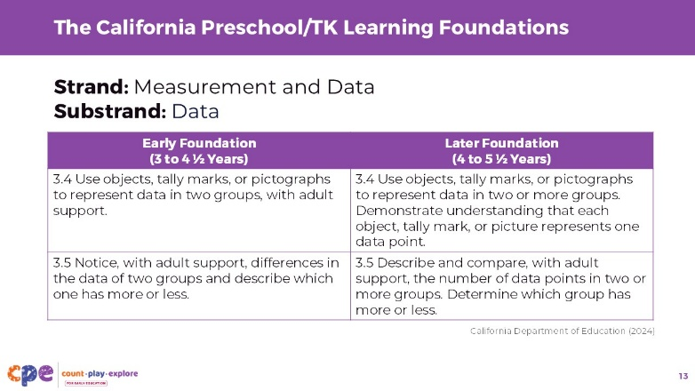

Talking Points
- Let’s review how data understanding is represented in state standards and foundations.
- We will start by reviewing the California Preschool/Transitional Kindergarten Learning Foundations (PTKLF; California Department of Education, 2024). The recently revised foundations were designed to align with expectations stated in the California Common Core Kindergarten Mathematics Standards.
- One foundation in the “Operations and Algebraic Thinking” strand describes children’s ability to sort and classify objects according to their attributes, which is an important skill when collecting and representing data.
- Two foundations in the “Measurement and Data” strand describe children’s ability to represent data and interpret data.
  - The early foundations describe children’s ability to use objects, tally marks, and pictographs to represent data in two groups and decide, with adult support, which group has more or less.
  - The later foundations describe children’s ability to use objects, tally marks, and pictographs to represent data in two or more groups and compare the number of data points in each group. At this age, children also understand that each object, tally mark, or picture represents one data point.

Facilitator Notes
- Slides 13 and 14 make connections to foundations and standards for data.
- The PTKLF addresses children ages three to five. This includes children in both preschool and TK. The California Common Core State Standards in Mathematics include standards for children in kindergarten.
- The foundations and standards listed in some of the slides are condensed. Consider providing participants with copies of the relevant California Preschool/TK Learning Foundations or the California Common Core State Standards. Decide whether electronic or printed copies will be more useful for your participants.

Slide 14: The California Common Core State Standards
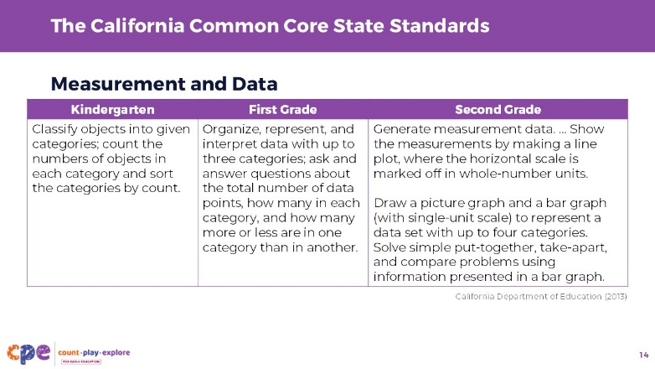

Talking Points
- Let’s review how learning about data is represented in the California Common Core State Standards: Mathematics (California Department of Education, 2013) for children in kindergarten, first grade, and second grade.
- In kindergarten, one standard in the domain “Measurement and Data” describes children’s ability to classify and sort objects into categories and count the number of objects in each category.
- In first grade, one standard describes children’s ability to organize, represent, and interpret data with up to three categories and then to answer questions about the data.
- In second grade, one standard describes children’s ability to represent data using picture graphs, bar graphs, and line plots. Children at this age are also expected to solve problems using information in the graph.

Slide 15: Three Data-Related Skills
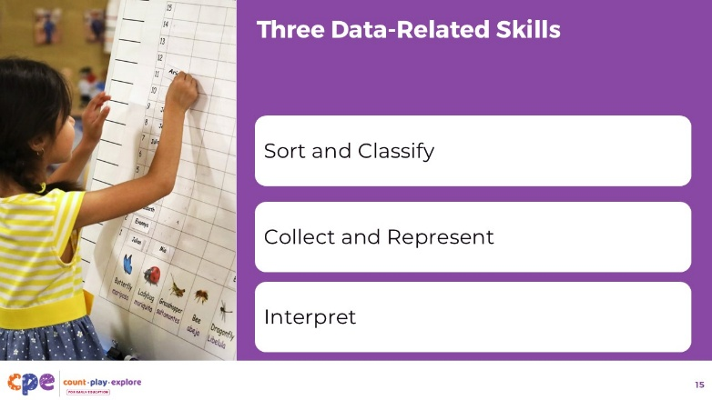

Talking Points
- The following slides describe three important data skills that children develop from preschool to early elementary. These skills include children’s ability to:
  - sort and classify data,
  - collect and represent data, and
  - interpret data.

Slide 16: Let’s Sort
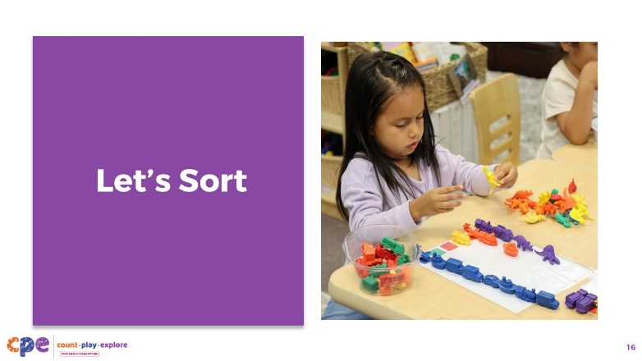
Materials: loose parts that vary in color, size, type, or function such as bottle caps, buttons, shells, counting bears, or colored pebbles.

Talking Points
- Sorting and classifying are the first steps in data collection.
- Let’s take a moment to do some sorting.
  - Notice the materials on your table.
  - Together with the people in your table group, decide how you might sort these items. What are the names of the different groups you have sorted your items into?
  - Are you able to sort these items in another way?

Facilitator Notes
- Provide each table group with a collection of loose parts that vary in color, size, type, or function.

Slide 17: Sorting and Classifying
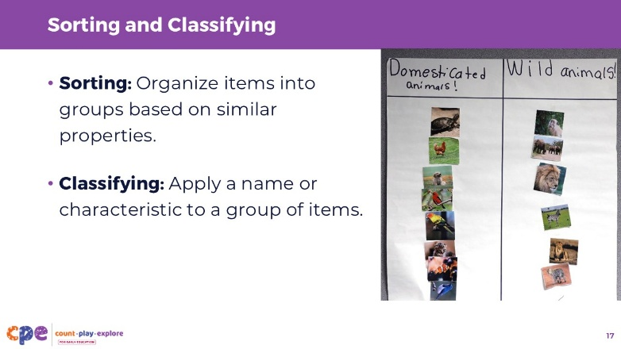

Talking Points
- Sorting involves organizing items into groups based on similar attributes. For example:
  - putting all blue cars in one pile and all red cars in another pile
- Classifying involves arranging objects into groups and naming these groups. For example:
  - naming one of the groups “blue cars” and the other group “red cars”
- Sorting requires children to notice similarities and differences between objects and to separate these objects according to these similar attributes.
- This process of grouping things based on similar attributes provides the foundation for the development of children’s ability to collect and represent data.

Slide 18: Sorting as a Foundation for Data Collection and Representation
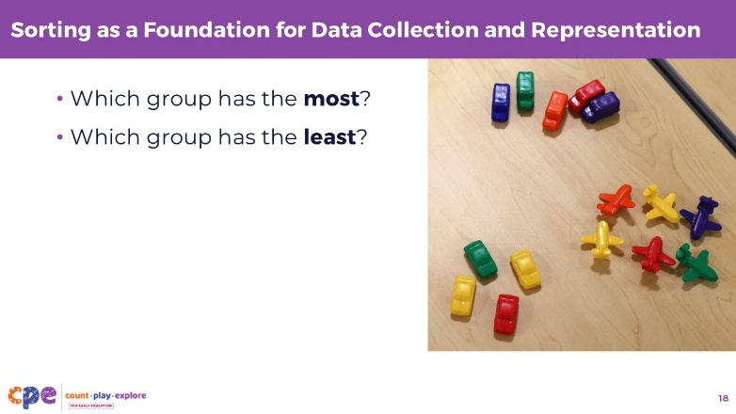

Talking Points
- Once objects are sorted into groups, children can start answering questions.
- What types of questions might children ask after sorting objects into groups?
- [Provide time for participants to answer the question. Then debrief and make connections to participants’ answers.] Children might wonder which group has the most and which group has the least. Children may also want to compare the groups, for example, by counting the number of objects in a group.

Slide 19: Observe: Data Digging with Dinosaurs
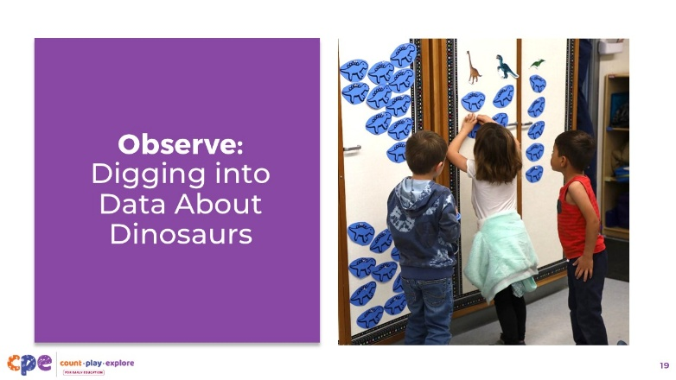
Time: 10–20 minutes (including debrief on the next slide)
Materials: Data video clip

Talking Points
- Let’s observe a video clip of a group of children in TK as they first sort and then collect and represent data on dinosaurs. As you observe, pay attention to the way the children are sorting. How did the children sort the dinosaurs? How did the process of sorting help the children in collecting data?
- After watching the clip, we will discuss what you noticed.

Facilitator Notes
- Choose a video clip related to data.
- We provide the following video clip (you may choose other videos to use):
  - Digging into Data About Dinosaurs (4–5 years)
  - Digging into Data About Dinosaurs (4–5 years) - Audio Descriptive Version

Slide 20: Discuss: Data Digging with Dinosaurs
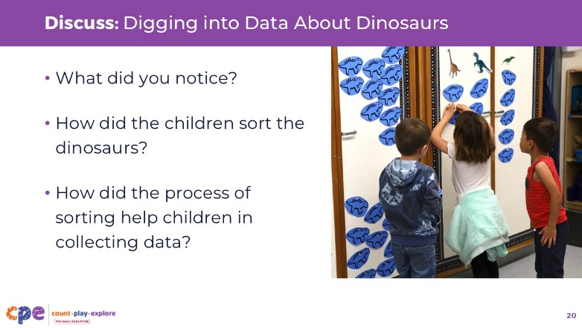
Time: 10–20 minutes (including video observation on the previous slide)

Talking Points
- Let’s discuss what you noticed.
  - What did you notice?
  - How did the children sort the dinosaurs?
  - How did the process of sorting help children in collecting data?

Facilitator Notes
- Adjust the debrief based on your group size, session length and format, and participants’ needs. Consider recording the ideas participants share about the ways children develop an understanding of data collection and representation.
- Consider using the following adaptations based on session length:
  - For shorter sessions, invite participants to share with the larger group what they noticed about ways children showed their knowledge and skills related to data collection and representation.
  - For longer sessions, offer time for participants to share their observations in pairs or at their tables. Then, invite each table to share some of their observations.
- Here are some examples of how children in the video clip “Digging into Data About Dinosaurs (4–5 years)” engaged in sorting and data collection:
  - The educator in the video defined the groups that children would sort the dinosaurs into. She gave them three groups: two-legged walkers, four-legged walkers, and dinosaurs that do not walk. Each child then sorted their dinosaurs into these groups.
  - By first sorting the toy dinosaurs into groups, the children had an initial visual representation of the groups of data they needed to represent.

Slide 21: Data Collection
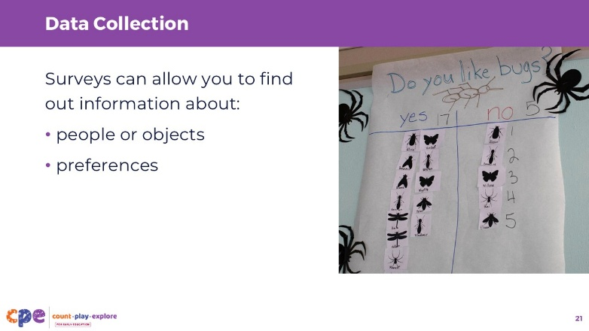

Talking Points
- Some questions can be answered by sorting concrete objects into groups and then counting and representing the number of objects in each group.
  - In the video we just watched, the question was, “Which type of toy dinosaur do we have the most of?” Children sorted the dinosaurs into groups of two-legged walkers, four-legged walkers, and those that do not walk.
- However, not all questions can be answered by sorting concrete objects. Some questions require us to collect information using surveys.
  - Surveys can allow you to find out information about people. For example, “What mode of transportation do you use to get to school?” or “How many children have a birthday in the month of March?”
  - Surveys can also allow you to collect information about preferences. For example, “What is your favorite flavor of ice cream?” or voting for the name of a classroom pet.
- Other questions can be answered by documenting observations. For example:
  - How did the sunflower grow over time?
  - Do we have more rainy or sunny days in April?

Slide 22: Data Representation
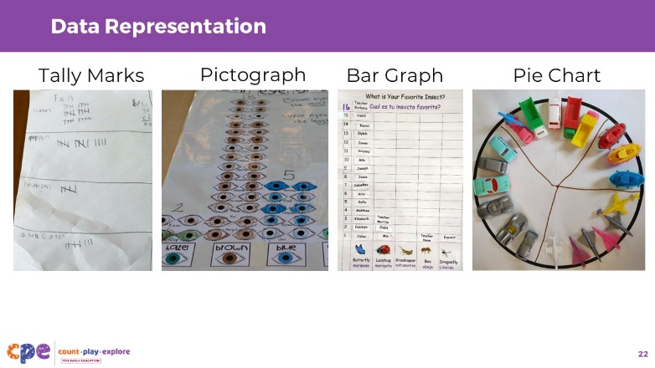

Talking Points
- Representing data in tables, charts, or graphs is a powerful way to visually show children the different number of objects in each group. It allows children to observe the data they have collected and draw conclusions.
- The processes of data collection and representation are related and sometimes happen at the same time. For example, educators may set up a table or chart with columns for each group. As children collect their data, they might add a data point under the appropriate column. As such, they are collecting their data and simultaneously representing it in a table.
- Different ways children in preschool or early elementary can record their data points onto a table or chart include the following:
  - Tally marks—adding a tally mark for each data point
  - Pictographs—drawing a picture or adding a sticker for each data point
  - Bar graphs—coloring a square, adding names, or adding a connecting cube to a bar for each data point
  - Pie chart—slices or wedges of a circle showing each group

Slide 23: Observe: Collecting Pumpkin Data
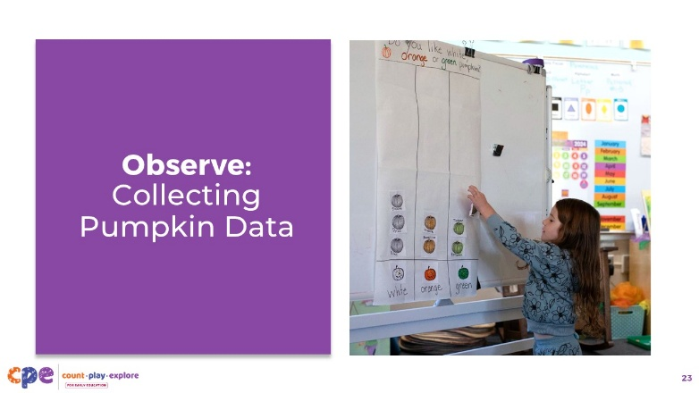
Time: 10–20 minutes (including debrief on the next slide)
Materials: Preschool, TK, or K data video clip

Talking Points
- Let’s observe a video clip of a group of preschool children as they collect data about their favorite pumpkin color. As you observe, pay attention to the way children are collecting their data. How did the educator scaffold this experience for the children?
- After watching the clip, we will discuss what you noticed.

Facilitator Notes
- Choose a video clip related to data.
- We provide the following video clip (you may choose other videos to use):
  - Collecting Pumpkin Data (3–5 years)
  - Collecting Pumpkin Data (3–5 years) - Audio Descriptive Version

Slide 24: Discuss: Collecting Pumpkin Data
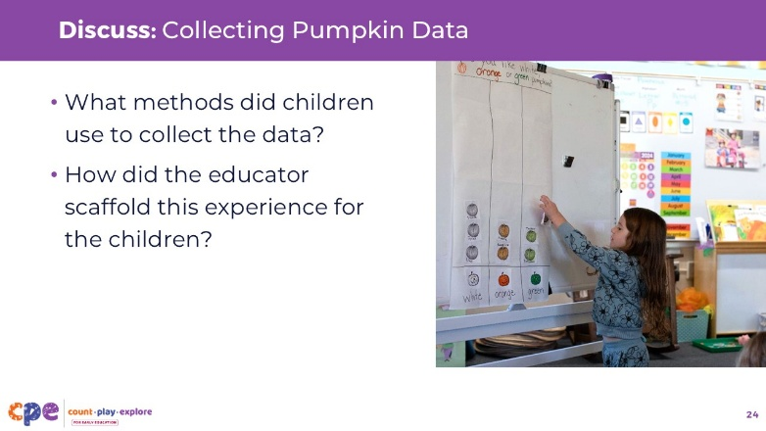
Time: 10–20 minutes (including video observation on the previous slide)

Talking Points
- Let’s discuss what you noticed.
  - What methods did children use to collect the data?
  - How did the educator scaffold this experience for the children?

Facilitator Notes
- Adjust the debrief based on your group size, session length and format, and participants’ needs. Consider recording the ideas participants share about the ways children develop an understanding of data collection and representation.
- Consider using the following adaptations based on session length:
  - For shorter sessions, invite participants to share with the larger group what they noticed about ways children showed their knowledge and skills related to data collection and representation.
  - For longer sessions, offer time for participants to share their observations in pairs or at their tables. Then, invite each table to share some of their observations.
- Here are some examples of ways children in the video clip “Collecting Pumpkin Data (4–5 years)” engaged in data collection:
  - As children arrived at school, they answered the question, “What is your favorite pumpkin color?” by adding a picture to the correct column of a chart. The educator scaffolded this experience by providing guidance on where children might place their picture and explaining what each column represented.
  - In addition, each child surveyed all other children in their classroom and collected data on their own personal chart. Children were able to choose how they preferred to record the data: using tally marks or pictures.

Slide 25: Data Collection and Representation: Development
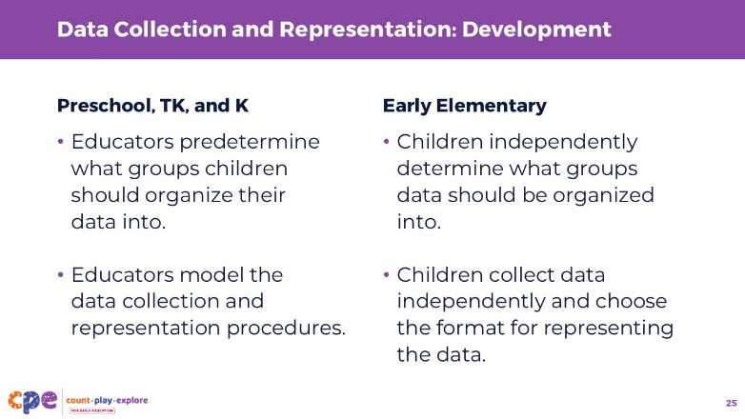

Talking Points
- From preschool to the early elementary years, children can engage in similar data collection and representation activities and may even answer similar types of questions. However, the level of scaffolding and support from the educator will change. As children become more experienced with the data collection and representation process, they will be able to engage in the activities more independently.
- For example, for the process of determining what groups data is sorted into:
  - In preschool, TK, and K, educators may predetermine what groups children should organize their data into. Predetermining groups for younger children allows them to focus specifically on the process of collecting data from everyone in the classroom and sorting it into the correct groups.
  - In early elementary, children may independently decide the groups that their data is sorted into and name their groups. Allowing older children to be part of the process of determining the groups helps them understand all steps involved in managing and collecting data.
- In addition, for the process of collecting data:
  - In preschool, educators may provide chart templates for children to use, and educators may need to model where to place tally marks or what each column of the chart represents.
  - In early elementary, children may independently choose how to organize their chart or graph. They will also be able to collect their data more independently; for example, by surveying everyone in their class or conducting observations.

Slide 26: Data Interpretation
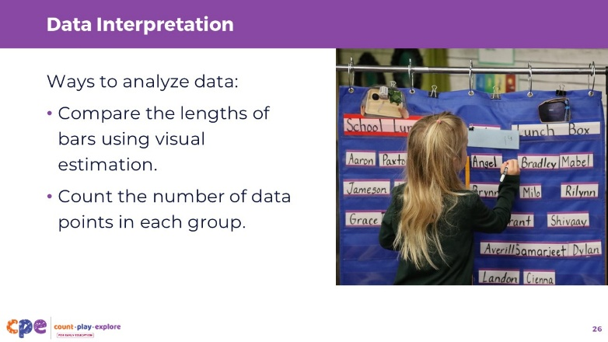

Talking Points
- Once the data is collected and represented, children can engage in data interpretation. Interpreting data can be done using a variety of methods:
  - comparing the lengths of bars in two groups using visual estimation
  - counting the number of data points in each group (such as tally marks or pictographs) to determine which one has more

Slide 27: Data Interpretation: Development
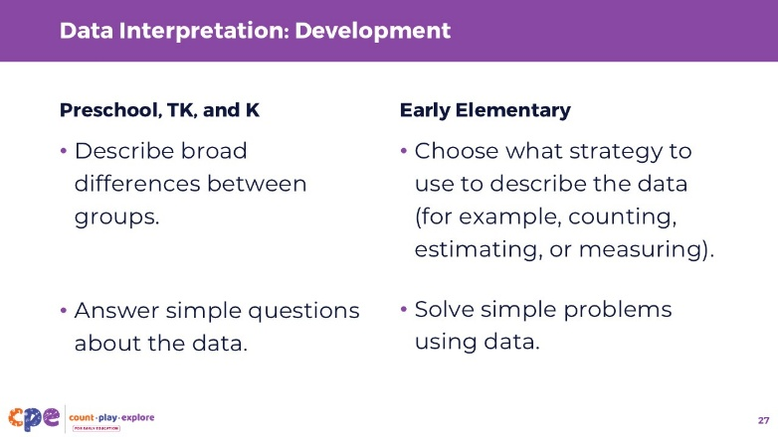

Talking Points
- Let’s review how children develop their data interpretation skills from preschool to early elementary.
- Children develop their ability to notice and describe patterns in data:
  - In preschool, TK, and K, children notice and describe differences between groups more broadly, such as “this one has more” or “this tower is bigger.” Educators can encourage children to be more precise in their observations by suggesting they count the number of data points in each group.
  - In early elementary, children may use different strategies, such as counting, estimating, or measuring, when describing and comparing the number of data points in each group.
- In addition, children grow in their ability to draw conclusions from data:
  - In preschool, TK, and K, children can answer simple questions about the data such as, “Which group has the most?” or “Which group has the least?” This allows children to draw broad conclusions.
  - In early elementary, children can answer more specific questions that involve some problem-solving, such as “How many more are in this group compared to the other one?” or “How many data points are there all together?”

Slide 28: Supporting Data Collection and Representation
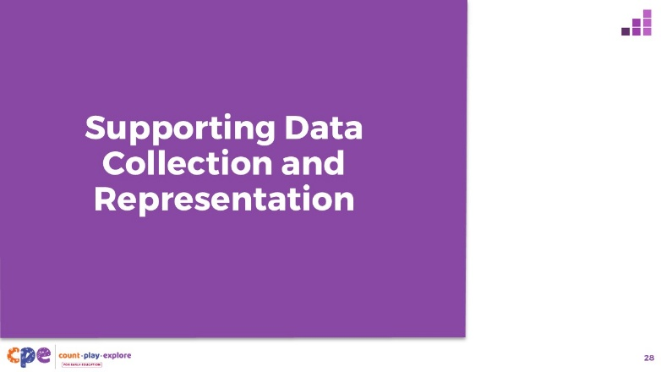

Talking Points
- We explored how children develop an understanding of data. Now, let’s discuss ways to support children in learning about data—in our learning settings and at home.

Slide 29: Explore: M⁵ Early Math Approach
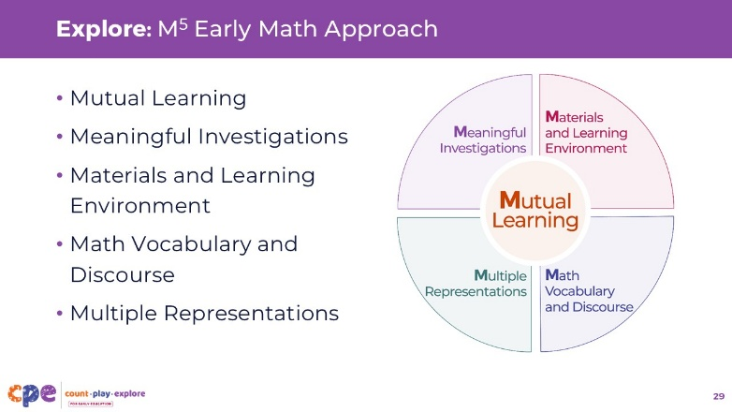
Time: 15 minutes
Materials: M⁵ Overview handout

Talking Points
- We refer to five core early math teaching practices as the M⁵ Early Math Approach. These practices include the following:
  - Mutual Learning
  - Meaningful Investigations
  - Materials and Learning Environment
  - Math Vocabulary and Discourse
  - Multiple Representations
- Let’s explore the M⁵ practices using the M⁵ Overview handout.

Facilitator Notes
- Consider your participants and their prior experiences with the M⁵ Early Math Approach. Then, decide how you might use the M⁵ Overview handout.
  - For groups with significant experience with M⁵ practices, you might offer a few minutes for participants to review the handout and share their areas of strength and practices they are working on with a partner. You can also use this slide to revisit the M5 practices briefly and move to the next slide.
  - For groups with less experience with M5 practices, you might offer more time for participants to explore each practice in the handout. For example, you might allow time for them to review the practices independently. Invite them to make a square over practices that they have “squared away” (practices they understand and use), a circle over “what’s still going around in their heads” (practices they still have questions about), and a triangle over three ideas that they will use in their settings. For more ideas on providing a more comprehensive review, visit the M⁵ Early Math Approach suite.

Slide 30: Observe: M⁵ in Action
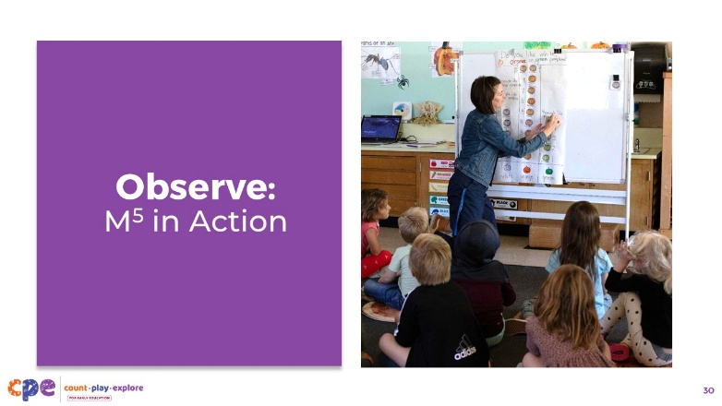
Time: 15–20 minutes (including debrief on the next slide)
Materials: Observing M⁵ in Action: Data handout; Preschool, TK, or K data video clip

Talking Points
- Let’s observe a video clip of the same group of preschool children as they interpret the data they have collected about pumpkins. As you observe, pay attention to the strategies children use to determine which group had more and which had less. How did the educator scaffold this experience for the children?
- After watching the clip, we will discuss what you noticed.

Facilitator Notes
- Choose a video clip related to data collection, presentation, or interpretation.
- We provide the following video clip (you may choose other videos to use):
  - Interpreting Pumpkin Data (4–5 years)
  - Interpreting Pumpkin Data (4–5 years) - Audio Descriptive Version
- Invite participants to use the Observing M⁵ in Action: Data handout.
- For larger groups and longer sessions, use a jigsaw approach. Before playing the video clip, assign each table one practice to focus on during the video. If there are more than five tables, assign more than one table to focus on each practice.
- For smaller groups and shorter sessions, consider showing the video clip two to three times, inviting participants to focus on specific practices each time. Encourage them to record observations on the handout.

Slide 31: Discuss: M⁵ in Action
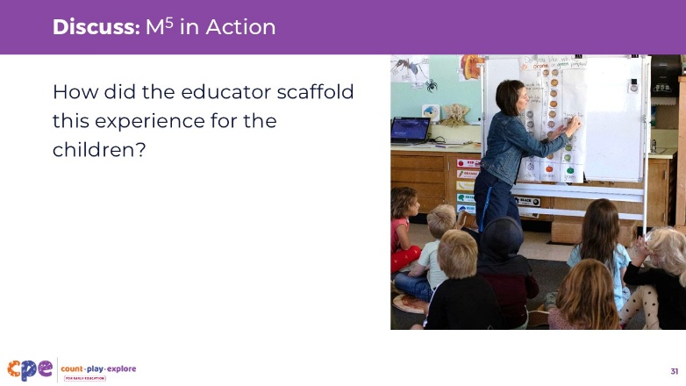
Time: 15–20 minutes (including video observation on the previous slide)

Talking Points
- Let’s discuss what you noticed.
  - How did the educator scaffold this experience for the children?

Facilitator Notes
- Adjust the debrief based on your group size, session length and format, and participants’ needs.
  - For larger groups or longer sessions: After observing the video clip, ask each table group to discuss what they noticed about their assigned practice. Then, invite each group to share their observations with the larger group. As each group shares, paraphrase, affirm, and add to their responses as needed. Consider charting each group’s observations to make practices visible.
  - For smaller groups or shorter sessions: Invite participants to share their observations with the whole group. Chart their observations to make the practices visible. As participants share, paraphrase, affirm, and add to their responses as needed. Consider inviting participants to share something they learned with someone from another table. For example, ask them to find someone with a similar colored shirt, move to meet them, and share something they learned about that person.
- Here are some examples of how the educator scaffolded the experience for children in the video clip “Interpreting Pumpkin Data (4–5 years)”:
  - This activity was a meaningful investigation for children since it was based on a question of interest (“Do you like white, orange, or green pumpkins?”), and children worked together to find the answer. Children were able to answer this question through collecting, representing, and interpreting data.
  - The educator asked children open-ended questions such as, “What did you notice?” This open-ended question allowed children to demonstrate their understanding in different ways. Some children compared the sizes of the different groups; one child counted the total number of data points in the graph. Through this, the educator learned more about children’s emerging skills and knowledge.
  - Children were introduced to and used a variety of comparative vocabulary such as more, less, most, least, and medium.
  - As was seen in the previous video Collecting Pumpkin Data (4–5 years), children were encouraged to collect data both individually (by surveying children across the class using a clipboard) and as a group using the large chart. This is an example of multiple representations.

Slide 32: Explore: Using M⁵ to Support Learning About Data
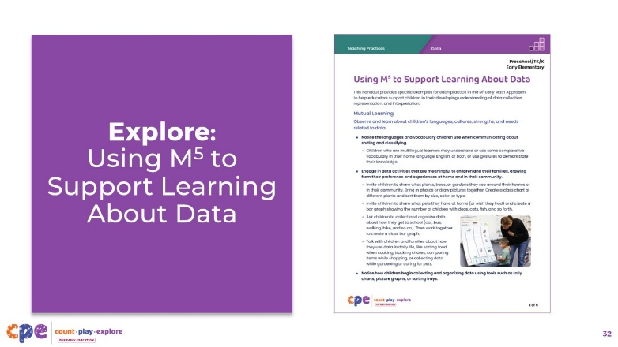
Time: 20–30 minutes (including debrief on the next slide)
Materials: Using M⁵ to Support Learning About Data handout for preschool, TK, and K; Using M⁵ to Support Learning About Data handout for early elementary; paper; and markers

Talking Points
- Let’s consider ways to use M⁵ teaching practices to support children’s understanding of data.
- Take out the Using M⁵ to Support Learning About Data handout.
- Review the ideas on using M⁵ to support children to develop data skills. As you read through this handout:
  - Draw a star next to any strategies you would like to try.
  - Draw a square around any strategies you already use—things you have “squared-away.”
  - Draw a circle around any strategies you still have questions about—things that are “circling” in your mind.
  - Each group will have 2–3 minutes to share with the whole group.
- [For shorter sessions:] Consider the practices you reviewed. With a partner, discuss what you might want to try and why. [If time permits, invite some participants to share with the larger group what practices they will try and why.]
- [For longer sessions, use slide 33 to facilitate the discussion.]

Facilitator Notes
- Consider the participants in your session and what age group of children they work with. Decide whether you want to present them with the Using M⁵ to Support Learning About Data handout that is specific to children in preschool, TK, and K or the handout that is for children in early elementary. You may also consider providing them with the handouts for both age groups and letting the participants decide which one to review.
- Provide 5–7 minutes for participants to review the handout independently.

Slide 33: Discuss: Using M⁵ to Support Learning About Data
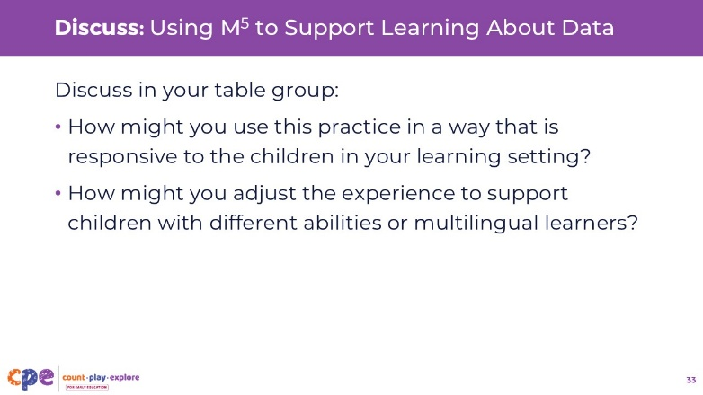
Time: 20–30 minutes (including review of the document on the previous slide)
Materials: Using M⁵ to Support Learning About Data handout, paper, and markers

Talking Points
- Now, let’s discuss the handout.
  - In your table group, discuss the strategies that you have drawn a star next to, so the strategies you would like to try.
- Consider the following questions:
  - How might you use this practice in a way that is responsive to the children in your learning setting?
  - How might you adjust the experience to support children with different abilities or multilingual learners?
- [After each group has shared:] You reviewed some ways to use the M⁵ Early Math Approach to support children’s understanding of data. Hopefully, you will find these strategies helpful in your setting.

Facilitator Notes
- Move around the room while participants work in groups. Provide support as needed.

Slide 34: Reflect: Connect, Extend, Challenge
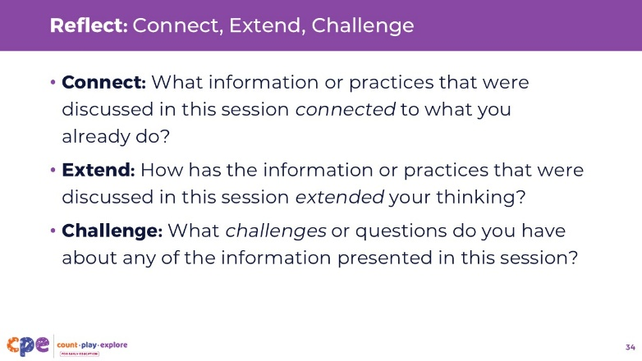
Time: 5–10 minutes
Materials: Paper, pens

Talking Points
- We discussed three foundational skills in children’s understanding of data: sorting and classifying, collecting and representing, and interpreting.
- We also discussed ways you can support children in developing these foundations skills.
- We will end our session today with some reflection.
- Take a piece of paper and divide it into three columns. Then add the following headings to these columns: Connect, Extend, and Challenge.
- What information or practices that were discussed in this session connected to what you already do? Record your examples in the “Connect” column.
- [Allow two minutes for participants to write down their ideas.]
- How has the information or practices that were discussed in this session extended your thinking? Record your examples in the “Extend” column.
- [Allow two minutes for participants to write down their ideas.]
- What challenges or questions do you have about any of the information presented in this session? Record your examples in the “Challenge” column.
- [Allow two minutes for participants to write down their ideas. Then choose a facilitation approach from the facilitator notes below and provide 3–5 minutes for participants to share what they recorded on their paper with others].
- Thank you for your time, attention, and engagement. It has been wonderful working with you.

Facilitator Notes
- Adjust the way you debrief the activity based on group size, session length and format, and participants’ needs.
  - For small groups, go through each column one by one and invite participants to share what they recorded with the whole group.
  - For large groups, invite participants to go through each column one by one and share with their table group.

