Addition and Subtraction: Preschool, Transitional Kindergarten, and Kindergarten (PPT 2b)
Use this facilitator guide with the slides “Addition and Subtraction: Preschool, Transitional Kindergarten, and Kindergarten.” This set of slides provides descriptions of how children in preschool, transitional kindergarten (TK), and Kindergarten (K), develop an understanding of addition and subtraction and ways educators can support them to solve addition and subtraction problems. Facilitators can find talking points and guidance for activities and group discussions in this guide. The same text is also located in the notes portion of the slides. Adapt this facilitator guide based on your group size, session length and format, and participants’ needs.

Session At-a-Glance
Slide numbers | Overview of content | Approximate time (in minutes)
1-3 | Introduction & session goals | 5
4-16 | How children in preschool, TK, and K understand and use addition and subtraction:  - Video observation  - California learning foundations and standards  - Adding makes more and taking away makes less  - Composing and decomposing numbers  - Activity for children | 25-35
17-24 | How children solve addition and subtraction problems:  - Adult activity  - Counting strategies | 20-35
25-34 | How to support children to add and subtract:  - Observing and discussing M⁵  - Adding and subtracting with stories | 45-75
35 | Reflection and Planning | 5-7
The times are approximate and may vary based on session goals, group size, and participants’ previous experience and familiarity with the content.

To Prepare for Your Session
- As you plan your professional learning session, consider the content in each of the PowerPoint presentations (PPTs) in this suite:
  - PPT 1 “Introduction to Addition and Subtraction: Birth—8 Years” describes how children (birth to eight years old) develop foundational concepts of addition and subtraction.
  - PPT 2b “Addition and Subtraction: Preschool, Transitional Kindergarten, and Kindergarten” and PPT 2c “Addition and Subtraction: Early Elementary” describe in greater depth how children at different age levels develop their understanding and ways of solving addition and subtraction problems. These PPTs also include ideas on how to support children in specific age ranges to add and subtract.
  - Note: This suite does not offer a PPT 2a that focuses on infants’ and toddlers’ development of addition and subtraction concepts. Content related to infants and toddlers is addressed in PPT 1 “Introduction to Addition and Subtraction.” For more information on ways infants and toddlers develop knowledge and skills related to addition and subtraction, review the Number and Counting suite. The way infants and toddlers understand addition and subtraction is closely related to their knowledge of and skills with number and counting.
- We encourage you to offer the content in PPT 1 before, or in combination with, the content in PPT 2b. If your participants work with children in more than one age range, you might combine parts of PPT 2b and PPT 2c in one session or a series of sessions. Together, PPT 1 and one of the age-specific slide decks have been designed for about three hours of professional learning. However, you may adjust slide decks to best meet participant needs and time allowances.
- Adjust talking points to reflect your session length and participant needs. If necessary, add introductory and “housekeeping” information.
- When appropriate, remind participants that “TK” refers to transitional kindergarten and “K” refers to kindergarten.
- Before your session, carefully review all handouts and prepare the necessary materials. Select a facilitation method that works best for your session length and format, group size, and participant needs.

Materials Needed
- Scratch paper, chart paper, and writing tools
- Dice (optional)
- Collections of small objects (for example, paper clips, shells, cotton balls, counting chips) that participants can use to engage in adding and subtracting experiences throughout this session. If your agency implements Counting Collections, you might provide some of these collections or invite educators to bring their own collections of objects from their learning settings.
- Animal Islands handout, materials to play Animal Islands (optional)
- Alphabet Counting handout
- M⁵ Overview handout
- Observing M⁵ in Action: Addition and Subtraction handout
- Using M⁵ to Support Learning About Addition and Subtraction handout
- Using Children’s Literature to Support Addition and Subtraction handout, children’s books that include opportunities to add or subtract (see suggested titles in the Facilitator Notes)

SLIDE 1: Addition and Subtraction: Preschool, Transitional Kindergarten, and Kindergarten
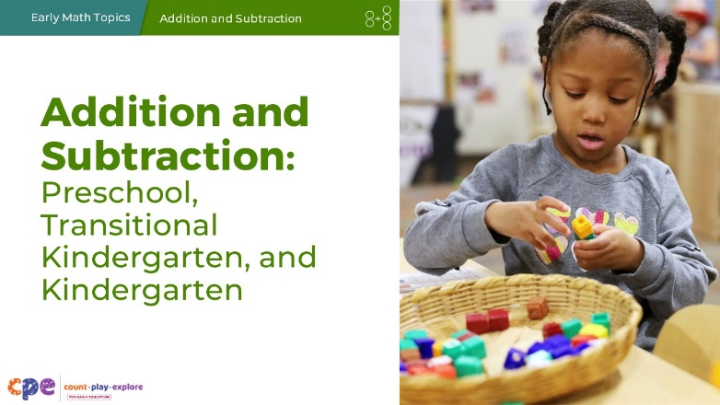

Talking Points
- In this session, we will explore how children in preschool, transitional kindergarten (TK), and kindergarten (K) develop an understanding of addition and subtraction. We will also focus on ways we can support children (three to six years old) to understand and use addition and subtraction.
- We will use “TK” to refer to transitional kindergarten and “K” for kindergarten.

Facilitator Notes
- Adjust talking points to reflect your session length and participant needs. If necessary, add introductory and “housekeeping” information.

SLIDE 2: Acknowledgments
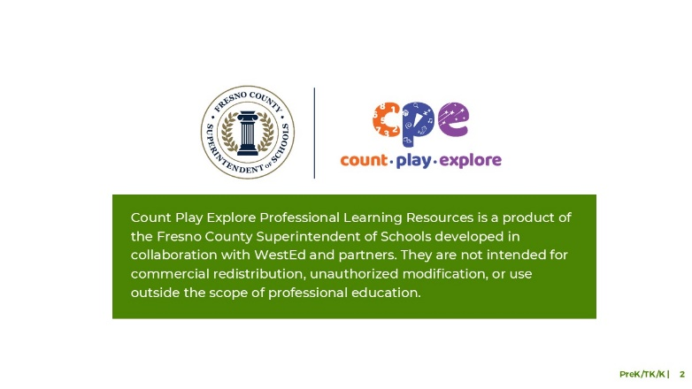

Talking Points
The Count Play Explore Professional Learning Resources were made possible by Count Play Explore, an early math, science, and computer science initiative led by the Fresno County Superintendent of Schools, Early Care and Education Department. This initiative is generously funded by the California Department of Education and the California State Board of Education. These resources are intended to be used as a guide for implementing evidence-based strategies, promoting active learning, and encouraging developmentally appropriate practices in early education settings. They are not intended for commercial redistribution, unauthorized modification, or use outside the scope of professional education.

SLIDE 3: Session Goals
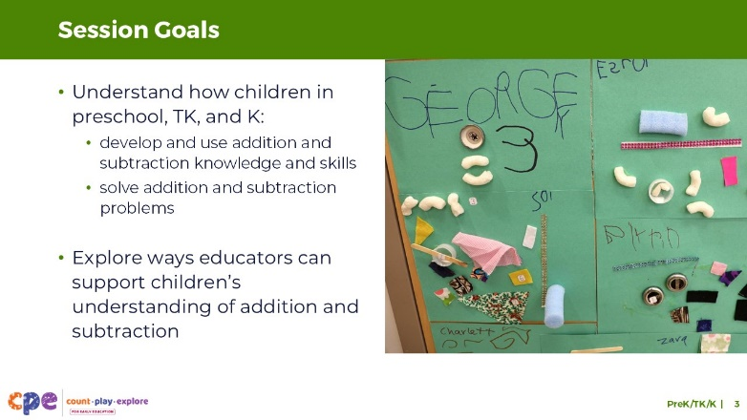

Talking Points
- Our goals for this session are the following:
  - Understand how children in preschool, TK, and K develop addition and subtraction knowledge and skills, and use this knowledge to solve addition and subtraction problems.
  - Explore ways educators can support children’s understanding of addition and subtraction.
- Throughout our session, we will take time to reflect on our current practices. We will also think about how we could use information from this session in our work.

Facilitator Notes
- Adjust slide content and talking points to reflect what you plan to address in your professional learning session.

SLIDE 4: Observe: Children Adding and Subtracting
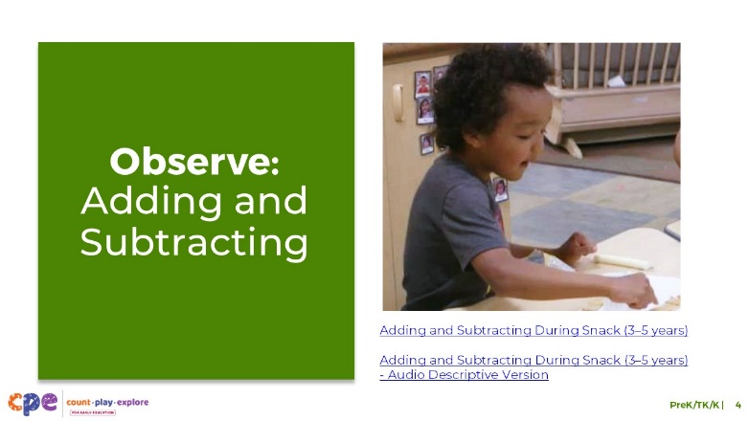
Time: 5–10 minutes
Materials: Video clip of children adding and subtracting in preschool, transitional kindergarten, or kindergarten.

Talking Points
- Let’s begin by observing children using addition and subtraction.
- As you observe the clip, notice how children add or subtract and ways the educators support them. You might consider ways you have noticed children in your settings adding and subtracting in similar or different ways.
- [Choose a strategy for facilitating this observation. Adapt the talking points to reflect this strategy.]
- Thank you for sharing what you noticed about the ways children add and subtract and ways educators support them. In this session, we will explore more about how children learn and use addition and subtraction.

Facilitator Notes
- Choose a video clip that shows children learning about and using addition or subtraction.
- We provide the following video clips (you may use other videos):
- In this video, children explore adding and subtracting while eating crackers at snack time. Children use counting strategies to add or subtract.
  - Adding and Subtracting During Snack (3–5 Years)
  - Adding and Subtracting During Snack (3–5 Years) - Audio Descriptive Version
- In this video, children compose and decompose the number 5 using concrete objects in an educator-led experience. Version: In this video, children compose and decompose the number 5 using concrete objects in an educator-led experience.
  - Composing and Decomposing the Number 5 (3–5 Years)
  - Composing and Decomposing the Number 5 (3–5 Years) - Audio Descriptive Version
- In this video, an educator shares a book with children and supports them in adding and subtracting as it relates to the story.
  - Adding During Storytime (3–5 Years)
  - Adding During Storytime (3–5 Years) - Audio Descriptive Version
- In this video, an educator shares a book with children about ten dinosaurs coming to a party, one at a time. Then, the dinosaurs leave the party, one at a time. The children model the action in the story, pretending to be the dinosaurs arriving and leaving the party.
  - Counting and Adding While Reading (3–5 Years)
  - Counting and Adding While Reading (3–5 years) - Audio Descriptive Version
- For larger groups or shorter sessions, invite participants to share with the larger group what they noticed about the ways children added or subtracted and ways they have noticed children in their settings adding and subtracting in similar or different ways.
- For smaller groups or longer sessions, encourage participants to discuss with pairs or their table group. Then, invite participants to share with the larger group what they noticed about ways children added or subtracted and ways they have noticed children in their settings adding and subtracting in similar or different ways.

SLIDE 5: Adding and Subtracting to Solve Problems of Interest
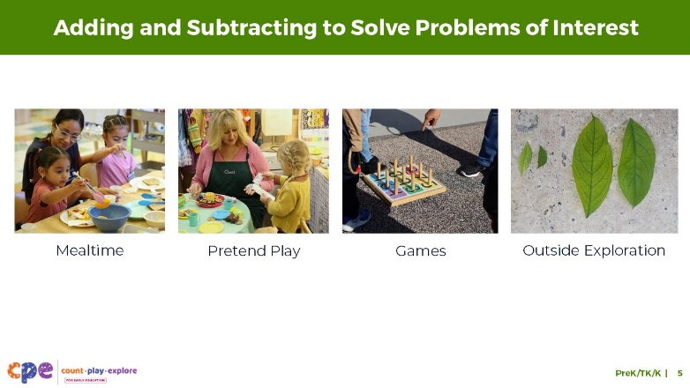

Talking Points
- Children learn about addition and subtraction as part of daily interactions and play when provided opportunities to add and subtract to solve problems of interest.
- For example, children might add or subtract when engaging in the following:
  - Eating a snack or preparing for a meal: Children might subtract to figure out how many orange slices are left after they take some.
  - Engage in pretend play: Children might add to find out how much pretend money their customer needs to buy three apples in the café.
  - Playing a game: Children might add points to determine who is the winner.
  - Exploring outside: Children might collect and sort rocks, leaves, or other natural materials and use addition to find a total amount. For example, 2 big leaves plus 2 small leaves make 4 leaves in all.
- Addition and subtraction experiences that are a part of daily interactions and play build on children’s interests, enhance engagement, and allow children to physically manipulate and explore how adding and subtracting changes quantity—deepening children’s understanding of these math concepts.
- In this session, we will explore ways educators can use authentic, daily experiences and concrete objects to support children to add and subtract in ways that are most effective for them.

Facilitator Notes
- Consider inviting participants to share the ways children in their learning setting might add or subtract in different contexts and with different concrete objects.

SLIDE 6: Learning About Addition and Subtraction
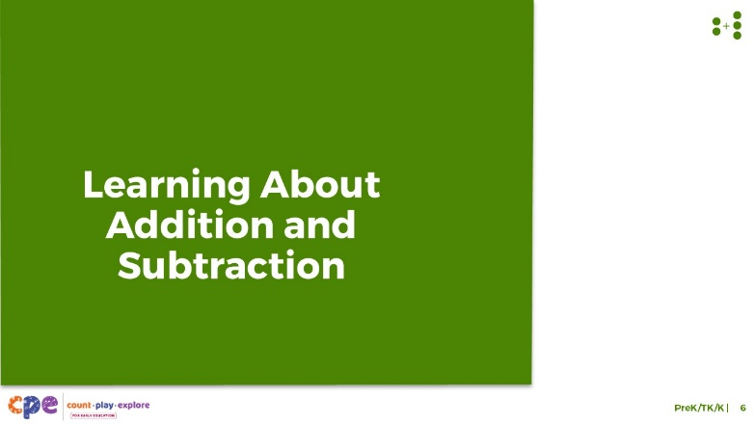

Talking Points
- Now, we will explore how children in preschool, TK, and K understand and use addition and subtraction.

SLIDE 7: The California Preschool/TK Learning Foundations: Number Operations
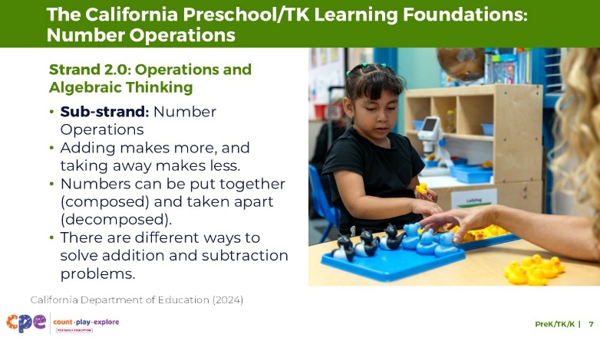

Talking Points
- Let’s review how addition and subtraction is described in the Preschool/Transitional Kindergarten Learning Foundations (California Department of Education, 2024).
- There are three preschool/TK foundations that describe what children learn about addition and subtraction.
- These foundations are within Strand 2.0, Operations and Algebraic Thinking, within the sub-strand Number Operations.
- These foundations describe children’s ability to demonstrate the following:
  - Adding makes more, and taking away makes less.
  - Numbers can be put together (composed) and taken apart (decomposed).
  - There are different ways to solve addition and subtraction problems.

Facilitator Notes
- Note: Place this slide featuring California Preschool/TK Learning Foundations and slide 8 featuring Kindergarten Common Core Standards where they work best for your participants’ needs.
- Consider providing participants with copies of the relevant California Preschool/TK Learning Foundations: OA.2.1–2.3.

SLIDE 8: California Common Core—Kindergarten
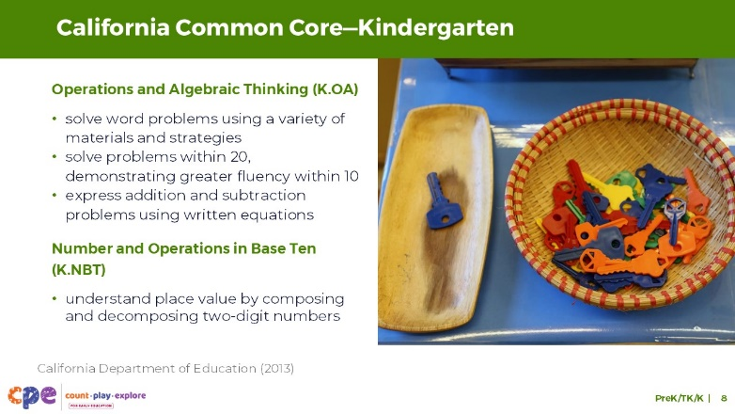

Talking Points
- Let’s review how addition and subtraction is represented in the California Common Core State Standards (California Department of Education, 2013).
- A variety of kindergarten standards describe what children learn about addition and subtraction.
- Standards under the “Operations and Algebraic Thinking” strand describe children’s ability to do the following:
  - solve word problems using a variety of materials and strategies (For example, the standards highlight counting on, making 10, and decomposition strategies.)
  - solve problems within 20, demonstrating greater fluency within 10
  - express their addition and subtraction problems using written equations
- The “Number and Operations in Base Ten” strand also includes a standard related to addition and subtraction.
  - This standard describes how children understand place value by composing and decomposing two-digit numbers. For example, children learn that 11 is composed of 10 and 1.

Facilitator Notes
- Consider providing participants with copies of the relevant California Common Core State Standards: K.OA.1–5 and K.NBT.1.

SLIDE 9: What Children Understand About Addition and Subtraction
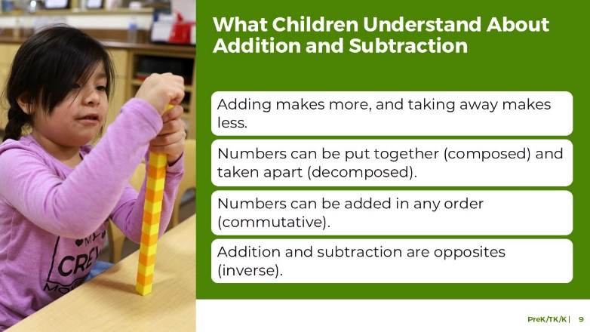

Talking Points
- We will start by reviewing what children understand about addition and subtraction. From infancy and into early elementary, children will develop an understanding of math concepts, such as the following:
  - Adding makes more, and taking away makes less.
  - Numbers can be put together (composed) and taken apart (decomposed).
  - Numbers can be added in any order (commutative).
  - Addition and subtraction are opposites (inverse).
- In today’s session, we will focus on the first two concepts and how children’s understanding of these concepts creates a foundation for solving addition and subtraction problems in preschool, TK, and K.

Facilitator Notes
- More information on these concepts, as well as additional ways to engage adult learners, can be found in PPT 1 “Introduction to Addition and Subtraction: Birth–8 Years.”

SLIDE 10: Adding Makes More, and Taking Away Makes Less
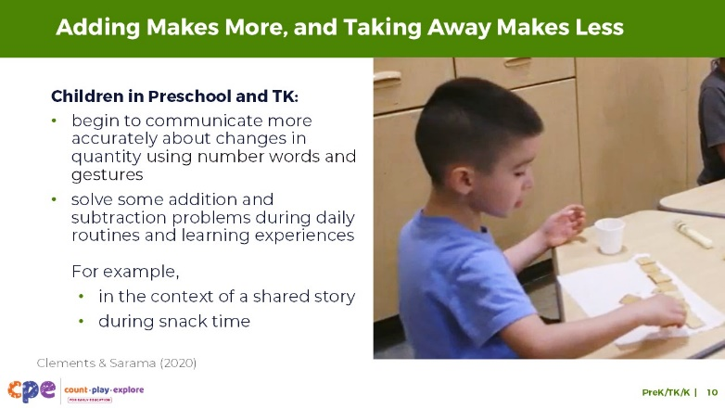

Talking Points
- Infants and toddlers understand that adding makes more and taking away makes less (McCrink & Wynn, 2004).
- In preschool, children can begin to communicate more accurately about changes in quantity using number words (for example, “three”) and gestures (for example, holding up three fingers). They might communicate using their home language, English, or both.
- They explore the concepts of adding more and taking away as they solve addition and subtraction problems during daily routines and playful experiences (Clements & Sarama, 2020). For example,
  - When reading Pete the Cat and His Four Groovy Buttons by Eric Litwin, children make predictions about how many buttons Pete has left after he loses some. They understand that losing a button means there will be fewer buttons and might be able to communicate a quantity that is less than what he had before.
  - When adding crackers to their plate, children understand this results in more, and they might predict how many they have in all.

Facilitator Notes
- For more information about what infants and toddlers understand about adding to make more and taking away to make less, review PPT 1 “Introduction to Addition and Subtraction: Birth–8 Years.”

SLIDE 11: Different Ways to Make 10
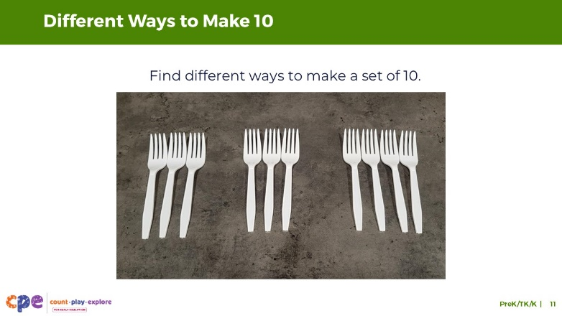
Time: 5–10 minutes
Materials: Collections of small objects (for example, paperclips, shells, cotton balls, counting chips)

Talking Points
- We reviewed the concept of adding makes more and taking away makes less. Let’s explore a different concept that is a part of adding and subtracting.
- [Select a facilitation strategy from the Facilitator Notes.]
- Using the materials at your table, find different ways to make 10.
  - For example, I can make a set of 10 by combining sets of 3, and 3, and 4!
- You might record the different sets you make.
- [Provide time for participants to work.]
- [Invite a few participants to share their experience and the different ways they created a set of 10 objects.]
- This activity explored the idea that numbers can be put together and taken apart. Sets of objects can be combined to create a set of 10.
- Similarly, a group of 10 objects can be broken apart into smaller sets in different ways.

Facilitator Notes
- Adjust the way you organize the activity based on group size, session length and format, and participants’ needs. For example,
  - For longer sessions, invite participants to work individually and share their experiences with their tables before discussing as a larger group.
  - For shorter sessions, invite participants to work with a partner and share with the larger group.

SLIDE 12: Number Composition
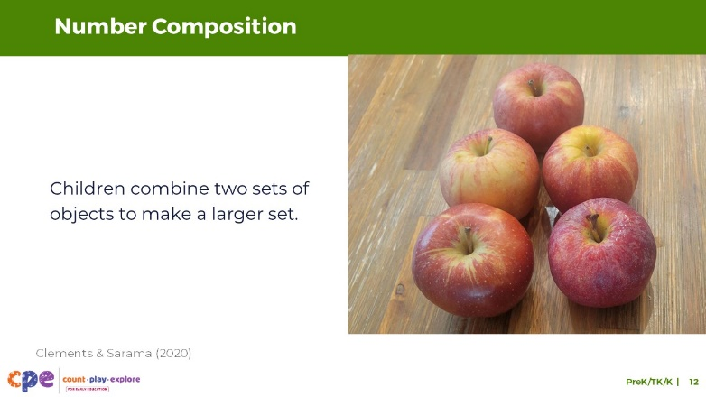

Talking Points
- In preschool, children begin to explore the idea that numbers can be put together and taken apart. Children combine two sets of objects to make a larger set (Clements & Sarama, 2020). Through experiences of combining sets, they learn about number composition.
- For example, 3 apples and 2 apples can be combined to make a set of 5 apples.

SLIDE 13: Number Decomposition
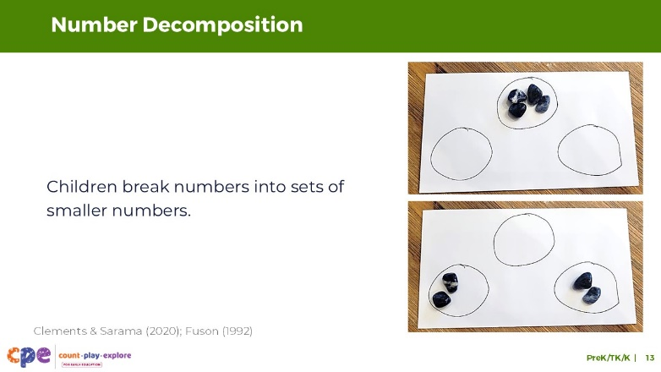

Talking Points
- In preschool, children also explore ways to break a larger set into smaller sets (Clements & Sarama, 2020; Fuson, 1992).
- They build an understanding that there are many ways to decompose numbers or break larger sets into smaller sets.
- For example, a set of 4 rocks can be broken into a set of 2 rocks and a set of 2 rocks.

SLIDE 14: Composing and Decomposing Numbers in Preschool, TK, and K
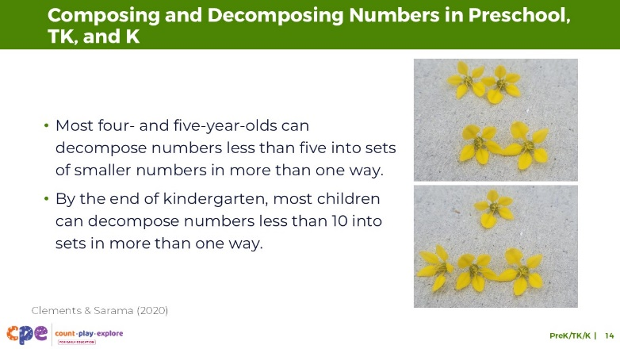

Talking Points
- By the ages of four and five, children typically can decompose numbers less than five into sets of smaller numbers in more than one way (Clements & Sarama, 2020). For example,
  - 4 leaves can be decomposed into a set of 2 leaves and a set of 2 leaves.
  - 4 leaves can also be a set of 3 leaves and a set of 1 leaf.
- By the end of kindergarten, children typically decompose numbers less than 10 into sets in more than one way (for example, decompose 7 into 3 and 4 or 5 and 2).
- Solving problems involving composing and decomposing numbers is more meaningful when the problems are related to children’s daily lives or cultures. Learning about children’s diverse experiences can support educators to offer problems and materials that might be most relevant and engaging for children.

SLIDE 15: Explore: Composing and Decomposing Numbers
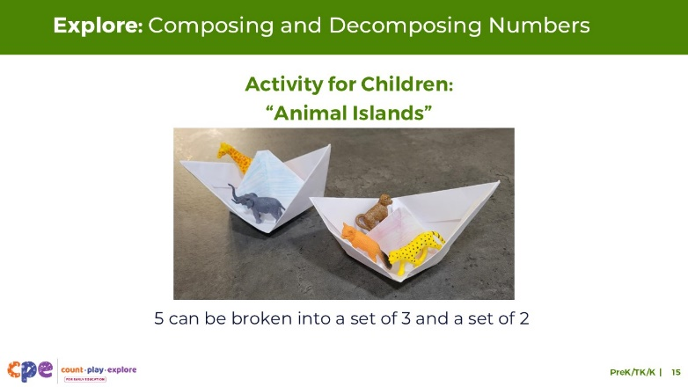
Time: 10–20 minutes
Materials: Animal Islands handout, materials to play Animal Islands (optional)

Talking Points
- We can support children’s understanding of addition and subtraction through meaningful investigations and activities that encourage children to add and subtract in different ways.
- Let’s explore a playful activity that can encourage children to compose and decompose numbers.
- Take out the Animal Islands activity for children.
- This handout describes how to play Animal Islands with children.
  - With a partner, review the handout together. Then, discuss how you might use this activity in your settings.
  - Consider the children in your setting. Use the ideas at the end of the handout to brainstorm ways to modify this activity to meet the interests and needs of the children in your learning setting.

Facilitator Notes
- Provide 5–10 minutes for participants to review and discuss the handout.
- You might invite participants to share, with the larger group, how they might use the activity in their setting and how this activity models a meaningful investigation for children.
- Refer to the M⁵ section in the Animal Islands handout for examples of ways educators can modify this activity to respond to children’s interests, languages, cultures and lived experiences, abilities, and emerging skills. More information on the M⁵ Early Math Approach is provided on slide 27.
- For longer sessions, consider offering time for participants to do the activity. Be sure to prepare and bring the necessary materials. Encourage participants to discuss what they notice as they engage in the activity.

SLIDE 16: Composing and decomposing numbers supports understanding place value.
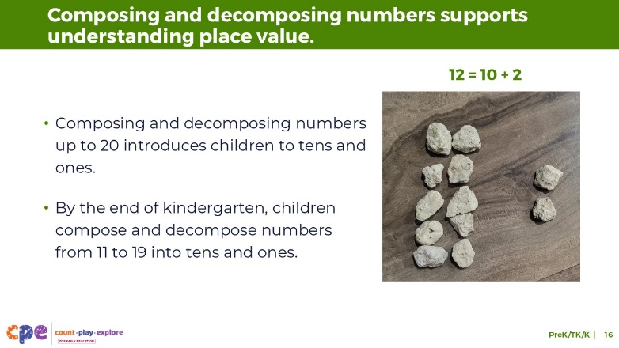

Talking Points
- As children learn to count beyond 10 and have experiences of composing and decomposing numbers, they grow their understanding that numbers between 10 and 20 are composed of tens and ones.
- By the end of kindergarten, the goal is for children to be able to compose and decompose numbers from 11 to 19 into tens and ones using objects, drawings, or equations.
  - For example, a set of 10 grey rocks and a set of 2 white rocks can be composed to make a set of 12 rocks.
  - In another example, 15 can be decomposed into a group of 10 and a group of 5.
- Composing and decomposing using tens and ones sets the foundation for children to understand place value and the base ten number system in grades one and two.
  - For example, children will understand that the 1 in the two-digit numeral 12 represents a ten, and the 2 in 12 represents ones. Ten and 2 can be composed to make 12.

Facilitator Notes
- More information on composing and decomposing numbers and place value is featured in PPT 2c “Addition and Subtraction: Early Elementary.”

SLIDE 17: Solving Addition and Subtraction Problems
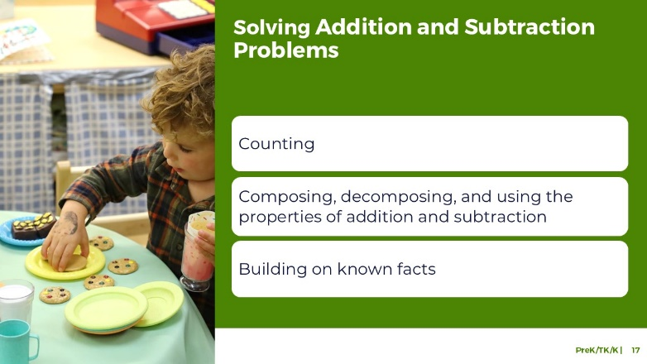

Talking Points
- We have discussed key understandings that children develop about addition and subtraction.
- Now, we will examine different strategies children might use to solve addition and subtraction problems. These include:
  - counting
  - composing, decomposing, and using properties of addition and subtraction
  - building on known facts
- In this session, we will focus on children’s use of counting strategies.

Facilitator Notes
- More information on other strategies children use to add and subtract is featured in PPT 2c “Addition and Subtraction: Early Elementary.”

SLIDE 18: Play: Alphabet Addition and Subtraction (Optional)
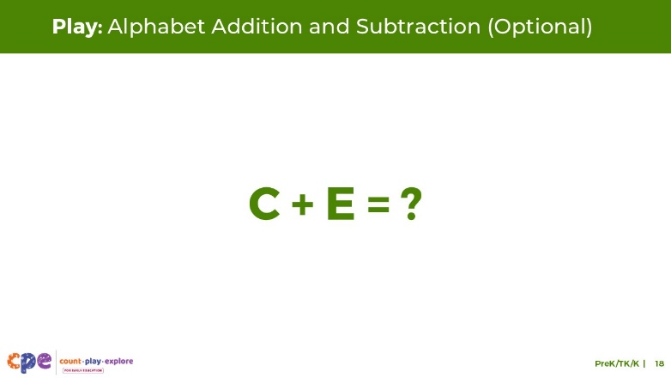
Time: 15–30 minutes (including debrief on next slide)
Materials: Alphabet Counting handout, small items to count, containers, paper, and pencils

Talking Points
- Before we discuss ways that children solve addition and subtraction problems, let’s remember what it feels like to learn how to add and subtract.
- We will play a game called Alphabet Counting.
- Take out the Alphabet Counting handout.
- The purpose of this activity is to experience what it feels like to learn how to add and subtract for the first time. [Use the instructions on the handout as talking points and guide the educators through the different sections.]

Facilitator Notes
- The Alphabet Counting activity has multiple parts. Depending on the amount of time you have in your session, you may choose to engage in the entire activity or just the first and fourth parts (“Learning About Alphabet World” and “Addition and Subtraction”).
- Note: This activity is designed to help adult learners experience adding and subtracting as if it were the first time they were adding or subtracting. Using the alphabet instead of numbers introduces a system that adults do not typically associate with numerical values. This adds new challenges for them—similar to how adding and subtracting may initially be challenging for young children. The experience is not intended to draw parallels between the number system and the alphabet. Children learn the alphabet and number systems in different ways.
- Math is playful. This principle is key to the Count Play Explore professional development approach. This activity invites adults to explore adding and subtracting through play.
- Math mindsets matter. This experience may activate a variety of feelings for participants. Some may enjoy this experience, while others may find it stressful.
  - Allow participants to engage in ways that they feel most comfortable. Some may think through these problems independently, whereas others may prefer to work in pairs or small groups.
  - The goal of this activity is to experience adding and subtracting as a beginner. This experience is likely to be challenging for participants. Remind them that it is okay if they do not get the correct answers.
  - When inviting participants to share, consider their comfort level. Some participants may not feel comfortable sharing with the whole group. Adapt how you facilitate this activity based on participant needs and session length.

SLIDE 19: Discuss: Alphabet Addition and Subtraction (Optional)
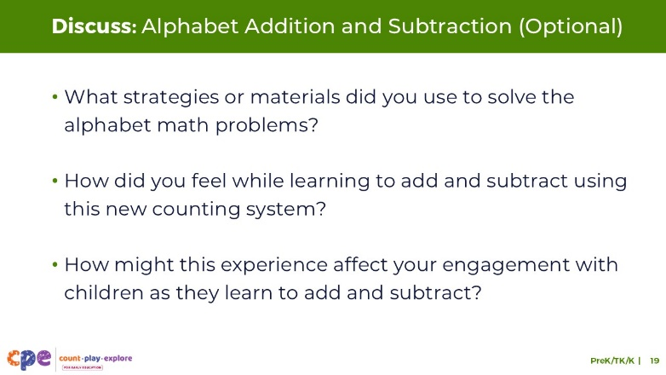
Time: 15–30 minutes (including the activity on previous slide)
Materials: Small items to count, containers, paper, and pencils

Talking Points
- Let’s discuss this experience of learning the alphabet counting system to add and subtract.
- [Select a facilitation approach and use the prompts in the Facilitator Notes to support a discussion.]
- Thank you for discussing your experiences.
- This activity demonstrated that learning to add and subtract can be challenging. Children need to learn many things at once. For example, they have to learn number words, number order, and how adding and subtracting works.

Facilitator Notes
- Support participants in discussing the experience in pairs, table groups, or the whole group based on group size, session length and format, and participant needs.
- Use the prompts below to guide your discussion. Note: The prompts below include additional prompts and questions that do not appear on the slide.
  - What strategies or materials did you use to solve the alphabet math problems? In what ways did your assets, such as prior knowledge of the alphabet, help you when using the alphabet list to add or subtract? In what ways did the strategies you used resemble those that children use when they first learn to add and subtract?
  - How did you feel while learning to add and subtract using this new counting system? What can this tell us about how children feel when learning to add and subtract?
  - How could this experience affect your engagement with children as they learn to add and subtract? How does this experience relate to your work with multilingual learners who may be learning to add and subtract in more than one language?
- Consider summarizing some key points. For example, “I noticed you used different strategies to solve these problems. Some of you used your fingers to add and subtract, others used small items, and some made an alphabet number line. These are the types of strategies and materials children often use when they learn to add and subtract.”
- Note: This activity is also featured in the PPT 1 “Introduction to Number and Counting: Birth–8 Years” session. If using the activity in this session, “Addition and Subtraction: Preschool, Transitional Kindergarten, and Kindergarten,” adjust the experience and reflection questions to focus on addition and subtraction instead of counting. For example, the reflection questions above have been adjusted to focus on adding and subtracting.

SLIDE 20: Counting Strategies
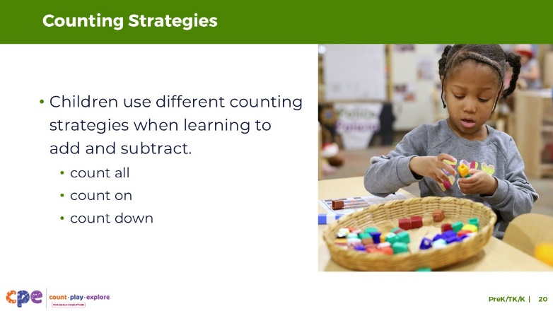

Talking Points
- We have just experienced what it feels like to learn how to add and subtract.
- When you used alphabet counting to add and subtract, you used different strategies to support you to add and subtract, just like children do.
- One strategy you might have used was a counting strategy. You might have worked through the alphabet system, starting at “A” each time, to help you solve the problem.
- Children use different counting strategies when learning to add and subtract. They might use counting-all, counting-on, and counting-down strategies.

SLIDE 21: Counting All and Counting On: Addition
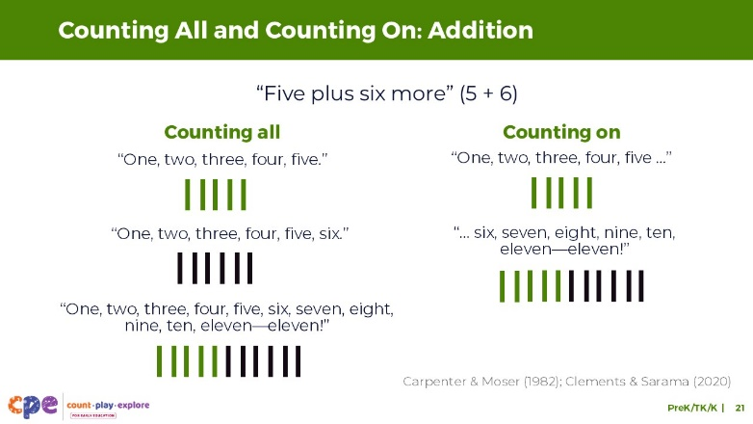

Talking Points
- The count-all strategy is the first strategy children use to add and subtract numbers (Carpenter & Moser, 1982; Clements & Sarama, 2020).
- Children combine sets of objects and then count them to find out how many there are in all.
  - For example, a child has a set of 5 blue sticks and a set of 6 red sticks. To add these sets together, a child might count the blue sticks, “One, two, three, four, five,” and then count the red sticks, “One, two, three, four, five, six.” To add these sets, the child might physically push the two sets together and then count them all, “One, two, three, four, five, six, seven, eight, nine, ten, eleven—eleven!”
- As children get more practice with counting, adding, and subtracting, they might use counting-on strategies. This means they start at one of the addends—one of the numbers in the addition problem—and count up from that number to find a new total.
  - For example, a child counts the first set of blue sticks, “One, two, three, four, five …” and then add 6 more to their set, “…six, seven, eight, nine, ten, eleven—eleven!”
- Counting on is a more advanced strategy because it requires children to start counting from numbers other than one.
- As children gain more experience with the count sequence and a deeper understanding of counting, they might make the transition from counting all to counting on.
- Children might count in the home language, English, or both. Support children to use the language that is most effective for them when using counting strategies to add and subtract.

SLIDE 22: Counting On from Larger
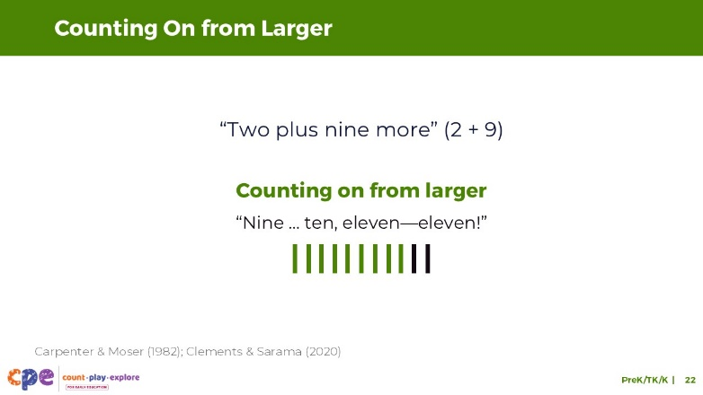

Talking Points
- Eventually, children will discover the “counting on from larger” strategy. This is related to the commutative property—children understand that the order in which numbers are added doesn’t matter. They will start counting on from the larger number.
  - For example, in adding 9 sticks to a group of 2, it is faster and easier to start counting on from 9.
  - A child might say, “Nine … ten, eleven—eleven!”

SLIDE 23: Counting All and Counting Down: Subtraction
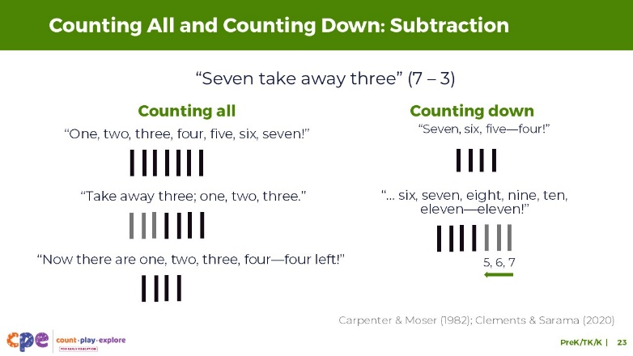

Talking Points
- Children might use similar counting strategies to subtract.
- They might use a counting-all strategy—counting a total number in a set, counting the items taken out of the set, and then counting all the remaining items to figure out how many are left (Carpenter & Moser, 1982; Clements & Sarama, 2020).
  - Let’s use the example of 7 take away 3.
  - A child counts a set of sticks to determine that there are 7 sticks. The child then removes 3 sticks (subtract 3) and counts the set again to learn that taking 3 away from a set of 7 results in 4 sticks.
- Another strategy children might use to subtract is the counting-down strategy. This means that a child starts at a number and then counts backward by the number that is being subtracted.
  - Let’s use 7 take away 3 again.
  - Children count down starting at 7, “Seven, six, five,” and then say, “four!” [Model this with gestures: hold up 7 fingers. When you count backward, put 3 fingers down to result in 4 fingers.]
  - Counting down is challenging because it requires children to know how to count backward, and to hold in memory how many fingers or objects they are removing.
- It takes time and a lot of practice for children to comfortably transition from counting all to counting-on or counting-down strategies. While some children make this transition in preschool, others may only make this transition in kindergarten or first grade. Some children might discover this strategy on their own as they explore adding and subtracting. Others might benefit from more explicit support from educators and families.

Facilitator Notes
- If you used the Alphabet Counting activity on slide 18 ask participants to explain why the count-on strategy could be challenging as it relates to their experience using the alphabet. For example, it might have been difficult to begin counting by starting at “E.” Some participants may have had to start at “A” each time.

SLIDE 24: Supporting Children to Use Counting Strategies
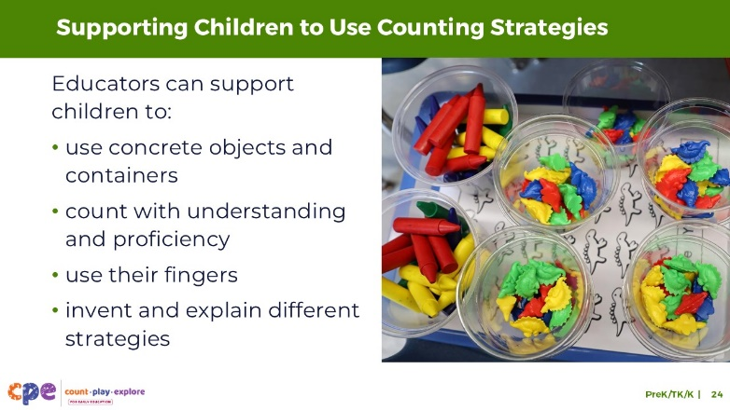
Time: 5 minutes
Materials: Collections of small objects (for example, paperclips, shells, cotton balls, counting chips)

Talking Points
- Educators can support children to use counting strategies in different ways. For example, educators can support children to do the following:
  - Use concrete objects and containers. Physical containers can help reinforce ideas related to combining to make a larger set or separating to make smaller sets.
  - Count with understanding and proficiency. Counting with understanding and proficiency enhances children’s ability to use different counting strategies to solve addition or subtraction problems. Encourage children to count often through daily routines and meaningful experiences that encourage children to count to find out how many.
  - Invent their own strategies. For example, counting all of the objects after adding to or taking away from a set. Or counting on fingers, adding more fingers as they count.
  - Use their fingers to support adding and subtracting processes (Polleti et al., 2025).
  - Explain their approaches and strategies. For example, Educators might ask, “How might we figure out how many we have in all if we add four more to our set of eight?” or, “What did you do to figure that out? Can you tell me or show me?”

Facilitator Notes
- The Number and Counting suite provides more information on how to support children’s understanding of number and counting.

SLIDE 25: Supporting Children to Add and Subtract
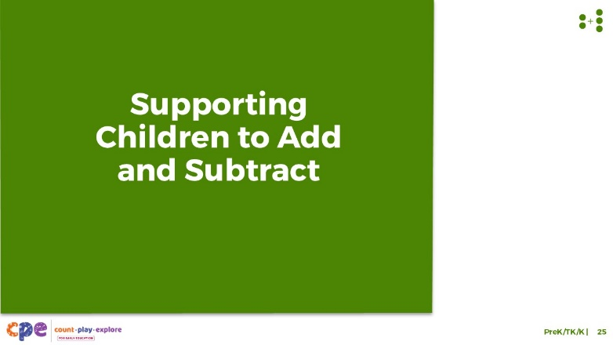

Talking Points
- We explored what children come to understand about addition and subtraction and strategies children might use to solve addition and subtraction problems. We also discussed some ways educators can support children to use counting strategies to add and subtract. Now, let’s discuss more ways we can support children to add and subtract.

SLIDE 26: How to Support Understanding of Addition and Subtraction
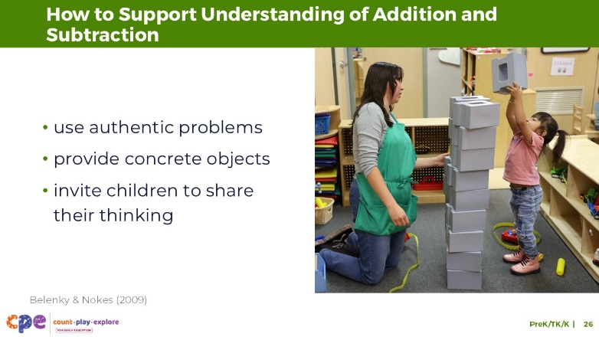

Talking Points
- Educators can support children’s understanding of addition and subtraction by doing the following:
  - Notice or identify problems of interest that are meaningful to a child or group of children and offer concrete objects to support children to add and subtract.
  - Build on children’s interests and lived experiences to enhance engagement and motivate children to solve addition and subtraction problems.
  - Support children to use concrete objects to add and subtract. Using concrete objects can enhance conceptual understanding of addition and subtraction. Children of all ages should be offered concrete objects to support math learning, even after they begin using more abstract representations such as written equations (Belenky & Nokes, 2009). It is not until later in the kindergarten year that children use written equations to represent addition and subtraction.
  - Invite children to explain their thinking.
- Now, we will explore more teaching practices that support children to add and subtract.

SLIDE 27: Explore: M⁵ Early Math Approach
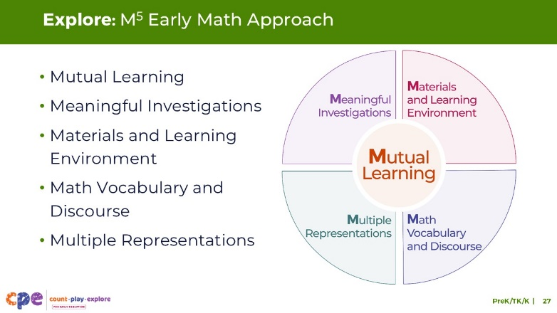
Time: 15 minutes
Materials: M⁵ Overview handout

Talking Points
- We refer to five early math teaching practices as the M⁵ Early Math Approach. These practices include:
  - Mutual Learning
  - Meaningful Investigations
  - Materials and Learning Environment
  - Math Vocabulary and Discourse
  - Multiple Representations
- Let’s explore the M⁵ practices. Then, we will consider ways to use M⁵ to support children to add and subtract.

Facilitator Notes
- Consider your participants and their prior experiences with M⁵.
  - For groups that have significant experience with M⁵, you might offer a few minutes for participants to share with a partner their areas of strength and what practices they are working on. Use this slide to briefly revisit the M⁵ practices and move to the next slide.
  - For groups that have less experience with M⁵, offer more time for participants to explore each practice. For example, allow time for them to review the practices on their own. Invite them to make a square over practices that they have “squared away” (practices they understand and use), a circle over “what’s still going around in their heads” (practices they still have questions about), and a triangle over three ideas that they will use in their settings. For more ideas on how to provide a comprehensive review, visit the M⁵ Early Math Approach suite.

SLIDE 28: Observe: M⁵ in Action
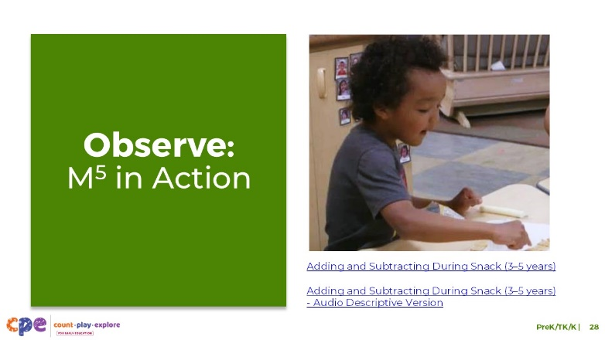
Time: 5–7 minutes (not including debrief)
Materials: Observing M⁵ in Action: Addition and Subtraction handout; preschool, TK, or K addition and subtraction video clip; chart paper; markers

Talking Points
- Now, we are going to observe a video that shows how educators use the M⁵ Early Math Approach to help children use addition and subtraction.
- Take out the Observing M⁵ in Action: Addition and Subtraction handout.
- [Choose a strategy for facilitating this observation. Adapt the talking points to reflect this strategy.]

Facilitator Notes
- Choose a video clip that shows children learning about and using addition or subtraction. This may be the same clip used for observing children adding and subtracting.
- We provide the following video clips (you may use other videos):
  - Adding and Subtracting During Snack (3–5 Years)
  - Adding and Subtracting During Snack (3–5 Years) - Audio Descriptive Version
  - Composing and Decomposing the Number 5 (3–5 Years)
  - Composing and Decomposing the Number 5 (3–5 Years) - Audio Descriptive Version
  - Adding During Storytime (3–5 Years)
  - Adding During Storytime (3–5 Years) - Audio Descriptive Version
  - Counting and Adding While Reading (3–5 Years)
  - Counting and Adding While Reading (3–5 years) - Audio Descriptive Version
- Note: Sample answers are provided for the video “Adding and Subtracting during Snack (3–5 Years)” in the Facilitator Notes on the next slide.
- Invite participants to take out the Observing M⁵ in Action: Addition and Subtraction handout.
- For larger groups or shorter sessions, use a jigsaw approach. Before playing the video clip, assign each table one practice to focus on during the video. [If there are more than five tables, assign more than one table to focus on each practice.]
- For smaller groups or longer sessions, consider showing the video clip two to three times, inviting participants to focus on specific practices each time. Encourage them to record observations on the handout.

SLIDE 29: Discuss: M⁵ in Action
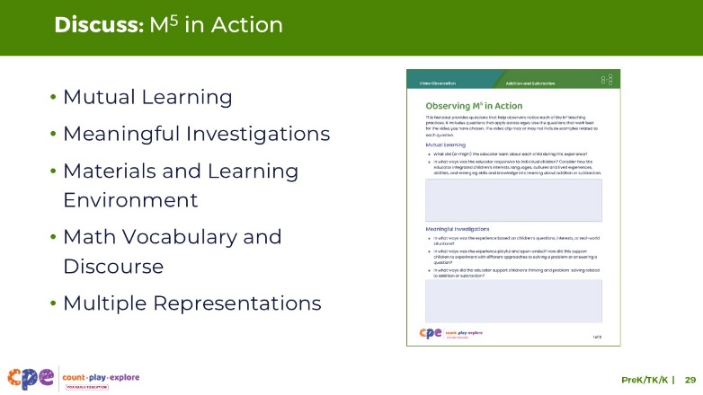
Time: 20–30 minutes (varies based on session goals)
Materials: Observing M⁵ in Action: Addition and Subtraction handout; preschool, TK, or K addition and subtraction video clip; chart paper (optional); markers (optional); dice (optional)

Talking Points
- Let’s unpack your observations of each M⁵ practice.

Facilitator Notes
- Use the Answer Key for Observing M⁵ in Action: Addition and Subtraction for examples of ways the M⁵ Early Math Approach was used in the clip “Adding and Subtracting during Snack (3–5 Years).”
- For larger groups, shorter sessions: After observing the video clip, ask each table group to discuss what they noticed about their assigned practice. Then, invite each group to share their observations with the larger group. As each group shares, paraphrase, affirm, and add to their responses as needed.
- For smaller groups, longer sessions: Encourage participants to use addition and subtraction as a playful way to find a partner (or partners). For example,
  - Create a group by adding and subtracting to make 5: Each person will roll a die and get a number. Using that number, they will find one or more people that, together, using addition or subtraction, can make 5. For example, a person who rolled a 2 might find someone who rolled a 1 and someone who rolled a 4. Together, 2 plus 4, minus 1, makes 5. After finding their group, participants will discuss the handout.
- Consider recording participants’ observations to make the practices visible. As participants share, paraphrase, affirm, and add to their responses as needed.

SLIDE 30: Explore: Using M⁵ to Support Learning About Addition and Subtraction
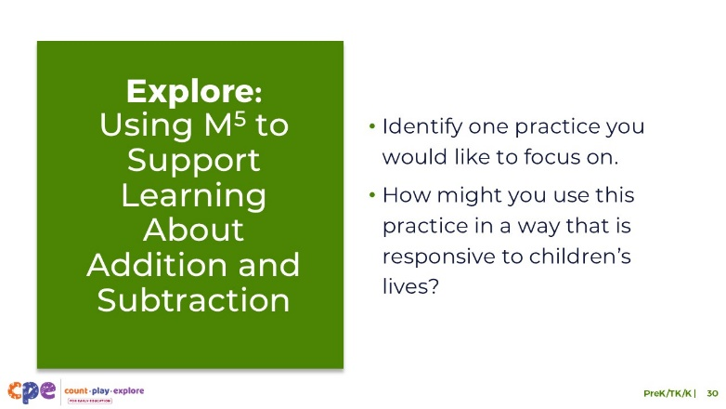
Time: 20–30 minutes (including debrief on the next slide)
Materials: Using M⁵ to Support Learning About Addition and Subtraction handout

Talking Points
- We discussed the M⁵ Early Math Approach. Let’s consider ways to use M⁵ to support children’s understanding of addition and subtraction.
- Take out Using M⁵ to Support Learning About Addition and Subtraction handout.
- Review the ideas on how to use M⁵ to support the understanding of addition and subtraction in preschool, TK, and K children. As you review, consider the children in your learning setting. Think about how you currently implement or would like to implement M⁵ approaches in ways that are responsive to the children in your learning setting. How might you adjust your approach based on children’s interests, cultures, abilities, and languages?
- You might make notes, circle, or highlight as you review.

SLIDE 31: Discuss: Using M⁵ to Support Learning About Addition and Subtraction
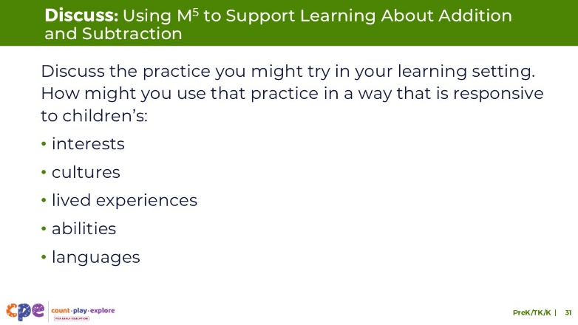
Time: 20–30 minutes (including exploring the handout on the previous slide)
Materials: Using M⁵ to Support Learning About Addition and Subtraction handout, dice (optional)

Talking Points
- Now, we will discuss the handout.
- Discuss the practice you already use or might try in your learning setting. Consider children’s individual abilities, interests, cultures, and languages.
- [Select a facilitation strategy to support participants’ discussion of the handout.]
- Thank you for sharing ways you might use the M⁵ Early Math Approach to support children to add and subtract in your learning setting.

Facilitator Notes
- For shorter sessions, invite a few volunteers to share with the larger group or encourage participants to discuss the handout with their table group.
- For longer sessions, encourage participants to use addition and subtraction as a playful way to find a partner (or partners). For example,
  - Create a group by adding and subtracting to make 7. Each person will roll a die and get a number. Using that number, they will find one or more people that, together, using addition or subtraction, can make 7. For example, a person who rolled a 3 might find someone who rolled a 3 and someone who rolled a 1. Together, 3 plus 3, plus 1, makes 7. After participants find their group, they will discus the handout.

SLIDE 32: Explore: Adding and Subtracting with a Story
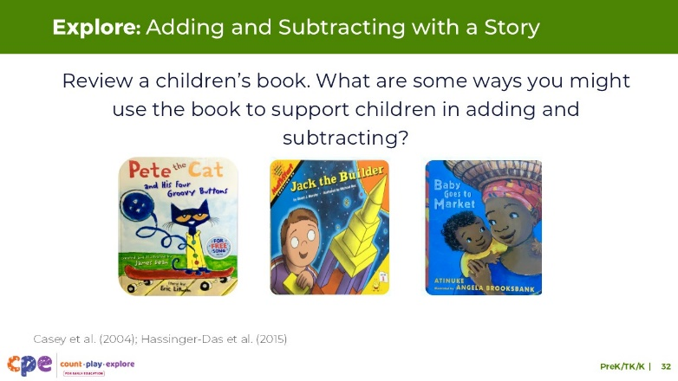
Time: 15–20 minutes
Materials: Using Children’s Literature to Support Addition and Subtraction handout, children’s books that include opportunities to add or subtract (see suggested titles in the Facilitator Notes), collections of objects that participants might use to add or subtract, Book Guides (optional).

Talking Points
- We can support children’s understanding of addition and subtraction when sharing stories with children (Casey et al., 2004; Hassinger-Das et al., 2015).
- Stories can provide meaningful problems, rooted in the story’s plot, that make adding or subtracting purposeful.
- Stories can also connect adding and subtracting to real-life situations.
- Finally, stories can provide visuals that children can use to support them add or subtract (for example, using a counting-all strategy to find out how many).
- Let’s explore a few children’s books that might encourage children to add or subtract.
- After reviewing the book, plan for ways you might encourage children to add and subtract as it relates to the story.
- Review the Using Children’s Literature to Support Addition and Subtraction handout to guide your planning.
- Explore the materials at your table to test out some of your ideas.
- [Choose a facilitation strategy to support participants’ engagement. Adapt talking points as needed.]

Facilitator Notes
- We have included a few books to consider using. However, you may find other books on the Count Play Explore website:
  - Pete the Cat and His Four Groovy Buttons (Pete the Cat y sus cuatro botones Groovy in Spanish) by Eric Litwin
  - Baby Goes to Market (Bebé va al mercado in Spanish) by Atinuke
  - Jack the Builder (Jacobo el constructor in Spanish) by Stuart J. Murphy
- Select a facilitation strategy that meets your session goals. For example,
  - Use a jigsaw approach, assigning different books to different groups. Encourage groups to plan together using the questions on the handout. Then, small groups can share with the larger group.
  - Encourage participants to work in pairs. Invite them to choose a book they would like to review (you might need more than one copy of each book). Invite participants to use the handout to guide their planning. Then, ask a few volunteers to share with the larger group.
- The Count Play Explore Website also provides Book Guides for each of the books listed above, as well as other books you could select. The book guides provide ideas on how educators might use the book to support children’s math learning. Consider printing and distributing the Book Guides and related activities to share with educators. Review the Book Guide and related activity with educators to support them in understanding ways they might use these resources. Educators can reference the handout Using Children’s Literature to Support Addition and Subtraction to guide their planning.

SLIDE 33: Reflection and Planning
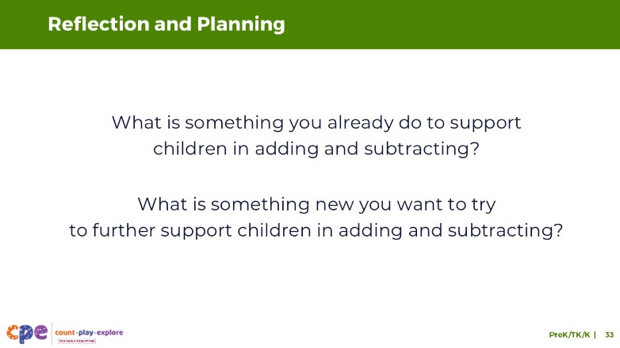
Time: 5–7 minutes

Talking Points
- Today, we discussed how children develop their understanding of addition and subtraction and the strategies they might use to solve addition and subtraction problems. We also discussed ways educators can support children to add and subtract.
- Think about your learning setting and the practices you already use.
- What is something you already do to support children to add and subtract?
- What is something new you might want to try to further support children to add and subtract?
- You might record your ideas.
- [Allow three to four minutes for participants to think and record their reflections. Consider inviting participants to share with a partner or the larger group.]
- Thank you for your time, attention, and engagement. It’s been wonderful working with you.

Facilitator Notes
- As participants discuss their reflections, note the questions that they still have and what they would like to try. You might use this information to identify topics for future training, coaching, or communities of practice.

