Addition and Subtraction: Early Elementary (PPT 2c)
Use this facilitator guide with the slides “Addition and Subtraction: Early Elementary.” This set of slides provides descriptions of how children in early elementary grades develop an understanding of addition and subtraction and ways educators can support them to solve addition and subtraction problems. Facilitators can find talking points and guidance for activities and group discussions in this guide. The text in the guide is also located in the notes portion of the slides. Adapt this facilitator guide based on your group size, session length and format, and participants’ needs.

Session At-a-Glance
Slide numbers | Overview of content | Approximate time (in minutes)
1-4 | Introduction & Session Goals  - Adult activity | 10-15
5-19 | How children in elementary grades develop an understanding of addition and subtraction:  - California Common Core Standards  - Adult activity  - Composing and decomposing numbers  - Properties of addition and subtraction | 20-30
20-27 | How children solve addition and subtraction problems:  - Video observation  - Counting strategies  - Composing and decomposing numbers  - Building on known facts  - Different problem types | 15-20
28-38 | How to support children to add and subtract:  - Exploring materials  - Activity for children  - Observing and discussing M⁵ | 45-75
39 | Reflection and Planning | 5-7
The times are approximate and may vary based on session goals, group size, and participants’ previous experience and familiarity with the content.

To Prepare for Your Session
- As you plan your professional learning session, consider the content in each of the PowerPoint presentations (PPTs) in this suite:
- PPT 1 “Introduction to Addition and Subtraction: Birth—8 Years” describes how children (birth to eight years old) develop foundational concepts of addition and subtraction.
- PPT 2b “Addition and Subtraction: Preschool, Transitional Kindergarten, and Kindergarten” and PPT 2c “Addition and Subtraction: Early Elementary” describe in greater depth how children at different age levels develop their understanding and ways of solving addition and subtraction problems. These PPTs also include ideas on how to support children in specific age ranges to add and subtract.
- Note: This suite does not offer a PPT 2a that focuses on infants’ and toddlers’ development of addition and subtraction concepts. Content related to infants and toddlers is addressed in PPT 1 “Introduction to Addition and Subtraction.” For more information on ways infants and toddlers develop knowledge and skills related to addition and subtraction, review the Number and Counting suite. The way infants and toddlers understand addition and subtraction is closely related to their knowledge of and skills with number and counting.
- We encourage you to offer the content in PPT 1 before, or in combination with, the content in PPT 2c. If your participants work with children in more than one age range, you might combine parts of PPT 2b and PPT 2c in one session or a series of sessions. Together, PPT 1 and one of the age-specific slide decks have been designed for about three hours of professional learning. However, you may adjust slide decks to best meet participant needs and time allowances.
- Adjust talking points to reflect your session length and participant needs. If necessary, add introductory and “housekeeping” information.
- When appropriate, remind participants that “TK” refers to transitional kindergarten and “K” refers to kindergarten.
- Before your session, carefully review all handouts and prepare the necessary materials. Select a facilitation method that works best for your session length and format, group size, and participant needs.

Materials Needed
- Scratch paper, chart paper, and writing tools
- Base ten blocks, ten frames, number lines
- Catch and Compute activity: A medium-sized ball with numbers written on it
- Close the Grid handout, collections of small objects (for example, paper clips, shells, cotton balls, counting chips), two dice
- Let It Roll! handout, materials to play Let It Roll! (optional)
- M⁵ Overview handout
- Observing M⁵ in Action: Addition and Subtraction handout, sample answers handout, early elementary measurement video clip
- Using M⁵ to Support Learning About Addition and Subtraction handout

SLIDE 1: Addition and Subtraction: Early Elementary
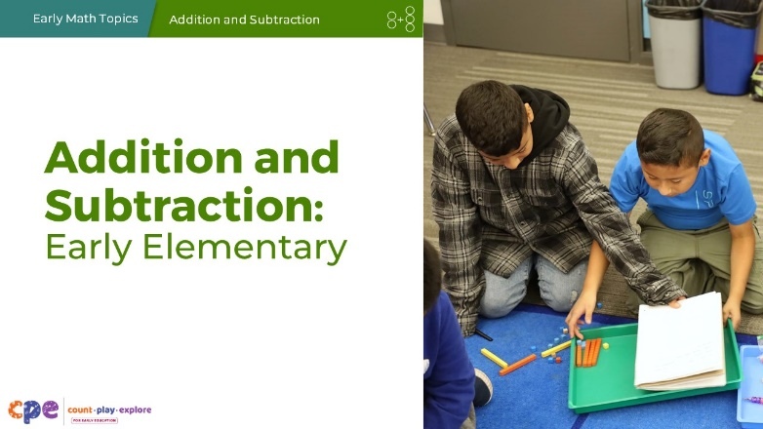

Talking Points
- In this session, we will explore how children in early elementary grades develop an understanding of addition and subtraction. We will also focus on ways we can support children in early elementary grades to understand and use addition and subtraction.

SLIDE 2: Acknowledgments
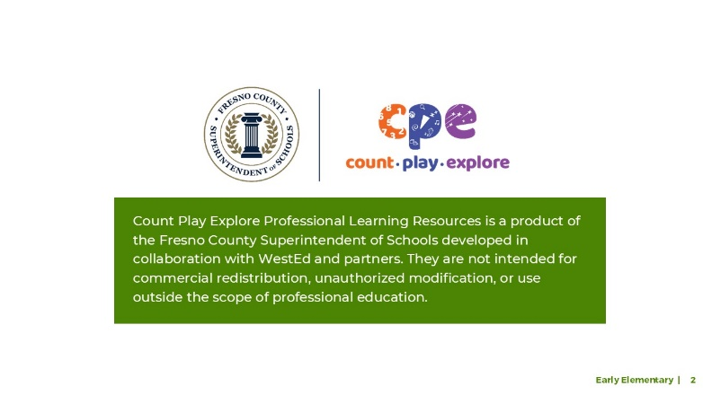

Talking Points
The Count Play Explore Professional Learning Resources were made possible by Count Play Explore, an early math, science, and computer science initiative led by the Fresno County Superintendent of Schools, Early Care and Education Department. This initiative is generously funded by the California Department of Education and the California State Board of Education. These resources, developed in collaboration by WestEd and partners, are intended to be used as a guide for implementing evidence-based strategies, promoting active learning, and encouraging developmentally appropriate practices in early education settings. They are not intended for commercial redistribution, unauthorized modification, or use outside the scope of professional education.

SLIDE 3: Session Goals
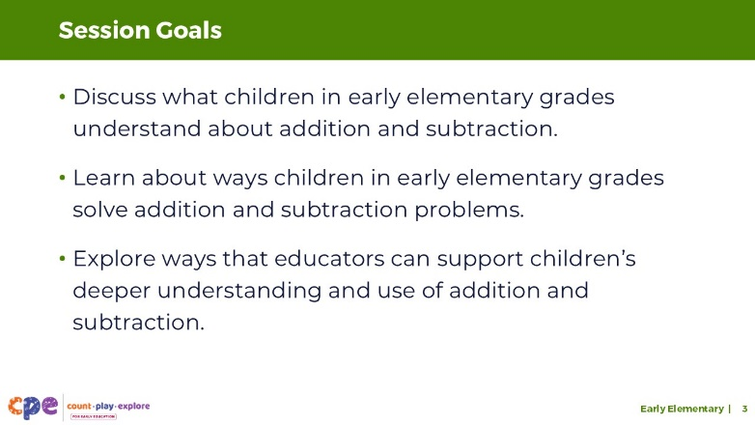

Talking Points
- Our goals for today’s session are the following:
  - Discuss what children in early elementary grades understand about addition and subtraction.
  - Learn about ways children in early elementary grades solve addition and subtraction problems.
  - Explore ways educators can support children’s deeper understanding and use of addition and subtraction.
- Throughout our session, we will take time to reflect on our current practices. We will also think about how we might use information from this session in our work.

Facilitator Notes
- Adjust slide content and talking points to reflect what you plan to address in your professional learning session.

SLIDE 4: Play: Catch and Compute!
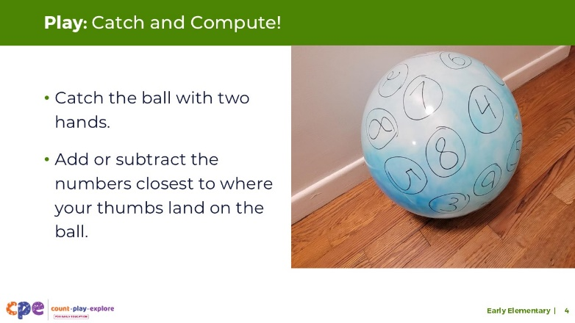
Time: 5–10 minutes
Materials: A medium-sized ball with numbers written on it

Talking Points
- Before we learn more about how early elementary–aged children add and subtract, let’s play with adding and subtracting.
- We will play a game called Catch and Compute!
- In this game, you will catch a ball with two hands. The ball has numbers written on it. Notice the numbers closest to where your thumbs land on the ball. Then, you will add or subtract those numbers. You can choose to either add or subtract the numbers.
- You can solve the problem in different ways, and you might use languages other than English to support your problem-solving. Consider asking others at your table to work collaboratively with you.
- After you solve the problem, pass the ball to someone else.
- As we play, consider what strategies you used when adding and subtracting. Did you count forward or backward? Did you rely on known number facts? Did you use strategies to compose or decompose numbers?
- [Play Catch and Compute!]
- Thank you for adding and subtracting with me! This was a playful way for us to use addition and subtraction.
- As we played, what did you notice about the strategies you used to solve the problems?
- [Encourage participants to share. Acknowledge and affirm responses.]
- As we explore the ways children add and subtract, think back to this experience and make connections between ways you approached these problems and ways children might approach similar problems.

Facilitator Notes
- Preparing materials for the game:
- Use a permanent marker to write numbers on a ball (for example, an inflatable beach ball) in different places.
- Adjust the numbers you use based on participant needs and abilities. For example, use a variety of smaller numbers that are simple to add, such as 1, 2, 3, 4, 5, 6, 7, 8, 9, 10, 20, 30, 40, 50. Or you might challenge participants by using a variety of larger numbers, such as, 12, 15, 18, 23, 29, 36, 38, 47, 52, 55, 64, 68, 84, 92, 99, 106.
- Math is playful. This principle is key to the Count Play Explore professional development approach. This activity invites adults to explore adding and subtracting through play.
- Math mindsets matter. This experience may activate a variety of feelings for participants. Some may enjoy this experience, while others may find it stressful.
- Allow participants to engage in ways that they feel most comfortable. Some may think through these problems independently, whereas others may prefer to work in pairs or small groups.
- This experience might be challenging for participants. Remind them that it is okay if they do not get the correct answers.
- When inviting participants to share, consider their comfort level. Some participants may not feel comfortable sharing with the whole group. Adapt how you facilitate this activity based on participant needs and session length.
- This is an activity that requires participants to be able to catch and throw a ball. Consider the physical abilities of individuals in your session and how you might adapt the experience to be inclusive. For example,
- If participants cannot stand, invite them to play the game from a seated position. If participants have other physical limitations, encourage participants to hand the ball to the next player instead of throwing and catching.

SLIDE 5: Learning About Addition and Subtraction
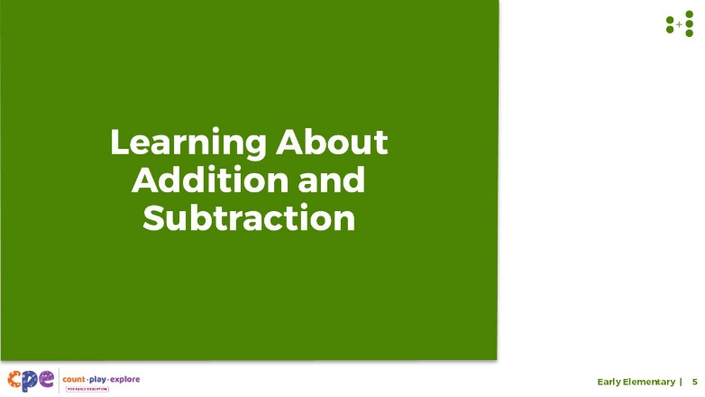

Talking Points
- Now, we will explore how children in early elementary grades develop an understanding of addition and subtraction.

SLIDE 6: California Common Core—First and Second Grade
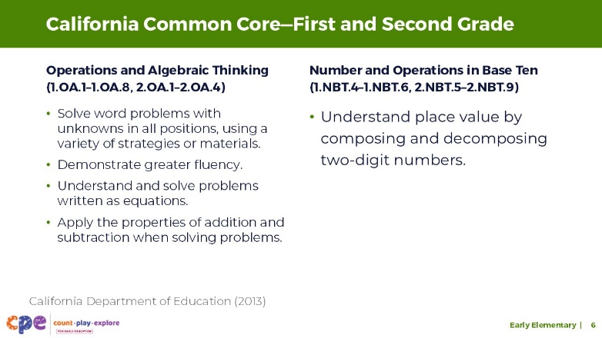

Talking Points
- A variety of first and second grade standards describe what children learn about addition and subtraction (California Department of Education, 2013).
- Standards under the “Operations and Algebraic Thinking” strand describe children’s ability to solve addition and subtraction problems. These standards describe children’s ability to do the following:
- Solve word problems with unknowns in all positions, using a variety of strategies or materials.
- Demonstrate greater fluency (within 20 by second grade).
- Understand and solve problems written as equations.
- Apply the properties of addition and subtraction when solving problems (by the end of first grade).
- Additionally, standards under the “Number and Operations in Base Ten” strand describe children’s understanding of place value and how it relates to composing and decomposing two-digit numbers.
- It is important to remember that children across diverse communities develop understanding in different ways and at different times. The standards provide meaningful goals that educators can use to support children in building mathematical knowledge and skills. Educators can use their knowledge about individual children to provide responsive support for math learning.

Facilitator Notes
- Note: This slide makes connections between the components of addition and subtraction and relevant standards. Place this slide where it works best for your participants’ needs.
- You might provide participants with copies of the relevant California Common Core State Standards.
- Grade One: 1.OA.1–1.OA.8 and 1.NBT.4–1.NBT.6
- Grade Two: 2.OA.1–2.OA.4 and 2.NBT.5–2.NBT.9

SLIDE 7: What Children Understand About Addition and Subtraction
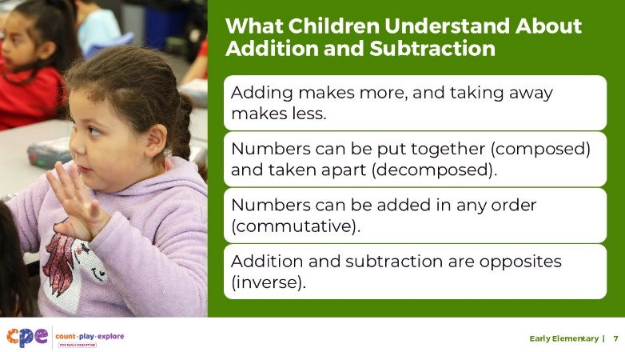

Talking Points
- From infancy and into early elementary, children will develop understandings, such as the following:
- Adding makes more, and taking away makes less.
- Numbers can be put together and taken apart.
- Numbers can be added in any order (commutative and associative).
- Addition and subtraction are opposites (inverse).
- In today’s session, we will focus on the concepts and skills of addition and subtraction that children develop in the early elementary grades. We will specifically focus on these ideas:
- Numbers can be put together and taken apart.
- Numbers can be added in any order (commutative and associative).
- Addition and subtraction are opposites (inverse).

SLIDE 8: Play: Close the Grid
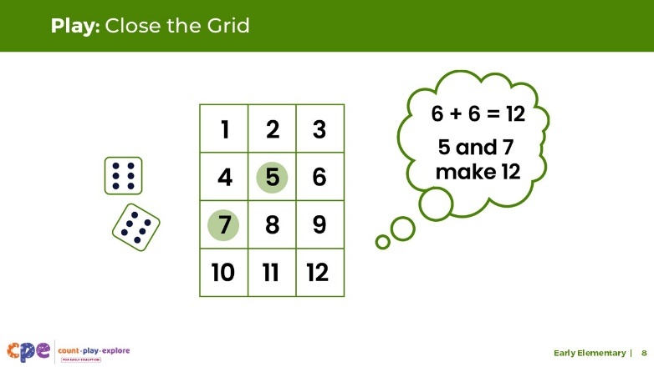
Time: 10–20 minutes
Materials: Close the Grid handout, collections of small objects (for example, paper clips, shells, cotton balls, counting chips), two dice

Talking Points
- Let’s play a game called Close the Grid. In this game, you will explore ways numbers can be put together or taken apart. As you play, consider the mathematical skills you need to successfully engage in the game. This is an adaptation of a game called Shut the Box.
- To play the game, you will roll the dice to get two numbers. For example, 6 and 6. Then, you will add those numbers. In our example, 6 + 6 = 12.
- Now, we will cover the numbers on the gameboard that make 12. For example, 5 and 7 make 12, so I will cover 5 and 7 with my markers.
- The object of the game is to cover all of the numbers and close the grid.
- Review the handout for more information on how to play the game.
- [Select a facilitation strategy from the Facilitator Notes. Encourage participants to use the handout to play Close the Grid.]
- [After participants play Close the Grid:] This activity explored the idea that numbers can be put together and taken apart. In the next few slides, we will discuss how children develop an understanding of this concept.

Facilitator Notes
- Review the Close the Grid handout prior to sharing this activity to make sure you have the necessary materials.
- Support participants to form small groups (two to three individuals per group).

SLIDE 9: Number Composition and Decomposition
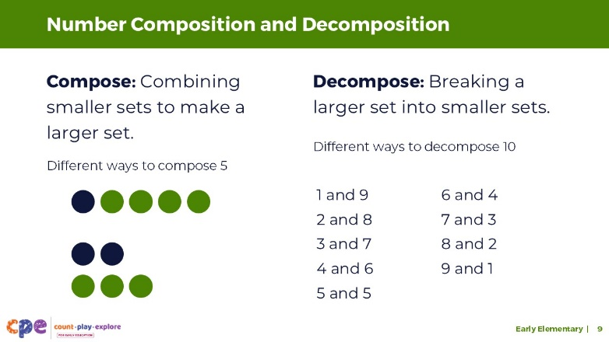
This slide contains animation. See instructions in the Talking Points.

Talking Points
- Between the ages of four and five, children explore different ways to combine smaller sets to make a larger set. This is called number composition (Clements & Sarama, 2020).
- For example, children can explore different ways to make 5: 1 and 4, 2 and 3.
- [Click to reveal content related to decomposition.] They also experiment with different ways to break larger sets into smaller sets. This is called decomposition (Clements & Sarama, 2020).
- For example, children might explore different ways to break 10 into smaller groups: 1 and 9, 2 and 8, 3 and 7, and so on.
- Later in the session, we will explore ways children in elementary grades use composition and decomposition to support solving addition and subtraction problems.

Facilitator Notes
- Consider inviting participants to make connections to the ways they experienced composition and decomposition in the Close the Grid game.
- You might invite participants to discuss in their table groups or with a partner ways they might adapt the Close the Grid game to use with the children in their learning settings.
- Encourage participants to consider children’s interests, languages, and abilities. For example, incorporate body movements into the game such as, hopping the number before covering it on the board.
- For shorter sessions, use a simpler way to engage adult learners in composing or decomposing numbers. PPT 1 “Introduction to Addition and Subtraction” and PPT 2b “Addition and Subtraction: Preschool, TK, K” both include a brief activity to engage participants in composing and decomposing numbers.

SLIDE 10: Composing and Decomposing Numbers Supports Understanding Place Value
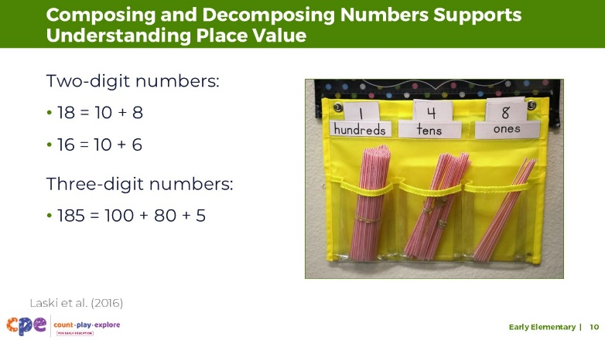

Talking Points
- Composing and decomposing numbers supports understanding place value.
- Starting in kindergarten, children compose and decompose numbers from 11 to 19 into 10 ones to make 10 and some additional ones. For example, children might use objects, drawings, or equations to record each composition or decomposition, such as 18 = 10 + 8 (Laski et al., 2016).
- By the end of second grade, children extend their understanding of place value to the hundreds. This includes understanding the following:
- One hundred can be thought of as a bundle of 10 tens.
- Three-digit numbers are composed of hundreds, tens, and ones.

SLIDE 11: Properties of Addition and Subtraction
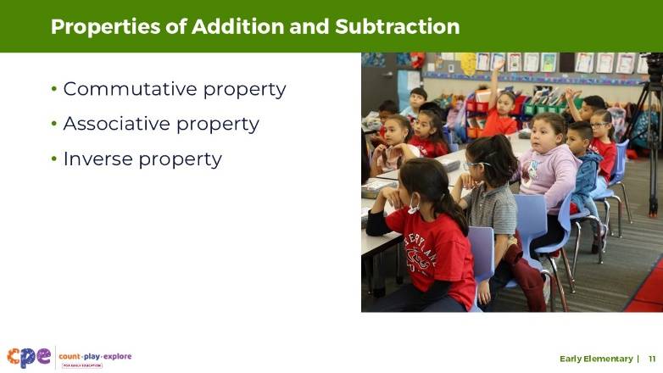

Talking Points
- As children deepen their understanding of number composition and decomposition, they also develop a deeper understanding of addition and subtraction.
- In the early elementary grades, children develop an understanding of three properties of addition and subtraction:
- commutative property
- associative property
- inverse property
- Let’s explore some of these properties!

SLIDE 12: Let’s Add!
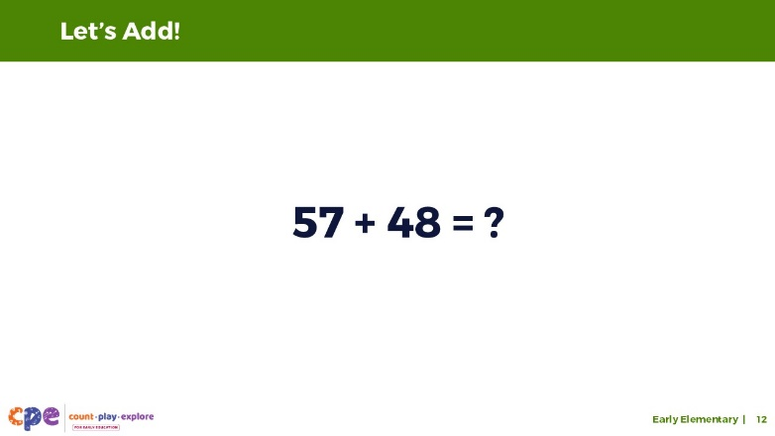
Time: 2–3 minutes
This slide contains animation. See instructions in the Talking Points.

Talking Points
- Now, we will explore a property of addition that children grow to understand. We will use written equations for our adult activity.
- Here is an equation. Solve it using any strategy you prefer.
- 57 + 48 = ?
- [Allow time for participants to solve the equations individually.]
- [Click to reveal the answer, 105.]
- As you may have discovered, the answer to this equation is 105.

SLIDE 13: Let’s Add! (Continued)
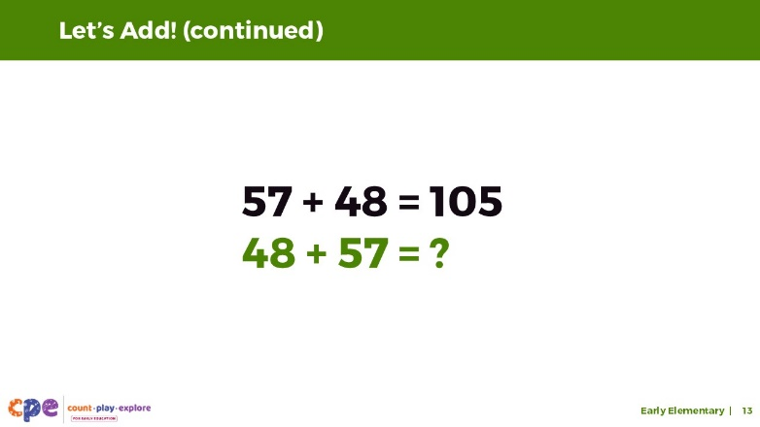
This slide contains animation. See instructions in the Talking Points.

Talking Points
- Now, let’s consider a different problem: 48 + 57 = ?
- [Allow time for participants to solve the equations individually.]
- [Invite volunteers to share their answer. Encourage participants to explain how they solved the problem.]
- [Click to reveal the answer, 105.]

SLIDE 14: Commutative Property of Addition
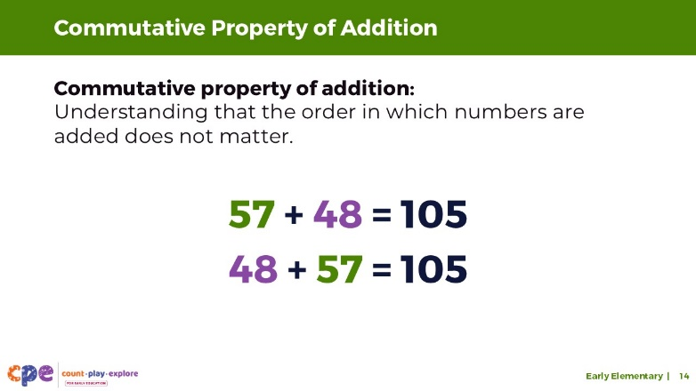

Talking Points
- We knew the answer very quickly because we understand that the order of the numbers being added together—the addends—does not matter.
- This is known as the commutative property.
- 57 + 48 is the same as 48 + 57.

SLIDE 15: Adding More Numbers
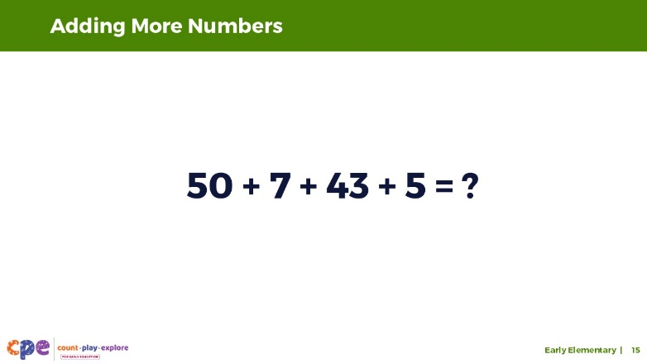
Time: 2–3 minutes
This slide contains animation. See instructions in the Talking Points.

Talking Points
- Let’s explore another property of addition related to the idea that the order in which numbers are added doesn’t matter.
- Here is an equation. Solve it using any strategy you prefer.
- 50 + 7 + 43 + 5 =?
- [Provide time for participants to solve the problem.]
- [Click to reveal the answer, 105.]
- You have discovered that the answer is 105. However, you might have used different strategies to come to that answer.
- Discuss with your table group the ways you solved this problem.
- [Provide time for participants to discuss. Then, invite a few volunteers to share with the larger group.]
- Thank you for sharing ways you solved this addition problem.

Facilitator Notes
- Consider charting the different ways participants solved the problem. For example,
- adding 50 + 7, then 43 + 5; finally, adding 57 + 48 using a “column method”
- adding 43 + 7 to get 50, then adding 50 + 50 to equal 100; finally, adding 5

SLIDE 16: Associative Property of Addition
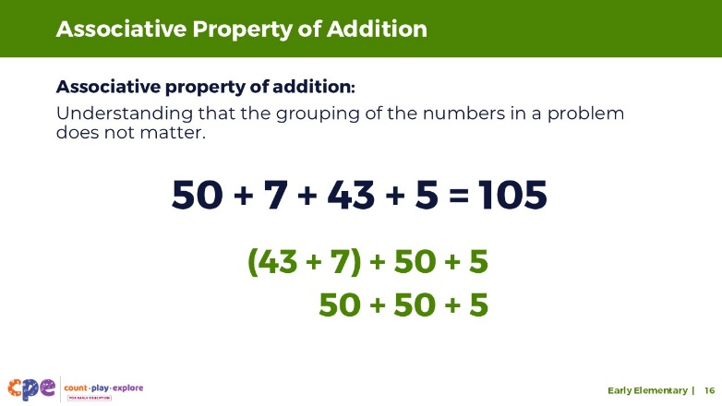
This slide contains animation. See instructions in the Talking Points.

Talking Points
- You experienced the associative property of addition. The associative property of addition means that numbers can be added in any order or any grouping.
- For example, children in second grade are likely to have fluency in the different ways to compose 10. They are likely to know that 3 and 7 makes 10.
- [Click to reveal an example.]
- Therefore, to solve the problem 50 + 7 + 43 + 5, children might first add 7 and 43, because 7 and 3 make a 10. So, 43 becomes 50. Now, it is easier to add 50, 50, and 5.
- The associative property of addition is strongly related to the commutative property of addition (Barnett & Ding, 2018).
- When children understand the associative property, they can group numbers in a way that helps them solve the problem.

SLIDE 17: Let’s Subtract!
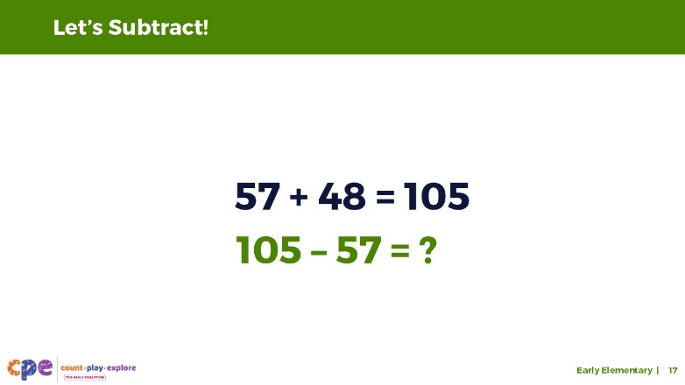
This slide contains animation. See instructions in the Talking Points.

Talking Points
- Now, we will explore one more property of addition and subtraction.
- Here is the same equation we worked with previously: 57 + 48 = 105.
- [Click to reveal a new equation.]
- Here is a new equation: 105 – 57. Solve it using any strategy you prefer.
- [Provide time for participants to solve the problem.]
- How were you able to solve this so quickly?
- [Affirm and support participants’ responses.]

SLIDE 18: Inverse Property of Addition and Subtraction
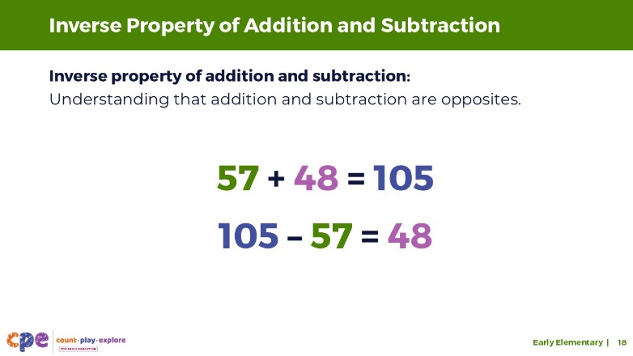

Talking Points
- Many of you might have used the inverse property of addition and subtraction.
- The inverse property of addition and subtraction is the idea that addition and subtraction are opposites. For example, we knew that 57 and 48 make 105. So, we could easily figure out that if we take 57 away from 105, the part that remains will be 48.

SLIDE 19: How Children Come to Understand the Properties of Addition and Subtraction
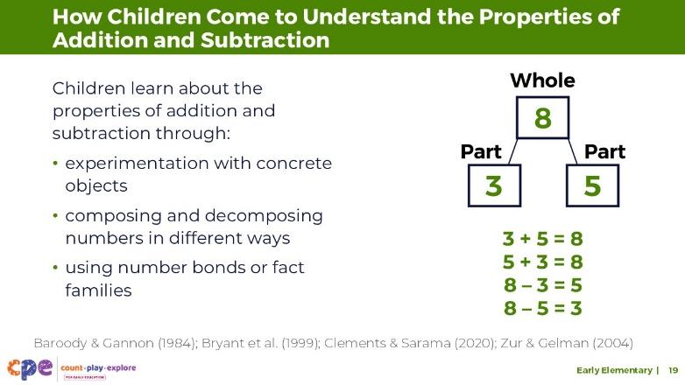
This slide contains animation. See instructions in the Talking Points.

Talking Points
- Most children experience the commutative, associative, and inverse properties over time, starting in preschool, by exploring addition and subtraction in different ways—for example, adding and subtracting during daily routines, such as putting away toys and materials, at mealtimes, or while playing games involving taking away or adding to (Baroody & Gannon, 1984; Bryant et al., 1999; Clements & Sarama, 2020; Zur & Gelman, 2004).
- Educators can help children learn about these properties by encouraging children to experiment with adding and subtracting concrete objects and inviting them to compose and decompose numbers in different ways.
- Sometimes children learn about these relationships using “fact families”—a collection of math facts that show the relationship between the same set of numbers. Educators might encourage children to represent fact families using “number bonds.”
- [Click to reveal an example of a number bond.] Number bonds help children understand how two smaller numbers are a part of a total or a whole. For example, children might make a number bond using 8 as the whole and 3 and 5 as the parts. Children can understand that 3 + 5 = 8, and 5 + 3 also equals 8. The order in which the numbers are added does not change the answer.
- Children also notice that 3 and 5 are both parts of a whole (8). If one of those parts is removed, for example, 8 – 3, the remaining part will be 5. When we combine the two parts, 3 and 5, we get 8. This is the inverse property.
- Educators can also present problems that illustrate these principles right after each other to help children realize through inquiry that, although the problems might be different, they are related and sometimes share the same answer. For example, educators might present 3 items that appeal to children and ask the children to add 5 more, solving for 3 + 5. Educators can then ask children to take away 3, solving for 8 – 3. Educators can ask children what patterns they notice to highlight the inverse relationship between the equations.

SLIDE 20: Solving Addition and Subtraction Problems
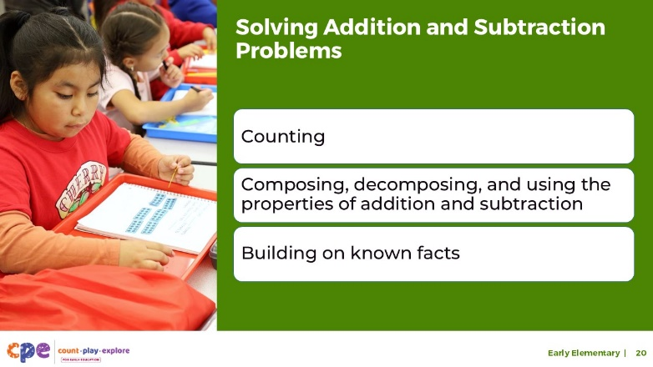

Talking Points
- We have discussed the different understandings that children develop about addition and subtraction.
- Now, we will examine different strategies children might use to solve addition and subtraction problems. These include:
- counting
- composing, decomposing, and using the properties of addition and subtraction
- building on known facts

SLIDE 21: Observe: Children Adding
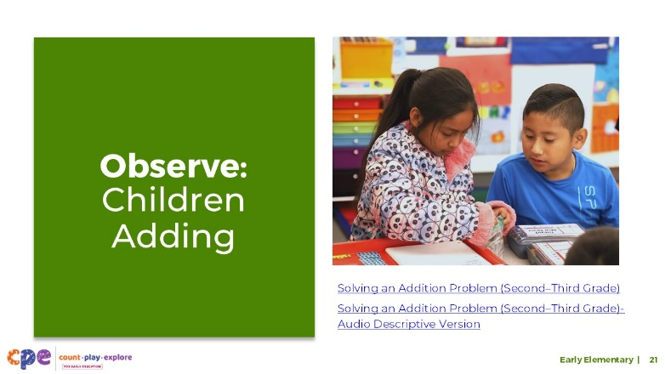
Time: 10–15 minutes
Materials: Early elementary addition and subtraction video clip

Talking Points
- Let’s observe a video clip of children solving an addition problem.
- As you observe, notice what children understand about addition and subtraction.
- What do you notice about some of the strategies they use to solve the addition problem?
- After observing the video clip, we will discuss what you noticed.
- [Play the video clip.]
- [Invite participants to share observations about what children understand regarding addition and subtraction, as well as the strategies the children used.]
- Thank you for sharing what you noticed about how children in the video used addition. We will revisit some of what you observed as we explore strategies children in the early elementary grades use to add or subtract.
- Later, we’ll discuss how educators can support children to try different strategies for addition and subtraction. For now, it’s important to note that there is no one right or wrong way for children to utilize strategies to creatively compose and decompose numbers. It is an educator’s role to notice and respond to the richness of children’s sense-making and to support peers in learning from one another.

Facilitator Notes
- Choose an early elementary grade video clip of children adding or subtracting.
- We provide the following video clip (you may use other videos):
- Solving an Addition Problem (Second–Third Grade), Solving an Addition Problem (Second–Third Grade) - Audio Descriptive Version: In this video clip, children in second grade use concrete objects (for example, base ten blocks and ten frames) to solve a word problem. Children work collaboratively and engage in math discourse as they explain their approaches to their partners.
- Consider playing the video more than once. The first time, invite participants to become familiar with the clip. Then, invite participants to observe ways children use different strategies and understandings to support their addition process.

SLIDE 22: Early Counting Strategies
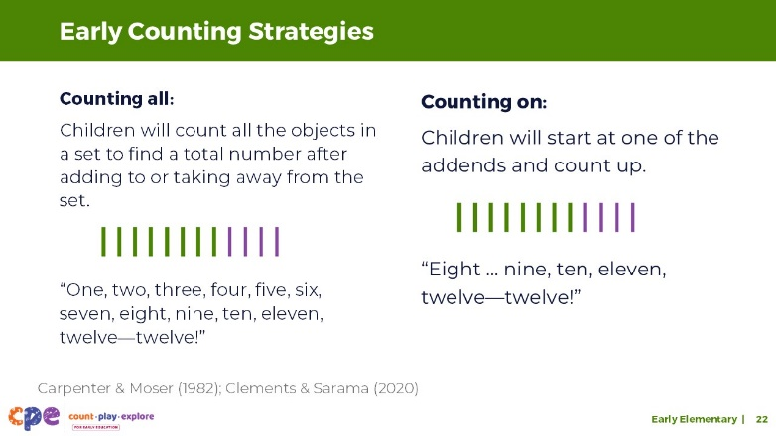

Talking Points
- The count-all strategy is the first strategy children will use to add and subtract numbers.
- This means that children will count all the objects in a set to find a total number after adding to or taking away from that set. For example,
- A child might combine a set of 8 and a set of 4. Then, the child will count all of the objects in the set, “One, two, three, four, five, six, seven, eight, nine, ten, eleven, twelve—twelve!”
- By the end of kindergarten and into first grade, children learn to use the “count on” strategy for addition (Carpenter & Moser, 1982; Clements & Sarama, 2020).
- The count-on strategy is when a child starts at a number and counts up from that number. For example,
- When solving addition problems, such as adding 4 to a set of 8, a child might say aloud or whisper to himself, “Eight …” and then count on 4 more fingers or objects saying, “… nine, ten, eleven, twelve—twelve!”
- Children might count using their home language, English, or both. Educators can support children to use the language that is most effective for them.

Facilitator Notes
- Review PPT 2b “Addition and Subtraction: Preschool, Transitional Kindergarten, and Kindergarten” for more information on emerging counting strategies. Information on counting strategies is also featured in PPT 1 “Introduction to Addition and Subtraction.”
- Consider inviting participants to use the collections of objects at their table to model the counting strategies described on the slide.

SLIDE 23: Advanced Counting Strategies
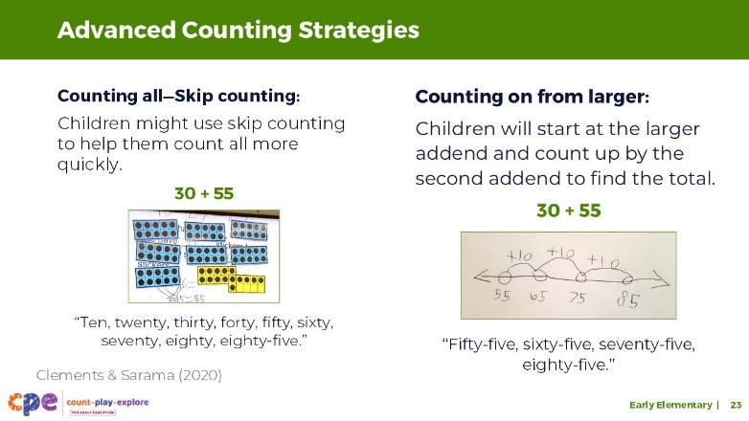

Talking Points
- Children might continue to use count-all strategies, even when they start using larger numbers. They might use skip counting to help them “count all” more quickly (Clements & Sarama, 2020). For example,
- A child might add 30 and 55 by skip counting: “Ten, twenty, thirty, forty, fifty, sixty, seventy, eighty, eighty-five.”
- Children might also use a counting-on strategy. Children who understand the commutative property (the idea that the order in which numbers are added does not matter) might realize that adding 55 to a set of 30 is the same as adding 30 to a set of 55. They might start counting up from the larger number. For example, “Fifty-five …,” and then count on, “…sixty-five, seventy-five, eighty-five.”
- Counting on can be challenging for children because it requires them to start counting from numbers other than one.

Facilitator Notes
- Encourage participants to discuss the counting strategies demonstrated in the “Solving an Addition Problem (Second—Third Grade)” video clip. Consider playing parts of the clip to support participants’ discussion.
- Here is an example of how children in the video used counting strategies:
- Children in this video use a variation of a counting-all strategy. For example, David physically combines all the tens and then uses skip counting to count them all. He uses a counting-on strategy to add the ones to the tens.

SLIDE 24: Counting Strategies: Subtracting
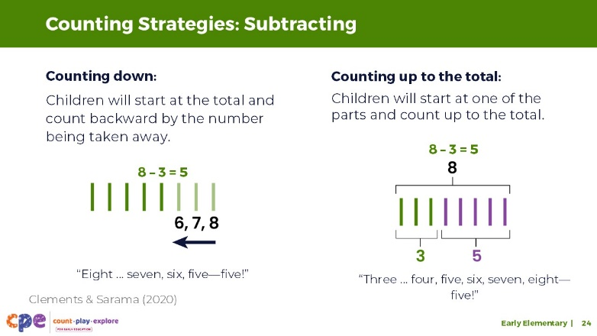

Talking Points
- Similar to counting-on strategies, children might use counting-down strategies to help them solve subtraction problems. This means that a child might start at a number and then count backward by the number that is being subtracted.
- For subtraction problems such as taking 3 away from a set of 8, a child might hold up 8 fingers and while removing 3 fingers, count “eight… seven, six, five.” [Use gestures to model the talking points by holding up 8 fingers. Then, fold 3 fingers down as you count backward to 5.]
- Counting down is challenging because it requires children to know how to count backward and hold in memory how many fingers or objects they are removing.
- Children might use number lines to support counting down as a strategy for subtraction.
- Some children might use a “counting-up-to-the-total” strategy to solve subtraction problems (Clements & Sarama, 2020). This happens when children begin to understand part–whole relationships as they relate to addition and subtraction.
- For example, if solving 8 – 3, children might understand that the total is 8. One part of that 8 is 3. They might use addition to count on from 3, “Three … four, five, six, seven, eight” (counting on 5 fingers), to realize that the missing part is 5. [You might use gestures to model this approach. Hold up 3 fingers. Then, add 5 more fingers to result in 8.]
- This understanding of part–whole relationships is supported by opportunities to compose and decompose numbers in different ways.
- It takes time and a lot of practice for children to comfortably transition from counting-all to counting-on or counting-down strategies. While some children make this transition in kindergarten, others may only make this transition in first grade.

Facilitator Notes
- PPT 2b “Addition and Subtraction: Preschool, Transitional Kindergarten, and Kindergarten” and PPT 1 “Introduction to Addition and Subtraction” also feature counting strategies.
- Consider inviting participants to discuss the ways children in their learning setting have used counting strategies to add or subtract.

SLIDE 25: Composing and Decomposing to Solve Addition or Subtraction Problems
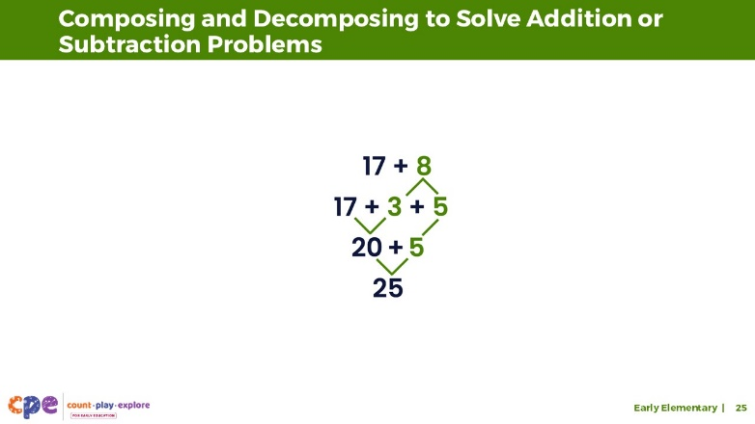
This slide contains animation. See instructions in the Talking Points.

Talking Points
- As children deepen their understanding of number relationships and the properties of addition and subtraction, they become more flexible in how they solve problems. For example, they can decompose or compose numbers in different ways or decide which two numbers to add first.
- Consider the ways children might compose or decompose numbers to solve 17 + 8.
- [Provide time for participants to consider ways children might compose or decompose numbers to solve 17 + 8. You might invite participants to discuss in small groups. Then, share with the larger group.]
- You discussed some ways children might compose or decompose to solve 17 + 8. Here is one way:
- [Click to reveal 3 + 5.] Children might first decompose 8 into 3 and 5.
- [Click to reveal 17 + 3.] Then, they might add 17 and 3 to get 20.
- [Click to reveal 20 + 5.] Now it is easier to add 20 and 5 …
- [Click to reveal 25.] … to equal 25.
- Children might use different strategies in flexible ways to solve problems.
- This approach to solving addition or subtraction problems might seem different from how we learned to add or subtract when we were in school. Some older methods of teaching children to add or subtract focused on arriving at a correct answer—often by using a system of steps (for example, adding numbers in columns).
- Some ways children are taught to solve addition and subtraction problems today (for example, by using number composition and decomposition) help children use math with understanding to solve problems (Clements & Sarama, 2020). Instead of following steps to arrive at a correct answer, children are able to understand how addition and subtraction work and why they arrive at a certain answer.

Facilitator Notes
- You might encourage participants to discuss the ways children used composition and decomposition as a strategy to support them to add in the “Solving an Addition Problem (Early Elementary)” video clip. Consider playing parts of the clip to support participants’ discussion.
- Here is an example of how children in the video used composition and decomposition to support adding: The children understand that numbers can be put together and taken apart. For example, the children model the addends, 39 and 46, using ten frames and base ten blocks. To do this, they first decompose each addend into tens and ones (3 tens, 9 ones, and 4 tens, 6 ones). Then, they compose the tens and ones in ways that support their addition process.

SLIDE 26: Building on Known Facts
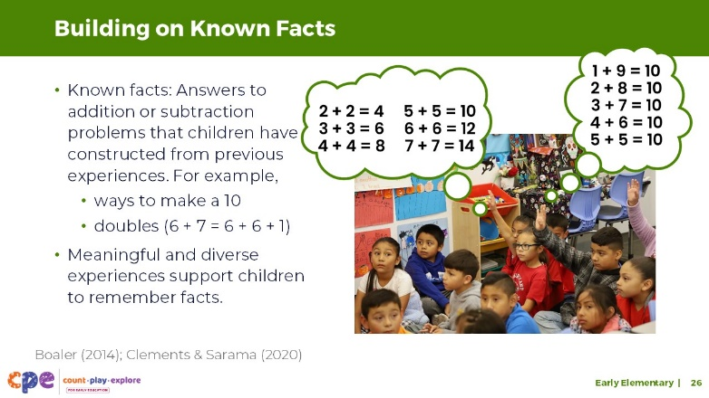

Talking Points
- Another way children might solve addition and subtraction problems is by building on known facts.
- These known facts—answers to addition or subtraction problems that children have constructed from previous experiences—can be used to solve other problems. For example, children might know from memory:
- Addends that equal 10 (such as 8 + 2, 6 + 4, 7 + 3, 5 + 5)
- Sums of doubles (such as 1 + 1, 2 + 2, 3 + 3, and so on)
- Children might use known facts of doubles to solve problems. For example, to solve 6 + 7, children might know from memory that 6 + 6 = 12, and then add one to get 13.
- To come to know facts, young children can draw from meaningful and diverse experiences with addition and subtraction across home and school experiences that support them to solve a variety of addition and subtraction problems in different ways and in different contexts.
- If children memorize addition or subtraction facts without understanding the relationships between the numbers, their knowledge is less useful. Children who only memorize facts will often struggle to apply facts to new and more complex problems.
- However, when children are encouraged to find patterns in their reasoning and build an understanding of how numbers are related, they remember facts in a way that is flexible and useful (Boaler, 2014; Clements & Sarama, 2020).
- It is important to learn about children’s abilities and prior knowledge to best support them in their ability to use known facts as a way to add and subtract.

Facilitator Notes
- Invite participants to share some of the facts children in their learning setting know from memory.

SLIDE 27: Problem Types
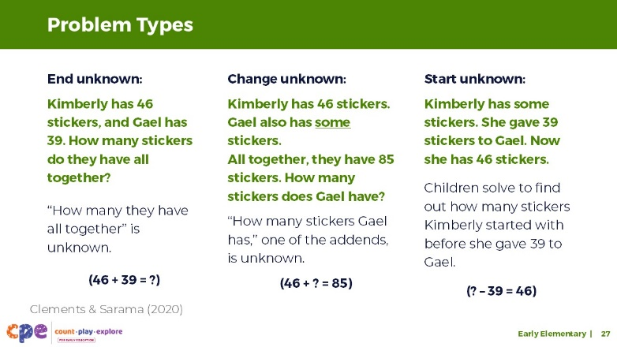

Talking Points
- We reviewed different strategies children might use to add and subtract.
- As children gain more experience using different strategies, they adjust the strategy they use to solve a problem based on the type of problem they are solving (Clements & Sarama, 2020).
- Children explore many types of problems using addition and subtraction. Here are three examples:
- End unknown: In end unknown problems, the end result is what is unknown. For example, “Kimberly has 46 stickers and Gael has 39. How many stickers do they have altogether?” “How many they have all together” is the unknown that children try to figure out.
- Change unknown: In change unknown problems, how much is added or taken away is the unknown part. Here’s one example of a change unknown problem: “Kimberly has 46 stickers. Gael also has some stickers. All together, they have 85 stickers. How many stickers does Gael have?” In this problem, one of the addends—the numbers being added—is unknown.
- Start unknown: In start unknown, the starting amount is unknown. Here is an example of a start unknown problem presented in the video: “Kimberly has some stickers. She gave 39 stickers to Gael. Now she has 46 stickers.” In this problem, children solve to find out how many stickers Kimberly started with, before she gave 39 to Gael.
- Discuss with your table groups different ways children might solve these problems. You might also discuss the ways children in the video solved the start unknown problem.
- [After participants discuss with their table groups, invite volunteers to share with the larger group.]
- You discussed different ways children might solve these word problems. There is not one right or wrong way to do this. It is important that educators provide children with opportunities to experiment with different ways to solve a problem. Children should also be encouraged to explain their approach to an educator or peers.

Facilitator Notes
- For more information on problem types, you might visit the following link and use the “Helping Your Child with Word Problems” handout.
- Consider inviting participants to review the handout. Then, create word problems that align with the problem type of their choice.
- Partners might try to guess the problem type that others’ word problems illustrate.
- Encourage participants to use the materials available to them at their tables to support their problem-solving.
- Prompt participants to explain why they used a certain strategy or materials.

SLIDE 28: Supporting Children to Add and Subtract
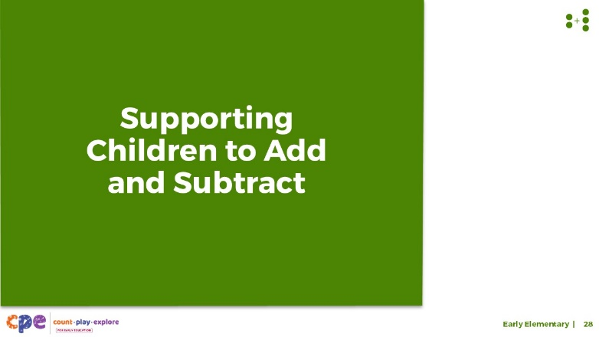

Talking Points
- We explored how children develop a deeper understanding of addition and subtraction and strategies children use to solve addition and subtraction problems. Now, let’s discuss ways we can support children to add and subtract.

SLIDE 29: Explore: M⁵ Early Math Approach
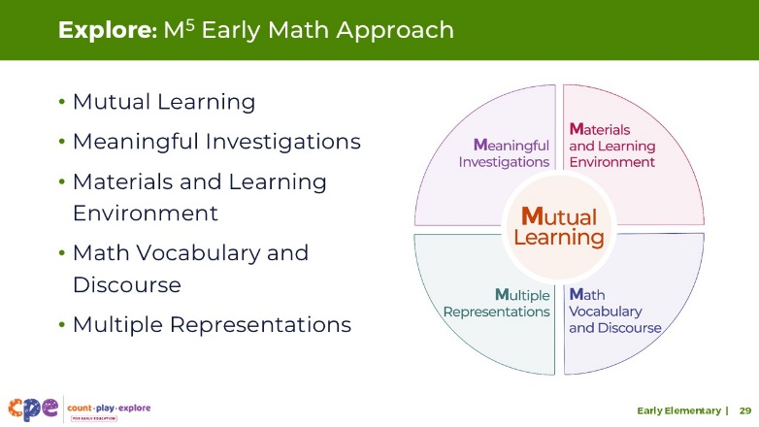
Time: 15 minutes
Materials: M⁵ Overview handout

Talking Points
- We refer to five early math teaching practices as the M⁵ Early Math Approach. These practices include:
- Mutual Learning
- Meaningful Investigations
- Materials and Learning Environment
- Math Vocabulary and Discourse
- Multiple Representations
- Let’s explore the M⁵ practices. Then, we will consider ways to use M⁵ to support children to add and subtract.

Facilitator Notes
- Consider your participants and their prior experiences with M⁵.
- For groups that have significant experience with M⁵, offer a few minutes for participants to share with a partner their areas of strength and what practices they are working on. Use this slide to briefly revisit the M⁵ practices and move to the next slide.
- For groups that have less experience with M⁵, offer more time for participants to explore each practice. For example, allow time for them to review the practices on their own. Invite them to make a square over practices that they have “squared away” (practices they understand and use), a circle over “what’s still going around in their heads” (practices they still have questions about), and a triangle over three ideas that they will use in their learning settings. For more ideas on how to provide a comprehensive review, visit the M⁵ Early Math Approach suite.

SLIDE 30: Materials
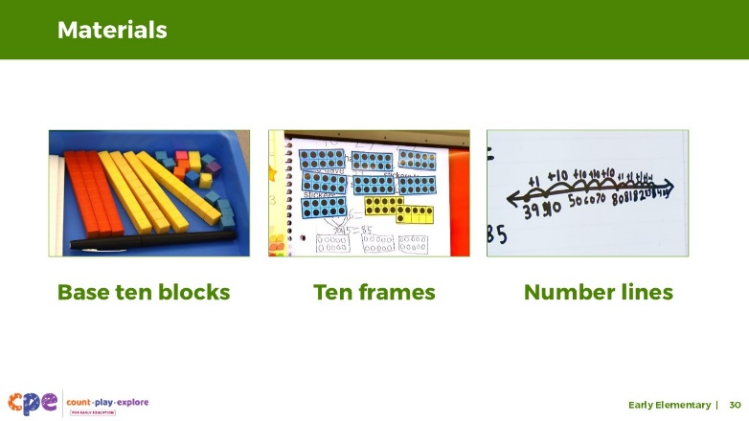

Talking Points
- Before we explore all five of the M⁵ teaching practices, let’s take a moment to focus on one of them: Materials and Learning Environment.
- Throughout preschool, TK, and K, children mostly rely on concrete objects to represent arithmetic problems.
- In grades one and two, children learn to use many different materials to solve problems. Here are three commonly used materials:
- base ten blocks
- ten frames
- number lines

Facilitator Notes
- Invite participants to share other concrete materials they have used in the past to engage children in adding and subtracting.

Slide 31: Base Ten Blocks and Ten Frames
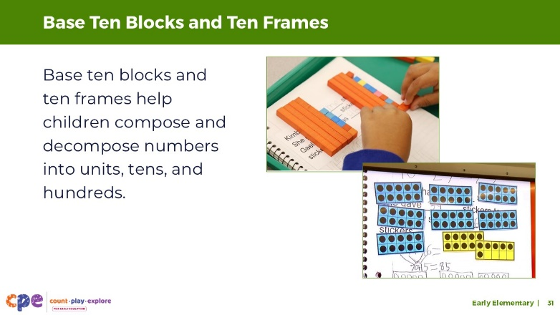

Talking Points
- Base ten blocks are common materials children are introduced to in the early elementary grades.
- Once children begin to solve problems using number decomposition, base ten blocks help children compose and decompose numbers into units, tens, and hundreds using the appropriate blocks. Base ten blocks help emphasize the structure of our number system.
- Ten frames serve a similar purpose. When children use ten frames, they can model numbers using tens and ones.
- The ten frames also provide a visual representation of different quantities that help children use subitizing to determine quantity. For example, children will learn that one row of a ten frame is always 5. They will be able to determine that there are 5 dots without counting each dot; one row and 1 dot below the row is always 6.
- We observed children using ten frames and base ten blocks to add and subtract in the video clip.

Slide 32: Number Lines
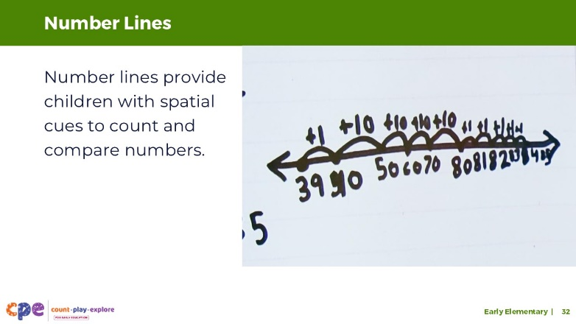

Talking Points
- Children might learn to use number lines to add or subtract. Number lines are another material that children might use to support them to add and subtract.
- Number lines provide children with spatial cues to compare numbers.
- For example, in a number line, children can notice how 10 is to the left of the 30, or 8 is closer to 10 than it is to 5.
- Number lines can also support children who use counting strategies because it allows them to keep track of where they started and show the number of spaces they are moving.
- For example, when solving 8 + 4 using a counting-on strategy, children can start their finger at 8, then count 4 jumps to the right. Their finger will then land on the result, 12.
- Research suggests that the materials and tools children are provided with are important for their success in solving addition and subtraction problems. In fact, it is important that the tool a child uses aligns with the strategy they are using (Schiffman & Laski, 2018).
- For example, a child using counting strategies might benefit from concrete objects or a number line while a child using decomposition strategies might benefit from base ten blocks or ten frames.
- Educators can help children understand how to use different tools in combination with different strategies. Children can also be offered a choice in which materials to use to support their problem-solving.

SLIDE 33: Play: Using Base Ten Blocks, Ten Frames, and Number Lines
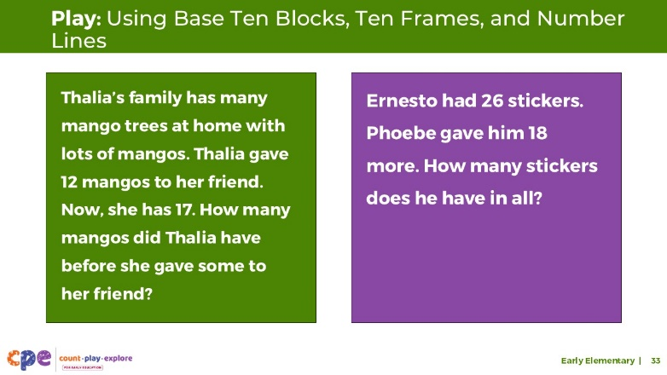
Time: 15–20 minutes
Materials: Base ten blocks, ten frames, number lines

Talking Points
- Let’s try it.
- Here are two word problems:
- Thalia’s family has some mango trees at home with many mangos. Thalia gave 12 mangos to her friend. Now, she has 17. How many mangos did Thalia have before she gave some to her friend?
- Ernesto had 26 stickers. Phoebe gave him 18 more. How many stickers does he have in all?
- Use the base ten blocks or ten frames or create number lines to solve each problem. Experiment with the different materials as you solve the different problems.
- [Choose a facilitation strategy to support participants in engaging with the materials.]
- Thank you for exploring some of the materials children might use to support them to add or subtract.

Facilitator Notes
- Consider using a “Think-Pair-Share” protocol. Invite participants to solve the addition and subtraction problem individually (think). Then, encourage them to find a partner (pair). With that partner, support participants in discussing their approach (share). Prompt pairs to discuss the following:
- the answers they came up with (including discussing why they may have gotten different answers)
- the strategies they used to solve the problem
- their experience using the different materials to support their process
- Encourage participants to share with the larger group about their experiences using base ten blocks, ten frames, and number lines.
- Consider asking these additional reflection questions:
- Which of these materials do you already use with children in your learning setting?
- Which additional materials might you invite children to use when solving addition and subtraction problems?

SLIDE 34: Explore: Playful Activities to Support Addition and Subtraction
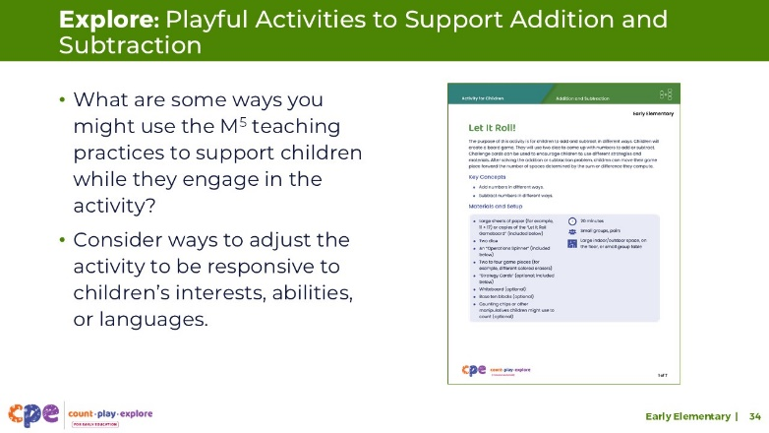
Time: 10–20 minutes
Materials: Let It Roll! handout, materials to play Let It Roll! (optional)

Talking Points
- We experimented with some materials children might use to support them in adding and subtracting. Now, we will explore a playful activity that encourages children to add and subtract in different ways using various materials.
- Take out the Let It Roll! activity for children.
- This handout provides instructions on how to support children in creating and using a gameboard to add and subtract in different ways, with ideas on how to support children’s learning using the M⁵ Early Math Approach.
- Review the handout with a partner.
- Discuss ways to use the M⁵ teaching practices to support children while they engage in the activity. Consider ways to adjust the activity to be responsive to children’s interests, abilities, or languages.

Facilitator Notes
- Provide 5–10 minutes for participants to review and discuss the handout.
- Invite participants to share with the larger group how they might use the activity in their setting.
- For longer sessions, consider offering time for participants to do the activity. Be sure to prepare and bring the necessary materials. Encourage participants to discuss what they noticed about ways they used addition or subtraction as they engaged in the activity.

SLIDE 35: Explore: Using M⁵ to Support Learning About Adding and Subtracting
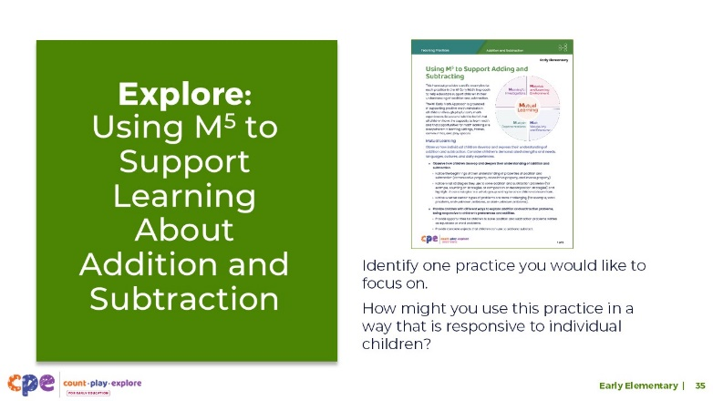
Time: 20–30 minutes (including debrief on next slide)
Materials: Using M⁵ to Support Learning About Addition and Subtraction handout

Talking Points
- We explored some materials and representations that support children to add and subtract.
- Now, we will review more of the M⁵ teaching practices.
- Take out the handout Using M⁵ to Support Learning About Addition and Subtraction.
- Review the ideas on how to use M⁵ to support children in early elementary grades to add and subtract.
- Identify one practice you would like to focus on in your learning setting. Consider the unique interests and cultures of children in your context, and discuss the following questions:
- How might you use this practice in a way that is responsive to the children in your learning setting?
- How might you adjust the experience to support different abilities or multilingual learners?
- You might make notes or highlight as you review.

SLIDE 36: Discuss: Using M⁵ to Support Learning About Addition and Subtraction
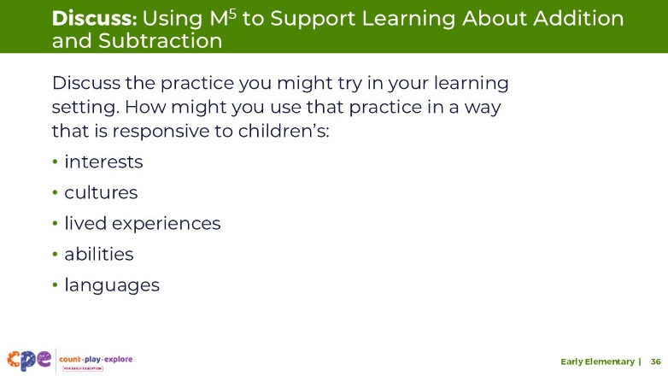
Time: 20–30 minutes (including exploring the handout on previous slide)
Materials: Using M⁵ to Support Learning About Addition and Subtraction handout, dice (optional)

Talking Points
- Now, we will discuss the handout.
- Discuss the practice you might try in your learning setting. How might you use that practice in a way that is responsive to children in your context? How might you adjust the practice for children with different ability levels or for multilingual learners?
- [Select a facilitation strategy to support participants’ discussion of the handout.]
- Thank you for sharing ways you might use M⁵ to support children to add and subtract in your learning setting.

Facilitator Notes
- Adjust the way participants discuss the handout based on your group size, session length and format, and participant needs. For example,
- For shorter sessions, invite a few volunteers to share with the larger group or encourage participants to discuss the handout with their table group.
- For longer sessions, encourage participants to use addition and subtraction as a playful way to find a partner (or partners). Participants will discuss the handout once they find their partners. For example,
- Create a group by adding and subtracting to make 5: Each person will roll a die and get a number. Using that number, they will find one or more people that, together, using addition or subtraction, can make 5. For example, a person who rolled a 2 might find someone who rolled a 1 and someone who rolled a 4. Together, 2 plus 4, minus 1, makes 5.

SLIDE 37: Observe: M⁵ in Action
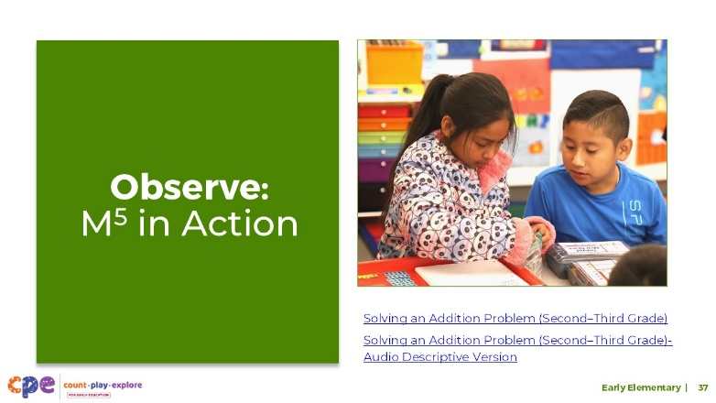
Time: 5–7 minutes (not including debrief)
Materials: Observing M5 in Action: Addition and Subtraction handout, early elementary addition video clip, chart paper (optional), markers (optional)

Talking Points
- Now, we are going to observe a video and notice ways the educator used M⁵ to help children in the early elementary grades add and subtract.
- Take out the Observing M⁵ in Action: Addition and Subtraction handout.
- [Choose a strategy for facilitating this observation. Adapt the talking points to reflect this strategy.]

Facilitator Notes
- Choose a video clip that shows children learning about and using addition or subtraction. This may be the same clip used for observing children adding and subtracting.
- We provide the following video clip of addition in the early elementary grades (you might choose other videos to use):
- Solving an Addition Problem (Second–Third Grade), Solving an Addition Problem (Second–Third Grade) - Audio Descriptive Version
- Note: Sample answers are provided for the video “Solving an Addition Problem (Second Grade)” in the Facilitator Notes on the next slide.
- For larger groups or shorter sessions, use a jigsaw approach. Before playing the video clip, assign each table one practice to focus on during the video. [If there are more than five tables, assign more than one table to focus on each practice.]
- For smaller groups or longer sessions, consider showing the video clip two to three times, inviting participants to focus on specific practices each time. Encourage them to record observations on the handout.

SLIDE 38: Discuss: M⁵ in Action
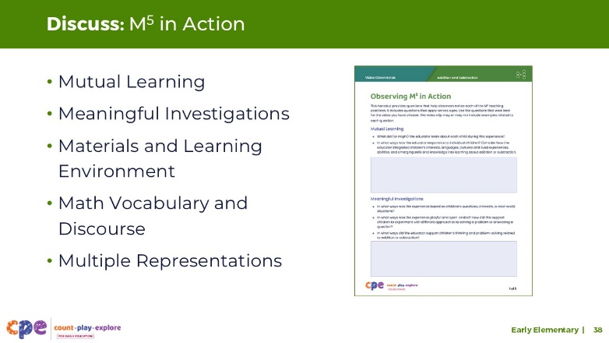
Time: 20–30 minutes (varies based on session goals)
Materials: Observing M⁵ in Action: Addition and Subtraction handout, Early Elementary grades addition video clip, chart paper (optional), markers (optional), dice (optional)

Talking Points
- Let’s unpack your observations of each M⁵ practice.

Facilitator Notes
- Use the Answer Key for Observing M⁵ in Action: Addition and Subtraction for examples of ways M⁵ was used in the video clip.
- For larger groups or shorter sessions, ask each table group to discuss what they noticed about their assigned practice after observing the video. Then, invite each group to share their observations with the larger group. As each group shares, paraphrase, affirm, and add to their responses as needed.
- For smaller groups or longer sessions, encourage participants to use addition and subtraction as a playful way to find a partner (or partners). Participants will discuss the handout once they find their partners.
- For longer sessions, encourage participants to use addition and subtraction as a playful way to find a partner (or partners). Participants will discuss the handout once they find their partners. For example,
- Create a group by adding and subtracting to make 7: Each person will roll a die and get a number. Using that number, they will find one or more people that, together, using addition or subtraction, can make 7. For example, a person who rolled a 3 might find two people that each rolled a 2. Together, 3 plus 2, plus 2, makes 7.
- Consider recording participants’ observations to make the practices visible. As participants share, paraphrase, affirm, and add to their responses as needed.

SLIDE 39: Reflection and Planning
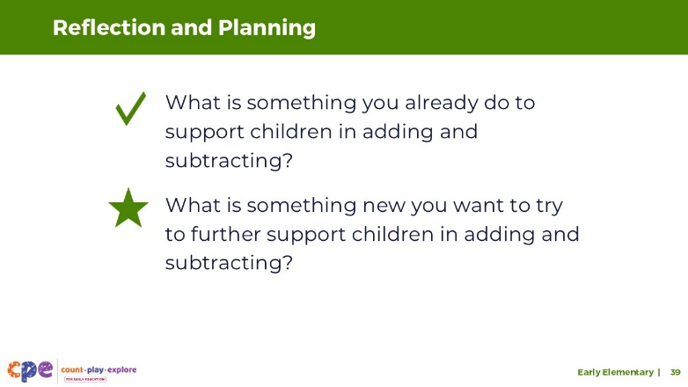
Time: 5–7 minutes

Talking Points
- Today, we discussed what children understand about addition and subtraction and strategies they might use to solve addition and subtraction problems. We also discussed how educators might support children to add and subtract.
- Think about your learning setting and the practices you already use.
- What is something you already do to support children to add and subtract?
- What is something new you might want to try to further support children to add and subtract?
- You might record your ideas.
- [Allow three to four minutes for participants to think and record their reflections. Consider inviting participants to share with a partner or the larger group.]
- Thank you for your time, attention, and engagement. It’s been wonderful working with you.

Facilitator Notes
- As participants discuss their reflections, note the questions that they still have and what they would like to try. Use this information to identify topics for future training, coaching, or communities of practice.

