Measurement: Preschool, Transitional Kindergarten, and Kindergarten (PPT 2b)
Use this facilitator guide with the slides “Measurement: Preschool, Transitional Kindergarten, and Kindergarten.” This set of slides provides descriptions of how children in preschool, transitional kindergarten (TK) and kindergarten (K) develop their understanding of measurement concepts and ways educators can support them as they develop early measurement skills. Facilitators can find talking points and guidance for activities and group discussions in this guide. The text in the guide is also located in the notes portion of the slides.

Session at-a-Glance
Slide Numbers | Overview of Content | Approximate time (in minutes)
1-3 | Introduction & session goals | 5
4-5 | Everyday opportunities for children to measure  - Measuring in STEAM | 10-15
6-23 | How children in preschool, TK, and K learn about measurement:  - California learning foundations and standards  - Comparing  - Ordering  - Measuring  - Video observation | 30-40
24-29 | How to support children in learning about measurement:  - Observing and discussing M⁵  - Activity for children | 45-75
30 | Reflection | 5-7
The times are approximate and may vary based on session goals, group size, and participants’ previous experience and familiarity with the content.

To prepare for your session
- As you plan your professional learning session, consider the content in each of the PPTs in this suite:
  - PPT 1 “Introduction to Measurement: Birth–8 Years” describes how children develop an understanding of measurement from birth to age eight.
  - PPT 2a “Measurement: Infants and Toddlers,” and PPT 2b “Measurement: Preschool, Transitional Kindergarten, and Kindergarten” and PPT 2c (coming soon) “Measurement: Early Elementary” describe in greater depth how children at different age levels develop an understanding of measurement. These PPTs also include ideas on how to support children in specific age ranges to develop measurement skills.
- We encourage you to offer the content in PPT 1 before, or in combination with, one age-specific slide deck (PPT 2a, PPT 2b, or PPT 2c (coming soon)). Together, PPT 1 and one of the age-specific slide decks are designed for a three-hour professional learning session. However, you can adjust slide decks to best meet participant needs and time allowances.
- Before your session, carefully review all handouts and prepare the necessary materials. Select a facilitation method that works best for your session length and format, group size, and participant needs.
- Consider using photos, videos, or stories from the learning settings where educators work within this session. Making the information more personal for participants can create a greater connection to the content and foster feelings of belonging in math.

Materials Needed
- Scratch paper, chart paper, and writing tools
- A variety of standard and nonstandard measurement tools. An activity in the session requires participants to use these tools. Additionally, you may want to encourage participants to explore and play with these tools during breaks in your session.
  - Examples of standard measurement tools include measuring tapes, rulers, measuring cups and spoons, balance scales, or thermometers.
  - Examples of nonstandard measurement tools include blocks, string, paper clips, crayons, or craft sticks.
- Measuring in STEAM Investigations handout
- M⁵ Overview handout
- Observing M⁵ in Action: Measurement handout, sample answers handout, Preschool, TK, or K measurement video clip
- Using M⁵ to Support Learning About Measurement handout
- Measuring with Hands and Feet handout, colored paper, markers, scissors

Slide 1: Measurement: Preschool, Transitional Kindergarten, and Kindergarten
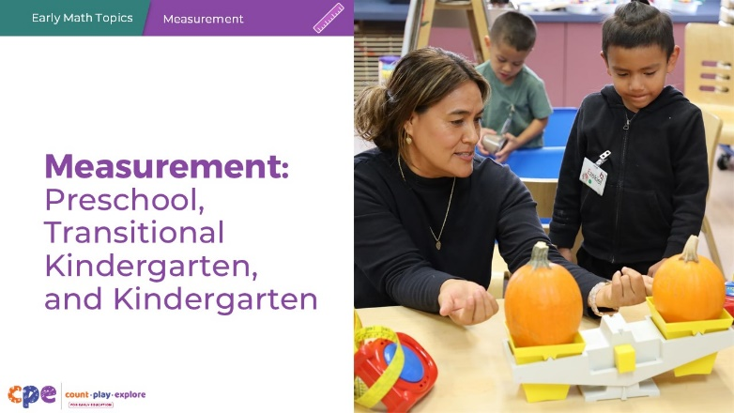

Talking Points
- In this session, we will explore how children in preschool, transitional kindergarten, and kindergarten develop an understanding of measurement, and how educators can support them to develop early measurement skills.
- Children three to five years old may be in preschool or transitional kindergarten. They may be in center-based programs; family child care programs; or family, friend, and neighbor care. Across all settings, children at this age learn math through play, daily routines, and meaningful interactions with peers and adults.
- We will use “TK” to refer to transitional kindergarten and “K” for kindergarten.

Facilitator Notes
- Adjust the talking points to reflect the session length and participant needs. If necessary, add introductory and “housekeeping” information.

Slide 2: Acknowledgments
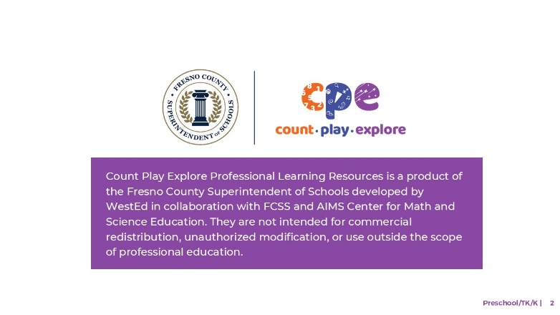

Talking Points
The Count Play Explore Professional Learning Resources were made possible by Count Play Explore, an early math, science, and computer science initiative led by the Fresno County Superintendent of Schools, Early Care and Education Department. This initiative is generously funded by the California Department of Education and the California State Board of Education. These resources, developed by WestEd in collaboration with FCCS and AIMS Center for Math and Science Education, are intended to be used as a guide for implementing evidence-based strategies, promoting active learning, and encouraging developmentally appropriate practices in early education settings. They are not intended for commercial redistribution, unauthorized modification, or use outside the scope of professional education.

Slide 3: Session Goals
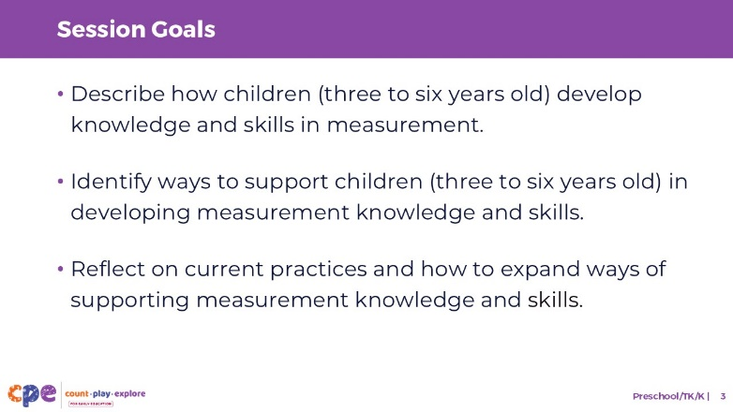

Talking Points
- First, we will review how children in preschool, TK, and K develop knowledge and skills in measurement.
- Then, we will explore ways educators can support preschool, TK, and K children in developing knowledge and skills in measurement.
- Throughout the session, we will reflect on our current practices. We will also think about how we might use information from this session in our work.

Facilitator Notes
- Adjust slide content and talking points to reflect what you plan to address in your professional learning session.
- For longer sessions, start the session by engaging participants in the interactive How Tall Am I? activity described in PPT 1 “Introduction to Measurement: Birth–8 Years” and its corresponding handout. The purpose of this activity is to help participants explore important measurement ideas such as estimation, starting points, approximation, and accuracy. Alternatively, engage participants in the activity in slide 4.

Slide 4: Discuss: Everyday Opportunities for Children to Measure
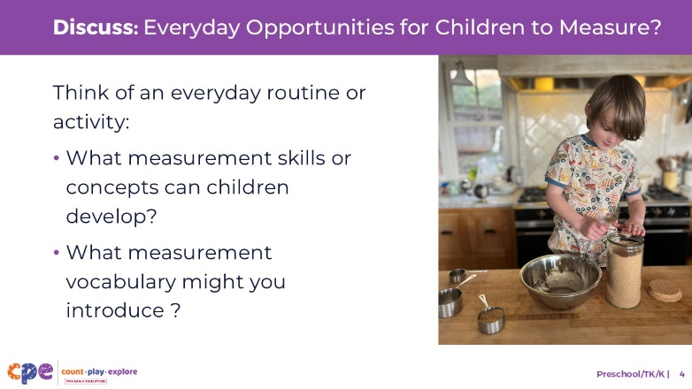
Time: 8–10 minutes
Materials: Variety of standard and nonstandard measurement tools

Talking Points
- Children have many opportunities in their everyday routines and experiences to explore ideas around measurement or use measurement tools. For example, they might measure how tall their block tower is or measure ingredients while making play dough.
- We have provided a variety of measurement tools on your tables. We have included both standard and nonstandard measurement tools:
  - Nonstandard measurement tools include everyday items like counting bears, blocks, unit cubes, your hands, or paper clips.
  - Standard measurement tools include more traditional tools such as a ruler, scale, yard stick, or meter stick.
- Think about some of the everyday routines, learning activities or investigations that occur in your learning setting. How might you invite children to use some of these standard or nonstandard measurement tools during those learning experiences?
- Share your ideas with your table group. Then, discuss the following with your group:
  - What measurement skills or concepts would children develop through this routine, activity, or investigation?
  - What measurement vocabulary might you introduce during these learning experiences?

Facilitator Notes
- Have a variety of standard and nonstandard measurement tools available for participants.
- Adjust the way you organize the activity based on group size, session length and format, and participants’ needs.
  - For longer sessions, consider asking each table group to share one or two examples with the large group.
- Go around the room and notice the ideas participants are discussing. When relevant, make references to these ideas throughout the session.

Slide 5: Explore: Measuring in STEAM Investigations
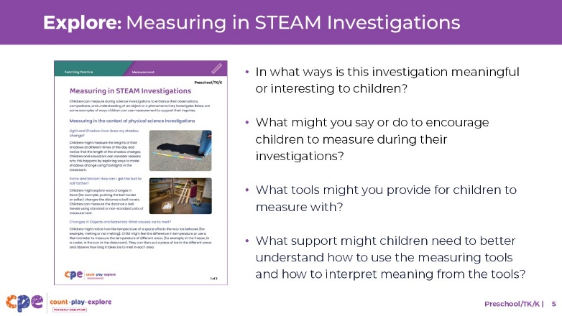
Time: 5–10 minutes
Materials: Measuring in STEAM Investigations handout

Talking Points
- STEAM investigations—investigations using science, technology, engineering, the arts, and math to construct meaning about the world—provide meaningful contexts for children to use measurement.
- Supporting children to measure within an investigation allows children to observe objects and phenomena with greater precision and accuracy.
- Take out the “Measuring in STEAM Investigations” handout.
- This handout describes ways to use measurement during different STEAM investigations within five STEAM content areas: physical science, life science, earth and space science, engineering and technology, and computer science.
- Review the STEAM investigations described in the handout.
- Place a star next to an investigation that might be meaningful for children in your setting to investigate.
- Use the following questions to brainstorm ways you might use measurement to support children’s investigations:
  - In what ways is this investigation meaningful or interesting to children?
  - What might you say or do to encourage children to measure as part of their investigations?
  - What tools might you provide for children to measure with? Consider standard and nonstandard units that are meaningful to children.
  - What support might children need to better understand how to use the measuring tools and how to interpret meaning from the tools (both standard and nonstandard units)?
- [In small groups, invite participants to share ways they might encourage children to measure during STEAM investigations. You might invite a few volunteers to share with the larger group.]
- Thank you for thinking about ways you might support children to measure during STEAM investigations.

Facilitator Notes
- You might use a jigsaw approach, assigning different groups to a different content area to review (for example, one group can review physical science and another group can review life science).

Slide 6: Learning About Measurement
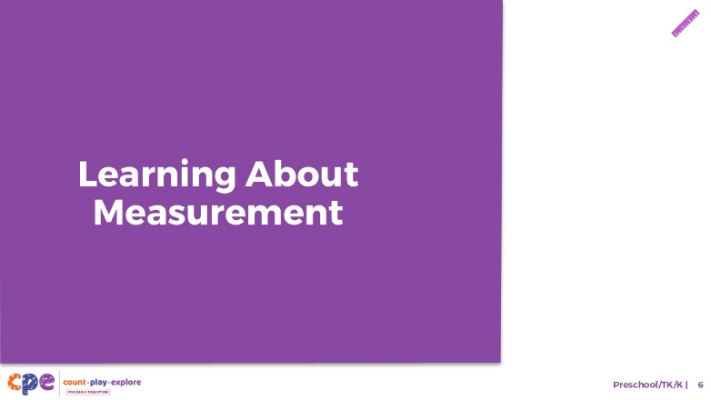

Talking Points
- Now, we will explore how children in preschool, TK, and K develop an understanding of measurement.

Slide 7: The California Preschool/TK Learning Foundations
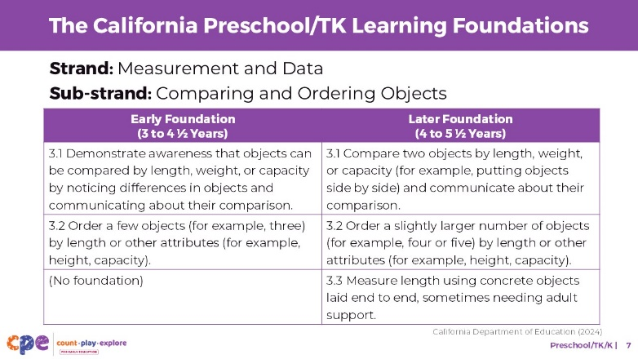

Talking Points
- Let’s review how measurement understanding is represented in the California Preschool/Transitional Kindergarten Learning Foundations (PTKLF; California Department of Education, 2024). The recently revised foundations were designed to align with expectations stated in the California Common Core State Standards: Mathematics (California Department of Education, 2013).
- Three foundations in the “Measurement and Data” strand describe what children learn about measurement in preschool or TK. These foundations describe children’s ability to:
  - Compare the measurable attributes of objects (Foundation 3.1)
  - Order objects by measurable attributes (Foundation 3.2)
  - Measure the length of objects (Foundation 3.3)

Facilitator Notes
- Slides 7 and 8 make connections to foundations and standards for measurement.
- The PTKLF addresses children ages three to five, this includes children in both preschool and TK. The California Common Core State Standards: Mathematics include standards for children in kindergarten.
- The foundations and standards listed in some of the slides are condensed. Consider providing participants with copies of the relevant California Preschool/TK Learning Foundations or the California Common Core State Standards. Consider whether electronic or printed copies will be more useful for your participants.

Slide 8: The California Common Core State Standards
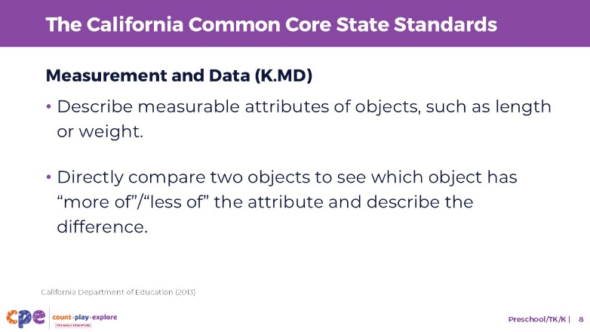

Talking Points
- For children in kindergarten, let’s review how measurement learning is represented in the California Common Core State Standards: Mathematics (California Department of Education, 2013).
- Two kindergarten standards in the domain “Measurement and Data” describe what children learn about measurement:
  - One standard describes children’s ability to describe the measurable attributes of objects, such as length or weight.
  - Another standard describes children’s ability to directly compare two objects to see which object has “more of”/”less of” the attribute and describe the difference.

Slide 9: Measurement Skills
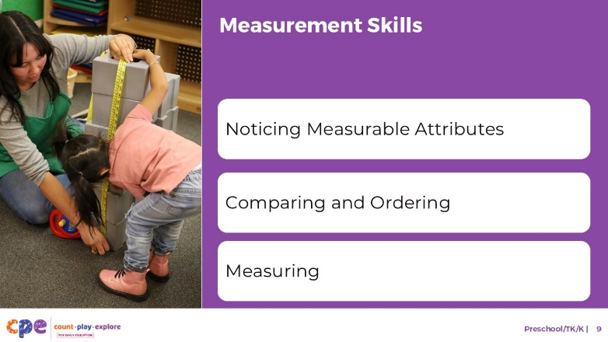

Talking Points
- This suite addresses several important measurement skills:
  - Noticing measurable attributes
  - Comparing and ordering
  - Measuring

Slide 10: Noticing Measurable Attributes
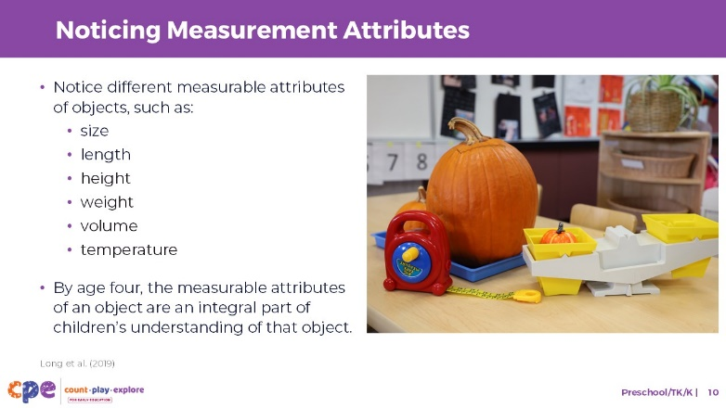

Talking Points
- Noticing measurable attributes of objects describes young children’s ability to notice characteristics of objects that can be measured (for example, size, length, height, weight, volume, or temperature).
- Infants and toddlers learn about measurable attributes of objects through play and exploration.
- By the time children are four years old, the measurable attributes of an object are an integral part of children’s understanding of that object (Long et al., 2019).
  - For example, when thinking about an elephant, its large size is an important part of children’s understanding of elephants.
- In fact, the measurable attributes of objects are such an important part of children’s understanding of objects, that presenting real-world objects in a size that isn’t typical for that object is confusing to children (Long et al., 2019).

Slide 11: Is it big or small?
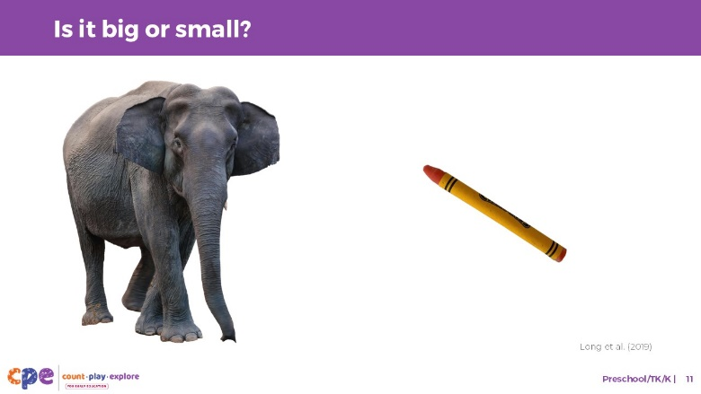

Talking Points
- Let’s explore how researchers examine what children know about real-world size.
- I am about to show you two pictures of objects very quickly. You will be asked to point to the object that is smaller on the screen.
- [Click to show the image, then after 1–2 seconds, click again to make the image disappear.]
- [Pause for participants to answer the question.] As you noticed, the picture on the right was smaller.

Facilitation Notes
- The goal of the activity on slides 10 and 11 is for participants to make a quick decision. It is therefore important that they only have 1–2 seconds to view the image before making a decision (Long et al., 2019).

Slide 12: Is it big or small? (continued)
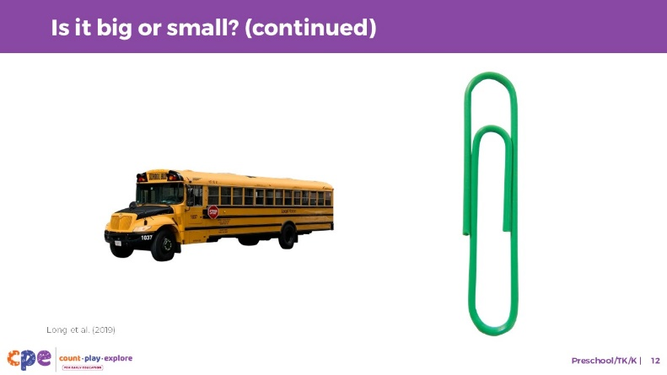

Talking Points
- Let’s try another one. Again, point to the object that is smaller on the screen.
- [Click to show the image, then after 1–2 seconds, click again to make the image disappear. (Long et al, 2019).]
- [Pause for participants to answer the question.] As you noticed, the picture on the left was smaller. Did you notice a difference between the first pair and the second pair of pictures in how quickly you could answer which is bigger? [After participants answer]. Why do you think it took you slightly longer to tell which is bigger for the second pair of pictures?
- [Pause for participants to answer the question.] You may have noticed that for the first slide, the real-world size of the items was in alignment with the size of the pictures on the screen. Meaning, in the real-world an elephant is bigger than a crayon, and the elephant picture was also bigger than the crayon picture.
- For the second slide, although a school bus is bigger in the real world than a paper clip, the picture of a school bus was smaller on the screen than the paper clip.
- Researchers found that children had a more difficult time when the actual size and real-world size of the pictures were not aligned. This suggests that starting around age four, children learn about size as part of their understanding of objects. These findings show how important the measurable attributes of objects are for our understanding of objects.

Slide 13: Observe: Comparing Length
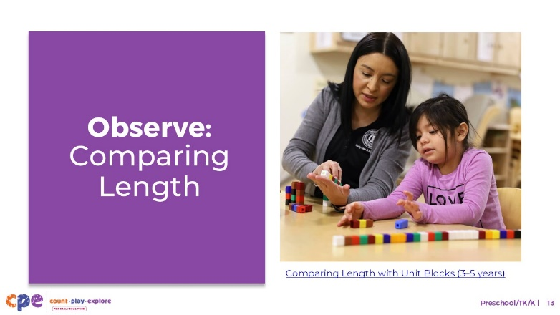
Time: 10–20 minutes (including debrief on the next slide)
Materials: Preschool, TK, or K measurement video clip

Talking Points
- The skill we just discussed—noticing measurable attributes—provides the foundation for children to compare and order objects by measurable attributes.
- Comparing objects by their measurable attributes is finding out which object is bigger, longer, or heavier.
- Ordering objects is arranging objects in sequence by their measurable attributes (for example, from smallest to largest).
- Children and adults compare and order objects by length or height using a variety of different strategies.
- Let’s observe a video clip showing a preschool child comparing and ordering. As you observe, pay attention to how the child is comparing length and the vocabulary that she uses. After watching the clip, we will discuss what you noticed.

Facilitator Notes
- Choose a preschool, TK, or K video clip that shows children comparing and ordering.
- We provide the following video clips (you may choose other videos to use):
  - Comparing Length with Unit Blocks (3–5 years). Note this video is divided into two parts. If using this video, pause the video after part 1 (around 1:28), and then show part 2 later in this session. The Facilitator Notes in the next slide focus on Part I of this video.
  - Comparing Length with Unit Blocks (3–5 years) - Audio Descriptive Version
  - Measuring with Pumpkins (3-5 years)
  - Measuring with Pumpkins (3-5 years) - Audio Descriptive Version
  - Using Spanish Measurement Vocabulary at the Sensory Table (3-5 years)
  - Using Spanish Measurement Vocabulary at the Sensory Table (3-5 years) - Audio Descriptive Version
- Consider playing the video more than once. The first time, invite participants to become familiar with the clip. Then, invite participants to observe specific ways the child is comparing and ordering.

Slide 14: Discuss: Comparing Length
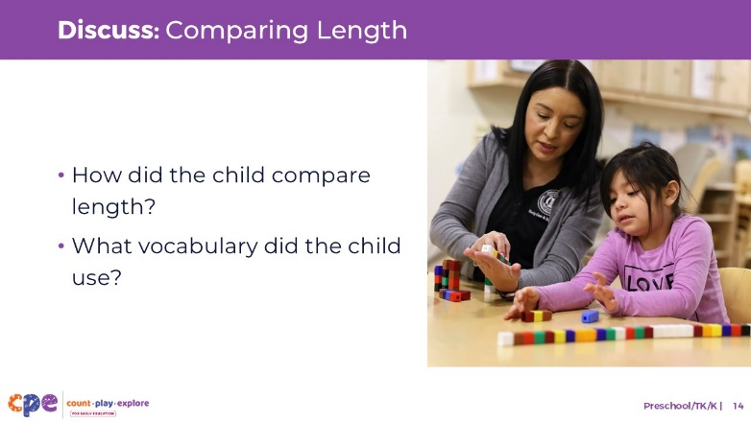
Time: 10–20 minutes (including video observation on previous slide)

Talking Points
- Let’s discuss what you notice. In the video you observed,
  - How did the child compare length?
  - What vocabulary did the child use?
- [After discussion:] This video provided some examples of how a child compared and ordered objects.
- In the next few slides, we will discuss some of these strategies in more detail.

Facilitator Notes
- Adjust the debrief based on your group size, session length and format, and participant needs. Consider charting participants’ observations to provide a visual of ways children understand measurement.
- Consider using the following adaptations based on session length:
  - For shorter sessions, invite participants to share with the large group what they noticed about how children in the video showed their knowledge and skills related to measurement.
  - For longer sessions, offer time for participants to share their observations in pairs or at their tables. Then, invite each table to share some of their observations.
- Here are some examples of how a child in part 1 of the video clip Comparing Length with Unit Blocks (3–5 years) compared and ordered:
  - The child compared the heights of different family members. For example, she understood that a shorter tower represented family members who are shorter.
  - The child didn’t physically order the towers from smallest to biggest but showed some understanding of who is shorter and who is taller in her family.
  - The child used a variety of comparative vocabulary such as short, tall, and more.

Slide 15: Comparing
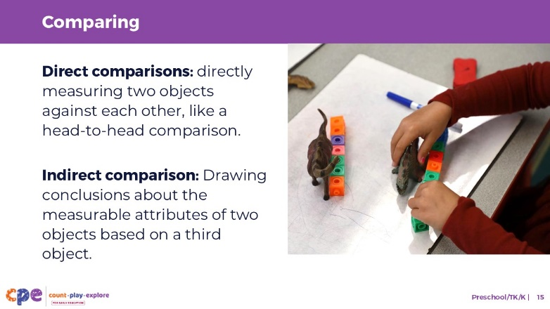

Talking Points
- Children learn to compare and order objects along measurable attributes (such as length, height, weight, volume) between the ages of three and five.
- The child in part 1 of the video engaged in direct comparison as they compared the height of different towers with one another.
- Another way to compare two objects is by using indirect comparison. Indirect comparison involves using a third object as a reference point.
- For example, a piece of string can be used to compare the length of two objects that cannot be easily placed next to each other.
- Children begin to engage in indirect comparisons starting in kindergarten and first grade.

Slide 16: Ordering
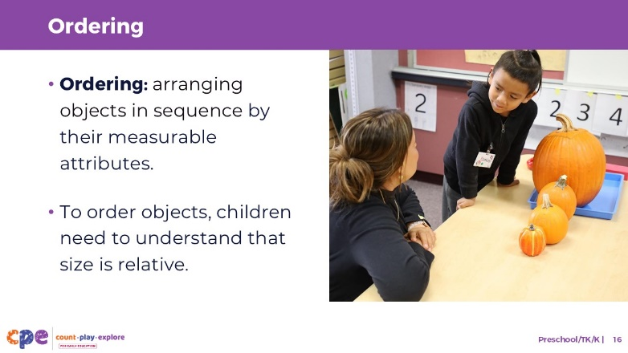

Talking Points
- Children also learn to order objects along measurable attributes (such as length, height, weight, volume) between the ages of three and five.
- To do this, children need to understand that size is relative. For example, they need to understand that while a dog is small compared to an elephant, a dog is big when compared to a mouse.
- Children learn to order more objects with age. Between the ages of three and four, children can order three objects. Between the ages of four and five, children can order four to five objects.
- As children first start to compare or order objects, they do so without measuring, meaning they use the comparison strategies we just described. Eventually, in first and second grade children learn to use measurement tools to help them compare and order. For example, in second grade, children may use a ruler to measure the length of three objects, then order them based on their length in inches.

Slide 17: Comparative Vocabulary
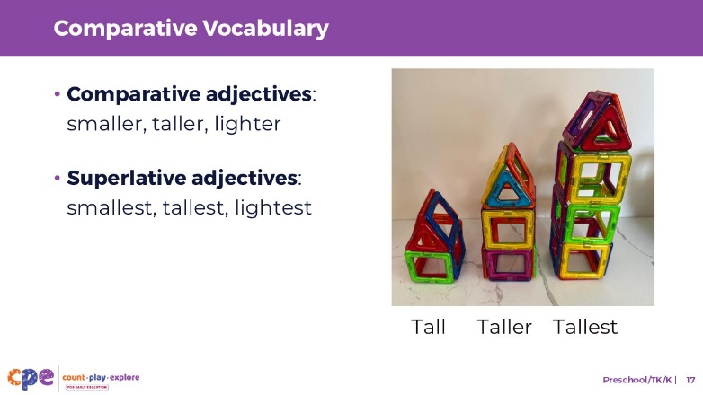

Talking Points
- In the video we just watched, the educator and child used a variety of comparative vocabulary. What were some examples of the comparative vocabulary they used? [Pause for participants to answer the question.]
- Infants and toddlers may use vocabulary in their home language, English, or both, such as “big” or “little” to describe the size or length of an object. It is not until the ages of three or four that children begin to learn that there are specific terms for specific attributes. For example, they learn that tall and short are used to describe height, and wide and narrow for width.
- Around age four, children begin to use comparative and superlative adjectives to communicate about comparisons and order more precisely.
  - Comparative adjectives compare two objects to one another. For example, bigger, smaller, heavier.
  - Superlative adjectives are used when comparing three or more objects. They describe something as being the most or least. For example, biggest, tallest, heaviest.

Slide 18: Comparative Vocabulary in Other Languages
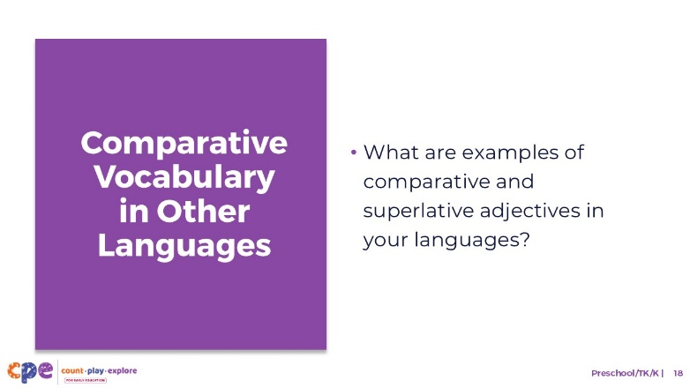

Talking Points
- Children may learn comparative vocabulary in their home language, English, or both.
- Languages differ in how they form comparative and superlative adjectives. In English, you generally form comparative adjectives by adding “er” to the end of a word, and superlative adjectives by adding “est.”
- [Ask if there are any multilingual participants in the room. Ask if they are willing to share how comparative and superlative adjectives are formed in their home language.]
- It is important to remember that children develop at their own pace and in their own way. A variety of factors impact children’s learning and development in measurement including their language development, and thus children vary in how and when they learn comparative vocabulary.

Facilitation Notes
- Consider preparing some examples of comparative and superlative adjectives in the languages that are common in the settings your educators work in.

Slide 19: Measuring
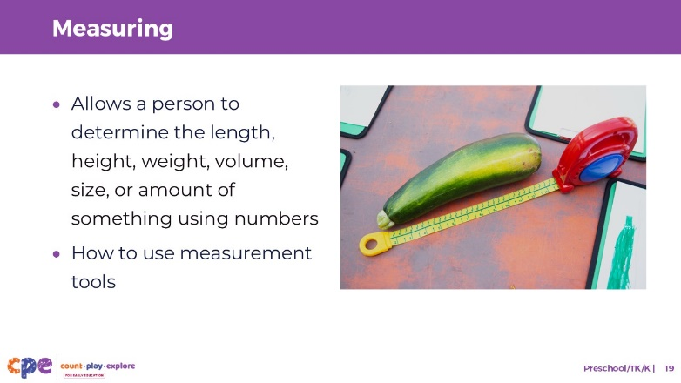

Talking Points
- Measurement is the process of quantifying—giving a number to—attributes of objects. For example, we can measure the size, height, or length of something. We can also measure the volume, weight, or temperature of something.
- Measuring skills for young children include learning how to use measurement tools.
- Measuring also allows people to compare two objects more precisely on a measurable attribute by determining which is more and which is less, and how much more or how much less.

Slide 20: Observe: Measuring with Cubes
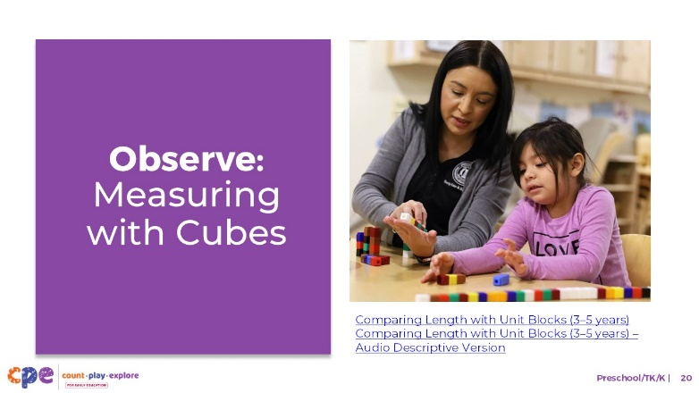
Time: 10–20 minutes (including debrief on the next slide)
Materials: Preschool, TK, or K measurement video clip

Talking Points
- Let’s observe a video of a child exploring measurement. As you observe, pay attention to the measurement concepts the child is exploring.
- After watching the clip, we will discuss what you noticed.

Facilitator Notes
- Choose a preschool, TK, or K video clip related to measurement. We provide the following video clip (you may choose other videos to use):
  - Comparing Length with Unit Blocks (3–5 years). Note this video is divided into two parts. If using this video, pause the video after part 1 (around 1:28), and then show part 2 later in this session. The Facilitator Notes in the next slide focus on Part I of this video.
  - Comparing Length with Unit Blocks (3–5 years) - Audio Descriptive Version
  - Measuring with Pumpkins (3-5 years)
  - Measuring with Pumpkins (3-5 years) - Audio Descriptive Version
  - Using Spanish Measurement Vocabulary at the Sensory Table (3-5 years)
  - Using Spanish Measurement Vocabulary at the Sensory Table (3-5 years) - Audio Descriptive Version
- Consider playing the video more than once. The first time, invite participants to become familiar with the clip. Then, invite participants to observe specific ways the child is comparing and ordering.

Slide 21: Discuss: Measuring with Cubes
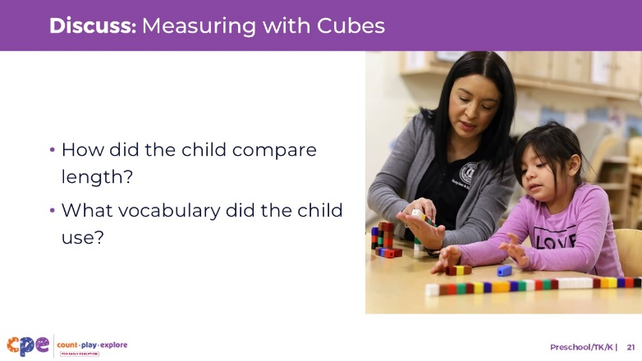
Time: 10–20 minutes (including video observation on previous slide)

Talking Points
- Let’s discuss what you notice.
  - What measurement concepts was the child exploring?
- [After discussion:] This video provided some examples of how children compare and order objects.
- In the next few slides, we will discuss some of these strategies in more detail.

Facilitator Notes
- Adjust the debrief based on your group size, session length and format, and participant needs. Consider charting participants’ observations to provide a visual of ways children understand measurement.
- Consider using the following adaptations based on session length:
  - For shorter sessions, invite participants to share with the large group what they noticed about how children in the video showed their knowledge and skills related to measurement.
  - For longer sessions, offer time for participants to share their observations in pairs or at their tables. Then, invite each table to share some of their observations.
- Here are some examples of how children in the video clip Comparing Length with Unit Blocks (3–5 years) explored the measurable attributes of objects:
  - The child compared the size of her hand to the educator’s hand and made predictors. For example, when the educator asked, “Do you think my hand is six?” The child responded “no” and was able to predict that the educator’s hand would be “more” cubes long. The child was also able to make an estimation of how many cubes would be needed to measure the educator’s hand.
  - The child demonstrated an understanding of measurement when she used unit cubes to measure the length of her hand. With support from the educator, the child understood that she needed to align the cubes at the base of her hand. The child then added cubes until she reached the tip of her fingers. The child also understood that she needed to count the number of cubes to find out the length of the hand.

Slide 22: Measuring Using Nonstandard Measurement Tools
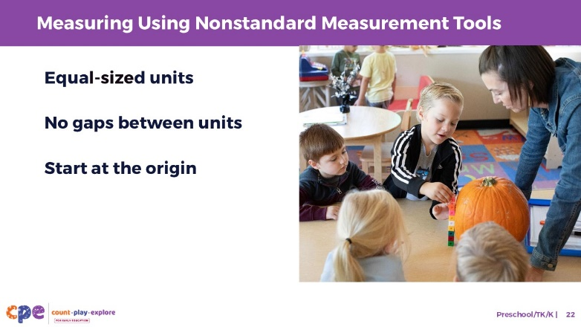

Talking Points
- When children are first introduced to measuring in the preschool years, they often use nonstandard measurement tools. At this age, children might show an interest in standard tools but may not use them with accuracy. This is because using standard tools requires additional math skills, such as reading numbers.
- The use of nonstandard measuring tools also requires support. Children are likely to need scaffolding and modeling from an adult to understand the “rules” that apply to measurement. These rules include:
  - Equal-sized units: constant, equal-sized units for meaningful measurement.
  - No gaps between units: laying each unit, end to end, to measure distance. For example, when using nonstandard tools like blocks, children need to place each block end-to-end to measure the length of an object.
  - Measurement starts at the origin: You need to know where to start beginning to measure your object, or know where the “zero” is.
- Think back to the video you just watched. In what ways did the child demonstrate an understanding of these rules?
- [After discussion:] The child used equal-sized connecting cubes. Using units that connected to each other allowed the child to easily place them end-to-end without gaps. With some support from the educator, the child aligned the cubes at the base of her hand.

Slide 23: Measuring Using Standard Measurement Tools
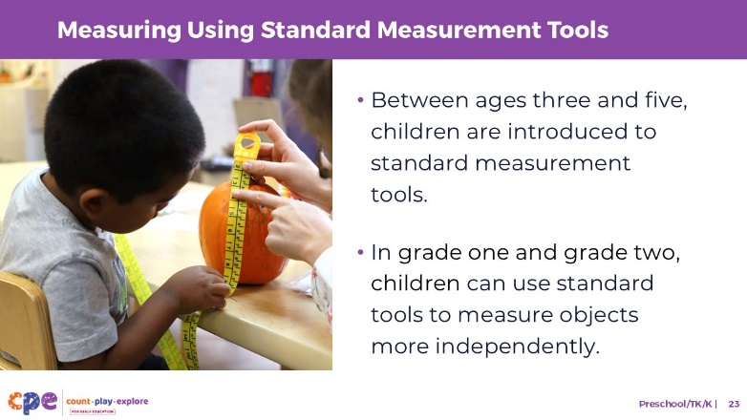

Talking Points
- Observe the materials on your table. What standard measurement tools do you have at your table? [Pause for participants to answer the question.]
- Many children are introduced to standard measurement tools between the ages of three and five. Standard tools for measurement include more traditional tools such as rulers, a scale, or a yardstick.
- While children may playfully engage with standard measurement tools in their learning environment, they often need modeling and scaffolding from an adult to know how to use these tools accurately.
- In first and second grade, most children begin to use these tools more consistently and independently. They can, for example, use a ruler to measure the length of an object and express that length using the appropriate units.
- Traditions and routines in children’s homes and communities influence their experiences with measurement.
  - For example, when cooking, some families may estimate how much of each ingredient to put into the dish, others might use measuring cups, and others might weigh ingredients using a scale. Children may therefore have varied experiences with different measurement tools and strategies.
  - Asking families about important measurement traditions and routines for their family can help educators incorporate those into their setting. Consider asking families to share their traditions or routines in the classroom.

Slide 24: Supporting Measurement
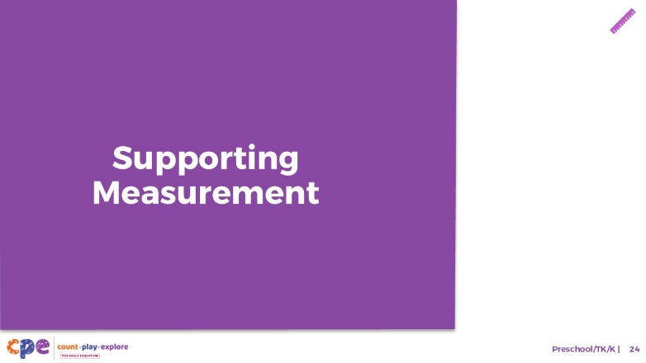

Talking Points
- We explored how children in preschool, TK, and K develop an understanding of measurement. Now, let’s discuss ways to support children in learning about measurement—in our learning settings and at home.

Slide 25: Explore: M⁵ Early Math Approach
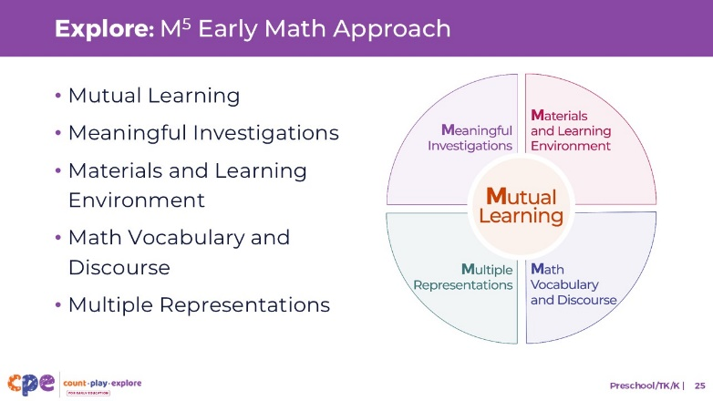
Time: 15 minutes
Materials: M⁵ Overview handout

Talking Points
- We refer to five core early math teaching practices as the M⁵ Early Math Approach. These practices include the following:
  - Mutual Learning
  - Meaningful Investigations
  - Materials and Learning Environment
  - Math Vocabulary and Discourse
  - Multiple Representations
- Let’s explore the M⁵ practices using the M⁵ Overview handout. Then, we will observe M⁵ in action.

Facilitator Notes
- Consider your participants and their prior experiences with M⁵. Then, decide how you might use the M⁵ Overview handout.
  - For groups with significant experience with M⁵, offer a few minutes for participants to review the handout and share their areas of strength and practices they are working on with a partner. You can also use this slide to revisit the M⁵ practices briefly and move to the next slide.
  - For groups with less experience with M⁵, offer more time for participants to explore each practice in the handout. For example, allow time for them to review the practices independently. Invite them to make a square over practices that they have “squared away” (practices they understand and use), a circle over “what’s still going around in their heads” (practices they still have questions about), and a triangle over three ideas that they will use in their settings. For more ideas on providing a more comprehensive review, visit the M⁵ Early Math Approach suite.

Slide 26: Discuss: M⁵ in Action
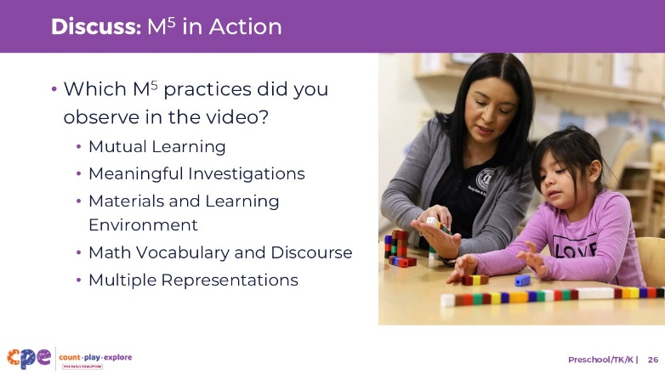
Time: 20–30 minutes (include the review of the video on the previous slide)
Materials: Observing M⁵ in Action: Measurement handout, Sample Answers for Observing M⁵ in Action: Measurement handout; preschool, TK, or K measurement video clip; chart paper, markers

Talking Points
- We observed examples of how children (three to six years old) learn about measurement. Then, we explored the M⁵ Early Math Approach for supporting children’s early math learning.
- Now, we are going to think back to part 1 and part 2 of the video we watched previously.
- [Choose a strategy for facilitating this observation and debrief (on the next slide). Adapt the talking points to reflect this strategy.]
- Let’s unpack your observations of each M⁵ practice.

Facilitator Notes
- Consider whether it would be helpful to show the video clip “Comparing Length with Unit Blocks (3–5 years)” one more time, this time asking participants to focus on how the educator used
- Invite participants to use the Observing M⁵ in Action: Measurement handout.
  - For larger groups: use a jigsaw approach. Assign each table one practice to focus on. [If there are more than five tables, assign more than one table to focus on each practice.] Then, invite each group to share their observations with the whole group. As each group shares, paraphrase, affirm, and add to their responses as needed. Consider charting each group’s observations to make practices visible.
  - For smaller groups: inviting participants to focus on all five M5 practices. Then, invite participants to share their observations with the whole group. Chart their observations to make the practices visible. As participants share, paraphrase, affirm, and add to their responses as needed. Consider inviting participants to share something they learned with someone from another table. For example, ask them to find someone with similar shoes, meet them, and share something they learned.
- Use the Sample Answers for Observing M⁵ in Action: Measurement handout for examples of ways M5 was used in the recommended video clips.
- For additional ideas on facilitating debriefs, visit the Facilitating STEAM Professional Learning module.

Slide 27: Explore: Using M⁵ to Support Learning About Measurement
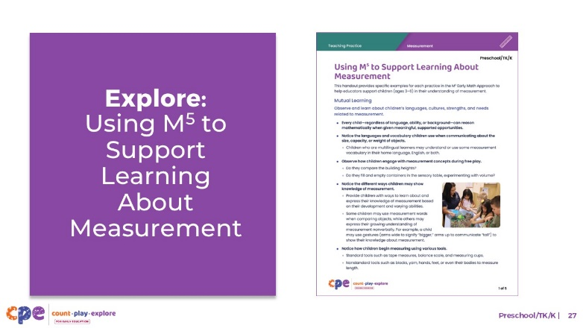
Time: 20–30 minutes (including debrief on the next slide)
Materials: Using M⁵ to Support Learning About Measurement handout, paper, and markers

Talking Points
- Let’s consider ways to use M⁵ teaching practices to support children’s understanding of measurement.
- Take out the Using M⁵ to Support Learning About Measurement handout.
- Review the ideas on using M⁵ to support children in preschool, TK, or K to develop measurement skills. You might make notes, circle, or highlight as you review.
- [For shorter sessions:] Consider the practices you reviewed. With a partner, discuss what you might want to try and why. [If time permits, invite some participants to share with the large group what practices they will try and why.]
- [For longer sessions, use slide 32 to facilitate the discussion.]

Facilitator Notes
- Provide 5–7 minutes for participants to review the handout independently.
- For shorter sessions, instead of using the next slide move on to slide 33.

Slide 28: Discuss: Using M⁵ to Support Learning About Measurement
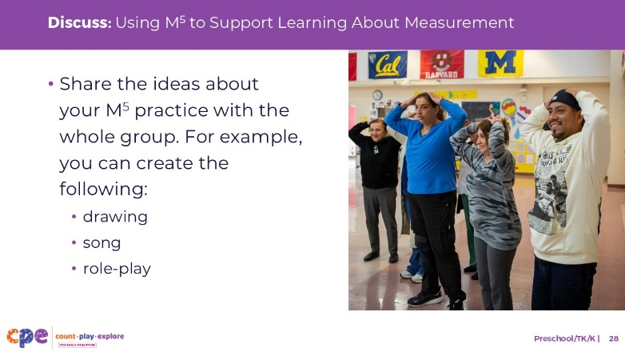
Time: 20–30 minutes (including review of the document on the previous slide)
Materials: Using M⁵ to Support Learning About Measurement handout, paper, and markers

Talking Points
- You reviewed some ideas on using the M⁵ Early Math Approach to support children in understanding measurement. Next, let’s reflect on ways to continue supporting children’s understanding of measurement.
- [Select a way to organize this activity from the facilitator notes. Then, adapt these talking points based on your selection.]
  - [Assign each group one M⁵ practice.] Briefly discuss the ideas described for your assigned practice. Then, decide how you will share these ideas with the whole group.
  - Be creative, for example, you might create a drawing, song, or role-play to share your learning.
  - Consider ways to represent the diversity of children’s interests, languages, cultures and lived experiences, abilities, and emerging skills.
  - Each group will have two to three minutes to share their M⁵ practice with the whole group.
- [Provide time for participants to prepare their presentations. Then, invite groups to share their assigned practices. Offer additional information about each practice as needed.]
- [After each group has shared:] You reviewed some ways to use the M⁵ Early Math Approach to support children’s understanding of measurement. Hopefully, you will find these strategies helpful in your setting.

Facilitator Notes
- Adjust the way you organize this activity based on group size:
  - For smaller sessions, divide participants into five groups. Assign each group one M⁵ practice. Each group will discuss their assigned practice briefly and identify a way to share the information with the whole group.
  - For larger groups, create groups of five to seven participants each. Assign each group an M⁵ practice. As necessary, assign more than one group to the same practice. Each group will discuss their assigned practice briefly and identify a way to share the information with the whole group.
- Move around the room while participants work in groups. Provide support as needed.

SLIDE 29 Play: Measuring with Hands or Feet
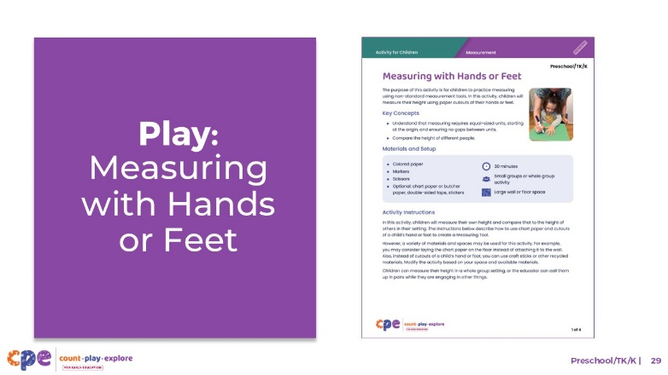
Time: 10–20 minutes
Materials: Measuring with Hands or Feet handout, materials to play “Measuring with Hands or Feet” (optional)

Talking Points
- Let’s explore a playful activity that can encourage children to measure using nonstandard tools.
- Take out the “Measuring with Hands or Feet” activity for children.
  - With a partner, review the handout together. Then, discuss how you might use this activity in your settings.
  - Consider the children in your setting. Use the ideas at the end of the handout to brainstorm ways you might modify this activity to meet the interests and needs of the children in your learning setting.

Facilitator Notes
- Provide 5–10 minutes for participants to review and discuss the handout.
- You might invite participants to share with the larger group how they might use the activity in their setting.
- Refer to the M⁵ section in the “Measuring with Hands or Feet” activity for examples of ways educators might modify this activity to respond to children’s interests, languages, cultures and lived experiences, abilities, and emerging skills.
- For longer sessions, consider offering time for participants to do the activity. Be sure to prepare and bring the necessary materials. Encourage participants to discuss what they notice as they engage in the activity.

Slide 30: Reflect: Pair and Share
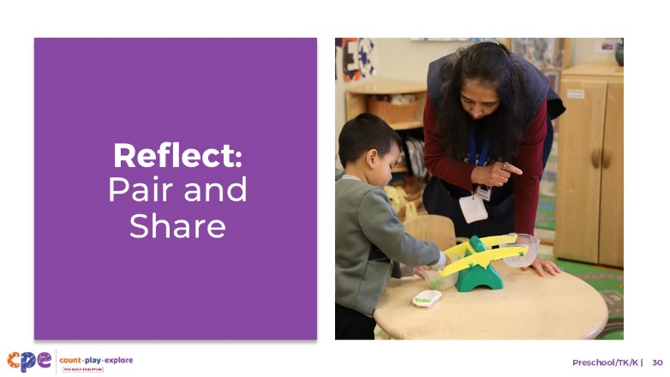
Time: 5–7 minutes

Talking Points
- Take a few minutes to think about our session. Write down five things you have learned today.
- [Allow two minutes for participants to write down their ideas.]
- Next, please turn to a partner. Take three minutes to share with your partners what you learned today.
- [Provide participants with three minutes to share with their partner.]
- Thank you for your time, attention, and engagement. It has been wonderful working with you.

Facilitator Notes
- As participants discuss their reflections, note the questions that they still have and what they would like to try. You might use this information to identify topics for future training, coaching, or communities of practice.

