Introduction to Measurement: Birth–8 Years (PPT 1)
Use this facilitator guide with the slides “Introduction to Measurement: Birth–8 Years.” This set of slides provides an overview of the development of key concepts and skills in measurement for children from birth to eight years old. When planning a professional learning session on measurement, facilitators can use these slides as an introduction or in combination with the age-specific slide decks. Facilitators can find talking points and guidance for activities and group discussions in this guide. The text in the guide is also located in the notes portion of the slides.

Session at-a-Glance
Slide Numbers | Overview of Content | Approximate time (in minutess)
1-3 | Introduction & session goals | 4-5
4-8 | Introducing measurement:  - Activity for Adults  - Defining measurement | 15-30
9-22 | Overview of how children develop an understanding of measurement:  - Noticing measurable attributes  - Comparing and ordering  - Measuring | 10-20
23 | Closing reflection activity | 5-10
The times are approximate and may vary based on session goals, group size, and participants’ previous experience and familiarity with the content.

To prepare for your session
- As you plan your professional learning session, consider the content in each of the PPTs in this suite:
  - PPT 1 “Introduction to Measurement: Birth–8 Years” describes how children develop an understanding of measurement from birth to age eight.
  - PPT 2a “Measurement: Infants and Toddlers,” and PPT 2b “Measurement: Preschool, Transitional Kindergarten, and Kindergarten” and PPT 2c (coming soon) “Measurement: Early Elementary” describe in greater depth how children at different age levels develop an understanding of measurement. These PPTs also include ideas on how to support children in specific age ranges to develop measurement skills.
- We encourage you to offer the content in PPT 1 before, or in combination with, one age-specific slide deck (PPT 2a, PPT 2b, or PPT2c (coming soon)). Together, PPT 1 and one of the age-specific slide decks are designed for a three-hour professional learning session. However, you can adjust slide decks to best meet participant needs and time allowances.
- Before your session, carefully review all handouts and prepare the necessary materials. Select a facilitation method that works best for your session length and format, group size, and participant needs.
- Consider using photos, videos, or stories from the learning settings where educators work within this session. Making the information more personal for participants can create a greater connection to the content and foster feelings of belonging in math.

Materials Needed
- Scratch paper, chart paper, and writing tools
- A variety of standard and nonstandard measurement tools. An activity in the session requires participants to use these tools. Additionally, you may want to encourage participants to explore and play with these tools during breaks in your session.
  - Examples of standard measurement tools include measuring tapes, rulers, measuring cups and spoons, balance scales, or thermometers.
  - Examples of nonstandard measurement tools include blocks, string, paper clips, crayons, or craft sticks.
- Blindfolds (such as scarves or eye masks) and everyday objects or children’s toys (such as pens, sticky notes, hole punch, blocks, spoons, balls)
- How Tall Am I? handout, non-stretchy string, ribbon, or twine; scissors; paper; pencil

Slide 1: Introduction to Measurement: Birth–8 Years
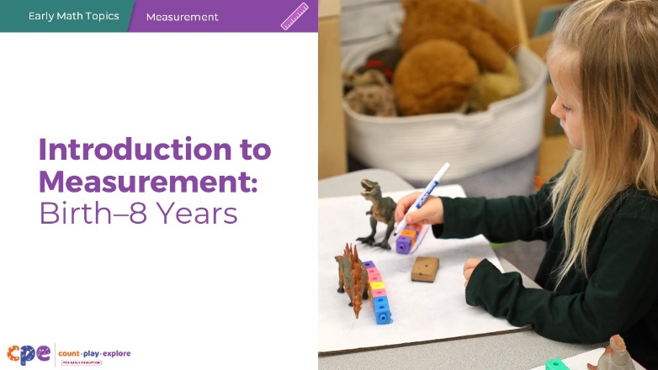

Talking Points
- Welcome! Today, we will explore how children develop an understanding of measurement.

Facilitator Notes
- Adjust talking points to include relevant introductions, “housekeeping,” and other important information for your participants.
- You might share with participants that, in this session, we use “TK” to refer to transitional kindergarten and “K” for kindergarten.

Slide 2: Acknowledgments
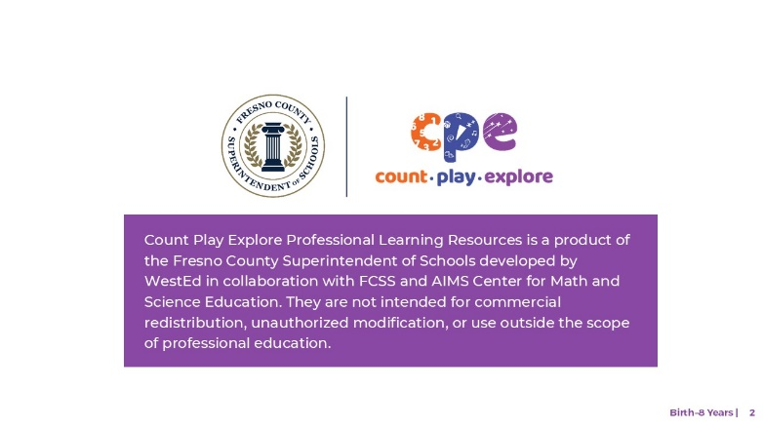

Talking Points
The Count Play Explore Professional Learning Resources were made possible by Count Play Explore, an early math, science, and computer science initiative led by the Fresno County Superintendent of Schools, Early Care and Education Department. This initiative is generously funded by the California Department of Education and the California State Board of Education. These resources, developed by WestEd in collaboration with FCSS and AIMS Center for Math and Science Education, are intended to be used as a guide for implementing evidence-based strategies, promoting active learning, and encouraging developmentally appropriate practices in early education settings. They are not intended for commercial redistribution, unauthorized modification, or use outside the scope of professional education.

Slide 3: Session Goals
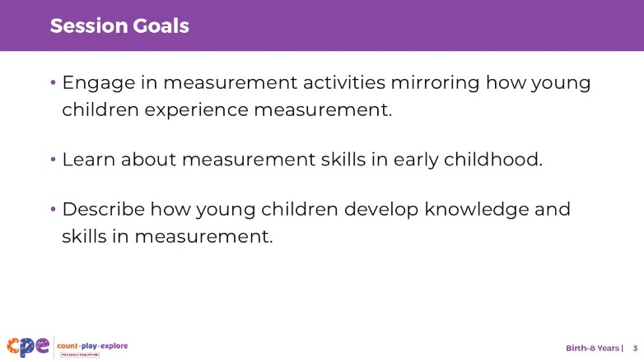

Talking Points
- In this session, we will start by engaging in some measurement activities to focus on experiencing measurement in a manner similar to how young children learn.
  - The methods we will use to learn together mirror the ways children learn. We will play, observe, explore, and reflect.
- Next, we will learn about measurement skills in early childhood.
- We will also describe and review the ways children develop knowledge and skills in measurement.

Facilitator Notes
- Adjust slide content and talking points to reflect what you plan to address in your professional learning session.

Slide 4: Measure: How Tall Am I?
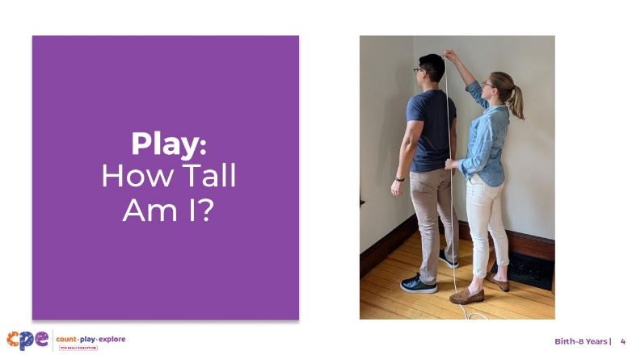
Time: 15–30 minutes (including debrief on the next slide)
Materials: How Tall Am I? handout; non-stretchy string, ribbon, or twine; scissors; paper; pencil

Talking Points
- Let’s begin our session with a measurement activity specially designed for adults.
- Take out the How Tall Am I? handout. [Review the handout with participants and provide support as needed.]

Facilitator Notes
- Math is playful. This principle is key to the Count Play Explore professional development approach. This activity invites adults to explore measurement through a hands-on playful activity.
- Select a facilitation method that works best for your session length and format, group size, and participant needs.

Slide 5: Discuss: How Tall Am I?
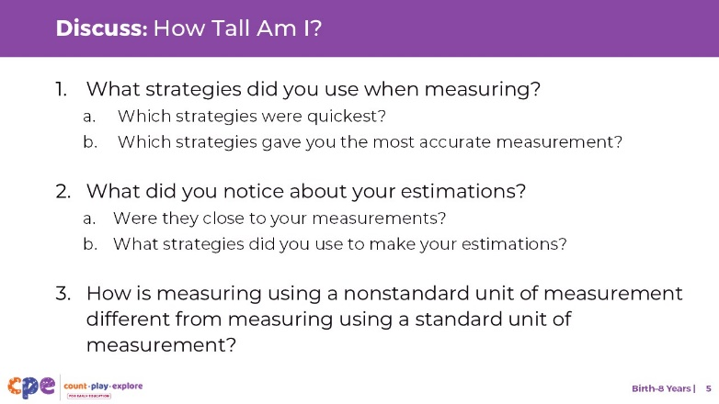
Time: 15–30 minutes (including the activity on previous slide)
Materials: How Tall Am I? handout; non-stretchy string, ribbon, or twine; scissors; paper; pencil

Talking Points
- Let’s take some time to discuss this activity. At your table, discuss the following questions:
  - What strategies did you use when measuring? Which strategies were quickest? Which strategies gave you the most accurate measurement?
  - What did you notice about your estimations? Were they close to your measurements? What strategies did you use to make your estimations?
  - How is measuring using a nonstandard unit of measurement (for example, the string) different from measuring using a standard unit of measurement (a tape measure)?
- [After some time for small group discussion, invite participants to share with the whole group. Then, summarize some key points. For example, “I noticed you each recorded and communicated your measurements in different ways. Some of you used fractions in your answer, ‘I am three and a quarter times the circumference of my head tall,’ while others were more approximate, ‘I am about three heads tall’.”]
- In this playful activity, we explored the creative use of nonstandard units of measurement to measure our height. This helps us understand how young children learn about concepts of measurement by using nonstandard units of measurement.

Facilitator Notes
- Adjust the discussion method (for example, in pairs, at tables, or in a whole group) based on group size, session length and format, and participant needs.
- Consider making connections to this activity throughout the session, drawing from participants’ reflections and experiences.

Slide 6: Measurement is Everywhere!
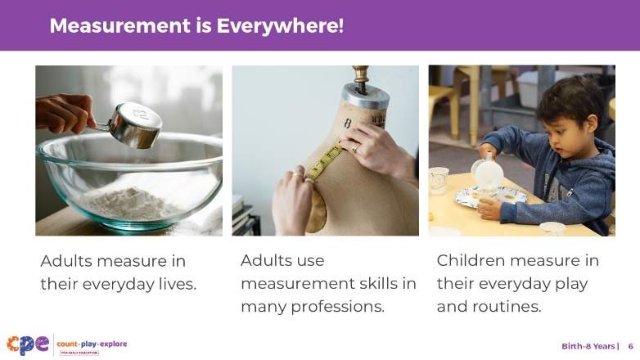

Talking Points
- Measurement plays a helpful role in the lives of children and adults. That is why it is important for us to help children develop their measurement understanding and skills.
- How do you use measurement in your everyday life?
- [Provide time for participants to share examples with the whole group before describing the examples below.]
- [Click: photo examples with short descriptions will appear on the screen.]
- We measure every day. For example, we measure when we do the following:
  - Cook or bake—when we bake a cake or make soup, we might estimate or measure how much of each ingredient we need. We might use measuring cups or a scale.
  - Drive—when we park our car in a parking spot, we need to have an understanding of the size of our car and how that compares to the size of the parking spot. We estimate distances when deciding which spot is closer to the entrance of the store.
- Many professionals use measurement.
  - Tailors use measurement tools, such as a tape measure, to make clothes that fit a person’s particular size.
  - Meteorologists use a variety of measurement tools, such as thermometers and barometers, to measure temperature, atmospheric pressure, wind speed, or to make predictions about the weather.
  - Carpenters use measurement tools, such as a measuring tape, to know how long different pieces of wood need to be to fit together.
- Children also use measurement in their everyday routines and interactions.
  - When children fill a cup of milk, they are estimating how much to pour in until it is full.
  - When children build, they might think about the height and length of their structure.

Slide 7: Measurement: An Overview
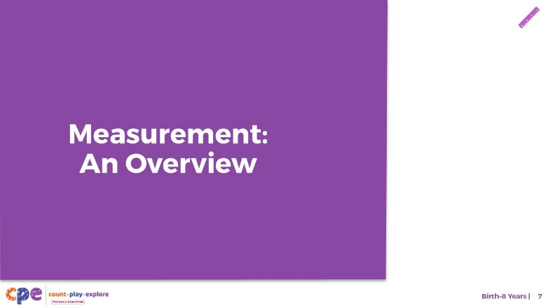

Talking Points
- Before we review how children develop an understanding of measurement, let’s begin by defining “measurement.”

Slide 8: What is Measurement?
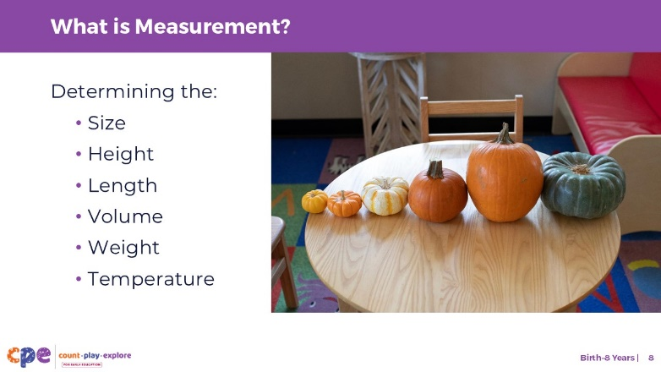

Talking Points
- Measurement is the process of quantifying—giving a number to—attributes of objects. For example, we can measure the size, height, or length of something. We can also measure the volume, weight, or temperature of something.
- Measurement helps us communicate more accurately about the attributes of objects.
  - For example, instead of saying, “This pumpkin is tall,” we can more accurately communicate how tall by saying, “This pumpkin is five inches tall.”

Slide 9: Learning About Measurement
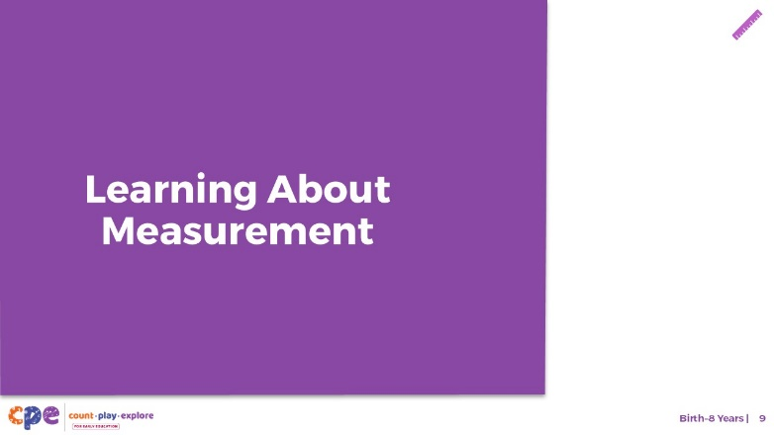

Talking Points
- Now, let’s discuss how young children develop an understanding of measurement.

Slide 10: Measurement Skills
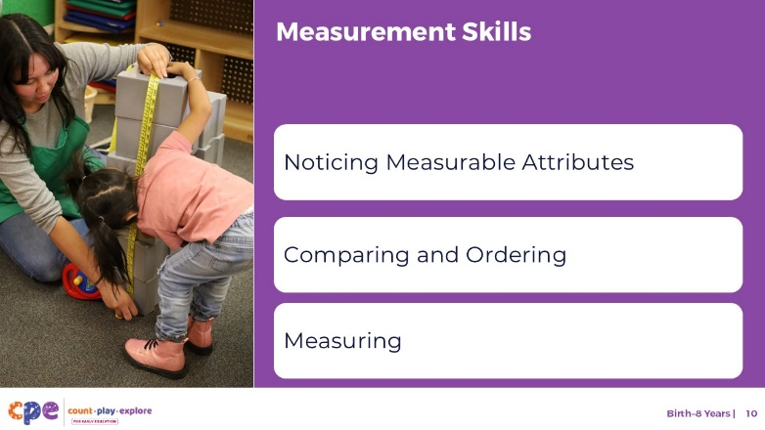

Talking Points
- The following slides describe important measurement skills. These skills include children’s ability to:
  - Notice the measurable attributes of objects
  - Compare and order
  - Measure

Facilitator Notes
- Slide 22 includes a table that describes how children’s understanding of these measurement skills progresses over time.

Slide 11: What Do You Notice?
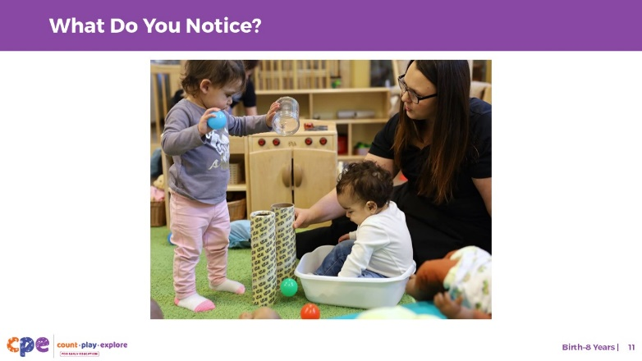

Talking Points
- Noticing measurable attributes of objects describes young children’s ability to notice the different attributes of objects, such as size, length, height, weight, or volume, which can be quantified or measured.
- Infants and toddlers learn about measurable attributes of objects through play and exploration.
  - Observe the photo on this slide.
  - What do you notice about how the two infants are exploring objects?
  - What might the infants be learning about these objects and their measurable attributes?
- [After participants share with the whole group, summarize some key points from the discussion. Some examples might include, “When children try to fit objects like the ball or their own body into a container, they are learning about length or size (big versus small). When they pick up two objects, they might notice the weight of each object (light versus heavy), and that the objects are the same height.”]

Slide 12: Noticing Measurable Attributes
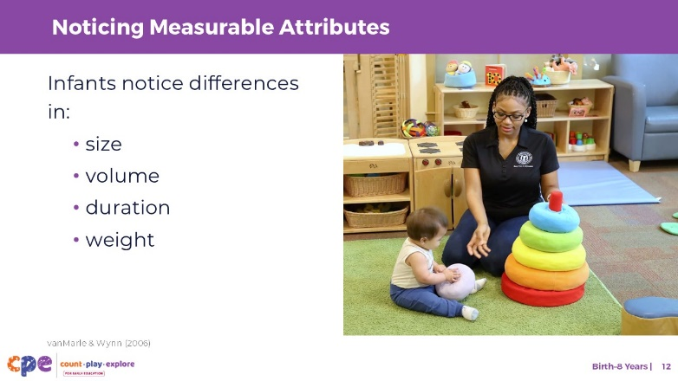

Talking Points
- Infants and toddlers notice different measurable attributes of objects.
  - They notice differences or changes in size, for example a big block compared to a small block.
  - They notice differences or changes in the volume of an object, for example when they fill and empty a bucket with balls or a cup with water.
- Infants and toddlers also notice measurable attributes of objects using senses other than vision.
  - For example, infants notice when the duration of a sound becomes longer or shorter (vanMarle & Wynn, 2006).
  - Toddlers notice differences or changes in the weight of objects, for example when a bucket filled with sand feels heavier.
- Although infants and toddlers notice the height, length, or weight of objects, they often tend to use the same words for multiple attributes. For example, they may use the term “big” for both length and weight.

Slide 13: Play: Big, Bigger, Biggest
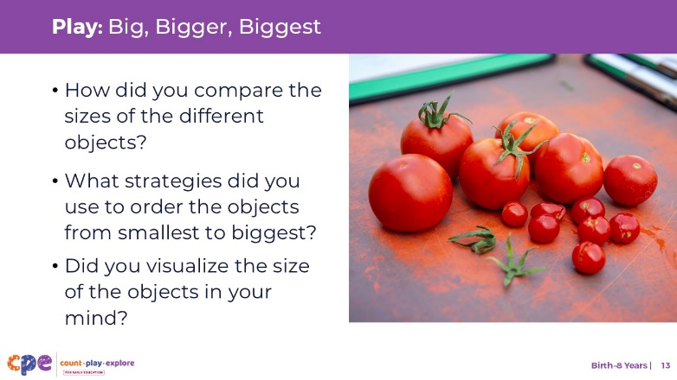
Materials: blindfolds (such as scarves or eye masks), everyday objects or children’s toys (such as pens, sticky notes, hole punch, blocks, spoons, balls)
Time: 7–10 minutes

Talking Points
- The skill we just discussed—noticing measurable attributes—provides the foundation for children to compare and order objects by measurable attributes.
- Let’s start with a playful activity. In this activity, you will compare the sizes of a few objects and order the objects from smallest to largest. However, you will be blindfolded while you do this.
- [Ask one participant per table group to blindfold themselves and provide them with four or five different objects to order from smallest to biggest.]
- [After everyone has ordered their objects, invite participants to discuss the following questions in table groups or as a large group:]
  - How did you compare the sizes of the different objects?
  - What strategies did you use to order the objects from smallest to biggest? Did you compare the size of each object to every other object?
  - Did you visualize the size of the objects in your mind?
- By being blindfolded, you were not able to use visual cues to compare and order objects. Some of you may have compared the size of each object to every other object. This strategy is called direct comparison. Others may have compared some objects to one another and then made certain conclusions about the comparisons of other objects. This strategy is called indirect comparison.
- Both strategies mirror the ways that children learn to compare objects. Children may compare and order objects using direct or indirect comparison. Let’s explore these two strategies together.

Facilitation Notes
- Make sure that participants being blindfolded feel comfortable doing so. Otherwise, offer the alternative of simply closing their eyes before the activity.
- If someone is visually impaired in the group, consider opening up the discussion to strategies that they naturally use to compare items in their daily lives.
- Adjust the way you organize this activity based on your group size and the number of objects you have available:
  - For smaller sessions, provide all participants with a blindfold and their own set of objects. Each participant can then compare and order their own set of objects.
  - For larger sessions, provide each table group with 1–2 blindfolds and 1–2 sets of objects per table. Participants at each table can take turns doing the activity. While those with blindfolds on compare and order the objects by size, the other participants can observe the type of strategies those with blindfolds are using to compare and order.

Slide 14: Direct Comparisons
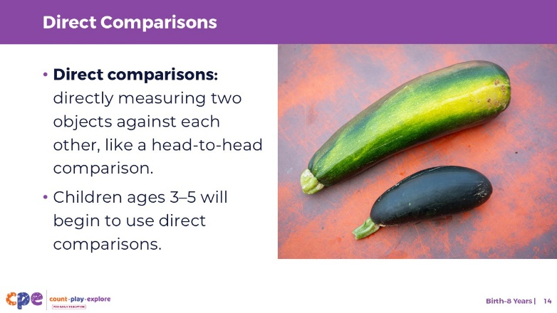

Talking Points
- Comparing objects by their measurable attributes is finding out which object is bigger, longer, or heavier.
- The most common way we compare objects is by using direct comparisons. Direct comparison is when two objects are directly measured against each other, like a head-to-head comparison.
  - For example, you can determine which cup is taller by putting two cups next to each other.
- Between the ages of 3 and 5, children learn to compare objects based on measurable attributes.

Slide 15: Indirect Comparisons
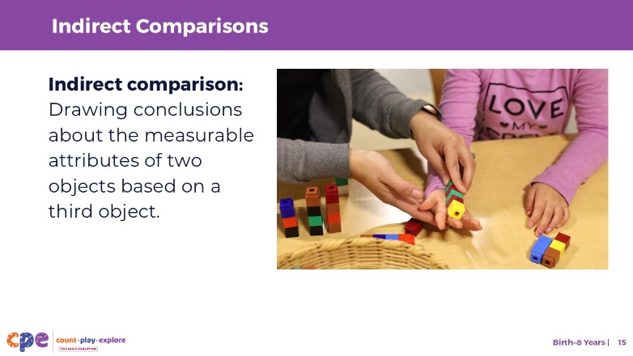

Talking Points
- Children might also use indirect comparisons.
- Indirect comparisons involve using a third object as a reference point. For example, you can use a piece of string to compare the length of two objects that cannot be easily placed next to each other.
- Adults often engage in indirect comparison when the two objects we want to compare are not in the same place physically, and if we don’t have a measurement tool like a tape measure available.
  - For example, if you wanted to buy a new table that matches the height of an existing table, you might measure the height of a table with a string. Then you may go to the store, and check whether the tables they have are the same height, or whether they are taller or shorter. Here you would use the string as a reference and compare two tables with the string.
- Children begin to use indirect comparisons starting in kindergarten and first grade.

Slide 16: Ordering
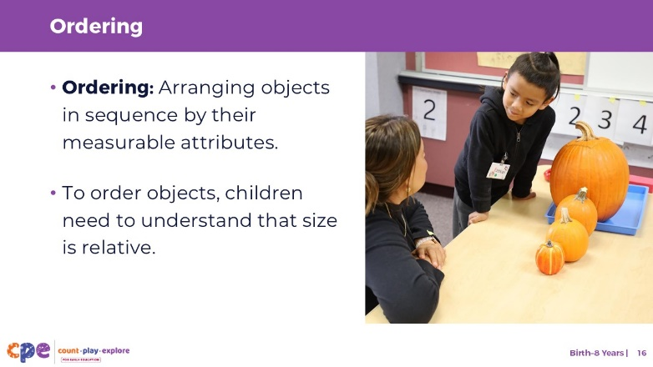

Talking Points
- Ordering objects by their measurable attributes involves arranging them in a sequence, such as from smallest to biggest, lightest to heaviest, or shortest to longest.
- Between the ages of 3 and 5, children learn to order objects by measurable attributes.
- To do this, children need to understand that size is relative.
  - For example, they need to understand that while a dog is small compared to an elephant, a dog is big when compared to a mouse.

Slide 17: Comparative Vocabulary
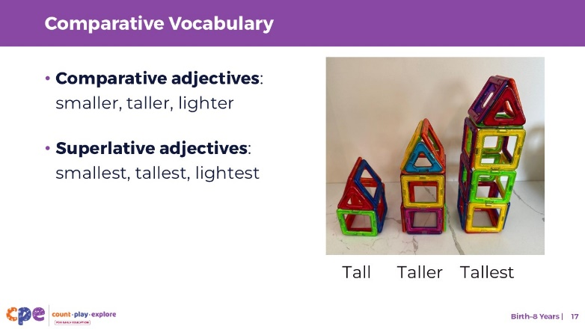

Talking Points
- In addition to learning how to compare and order objects based on measurable attributes, children also learn to describe these comparisons.
- Starting around 12 months and into their 2nd and 3rd year, children learn some vocabulary to describe the measurable attributes of objects, in English, their home language, or both.
  - At first, children tend to use the same words for multiple attributes. For example, they will use “big” for both length and height. Then they begin to learn that there are specific words for specific attributes. For example, they learn that tall and short are words used to describe height, and wide and narrow for width.
  - In Spanish, children might at first use “grande” for both length, width, and weight. Then they begin to use words like “alto” for tall and “pesado” for heavy.
- Between the ages of 3 and 4, children learn to use comparative and superlative adjectives to communicate about comparisons and order more precisely.
  - Comparative adjectives compare two things and in English usually end in “er” like smaller, bigger, lighter, longer.
  - Superlative adjectives compare more than two things and in English usually end in “est” like smallest, biggest, lightest, longest.
- However, it is important to remember that children develop at their own pace and in their own way. A variety of factors impact children’s learning and development in measurement including their language development. Thus, when children learn comparative vocabulary may vary.
- [Invite participants to share:] What are some examples of comparative and superlative measurement vocabulary in your home language?

Slide 18: Measuring
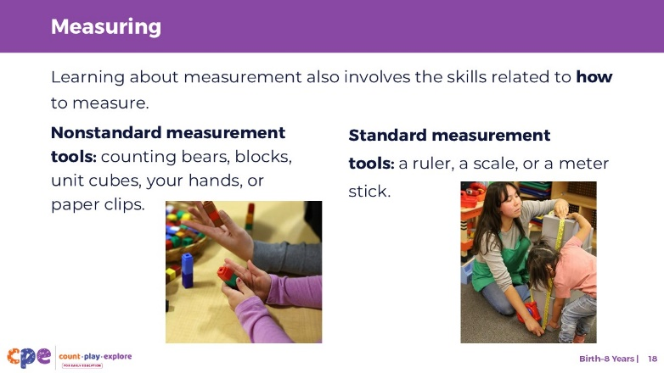

Talking Points
- Learning about measurement also includes learning the skills related to how to measure. This includes learning how to use measurement tools.
- When children first learn to measure, they often use nonstandard measurement tools. Eventually, they transition to using mostly standard measurement tools.
  - Nonstandard measurement tools include everyday items like counting bears, blocks, unit cubes, your hands, or paper clips.
  - Standard measurement tools include more traditional tools such as a ruler, a scale, or a meter stick.

Slide 19: Explore: How big is the table?
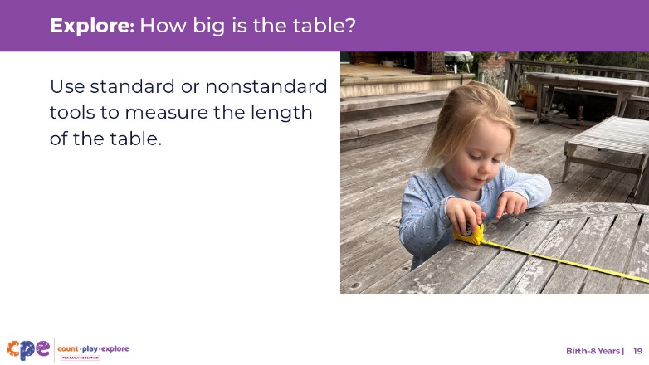
Time: 7–10 minutes
Materials: Variety of standard and nonstandard measurement tools

Talking Points
- Before we review how children learn to measure, we will take a moment to explore some measurement tools that children might use as they first learn to measure.
- Your goal is to measure the length of the table using one of these measurement tools [indicate to participants where they can find the measurement tools].
- You may choose either a standard or nonstandard measurement tool.
- [Provide time for participants to measure. Then, invite each individual or group to share their measurement and briefly share their experience using the following questions.]
  - Which measurement tool did you use? Was it a standard or nonstandard measurement tool?
  - What was your experience using the measurement tool?
  - Was the tool easy or difficult to use? Why?
- [As participants debrief, highlight how the experiences of participants using a nonstandard tool were different from those using standard tools.]

Facilitator Notes
- Have a variety of standard and nonstandard measurement tools available for participants.
- Adjust the way you organize the activity based on group size, session length and format, and participants’ needs. For example:
  - For small groups, invite participants to work individually and share their experiences with their tables before discussing as a larger group.
  - For larger groups, invite participants to work with a partner and share with the larger group.

Slide 20: Rules for Measuring
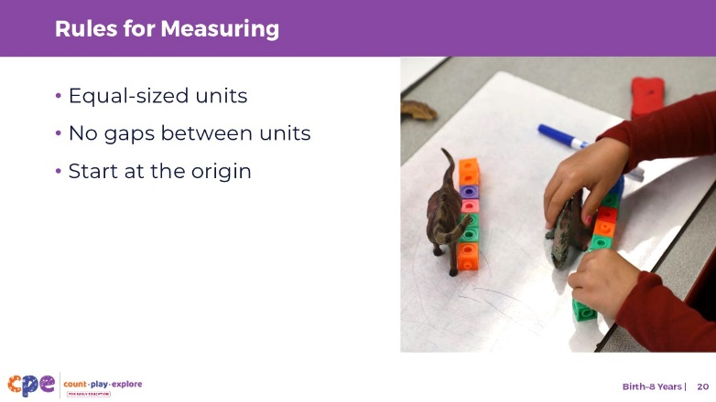

Talking Points
- When learning to measure, and when learning to use tools for measurement, children need to understand the following ideas:
  - Different attributes require different measurement tools (weight requires a scale, temperature requires a thermometer).
  - Equal-sized units: you need constant, equal-sized units for meaningful measurement.
  - No gaps between units: When measuring distance, you need to lay each unit end to end. While rulers or tape measures in their design do not include gaps between units, this is an understanding that children develop when using nonstandard tools like blocks and they have to place each block end-to-end to measure the length of an object.
  - Measurement starts at the origin: you need to know the location of the “zero” or origin of your object.
  - Standard measurement tools have standardized units. This allows us to communicate about size, length, or height universally. Children can explore this idea by investigating whether they obtain the same measurement when using their own feet versus the educators’ feet to measure the length of a rug. They will realize that because everyone’s feet are different sizes, you get different results.
- Note that across different cultures, there are various traditions for using units of measurement. What is standard for one country or place, maybe not be standard in another. For example, in India, ratti is a unit of measuring weight that is based on the weight of a seed. It is still used as a standard unit of measuring jewels.

Slide 21: Using Standard Measurement Tools
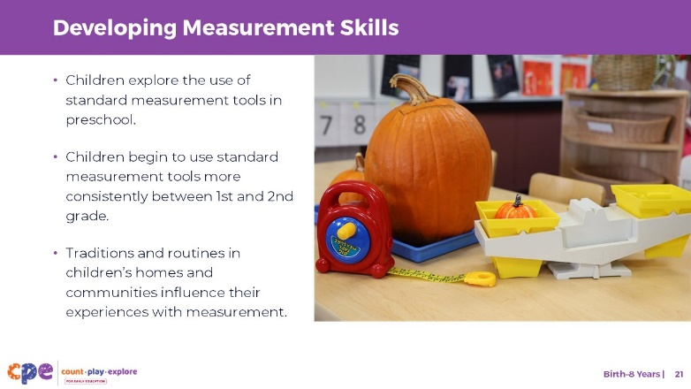

Talking Points
- While children begin to explore measurement concepts such as comparing and ordering without an understanding of number (for example, by noticing which of two objects is longer), they need to understand numbers, the count list, and numerals to use standard measurement tools.
  - For example, children need to understand what the numerals on a tape measure represent, and they need to be able to count the number of steps it takes to cover the length of the carpet.
- Even though children may be introduced to standard measurement tools between the ages of 3 and 5, they begin to use them more consistently starting in grade 1 and grade 2.
- Once children develop an understanding of fractions and decimals, they can apply this knowledge to measurement by expressing measurements more precisely, using fractions or decimals.
- Traditions and routines in children’s homes and communities influence their experiences with measurement.
  - For example, when cooking, some families may estimate how much of each ingredient to put into the dish, others might use measuring cups, and others might weigh ingredients using a scale. Children may therefore have varied experience with different measurement tools and strategies.
  - Additionally, how people measure varies by a country or community. Some countries use the metric system (meters, grams) and in the U.S, we use the imperial system (inches, feet, pounds). Indigenous cultures have ways of understanding time or direction that have been passed down for generations. Therefore, what is considered standard units may change by a country or community.
  - Asking families about important traditions and routines for their family can help educators incorporate those into their setting.

Slide 22: An Overview of Measurement Knowledge and Skills
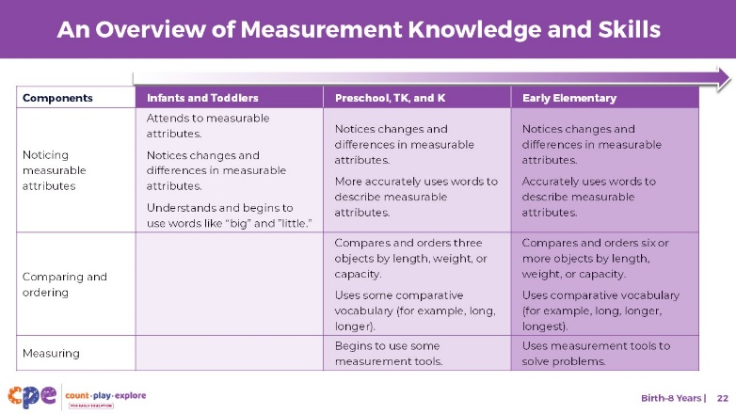

Talking Points
- We have discussed several measurement skills: noticing measurable attributes, comparing and ordering, and measuring using measurement tools. Think about how children’s math learning develops and becomes more complex over time.
- This slide shows what children know about measurement at three distinct points of development.
  - Infants notice changes in the measurable attributes of objects. Toddlers learn to communicate a few words like “big” and “little” to describe measurable attributes.
  - Children in preschool, transitional kindergarten, and kindergarten can compare and order two, and eventually three, objects by length, weight, or volume. They learn to use some comparative and superlative adjectives like long, longer, and longest to communicate comparisons more precisely. With adult support, they also begin to use standard and nonstandard tools to measure objects.
  - In early elementary school, children can compare and order six or more objects by various attributes. They learn to use nonstandard and standard measurement tools more independently and can use these tools to solve problems. They also begin to estimate lengths.

Slide 23: Reflect: Snowstorm!
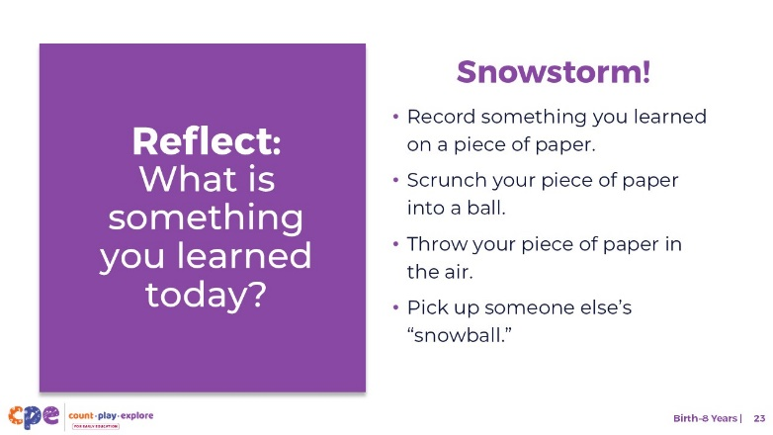
Time: 5–10 minutes
Materials: Piece of paper and pencil or pen

Talking Points
- We discussed several measurement skills: noticing measurable attributes; comparing and ordering; and measuring.
- We explored how these measurement skills develop throughout early childhood. We also applied some of these measurement skills in a playful, hands-on experience.
- Consider what you learned today. Then, record something you learned on a piece of paper. [Provide a few minutes for participants to record what they learned.]
- Scrunch your piece of paper into a ball and when I give the signal, throw your piece of paper in the air. You will then pick up one of the pieces of paper that is close to you (and that is not your own.)
- [Once participants have thrown their paper in the air, select a facilitation method that works best for your session length and format, group size, and participant needs.]
- This session described how children come to an understanding of measurement skills. When you return to your learning setting, notice the way children use measurement. Pay attention to the ways you support children to develop an understanding of measurement skills. Noticing will help you be more intentional about the ways you support children’s learning in this math area.

Facilitator Notes
- Adjust the way you organize the activity based on group size, session length and format, and participants’ needs.
  - For small groups, invite participants to share what is on the paper they picked up with the entire group.
  - For large groups, invite participants to share what is on the paper they picked up with their table group.

