Measurement: Infants and Toddlers (PPT 2a)
Use this facilitator guide with the slides “Measurement: Infants and Toddlers.” This set of slides provides descriptions of how infants and toddlers develop their understanding of measurement concepts and ways educators can support them as they develop early measurement skills. Facilitators can find talking points and guidance for activities and group discussions in this guide. The text in the guide is also located in the notes portion of the slides.

Session at-a-Glance
Slide Numbers | Overview of Content | Approximate time (in minutess)
1-5 | Introduction & session goals  - Video observation | 15-20
6-13 | How infants and toddlers learn about measurement:  - California Learning and Development Foundations  - Noticing measurable attributes  - Measurement vocabulary | 10-20
14-20 | How to support children in learning about measurement:  - Daily opportunities to explore measurement  - Observing and discussing M⁵  - Video observation | 45-75
21 | Reflection activity | 5-7
The times are approximate and may vary based on session goals, group size, and participants’ previous experience and familiarity with the content.

To prepare for your session
- As you plan your professional learning session, consider the content in each of the PPTs in this suite:
  - PPT 1 “Introduction to Measurement: Birth–8 Years” describes how children develop an understanding of measurement from birth to age eight.
  - PPT 2a “Measurement: Infants and Toddlers,” and PPT 2b “Measurement: Preschool, Transitional Kindergarten, and Kindergarten” and PPT 2c (coming soon) “Measurement: Early Elementary” describe in greater depth how children at different age levels develop an understanding of measurement. These PPTs also include ideas on how to support children in specific age ranges to develop measurement skills.
- We encourage you to offer the content in PPT 1 before, or in combination with, one age-specific slide deck (PPT 2a, PPT 2b, or PPT 2c (coming soon)). Together, PPT 1 and one of the age-specific slide decks are designed for a three-hour professional learning session. However, you can adjust slide decks to best meet participant needs and time allowances.
- Before your session, carefully review all handouts and prepare the necessary materials. Select a facilitation method that works best for your session length and format, group size, and participant needs.
- Consider using photos, videos, or stories from the learning settings where educators work within this session. Making the information more personal for participants can create a greater connection to the content and foster feelings of belonging in math.

Materials Needed
- Scratch paper, chart paper, and writing tools
- Daily Opportunities to Explore Measurement handout
- M⁵ Overview handout
- Observing M⁵ in Action: Measurement handout, sample answers handout, infant or toddler measurement video clip
- Using M⁵ to Support Learning About Measurement handout

Slide 1: Measurement: Infants and Toddlers
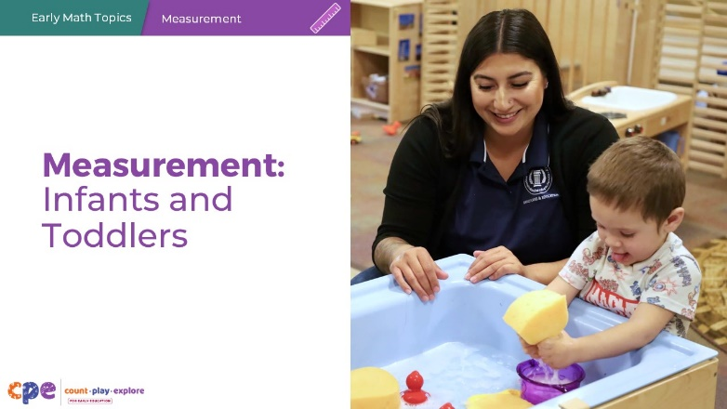

Talking Points
- In this session, we will explore how infants and toddlers develop their understanding of measurement concepts. We will also focus on ways we can support infants and toddlers as they develop early measurement skills.
- Infants and toddlers may be in center-based programs; family child care programs; or family, friend, and neighbor care. Across all settings, children at this age learn math through play, daily routines, and meaningful interactions with peers and adults.

Facilitator Notes
- Adjust the talking points to reflect the session length and participant needs. If necessary, add introductory and “housekeeping” information.

Slide 2: Acknowledgments
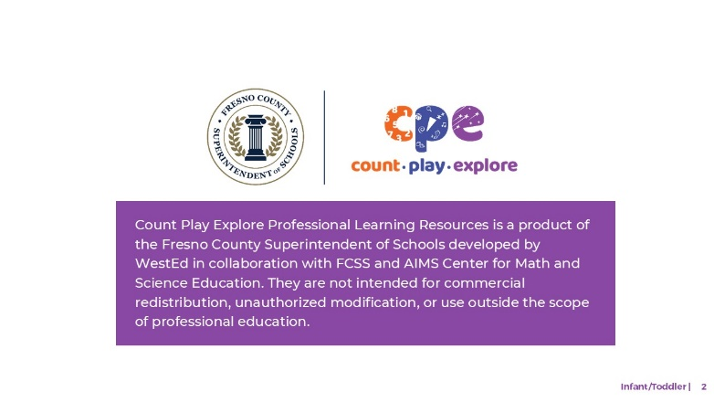

Talking Points
The Count Play Explore Professional Learning Resources were made possible by Count Play Explore, an early math, science, and computer science initiative led by the Fresno County Superintendent of Schools, Early Care and Education Department. This initiative is generously funded by the California Department of Education and the California State Board of Education. These resources, developed by WestEd in collaboration with FCCS and AIMS Center for Math and Science Education, are intended to be used as a guide for implementing evidence-based strategies, promoting active learning, and encouraging developmentally appropriate practices in early education settings. They are not intended for commercial redistribution, unauthorized modification, or use outside the scope of professional education.

Slide 3: Session Goals
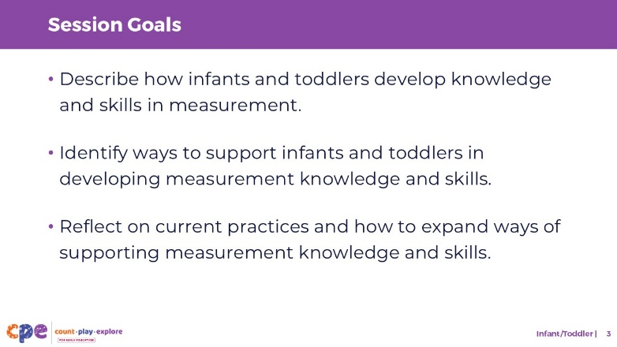

Talking Points
- First, we will review how infants and toddlers develop knowledge and skills in measurement. For example, how do infants and toddlers notice and explore the size, length, or height of objects? How do infants and toddlers notice and communicate about differences in size?
- Then, we will explore ways educators can support infants and toddlers in developing knowledge and skills in measurement.
- Throughout the session, we will reflect on our current practices. We will also think about how we might use information from this session in our work.

Facilitator Notes
- Adjust slide content and talking points to reflect what you plan to address in your professional learning session.
- For longer sessions, start the session by engaging participants in the interactive How Tall Am I? activity described in PPT 1 “Introduction to Measurement: Birth–8 Years,” and its corresponding handout. The purpose of this activity is to help participants explore important ideas in measurement such as estimation, starting points, and accuracy.

Slide 4: Observe: Exploring Measurement Through Play
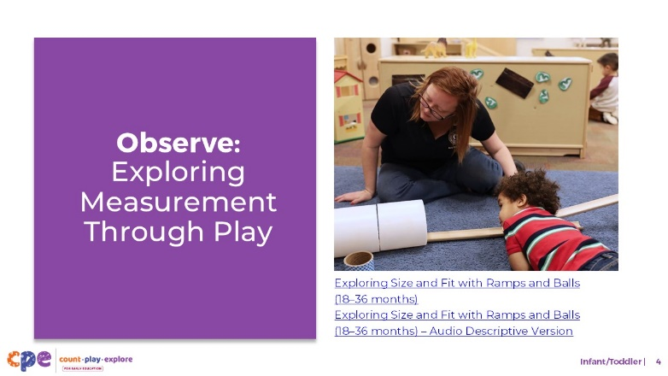
Time: 10–20 minutes (including debrief on the next slide)
Materials: Infant or toddler measurement video clip

Talking Points
- Before we get started, let’s observe a video clip of young children exploring measurement concepts through play. As you observe, pay attention to the ways the children are exploring measurement. What materials are they engaging with? What measurement concepts were they exploring?
- After watching the clip, we will discuss what you noticed.

Facilitator Notes
- Choose an infant or toddler video clip related to measurement.
- We provide the following video clips (you may choose other videos to use):
  - Comparing with Baskets and Buckets (8–18 months)
  - Comparing with Baskets and Buckets (8–18 months) - Audio Descriptive Version
  - Exploring Size and Fit with Ramps and Balls (18–36 months)
  - Exploring Size and Fit with Ramps and Balls (18–36 months) - Audio Descriptive Version
  - Exploring Measurement at the Water Table (18–36 months)
  - Exploring Measurement at the Water Table (18–36 months) - Audio Descriptive Version
- Consider playing the video more than once. The first time, invite participants to become familiar with the clip. Then, invite participants to observe specific ways children are exploring measurement.

Slide 5: Discuss: Exploring Measurement Through Play
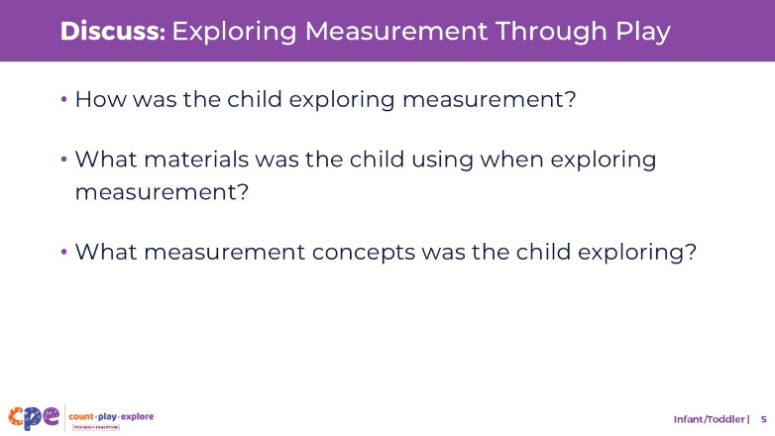
Time: 10–20 minutes (including video observation on previous slide)

Talking Points
- Let’s discuss what you noticed.
  - How was the child exploring measurement?
  - What materials was the child using when exploring measurement?
  - What measurement concepts was the child exploring?
- [After discussion:] You noticed many ways this child was beginning to develop an understanding of measurement concepts.

Facilitator Notes
- Adjust the debrief based on your group size, session length and format, and participant needs. Consider charting participants’ observations to provide a visual of ways children understand measurement.
- Consider using the following adaptations based on session length:
  - For shorter sessions, invite participants to share with the large group what they noticed about ways infants and toddlers showed their knowledge and skills related to measurement.
  - For longer sessions, offer time for participants to share their observations in pairs or at their tables. Then, invite each table to share some of their observations.
- Here are some examples of how children in the video clip Exploring Size and Fit with Ramps and Balls (18–36 months) noticed and investigated the measurable attributes of objects:
  - The child noticed height when they decided whether to add one or two blocks under the ramp.
  - The child explored size and fit while playing with balls, ramps, tubes, and rings.
  - The child noticed that the small ball fit inside the small tube but that the big ball got stuck.

Slide 6: How Children Learn About Measurement
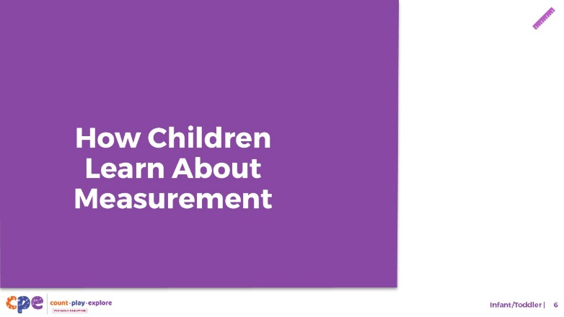

Talking Points
- Now, we will explore how infants and toddlers typically develop an understanding of measurement.

Slide 7: The California Infant/Toddler Learning and Development Foundations
Subtitle: Foundation: Spatial Thinking
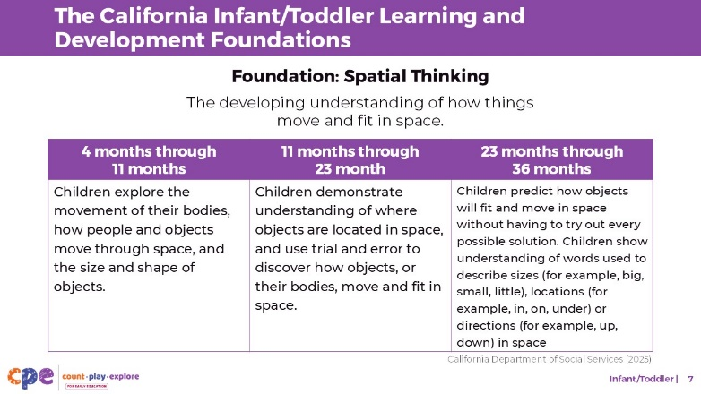

Talking Points
- Before we get started, let’s review some relevant foundations from the California Infant/Toddler Learning and Development Foundations (California Department of Social Services, 2025).
- Although there is no specific foundation on measurement, the foundation on Spatial Thinking includes measurement ideas related to size. This foundation describes how children learn about size through explorations of their environment. For the older toddler age group, the foundation also describes how children develop an understanding of vocabulary to describe size such as big, little, or small.

Facilitator Notes
- You may want to provide participants with copies of the relevant California Infant/Toddler Learning and Development Foundations. Consider whether electronic or printed copies will be more useful for your participants.

Slide 8: Measurement Skills
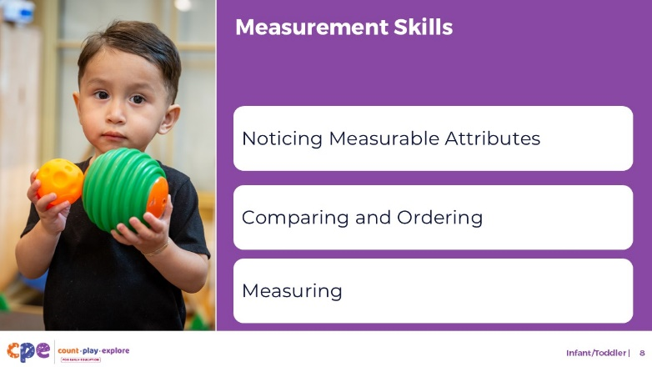

Talking Points
- This suite addresses several important measurement skills:
  - Noticing measurable attributes
  - Comparing and ordering
  - Measuring
- For infants and toddlers, we focus on the first skill: noticing measurable attributes. Children typically begin to develop skills of comparing, ordering, and measuring around age three or four.

Slide 9: Noticing Measurable Attributes
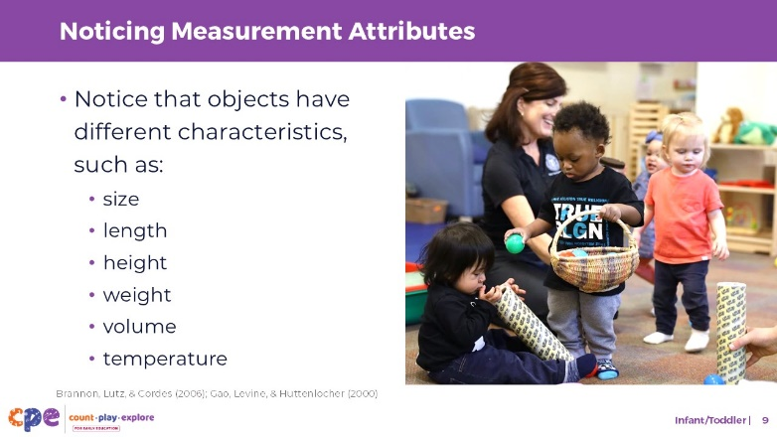

Talking Points
- Noticing measurable attributes of objects describes young children’s ability to pay attention to the attributes of objects that can be measured (for example, their size, length, height, weight, distance, temperature, or volume).
- Infants and toddlers learn about measurable attributes of objects through play and exploration.
- Infants just a few months old notice attributes of objects such as size (Brannon, Lutz, & Cordes, 2006), length, or volume (Gao, Levine, & Huttenlocher, 2000).
- In the next few slides, let’s explore how researchers measure what infants know about the measurable attributes of objects.

Slide 10: Which is bigger?
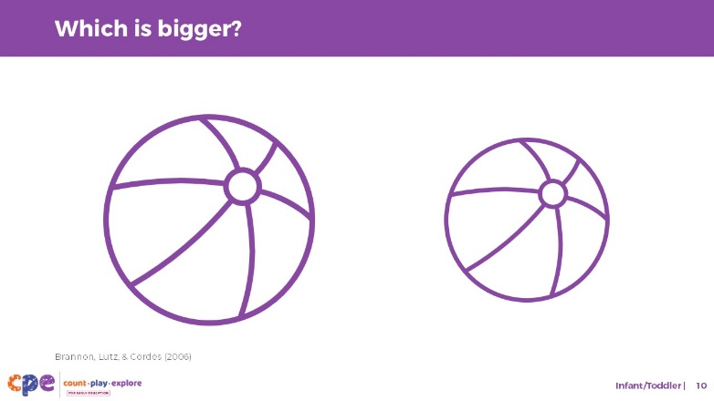

Talking Points
- Since infants cannot yet tell us verbally what they know, research with young infants measures how long they look at an object or picture. Infants will look longer at something when it is new or interesting to them.
- Researchers use cartoons or pictures to keep infants engaged (Brannon, Lutz, & Cordes, 2006).
  - This slide shows two beach balls. Which one is bigger?
  - [Pause for participants to answer the question.] As you noticed, the picture on the left was bigger.
  - The difference between the two beach balls was quite big which makes it easy for adults to know which picture is bigger.
- When researchers show infants the same picture but in a different size (for example, double the size, or half the size), infants are more interested in this new picture, and will look at it for longer. This suggests that infants notice a change in size.

Slide 11: Which one has more?
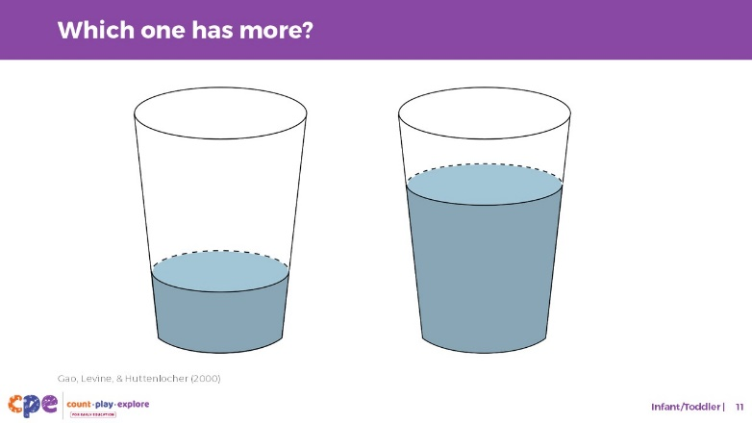

Talking Points
- Researchers have done very similar research to determine what infants know about volume (Gao, Levine, & Huttenlocher, 2000). For this type of research, they show infants pictures of a cup that contains different amounts of liquid.
  - This slide shows two cups filled with water. Which cup has more water?
  - [Pause for participants to answer the question.] As you noticed, the picture on the right had more water.
- Again, research with infants uses a very similar strategy. Researchers show infants a picture of a cup that is a quarter full repeatedly and measure how long infants look at it. When researchers then show infants the same cup but that is now three quarters full, infants look longer at the full cup because it looks new to them. This suggests that infants notice a change in volume.

Slide 12: Noticing Measurable Attributes: Development
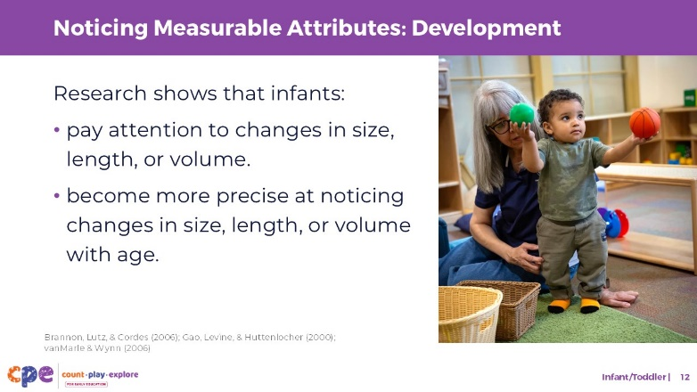

Talking Points
- Infants as young as six-month-olds can notice big changes in volume (Gao, Levine, & Huttenlocher, 2000).
- Six-month-olds also notice big changes in size, such as a one to two (1:2) ratio of change in the size of an object or picture (Brannon, Lutz, & Cordes, 2006). This means that infants notice when an object either doubles or halves in size. Infants become better at noticing smaller differences in size as they get older.
- This understanding is not limited to what infants see. Young infants also notice when the duration of a sound changes (vanMarle & Wynn, 2006).
- Noticing changes in the size and other measurable attributes is important because it provides the foundation for all other measurement skills.
- Before children can learn to describe, compare, or measure attributes of objects, they need to notice those measurable attributes.

Slide 13: Measurement Vocabulary
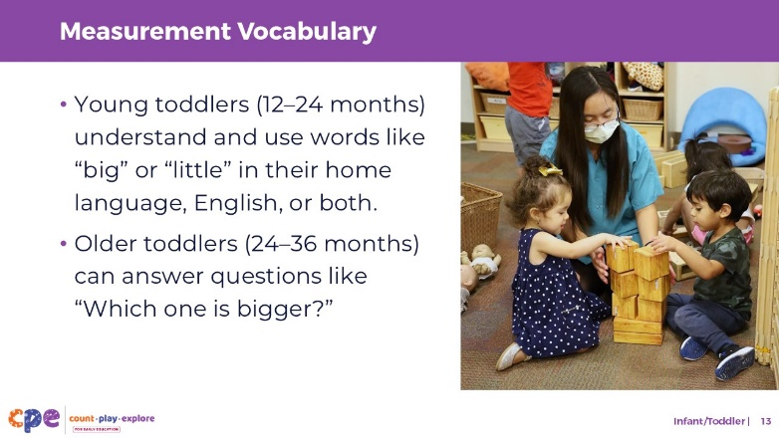

Talking Points
- In addition, young children learn vocabulary to describe an object’s measurable attributes.
- Between 12 and 24 months, children may use vocabulary like “big” or “little” to describe the size or length of an object in English, their home language, or both.
  - At first, children tend to use the same words for multiple attributes. For example, they will use “big” for size, length, and height. It is not generally until the ages of 3 or 4 that children begin to learn that there are specific terms for specific attributes. For example, they learn that “tall” and “short” describe height and “wide” and “narrow” describe width.
  - In Spanish, children might at first use “grande” for length, width, and weight. Then they begin to use words like “alto” for tall and “pesado” for heavy.
  - Additionally, when first learning words like “big” or “little,” young children tend to use them as absolute descriptors of an object, not as relative terms. For example, they may think the word “big” describes all adults, and not understand that some adults are “smaller” relative to other adults.
- Between 24 and 36 months, children can answer questions like “Which one is bigger?” using spoken language, sign language, or gestures. For example, when asked, “Which doll is bigger?” a toddler might point to the biggest doll or communicate, “This one.”

Slide 14: Supporting Measurement
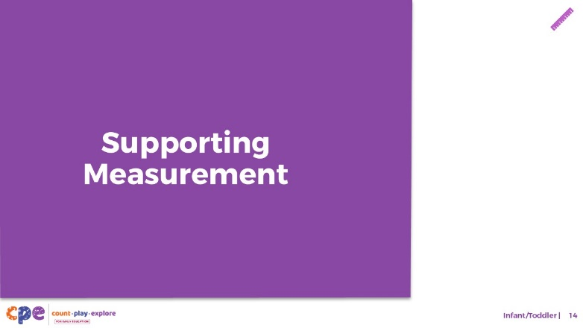

Talking Points
- We explored how infants and toddlers develop an understanding of measurement. Now, let’s discuss ways to support children in learning about measurement—in our learning settings and at home.

Slide 15: Daily Opportunities to Explore Measurement
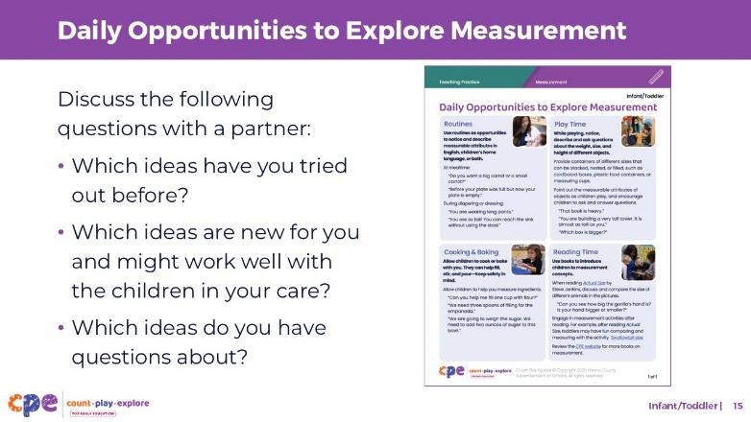
Time: 5–10 minutes
Materials: Daily Opportunities to Explore Measurement handout

Talking Points
- Let’s review how infants and toddlers develop an understanding of measurement through daily routines at home, in their communities, and in early learning and care settings.
- Take out the Daily Opportunities to Explore Measurement handout. This handout offers some ideas on supporting infants’ and toddlers’ developing understanding of measurement through daily routines.
- Review the handout on your own. Then, with a partner, discuss the following questions:
  - Which ideas have you tried out before?
  - Which ideas are new for you and might work well with the children in your care?
  - Which ideas do you have questions about?

Slide 16: Explore: M⁵ Early Math Approach
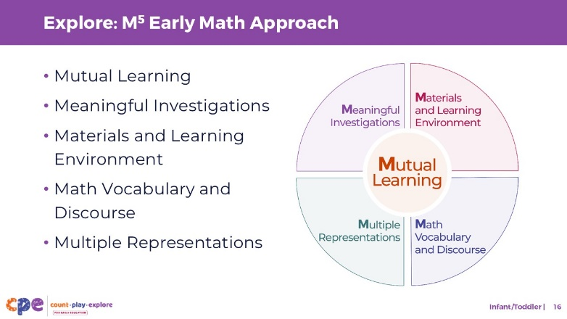
Time: 15 minutes
Materials: M⁵ Overview handout

Talking Points
- We refer to five core early math teaching practices as the M⁵ Early Math Approach. These practices include the following:
  - Mutual Learning
  - Meaningful Investigations
  - Materials and Learning Environment
  - Math Vocabulary and Discourse
  - Multiple Representations
- Let’s explore the M⁵ practices using the M⁵ Overview handout. Then, we will observe M⁵ in action. These evidence-based practices support rigorous and meaningful teaching and learning in ways that honor children’s background, experiences, and preferences.

Facilitator Notes
- Consider your participants and their prior experiences with M⁵. Then, decide how you might use the M⁵ Overview handout.
  - For groups with significant experience with M⁵, you might offer a few minutes for participants to review the handout and share their areas of strength and practices they are working on with a partner. You can also use this slide to revisit the M⁵ practices briefly and move to the next slide.
  - For groups with less experience with M⁵, you might offer more time for participants to explore each practice in the handout. For example, you might allow time for them to review the practices independently. Invite them to make a square over practices that they have “squared away” (practices they understand and use), a circle over “what’s still going around in their heads” (practices they still have questions about), and a triangle over three ideas that they will use in their settings. For more ideas on providing a more comprehensive review, visit the M⁵ Early Math Approach suite.

Slide 17: Observe: M⁵ in Action
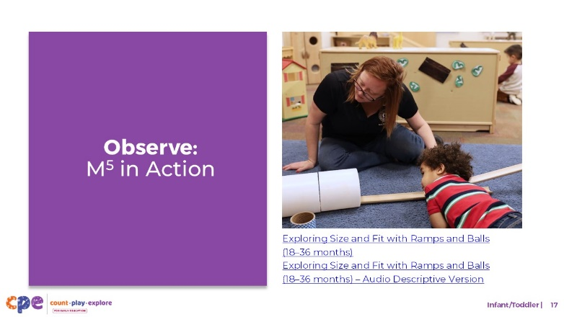
Time: 20–30 minutes (including debrief on the next slide)
Materials: Observing M⁵ in Action: Measurement handout, infant or toddler measurement video clip, chart paper, and markers

Talking Points
- We observed how infants and toddlers develop an early understanding of measurement skills. Then, we explored the M⁵ Early Math Approach. Now, we will observe a video showing how educators might use M⁵ to help infants and toddlers develop measurement skills.
- [Choose a strategy for facilitating this observation and debrief (on the next slide). Adapt the talking points to reflect this strategy.]

Facilitator Notes
- Choose an infant and toddler video clip that shows children learning about measurement. The same clip could be used from when participants observed children learning about measurement.
- We provide the following clips (you can choose to share a different clip):
  - Comparing with Baskets and Buckets (8–18 months)
  - Comparing with Baskets and Buckets (8–18 months) - Audio Descriptive Version
  - Exploring Size and Fit with Ramps and Balls (18–36 months)
  - Exploring Size and Fit with Ramps and Balls (18–36 months) - Audio Descriptive Version
  - Exploring Measurement at the Water Table (18–36 months)
  - Exploring Measurement at the Water Table (18–36 months) - Audio Descriptive Version
- Invite participants to use the Observing M⁵ in Action: Measurement handout.
- For larger groups and longer sessions, use a jigsaw approach. Before playing the video clip, assign each table one practice to focus on during the video. [If there are more than five tables, assign more than one table to focus on each practice.]
- For smaller groups and shorter sessions, consider showing the video clip two to three times, inviting participants to focus on specific practices each time. Encourage them to record observations on the handout.

Slide 18: Discuss: M⁵ in Action
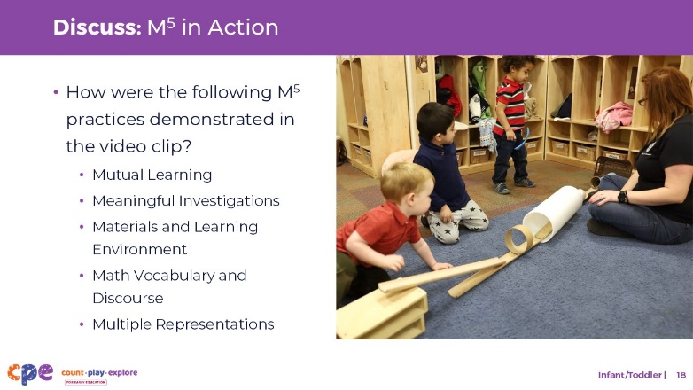
Time: 20–30 minutes (include the review of the video on previous slide)
Materials: Sample Answers for Observing M⁵ in Action: Measurement handout, infant or toddler measurement video clip, chart paper, markers

Talking Points
- Let’s unpack your observations of each M⁵ practice.

Facilitator Notes
- Use the Sample Answers for Observing M⁵ in Action: Measurement handout for examples of ways M⁵ was used in the video clip Exploring Size and Fit with Ramps and Balls (18–36 months).
- For larger groups or longer sessions, after observing the video clip, ask each table group to discuss what they noticed about their assigned practice. Then, invite each group to share their observations with the whole group. As each group shares, paraphrase, affirm, and add to their responses as needed. Consider charting each group’s observations to make practices visible.
- For smaller groups or shorter sessions, invite participants to share their observations with the whole group. Chart their observations to make the practices visible. As participants share their observations, paraphrase, affirm, and add to their responses as needed. Consider inviting participants to share something they learned with someone from another table. For example, you might ask them to find someone with similar shoes, meet them, and share something they learned.

Slide 19: Explore: Using M⁵ to Support Learning About Measurement
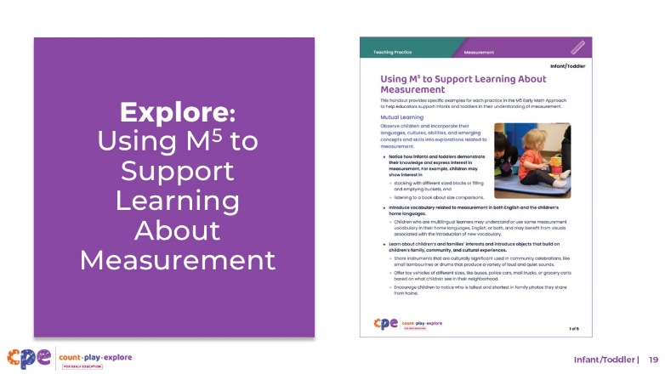
Time: 20–30 minutes (including debrief on the next slide)
Materials: Using M⁵ to Support Learning About Measurement handout, paper, and markers

Talking Points
- Let’s consider ways to use M⁵ teaching practices to support infants’ and toddlers’ understanding of measurement.
- Take out the Using M⁵ to Support Learning About Measurement handout.
- Review the ideas on using M⁵ to support infants’ and toddlers’ understanding of measurement. Take notes, circle, or highlight as you review.
- [For shorter sessions:] Consider the practices you reviewed. With a partner, discuss what you might want to try and why. [If time permits, invite some participants to share with the large group what practices they will try and why.]
- [For longer sessions, use slide 20 to facilitate the discussion.]

Facilitator Notes
- Provide five to seven minutes for participants to review the handout independently.
- For shorter sessions, instead of using the next slide, move on to slide 21.

Slide 20: Discuss: Using M⁵ to Support Learning About Measurement
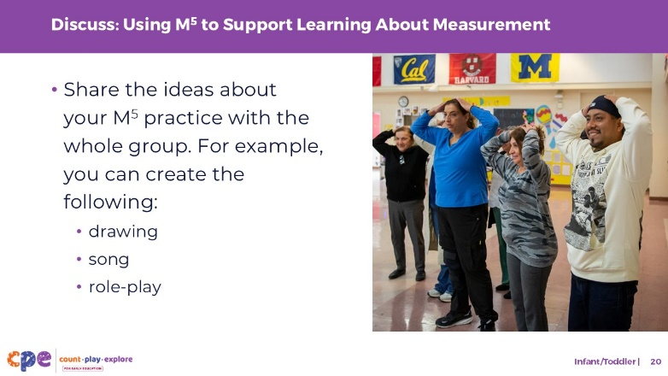
Time: 20–30 minutes (including review of the document on the previous slide)
Materials: Using M⁵ to Support Learning About Measurement handout, paper, and markers

Talking Points
- You reviewed some ideas on using the M⁵ Early Math Approach to support infants and toddlers in understanding measurement. Next, let’s reflect on ways to continue supporting children’s understanding of measurement.
- [Select a way to organize this activity from the facilitator notes. Then, adapt these talking points based on your selection.]
  - [Assign each group one M⁵ practice.] Briefly discuss the ideas described for your assigned practice. Then, decide how you will share these ideas with the whole group.
  - Be creative, you can create a drawing, song, or role-play to share your learning.
  - Consider ways to incorporate the diversity of children’s interests, languages, cultures and lived experiences, abilities, and emerging skills into their learning about measurement.
  - Each group will have two to three minutes to share their M⁵ practice with the whole group.
- [Provide time for participants to prepare their presentations. Then, invite groups to share their assigned practices. Offer additional information about each practice as needed.]
- [After each group has shared:] You reviewed some ways to use the M⁵ Early Math Approach to support infants’ and toddlers’ developing understanding of measurement. Hopefully, you will find these strategies helpful in your setting.

Facilitator Notes
- Adjust the way you organize this activity based on group size:
  - For smaller sessions, divide participants into five groups. Assign each group one M⁵ practice. Each group will discuss their assigned practice briefly and identify a way to share the information with the whole group.
  - For larger groups, create groups of five to seven participants each. Assign each group an M⁵ practice. As necessary, assign more than one group to the same practice. Each group will discuss their assigned practice briefly and identify a way to share the information with the whole group.
- Move around the room while participants work in groups. Provide support as needed.

Slide 21: Reflect: Pair and Share
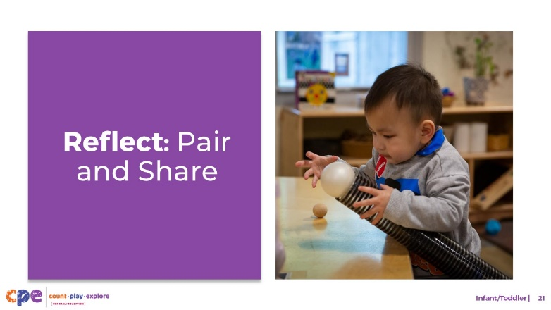
Time: 5–7 minutes

Talking Points
- Take a few minutes to think about our session. Write down two things you have learned today.
- [Allow two minutes for participants to write down their ideas.]
- Next, please turn to a partner. Take three minutes to share with your partners what you learned today.
- [Provide participants three minutes to share with their partner.]
- Thank you for your time, attention, and engagement. It has been wonderful working with you.

Facilitator Notes
- As participants discuss their reflections, note the questions that they still have and what they would like to try. You might use this information to identify topics for future training, coaching, or communities of practice.

