Building a Culture of Inquiry
Use this facilitator guide with the slides “Building a Culture of Inquiry.” It provides facilitators with talking points and guidance for activities, handouts, and group discussions. The same text is also located in the notes portion of the slides. Adapt this facilitator guide based on your group size, session length and format, and participants’ needs.

Session At-a-Glance
Slide numbers | Overview of content | Approximate time (in minutes)
1–3 | Introduction and Session Goals | 5
4–15 | Exploring and experiencing inquiry  - Activity for Adults: What do you wonder?  - Defining inquiry and exploring why it is important  - Video observation  - Handout: Inquiry across Ages and Contexts | 45–75
16–19 | Building a Culture of Inquiry  - Activity for Adults: Inquiry Mindsets  - Handout: M⁵ Early STEAM Approach | 20–30
20 | Reflection | 10
The times are approximate and may vary based on session goals, group size, and participants’ previous experience and familiarity with the content.

To Prepare for Your Session
- Consider using photos, videos, or stories from the learning settings where educators work within this session. Making the information more personal for participants can create a greater connection to the content and foster feelings of belonging in STEAM.
- Before your session, carefully review all handouts and prepare the necessary materials. Throughout the facilitator guide, we offer options for facilitation approaches. Select the facilitation approach that works best for your session length and format, group size, and participant needs.

Materials Needed
- Chart paper, paper, and writing tools
- Balls of different sizes and materials, masking tape (optional)
- Inquiry across Ages and Contexts handout
- Inquiry Mindsets handout, the book, Ada Twist, Scientist by Andrea Beaty
- M⁵ Early STEAM Approach Overview handout

Slide 1: Building a Culture of Inquiry
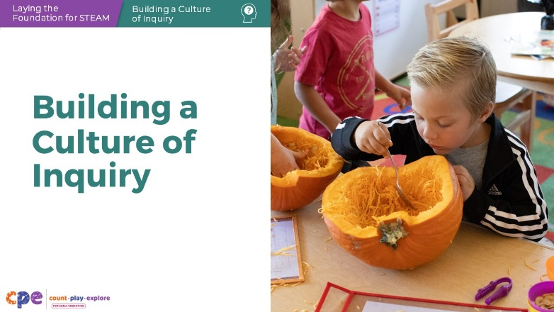

Talking Points
- Hello, and welcome everyone! Today, we will be exploring how to build a culture of inquiry in your learning setting with children from birth through eight years old.

Facilitator Notes
- Adjust the talking points to reflect the session length and participant needs. If necessary, add introductory and “housekeeping” information.

Slide 2: Acknowledgments
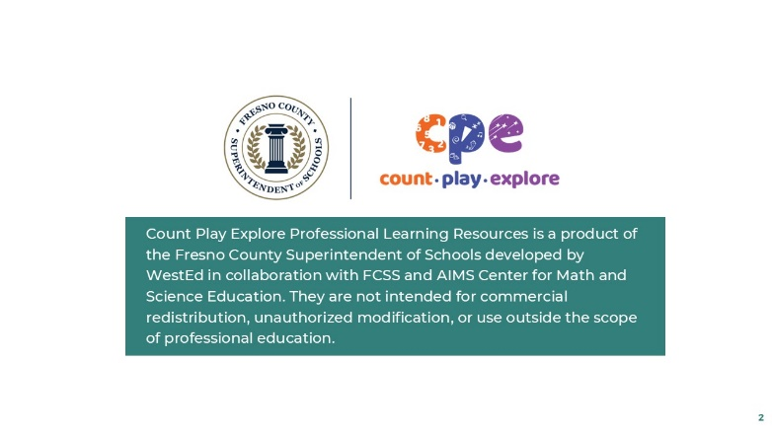

Talking Points
- The Count Play Explore Professional Learning Resources were made possible by Count Play Explore, an early math, science, and computer science initiative led by the Fresno County Superintendent of Schools, Early Care and Education Department. This initiative is generously funded by the California Department of Education and the California State Board of Education.
- These resources, developed in collaboration with WestEd and partners, are intended to be used as a guide for implementing evidence-based strategies, promoting active learning, and encouraging developmentally appropriate practices in early education settings. They are not intended for commercial redistribution, unauthorized modification, or use outside the scope of professional education.

Slide 3: Session Goals
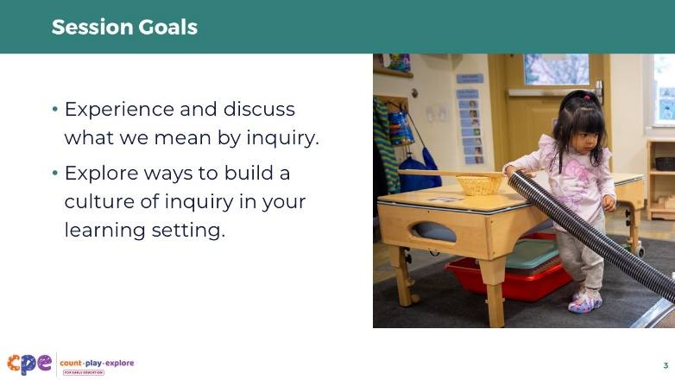

Talking Points
- In this session, we will:
  - experience and discuss what we mean by inquiry and
  - explore ways to build a culture of inquiry in learning settings.

Facilitator Notes
- Adjust slide content and talking points to reflect what you plan to address in your professional learning session.

Slide 4: What do you wonder?
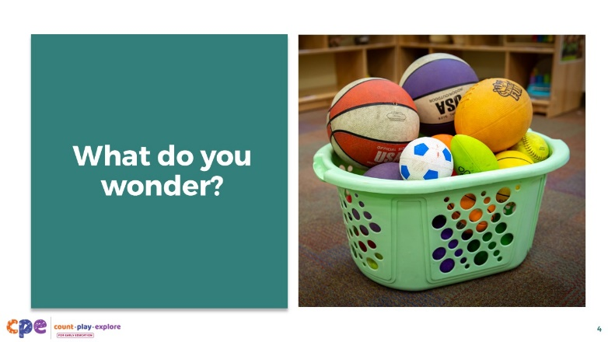
Time: 5 minutes
Materials: chart paper (optional)

Talking Points
- Let’s wonder together.
- Here is a photo of a basket of balls.
- Observe the balls. What do you wonder about the balls?
- [Select a facilitation strategy from the Facilitator Notes to support participants in generating questions.]
- [After participants generate questions and share with the larger group, emphasize the following:] Being curious and asking questions are drivers of inquiry. Curiosity provides the motivation to explore and experiment (Casey, 2014).

Facilitator Notes
- For shorter sessions, encourage participants to brainstorm questions in a whole group setting. You might document participants’ questions on chart paper.
- For longer sessions, invite small groups to document what they wonder about the basket of balls on their own sheet of chart paper. Then, encourage small groups to share with the larger group.
- Contribute your own questions to the brainstorming process as needed. For example, “Does one ball bounce higher than others?” “Which ball is the biggest?” “What does each of the balls feel like?”

Slide 5: What can you do to find out?
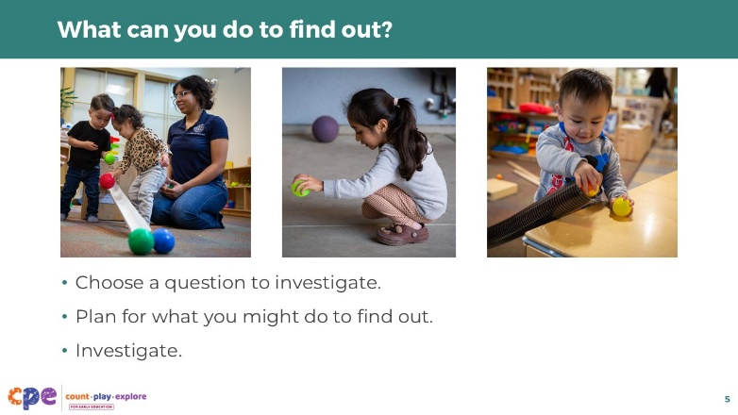
Time: 15 minutes
Materials: Balls of different sizes and materials, other optional materials include masking tape, markers, chart paper

Talking Points
- Now, let’s consider ways we might find out more about the questions we raised.
- With a partner (or small group), choose a question to investigate.
- Think about what you can do to find out the answer to your question.
- Make a plan for how you can investigate.
- Consider what you think might happen and why. Record your hypothesis.
- [Provide a few minutes for participants to plan and discuss.]
- Let’s investigate. Gather information to help you answer your question.
- Think about ways you might observe, measure, and document the findings from your investigation.

Facilitator Notes
- Support participants as they investigate answers to their questions about the balls.
- Consider guiding participants’ investigations by providing them a choice between two questions: “Which ball rolls the farthest?” or “Which ball bounces the highest?”
- Encourage groups to measure or document the results. For example, they might use the optional masking tape to mark the distance different balls travel. Offer chart paper to groups to support them to document.
- If groups finish their investigations sooner than others, consider encouraging them to discuss or extend their investigation. For example, ask the following:
  - “What did you learn through your investigation? Was your hypothesis correct? Why?”
  - “What new questions do you have?”
  - “How might you find out more about the question you are investigating?”
  - “What additional tools or materials might you need to continue exploring?”

Slide 6: Discuss: Engaging in Inquiry
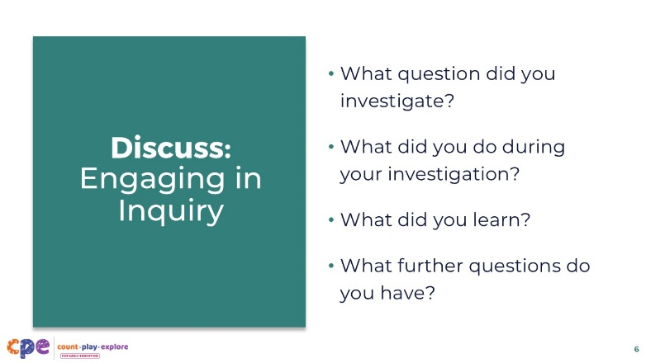
Time: 10 minutes

Talking Points
- Let’s take a few moments to share the different ways we investigated and what we learned.
  - What question did you investigate?
  - What did you do during your investigation?
  - What did you learn?
  - What, if any, further questions do you have?

Facilitator Notes
- Invite a few groups to share their experiences.
- You might prompt participants with the following questions as they discuss ways they investigated:
  - “In what ways did you plan and carry out an investigation to answer your question?”
  - “What worked well during your investigation? What might you change about your investigation to help you answer your question?”
  - “In what ways did you make predictions and test your ideas about how the balls move?”
  - “In what ways did you gather or document information during your investigation?”
  - “You explored concepts related to physical science (for example, exploring forces and how things move). What were some of the explanations you came up with as you investigated different physical science concepts?”
  - “What did it feel like to engage in this inquiry experience?”

Slide 7: What is inquiry?
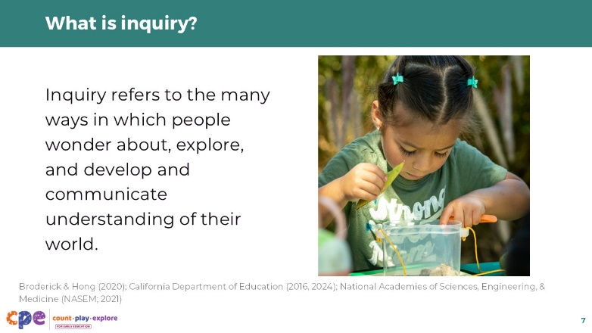

Talking Points
- Inquiry refers to the many ways people wonder about, explore, and develop and communicate their understanding of the world (Broderick & Hong, 2020; California Department of Education, 2016, 2024; National Academies of Sciences, Engineering, & Medicine [NASEM], 2021).
- Inquiry can begin with a feeling of being puzzled by something.
- Your curiosity, or puzzlement, about the different balls led you to use inquiry to find out more and build understanding of your world.
- We might see children puzzling or wondering about something during their play.
- Play is central to inquiry. Inquiry often emerges through play, which is one way children engage with their environment to make sense of the world.
- Storytelling and excitement might also be a starting point of inquiry. Storytelling is a way children can communicate information and wonder about concepts and phenomena they might experience.

Slide 8: Inquiry Supports Learning in STEAM
This slide contains animation. See instructions in the talking points.
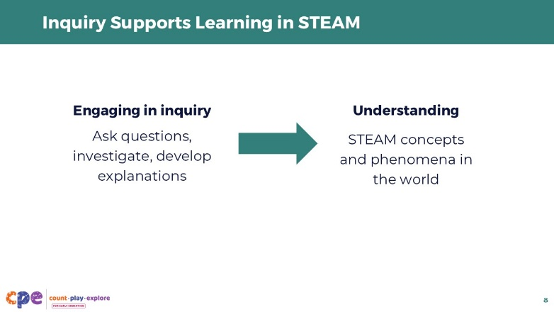

Talking Points
- Children can use inquiry to build understanding within STEAM experiences.
- STEAM is an integrated approach to exploring and making sense of the world around us. In STEAM learning experiences, children use science, technology (including computer science), engineering, the arts (including painting, sculpting, storytelling, drama, and music), and math to investigate, construct meaning, and communicate their ideas about objects and phenomena.
- When we say phenomena, we mean observable events that involve STEAM concepts, such as a seed sprouting, paint mixing to form a new color, or a ball rolling into a block structure and causing it to topple over.
- Across STEAM disciplines, children can
  - [Click] ask questions and express curiosity about phenomena in the world, use different skills and practices to investigate questions and curiosities, and
  - [Click] develop explanations or conclusions based on the evidence they gather.

Slide 9: Observe: Children Engaging in Inquiry
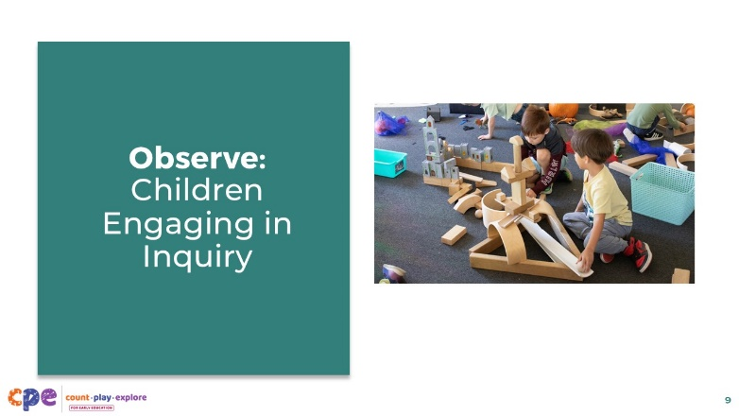
Time: 10 minutes (including discussion on the following slide)
Materials: Video clip of children engaging in inquiry

Talking Points
- Let’s notice the ways children engage in inquiry with balls.
- As you observe the video, consider the following questions:
  - What were the children curious about?
  - In what ways did the children test their predictions?
  - What might the children have learned during this inquiry experience?
  - In what ways did inquiry emerge through play?
  - How was the children’s engagement in inquiry similar to or different from your experience with inquiry?
- [Select and play a video clip showing children engaging in inquiry. We provide videos in the Facilitator Notes.]

Facilitator Notes
- Choose a video that shows children engaging in inquiry.
- We provide the following videos (you may use other videos):
  - Exploring Size and Fit with Ramps and Balls (18–36 Months)
  - Exploring Size and Fit with Ramps and Balls (18–36 Months) - Audio Descriptive Version
  - Problem Solving with Blocks (4–5 Years)
  - Problem Solving with Blocks (4–5 Years) - Audio Descriptive Version
- Note: Discussion points are provided for the videos in the Facilitator Notes on the next slide.

Slide 10: Discuss: Children Engaging in Inquiry
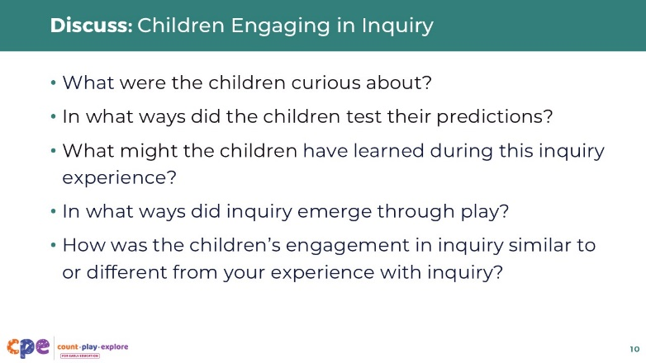
Time: 10 minutes (including observing the video on the previous slide)

Talking Points
- Let’s discuss what you noticed.
  - What were the children curious about?
  - In what ways did the children test their predictions?
  - What might the children have learned during this inquiry experience?
  - In what ways did inquiry emerge through play?
  - How was the children’s engagement in inquiry similar to or different from your experience with inquiry?

Facilitator Notes
- Adjust the debrief based on your group size, session length and format, and participant needs.
- Consider using the following adaptations based on session length:
  - For shorter sessions, invite participants to share with the larger group what they noticed about ways children engaged in inquiry.
  - For longer sessions, offer time for participants to share their observations in pairs or at their tables. Then, invite each table to share their observations.
- Here are some examples of ways children in the video, “Exploring Size and Fit with Ramps and Balls (18–36 Months)” engaged in inquiry:
- What was the child curious about?
  - The child was curious about different ways the balls move and how different balls can fit into different sizes of tubes.
- In what ways did the child test their predictions?
  - The child experimented with different sized balls and different sized tubes, noticing which balls would fit and which would not.
- What might the child have learned during this inquiry experience?
  - The child learned that size affects the way things fit—the larger ball was too big to fit into the smaller tube.
- In what ways did inquiry emerge through play?
  - The child and educator playfully explored with the ramps and tubes. They were both smiling and showed excitement. The educator provided guidance and explorations, for example, “Do you think the big ball will fit?”
- How was the child’s engagement in inquiry similar to or different from your experience with inquiry?
  - Both children and adults experienced joy, were motivated to test different ideas because they were curious, experienced failed attempts but kept trying, and engaged in meaning making during the inquiry process.
- Here are some examples of how children in the video “Problem Solving with Blocks (4–5 Years)” engaged in inquiry:
- What were the children curious about?
  - The children were curious about how the balls move. One child wanted to find ways to turn the ball.
  - Collaboratively, both children were curious about ways to use the ball to knock something down.
- In what ways did the children test their predictions?
  - One child tested ways to turn the ball by placing a block in different positions and noticing what happened when he released the ball down a ramp.
  - Collaboratively, the two children tested different ways to design the ramp structure and different ways to position the toy so that the ball would knock it down.
- What might the child have learned during this inquiry experience?
  - The child learned that he could use different blocks to turn a ball and also stop a ball.
  - Collaboratively, the children learned ways to change the force of the ball to knock down a structure.
- In what ways did inquiry emerge through play?
  - The children demonstrated curiosity and joy in their playful explorations. They were creating different structures and had different goals for their play. Through their play, they generated questions and identified problems (for example, “How can I make this ball turn?” and “How can we get the ball to knock over the figure?”). Their play scenarios provided the purpose for their inquiry experiences.
- How was the children’s engagement in inquiry similar to or different from your experience with inquiry?
  - Both children and adults experienced joy, were motivated to test different ideas because they were curious, encountered failed attempts but kept trying, and worked independently and collaboratively.

Slide 11: Why is inquiry important?
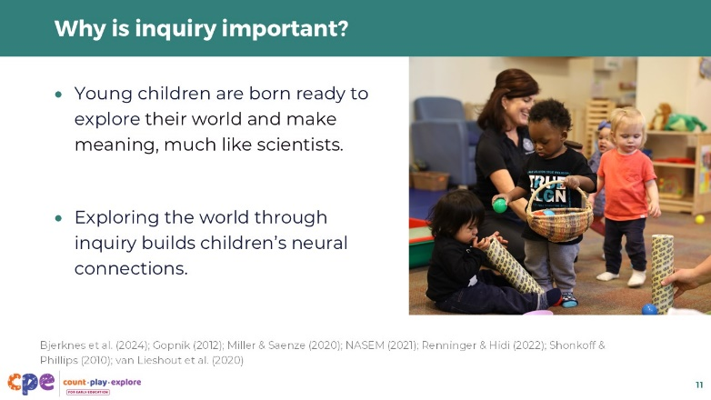

Talking Points
- Young children are born ready to explore their world and make meaning, much like scientists (Gopnik, 2012; Miller & Saenz, 2020; NASEM, 2021; Shonkoff & Phillips, 2010).
- In fact, curiosity is a trait we are all born with—one that helps us learn, grow, and thrive (Bjerknes et al., 2024; Renninger & Hidi, 2022; van Lieshout et al., 2020).
- Exploring the world through inquiry—by touching, pulling, pushing, climbing, figuring out what happens if—helps children’s brains build neural connections (Shonkoff & Phillips, 2010). This is especially meaningful for young children whose brains are developing at rapid rates.
- As children age, curiosity continues to guide and support learning and development throughout their lifespan.

Slide 12: Why is inquiry important? (continued)
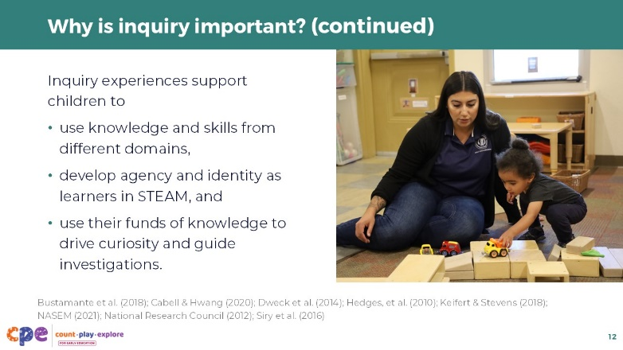

Talking Points
- Inquiry experiences support learning across domains. For example, they
  - offer opportunities to develop social and emotional skills, such as collaboration, communication, and persistence (National Research Council, 2012; Keifert & Stevens, 2018);
  - encourage children to use math, literacy, and fine and gross motor skills as part of their investigation process (Bustamante et al., 2018; Cabell & Hwang, 2020; NASEM, 2021); and
  - strengthen critical thinking skills needed to solve problems, answer questions, and develop deeper understandings of concepts (National Research Council, 2012).
- Inquiry experiences can also support children to develop agency and identity as learners in STEAM. For example, inquiry experiences offer the following:
  - They create safe spaces for children to take risks. Through inquiry experiences, children learn that mistakes can help them learn (Dweck et al., 2014).
  - They provide opportunities where children can feel a sense of agency, like, “I can do it!” These experiences enhance engagement and motivation to learn, which helps develop a positive sense of identity in STEAM (Dweck et al., 2014; Siry et al., 2016).
  - They can build on children’s funds of knowledge—a unique set of knowledge and skills based on children’s lived experiences in their families and communities (Hedges, et al., 2010). Children can draw from their everyday experiences, culture, and home practices to generate curiosity and guide investigations.

Slide 13: Explore: Inquiry across Ages and Contexts
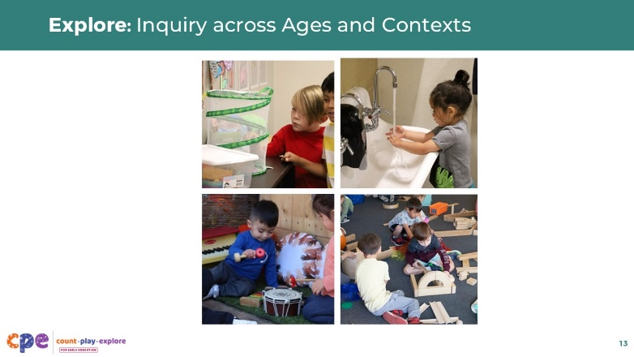
Time: 10–15 minutes (including the discussion on the next slide)
Materials: Inquiry across Ages and Contexts handout

Talking Points
- Here are a variety of cards with photos and brief vignettes featuring children across ages and across contexts engaging in inquiry.
- Choose a card that is meaningful to you. Review the vignette and photo and consider the following questions:
  - In what ways is the child demonstrating curiosity?
  - In what ways is the child investigating or experimenting?
  - What types of understandings might the child be building about different STEAM concepts and phenomena?
- Find someone at your table who chose a different card.
- Provide an overview of your card to your partner.
- Compare and contrast how the children in the two scenarios are engaging in inquiry in similar and different ways.

Facilitator Notes
- This activity is discussed on the following slide.

Slide 14: Discuss: Inquiry across Ages and Contexts
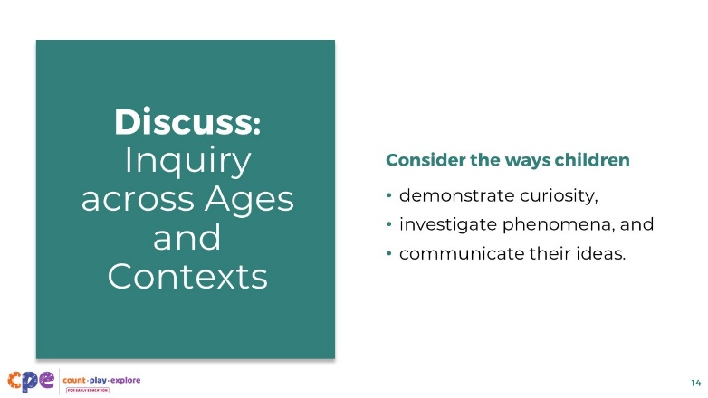
Time: 10–15 minutes (including the discussion on the previous slide)
Materials: Inquiry across Ages and Contexts handout

Talking Points
- The vignettes we just examined reflected children across different ages and contexts.
- Let’s discuss how children of different ages engage in inquiry and ways different contexts might offer opportunities for inquiry.
- [Encourage participants to respond to each point on the screen. Participants can use the photos and vignettes as examples. Use the sample answers in the Facilitator Notes to support discussion.]
- All children express curiosity or wonder. How might younger children and older children express curiosity in similar or different ways?
- All children interact with the environment to test their ideas and notice what happens. How might younger children and older children investigate in similar or different ways?
- All children communicate their thoughts and ideas. How might younger children and older children communicate their ideas in similar or different ways?

Facilitator Notes
- Here are some sample responses you might use to support a discussion.
- Express curiosity
  - Younger children might not verbally express what they are curious about. You might notice facial expressions, extended time looking at objects that inspire their curiosity, sounds of excitement (for example, the infant exploring musical instruments smiled every time he was able to create a sound).
  - Older children might demonstrate curiosity in similar ways. Some might verbalize what they are curious about by asking questions (for example, the children asked questions about butterflies and plants). Children might ask questions in different languages.
- Investigate phenomena
  - Younger children might mouth objects, bang objects together, or knock an object off a surface. Their investigations might be brief, and they will notice changes that happen immediately (for example, an infant during floor time noticed that wheels roll). Adults might highlight similarities and differences between objects. They might add language to children’s investigations and model different ways to use materials.
  - Older children might work more collaboratively. They might develop and revise plans before investigating, and they might notice more subtle changes over time (for example, the grade 2 child noticed ways the plants changed over time). Adults might offer materials that children need to test some of their ideas and budding understandings. Adults might encourage children to explain what they are doing and then challenge their theories in ways that support them to investigate more deeply.
- Communicate their ideas and understanding
  - Younger or nonverbal children may repeat their actions to show what they know (for example, the child making bubbles at the sink showed her educator how she was able to make bubbles).
  - Older children will be able to share complete thoughts through spoken language, written text, or drawings (for example, the children observing the butterflies drew pictures and engaged in discussion about what the butterflies preferred to eat).

Slide 15: Summary: What is inquiry?
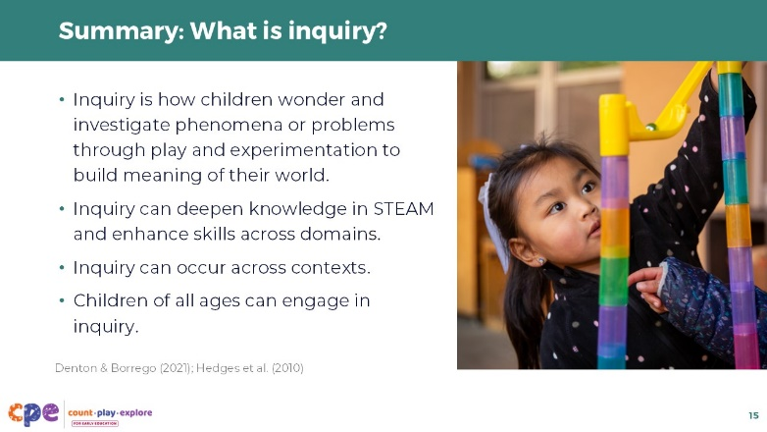

Talking Points
Let’s review some key points that we explored in the first part of our session.
- Inquiry is how people (adults and children) wonder about and investigate phenomena or problems through play and experimentation, building their understanding of the world.
- Inquiry can deepen knowledge in STEAM and enhance skills across domains.
- Inquiry can occur in different contexts, providing many diverse ways to support children as they wonder about and investigate different concepts and phenomena.
- Children of all ages can engage in inquiry in different ways, drawing on their unique funds of knowledge (Denton & Borrego, 2021, Hedges et al., 2010).

Slide 16: Building a Culture of Inquiry
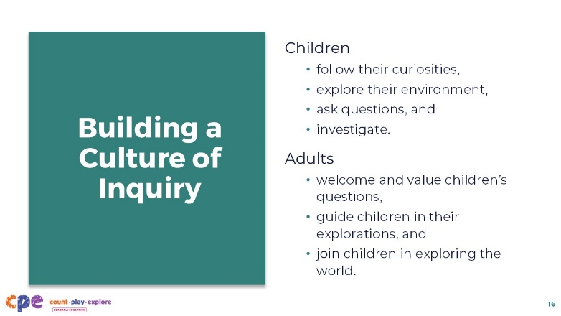

Talking Points
- We explored what inquiry is and why it is important. Now, we will consider some essential aspects of creating a culture of inquiry in our settings.
- To support inquiry-based learning, we can create an environment that encourages children to follow their curiosity, explore their environment, ask questions, learn from errors or mistakes, and engage in joyful investigations.
- Adults can further build a culture of inquiry by
  - valuing children’s questions,
  - guiding children in their explorations, and
  - joining children in exploring the world.
- Educators that embody these ideas build a culture of inquiry in their settings. They see themselves as guides and facilitators of learning, creating joyful spaces that invite children’s inquiries.
- To do this, we first need to embrace a mindset that is prepared to join children in their play and explorations.

Slide 17: Inquiry Mindsets
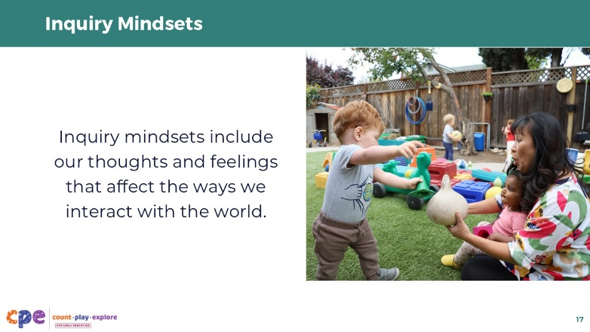

Talking Points
- Our mindsets consist of the thoughts and feelings that influence how we interact with the world.
- Having an inquiry mindset means we are curious and open.

Slide 18: Explore Inquiry Mindsets
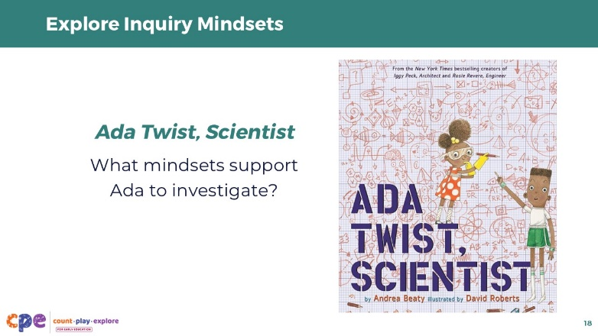
Time: 15 minutes
Materials: Inquiry Mindsets handout, the book, Ada Twist, Scientist by Andrea Beaty

Talking Points
- Let’s take some time to think about the mindsets of both children and educators that support their engagement in inquiry.
- [Use the Inquiry Mindsets handout to encourage educators to consider the mindsets that support inquiry. In this activity, you will share the book Ada Twist, Scientist by Andrea Beaty. You can read the book or have the book available for participants to read themselves. This book describes a curious child and ways her family embraces her curiosity. Participants will be encouraged to discuss the mindsets of the child and her parents.]
- [After small groups or partners discuss, use the sample responses in the facilitator notes to support a whole group discussion.]

Facilitator Notes
- Below are sample responses to the questions provided in the handout. You might use these sample responses to support a whole group discussion or facilitate small groups as they work.
- Here are some behaviors educators might notice in the story that give clues about the mindsets of the characters.
  - Ada asks many questions including why, how, what, and when; looks all around, observing; chases down sounds; tests sounds of mockingbirds; shows curiosity about the terrible stench; conducts research; makes hypotheses; experiences failure and tries again; reflects on her work; documents her questions
  - parents smile at their child’s curious thoughts; send Ada to the “thinking chair;” encourage and smile at Ada by saying, “You’ll figure it out;” help Ada sort fiction from fact
- For each behavior identified, what mindset does it demonstrate toward inquiry?
  - Ada’s questions ⇒ shows her curiosity and interest in the world.
  - Ada always observing ⇒ demonstrates her eagerness to understand phenomena around her.
  - documenting her questions ⇒ shows that Ada values her curiosity and takes her inquiries seriously.
  - parents saying, “You’ll figure it out” ⇒ reflects their confidence in Ada’s abilities, supporting her agency and independence as a learner.
- Were there any behaviors observed that might limit Ada’s excitement toward inquiry? Why do you think the adults in Ada’s life reacted the way they did? Have you ever felt this way?
  - being told “Stop!” by her parents
  - being put in time out by her parents
  - Ms. Greer being overwhelmed by Ada’s curiosity
- How might you support Ada’s curious mind in your learning setting?
  - provide her time and space to investigate
  - allow her access to resources to gather information
  - positively acknowledge her curiosity, efforts, and results
  - help her find safe and appropriate ways to answer her questions
  - become comfortable with children’s questions and curiosity
- What are ways you might change your mindset toward inquiry to better support a child like Ada?
  - being open to making changes in the schedule
  - recognizing ways to rearrange your classroom space
  - helping children understand routines and structures that allow them to engage in inquiry safely and responsibly (for example, cleaning up their materials when they finish an activity)
  - talking more with children to better understand what they are trying to figure out
- Having an inquiry mindset is similar to a beginner’s mindset—one that encourages a person to take on a fresh, open, and curious approach to a subject or experience. This mindset serves as the spark that leads to inquiry. Invite participants to consider times when they were a beginner and how they felt during those experiences.

Slide 19: M⁵ Early STEAM Approach
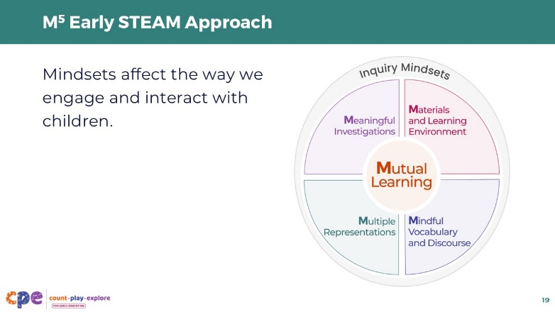
Materials: M⁵ Early STEAM Approach Overview handout

Talking Points
- Inquiry mindsets are part of a broader approach to supporting children as they engage in STEAM inquiry.
- This approach is called the M⁵ Early STEAM Approach.
- It includes five teaching practices: Mutual Learning, Meaningful Investigations, Materials and Learning Environment, Mindful Vocabulary and Discourse, and Multiple Representations.
- Today, we focused on Inquiry Mindsets. The Inquiry Mindsets approach is represented in the graphic by a circle that encompasses all the M⁵ practices because our mindsets affect the ways we engage and interact with children.
- Let’s briefly discuss the five teaching practices in the M⁵ approach and make connections to our inquiry experience with balls.
  - Mutual Learning: Learning about children’s interests, abilities, and lived experiences helps develop meaningful inquiries and provide appropriate scaffolding that is responsive to children’s strengths. Because inquiry is inspired by what children are curious about, it is important for educators to observe and respond to what interests children and what questions they ask—just as you generated your own questions based on your interests and curiosities during our investigation with balls.
  - Meaningful Investigations: Providing inquiry-based, playful experiences with different entry points allows children to actively investigate in ways that are aligned with their abilities and supports them in making sense of STEAM concepts and phenomena. These experiences encourage children to create their own questions and explore STEAM concepts and phenomena in their own ways. Consider the variety of questions you generated during our inquiry experience with balls.
  - Materials and Learning Environment: Creating an environment that includes open-ended materials, scientific tools, sufficient time, and documentation of children’s experiences and learning supports engagement in inquiry. Consider the materials you were provided today. How did these materials support your engagement in inquiry? [Encourage participants to respond.]
  - Mindful Vocabulary and Discourse: Using STEAM vocabulary and prompts supports children’s engagement in inquiry, deepens their understanding of STEAM concepts and phenomena, and strengthens their abilities to communicate their ideas and understandings. Think about the vocabulary you used during your investigation with balls, as well as the ways you communicated—through both gestures and language. You also engaged in discourse by sharing your ideas, explaining your plans, and describing your thinking processes with others.
  - Multiple Representations: Providing a variety of inquiry experiences enables children to express their understanding of STEAM concepts and phenomena in different ways. In our experience with balls today, you explored concepts related to force and motion. We might continue to explore these concepts by investigating other forces, such as the wind or the muscles in our bodies, and observing how these forces make objects move.

Facilitator Notes
- The M⁵ Early STEAM Approach is an adaptation of the M⁵ Early Math Approach. These approaches are intentionally similar to provide a consistent approach in supporting early learning across domains.
- You might provide copies of the M⁵ Early STEAM Approach Overview handout for participants to keep and reference in other sessions or use as part of their ongoing professional learning.
- Adjust talking points on this slide if you choose to engage participants with the handout in an active way. Consider the following approach:
  - Invite participants to add examples of ways they experienced the M⁵ Early STEAM Approach in their investigation with balls earlier in the session. They can add notes to the handout and discuss with small groups or in a whole group setting.

Slide 20: Write a Letter
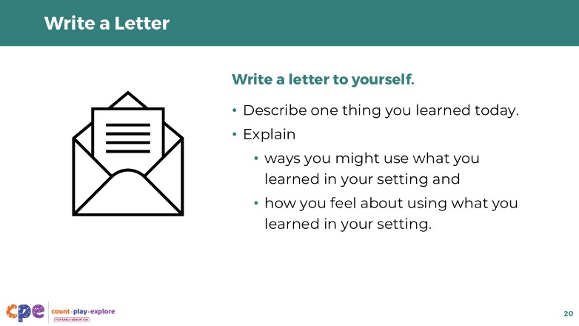
Time: 10 minutes

Talking Points
- As we close our session today, we invite you to reflect on your experiences and what you might have learned.
- Write a letter to yourself. Include the following in your letter:
  - Describe one thing that you learned today.
  - Explain ways you might use what you learned in your setting.
  - Include some of your thoughts and feelings—your mindset—about what you learned. For example, you might be excited to engage in inquiry with the children in your setting or you might be feeling cautious about engaging in inquiry.
- [Invite participants to share with a partner. Encourage a few volunteers to share with the larger group after they have discussed in pairs.]

Slide 21: Apply to Your Setting
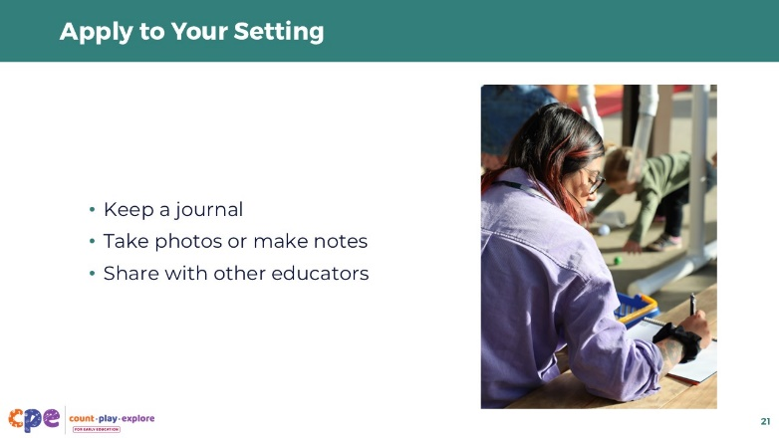

Talking Points
- Thank you for sharing your experiences today and your plans for building a culture of inquiry in your setting.
- Here are some additional ways you might apply what we have learned today to your setting over time:
  - Keep a journal describing the concepts and phenomena that spark children’s curiosity.
  - Take photos or make notes to capture children’s curiosities over time and record how you support children in their explorations.
  - Share the inquiries you have been exploring in your setting with other educators.

Facilitator Notes
- Provide ongoing support for participants after this session by offering opportunities to learn how others are engaging in inquiry with children. You might create a shared Google Document or create a Padlet as a digital space to share images and stories.
- Facilitate a community of practice where participants can share how they are engaging in inquiry in their learning settings.

Slide 22: Thank you!


Talking Points
- Thank you all for your time and attention today.
- Let’s remember that building a culture of inquiry is not something that happens in one day. It is a process we can work on daily.

