STEAM Identity and Sense of Belonging
Use this facilitator guide with the slides “STEAM Identity and Sense of Belonging.” Facilitators can find talking points and guidance for activities and group discussions in this guide. The same text is also located in the notes portion of the slides. Adapt this facilitator guide based on your group size, session length and format, and participants’ needs.

Session At-a-Glance
Slide numbers | Overview of content | Approximate time (in minutes)
1-4 | Introduction and Session Goals | 5-10
5-15 | Exploring feelings, experiences, and identities related to STEAM  - Adult activity: Shadow Puppet Play  - Adult activity: Imagine a STEAM Educator | 40-60
16-22 | Examining biases and stereotypes in STEAM | 15-20
23-26 | Exploring STEAM in our lives and learning settings  - Adult activity: STEAM in My Life | 25-35
27-28 | Reflection | 10
The times are approximate and may vary based on session goals, group size, and participants’ previous experience and familiarity with the content.

To Prepare for Your Session
This session focuses on supporting educators’ sense of identity and feelings of belonging in STEAM. Find opportunities within this session to share about your own journey with STEAM. Modeling this type of vulnerability can help participants feel more connected to you and comfortable sharing their own experiences.
Consider using photos, videos, or stories from the learning settings where educators work within this session. Making the information more personal for participants can create a greater connection to the content and foster feelings of belonging in STEAM.

Materials Needed
- Feelings about Science activity: Emoji cards, other optional materials including tape, chart paper, string, painter’s tape
- Shadow Puppet Play handout, paper, scissors, tape, colored transparent sheets, permanent markers, light sources (ensure they are bright enough to cast clear shadows in your space), craft sticks
- Imagine a Science Educator handout, drawing materials
- STEAM in My Life handout

SLIDE 1: STEAM Identity and Sense of Belonging
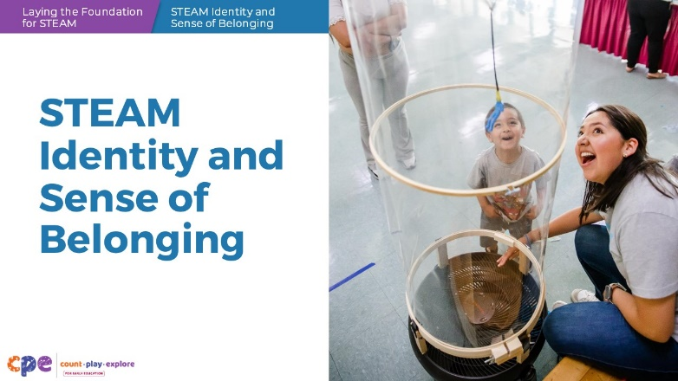

Talking Points
- In this session, we will explore your personal identities and feelings of belonging as STEAM learners and educators. By STEAM, we refer to Science, Technology, Engineering, Arts, and Mathematics.

Facilitator Notes
- Adjust talking points to reflect your session length and participant needs. If necessary, add introductory and “housekeeping” information.

SLIDE 2: Feelings About Science
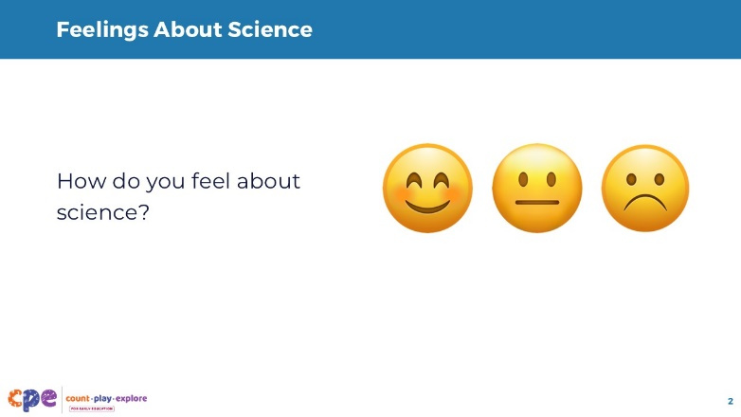
Materials: Emoji cards; other optional materials include tape, chart paper, string, painter’s tape
Time: 5 minutes

Talking Points
- As you get settled, consider how you feel about science. Select an emoji card from the table that reflects the way you feel about science.
- Then, add it to the chart in the column above the respective emoji card to create a bar graph. [See facilitator notes for information about ways to create a bar graph.]
- This data gives us an idea about how you feel about science. We will discuss these feelings with others later in our session.

Facilitator Notes
- Make emoji cards by printing the emoji images from this slide or create your own. You might also use sticky notes instead of emoji cards.
- Create a large bar graph on the wall or on a sheet of chart paper to represent the different ways educators feel about supporting science learning.
- Draw a line or use a piece of yarn or painter’s tape to create a horizontal axis. Place the three different emoji cards below the line to create three categories.
- Invite participants to tape their emoji card of choice on the chart in the respective column (for example, if a participant selected a happy emoji card, they would place their card above the horizontal axis of the chart in the “happy” emoji card column).
- Encourage participants to place one emoji card above the other, creating a bar graph.
- Instead of using physical cards, you might use a digital platform (for example, Slido®, Vevox®, Mentimeter®, and StreamAlive™) to encourage participants to share their feelings about science. You might use emojis or encourage participants to provide a word that represents their feelings.
- Consider sharing your own feelings about science. Being vulnerable and open with your feelings and experiences is a way to model a growth mindset.
- Math and science mindsets matter! This principle is key to the Count Play Explore approach to professional learning.
- This activity will be discussed further on slide 6.

SLIDE 3: Acknowledgments
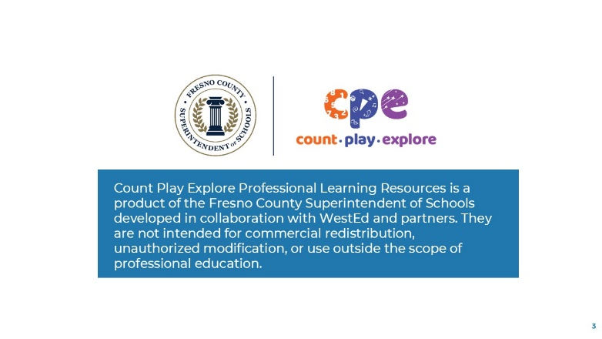

Talking Points
- The Count Play Explore Professional Learning Resources were made possible by Count Play Explore, an early math, science, and computer science initiative led by the Fresno County Superintendent of Schools, Early Care and Education Department. This initiative is generously funded by the California Department of Education and the California State Board of Education.
- These resources, developed in collaboration by WestEd and partners, are intended to be used as a guide for implementing evidence-based strategies, promoting active learning, and encouraging developmentally appropriate practices in early education settings. They are not intended for commercial redistribution, unauthorized modification, or use outside the scope of professional education.

SLIDE 4: Session Goals
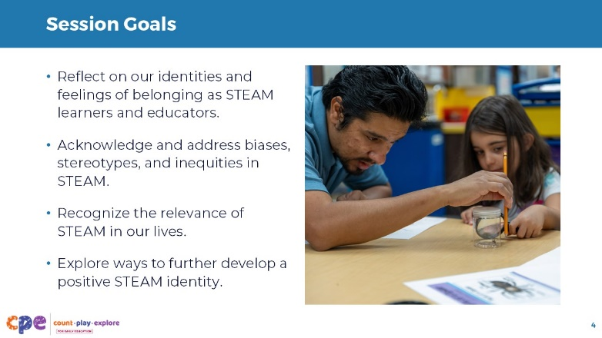

Talking Points
- In this session, we will
- reflect on our identities and feelings of belonging as STEAM learners and educators;
- acknowledge and address biases, stereotypes, and inequities in STEAM;
- recognize the relevance of STEAM in our lives; and
- explore ways to further develop a positive STEAM identity.

SLIDE 5: What is STEAM?
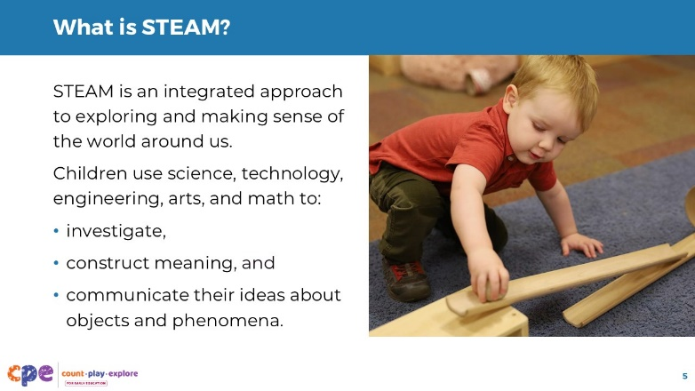

Talking Points
- STEAM is an integrated approach to exploring and making sense of the world around us. In STEAM learning experiences, children use science (including life, physical, earth and space science), technology (including computer science), engineering, arts (including painting, sculpting, drama, and music), and math to investigate, construct meaning, and communicate their ideas about objects and phenomena. By “phenomena,” we mean observable events that involve STEAM, such as a seed sprouting, paint mixing to form a new color, or a ball rolling into a block structure, causing it to topple over.
- In our session today, we may use the terms science or STEAM. For some parts of our session, it might feel more comfortable to consider science because it is a term we might be more familiar with when reflecting on specific experiences in one domain or context.
- Later in our session, we will participate in a STEAM activity that will help you notice how science, technology, engineering, arts, and math can work together.

SLIDE 6: How do you feel about science?
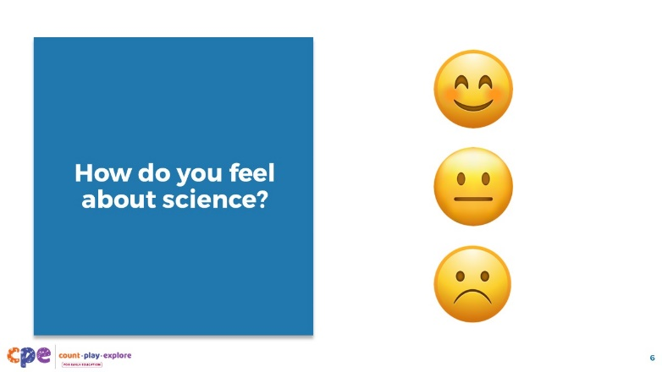
Time: 5-10 minutes

Talking Points
- Let’s share more about our feelings related to science.
- With your table group, explain which emoji card you selected earlier in the session and explain why you selected it.
- You might identify a specific event or two that has influenced this feeling and why it had such a big influence.
- I’ll go first. [Share which emoji card you selected and why you selected it.]
- [See the facilitator notes for suggestions on ways to facilitate a discussion.]
- Thank you for sharing your feelings about supporting science in your learning setting.

Facilitator Notes
- For shorter sessions, invite a few volunteers to share with the larger group about their feelings and the emoji cards they chose. For example, “Tell us about the emoji card you chose. Why did you choose that card?”
- For longer sessions, invite educators to share in small groups their feelings and the emoji cards they chose. For example, “Share which emoji card you chose and why you chose that card.” You might invite a few volunteers to share with the larger group.

SLIDE 7: Experiences as a Science Learner and Educator
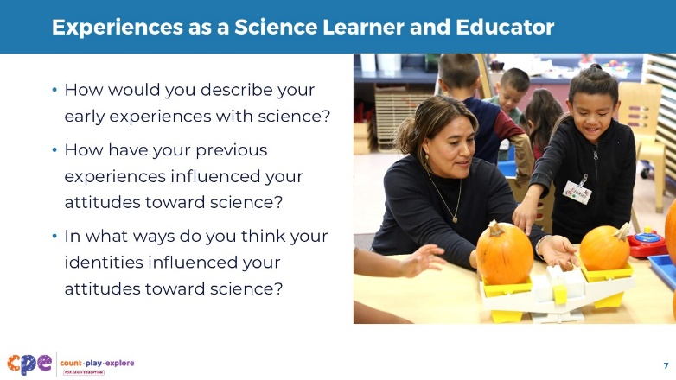
Time: 5 minutes

Talking Points
- Now, let’s consider your early experiences with science when you were a young science learner.
- How would you describe your early experiences with science? This could include experiences in school, home, or your community.
- How have your previous experiences influenced your attitudes toward science?
- In what ways do you think your identities influenced your attitudes toward science? By identity, we mean your personal concept of who you are, such as your cultural background, gender, personal experiences, professional role, or years of experience in your role.
- Turn and talk to someone at your table. Share your experiences when you were a young science learner. Discuss the ways your previous experiences, attitudes, and identity might affect your experiences and practices as educators.
- [Provide time for participants to discuss.]
- [Encourage a few volunteers to share with the larger group.]
- Think about how some of your own experiences might be similar to or different from those of children in your learning setting. Considering your own STEAM identity is important when you try to make a positive difference in children’s own sense of identity and feelings of belonging in STEAM.

SLIDE 8: Your Thoughts and Feelings Matter
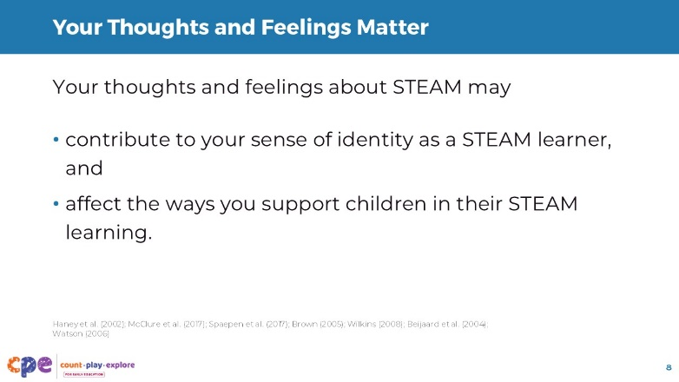

Talking Points
- It is important to consider our thoughts and feelings about science as well as our thoughts and feelings about technology, engineering, the arts, and math.
- Your personal and professional thoughts, feelings, and experiences with STEAM contribute to your sense of identity as a STEAM learner and educator (Beijaard et al., 2004; Watson, 2006).
- Your thoughts and feelings about STEAM can also affect the ways you support children in their STEAM learning and children’s sense of identity and belonging in STEAM (Haney et al., 2002; McClure et al., 2017; Spaepen et al., 2017; Brown, 2005; Wilkins, 2008).
- For example, educators who have positive thoughts and feelings toward science provide more science learning opportunities for children in their learning settings, provide more hands-on experiences, and engage in more inquiry-based learning with children (Haney et al., 2002; McClure et al., 2017; Spaepen et al., 2017; Todd Brown, 2005; Wilkins, 2008).

SLIDE 9: Identity and Sense of Belonging
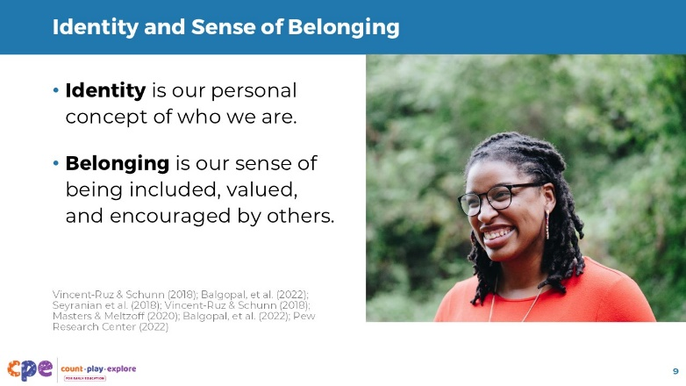

Talking Points
- What do we mean when we say STEAM identity and sense of belonging?
- Identity is our personal concept of who we are and whether we think we are a STEAM person.
- Our identities are complex and might change over time. They might include the different roles we play. For example, I am a parent, I am an educator, and I am a photographer. Our identities might also include our race, ethnicity, cultures, characteristics and personality traits. For example, I am organized, I am creative, I am calm (Vincent-Ruz & Schunn, 2018). [Include examples of your own culture, race, or ethnicity as an authentic example of your identity.]
- STEAM identity is how a person views themselves in terms of being someone who engages in STEAM—as a mathematician, scientist, artist, engineer, or computer programmer (Seyranian et al., 2018; Vincent-Ruz & Schunn, 2018). As STEAM educators, we are people who support others to learn STEAM concepts.
- Much of our identity is shaped by a collection of our experiences and belief in our abilities (Masters & Meltzoff, 2020). If we do something often and gain confidence in our abilities, it might become part of how we define ourselves.
- Consider your experiences supporting children in science or STEAM experiences. Is this something you do often? Do you believe in your abilities to support children to engage in STEAM? Consider how your experiences and opportunities to support science or STEAM learning might affect your identity as a STEAM educator.
- [Pause to allow time for educators to reflect. You might invite volunteers to share or encourage small group discussions.]
- Belonging is our sense of being included, valued, and encouraged by others to participate in STEAM (Balgopal et al., 2022).
- Consider the groups you feel a part of and accepted in. This may include your professional peers, a volunteer organization, or a hobby. What groups or spaces do you feel that you belong and what makes you feel this way?
- [Pause to allow time for educators to reflect. You might invite volunteers to share or encourage small group discussions.]
- Our identity and sense of belonging in STEAM can also be affected by our access to quality STEAM education and feeling connected to a role model in STEAM (Pew Research Center, 2022).
- Consider your learning setting. Are there others in your learning setting that value your contributions as a science or STEAM educator? Do you have peers that might support you in exploring and developing as a STEAM learner and educator? Consider what role models or professional support you might, or might not, have access to that can bolster your feelings of belonging as a STEAM educator.
- In our session today, we are part of such a community. We will explore ways that science and STEAM are relevant to our lives and discover ways that we each belong in STEAM.

SLIDE 10: Play: Shadow Puppets
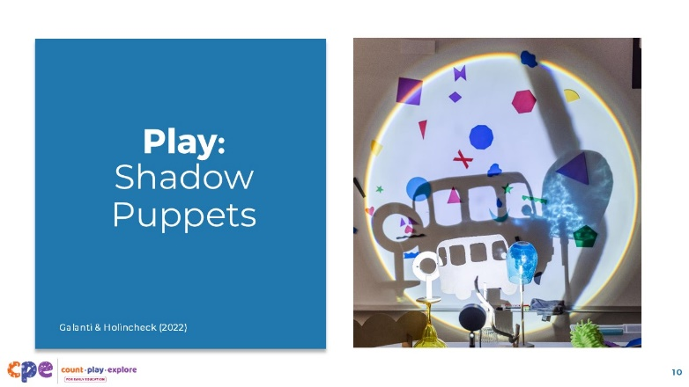
Time: 30 minutes (including the discussion on the following slide)
Materials: Shadow Puppet Play handout, paper, scissors, tape, colored transparent sheets, permanent markers, lights source (ensure they are bright enough to cast clear shadows in your space), craft sticks

Talking Points
- Being a STEAM learner is a part of our identities as STEAM educators (Galanti & Holincheck, 2022).
- Let’s take some time to experience being a STEAM learner through a playful activity.
- In small groups, use the “Shadow Puppet Play” handout to guide you through an exploration of light and shadows. You will have about 15 minutes to
- explore ways to change the shape, size, and color of shadows; and
- create a play to showcase what you have learned.
- When we are finished exploring and creating, we will share some of our plays with others.
- [Use the Shadow Puppet Play handout to prepare for and facilitate this activity. You might use additional prompts in the Facilitator Notes to support engagement.]

Facilitator Notes
- Organize participants into groups of 3-4.
- Review the handout with participants before they begin working in their teams.
- As participants explore materials, circulate around the room to provide support and prompt thinking. For example:
- How can you change the shape or color of the shadow?
- What might happen if you move the light instead of the puppet?
- I notice you … Tell me more about that.
- As you move around the room, notice ways participants are engaging with the materials. Consider making notes about what participants say and do related to
- ways to make the shadows change,
- planning their play and ways to make the shadows change, and
- experimenting with ways to make the shadows change.
- You might revisit these examples during your discussion.
- Consider explaining to participants that the way you scaffolded their engagement is similar to ways they might scaffold children’s engagement in similar experiences.
- After participants explore and create their play, invite a few groups to share their plays.
- For shorter sessions, invite pairs of groups to share their plays with each other.
- For longer sessions, invite each group to share their plays with the larger group.

SLIDE 11: Discuss: Being a STEAM Learner
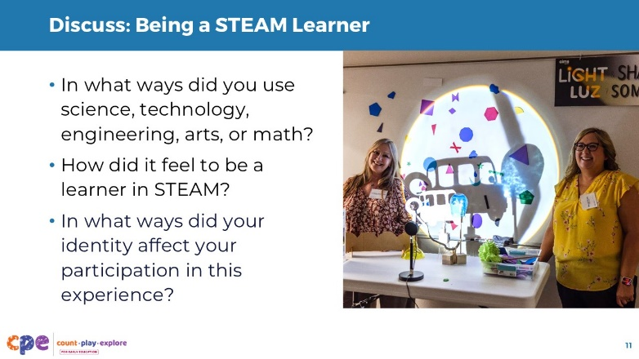
Time: 30 minutes (including the activity on the previous slide)
Materials: Shadow Puppet Play handout

Talking Points
- [Select a facilitation strategy and review the Facilitator Notes to support a discussion. Adapt talking points as needed.]
- In what ways did you use science, technology, engineering, arts, or math?
- How did it feel to be a learner in STEAM?
- In what ways did aspects of your identity (for example, your culture, language, or interests) affect your participation in this experience?
- [Provide time for participants to share.]
- Thank you for sharing your experiences as STEAM learners.
- We all have the capacity to continue learning and exploring STEAM concepts.
- STEAM experiences can be powerful because they allow us to use many different skills, enabling each of us to contribute in meaningful ways and develop our identities and sense of belonging in STEAM.

Facilitator Notes
- For shorter sessions, encourage a few volunteers to share with the larger group.
- For longer sessions, encourage small groups or partners to discuss the reflection questions. You might invite a few volunteers to share with the larger group following their small group discussion.
- Use the notes below to support discussions:
- In what ways did you use science, technology, engineering, arts, or math?
  - We used science to explore how to change the shadows. We noticed that changing the distance between the puppet, the wall, and the light source caused changes in the size of the shadow. We also used science terms such as translucent, transparent, and opaque.
  - Technology was represented by the light source. It was interesting to think about how it works and explore ways to adjust the light.
  - We used the arts as we created our play. We had to think creatively about how to communicate and demonstrate what we learned about shadows. We also used the arts to create our puppets.
  - We used math when considering size, distance, and shape.
- How did it feel to be a learner in STEAM?
  - It felt good to be able to do science through art. I am more comfortable with arts.
  - It was nice to be able to use science to do art. I am more comfortable working with science concepts than creative art tasks.
  - Creating my own story allowed me to use science (changing the shadows) in a way that connected with my culture.

SLIDE 12: Who is a science educator?
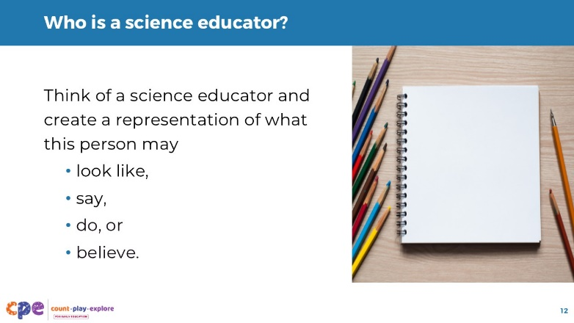
Time: 10 minutes
Materials: Imagine a Science Educator handout, drawing materials

Talking Points
- Now we will explore more about our thoughts and attitudes toward STEAM in early childhood. We will think about the identity of science educators.
- Take out the Imagine a Science Educator handout.
- [Support participants to review the handout and engage in the activity.]

Facilitator Notes
- Provide about 5 minutes for participants to create a representation of a science educator. Then, encourage participants to share and explain their representations to a partner.
- For shorter sessions, invite a few participants to share their representations with the larger group, reminding them there is no right or wrong response to this activity.
- For longer sessions, you might encourage partners to discuss with their smaller group. Then, invite a few volunteers to share with the larger group.
- This experience focuses on science educators. You might adapt this activity to encourage participants to create representations of educators who support math, computer science, the arts, or technology.

SLIDE 13: Reflect: My Identity as a STEAM Educator
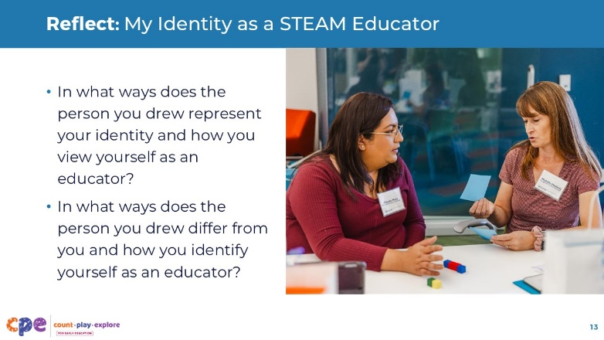
Time: 5 minutes

Talking Points
- Let’s think more deeply about our representations of science educators.
- In what ways does the person you drew represent your identity and how you view yourself as an educator?
- In what ways does the person you drew differ from you and how you identify yourself?
- Consider why there are differences or similarities between yourself and the way you represented a science educator.
- [Provide time for participants to reflect. Invite participants to make notes on ways they are similar to or different from their drawing.]
- [Encourage a few volunteers to share with the larger group.]

SLIDE 14: Identities Evolve and Change
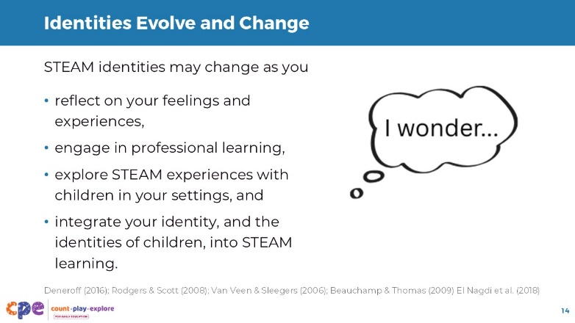

Talking Points
- There are many ways to be a science educator. Some of you may have connected closely to your representation. Others may feel disconnected from your representation.
- Unfortunately, many early childhood educators do not feel prepared to support science or STEAM learning (Corp et al., 2020; Shernoff et al., 2017), and many do not see themselves as STEAM educators (Karaolis & Philippou, 2019).
- What is exciting, however, is that educators’ identities are dynamic—they change over time as a result of changes in feelings and experiences (Deneroff, 2016; Rodgers & Scott, 2008; Van Veen & Sleegers, 2006).
- STEAM educators’ identity development is an ongoing process aided by
- reflecting on your own thoughts, feelings, and experiences (Beauchamp & Thomas, 2009);
- engaging in professional learning;
- exploring STEAM experiences with the children in your learning settings (El Nagdi et al., 2018); and
- intentionally integrating your identity—home language, cultural practices, and lived experiences—and the identity of the children in you setting into STEAM learning.

SLIDE 15: Being a STEAM Educator
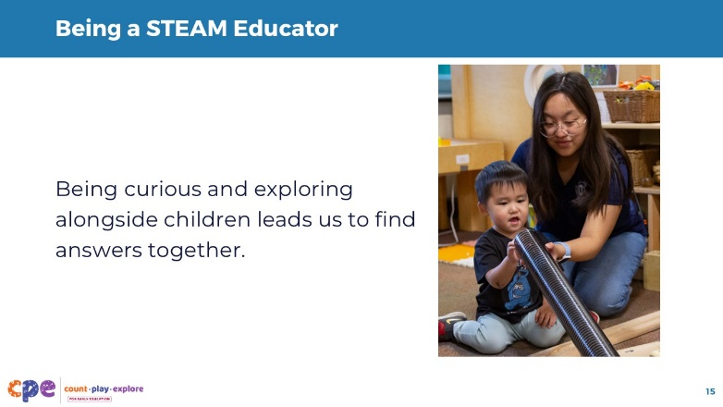

Talking Points
- We have explored our identities as STEAM learners and educators through reflection and discussion about our thoughts, feelings, and experiences with science and STEAM.
- As you consider your representation of what a science educator should be, remember that there are many ways to be an early STEAM educator.
- In early education, a good STEAM educator is curious about the world, asks questions, and explores alongside children. You do not have to know everything about STEAM. You can serve as a role model for children of what it means to participate and belong in STEAM.
- For those who might have felt disconnected from your representation of what a science educator should be, we invite you to allow your representation to transform into a representation of who you are, and can be, as a STEAM educator.
- For those who felt connected with their representation, we invite you to further build on these ideas and integrate more of yourself into your role as a STEAM educator.

SLIDE 16: Who belongs in STEAM?
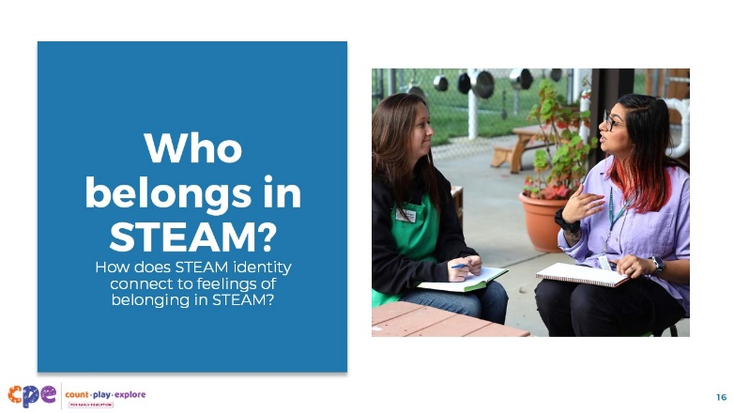

Talking Points
- Now, we will take some time to consider thoughts and beliefs about who belongs in STEAM.
- Let’s think about where feelings of belonging might stem from.
- How does STEAM identity connect to feelings of belonging in STEAM? In what ways might they influence each other?
- [Encourage small groups to share. Then, invite a few volunteers to share with the larger group.]
- Thank you for sharing some ideas about ways identity connects to feelings of belonging.
- When children or educators see their cultural, personal, or community identities affirmed in STEAM spaces, they are more likely to feel that they belong there.
- At the same time, a strong sense of belonging in STEAM can reinforce and expand one’s STEAM identity—strengthening the confidence to persist, contribute, and innovate.

SLIDE 17: Biases and Stereotypes
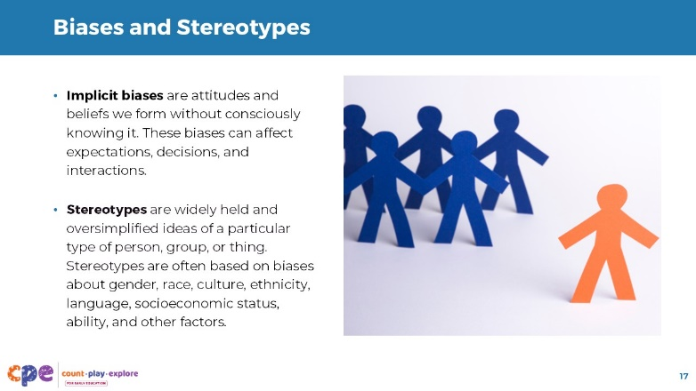

Talking Points
- As we discussed, our personal experiences contribute to our thoughts and feelings about STEAM.
- Access to resources, role models that connect with you, opportunities as well as biases and stereotypes can also affect our sense of identity and feelings of belonging in STEAM.
- Implicit biases are attitudes and beliefs we form without consciously knowing it. These biases can affect expectations, decisions, and interactions with children in our learning settings as we provide STEAM opportunities. They can also lead to behaviors that reinforce stereotypes.
- Stereotypes are widely held and oversimplified ideas of a particular type of person, group, or thing. Stereotypes are often based on biases about gender, race, culture, ethnicity, language, socioeconomic status, ability, and other factors. Stereotypes can influence our feelings and thoughts about STEAM throughout life.

SLIDE 18: Math Myths
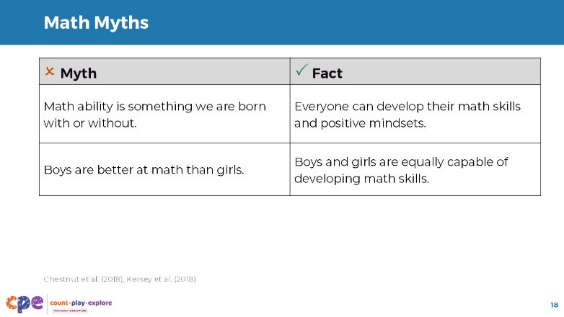

Talking Points
- Stereotypes can influence our feelings and thoughts about science and math throughout life. This can lead to myths about who can be a math and science learner and how individuals participate in math and science. For example:
- It is a myth that math ability is something we are born with or without. The fact is that everyone can develop their math skills and positive mindsets (Chestnut et al., 2018).
- Another myth is that boys are better at math than girls. However, boys and girls are equally capable of developing math skills (Kersey et al., 2018).

Facilitator Notes
- You might engage participants in this slide and the slide that follows in different ways. For example:
  - You might ask participants to respond to the myths before showing them the facts. Add animation to these slides to hide the “facts” from participants to allow them to respond first before revealing the “facts.”
  - Encourage participants to read the slide on their own and then reflect on what they read.

SLIDE 19: Science Myths
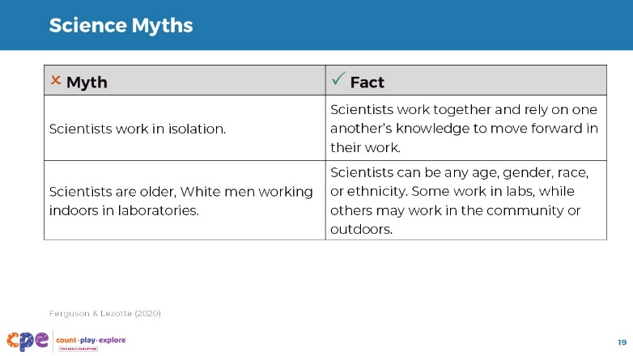

Talking Points
- Stereotypes also contribute to myths about science. For example:
  - It is a myth that scientists work in isolation. Science is a collaborative process. Many scientists work with others and build on each other’s knowledge and skills to move forward in their work.
  - It is also a myth that scientists are primarily older, White men in lab coats, working indoors (Ferguson & Lezotte, 2020). Scientists can be any gender, race, or ethnicity. Some scientists work in labs, but many work in the community or outdoors. For example, scientists can be biologists, computer scientists, zoologists, or astronomers.
- Just as scientists can be diverse, so can science educators. Think about your drawings of science educators. The drawings you created were very different and showed many ways a science educator might look and interact with children.

Facilitator Notes
- You might encourage participants to consider how their representations of science educators did or did not reflect myths about who is or is not a science educator.

SLIDE 20: Biases and Stereotypes Affect Participation in STEAM
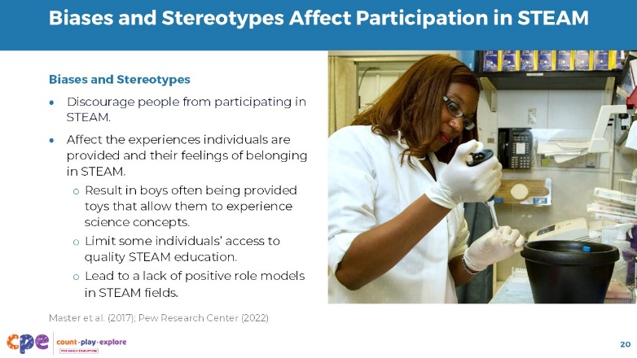

Talking Points
- Although stereotypes are not based in facts, the belief in stereotypes might discourage women and people of color from participating in STEAM (Master et al., 2017; Pew Research Center, 2022).
- Biases and stereotypes can also affect the opportunities and resources provided to women and people of color. This can also affect feelings of belonging.
  - Consider the difference in toys offered to boys and girls at a very young age. Boys are often provided with toys that allow them to experience science concepts. For example, think about how rolling a toy car, throwing a basketball, or building with blocks might provide opportunities to think about science concepts like cause and effect, forces and how things move, and early engineering. Many toys for girls do not provide similar opportunities.
  - Some schools might limit children’s access to STEAM opportunities due to funding or a focus on standardized testing. This creates inequity in some children’s opportunities to develop as STEAM learners.
  - Individuals might also be affected by stereotypes and bias through the presence of STEAM role models. Many people are unable to connect with a STEAM role model who looks like them or shares their cultural background.

SLIDE 21: Biases and Stereotypes Affect Participation in STEAM (continued)
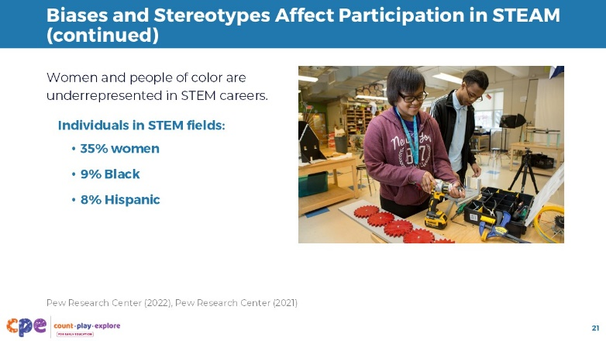

Talking Points
- We can notice the effects of stereotypes and biases when examining the workforce. For example, women and people of color are underrepresented in science, technology, engineering, and mathematics-based jobs (Pew Research Center, 2021):
  - 35% are women
  - 9% are Black
  - 8% are Hispanic

SLIDE 22: Reflect: Stereotypes and My Experiences
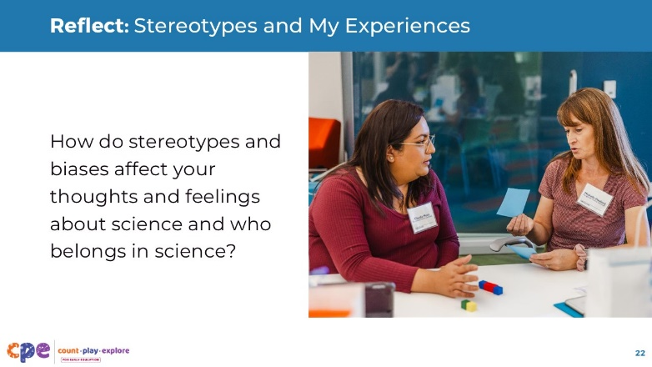
Time: 5 minutes

Talking Points
- Let’s take a moment to pause and reflect.
- We have considered our previous experiences with and feelings about STEAM.
- We have also examined some stereotypes and biases about who belongs in STEAM.
- Take a moment to consider how stereotypes and biases affect your thoughts and feelings about STEAM and who belongs in STEAM.
- [You might invite volunteers to share. Alternatively, given the sensitive nature of this topic, participants might choose to sit with their thoughts privately or with a partner.]
- Acknowledging the role of stereotypes and biases in shaping our sense of identity as a STEAM learner and educator is important. When we recognize where our thoughts and feelings are coming from, we can make active efforts to change them.
- Instead of holding onto stereotypes or past experiences, we can begin to develop a new image of what it means to be a STEAM learner and educator—an image that includes ourselves as capable and competent in STEAM.
- Our ability to acknowledge and address biases and confront stereotypes can support children’s identity and sense of belonging in STEAM.
- Take 30 seconds to think through one active step you can take to address stereotypes and biases in your life or in your learning setting regarding STEAM.

SLIDE 23: STEAM is Everywhere and is for Everyone
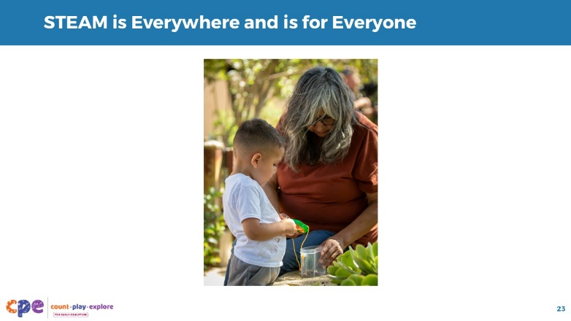

Talking Points
- Exploring our thoughts and feelings about science and acknowledging stereotypes and biases are some ways we can develop our identities as STEAM educators.
- Another way to develop our identities and feelings of belonging in STEAM is by recognizing the relevance and importance of STEAM in our lives (Hazari et al., 2010).
- During this part of our session, we will think about ways STEAM relates to our identities, is a part of our routines and daily experiences, and is happening within our interactions with children.

SLIDE 24: STEAM in My Life
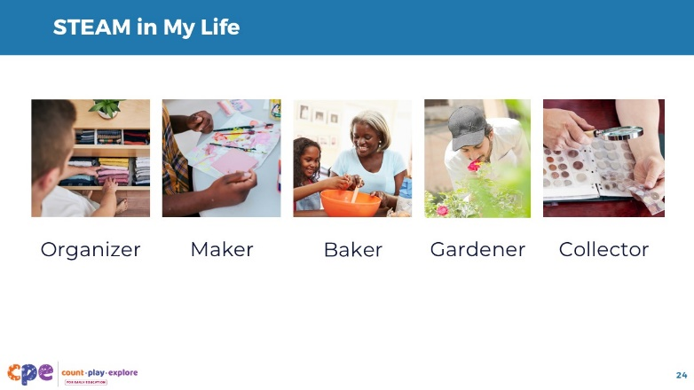
Time: 15 minutes
Materials: STEAM in My Life handout

Talking Points
- Our cultures, lived experiences, and interests provide spaces for us to find ways that we engage in STEAM and develop our identity as STEAM learners and educators.
- Let’s consider some aspects of our personal identities.
- [Review the “STEAM in My Life” handout with participants.]
- [Move around the room to support participant engagement as needed.]
- STEAM phenomena are happening all around us in our lives in different ways.
- Noticing opportunities to explore and wonder about STEAM concepts and phenomena can help us develop our identities as STEAM learners and educators.

Slide 25: STEAM in Your Life
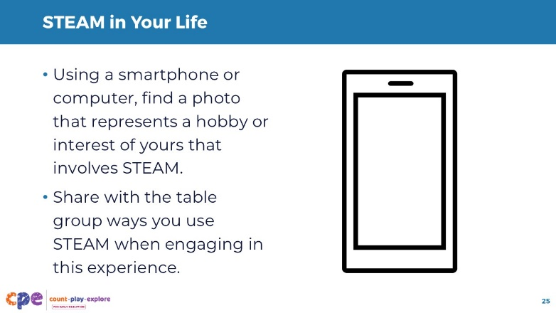
Time: 10 minutes

Talking Points
- Let’s explore more about ways we experience STEAM in our lives.
- Using a smartphone or computer, find a photo that represents a hobby or interest of yours that involves STEAM.
- Share with the table group ways you use STEAM when engaging in this experience.
- [Encourage participants to share and discuss in their table groups. If participants do not have access to a smartphone or computer, you can ask them to share their interest without including a photo.]
- Thank you for sharing different parts of your identity. These are just a few ways that parts of your identity relate to STEAM.
- We all come from cultures and communities with many different types of STEAM professionals and cultural traditions. Some of these might be trade workers and artisans—not your “traditional” scientist or engineer. Part of developing our identities and feelings of belonging in STEAM can involve reconnecting with and identifying those people in our families and communities who have been practicing STEAM (for example, weavers, musicians, and woodworkers) without the label of STEAM.

SLIDE 26: STEAM in My Learning Setting
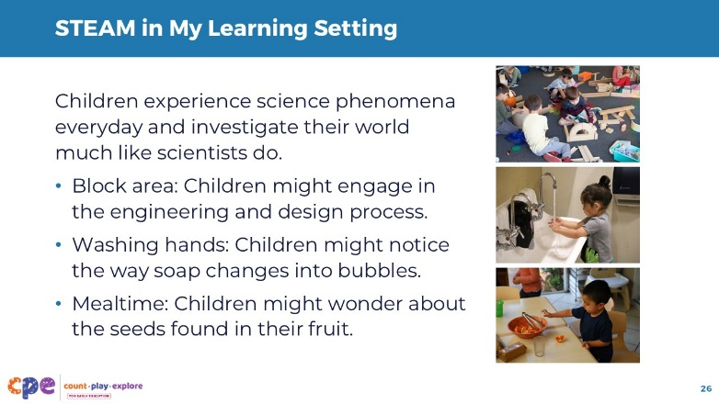

Talking Points
- Just like STEAM opportunities are present in your daily lives outside of the learning setting, STEAM opportunities are also all around us within our learning settings. In fact, just like scientists, children are curious and learn about the world through interactions with objects and materials. For example,
  - Children might use engineering and design principles as they identify problems, construct solutions, and test their designs while building in the block center.
  - During hand washing, children might experience cause and effect as they notice the way friction and water cause soap to make suds and bubbles.
  - At mealtime, children might think about life science as they find seeds in an orange slice. They might wonder about what the seeds do and start collecting seeds from different foods.
- STEAM is a part of our day inside our learning settings and outside of them too!
- When you return to your learning setting, identify when children are engaging in STEAM during daily routines and planned experiences. This can help support children’s feelings of belonging and sense of identity in STEAM.

Facilitator Notes
- Consider inviting participants to identify and share opportunities for STEAM learning in their settings.

SLIDE 27: Developing My Identity and Sense of Belonging in STEAM
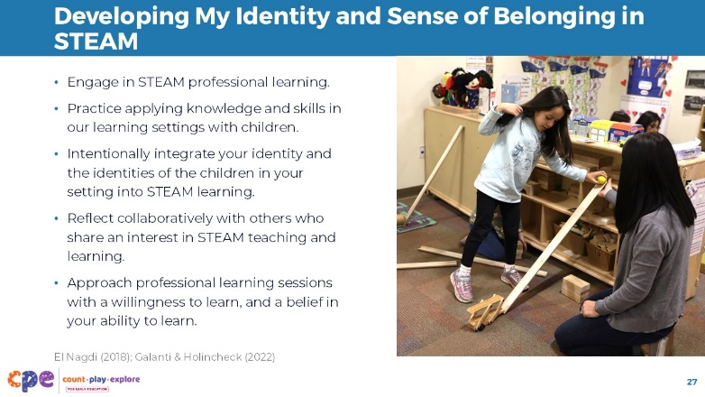
This slide contains animation. See instructions in the Talking Points.

Talking Points
- We started this session by considering how we feel about being a STEAM learner and educator.
- We also explored ways STEAM is already a part of our lives.
- Many of us are in different places along the journey of developing our identities and feelings of belonging as STEAM educators. What are some ways you think you can develop your identity and sense of belonging as a STEAM educator?
- [Encourage volunteers to share with the larger group.]
- [Click]To further develop our identities and feelings of belonging as STEAM educators, we can
  - actively seek out and engage in STEAM professional learning (El Nagdi, 2018);
  - practice applying what is learned to our learning settings with children (El Nagdi, 2018);
  - intentionally integrate your identity—home language, cultural practices, and lived experiences—and the identities of the children in your setting into STEAM learning;
  - reflect collaboratively with others who share an interest in STEAM teaching and learning (Galanti & Holincheck, 2022); and
  - approach professional learning sessions with a willingness to learn, and a belief in our ability to learn (Galanti & Holincheck, 2022).

SLIDE 28: I Am a STEAM Learner and Educator
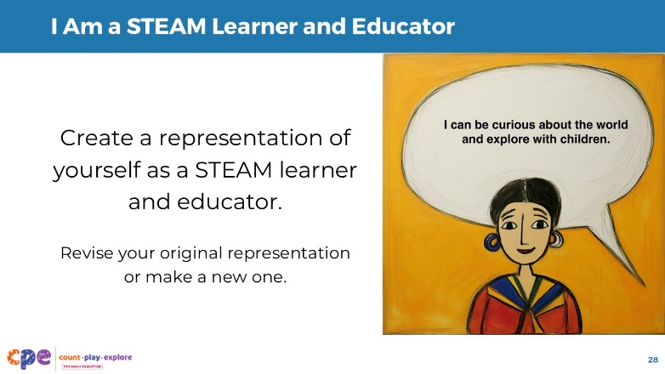
Time: 15 minutes
Materials: Paper, drawing materials (for example, crayons, colored pencils, markers)

Talking Points
- We will close our session today by reimagining ourselves as the STEAM learner and educator that we are or want to be.
- Draw yourself as a STEAM educator. You might revise your earlier drawing of a science educator or create a new one.
- You may add symbols or objects to identify aspects you want to highlight or feel are your strengths.
- Then, consider ways to describe yourself as a STEAM learner and educator.
- Finally, add a dialogue bubble to your drawing that says, “I can …” to plan for ways to further build your identity and sense of belonging as a STEAM learner and educator. For example, I can
  - practice engaging in STEAM in my learning settings, and
  - find support with peers to discuss ways we are supporting children in STEAM experiences.
- [Provide time for participants to draw themselves as STEAM learners and educators.]
- Let’s think more about our representations. Consider the following questions:
  - How is your representation similar to or different from your original representation?
  - How does your new representation reflect what you learned about developing your STEAM identity and sense of belonging?
  - What is one change you can make tomorrow with the children in your setting to support the development of your own identity as well as the children’s STEAM identities and sense of belonging?
- [You might encourage participants to share with a partner or invite a few volunteers to share with the larger group.]
- Thank you for exploring your STEAM identities and sense of belonging with all of us today.

