Introduction to Addition and Subtraction:
Birth–8 Years (PPT 1)
Use this facilitator guide with the slides “Introduction to Addition and Subtraction: Birth–8 Years.” This set of slides provides an overview of the development of key concepts and skills in addition and subtraction for children from birth to eight years old. When planning a professional learning session on addition and subtraction, facilitators can use these slides as an introduction or in combination with the age-specific slide decks. Facilitators can find talking points and guidance for activities and group discussions in this guide. The text in the guide is also located in the notes portion of the slides. Adapt this facilitator guide based on your group size, session length and format, and participants’ needs.

Session At-a-Glance
Slide numbers | Overview of content | Approximate time (in minutes)
1-3 | Introduction & session goals | 5
4-9 | True or False game | 10
10-30 | Overview of how children develop an understanding of addition and subtraction:  - Video observation  - Adding makes more and taking away makes less  - Number composition and decomposition  - Properties of addition and subtraction | 25-35
31-38 | Overview of how children solve addition and subtraction problems:  - Counting strategies  - Using composition, decomposition, and the properties of addition and subtraction  - Building on known facts  - How addition and subtraction problems advance over time  - Video observation | 15-20
39 | Closing reflection | 5-10
The times are approximate and may vary based on session goals, group size, and participants’ previous experience and familiarity with the content.

To Prepare for Your Session
- As you plan your professional learning session, consider the content in each of the PowerPoint presentations (PPTs) in this suite:
  - PPT 1 “Introduction to Addition and Subtraction: Birth–8 Years” demonstrates how children (birth to eight years old) develop foundational concepts of addition and subtraction.
  - PPT 2b “Addition and Subtraction: Preschool, Transitional Kindergarten, and Kindergarten” and PPT 2c “Addition and Subtraction: Early Elementary” describe in greater depth how children at different age levels develop their understanding and ways of solving addition and subtraction problems. These PPTs also include ideas on how to support children in specific age ranges to add and subtract.
  - Note: This suite does not offer a PPT 2a that focuses on infants’ and toddlers’ development of addition and subtraction concepts. Content related to infants and toddlers is addressed in PPT 1 “Introduction to Addition and Subtraction: Birth–8 Years.” For more information on the ways infants and toddlers develop understanding of addition and subtraction, review the Number and Counting suite. The understanding of addition and subtraction in infants and toddlers is closely related to their knowledge of and skills with number and counting.
- We encourage you to use PPT 1 “Introduction to Addition and Subtraction: Birth—8 Years” in combination with one age-specific slide deck (PPT 2b or PPT 2c). Together, PPT 1 and one age-specific slide deck offer up to three hours of professional learning. However, you might adjust the slide deck depending on your participants’ needs and time allowances.
- Before your session, carefully review all handouts and prepare the necessary materials. Select a facilitation method that works best for your session length and format, group size, and participant needs.

Materials Needed
- Collections of small objects (for example, paper clips, shells, cotton balls, counting chips) that participants can use to engage in adding and subtracting experiences throughout this session. If your agency implements Counting Collections, you might provide some of these collections or invite educators to bring their own collections of small objects from their learning setting to use for counting, putting together, and taking away.
- Writing tools, scratch paper

SLIDE 1: Introduction to Addition and Subtraction:
Birth–8 Years
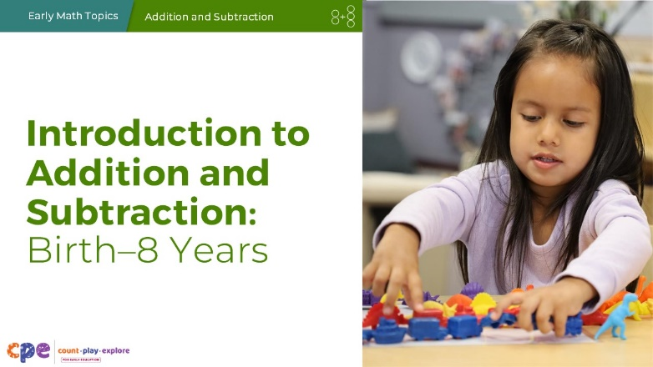

Talking Points
- Hello and welcome, everyone!
- Today, we are going to focus on how children develop an understanding of addition and subtraction from birth through the early elementary grades.

Facilitator Notes
- Adjust talking points to include relevant introductions, “housekeeping,” and other information that’s important for your participants to know.
- Share with participants that we might use “TK” to refer to transitional kindergarten and “K” for kindergarten.

SLIDE 2: Acknowledgments
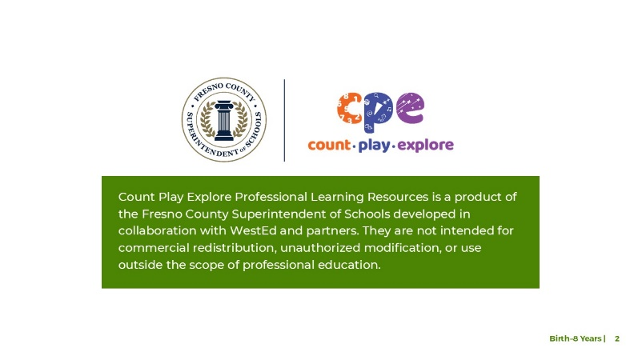
The Count Play Explore Professional Learning Resources were made possible by Count Play Explore, an early math, science, and computer science initiative led by the Fresno County Superintendent of Schools, Early Care and Education Department. This initiative is generously funded by the California Department of Education and the California State Board of Education. These resources, developed in collaboration by WestEd and partners, are intended to be used as a guide for implementing evidence-based strategies, promoting active learning, and encouraging developmentally appropriate practices in early education settings. They are not intended for commercial redistribution, unauthorized modification, or use outside the scope of professional education.

SLIDE 3: Session Goals
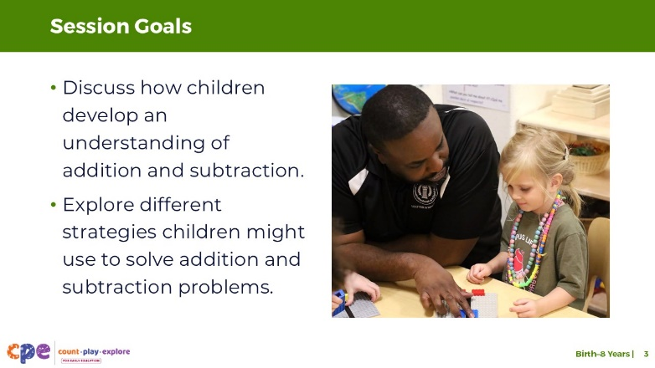

Talking Points
- Today, we will discuss how children develop an understanding of addition and subtraction from infancy into the early elementary years.
- We will also explore different strategies children might use to solve addition and subtraction problems.
- The ways we will learn together are like the ways children learn. We will play, observe, explore, and reflect. As we engage with one another, reflect on the strategies being used and think about how you might use them in your own context.

Facilitator Notes
- Adjust slide content and talking points to reflect what you plan to address in your professional learning session.

SLIDE 4: Play: True or False?
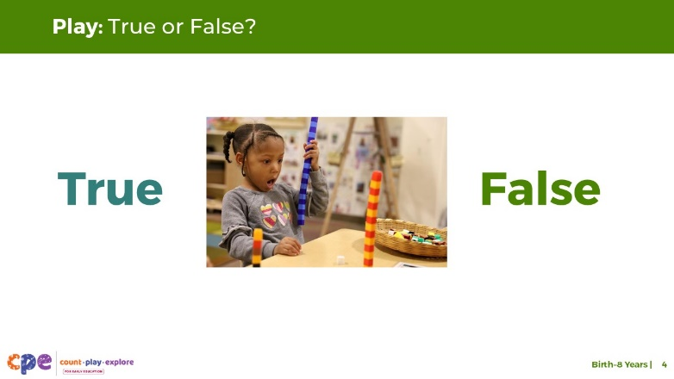

Talking Points
- Let’s start by playing a short game of “True or False” to explore some ideas about addition and subtraction.
- I will display some statements about addition and subtraction. Some of these statements are true. Other statements are false—not true.
- You do not need to answer out loud. Instead, think about whether you believe each statement is true or false.

SLIDE 5: True or False? #1
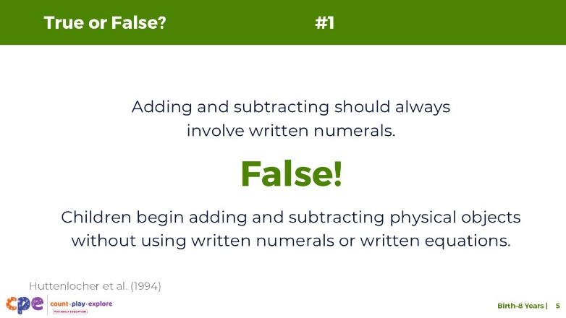
This slide contains animation. See instructions in the Talking Points.

Talking Points
- Adding and subtracting should always involve written numerals.
- [Pause to allow participants time to think about the statement.]
- [Click] False!
- [Click: The following text will appear on the screen:] Children begin adding and subtracting physical objects without using written numerals or written equations (Huttenlocher et al., 1994).

SLIDE 6: True or False? #2
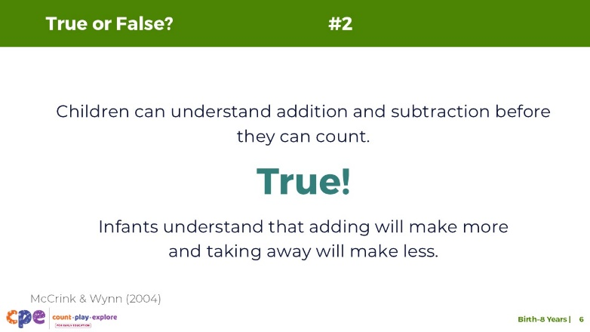
This slide contains animation. See instructions in the Talking Points.

Talking Points
- Children can understand addition and subtraction before they can count.
- [Pause to allow participants time to think about the statement.]
- [Click]True!
- [Click: The following text will appear on the screen:] Infants understand that adding will make more and taking away will make less (McCrink & Wynn, 2004). Even before children can count, they are able to notice changes in quantity. We will discuss this more later in the session.

SLIDE 7: True or False? #3
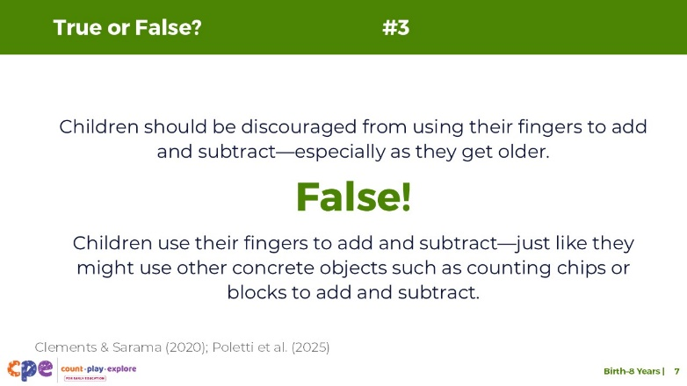
This slide contains animation. See instructions in the Talking Points.

Talking Points
- Children should be discouraged from using their fingers to add or subtract—especially as they get older.
- [Click] False!
- [Click: The following text will appear on the screen:] Children use their fingers to add and subtract—just like they might use concrete objects such as counting chips or blocks to add and subtract.
- In fact, using fingers to add and subtract in the early years helps children solve addition and subtraction problems with more accuracy (Poletti et al., 2025). As children get older, they might find more efficient—faster and more accurate—ways of adding and subtracting (Clements & Sarama, 2020).

SLIDE 8: True or False? #4
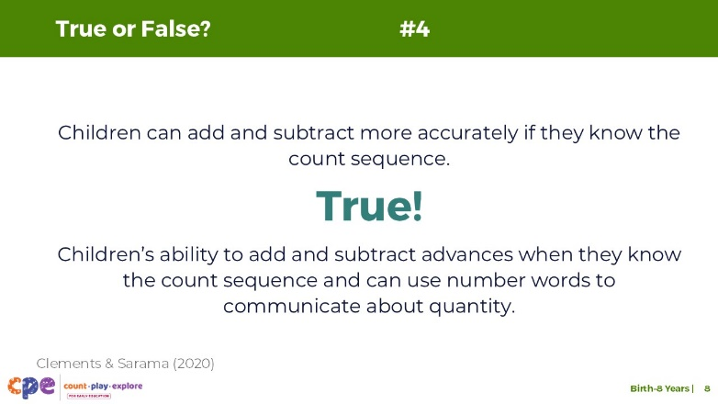
This slide contains animation. See instructions in the Talking Points.

Talking Points
- Children can add and subtract more accurately if they know the count sequence.
- [Click] True!
- [Click: The following text will appear on the screen:] Children understand that adding makes more and taking away makes less before they can count. However, children’s ability to add and subtract advances when they know the count sequence and can use number words to communicate about quantity (Clements & Sarama, 2020).

SLIDE 9: True or False? #5
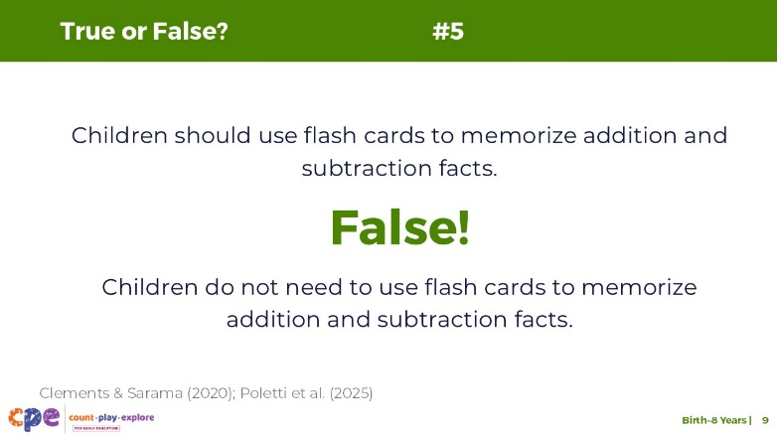
This slide contains animation. See instructions in the Talking Points.

Talking Points
- Children should use flash cards to memorize addition and subtraction facts.
- [Click] False!
- [Click: The following text will appear on the screen:] Children do not need to use flash cards to memorize addition and subtraction facts.
- For most children, using flash cards, or other rote tasks, is not the most effective way to help them remember addition and subtraction facts (Boaler, 2014; Clements & Sarama, 2020). If children memorize addition or subtraction facts without constructing an understanding of the relationships between the numbers, their knowledge is less useful. Children who only memorize facts through rote experiences often struggle to apply facts to new and more complex problems.
- Thank you for playing True of False! I hope this game helped you think more about addition and subtraction. We will revisit some of these ideas throughout our session.

SLIDE 10: Observe: Adding and Subtracting
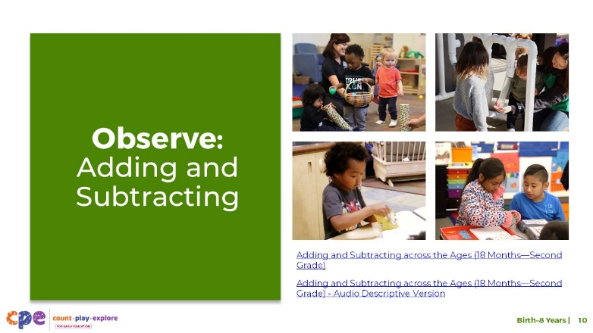
Time: 10–15 minutes (including discussion on next slide)
Materials: Adding and Subtracting across the Ages video

Talking Points
- We have done some thinking about addition and subtraction. Now, we will observe a video that shows children of different ages developing or using addition and subtraction knowledge and skills.
- As you observe, notice ways children engage in addition and subtraction and ways that educators promote this engagement.
- You might record your observations. After the clip, we will discuss what you noticed.

Facilitator Notes
- We provide the following video:
  - Adding and Subtracting Across the Ages (18 Months—Second Grade), Adding and Subtracting: Across the Ages (18 Months–Second Grade) - Audio Descriptive Version. This video presents a collection of clips depicting infants, toddlers, children in preschool, and children in early elementary grades using addition and subtraction in different ways.
- You might play the video more than once.

SLIDE 11: Discuss: Addition and Subtraction
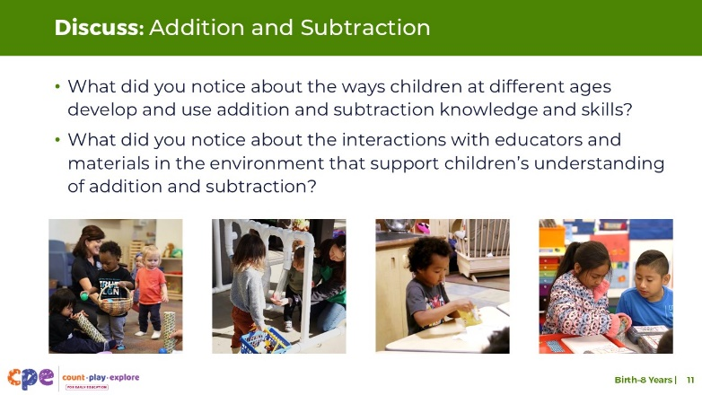
Time: 10–15 minutes (including discussion on next slide)

Talking Points
- Let’s discuss what you noticed about the ways children explored addition and subtraction and how educators supported this engagement.
  - What did you notice about the ways children at different ages develop and use addition and subtraction knowledge and skills?
  - What did you notice about the interactions with educators and materials in the environment that support children’s understanding of addition and subtraction?
- [Choose a facilitation method from the Facilitator Notes.]
- [After participants share what they notice:] Thank you for sharing your observations.
- We will revisit many of these ideas as we learn more about how children develop an understanding of addition and subtraction.

Facilitator Notes
- Adjust the debrief based on your group size, session length and format, and participant needs.
- Consider charting participants’ observations to visually show what participants noticed about the ways children develop and use addition and subtraction. For example,
  - Chart observations on a horizontal line to show children’s development over time. Begin charting what they notice about infants’ development and learning on the left and place observations about toddlers to the right of these observations. Note with participants that not all learning pathways are the same for each child and that these are general observations about children’s mathematical understanding.
  - Consider making a t-chart with one column labeled “Similar” and the other column labeled “Different.” Then, record what participants notice about children’s development and use of addition and subtraction that is similar across the ages (for example, all children used concrete objects) and what is different across the ages (for example, the size of the numbers children used).
- Some adaptations based on session length include the following:
  - For shorter sessions, invite participants to share with the larger group what they noticed about the ways children explored addition and subtraction.
  - For longer sessions, offer time for participants to share their observations in pairs or at their tables. Then, invite each table to share some of their observations with the larger group.
- Here are some examples of how children in the video clips explored addition and subtraction and some ways educators supported them to add and subtract:
  - All the children, across the ages, used concrete objects to explore addition and subtraction.
  - The size of numbers increased as children got older. For example, infants focused on “more” instead of specific amounts; toddlers worked with small sums (1 plus 2); preschool children added numbers in the teens (14 plus 3); elementary aged children added two-digit numbers (46 plus 39).
  - Infants, toddlers, and preschool-aged children added and subtracted during play contexts. Elementary-aged children added and subtracted in more abstract ways (for example, using a word problem).
  - Educators modeled language (“more,” “one, two, three,” “adding makes more”) and used gestures (holding up three fingers) to support children’s thinking.
  - Children were engaged in the experiences and were interested in finding solutions to addition or subtraction problems.
  - There were many ways children could represent and explore adding and subtracting across the video clips.

SLIDE 12: Developing an Understanding of Addition and Subtraction
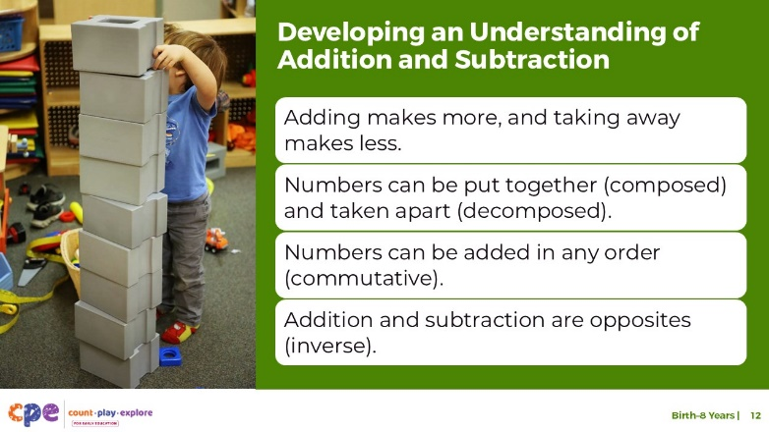

Talking Points
- Let’s learn more about how children develop their understanding of key addition and subtraction concepts, including the following:
  - Adding makes more, and taking away makes less.
  - Numbers can be put together (composed) and taken apart (decomposed).
  - Numbers can be added in any order (commutative).
  - Addition and subtraction are opposites (inverse).

Facilitator Notes
- For more in-depth information on how children develop addition and subtraction knowledge and skills, consider reviewing the research brief “The Development of Arithmetic Skills and Concepts from Infancy Through the Early School Years.”

SLIDE 13: Exploring Ideas of Addition and Subtraction
(Part 1)
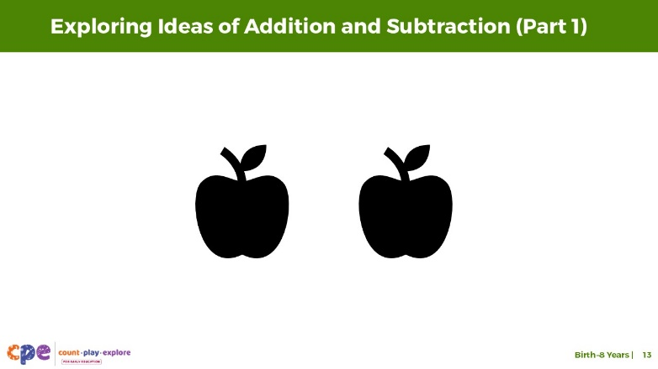
This slide contains animation. See instructions in the Talking Points.

Talking Points
- Let’s explore some ideas related to addition and subtraction.
- In the next few slides, I am going to illustrate a situation that is similar to how researchers have observed infants’ understanding of addition and subtraction. I will display some objects on the screen. Notice what happens.
- [Click: Two apples appear on the screen.]
- Here are some apples.

Facilitator Notes
- Slides 13–22 include animations. The animations show an object moving behind a rectangle. First, you will show participants an expected event. For example, moving an apple behind the rectangle results in having more apples once the rectangle is removed. Then, you will show participants an unexpected event. For example, moving an apple behind the rectangle does not result in having more apples once the rectangle is removed.
- Instead of using the images on slides 13–22, you might use physical objects to demonstrate and engage participants. For example,
  - Use a cardboard box (or other opaque container) to put objects into. Then, show the objects in the box to participants.

SLIDE 14: Hiding the Apples (Part 1)
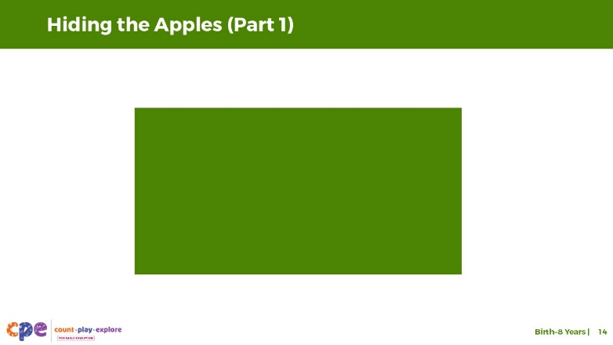
This slide contains animation. See instructions in the Talking Points.

Talking Points
- Now, I will hide the apples behind a rectangle.
- [Click: A rectangle moves down to hide the apples.]

SLIDE 15: Adding More Apples (Part 1)
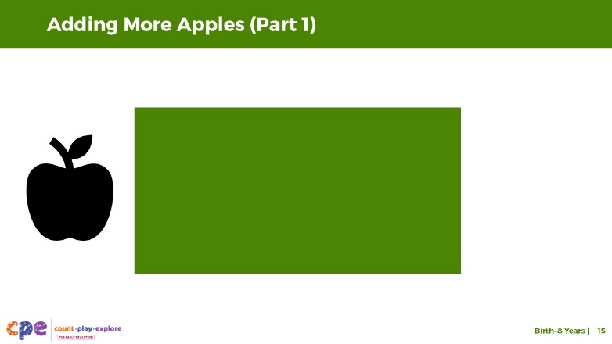
This slide contains animation. See instructions in the Talking Points.

Talking Points
- Let’s add another apple.
- [Click: A new apple appears on the screen.]

SLIDE 16: Hiding All Apples (Part 1)
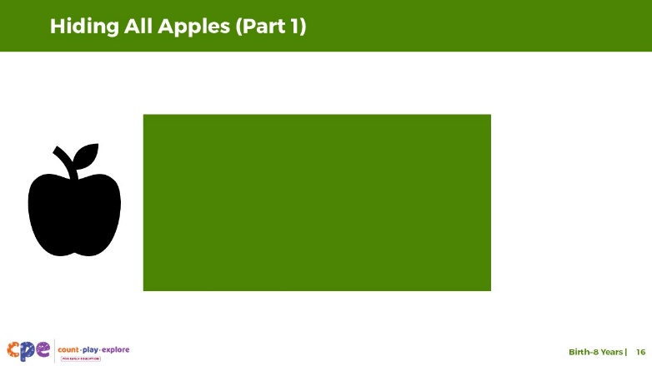
This slide contains animation. See instructions in the Talking Points.

Talking Points
- Now, I’ll move this apple behind the rectangle.
- [Click: The apple moves behind the rectangle.]

SLIDE 17: How many apples are hidden behind the rectangle? (Part 1)
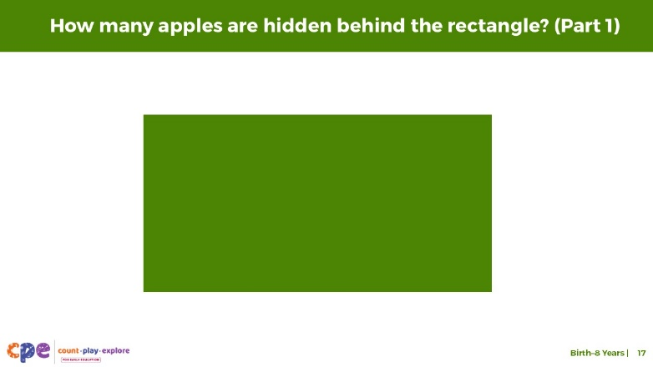
This slide contains animation. See instructions in the Talking Points.

Talking Points
- How many apples do you think are behind the rectangle?
- [Encourage participants to respond and explain their answers.]
- Let’s move the rectangle and find out.
- [Click: The rectangle moves to reveal three apples.]
- There are three apples behind the rectangle. We added an apple, and now there are more apples.

SLIDE 18: Exploring Ideas of Addition and Subtraction
(Part 2)
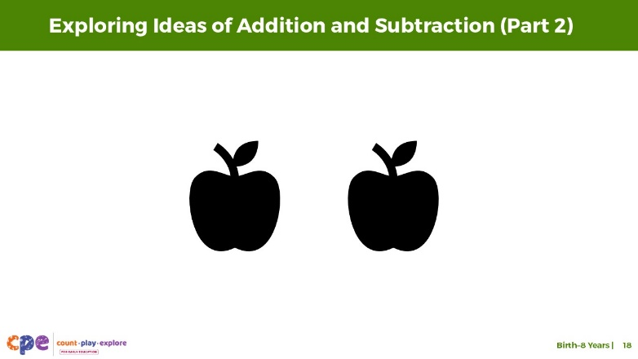
This slide contains animation. See instructions in the Talking Points.

Talking Points
- Let’s try it again.
- [Click: Two apples will appear on the screen.]
- Here are some apples.

SLIDE 19: Hiding the Apples (Part 2)
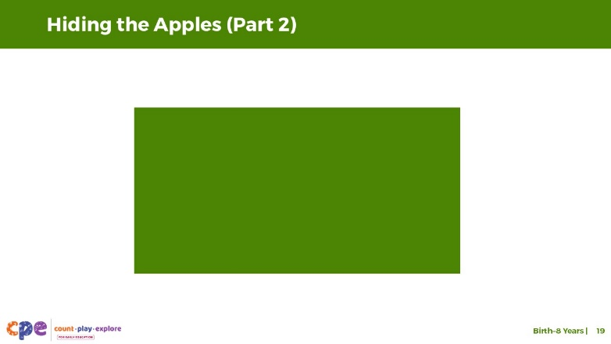
This slide contains animation. See instructions in the Talking Points.

Talking Points
- Now, I will hide the apples behind a rectangle.
- [Click: A rectangle moves down to hide the apples.]

SLIDE 20: Adding More Apples (Part 2)
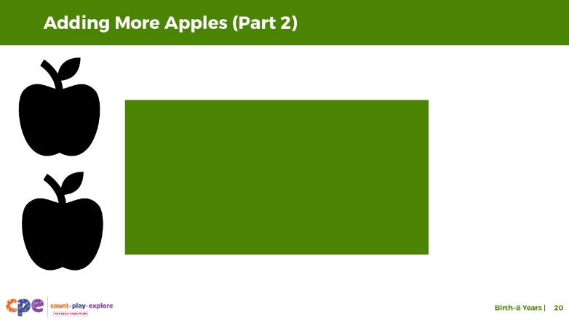

Talking Points
- Let’s add two more apples.

SLIDE 21: Hiding All Apples (Part 2)
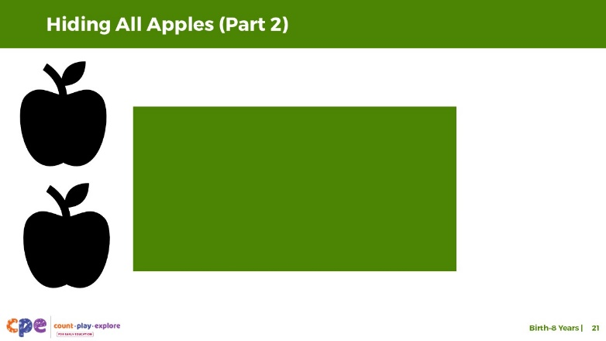
This slide contains animation. See instructions in the Talking Points.

Talking Points
- Now, I’ll move these apples behind the rectangle.
- [Click: The apples move behind the rectangle.]

SLIDE 22: How many apples are hidden behind the rectangle? (Part 2)
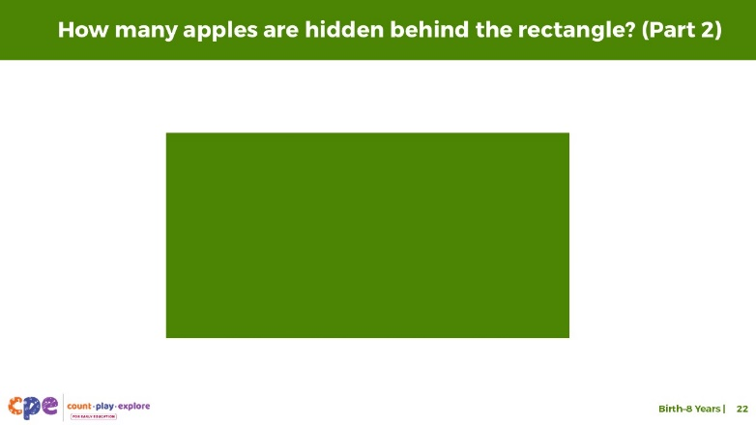
This slide contains animation. See instructions in the Talking Points.

Talking Points
- How many apples do you think are behind the rectangle?
- [Encourage participants to respond and explain their reasoning.]
- Let’s observe what is behind the rectangle.
- [Click: The rectangle moves to reveal two apples.]
- What do you notice about how many apples were hiding behind the rectangle?
- Does this surprise you at all? Why?
- [Adapt this phrase based on what participants share:] What you observed was surprising. We expected to find more apples after we moved the rectangle. Instead, we found the same amount, even though we added more to the set.

SLIDE 23: Adding Makes More, Taking Away Makes Less
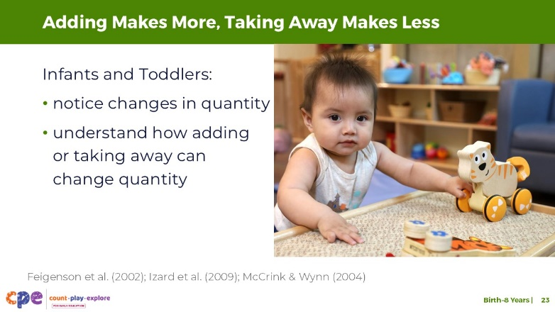

Talking Points
- Researchers have used similar ways to explore how infants (for example, 9–12-month-old children) think about addition and subtraction.
- Just like you, infants in these studies were surprised when they experienced an unexpected math outcome. They looked longer at the unexpected outcome. This extended observation in the case of unexpected outcome—but not when they observed an expected outcome—signaled to researchers that the infants noticed something was not right. Infants in these studies also thought that when more objects were added to a set, they should observe more objects (Feigenson et al., 2002; Izard et al., 2009; McCrink & Wynn, 2004).
- Please note, the experiences related to hiding objects and displaying unexpected outcomes is not how infants learn about quantity—these types of experiences were done only for research to help reveal what infants might be noticing about quantity.
- This research has shown that infants and toddlers notice changes in quantity and understand how adding or taking away can change quantity.
- Toddlers will build on these early understandings of addition and subtraction as they explore adding and taking away objects within daily experiences. They might communicate their understanding using gestures or words. For example,
- When collecting leaves during outside time, a child might add three more leaves to their collection and say, “More!”
- When playing in the kitchen area, a child might take away pretend food items from their pot as they serve their friends at the table. They might say, “All gone!” after taking away all of the objects from their pot.

SLIDE 24: Adding makes more, taking away makes less (continued)
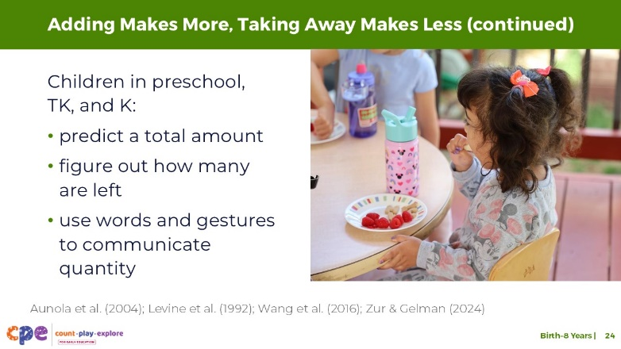

Talking Points
- Children in preschool, TK, and K (children ages three to six) continue to develop their understanding that adding makes more and taking away makes less. For example, when objects are added to a small set, they usually can predict the total amount (Zur & Gelman, 2004).
- Similarly, for subtraction, children ages three to six typically understand that when you remove a few objects from a set, you have less (Levine et al., 1992). For example, if children have six crackers and their friend asked for some, they might be able to predict how many will be left. They might lack accuracy but will likely predict an amount smaller than six.
- Children’s developing understanding of number and counting supports their ability to add and subtract (Aunola et al., 2004; Wang et al., 2016). For example, as children learn number words (such as “two”) and gestures (such as holding up two fingers), they can communicate more effectively about quantity after objects are added to, or taken from, a set.

SLIDE 25: Many Ways to Make 15
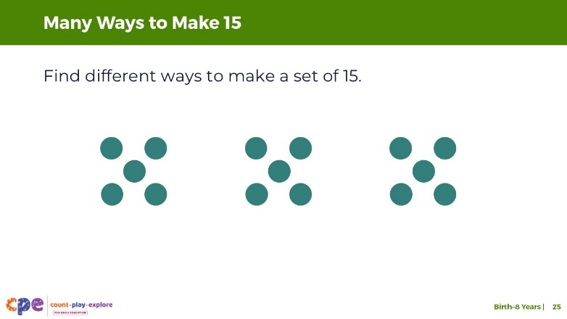
Time: 10 minutes
Materials: Collections of small objects (for example, paperclips, shells, cotton balls, counting chips)

Talking Points
- We reviewed the concept of adding makes more and taking away makes less. Let’s explore a different concept that is a part of adding and subtracting.
- [Select a facilitation strategy from the Facilitator Notes.]
- Using the materials at your table, find different ways to make a set of 15.
  - For example, I can make a set of 15 by combining three sets of 5.
- You might document the different sets you make.
- [Provide time for participants to work.]
- [Invite a few participants to share their experience and the different ways they created a set of 15 objects. If time allows, consider discussing other math understandings that were needed in order to represent a set of 15 in different ways.]
- This activity explored the idea that numbers can be put together and taken apart. Sets of objects can be combined to create a set of 15.
- Similarly, a group of 15 objects can be broken apart into smaller sets in different ways.

Facilitator Notes
- Adjust the way you organize the activity based on group size, session length and format, and participants’ needs. For example,
  - For longer sessions, you might invite participants to work individually and share their experiences with their tables before discussing as a larger group.
  - For shorter sessions, you might invite participants to work with a partner and share with the larger group.

SLIDE 26: Number Composition
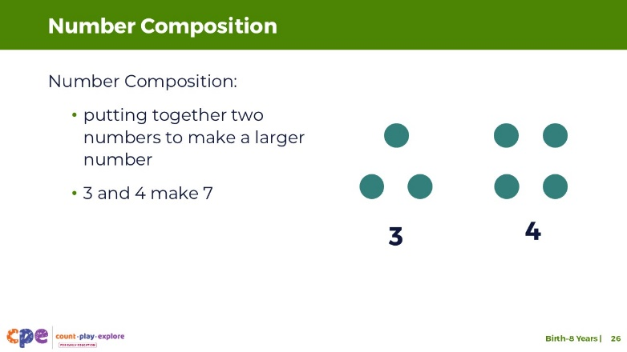
This slide contains animation. See instructions in the Talking Points.

Talking Points
- You have just explored the idea that numbers can be put together to make a new number or taken apart to make different numbers. Using math education terms, you experienced number composition and decomposition.
- Number composition describes putting together two (or more) numbers to make a larger number. For example, 3 and 4 can be put together to make 7.
- [Click: The dots on the screen will move together to model composing 7.]

SLIDE 27: Number Decomposition
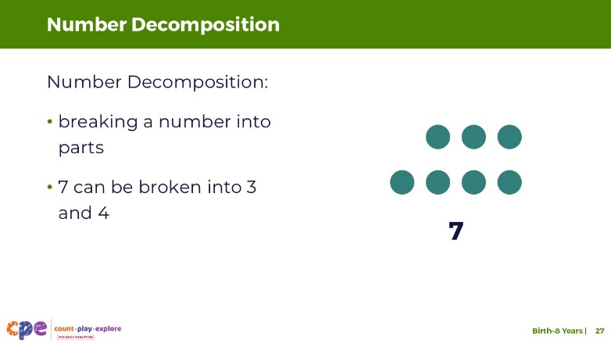
Time: 3–5 minutes
This slide contains animation. See instructions in the Talking Points.

Talking Points
- Number decomposition describes breaking a larger number into two (or more) sets of smaller numbers.
- [Click: The dots on the screen will move apart to model decomposition.] For example, 7 can be broken into 3 and 4.

SLIDE 28: Numbers can be put together and taken apart.
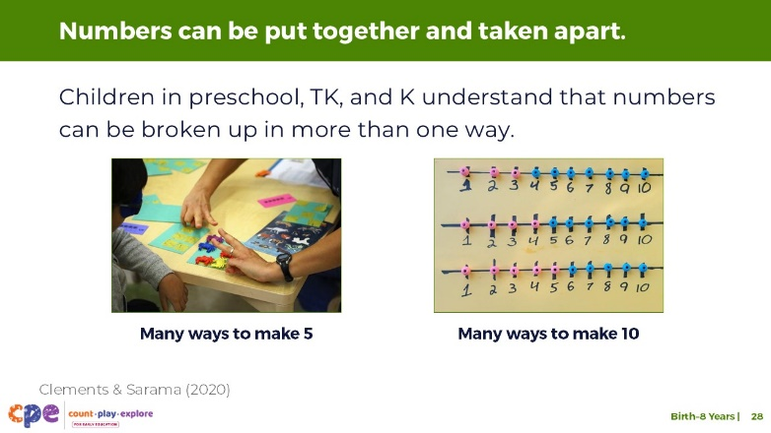

Talking Points
- Between the ages of three and six, children develop an understanding that numbers can be put together and taken apart (Clements & Sarama, 2020). For example,
  - By age five, children might know that 5 is composed of a set of 4 and a set of 1. They might also know that 5 is composed of a set of 2 and a set of 3.
  - In kindergarten, children might use this skill to decompose numbers less than or equal to 10 into two sets in more than one way. Children might figure out many ways to make 10.
- Children’s understanding of composing and decomposing numbers helps them understand and use the base ten system. For example,
  - Children in early elementary grades might learn that 47 is composed of 40 (4 tens) and 7 (7 ones).
- Later in the session, we will explore how composing and decomposing can be used as a strategy to solve addition and subtraction problems.

Facilitator Notes
- Consider inviting participants to reflect on their experiences composing and decomposing the number 15 (slide 25). Invite them to consider ways they engage children in their learning settings in similar experiences. Use PPT 2b “Addition and Subtraction: Preschool, Transitional Kindergarten, and Kindergarten,” or PPT 2c “Addition and Subtraction: Early Elementary” for more examples of ways to engage children in composing and decomposing numbers.

SLIDE 29: Explore: Let’s add and subtract!
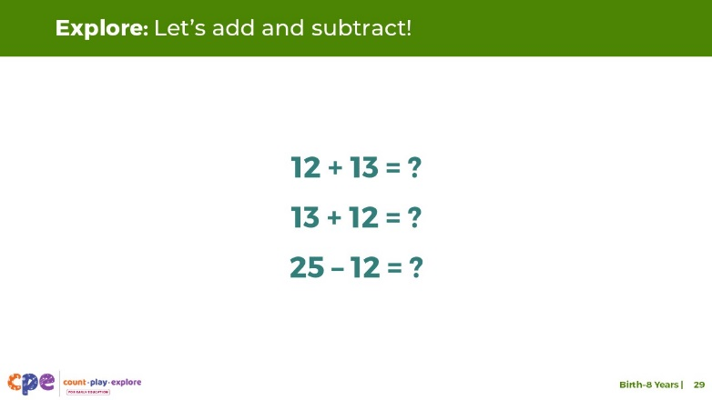
Time: 3–5 minutes

Talking Points
- Now, we will explore another concept that children understand about addition and subtraction.
- We will use written equations for our adult activity. However, it is important to remember that children should experience addition and subtraction using concrete objects and might not use written equations until later in kindergarten.
- Here are some equations. Solve them using any strategy you prefer.
  - 12 + 13 = ?
  - 13 + 12 = ?
  - 25 – 12 = ?
- [Allow time for participants to solve the equations individually.]
- What did you notice about these equations?
- [Invite participants to share with the larger group.]
- Thank you for sharing what you noticed about these equations.
- You probably discovered that solving the first problem helped you solve the other two problems. This is because you used two properties of addition and subtraction—the commutative and inverse properties—which we will define on the next slides.

SLIDE 30: Properties of Addition and Subtraction
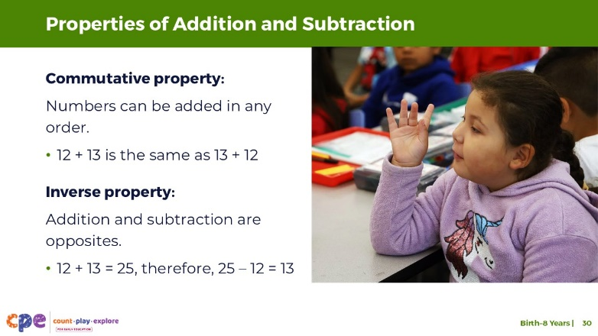

Talking Points
- Given many opportunities to experiment with adding and subtracting, children begin to understand properties of addition and subtraction and how they can add and subtract in different ways.
- Children might notice that they can add numbers in any order—this is the commutative property (Clements & Sarama, 2020).
- In the previous slide, you noticed that adding 12 to 13 or 13 to 12 resulted in the same answer.
- Children will naturally explore this concept. They might experience it during daily routines.
  - For example, children know that the number of animals in their barn is 6 whether they first put the 2 cows and then added the 4 sheep, or vice versa.
- Children might also notice that addition and subtraction are opposites—this is the inverse relationship (Clements & Sarama, 2020).
- In the previous slide, if you knew that 12 + 13 = 25, then you would also know that 25 – 12 = 13.
- Children might begin to develop an understanding of this concept during play or daily routines.
  - For example, if a friend adds 2 animals to the barn that already has 4 animals, children will understand that after taking away the 2 new animals they will have the original amount—4!
- Children in preschool through kindergarten might discover these ideas on their own and often use them without knowing the terms “commutative” or “inverse” (Clements & Sarama, 2020). They may notice these ideas through their experiences adding and subtracting concrete objects in different ways.
- It is not until the early elementary grades that children learn about these properties and begin to use them in more intentional ways to solve problems.

Facilitator Notes
- More information on how children develop and use their understanding of the properties of addition and subtraction and ways educators might support them is featured in PPT 2c “Addition and Subtraction: Early Elementary.”

SLIDE 31: Solving Addition and Subtraction Problems
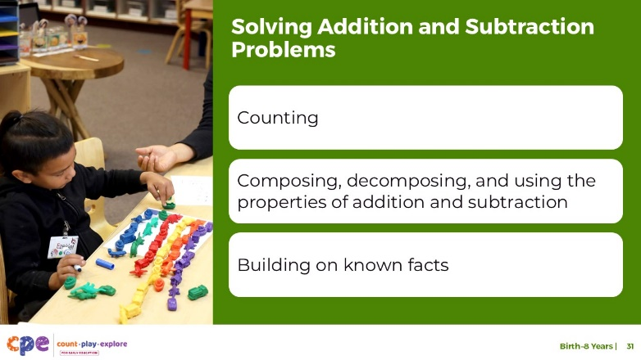

Talking Points
- We have discussed three key understandings that children develop about addition and subtraction.
- Now, we will talk about different strategies children use to solve addition and subtraction problems. Strategies might include the following:
  - counting
  - composing, decomposing, and using the properties of addition and subtraction
  - building on known facts

SLIDE 32: Counting Strategies
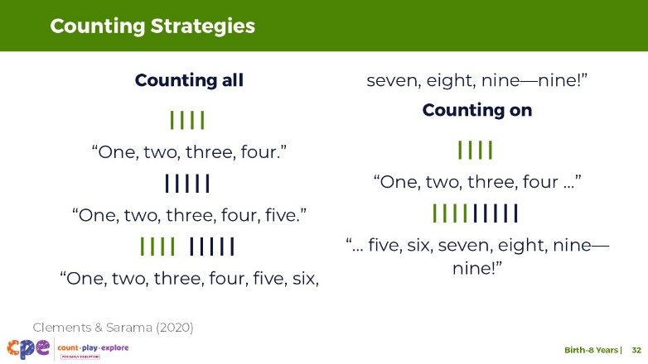

Talking Points
- Although children understand some concepts of addition and subtraction in infancy, children’s addition and subtraction skills become more accurate as they learn how to count.
- Between the ages three and five, most children use counting strategies and concrete objects to solve addition and subtraction problems (Clements & Sarama, 2020).
- Children will first use a counting-all strategy. To figure out how many, a child will count all of the objects in a set after adding to or subtracting from that set.
  - For example, a child might have a set of 4 blue sticks and a set of 5 red sticks. To add these sets together, a child might count the blue sticks, “one, two, three, four,” and then count the red sticks, “one, two, three, four, five.” To add these sets, the child might physically push the two sets together and then count them all, “One, two, three, four, five, six, seven, eight, nine—nine!”
- As children get more practice with counting, adding, and subtracting, they might use counting-on strategies. This means they start at one of the addends—one of the numbers in the addition problem—and count up from that number to find a new total (Clements & Sarama, 2020).
  - For example, a child might count the first set of blue sticks—“One, two, three, four …”—and then add 5 more to their set—“… five, six, seven, eight, nine—nine!”
- Children usually make this transition on their own because counting on becomes easier and allows them to be more accurate.
- In the early elementary grades, children might use skip counting by twos, fives, or tens to support their addition and subtraction.

Facilitator Notes
- Review PPT 2b “Addition and Subtraction: Preschool, Transitional Kindergarten, and Kindergarten” and PPT 2c “Addition and Subtraction: Early Elementary” for more information on counting strategies.
- You can play the video “Adding and Subtracting across the Ages” and encourage participants to notice the counting strategies children use in the video.

SLIDE 33: Using Composition, Decomposition, and the Properties of Addition and Subtraction
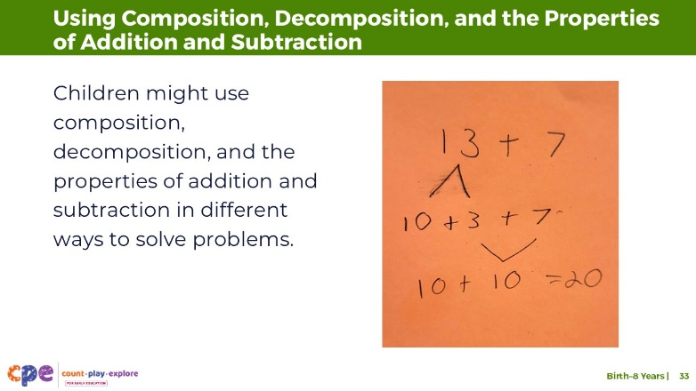

Talking Points
- As children gain a deeper understanding and more practice with adding and subtracting, their strategies become more efficient—quicker and more accurate (Clements & Sarama, 2020).
- Children in early elementary grades might use their understanding of composition, decomposition, and the properties of addition and subtraction to solve problems.
  - For example, to solve 13 + 7, children might first decompose 13 into 10 and 3.
  - Then, they might add the numbers in an order that is meaningful to them, using the commutative property—adding 7 and 3 makes a 10.
  - Finally, they might add 10 + 10 to get 20.

Facilitator Notes
- Review PPT 2c “Addition and Subtraction: Early Elementary” for more information on how children use composition, decomposition, and the properties of addition and subtraction.

SLIDE 34: Building on Known Facts
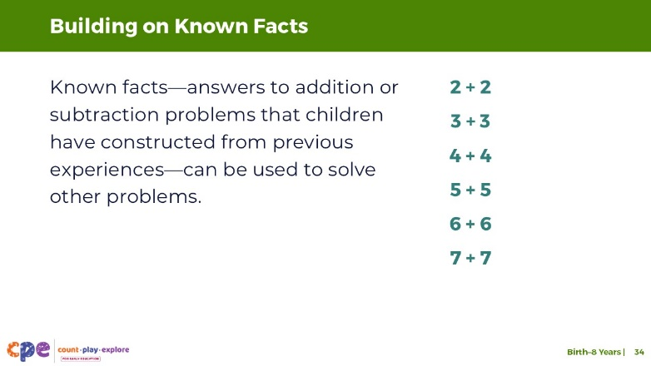

Talking Points
- Another strategy children might use to help them add and subtract involves building on addition or subtraction facts that they have constructed from prior experiences.
- As children explore and experience addition and subtraction over time, they begin to remember certain facts. They develop greater fluency and can recall answers to addition and subtraction problems without using any computation or counting—we call these known facts. For example, a child might know, without computing, that 3 + 3 = 6.
- Here, we have some examples of commonly known facts—doubles.
- In the early elementary years, children might use these known facts flexibly to add and subtract other numbers.
  - For example, if I know 5 + 5 = 10, I might extend this understanding to solve 5 + 6. I can solve it using my knowledge of doubles of 5 (which equals 10) and then add 1 more (5 + 6 = 11).
  - Here is another example: If I know that 3 + 3 = 6, I might extend this understanding to help me solve 13 + 13. I might think, 2 tens is 20 and 3 + 3 is 6. So, the answer is 26.
- Children build their knowledge of known facts by exploring addition and subtraction through solving problems of interest and using concrete objects (Baroody et al., 2009; Clements & Sarama, 2020). If children memorize addition or subtraction facts without understanding the relationships between the numbers, their knowledge is less useful. Children who only memorize facts through rote experiences—like flash cards or timed tests—might struggle to apply facts to new and more complex problems.

Facilitator Notes
- Review PPT 2c “Addition and Subtraction: Early Elementary” for more information on how children build on known facts to support solving addition and subtraction problems.

SLIDE 35: Addition and subtraction problems advance over time: Number Size
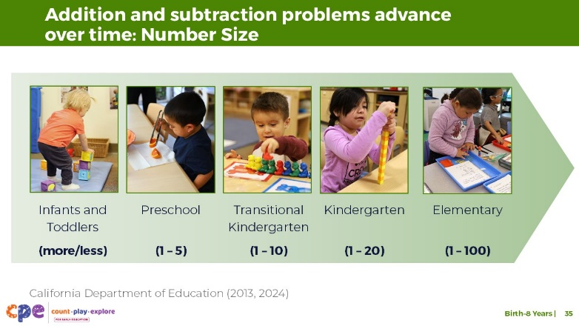

Talking Points
- We discussed children’s understanding of addition and subtraction. Then, we described strategies children use to solve addition and subtraction problems.
- Now, we will briefly discuss how addition and subtraction problems advance as children’s knowledge and skills develop.
- Addition and subtraction problems can become more advanced in different ways (Clements & Sarama, 2020). For example, children will start to work with larger numbers as they gain experience (California Department of Education, 2013, 2024).
  - Infants and toddlers begin by exploring concepts related to more and less.
  - As children enter preschool, they might explore addition and subtraction problems with small sets, such as 1–5.
  - In TK, children might start to solve addition and subtraction problems with a sum less than or equal to 10.
  - By kindergarten, children start to work with numbers less than or equal to 20.
  - By second grade, children are working with sums less than or equal to 100.
- Within a grade level, children’s abilities will vary. Educators need to observe children and provide support that is responsive to children’s abilities.

SLIDE 36: Addition and subtraction problems advance over time: Format
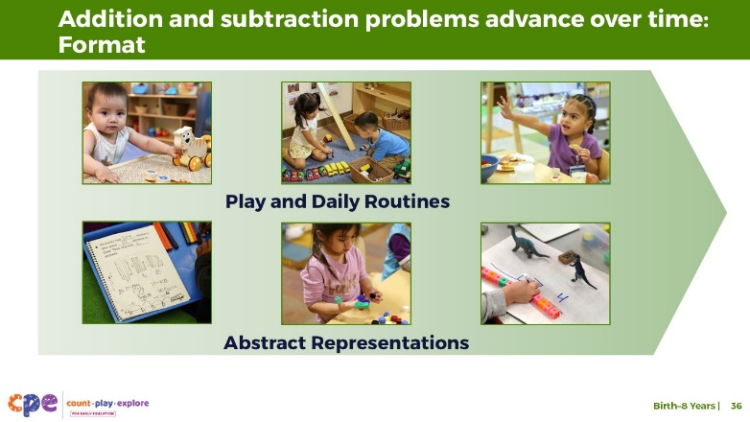

Talking Points
- Addition and subtraction problems can also become more advanced based on the format (Clements & Sarama, 2020). For example,
  - Younger children (toddlers and preschoolers) explore addition and subtraction problems within the context of play and daily routines. They use concrete objects to add and subtract in solving problems and answering questions that are part of their daily lives—for example, adding to find out how many rocks we collected outside or subtracting to figure out how many crackers we will have left if we eat two of them.
  - In the early elementary grades, children begin to explore addition and subtraction in more abstract formats. Although children in this age range still use concrete objects to support them in solving addition and subtraction problems, they are able to solve problems using written equations and other representations such as word problems.

SLIDE 37: Addition and subtraction problems advance over time: Problem Types
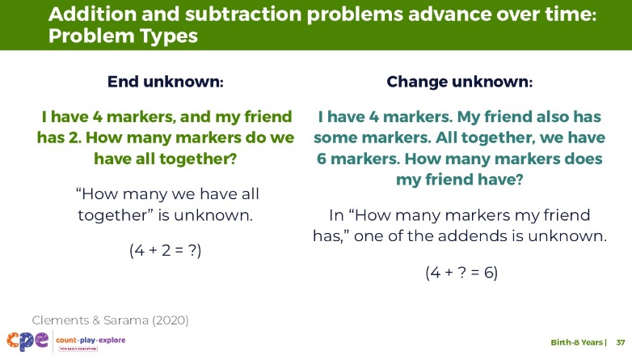

Talking Points
- Addition and subtraction problems can also advance depending on the problem type that children are working with (Clements & Sarama, 2020).
- Children explore many types of problems using addition and subtraction. Here are two examples:
  - End unknown: In end-unknown problems, the end result—the sum or difference—is what’s unknown. For example, “I have 4 markers and my friend has 2. How many markers do we have all together?” “How many we have all together” is the unknown that children try to figure out.
  - Change unknown: In change-unknown problems, how much is added or taken away is the unknown part. For example, “I have 4 markers. My friend also has some markers. All together, we have 6 markers. How many markers does my friend have?” In this problem, one of the addends—the numbers being added—is unknown.

Facilitator Notes
- Problem types are discussed in more detail in PPT 2c “Addition and Subtraction: Early Elementary.”

SLIDE 38: Observe: Children Adding and Subtracting
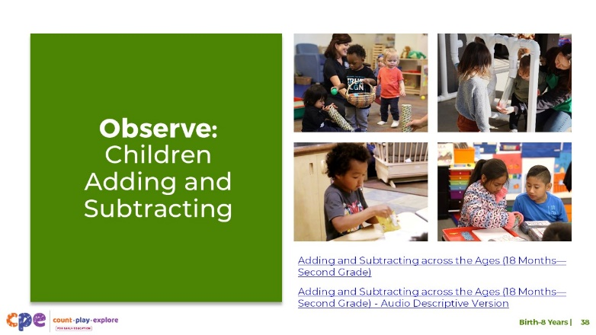

Talking Points
- In the beginning of this session, we observed a video of children, across the ages, adding and subtracting in different ways.
- Then, we discussed different concepts that children understand about adding and subtracting and ways children solve addition and subtraction problems.
- Now, we will observe the video again. Consider what you have learned about adding and subtracting. What do you notice about how children add and subtract and how educators support them? Pay attention to the use of concrete objects, counting strategies, number size, or other ideas we discussed.
- [Play the “Adding and Subtracting across the Ages (18 Months—Second Grade)” video. Then, invite participants to share what they notice. Use the Facilitator Notes to guide your discussion.]

Facilitator Notes
- If you recorded participants’ observations in the beginning of this session, you might add to those observations as you discuss the video again.
- The notes below provide some ideas from the video that may guide your discussion.
- Children explored counting strategies and ideas related to more and less.
- Educators supported infants to notice that adding makes more.
- Toddlers, preschoolers, and children in the elementary grades all used counting strategies.
- Children in the elementary grades used more advanced counting strategies (for example, counting by tens).
- Children across ages used concrete objects to support their adding and subtracting.
- Children’s abilities to communicate using number words advanced across the ages. For example,
  - Toddlers communicated using number words under five.
  - Preschoolers communicated using number words going into the teens. They were also able to explain how adding made more.
  - Children in the elementary grades communicated using number words under 100. They were also able to explain their process to a peer.
- The size of numbers the children worked with advanced as they got older.
  - Infants explored the concept of more, without a specific quantity.
  - Toddlers added 1 and 2 to make 3.
  - Preschoolers added 3 to 14 to make 17.
  - Elementary aged children added two-digit numbers to make 85.
- The formats children used to explore adding and subtracting changed over time.
  - For younger children, adding and subtracting occurred within play and daily experiences (for example, during snack time).
  - In the elementary grades, children added and subtracted in more abstract ways, using a word problem and equations.
- The problem types the children explored became more advanced. For example,
  - In the toddler setting, children added to find out how many in all. They solved an “end-unknown” problem.
  - In the elementary setting, children added to find out how many stickers Kimberly started with before she gave some to her friend. They solved a “start-unknown” problem.

SLIDE 39: Reflect
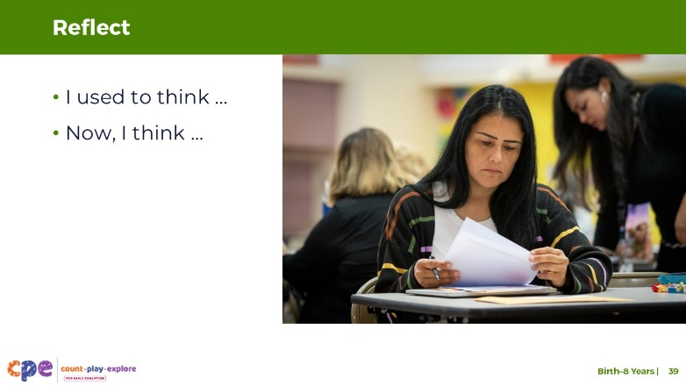
Time: 5–10 minutes
Materials: One note card per participant

Talking Points
- Let’s take a few moments to reflect on what we have learned today.
- On a note card, record some ideas you used to think about addition and subtraction with young children. Then, record how your ideas may have changed.
- Use the following prompts to guide your reflection.
  - I used to think …
  - Now, I think …
- This session described what children come to understand about addition and subtraction. When you return to your learning setting, notice the ways children add and subtract. Pay attention to ways you support children to develop an understanding of addition and subtraction. Noticing will help you be more intentional about ways you support children’s learning in this math area.

Facilitator Notes
- Adjust the way you organize the activity based on group size, session length and format, and participants’ needs.
- You might invite participants to share their reflections with their table groups.
- If you prefer to keep participants’ reflections anonymous, invite participants to bring their cards to you to share. You might collect the note cards to identify what participants learned and which related topics may be covered in coaching or future professional learning.

