# Introduction to Spatial Thinking: Birth–8 Years (PPT 1)

Use this facilitator guide with the slides “Introduction to Spatial Thinking: Birth–8 Years.” This set of slides provides an overview of the development of key concepts and skills in spatial thinking for children from birth to eight years old. When planning a professional learning session on spatial thinking, facilitators can use these slides as an introduction, or in combination with the age-specific slide decks. Facilitators can find talking points and guidance for activities and group discussions in this guide. The text in the guide is also located in the notes portion of the slides. Adapt this facilitator guide based on your group size, session length and format, and participants’ needs.

## SLIDE 1: Introduction to Spatial Thinking: Birth–8 Years

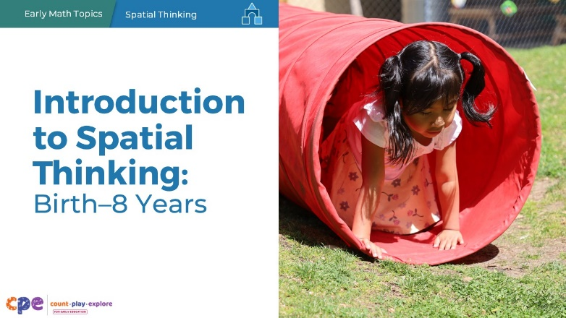

### Talking Points

* Hello and welcome, everyone! I’m excited to explore children’s spatial thinking with you.

### Facilitator Notes

* Adjust talking points to include relevant introductions, “housekeeping,” and other information participants should know.
* As you plan your professional learning session, consider the content in each PPT in this suite of resources.
  + PPT 1 “Introduction to Spatial Thinking: Birth–8 Years” provides introductory information about children’s spatial thinking from birth to eight years old. This session also includes opportunities for participants to use spatial thinking.
  + PPT 2a “Spatial Thinking: Infants and Toddlers” and PPT 2b “Spatial Thinking: Preschool, Transitional Kindergarten, and Kindergarten” describe in greater depth how children at different age levels develop spatial thinking. These PPTs also include ideas on how to support children in specific age ranges to develop spatial thinking.
  + Because spatial thinking is not a unique standard in the California Common Core State Standards for grades one or two, there is no PPT 2c focusing on early elementary grades. However, children in the early elementary grades use spatial thinking in many ways. If you are supporting early elementary educators, you might review the handout, [**Daily Opportunities to Support Spatial Thinking: Early Elementary**.](https://ece.fcoe.org/sites/ece.fcoe.org/files/2024-02/CAEMI-Suites-Daily-Opportunities-Spatial-Thinking-EE.pdf)
* We encourage you to offer the content in PPT 1 before or in combination with content in one of the age specific slide decks (PPT 2a or PPT 2b). Together PPT 1 and one of the age-specific slide decks provide about three hours of professional learning. However, you might adjust slide decks to best meet participant needs and time allowances.
* You might inform participants that we will use “TK” to refer to transitional kindergarten and “K” for kindergarten.

## SLIDE 2: Acknowledgments

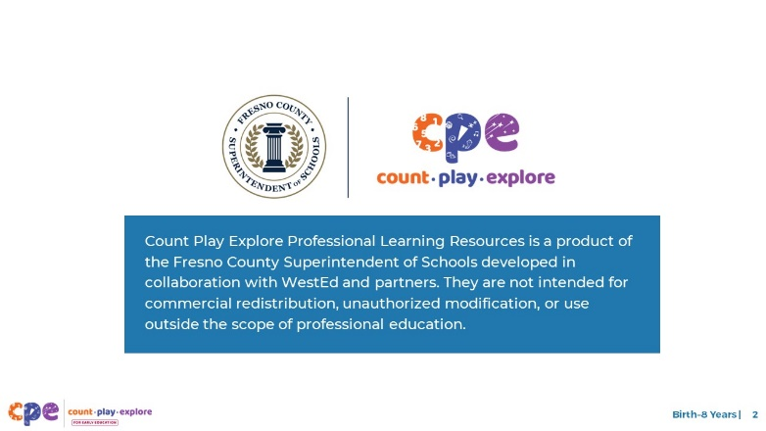

### Talking Points

The Count Play Explore Professional Learning Resources were made possible by Count Play Explore, an early math and science initiative led by the Fresno County Superintendent of Schools, Early Care and Education Department. This initiative is generously funded by the California Department of Education and the California State Board of Education. These resources are intended to be used as a guide for implementing evidence-based strategies, promoting active learning, and encouraging developmentally appropriate practices in early education settings. They are not intended for commercial redistribution, unauthorized modification, or use outside the scope of professional education.

## SLIDE 3: Session Goals

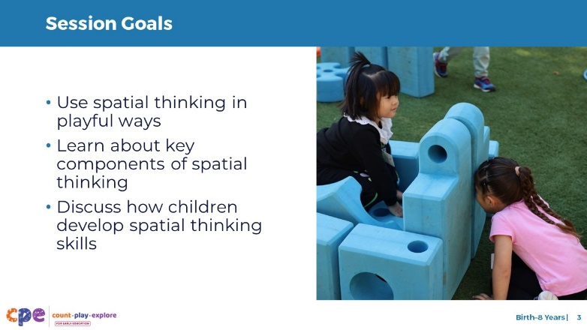

### Talking Points

* Today, we will:
  + use spatial thinking in playful ways,
  + learn about key components of spatial thinking, and
  + discuss how children develop spatial thinking skills.
* The ways we learn together are similar to how children learn. We will play, explore, discuss, and reflect.

### Facilitator Notes

* Adjust slide content and talking points to reflect what you plan to address in this session.

## SLIDE 4: Explore: Thinking About Space

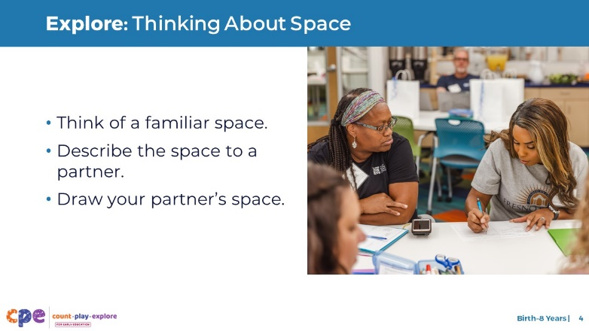

### Talking Points

* Let’s begin by exploring how we use spatial thinking.
* Think about a familiar space—for example, where you live or your early learning setting. Consider what you observe in that space and where items are located. [Provide a few minutes for participants to think about their spaces.]
* Next, take turns describing your space to someone next to you—for example, describe the size, shape, and location of the furniture and objects. As your partner shares, draw a map of the space they describe on scratch paper. [As participants share with their partners, move around the room and note the spatial vocabulary and thinking they are using.]
* [After participants finish sharing in pairs:] During this activity, I noticed you used several components of spatial thinking. You used spatial vocabulary, like “beside” and “under.” You used spatial orientation when describing the location of objects in this space. You may have used spatial navigation when you visualized yourself moving through the space.
* During this session, we will describe each of these components in greater detail and discuss how children develop them.

### Facilitator Notes

* Math is playful! This is a key principle promoted by the Count Play Explore approach to professional development. Engaging adult learners in a playful, real-life activity is an effective way to introduce them to the spatial concepts and skills described in this session.
* Throughout the session, revisit the activity “Thinking About Space” to introduce connections between each component and participants’ experiences during this activity.
* You might engage participants in the “Body-Scale Icosahedron” experience (slide 18) instead of, or in addition to, the experience described on this slide. After engaging in the “Body-Scale Icosahedron” experience, remind participants that they will revisit this experience as we describe each of these components in greater detail.

## SLIDE 5: Spatial Thinking: An Overview

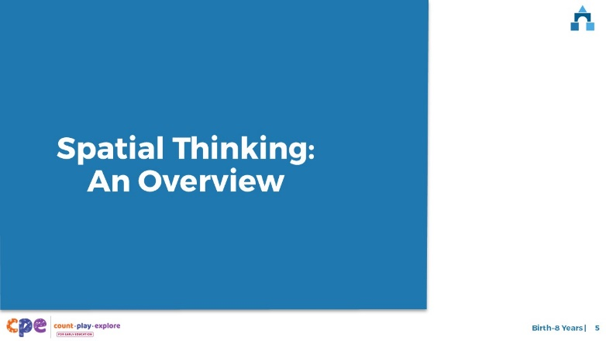

### Talking Points

* First, we will develop a shared understanding of spatial thinking and why it is important.
* Then, we will review how children develop spatial thinking.

### Facilitator Notes

* As a reminder, the content in this presentation is relevant to all children, from birth to eight years old. The content in PPT 2a and PPT 2b addresses spatial thinking for specific age levels: infants and toddlers (PPT 2a) and preschool, TK, and K (PPT 2b).

## SLIDE 6: Spatial Thinking Defined

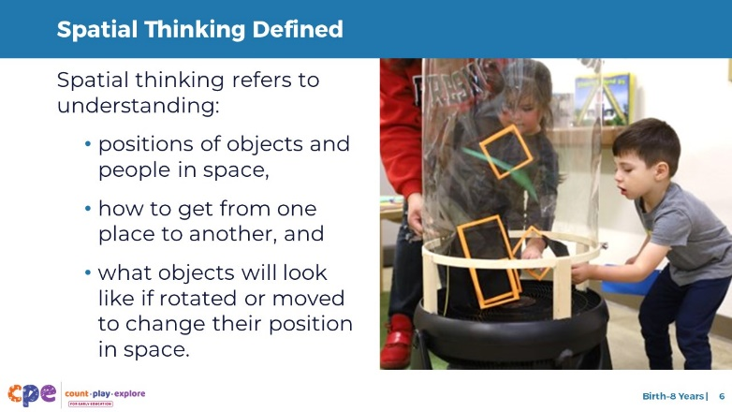

### Talking Points

* The terms “spatial thinking” and “spatial reasoning” refer to the same set of skills. We will use “spatial thinking” because this term is used in the California Preschool/Transitional Kindergarten Learning Foundations.
* Spatial thinking refers to understanding the positions of people and objects in space. It also includes knowing how to get from one place to another and the ability to mentally visualize what an object would look like if it was rotated.
* You used spatial thinking when you described a familiar place to your partner and drew a map of your partner’s space. [If you used the “Body-Scale Icosahedron” experience, “You used spatial thinking when you built the body-scale icosahedron.”]

## SLIDE 7: Using Spatial Thinking in Adult Life

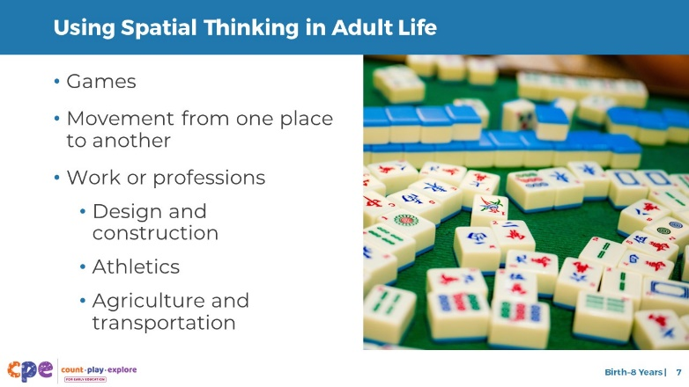

### Time

3–5 minutes

### Talking Points

* Spatial thinking plays a key role in the lives of children and adults.
* We use spatial thinking when playing games, moving from one place to another, or engaging in our work or profession.
  + When putting a puzzle together, we mentally or physically rotate pieces to figure out where they fit.
  + When playing games we use our spatial thinking skills. For example, when playing mahjong, a tile-based game developed in China, we pay attention to the position of different tiles. Similarly, when playing bingo, we pay attention to whether we have a vertical, horizontal, or diagonal row of numbers. [Adjust the game example based on the cultures of your participants (for example, instead of mahjong, use La Lotería, bingo, Jenga®, dominoes, or other games that use spatial thinking as your example).]
  + What are some games you play, or activities you do, that use spatial thinking? [Encourage participants to respond.]
  + When we use a map to get from one place to another, we use spatial orientation and spatial navigation.
  + We use spatial vocabulary and spatial navigation skills when we give directions to help someone get to a place.
  + Artists, architects, construction workers, and engineers use spatial thinking when drawing, designing, or creating structures.
  + Athletes and dancers use spatial thinking as they move their bodies through space to achieve specific goals, like hitting a home run or leaping across the stage.
  + Farmers use spatial thinking when they move tractors to harvest fields. Pilots, boat captains, race car drivers, astronauts, taxi drivers, and truck drivers use spatial thinking to safely move their vehicles through various spaces.

### Facilitator Notes

* For longer sessions, invite participants to discuss ways they use spatial thinking in their lives. Encourage participants to think about their interests, cultures, and lived experiences.

## SLIDE 8: Examples of Children’s Spatial Thinking

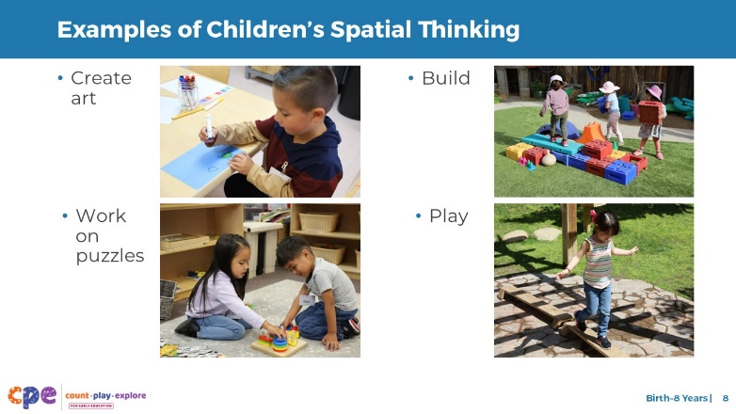

### Talking Points

* Children use spatial thinking and language in their play and everyday experiences. For example:
  + When children make art, they use spatial thinking to decide where to put various items, shapes, lines, or drawings on their paper.
  + When they work on a puzzle or build with blocks, they rotate, flip, and slide pieces in various directions to get them to fit.
  + During outdoor play, children use spatial thinking to navigate “up,” “down,” “under,” and “through” play equipment.
  + Children with various abilities might use spatial thinking in different ways. For example, a child with cerebral palsy might use a computer to draw or play puzzle games. A child with visual impairment might use touch to figure out the position of different parts of their play-dough sculpture.

### Facilitator Notes

* Math is everywhere! This principle is key to the Count Play Explore professional development approach.
* You might invite participants to share ways they have observed children using spatial thinking in their learning setting.

## SLIDE 9: Spatial Thinking Skills and Math Learning

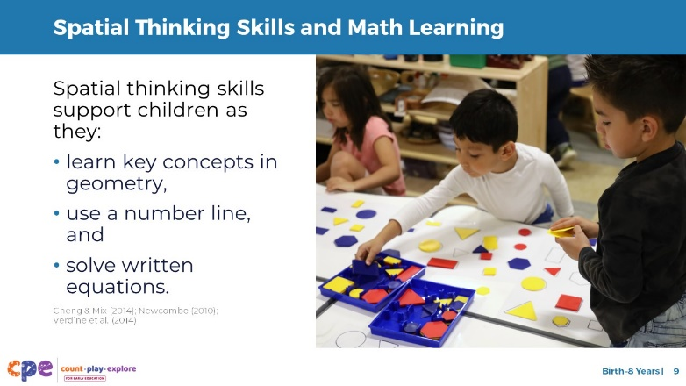

### Talking Points

* Spatial thinking skills are important math concepts addressed in the California Infant/Toddler Learning and Development Foundations, Preschool/Transitional Kindergarten Learning Foundations (PTKLF), and the Common Core State Standards: Mathematics.
* Spatial thinking skills help children to learn about and perform different math tasks (Cheng & Mix, 2014; Newcombe, 2010; Verdine et al., 2014). Several research studies relate spatial thinking skills to children’s ability to:
  + learn key geometry concepts, such as mentally rotating shapes to create new shapes (for example, two triangles can be used to create a rectangle);
  + use a number line (for example, children rely on spatial thinking skills to understand that the position of a number on a number line relates to its quantity); and
  + solve written equations (for example, children must consider the position of numbers in an equation to be able to solve the problem).

## SLIDE 10: Developing Spatial Thinking

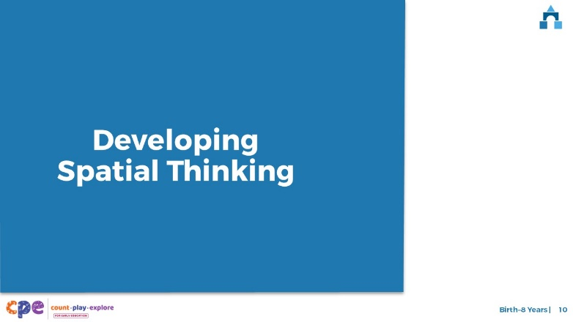

### Talking Points

* We defined spatial thinking and explored various ways that spatial thinking plays an important role in the lives of children and adults. Now, let’s discuss how young children develop spatial thinking.

## SLIDE 11: Four Components of Spatial Thinking

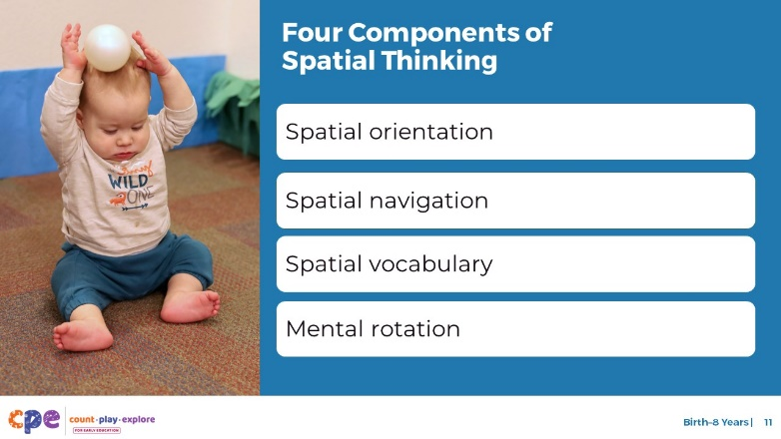

### Talking Points

* In the next few slides, we will describe four components of spatial thinking (you used these same skills in the activity we did earlier):
  + Spatial orientation
  + Spatial navigation
  + Spatial vocabulary
  + Mental rotation

### Facilitator Notes

* Consider inviting participants to record a brief, personally meaningful definition of each concept—a way to describe the concept in a way that makes sense to them—as you move through the next four slides. Ask them to fold a piece of paper in half and then half again, making four sections. Invite participants to label each section with one of the four concepts: spatial orientation, spatial navigation, spatial vocabulary, and mental rotation. They might also include a relevant and meaningful example.
* For a more in-depth understanding of how children develop spatial thinking, consider reviewing the research brief, “Shapes and Spatial Reasoning: The Development of Geometry Knowledge from Infancy Through the Early School Years.”

## SLIDE 12: Spatial Orientation

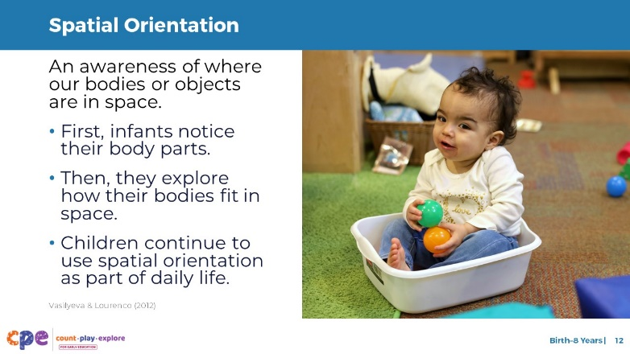

### Talking Points

* Spatial orientation is an awareness of where our bodies or objects are in space.
* From birth, infants begin to develop an awareness of their bodies in space (Vasilyeva & Laurenco, 2012), like noticing their hands and feet.
* They also notice where objects and other people are in space. For example, infants pay attention to where their caregiver is.
* Infants notice where objects are in relation to themselves. For example, infants may notice that a ball is far from their body. They may show this understanding by reaching or crawling toward the ball.
* Older children understand where objects are in relation to other people or objects. For example, “The ball is close to the door.”
* As children gain motor skills, they might explore how their bodies fit into space by climbing inside things, such as large boxes.
* From preschool through early elementary school, children continue to explore and use spatial orientation. For example, they use spatial orientation when they consider how a ball is positioned before they move it or think about their body’s position as they move to be near a friend.
* Spatial orientation helps children develop more complex spatial skills, such as spatial navigation and mental rotation.

### Facilitator Notes

* Optional activity (review the facilitator notes for slide 11): Provide time and guidance for participants to record their own definitions and examples of spatial orientation. For longer sessions, consider inviting participants to share their definitions with the group or a partner.
* If you used the “Body-Scale Icosahedron,” you might use this prompt:
  + **Spatial orientation** is how our bodies and objects are positioned in space. While building the icosahedron, in what ways did you position your body and objects?

## SLIDE 13: Spatial Navigation

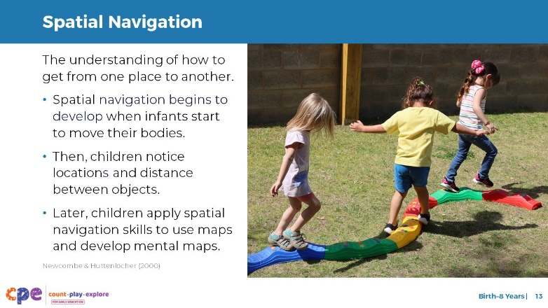

### Time

10 minutes (including brief reflection on this slide)

### Talking Points

* Spatial navigation is knowing how to get from one place to another.
* As infants begin to move around and explore their environment, they learn to navigate through space (Newcombe & Huttenlocher, 2000). They might be motivated to move to reach a toy or be closer to their caregiver. With their growing spatial navigation skills, they understand, for example, that they need to go around a pillow to reach a toy or their caregiver.
* Toddlers begin to understand that objects may look different from various angles. For example, chairs look different from the front and back. This understanding of different perspectives supports spatial navigation skills that are developed later. For example, when using a map, children need to consider what things might look like from different perspectives.
* Preschool-aged children consider the location of objects in relation to other objects. They think about whether objects are “above,” “below,” “near,” or “far” from each other and use this information to help them move through space to achieve their goal. For example, preschoolers might understand that their toy is “next” to the lamp that is “near” the door.
* Children in the early elementary grades apply their spatial navigation skills in different ways. For example, they might use a map to find a hidden treasure or toy. Or children might visualize the path (creating a mental map) from where they live to a friend’s home or how to get from where they live to school.
* Think about the activity we did earlier. With a partner, discuss the ways you used spatial orientation and spatial navigation skills in that activity. [**Note:** This talking point refers to the “Thinking About Space” activity on slide 4 or the optional activity, “Body-Scale Icosahedron.”]

### Facilitator Notes

* For longer sessions, invite a few partners to share with the larger group. Connect participants’ comments with the text on the slide.
* Optional activity (review the facilitator notes for slide 11): Provide time and guidance for participants to record their own definitions of spatial navigation and meaningful examples. For longer sessions, consider inviting participants to share their definitions with the group or a partner.
* If you engaged participants in the “Body Scale Icosahedron” experience earlier in the session, you might use the following prompt:
  + **Spatial navigation** is knowing where things are and how to get from one place to another. While building the icosahedron, in what ways did you use spatial navigation skills? For example, did you move around others as you were building? Did you give or receive directions on how to move or where to find something?

## SLIDE 14: Spatial Vocabulary

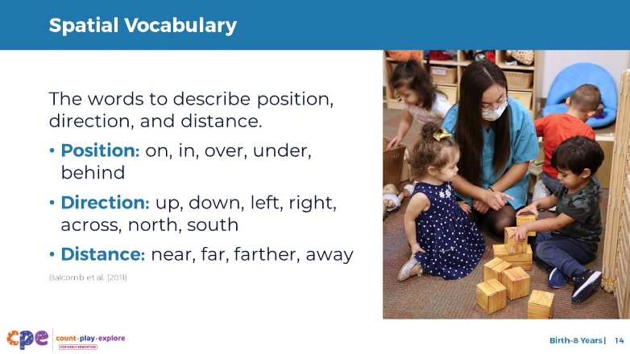

### Time

5–10 minutes (including debrief on this slide)

### Talking Points

* Children develop a sense of where they are in space (orientation) and how to navigate through space before they can use language to describe what they are experiencing. As children develop language skills, they might use vocabulary to describe spatial relationships.
* Think about the vocabulary you used in the activity we did earlier. [**Note:** This talking point refers to the “Thinking About Space” activity on slide 4 or the optional activity, “Body-Scale Icosahedron.”]
* What vocabulary did you use to describe position, direction, or distance? Let’s share some of that vocabulary. [Invite participants to share some of the words they used during the activity.]
* [After participants share some of the words they used:] We know and use a lot of spatial vocabulary. Many of the words you shared fit into one of three categories for spatial vocabulary.
* Spatial vocabulary includes words that describe the following:
  + Position, such as “on,” “in”, “over,” “under,” “behind,” “near,” and “between”
  + Direction, such as “up,” “down,” “left,” “right,” “across,” “north,” and “south”
  + Distance, such as “near,” “far,” “long,” “farther,” and “away”
* Children learn spatial vocabulary when adults intentionally use it to describe position, direction, and distance (Balcomb et al., 2011).
* It’s important to remember that children are learning a language before they begin using it. Modeling how to use spatial vocabulary is critical, even for our youngest learners.
* Infants and young toddlers might understand and respond to spatial vocabulary (for example, looking inside a container when an adult asks, “What’s inside?”). Children might also use gestures to communicate about space (for example, pointing up to indicate “up”).
* Toddlers will begin to use simple and common spatial words (for example, “up” and “down”). As children grow, they learn more words to describe spatial relations and directions in space (for example, “above” and “next to”).
* Educators can pay attention to multilingual learners’ use of spatial vocabulary. The language or languages a child learns will influence how they think about and describe position or location. For example, when communicating in English, a child whose home language is Spanish may say “in the table” instead of “on the table.”

### Facilitator Notes

* Optional activity (review the facilitator notes for slide 11): Provide time and guidance for participants to record their own definitions of spatial vocabulary and meaningful examples. For longer sessions, consider inviting participants to share their definitions with the group or a partner.
* If you engaged participants in the “Body Scale Icosahedron” experience earlier in the session, you might use the following prompt:
  + **Spatial vocabulary** is the language we use to describe position, direction, and distance. What spatial vocabulary did you use while building the icosahedron?

## SLIDE 15: Explore Mental Rotation

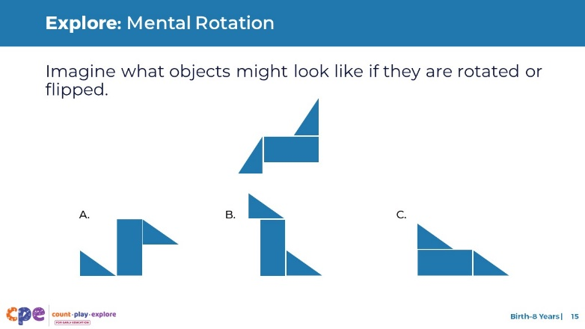

### Time

3 minutes

### Talking Points

* Mental rotation is the ability to imagine what objects might look like if they are rotated or flipped.
* Observe the image in the top row. Which of the images in the bottom row is the same as the image in the top row? [Pause to provide time for participants to think and respond. The correct answer is B.]
* To complete this task, you used mental rotation.

### Facilitator Notes

* For longer sessions, consider inviting participants to describe how they used mental rotation in this activity.
* Optional activity (see the facilitator notes for slide 11): Provide time and guidance for participants to record their own definitions of mental rotation and meaningful examples. For longer sessions, consider inviting participants to share their definitions with the group or a partner.
* If you engaged participants in the “Body Scale Icosahedron” experience earlier in the session, you might use the following prompt:
  + **Mental rotation** is being able to imagine what objects might look like when moved. In what ways did your mental rotation skills help you build the icosahedron?

## SLIDE 16: Mental Rotation

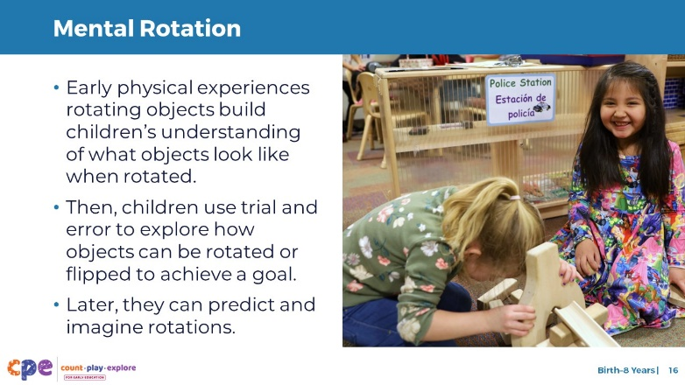

### Talking Points

* The foundations of mental rotation start early. Infants physically explore objects and learn what the objects look like when turned or flipped.
* Toddlers begin to experiment and use trial and error to explore how objects can be rotated or flipped to achieve a goal. For example, they might test out different orientations of shapes when trying to fit them into a shape sorter.
* Preschool and early elementary-aged children have a lot of physical experience with objects. They can predict or imagine what objects will look like when turned or flipped, without physically turning them.

## SLIDE 17: Overview of Children’s Development of Spatial Thinking

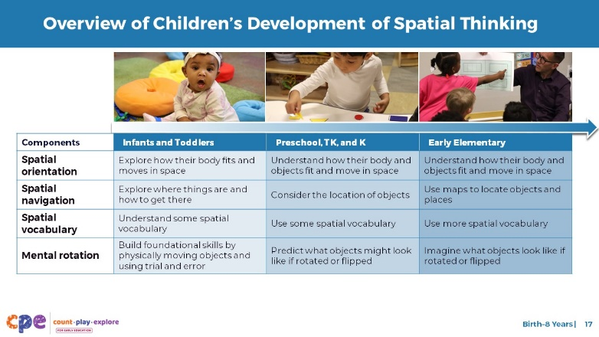

### Talking Points

* As we discussed, the development of these four components starts early and builds in complexity over time.
* This slide summarizes how children at three points of development explore and develop spatial thinking.
  + Infants and toddlers experiment with how their bodies and objects fit in space. They notice where things are in relation to themselves. They begin to explore where things are and how to get there. These young children begin to understand spatial vocabulary. Their early experiences in physically moving objects and using trial and error to learn how objects fit in space lay the foundations for spatial thinking and how objects may look from different perspectives.
  + Children in preschool, TK, and K build on their early spatial orientation and spatial navigation skills. They understand how their bodies and objects fit in space and pay attention to the orientation of objects relative to others. They think about where objects are and begin to use some spatial vocabulary. Preschool, TK, and K children also start to make predictions about what objects might look like if turned or flipped.
  + In the early elementary grades, children begin to master many of these concepts. They understand how their bodies and objects fit in space (for example, fitting their belongings inside their desk, fitting containers in their lunch box, or fitting words on a line when writing sentences). They start to use maps to locate objects and places and use a variety of spatial vocabulary accurately. They are also able to imagine what objects look like if turned or flipped.

## SLIDE 18: Play: Body-Scale Icosahedron

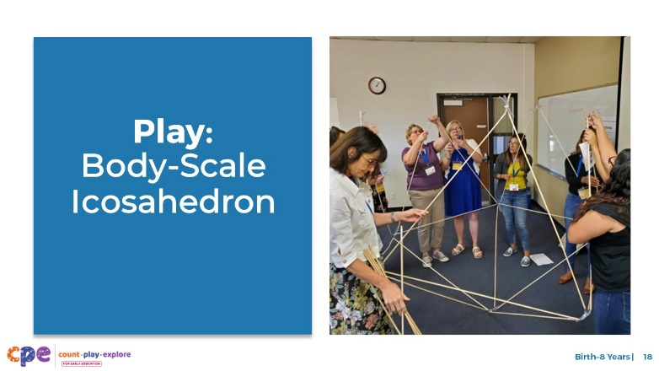

### Time

30–60 minutes (including reflection and debrief on the next slide)

### Materials

**Body-Scale Icosahedron** handout, wooden dowels, eye hooks, spring O-rings

### Talking Points

* Now, let’s apply spatial thinking in a playful, hands-on activity for adults.
* We will use our spatial thinking and geometry knowledge to construct a very large icosahedron [pronounced: eye-koh-suh-hee-druhn].
* An icosahedron is a three-dimensional shape with 20 faces that are all equilateral triangles.
* Take out the **Body-Scale Icosahedron** handout. [Review the handout with participants and provide support as needed. As participants build their icosahedrons, move around the room. Make note of the spatial thinking that participants use.]

### Facilitator Notes

* Math is playful! This principle is key to the Count Play Explore professional development approach. This activity invites adults to explore spatial thinking through play.
* You might invite participants to build the icosahedron without the step-by-step instructions to encourage more problem-solving and increase the use of spatial thinking skills. Consider explaining how to use the dowels (for example, connecting the eye hooks with O-rings) and sharing photos of the completed icosahedron. If participants need more support, invite them to use the step-by-step instructions on the handout.
* For additional support, share the video, “[Building the Body Scale Icosahedron (Activity for Adults)](https://youtu.be/3_AsHisCqQM), “[Building the Body Scale Icosahedron (Activity for Adults) – Audio Descriptive Version](https://youtu.be/Magv8F1TVug).”
* You might use this activity in place of the “Thinking About Space” activity on slide 4. Rearrange this slide as necessary.
* Icosahedra [pronounced: eye-koh-suh-hee-druh] is the plural of icosahedron [pronounced: eye-koh-suh-hee-druhn].
* Before your session, carefully review the handout and prepare the necessary materials.
* Select a facilitation method that works best for your session length and format, group size, and participant needs.

## SLIDE 19: Discuss: Body-Scale Icosahedron

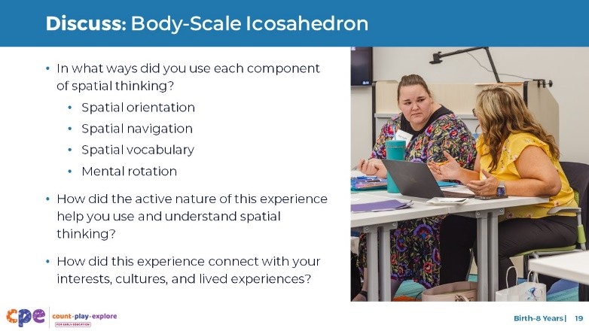

### Time

30–60 minutes (including the activity on the previous slide)

### Materials

**Body-Scale Icosahedron** handout

### **Talking** Points

* Let’s discuss this activity. At your table, describe how you used each of the following components of spatial thinking:
  + Spatial orientation
  + Spatial navigation
  + Spatial vocabulary
  + Mental rotation
* How did the active nature of this experience help you use and understand spatial thinking?
* Connecting activities to learners’ (adults’ and children’s) interests, languages, cultures, and lived experiences is important. What personal connections might you make to the experience of building the icosahedron? Consider your individual interests, languages, cultures, and lived experiences.
* [After some time for small group discussion, invite participants to share with the larger group. Then, summarize the purpose of doing this activity together.]

### Facilitator Notes

* If you chose to engage learners in the “Body-Scale Icosahedron” experience earlier in the session (slide 4), do not use this slide. The prompts and questions on this slide are included in facilitator notes on slides 12, 13, 14, and 16) to help participants make connections between this activity and each component of spatial thinking.
* Adjust the way participants discuss (for example, in pairs or at tables) based on your group size, session length and format, and participant needs.
* Allow time for participants to share their experiences with the whole group and summarize the purpose of this activity.
* To facilitate discussion, consider using the following prompts:
  + **Spatial orientation** is how our bodies and objects are positioned in space. While building the icosahedron, in what ways did you position your body and objects?
  + **Spatial navigation** is knowing where things are and how to get from one place to another. While building the icosahedron, in what ways did you use spatial navigation skills? For example, did you move around others as you were building? Did you give or receive directions on how to move or where to find something?
  + **Spatial vocabulary** is the language we use to describe position, direction, and distance. What spatial vocabulary did you use while building the icosahedron?
  + **Mental rotation** is being able to imagine what objects might look like when moved. In what ways did your mental rotation skills help you build the icosahedron?

## SLIDE 20: Reflect: What? So What? Now What?

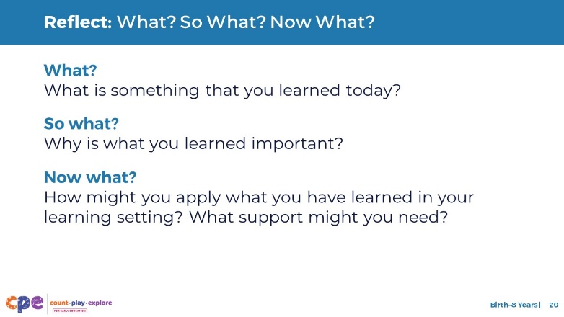

### Time

5–10 minutes

### Talking Points

* We discussed four components of spatial thinking: spatial orientation, spatial navigation, spatial vocabulary, and mental rotation.
* We explored how these four skills develop throughout early childhood. We also applied these spatial thinking skills in a playful, hands-on experience for adults.
* Now, let’s take a moment to reflect on our session. Consider the following questions.
  + What? What is something that you learned today?
  + So what? Why is what you learned important?
  + Now what? How might you apply what you have learned in your learning setting? What support might you need?
* [Provide five minutes for participants to think about and answer the questions on their own.]
* [Select a facilitation method that works best for your session length and format, group size, and participant needs.]
* Thank you for sharing your reflections with the larger group.
* This session was designed to describe the components of spatial thinking for children from birth to eight years old.
* When you return to your learning setting, notice the ways children use spatial thinking. Pay attention to how you support children’s spatial thinking.
* Noticing will help you be more intentional about how you support children’s spatial thinking.

### Facilitator Notes

* For shorter sessions, you might ask participants to record their thoughts and then share them with the larger group.
* For longer sessions, consider making the “What,” “So what,” and “Now what” responses more visible. Ask participants to record each thought on a separate sticky note. While they are recording, create three charts. Label them “What?” “So What?” and “Now What?” When participants finish recording their thoughts, invite them to post their sticky notes on the appropriate charts. Then, facilitate a gallery walk or use another method that allows participants to review others’ ideas.
* PPT 2a “Spatial Thinking: Infants and Toddlers” and PPT 2b “Spatial Thinking: Preschool, TK, K” provide age-specific information on how children develop spatial thinking and ways educators might support their development of spatial thinking.