Number and Counting: Preschool, Transitional Kindergarten, and Kindergarten (PPT 2b)

Use this facilitator guide with the slides “Number and Counting: Preschool, Transitional Kindergarten, and Kindergarten.” Facilitators can find talking points and guidance for activities and group discussions in this guide. The text in the guide is also located in the notes portion of the slides. Adapt this facilitator guide based on your group size, session length and format, and participants’ needs.

## SLIDE 1: Number and Counting: Preschool, Transitional Kindergarten, and Kindergarten

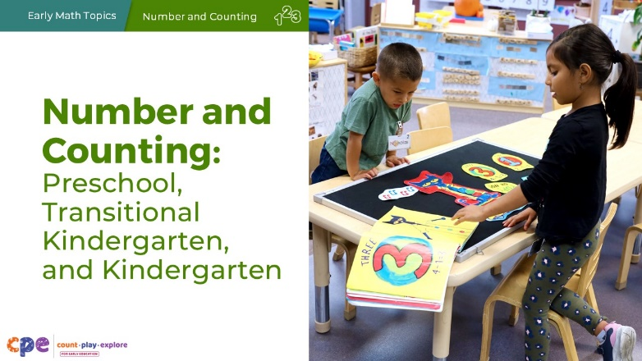

### Talking Points

* In this session, we will explore how children in preschool, transitional kindergarten, and kindergarten develop an understanding of number and counting. We will also focus on ways we can support children (three to six years old) to develop counting skills.
* Children three to five years old may be in preschool or transitional kindergarten. They may be in center-based programs; family child care programs; or family, friend, and neighbor care. Regardless of the setting, children this age learn math through play, daily routines and meaningful interactions with peers and adults.

### Facilitator Notes

* Adjust talking points to reflect your session length and participant needs. If necessary, add introductory and “housekeeping” information.
* We recommend providing collections of small objects (for example, paper clips, shells, cotton balls, counting chips) that participants can use to engage in counting experiences throughout this session. If your agency implements *Counting Collections* (Franke et al., 2018), provide some of these collections or invite educators to bring their own counting manipulatives from their learning setting. Consider providing enough manipulatives so each table group has their own set of small objects.
* Share with participants that, in this session, we use “TK” to refer to transitional kindergarten and “K” for kindergarten.
* As you plan your professional learning session, consider the content in each of the PPTs in this suite:
  + PPT 1 “Introduction to Number and Counting” describes how children develop knowledge and understanding of number and counting from birth to age eight.
  + PPT 2a “Number and Counting: Infants and Toddlers” and PPT 2b “Number and Counting: Preschool, Transitional Kindergarten, and Kindergarten” describe in greater depth how children at different age levels develop an understanding of number and counting. These PPTs also include guidance on how to support children in specific age ranges to develop number and counting skills.
* We encourage you to offer the content in PPT 1 before, or in combination with, content in one of the age specific slide decks (PPT 2a or PPT 2b). Together PPT 1 and one of the age specific slide decks have been designed for a three-hour professional learning session. However, you might adjust slide decks to best meet participant needs and time allowances.

## SLIDE 2: Acknowledgments

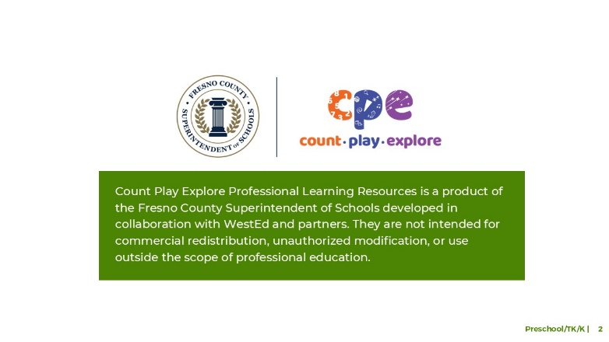

### Talking Points

The Count Play Explore Professional Learning Resources were made possible by Count Play Explore, an early math and science initiative led by the Fresno County Superintendent of Schools, Early Care and Education Department. This initiative is generously funded by the California Department of Education and the California State Board of Education. These resources, developed in collaboration by WestEd and partners, are intended to be used as a guide for implementing evidence-based strategies, promoting active learning, and encouraging developmentally appropriate practices in early education settings. They are not intended for commercial redistribution, unauthorized modification, or use outside the scope of professional education.

## SLIDE 3: Session Goals

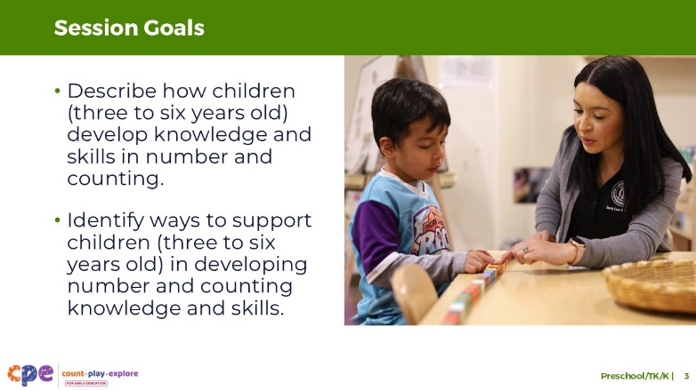

### Talking Points

* First, we will review how children in preschool, TK, and K develop knowledge and skills in number and counting.
* Then, we will explore some ways that educators and families can support preschool, TK, and K children to develop knowledge and skills in number and counting.
* We will also make connections to how children in first and second grade further understand number and advance their counting skills.
* Throughout our session, we will take time to reflect on our current practices. We will also think about how we might use information from this session in our work.

### Facilitator Notes

* Adjust slide content and talking points to reflect what you plan to address in your professional learning session.
* For longer sessions, you might start the session by engaging participants in the interactive **Alphabet Counting** activity described in PPT 1 “Introduction to Number and Counting: Birth–8 Years” and its corresponding handout. The purpose of this activity is to help participants become aware of the different skills involved in counting by inviting them to use a new counting system—the alphabet counting system.

## SLIDE 4: Play: Counting Fun

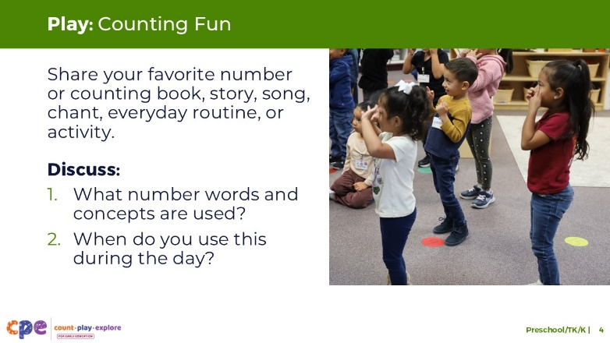

**Time:** 15–20 minutes

### Talking Points

* Children ages three to six are learning about numbers every day and count to find out how many. For example, they practice counting through books, songs, everyday routines, and activities.
* Think about some counting books, stories, songs, chants, everyday routines, or activities that you use in your learning setting—in English or any other language.
* Share, with your table group, one of your favorite number and counting books, stories, songs, chants, everyday routines, or activities to use with children ages three to six. Then, discuss the following with your group:
  + What number words or concepts are used?
  + When might you use these books, stories, songs, chants, or activities (for example, during a specific daily routine)? Share why it’s used during that routine.

### Facilitator Notes

* Adjust the way you organize the activity based on group size, session length and format, and participants’ needs.
  + For longer sessions, consider asking each table group to perform one or two songs for the large group.
  + For shorter sessions, consider inviting each table to focus on the first question.
* After participants share with their table group, consider sharing some of the following key takeaways:
  + Participants already engage children in counting through books and stories, songs, chants, everyday routines, or activities.
  + Participants engage children in number and counting as part of daily routines and play.
  + Participants use multiple representations, such as language, movement, and gestures, to engage children in number and counting.
  + Children differ in the ways they learn and can express what they know. Language-based activities that include gestures and movements offer more than one way to learn and express counting knowledge and skills.

## SLIDE 5: Learning About Number and Counting

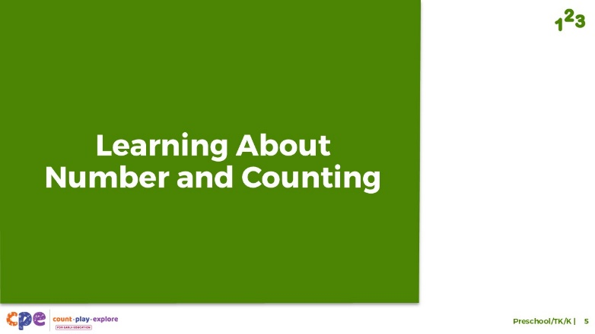

### Talking Points

* Now, we will explore how children in preschool, TK, and K develop an understanding of number and counting.

## SLIDE 6: The California Preschool/TK Learning Foundations

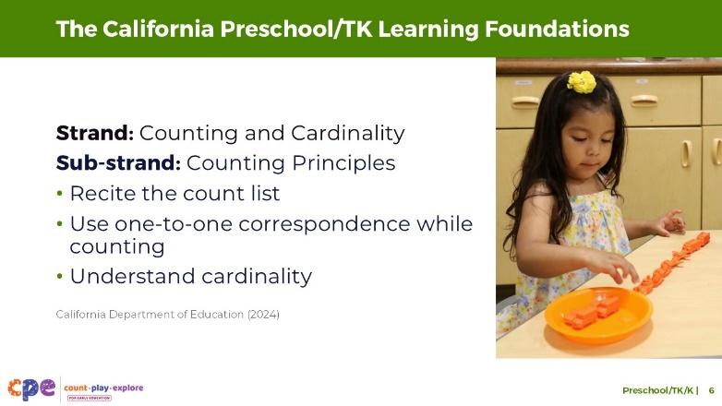

### Talking Points

* Let’s review how number and counting learning is represented in the California Preschool/Transitional Kindergarten Learning Foundations (PTKLF; California Department of Education, 2024). The recently revised foundations were designed to align with expectations stated in the California Common Core Kindergarten Mathematics Standards.
* Six standards in the “Counting and Cardinality” strand describe what children learn about number and counting in preschool or TK.
  + Three of these standards are part of the “Counting Principles” sub-strand.
  + These standards describe children’s ability to (1) recite the count list, (2) use one-to-one correspondence while counting, and (3) understand cardinality.

### Facilitator Notes

* Slides 6 through 8 make connections to foundations and standards for number and counting.
* The PTKLF addresses children aged 3–5, this includes both children in preschool and TK. The California Common Core State Standards in Mathematics include standards for children in kindergarten.
* The foundations and standards listed in some of the slides are condensed. Consider providing participants with copies of the relevant California Preschool/TK Learning Foundations or the California Common Core State Standards. Consider whether electronic or printed copies will be more useful for your participants.

## SLIDE 7: The California Preschool/TK Learning Foundations (continued)

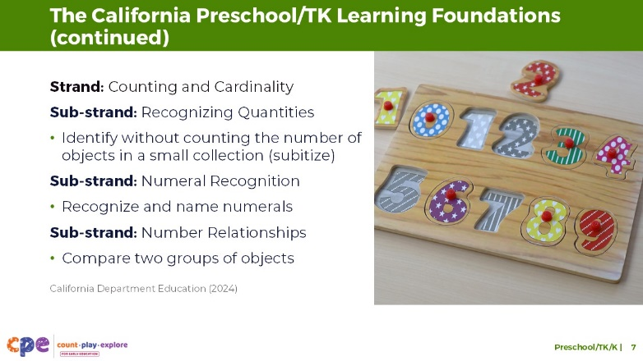

### Talking Points

* The remaining three standards describe children’s ability to:
  + identify without counting the number of objects in a small collection. This skill is called subitizing.
  + recognize numerals under 10.
  + compare quantities using strategies like counting. It also describes their ability to use vocabulary like “more,” “less,” and “same.”

## SLIDE 8: The California Common Core

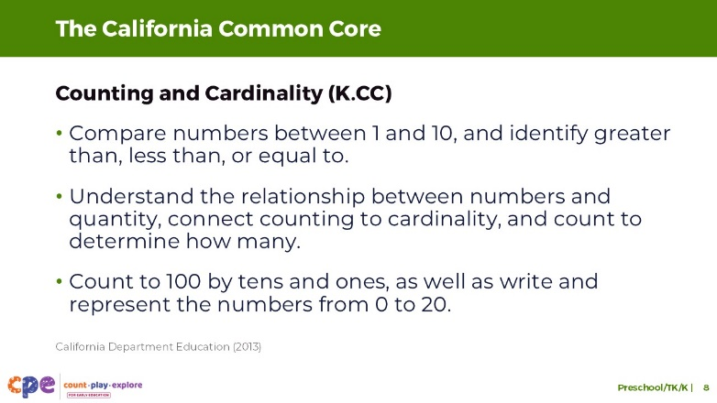

### Talking Points

* For children in kindergarten, let’s review how number and counting learning is represented in the California Common Core State Standards: Mathematics (California Common Core, 2011).
* Three kindergarten standards for counting and cardinality describe what children learn about number and counting:
  + One standard describes children’s ability to compare numbers between one and 10. This includes their ability to identify whether the group is greater than, less than, or equal to the number of objects in the other group.
  + Another standard describes children’s understanding of the relationship between numbers and quantity, connecting counting to cardinality, and counting to determine how many.
  + The last standard describes children’s ability to count to 100 by tens and ones. This standard also includes children’s ability to record and represent numbers from zero to 20.

## SLIDE 9: Four Components of Number and Counting

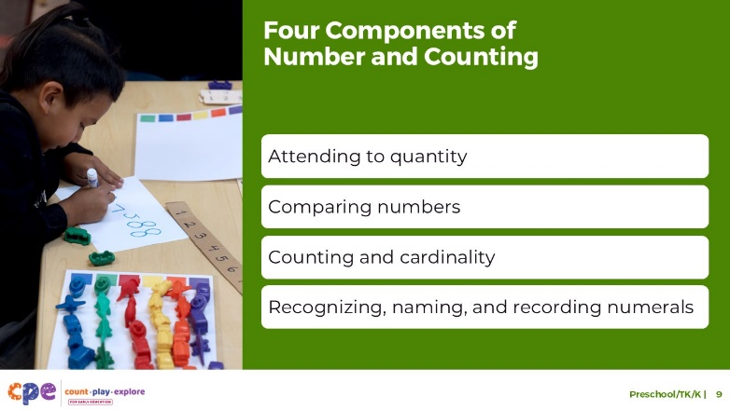

### Talking Points

* This learning suite addresses four components of children’s growing understanding of number and counting:
  + attending to quantity
  + counting and cardinality
  + comparing numbers
  + recognizing, naming, and recording numerals
* For this age group (three to six years old), we will focus on the last three components: counting and cardinality; comparing numbers; and recognizing, naming, and recording numerals. The first component, attending to quantity, describes infants’ and toddlers’ interest in quantity and ability to notice quantity in the environment. These abilities generally develop before preschool.

### Facilitator Notes

* For more information about how young children attend to quantity, review PPT 1 “Introduction to Number and Counting: Birth–8 Years.”

## SLIDE 10: Counting and Cardinality: Counting Principles

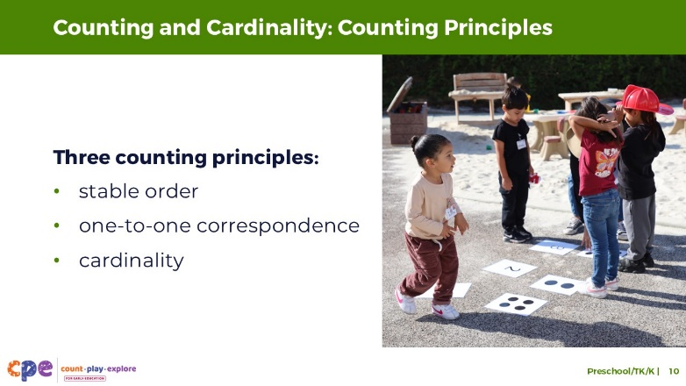

### Talking Points

* We will first focus on children’s developing understanding of counting and cardinality. This component represents one of children’s greatest math accomplishments in the early years. It also sets the basis for the development of other number skills such as making comparisons and solving addition and subtraction problems.
* Children learn about the meaning of counting by observing adults or other children use counting to find out how many.
* As children learn to count with meaning (or to find out how many), they learn to apply three counting principles naturally:
  + stable order
  + one-to-one correspondence
  + cardinality
* Before we explore these three counting principles in more detail, let’s take a moment to do some counting ourselves.

## SLIDE 11: Let’s Count!

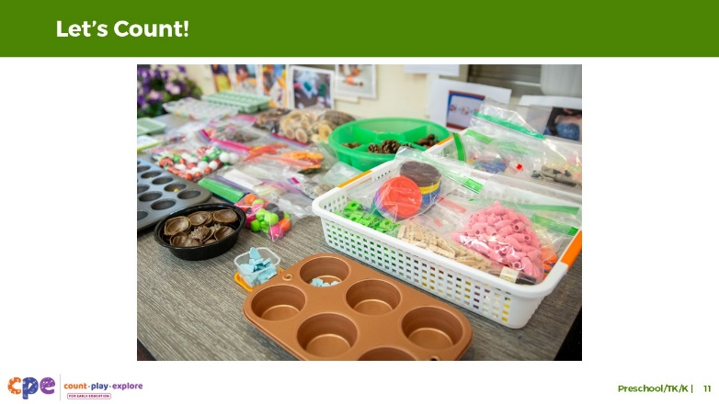

**Time:** 5–10 minutes

**Materials:** 30–40 small objects for each table or small group (paperclips, counters, pens, pinecones, or buttons)

### Talking Points

* [Select a facilitation strategy from the Facilitator Notes]
* [Provide each table group with their own collection of 30–40 small objects. Then:] Take turns counting the objects on your table. As you watch others count, notice the strategies they are using.
  + How are they keeping track of which objects they have counted and which ones they still need to count?
  + Are they counting by one or skip-counting by two or five?
  + What language are they counting in?
  + Is everyone using the same strategies?
* [Provide time for participants to count.]
* [Then, depending on the facilitator strategy you chose, invite participants to share their strategies and observations.]
* As adults, we count without having to think about it. Many of the strategies we use to count come naturally to adults but think what it takes for a child who is just learning to count. In the next few slides, we will discuss some of the concepts and skills children need to learn in order to develop an understanding of counting and cardinality.

### Facilitator Notes

* Adjust the way you organize the activity based on group size, session length and format, and participants’ needs. For example:
  + For longer sessions, you might invite participants to work individually and share their experiences with their tables before discussing as a larger group.
  + For shorter sessions, you might invite participants to work with a partner and share with the larger group.
* The activity is similar to *Counting Collections* (Franke et al., 2018)*,* an activity in which young children count a collection of objects and then make a representation of what they counted. Learn more about Counting Collections on the [DREME TE website.](https://prek-math-te.stanford.edu/counting/counting-collections-overview)
* Note: this slide is also featured in PPT 1: “Introduction to Number and Counting: Birth–8 Years.”

## SLIDE 12: Counting Principle 1: Stable Order

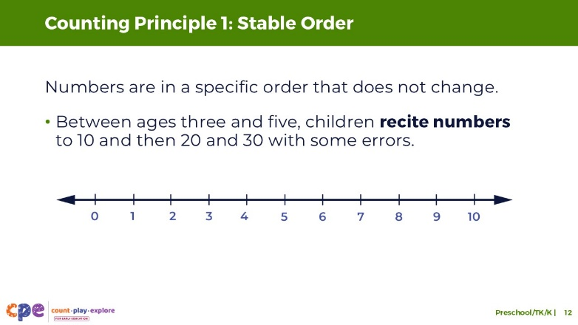

### Talking Points

* The first counting principle is stable order. **Stable order** is understanding that numbers are in a specific order, and this order never changes. It also means understanding that you always start counting at one.
* Children develop an understanding of stable order when they learn to recite the **count list**.The count list is the ordered list of number words in any language, including sign language.
  + For example, the count list in English is one, two, three, four, five, and so on.
* Between ages three and four, children learn to recite numbers up to 10 in their home language, English, or both. This skill requires a lot of practice and modeling from adults.
  + At first, children will make mistakes when reciting the count list to 10. They may skip or repeat a number, and children usually make the same mistakes consistently (for example, a child may always skip eight when counting from one to 10).
* Between the ages of four and five, children recite numbers up to 30.
  + For example, a child in TK might count a handful of pumpkin seeds they scooped out of a pumpkin.

## SLIDE 13: Stable Order: Kindergarten

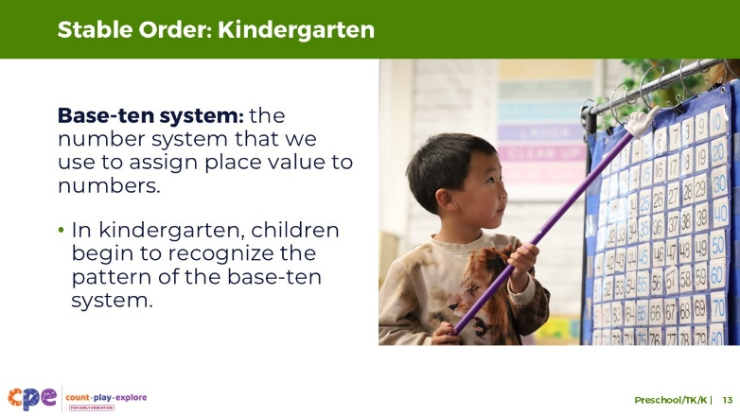

### Talking Points

* In kindergarten, as children learn to count to 100 in their home language, English, or both, they begin to recognize the pattern of the base-ten system.
  + The **base-ten system** is the number system that we use to assign place value to numbers. The base-ten system uses digits 0, 1, 2, 3, 4, 5, 6, 7, 8, and 9 to represent all other numbers in its system.
  + When children recognize the pattern of the base-ten number system, they realize an important mathematical concept. That is, once they start a new decade, they just repeat through the numbers one through nine before getting to the next decade.
  + Even once children start recognizing this pattern, they may need help recalling the sets of tens. For example, they might say “twenty-ten” instead of 30.

## SLIDE 14: The Role of Language in Counting

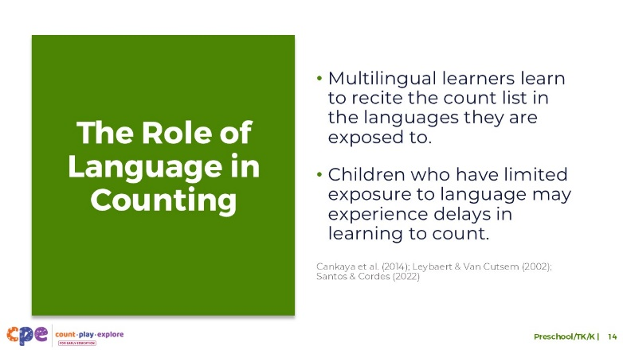

### Talking Points

* Before we discuss counting principles two and three, here is a note about the role of language in children’s ability to recite the count list.
* Consistent exposure and opportunity to use number words—in any language—plays an important role in learning to count, specifically learning to recite the count list.
  + Multilingual learners learn to recite parts of the count list in any of the languages they are exposed to frequently. For example, a child learning Spanish at home and English in their early learning and care setting may communicate their first few number words in Spanish.
  + The types of languages children are exposed to can also influence children’s understanding of number and counting (Cankaya et al., 2014). Languages vary in how they represent mathematical concepts, including their number-naming system. Languages such as Chinese or Japanese have a number system in which number words map directly onto a base-ten structure (for example, the word for “11” in Chinese is equivalent to “ten-one”). Languages such as English and Spanish have a less obvious number word system (for example, the word for “11” in English is “eleven”). Research suggests that children learning languages with more transparent number systems, such as Chinese, Japanese, or Arabic, may have an easier time (at least at first) in learning to recite numbers, especially numbers that follow ten.
* However, research suggests that children with limited language exposure in the early years may experience delays in learning to count or producing number words.
  + For example, children who are deaf or have hearing impairments and are learning sign language may experience delays in learning parts of the count list compared to hearing children (Santos & Cordes, 2022).
  + This might be because caregivers are not fluent in sign language and have fewer ways to communicate with their children. As a result, they may not be exposing the children to as much language—including number and counting words—as hearing children.

### Facilitator Notes

* Note: this slide is also featured in PPT 1: “Introduction to Number and Counting: Birth–8 Years.”

## SLIDE 15: Counting Principle 2: One-to-One Correspondence

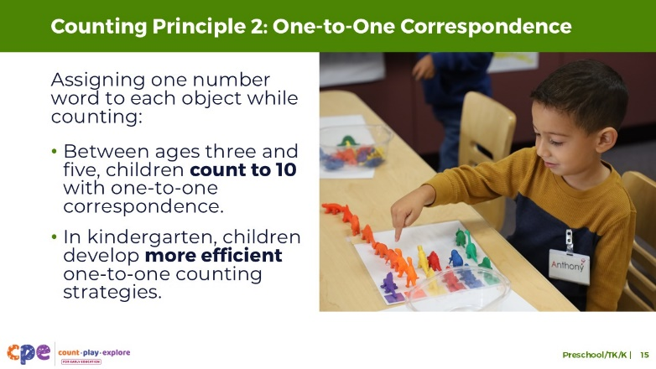

### Talking Points

* The second counting principle children develop an understanding of is **one-to-one correspondence**.One-to-one correspondence is the ability to assign one number word to each object while counting.
* In the early stages of learning to count a set of objects, children do better with small sets and when sets are organized in rows.
* Between ages three and five, children have many opportunities to count sets of objects as part of daily play and routine activities. As a result, they learn to count larger groups of objects (up to 10) with increasing accuracy, using one-to-one correspondence.
* As children are learning one-to-one correspondence, they may make errors, such as counting the same item twice or skipping one item. These errors are often related to their fine motor skills, memory, or ability to regulate their attention.
  + Adults can help children avoid these errors by modeling and encouraging them to use strategies like touching items as they count, counting items from left to right, and moving items they’ve counted to one side.
* Children develop more efficient one-to-one counting strategies between the ages of four and five. For example, they are more likely to use some of these strategies like moving items they’ve counted to one side, without support from an adult.

## SLIDE 16: Counting Principle 3: Understanding Cardinality

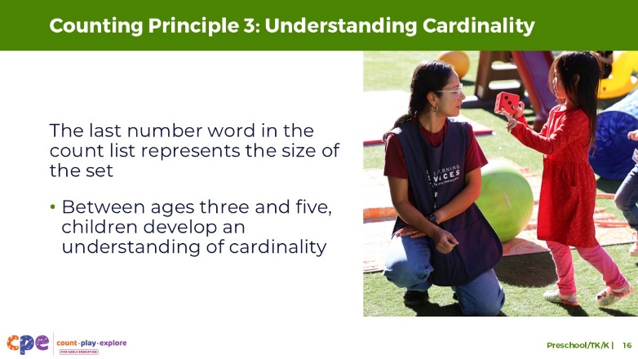

### Talking Points

* Developing an understanding of cardinality is the third counting principle.
* Most children develop an understanding of cardinality around age five.
* **Cardinality** is understanding that, when counting, the last number word in the count list represents the size of the set.
  + For example, a child might count a row of four toy cars: “one, two, three, four.” If they understand cardinality, they know that the number word “four” does not just label the fourth toy car but that it labels the total number of toy cars in this set.
* Developing an understanding of cardinality is quite complex and requires a lot of practice with counting and answering “how many” questions.
* Once children understand this concept, they also understand that how they arrange the objects doesn’t matter. They understand that counting from top to bottom, left to right, or in any variation does not affect the number of objects.
* Building on this foundation, children in the early grades use their counting skills to solve addition and subtraction problems.
* Research on multilingual children’s understanding of counting and cardinality shows that as children first learn to recite numbers, they may show different counting levels in their various languages (for example, a child may recite numbers to 10 in English but only to six in Spanish). However, this research also finds that once children develop an understanding of cardinality, they can represent this knowledge using any of their languages (Wagner et al., 2015).

## SLIDE 17: Counting in Kindergarten and Beyond

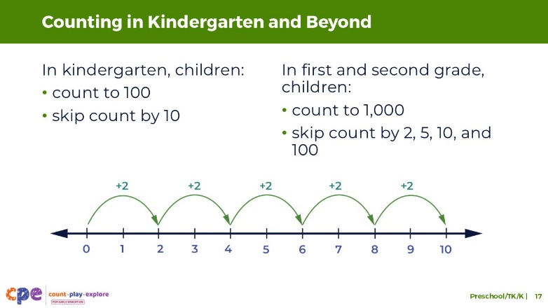

### Talking Points

* One of the skills children develop in the early grades is skip counting. Let’s practice some skip counting together.
* [Invite participants to skip count by two, five, and 10. Select a facilitation strategy from the Facilitator Notes.]
* [After the skip counting activity:] As children transition into kindergarten, first grade, and second grade, their understanding of number and counting skills progresses. That is, they can recite to higher numbers in their home language, English, or both.
* By the end of kindergarten, children can recite the count list to 100.
* As children transition into first grade, they can recite the count list to 120. By the end of second grade, children count within 1,000.
* Children also learn to skip count in their home language, English, or both. **Skip counting** is counting forward by a number other than one. Therefore, skip counting by ten is counting 10, 20, 30, and so on.
  + By the end of kindergarten, children learn to skip count by tens to 100. They also count forward from a number other than one.
  + As children transition into first and second grade, they can skip count by 2, 5, 10, and 100.

### Facilitator Notes

* Adjust the way you facilitate this short activity based on your group size, session length and format, and participants’ needs.
* Consider the following options for facilitating this activity:
  + Use an object such as a ball, or a balled-up piece of paper, that participants can toss across the room to different people. Each time someone catches the ball, they must name the next number in the skip counting sequence, then they toss the ball to the next person.
  + Invite participants to gather around in a circle and go around naming the next number in the skip counting sequence.

## SLIDE 18: Explore: Playful Activities to Support Number and Counting

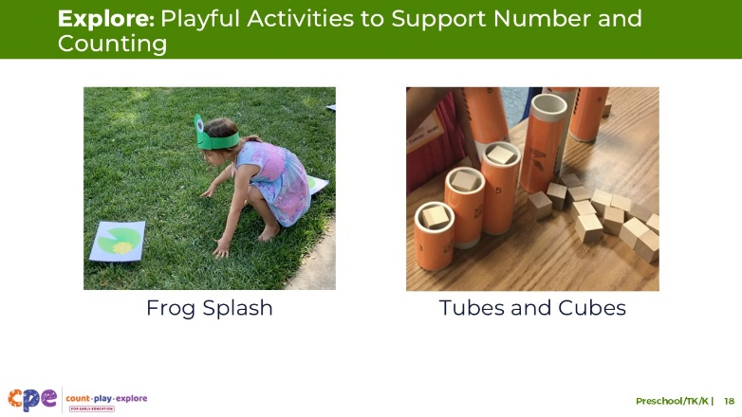

**Time:** 5–10 minutes

**Materials: Frog Splash or Tubes and Cubes: A Counting Activity** handout, chart paper, markers

### Talking Points

* Here are examples of two activities you can offer children to practice their counting skills. Of course, these are just two examples of activities. As we will discuss later in the session, you can support children’s knowledge and skills in number and counting in many other ways.
* Take out and read the **Frog Splash** and **Tubes and Cubes** activity.
* With a partner, choose one of the handouts. Review the handout together. Then, discuss how you might use this activity in your settings. Consider the following questions:
  + Think about the children in your setting. In what ways might you modify this activity to respond to children’s interests, languages, cultures and lived experiences, abilities, and emerging skills and knowledge?
  + What vocabulary might be introduced through this activity?
  + You may also want to share some other activities that you have used in your setting that allow children to practice similar number and counting skills.

### Facilitator Notes

* These handouts include instructions for setting up the activity and ideas on how to support children’s learning using the M5 Early Math Approach. The M5 Early Math Approach is introduced to participants later in this session, starting on slide 32. Consider introducing the activities here and returning to these activities again once you have reviewed slide 32.
* Provide 5–10 minutes for participants to review and discuss the handouts.
* Invite participants to share with the larger group how they might use the activity in their setting.
* Here are some ways participants might modify this activity to respond to children’s interests, languages, cultures and lived experiences, abilities, and emerging skills:
  + For children with motor impairments, have smaller lily pads in front of the child where the child can easily reach them.
  + For children who speak languages other than English, ask family members how to say counting words in the child’s home language.
  + To be responsive to cultures and lived experiences, invite children to bring objects in from home that can be used in the game.
* For longer sessions, consider offering time for participants to do the activity. Be sure to prepare and bring the necessary materials. Encourage participants to discuss what they notice as they engage in the activity.

## SLIDE 19: Observe: Learning About Counting and Cardinality

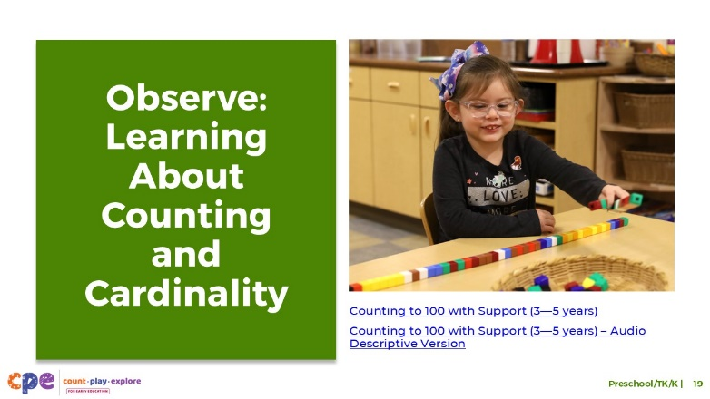

**Time:** 10–20 minutes (including debrief on next slide)

**Materials:** Preschool, TK, or K number and counting video clip

### Talking Points

* We have reviewed how children in preschool, TK, and K develop an understanding of counting and cardinality. Now, we will observe a video clip. As you observe, pay attention to the ways children are counting and understanding cardinality.
* After the clip, we will discuss what you noticed.

### Facilitator Notes

* Choose a preschool, TK, or K video clip that shows children counting.
* We provide the following videos (you may use other videos):
  + [Counting to 100 With Support (3–5 years)](https://youtu.be/rFKhGNLVck4)
  + [Counting to 100 With Support (3–5 years) – Audio Descriptive Version](https://youtu.be/lu0TeR4Xz8E)
  + [Counting Toy Vehicles in Spanish (3–5 years)](https://youtu.be/bDu4_Ra5AWY)
  + [Counting Toy Vehicles in Spanish (3–5 years) – Audio Descriptive Version](https://youtu.be/Q3cI1PqXVn4)
* **Note:** Discussion points are provided for the video “[Counting to 100 with Support (3–5 Years)](https://youtu.be/rFKhGNLVck4)” in the Facilitator Notes on the next slide.
* Consider playing the video more than once. The first time, invite participants to become familiar with the clip. Then, invite participants to observe specific ways children show their understanding of counting and cardinality.

## SLIDE 20: Discuss: Learning About Counting and Cardinality

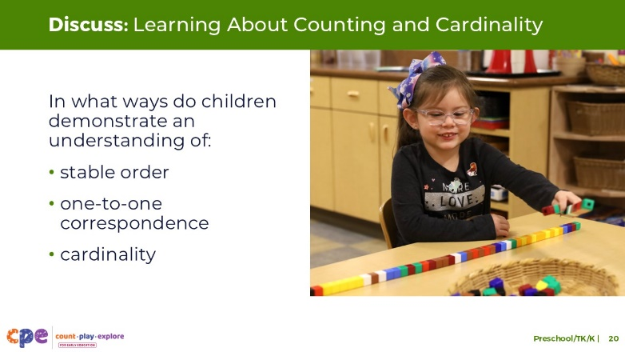

**Time:** 10–20 minutes (including observing video on the prior slide)

### Talking Points

* Let’s discuss what you noticed. In what ways did children in the video demonstrate their understanding of:
  + stable order
  + one-to-one correspondence
  + cardinality

### Facilitator Notes

* Adjust the debrief based on your group size, session length and format, and participant needs. Consider charting participants’ observations to provide a visual of ways children develop counting and cardinality skills.
* Consider using the following adaptations based on session length:
  + For shorter sessions, invite participants to share with the larger group what they noticed about ways preschool, TK, and K children showed their understanding of counting and cardinality.
  + For longer sessions, offer time for participants to share their observations in pairs or at their tables. Then, invite each table to share some of their observations.
* Here are some examples of how children in the preschool video clip “[Counting to 100 with Support (3–5 Years)](https://youtu.be/rFKhGNLVck4)” demonstrated an understanding of counting and cardinality:
  + The child was able to count to 95 with support from the educator at the decades. The child demonstrated an understanding of stable order.
  + The child engaged in one-to-one correspondence by pointing to each cube while reciting the count list.
  + The child understood that the last number word in her count list, 95, represented the total amount of cubes in her tower. The child demonstrated an understanding of cardinality.
  + The child was to calculate how many more cubes she needed to go from 95 to 100 cubes.

## Slide 21: Comparing Numbers: Visually Comparing Sets

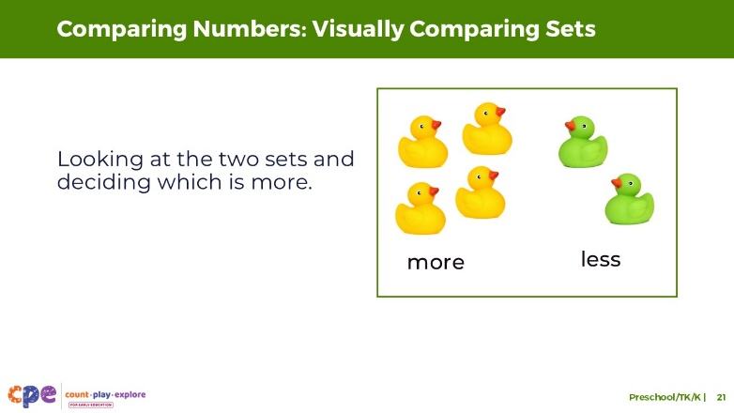

### Talking Points

* Next, let’s discuss how children compare numbers.
* Children, just like adults, may compare numbers using different strategies. Let’s review the different strategies children may use when comparing numbers.
* To compare two sets of objects, children can use visual strategies. This involves looking at the two sets and deciding which is more.
* Children and adults use this strategy when there are only a few objects.
* Children and adults can also use this visual comparison strategy when the difference between the two groups is very big.
* Although we call this a visual comparing strategy, this is not limited to the visual modality. Blind or visually impaired children and adults might compare sets by briefly touching the two sets to decide which one has more.

## Slide 22: Comparing Numbers: Matching

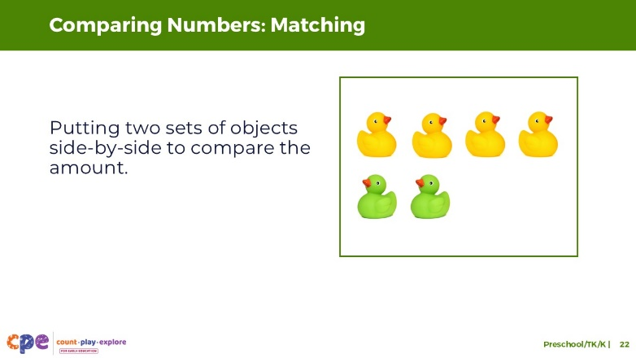

### Talking Points

* Around three years old, children learn to compare two sets of objects by matching. This involves lining up the two sets next to another in one-to-one correspondence. When children match two sets, they decide by comparing which line is longer or if they are the same.
* Young children may need scaffolding from an adult to use the matching strategy to compare two sets. However, eventually, children will engage in the matching strategy independently when asked questions like “Which one is more? How can we find out?”

## Slide 23: Comparing Numbers: Counting

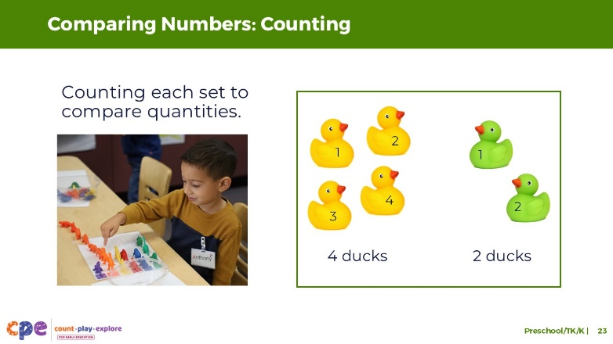

### Talking Points

* Lastly, children and adults can use counting to compare sets, which is often the most accurate way to compare sets.
* To use this strategy, children need to know how to count. Therefore, it is usually not until late preschool that children begin to use counting as a strategy to compare quantities.
  + For example, when comparing the number of blue and green cars, they might first count the blue cars to find six, then count the green cars to find five. Then they will need to use their understanding of the count list to know whether five or six is bigger.

## SLIDE 24: Comparing Numbers: Numerals

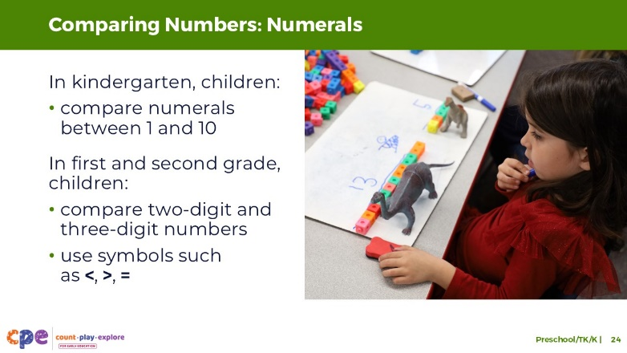

### Talking Points

* So far, we have discussed how children compare sets of *objects*. By the end of kindergarten, children can also compare *numerals* between one and ten. For example, if they observe numerals three and eight, they know that three is smaller. To compare numerals, children need to understand what numbers each numeral represents and the order of these numbers.
* As children move into first and second grade, they can compare two-digit and three-digit numbers using symbols such as <, >, = (less than, greater than, equal to) to record these comparisons.

## SLIDE 25: Comparative Vocabulary

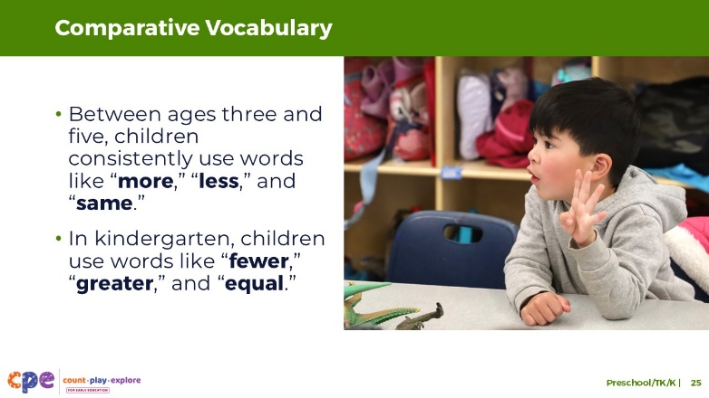

### Talking Points

* In addition to developing strategies to compare numbers, children also learn comparative vocabulary in their home language, English, or both.
* At around age three, children more consistently use language like “more,” “less,” and “same” to describe and compare numbers.
* In kindergarten, children may also use language like “equal,” “greater,” or “fewer.”

## SLIDE 26: Reflect: Counting and Comparing Numbers

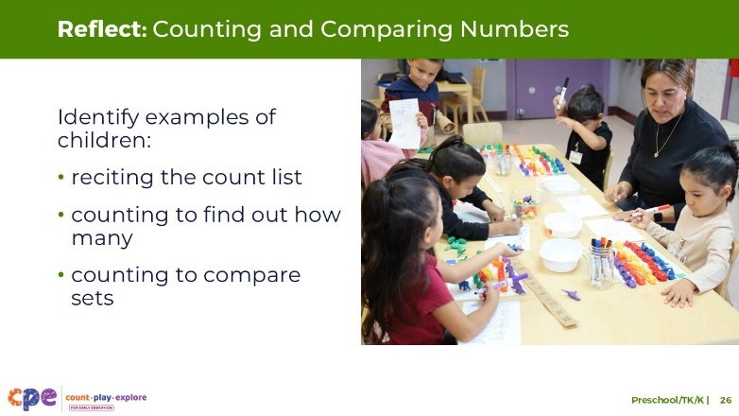

**Time:** 5–10 minutes

**Materials:** Paper, pens

### Talking Points

* Before we explore the next component, let’s think about how children in your setting count, develop an understanding of the counting principles, and compare numbers.
* Take a piece of paper and divide it into three sections. Label the top of the three sections, “Reciting the count list,” “Counting to find out how many,” and “Counting to compare sets.”
  + Think about your learning setting. Identify specific examples of children reciting the count list, counting to find out how many, and counting to compare sets. In your examples, describe when during the day this happened. For example, was this part of a daily routine or activity? Also describe the strategies you notice the child or children using. For example, were they subitizing or counting using one-to-one correspondence?
  + Record some of your examples under the three headings.
* [Choose a debrief strategy from the facilitator notes:] From your examples, you may have noticed that children’s interests, cultures and lived experiences, languages, abilities, and developing skills might affect how they count and use cardinality. For example, children may count in their home language, on their fingers, or silently in their head. Children with visual impairments might compare numbers by touching objects in a set.

### Facilitator Notes

* Adjust the way you debrief the activity based on your group size, session length and format, and participants’ needs.
* Consider using the following adaptations based on session length:
  + For longer sessions, invite tables to discuss and record their responses on chart paper. Each table might choose a recorder and a reporter. Recorders will document the table’s responses on their chart. Then, reporters share some of their tables’ responses with the larger group.
  + For shorter sessions, invite a few participants to share their ideas with the large group.

## SLIDE 27: Recognizing, Naming, and Recording Numerals: Definition

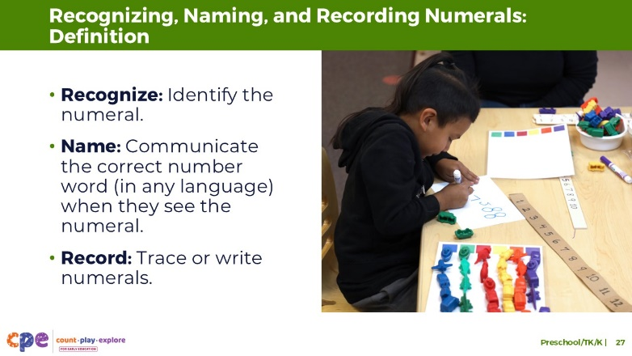

### Talking Points

* This last component describes children’s ability to recognize, name, and record—or write—numerals.
* Let’s discuss what each of these abilities mean:
  + Recognize: being able to identify the numeral. For example, if a child sees the numeral 2, they understand that it represents the quantity two.
  + Name: being able to communicate the correct number word (in any language) when they see the numeral. For example, if a child sees the numeral 2, they know that it is named “two” or “dos.”
  + Record: being able to trace or write numerals. Children’s accuracy in writing numerals increases as their fine motor skills develop. Children’s ability to record or write numerals follows a similar developmental path as their ability to record or write letters. For example, as children are just learning to write, they may write the mirror image of numerals.

## SLIDE 28: Recognizing, Naming, and Recording Numerals: Development

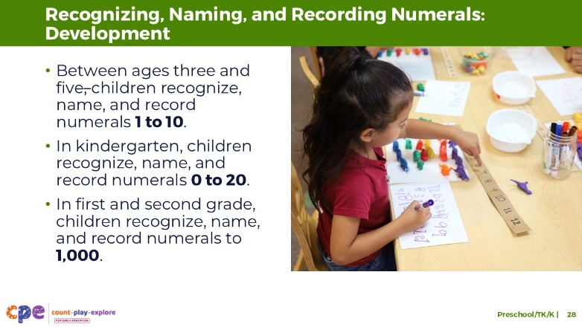

### Talking Points

* Preschool and TK children learn to recognize, name, and even record a few numerals under 10. By age five, children can recognize, name, and write all numerals from 1 to 10.
* By the end of kindergarten, children recognize, name, and record all numerals from 0 to 20.
* In first and second grades, they learn to recognize and record numerals up to 1,000 using base-ten numerals, number names, and expanded form.

## SLIDE 29: Observe: Learning About Number and Counting

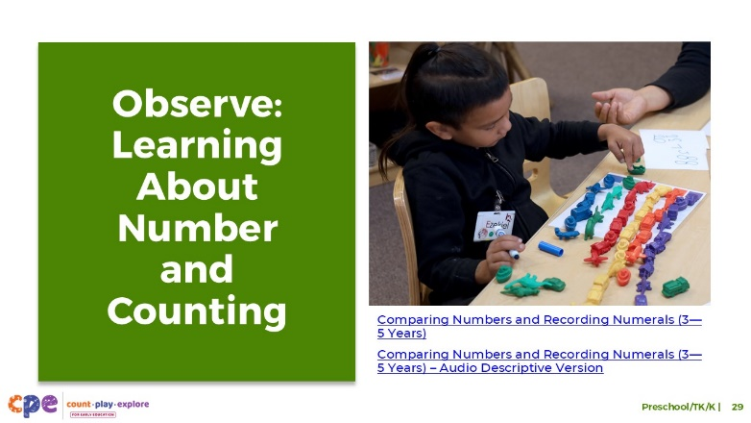

**Time:** 10–20 minutes (including the debrief on the next slide)

**Materials:** Preschool, TK, or K number and counting video clip

### Talking Points

* We have reviewed three components of number and counting that are relevant for children in preschool, TK, and K. Now, we will observe another video clip. As you observe, pay attention to the ways children are:
  + counting
  + comparing numbers
  + recognizing, naming, and recording numerals
* After the clip, we will discuss what you noticed.

### Facilitator Notes

* Choose a preschool, TK, or K video clip that shows children counting, comparing numbers, and recording numerals. These video clips are different from the ones presented in slides 19 and 20.
* We provide the following videos (you may use other videos):
  + [Comparing Numbers and Recording Numerals (3–5 years)](https://youtu.be/HJ05cWmCTTQ)
  + [Comparing Numbers and Recording Numerals (3–5 years) – Audio Descriptive Version](https://youtu.be/p3IY78KN7pE)
  + [Counting and Adding While Reading (3–5 years)](https://youtu.be/Amcf1-gVPJk)
  + [Counting and Adding While Reading (3–5 years) – Audio Descriptive Version](https://youtu.be/GjYUtP6BrXU)
  + [Counting During Circle Time (4–5 years)](https://youtu.be/iEj5zVpk5Mg)
  + [Counting During Circle Time (4–5 years) – Audio Descriptive Version](https://youtu.be/nPT5azVlVZ8)
  + [Counting During Outdoor Play (3–5 years)](https://youtu.be/hNJIlEmQsRs)
  + [Counting During Outdoor Play (3–5 years) – Audio Descriptive Version](https://youtu.be/vRmJp9G6cuw)
  + [Counting Family Members (3–5 years)](https://youtu.be/rNRFncCUtBc)
  + [Counting Family Members (3–5 years) – Audio Descriptive Version](https://youtu.be/Lt_460QXxNA)
* **Note:** Discussion points are provided for the video “[Comparing Numbers and Recording Numerals (3–5 Years)](https://youtu.be/p3IY78KN7pE)” in the Facilitator Notes on the next slide.
* If a component is not observed in the video, invite participants to:
  + Think about ways that children might develop knowledge and skills related to that component.
  + Explain how educators might support children to develop the knowledge and skills related to that component.
* Consider playing the video more than once. The first time, invite participants to become familiar with the clip. Then, invite participants to observe specific ways children show their understanding of the number and counting components.

## SLIDE 30: Discuss: Learning About Number and Counting

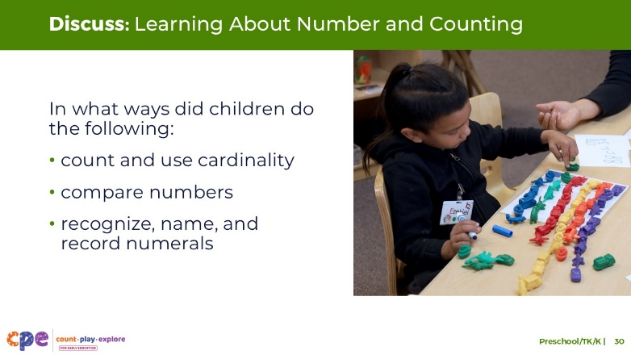

**Time:** 10–20 minutes (including observing the video on the prior slide)

### Talking Points

* Let’s discuss what you noticed. In what ways did children in the video demonstrate that they were doing the following:
  + comparing numbers
  + counting and understanding cardinality
  + recognizing, naming, and recording numerals
* [After discussion:] You noticed many ways that children in this video are developing number and counting skills.

### Facilitator Notes

* Adjust the debrief based on your group size, session length and format, and participant needs. Consider charting participants’ observations to provide a visual of ways children develop number and counting skills.
* Consider using the following adaptations based on session length:
  + For shorter sessions, invite participants to share with the larger group what they noticed about ways preschool, TK, and K children showed their knowledge and skills related to number and counting.
  + For longer sessions, offer time for participants to share their observations in pairs or at their tables. Then, invite each table to share some of their observations.
* Here are some examples of how children in the preschool video clip “[Comparing Numbers and Recording Numerals (3–5 Years)](https://youtu.be/p3IY78KN7pE)” compare, count, recognize, name, and record numerals:
  + **Comparing numbers:** After the child counted each color group, he was able to answer the educator’s question, “Which one is the biggest number so far?” by pointing to the correct color group or numeral. The child was also able to recognize when two color groups had the same number. For example, after counting the orange counters and realizing there were eight, the educator asked, “Did you have another eight?” The child pointed to the numeral eight and then remembered that the red counters also had eight. The child demonstrated understanding of comparative words such more, most, same, less, and smaller.
  + **Counting and cardinality:** The child counted and engaged in one-to-one correspondence to determine how many there were of each color group. The child had developed an understanding of cardinality because he understood that the last number word in his count list represented the size of the set.
  + **Recognizing, naming, and recording numerals:** After the child had counted a color group (for example, eight red counters), he pointed to the correct numeral on the number line (the numeral 8). Then he wrote that numeral on the piece of paper. The child did this for each color group.

## SLIDE 31: Supporting Number and Counting

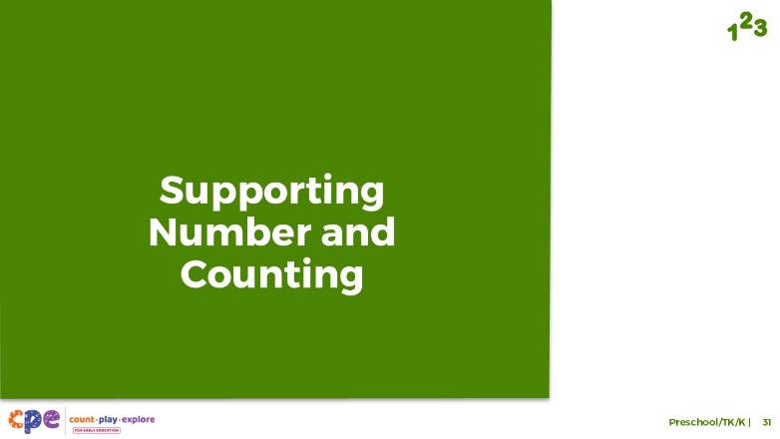

### Talking Points

* We explored three components that describe how children in preschool, TK, and K come to understand number and develop counting skills. We also observed some ways children in preschool, TK, and K compare, count, recognize, name, and record numerals. Now, let’s discuss ways we can support children to learn about numbers and develop counting skills in our learning settings.

## SLIDE 32: Explore: M5 Early Math Approach

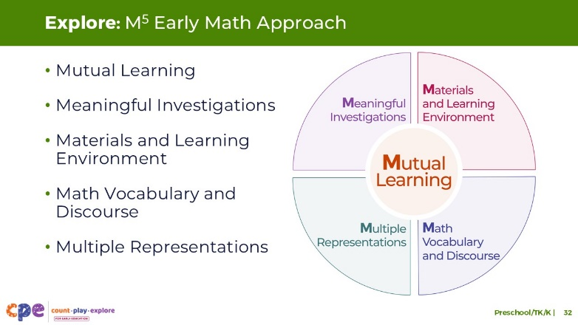

**Time:** 15 minutes

**Materials: M5 Overview** handout

### Talking Points

* We often refer to five core early math teaching practices as the M5 (pronounced: M to the fifth) Early Math Approach. These practices include:
  + Mutual Learning
  + Meaningful Investigations
  + Materials and Learning Environment
  + Math Vocabulary and Discourse
  + Multiple Representations
* Let’s explore the M5 practices. Then, we will observe M5 in action.

### Facilitator Notes

* Consider your participants and their prior experiences with M5.
  + For groups that have significant experience with M5, offer a few minutes for participants to share with a partner their areas of strength and what practices they are working on. Use this slide to briefly revisit the M5 practices and move to the next slide.
  + For groups that have less experience with M5, offer more time for participants to independently explore each practice. Invite them to make a square over practices that they have “squared away” (practices they understand and use), a circle over “what’s still going around in their heads” (practices they still have questions about), and a triangle over three ideas that they will use in their settings. For more ideas on how to provide a more comprehensive review, visit the **M5 Early Math Approach** Suite.

## SLIDE 33: Meaningful Investigations: Number and Counting

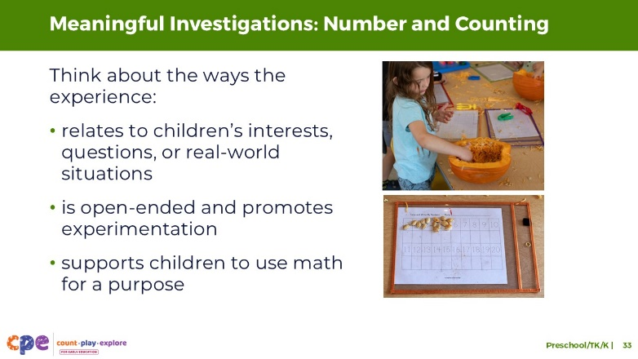

### Talking Points

* Let’s consider what meaningful investigations that promote number and counting learning may look like.
* Meaningful Investigations:
  + relate to children’s interests, questions, or real-world problems
  + are open-ended and promote problem solving and experimentation
  + support children to use math for a purpose
* When children participate in meaningful investigations, they are more likely to develop deeper understanding of math concepts. Motivated to solve a problem of interest, they are more likely to be engaged in the task and experience joy in their learning.
  + For example, while exploring pumpkins, children may notice that each pumpkin has a lot of seeds. They may begin counting the seeds and use a chart to show different amounts of seeds.
* Children’s daily routines or interactions offer opportunities for children to practice counting for a purpose.
  + For example, as two children are trying to share a box of crayons, the educator might encourage them to count how many crayons they each have to make sure they each have the same amount.

## SLIDE 34: Explore: Using M5 to Support Learning About Number and Counting

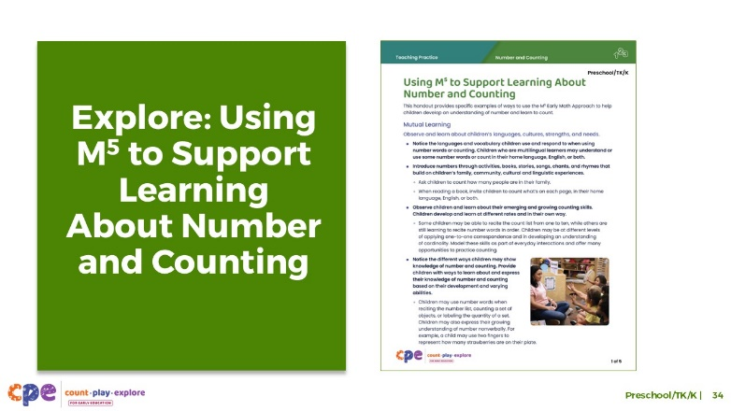

**Time:** 20–30 minutes (including the debrief on the next slide)

**Materials: Using M5 to Support Learning About Number and Counting** handout, paper, markers

### Talking Points

* We discussed the M5 Early Math Approach and discussed some examples of what meaningful investigations might look like for children ages three to six years. Let’s consider ways to use M5 to support children’s understanding of number and developing counting skills.
* Take out the **Using M5 to Support Learning About Number and Counting** handout.
* Review the ideas on how to use M5 to support children in preschool, TK, and K to understand number and developing counting skills. You might make notes, circle, or highlight as you review.
* [For shorter sessions:]: Consider the practices you reviewed. With a partner, discuss what you might want to try and why. [If time permits, invite some participants to share with the large group what practices they will try and why.]
* [For longer sessions, use slide 35 to facilitate the discussion.]

### Facilitator Notes

* Provide seven to ten minutes for participants to review the handout independently.
* For shorter sessions, instead of using the next slide move on to slide 36.

## SLIDE 35: Discuss: Using M5 to Support Learning About Number and Counting

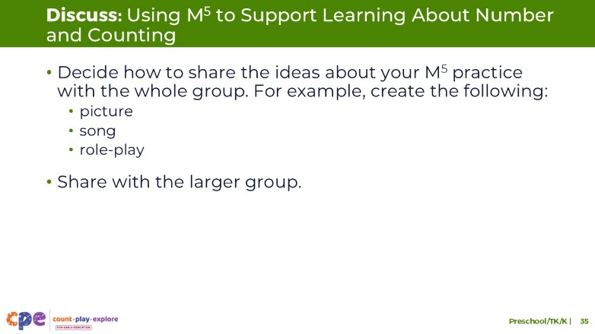

**Time:** 20–30 minutes (including a review of the document on the previous slide)

**Materials: Using M5 to Support Learning About Number and Counting** handout, paper, markers

### Talking Points

* You reviewed some ideas on ways to use the M5 Early Math Approach to support children to understand number and develop counting skills. Next, let’s reflect on ways we can continue to support children’s understanding of number and developing counting skills.
* [Select a way to organize this activity from the facilitator notes. Then, adapt these talking points based on your selection.]
  + [Assign each group one M5 practice.] Briefly discuss the ideas described for your assigned practice. Then, decide how you will share these ideas with the larger group.
  + Be creative. For example, create a drawing, song, or role-play to share what you learned.
  + Consider ways to represent the diversity of children’s interests, languages, cultures and lived experiences, abilities, and emerging skills.
  + Each group will have two to three minutes to present their M5 practice with the larger group.
* [Provide time for participants to prepare their presentations. Then, invite groups to share their assigned practices. Offer additional information about each practice as needed.]
* [After each group has shared:] You reviewed some ways to use the M5 Early Math Approach to support children’s understanding of number and developing counting skills. Hopefully, you will find these strategies helpful in your setting.

### Facilitator Notes

* Adjust the way you organize this activity based on group size:
  + For smaller sessions: Divide participants into five groups. Assign each group one M5 practice. Each group will discuss their assigned practice briefly and identify a way to share the information with the larger group.
  + For larger groups: Create groups of five to seven participants each. Assign each group an M5 practice. As necessary, assign more than one group the same practice. Each group will discuss their assigned practice briefly and identify a way to share the information with the larger group.
* Move around the room while participants work in groups. Provide support as needed.

## SLIDE 36: Observe: Supporting Learning About Number and Counting

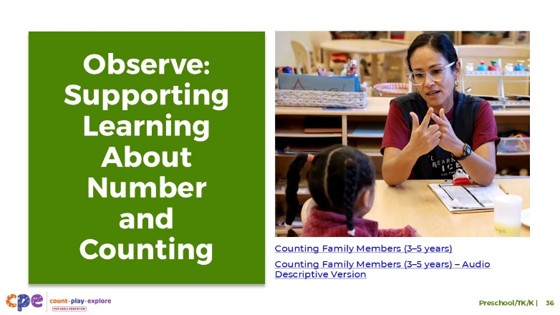

**Time:** 5–7 minutes (not including the debrief)

**Materials: Observing M5 in Action: Number and Counting** handout; preschool, TK, or K number and counting video clip; chart paper; markers

### Talking Points

* We observed examples of how children (three to six years old) learn about number and counting. Then, we explored the M5 Early Math Approach for supporting children’s early math learning. Now, we are going to observe a video that shows how educators use M5 to help children (three to six years old) understand number and develop counting skills.
* [Choose a strategy for facilitating this observation and debrief. Adapt the talking points to reflect this strategy.]

### Facilitator Notes

* Choose a video clip that shows children learning about number and counting. This may be the same video clip that you used earlier in this presentation.
* We provide the following videos (you might use other videos):
  + [Comparing Numbers and Recording Numerals (3–5 years)](https://youtu.be/HJ05cWmCTTQ)
  + [Comparing Numbers and Recording Numerals (3–5 years) – Audio Descriptive Version](https://youtu.be/p3IY78KN7pE)
  + [Counting and Adding While Reading (3–5 years)](https://youtu.be/Amcf1-gVPJk)
  + [Counting and Adding While Reading (3–5 years) – Audio Descriptive Version](https://youtu.be/GjYUtP6BrXU)
  + [Counting During Circle Time (4–5 years)](https://youtu.be/iEj5zVpk5Mg)
  + [Counting During Circle Time (4–5 years) – Audio Descriptive Version](https://youtu.be/nPT5azVlVZ8)
  + [Counting During Outdoor Play (3–5 years)](https://youtu.be/hNJIlEmQsRs)
  + [Counting During Outdoor Play (3–5 years) – Audio Descriptive Version](https://youtu.be/vRmJp9G6cuw)
  + [Counting Family Members (3–5 years)](https://youtu.be/rNRFncCUtBc)
  + [Counting Family Members (3–5 years) – Audio Descriptive Version](https://youtu.be/Lt_460QXxNA)
* Invite participants to take out the **Observing M5 in Action: Number and Counting** handout.
* For larger groups and longer sessions, use a jigsaw approach. Before playing the video clip, assign each table one practice to focus on during the video. If there are more than five tables, assign more than one table to focus on each practice.
* For smaller groups and shorter sessions, consider showing the video clip two to three times, inviting participants to focus on specific practices each time. Encourage them to record observations on the handout.

## SLIDE 37: Discuss: Supporting Learning About Number and Counting

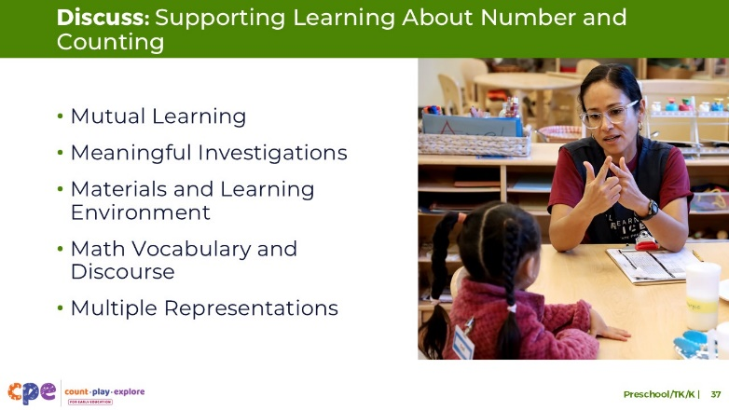

**Time:** 20–30 minutes (varies based on the session goals)

### Talking Points

* Let’s unpack your observations of each M5 practice.

### Facilitator Notes

* Use the **Answer Key for** **Observing M5 in Action: Number and Counting** handout for examples of ways M5 was used in the video “[Counting Family Members (3–5 Years)](https://youtu.be/rNRFncCUtBc).”
* For larger groups or longer sessions: After observing the video clip, ask each table group to discuss what they noticed about their assigned practice. Then, invite each group to share their observations with the larger group. As each group shares, paraphrase, affirm, and add to their responses as needed. Consider charting each group’s observations to make practices visible.
* For smaller groups or shorter sessions: Invite participants to share their observations with the whole group. Chart their observations to make the practices visible. As participants share, paraphrase, affirm, and add to their responses as needed. Consider inviting participants to share something they learned with someone from another table. For example, ask them to find someone with a similar colored shirt, move to meet them, and share something they learned about that person.
* For additional ideas on how to facilitate debriefs, visit the **Facilitating STEAM Professional Learning** suite of resources.

## SLIDE 38: Reflect: Three, Two, One

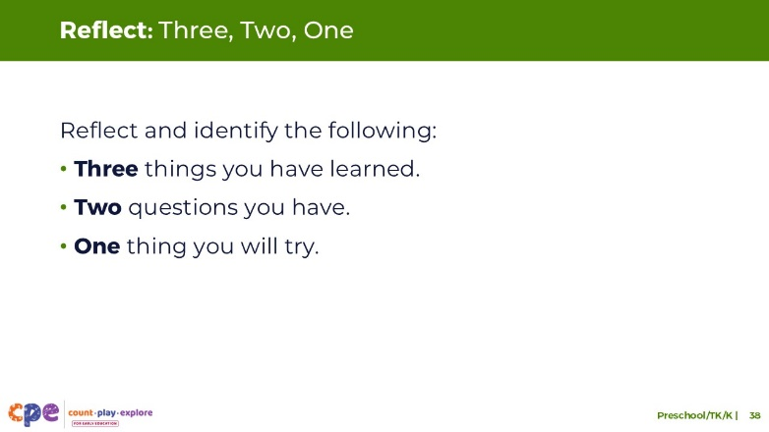

**Time:** 5–7 minutes

### Talking Points

* Take a few minutes to think about our session.
* Identify the following:
  + Three things you learned during this session.
  + Two questions you have.
  + One thing you will try in your learning setting next week.
* [Allow three to four minutes for participants to think. You might invite participants to share with a partner.]
* Thank you for your time, attention, and engagement. It’s been wonderful working with you.

### Facilitator Notes

* For longer sessions, consider asking participants to share their questions with the larger group.
* As participants discuss their reflections, note the questions that they still have and what they would like to try. Use this information to identify topics for future training, coaching, or communities of practice.