Introduction to Number and Counting:   
Birth–8 Years (PPT 1)

Use this facilitator guide with the slides “Introduction to Number and Counting: Birth–8 Years.” This set of slides provides an overview of the development of key concepts and skills in Number and Counting for children from birth to eight years old. When planning a professional learning session on Number and Counting, facilitators can use these slides as an introduction or in combination with the age-specific slide decks. Facilitators can find talking points and guidance for activities and group discussions in this guide. The text in the guide is also located in the notes portion of the slides. Adapt this facilitator guide based on your group size, session length and format, and participants’ needs.

## SLIDE 1: Introduction to Number and Counting: Birth–8 Years

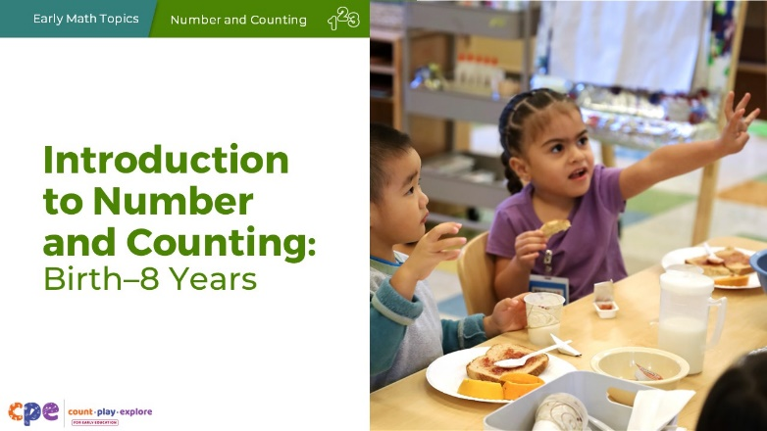

### Talking Points

* Welcome, everyone. Today, we will explore how children develop an understanding of number and counting.

### Facilitator Notes

* Adjust talking points to include relevant introductions, “housekeeping,” and other important information for your participants.
* We recommend providing collections of small objects (for example, paper clips, shells, cotton balls, counting chips) that participants can use to engage in counting experiences throughout this session. If your agency implements Counting Collections (Franke et al., 2018), you might provide some of these collections or invite educators to bring their own counting manipulatives from their learning setting. Consider providing enough manipulatives so each table group has their own set of small objects.
* Share with participants that, in this session, we use “TK” to refer to transitional kindergarten and “K” for kindergarten.
* As you plan your professional learning session, consider the content in each of the PPTs in this suite:
  + PPT 1 “Introduction to Number and Counting” describes how children develop an understanding of number and counting from birth to age eight.
  + PPT 2a “Number and Counting: Infants and Toddlers” and PPT 2b “Number and Counting: Preschool, Transitional Kindergarten, and Kindergarten” describe in greater depth how children at different age levels develop an understanding of number and counting. These age-specific PPTs also include guidance on how to support children in specific age ranges to develop number and counting skills.
  + Note, because most children have developed number and counting skills by the time they finish kindergarten, there is no PPT 2c focusing on early elementary. Starting in early elementary, children apply their number and counting skills to solving addition and subtraction problems. For more information on the ways children in grades 1 and 2 apply their number and counting skills to other math topics, review the **Addition and Subtraction** suite of resources.
* We encourage you to offer the content in PPT 1 before, or in combination with, content in one of the age specific slide decks (PPT 2a or PPT 2b). Together PPT 1 and one of the age specific slide decks have been designed for a three-hour professional learning session. However, you might adjust slide decks to best meet participant needs and time allowances.

## SLIDE 2: Acknowledgments

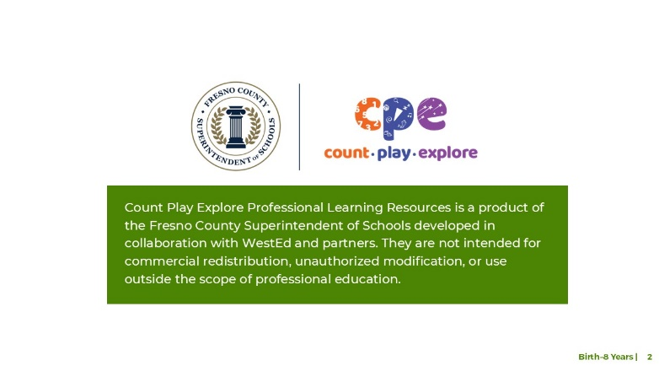

### Talking Points

The Count Play Explore Professional Learning Resources were made possible by Count Play Explore, an early math and science initiative led by the Fresno County Superintendent of Schools, Early Care and Education Department. This initiative is generously funded by the California Department of Education and the California State Board of Education. These resources, developed in collaboration by WestEd and partners, are intended to be used as a guide for implementing evidence-based strategies, promoting active learning, and encouraging developmentally appropriate practices in early education settings. They are not intended for commercial redistribution, unauthorized modification, or use outside the scope of professional education.

## SLIDE 3: Session Goals

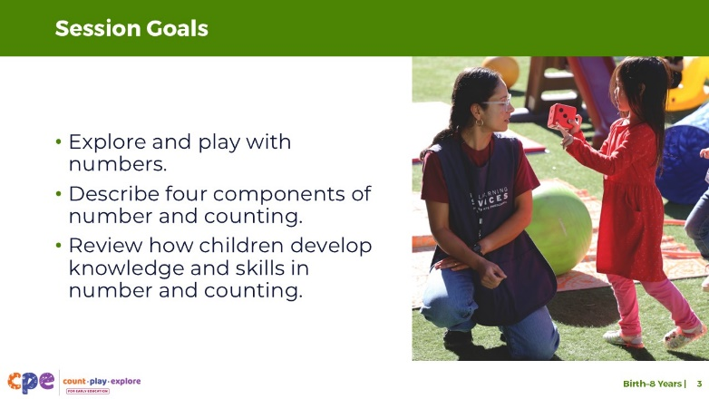

### Talking Points

* In this session, we will start by exploring and playing with numbers.
* Next, we will describe four key components of number and counting.
* We will also review the ways children develop knowledge and skills in number and counting.
* The ways we will learn together are similar to the ways children learn. We will play, observe, explore, and reflect.

### Facilitator Notes

* Adjust slide content and talking points to reflect what you plan to address in your professional learning session.

## SLIDE 4: Play: Alphabet Counting

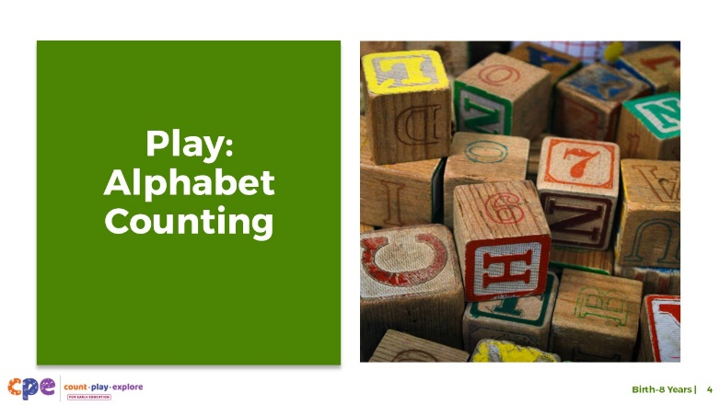

**Time**: 15–30 minutes (including the debrief on slide 5)

**Materials**: **Alphabet Counting** handout, small items to count, containers, paper, and pencils

### Talking Points

* Let’s play a counting activity specially designed for adults.
* Take out the **Alphabet Counting** handout.
* The purpose of this activity is to experience what it feels like to learn how to count for the first time. [Use the instructions on the handout as talking points and guide the educators through the different sections.]

### Facilitator Notes

* The **Alphabet Counting** activity has multiple parts. Depending on the amount of time you have in your session, you may choose to engage in the entire activity or just the first and second part (“Learning About Alphabet World” and “Counting Fingers and Toes”).
* Math is playful. This principle is key to the Count Play Explore professional development approach. This activity invites adults to explore counting through play.
* Math mindsets matter. This experience may activate a variety of feelings for participants. Some may enjoy this experience, while others may find it stressful.
  + Allow participants to engage in ways that they feel most comfortable. Some may think through these problems independently, while others prefer to work in pairs or small groups.
  + The goal of this activity is to experience counting as a beginner would. This experience is likely to be challenging for participants. Remind them that it is okay if they do not get the correct answers.
  + When inviting participants to share, consider their comfort level. Some participants may not feel comfortable sharing with the whole group. Adapt how you facilitate this activity based on participant needs and session length.

## SLIDE 5: Discuss: Alphabet Counting

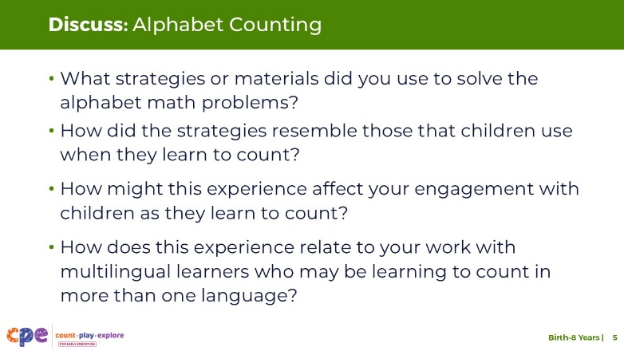

**Time**: 15–30 minutes (including slide 4)

**Materials**: Small items to count, containers, paper, and pencils

### Talking Points

* Let’s discuss this experience of learning the alphabet counting system. At your table, discuss the following questions:
  + What strategies or materials did you use to solve the alphabet math problems?
  + How did the strategies resemble those children use when they learn to count?
  + How might this experience affect your approach with children as they learn to count?
  + How does this experience relate to your work with multilingual learners who may be learning to count in more than one language?
* [After some time for small group discussion, invite participants to share with the whole group. Then, summarize some key points. For example, “I noticed you used different strategies to solve these problems. Some of you used your fingers to count, others used small items, and some made an alphabet number line. These are the types of strategies and materials children often use when they learn to count.”]
* This activity demonstrated that learning to count can be challenging. Children need to learn many things at once. For example, they have to learn number words, number order, and how counting works. In this session, we will explore how children learn about number and develop counting skills.

### Facilitator Notes

* Adjust the discussion method (for example, in pairs or at tables) based on group size, session length and format, and participant needs.
* Invite participants to share their experiences with the whole group if time permits.

## SLIDE 6: Number and Counting: An Overview

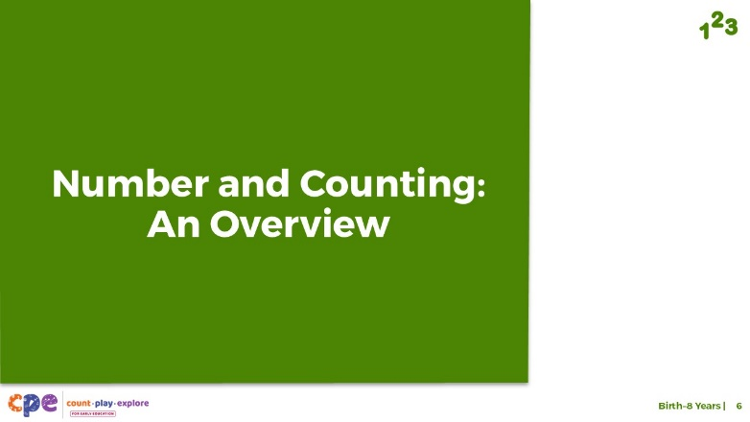

### Talking Points

* Before we review how children develop an understanding of number and counting, let’s begin by defining “number” and “counting.”

## SLIDE 7: Number and Counting Defined

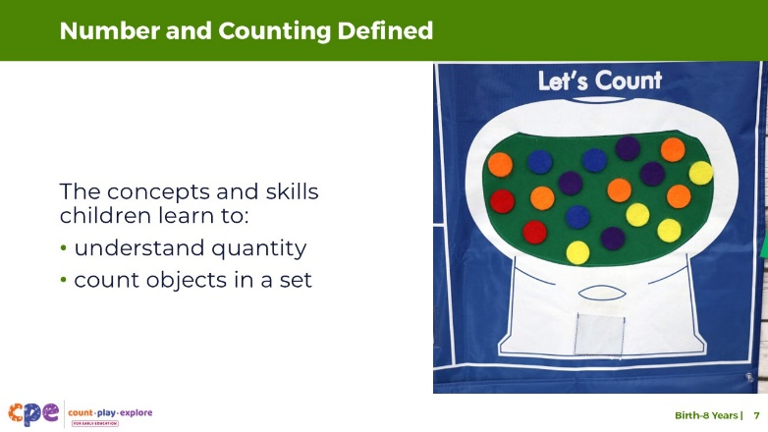

### Talking Points

* Numbers can be used to represent quantity (how many).
  + For example, when you have two red circles, “two” represents the number of red circles.
* Counting describes the process we use to identify the quantity of objects in a group.
* Altogether, this math area describes the concepts and skills children learn to understand quantity and to count objects in a set.

### Facilitator Notes

* You may be familiar with the term “number sense.”It refers to understanding number, counting, and number operations (for example, addition or subtraction). Content related to number sense is addressed in this suite of resources, which focuses on number and counting, as well as the **Addition and Subtraction** suite of resources, which focuses on developing addition and subtraction concepts and skills.
* This session introduces math vocabulary to describe various concepts and skills related to number and counting. Consider providing participants with the “Glossary of Number and Counting Vocabulary” handout at the start of the session.

## SLIDE 8: Different Ways to Represent Quantity

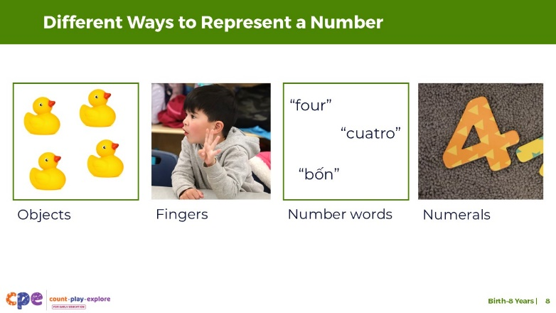

### Talking Points

* The amount of something can be represented in many ways.
* Children start by using concrete objects to represent quantity.
  + For example, showing you four rubber ducks.
* They can also use their fingers.
  + For example, holding up four fingers.
* They can use **number words**. Number words are the way we represent numbers using language. This includes words and sign language.
  + For example, saying “four” in English, “cuatro” in Spanish, or “bốn” in Vietnamese.
* At the end of preschool and into kindergarten, children learn to represent numbers using **numerals**, the symbols we use to record numbers.
  + For example, writing, using an Augmentative and Alternative Communication (AAC) device or using picture cards to record the symbol “4.”

## SLIDE 9: Learning About Number and Counting

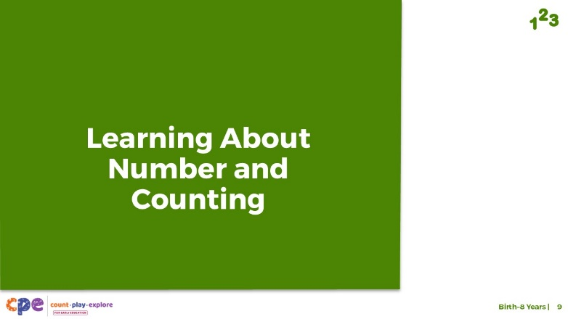

### Talking Points

* Now, let’s discuss how young children develop an understanding of number and counting.

## SLIDE 10: Four Components of Number and Counting

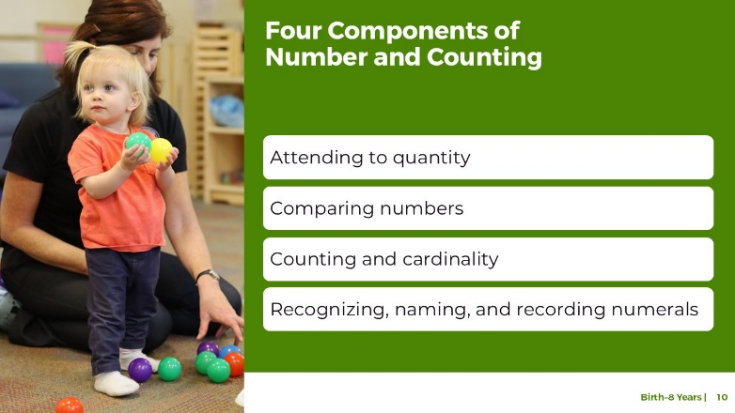

### Talking Points

* The following slides describe four important components of number and counting. These components include children’s ability to:
  + attend to quantity
  + compare numbers
  + count and develop an understanding of cardinality
  + recognize, name, and record numerals

### Facilitator Notes

* Consider reviewing **The Development of Counting from Infancy Through the Early School Years** research brief for a more in-depth understanding of how children develop counting skills.

## SLIDE 11: Attending to Quantity

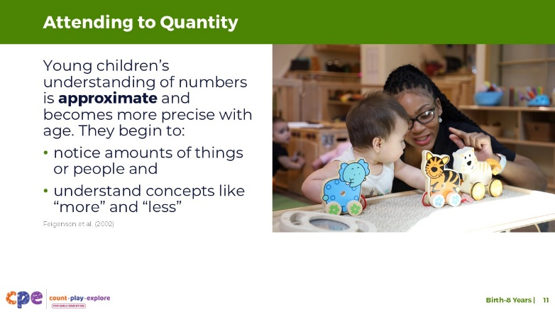

### Talking Points

* **Attending to quantity** describes young children’s ability to notice quantity in the environment. This skill also includes understanding concepts like “more” or “less.”
* Young children notice amounts of things or people. Infants can notice changes in the number of items in a set. For example, they notice if a picture changes from showing one block to four blocks.
* Young children understand concepts like “more” or “less” (Feigenson et al., 2002). For example, they might grab the bowl that has more crackers in it.
* Young infants’ understanding of number is **approximate**. This means that their understanding is not precise. For example, a six-month-old infant might not notice when the number of items changes from 10 to 12. However, they will notice if the number changes from 10 to 20 dots. As children get older, their ability to notice becomes more precise. They recognize smaller changes in number.

### Facilitator Notes

* Review PPT 2a: “Number and Counting: Infants and Toddlers” for a demonstration of how researchers study infant’s ability to attend to quantity.

## SLIDE 12: How Many Dots?

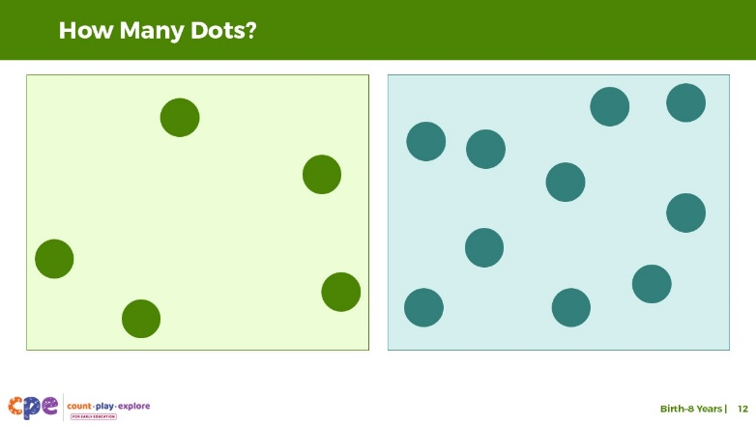

### Talking Points

* Children and adults know how many objects are in a small set through **subitizing** [pronunciation: soo-bi-ty-zing]. Subitizing is the ability to immediately observe the number of objects in a group without counting.
* [Click to reveal the picture on the left with five dots. After 1–2 seconds, click again to make the picture disappear.] How many dots did you observe? [After participants answer:]
  + That’s right. There were five dots. Now, let’s try again.
* [Click to reveal the picture on the right with 10 dots. After 1–2 seconds, click again to make the picture disappear.] How many dots did you observe? [After participants answer:]
  + This picture had 10 dots. What did you notice about this experience? Was it easier to observe 5 or 10 dots? [Provide time for participants to answer.]
* You just experienced **subitizing** [pronunciation: soo-bi-ty-zing]. Children and adults can observe how many objects are in a small set through **subitizing**. Subitizing is the ability to immediately observe the number of objects in a group without counting.
* The ability to subitize starts in infancy as infants attend to quantity. Starting around age three, children can subitize up to three objects and then four later in preschool.
* Adults can easily subitize small sets but it is more difficult to subitize larger sets.

### Facilitator Notes

* The goal of this activity is to show subitizing in action. Subitizing is a skill we use when identifying the number of objects in a small group by looking briefly and not by counting. Therefore, it’s important to show the dot pictures very briefly.
* Consider practicing clicking through these pictures before the session.
* For participants with visual impairments, consider offering tactile stimuli such as dice with raised bumps or glue dots on paper and asking how many bumps they feel without counting.

## SLIDE 13: Even More Dots

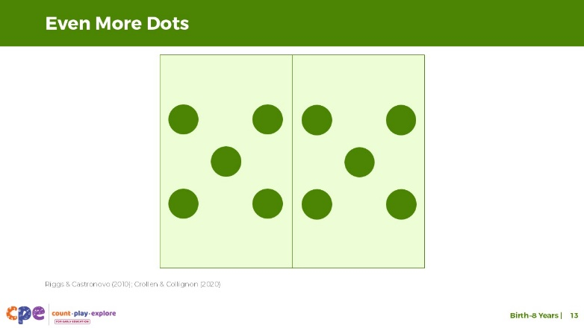

### Talking Points

* Let’s explore how we can use subitizing to identify the number of objects in a larger set.
* [Click to reveal the picture with 10 dots organized like a domino. After 1–2 seconds, click again to make the picture disappear.] How many dots did you observe?
* [After allowing time for participants to answer:] This picture had 10 dots. This is the same number of dots we observed in the last picture on the previous slide. You may have noticed that observing the 10 dots in this picture was easier. When observing this picture, you probably noticed that the dots were organized in two groups of five. Based on your conceptual understanding of addition, knowing that five and five equals ten, you could conclude that there were 10 dots altogether. This process is **conceptual subitizing**. Conceptual subitizing is the ability to immediately observe the number of objects in a group by composing small quantities into a whole.
* Conceptual subitizing develops at around five to six years of age.
* Subitizing is not only a visual skill. Research with blind adults suggests that they can subitize using tactile stimuli (for example, a die with raised bumps) as accurately as sighted adults do with visual stimuli (Riggs & Castronovo, 2010; Crollen & Collignon, 2020).

### Facilitator Notes

* The goal of this activity is to show conceptual subitizing in action. Subitizing is a skill we use when identifying the number of objects in a small group by looking briefly and not by counting. Therefore, it’s important to show the dot pictures very briefly.
* Consider practicing clicking through these pictures before the session.

## SLIDE 14: Comparing Numbers

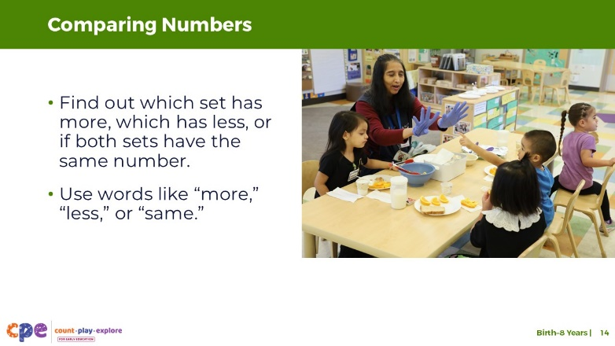

### Talking Points

* The component we just discussed—attending to quantity—provides the foundation for children to compare numbers. When comparing the number of objects in two sets, children find out which set has more or less or if the sets are equal.
* They also learn to use vocabulary like “more,” “less,” or “same” when comparing the number of objects in two sets.
* Children may compare numbers using strategies like visually comparing, matching, or counting. Let’s explore these different strategies together.

## SLIDE 15: Comparing Carrots and Bananas

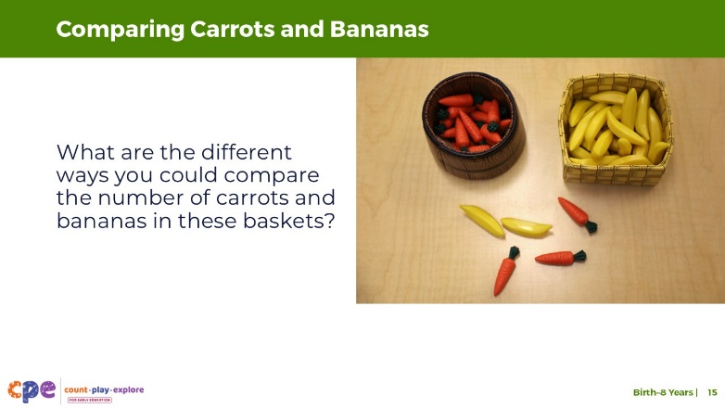

**Time:** 5–10 minutes

### Talking Points

* Let’s think about some ways we can compare two sets of objects.
* [Point to the baskets on the slide:] Take a look at the picture on this slide. What are the different ways you could compare the number of carrots and bananas in these baskets? Which basket has more?
* Turn to a partner and discuss your ideas. Discuss as many options as possible.
* [Provide participants with about five minutes to work in pairs. Then, invite the pairs to share their strategies with the larger group.] In pairs, you identified a variety of strategies to compare numbers. Some ways children learn to compare numbers include visually comparing, matching, and counting.

## SLIDE 16: Comparing Numbers: Different Strategies

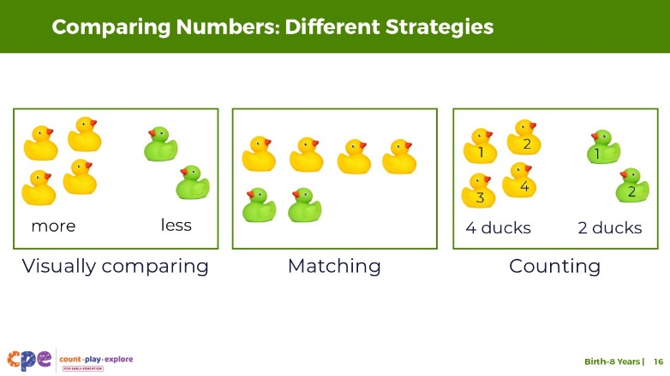

### Talking Points

* Next, let’s discuss how children compare numbers.
* Children, just like adults, may compare numbers using different strategies. Let’s review the different strategies children may use when comparing numbers:
  + Visually comparing: This strategy involves simply looking at two sets and deciding which is more without counting. Children and adults use this strategy when there are only a few objects being compared or when the difference between the two sets being compared is very big.
  + Matching: This strategy involves putting two sets of objects in one-to-one correspondence. When children match two sets, they identify whether one has more by comparing the length of the lines of objects.
  + Counting: This strategy involves counting the number of objects in each set to decide which one has more or whether they have the same amount.

## SLIDE 17: Let’s Count!

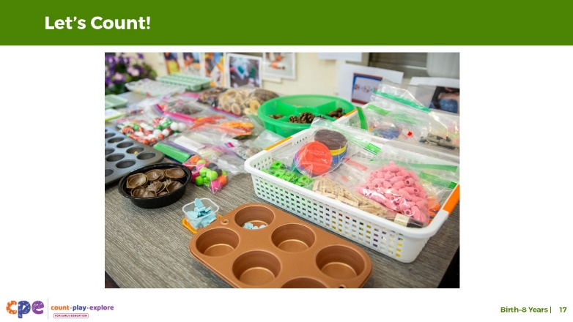

**Time:** 5–10 minutes

**Materials:** 30–40 small objects for each table or small group (paperclips, counters, pens, pinecones, or buttons)

### Talking Points

* [Select a facilitation strategy from the Facilitator Notes.]
* [Provide each table group with their own collection of 30–40 small objects. Then:] Take turns counting the objects on your table. As you watch others count, notice the strategies they are using.
  + How are they keeping track of which objects they have counted and which ones they still need to count?
  + Are they counting by one or skip-counting by two or five?
  + What language are they counting in?
  + Is everyone using the same strategies?
* [Provide time for participants to count.]
* [Then, depending on the facilitator strategy you chose, invite participants to share their strategies and observations.]
* As adults, we count without having to think about it. Many of the strategies we use to count come naturally to adults, just think what it takes for a child who is learning to count! We will discuss some of these concepts and skills children need to learn in order to develop an understanding of counting and cardinality in the following slides.

### Facilitator Notes

* Adjust the way you organize the activity based on group size, session length and format, and participants’ needs. For example:
  + For longer sessions, invite participants to work individually and share their experiences with their tables before discussing as a larger group.
  + For shorter sessions, invite participants to work with a partner and share with the larger group.
* This activity is similar to *Counting Collections* (Franke et al., 2018)*,* an activity in which young children count a collection of objects and then make a representation of what they counted. Learn more about Counting Collections on the [DREME TE website.](https://prek-math-te.stanford.edu/counting/counting-collections-overview)

## SLIDE 18: Counting Principle 1: Stable Order

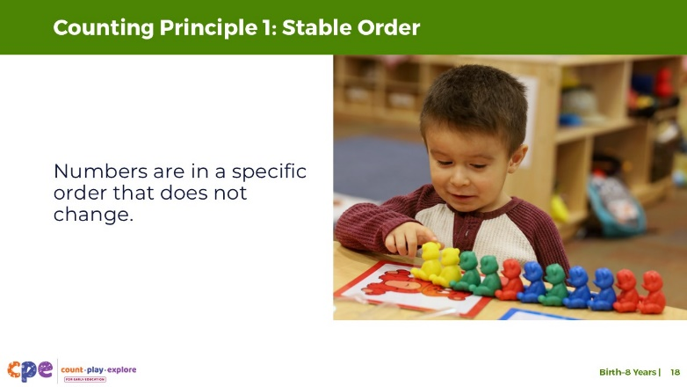

### Talking Points

* Children learn about counting by observing adults or other children use counting to find out how many.
* As children learn to count with meaning (or to find out how many), they learn to apply three counting principles: stable order, one-to-one correspondence, and cardinality.
* The first counting principle is **stable order.** Stable order is understanding that number words are in a specific order and this order never changes.
* Children begin understanding stable order when they learn to recite the count list.The count list is the ordered list of number words in any language, including sign language.
  + For example, the count list in English is one, two, three, four, five, and so on.
* Children first begin to recite parts of the count list at around age two. By age four, most children can recite the count list up to 10 and understand the principle of stable order.

## SLIDE 19: The Role of Language in Counting

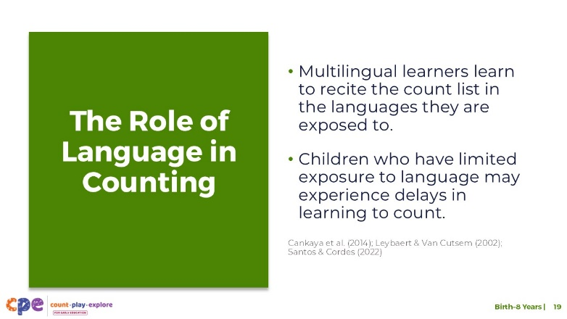

### Talking Points

* Before we discuss counting principles two and three, here is a note about the role of language in children’s ability to recite the count list.
* Consistent exposure and opportunity to use number words—in any language—plays an important role in learning to count, specifically learning to recite the count list.
  + Multilingual learners learn to recite parts of the count list in any of the languages they are exposed to frequently. For example, a child learning Spanish at home and English in their early learning and care setting may communicate their first few number words in Spanish. Typically, they will learn English number words quickly in their early learning and care setting. Multilingual learners learn to count at the same pace as monolingual children.
  + The types of languages children are exposed to can also influence children’s understanding of number and counting (Cankaya et al., 2014). Languages vary in how they represent mathematical concepts, including their number-naming system. Languages such as Chinese or Japanese have a number system in which number words map directly onto a base-ten structure (for example, the word for “11” in Chinese is equivalent to “ten-one”). Languages such as English and Spanish have a less obvious number word system (for example, the word for “11” in English is “eleven”). Research suggests that children learning languages with more transparent number systems, such as Chinese, Japanese, or Arabic, may have an easier time (at least at first) in learning to recite numbers, especially numbers that follow ten.
* However, research suggests that children with limited language exposure in the early years may experience delays in learning to count or producing number words.
  + For example, children who are deaf or have hearing impairments and are learning sign language may experience delays in learning parts of the count list compared to hearing children (Santos & Cordes, 2022).
  + This might be because caregivers are not fluent in sign language and have fewer ways to communicate with their children. As a result, they may not be exposing the children to as much language—including number and counting words—as hearing children.

## SLIDE 20: Counting Principle 2: One-to-One Correspondence

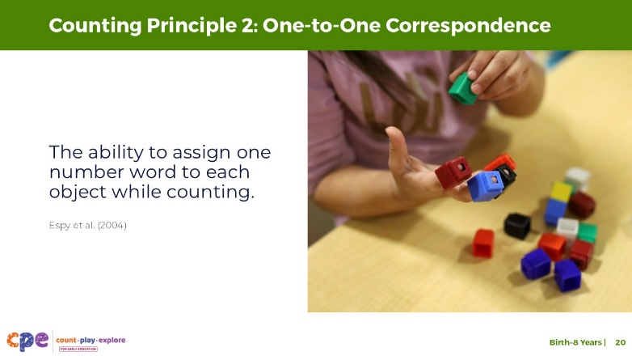

### Talking Points

* The second counting principle is **one-to-one correspondence—**the ability to assign one number word to each object while counting.
  + For example, when counting feathers on a dream catcher, a child might touch each feather as they say each number word.
* Understanding one-to-one correspondence requires a lot of practice and modeling from caregivers, educators, or older siblings.
  + Children first need to understand that every item only gets counted once.
  + Children also need to learn strategies to keep track of the items they already counted, and the items still left to be counted. [Make a connection to participant answers from the earlier counting activity.] Children might keep track by moving all the counted items to one side or arranging them in a line.
* Children’s approaches to learning skills, specifically their executive functioning skills, are important when learning to count and engage in one-to-one correspondence (Espy et al., 2004). Executive functioning includes children’s ability to ignore distracting information (inhibition) and remember information for short periods of time (working memory). When children are learning to engage in one-to-one correspondence, children need to remember which objects have already been counted.

## SLIDE 21: Counting Principle 3: Cardinality

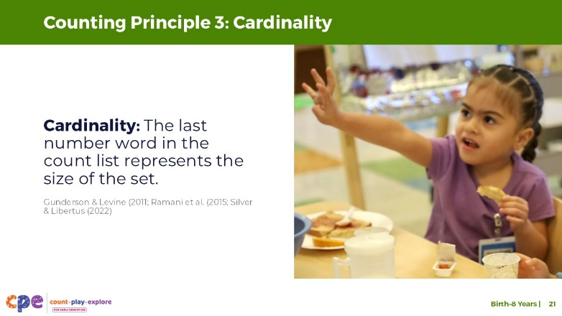

### Talking Points

* The third counting principle is **cardinality**.As mentioned earlier, cardinality is understanding that, when counting, the last number word in the count list represents the quantity of the set.
  + For example, a child might count a row of five apples as “one, two, three, four, five.” If they understand cardinality, they not only know that the number word “five” names the last apple. They also know that the number word “five” represents the total number of apples in this set.
* Developing an understanding of cardinality is quite complex and requires a lot of practice with counting.
* Most children develop an understanding of cardinality by the end of preschool or TK.
* However, it is important to remember that children develop at their own pace and in their own way and a variety of factors can impact children’s understanding of counting (Jordan & Levine, 2009; Silver & Libertus, 2022).
  + Children who experience more number words in meaningful contexts learn number words faster (Gunderson & Levine, 2011). Educators and families need to use number words and counting in daily routines and play.
  + Additionally, traditions and routines in children’s homes and communities influence their experiences with counting. For example, some children may learn to count using their fingers, while others are introduced to tools like an abacus. Asking families about important traditions and routines for their family can help educators incorporate those into their setting.

### Facilitator Notes

* Review PPT 2b: “Number and Counting: Preschool, Transitional Kindergarten, and Kindergarten” for more information on the three counting principles.
* Consider showing participants Count Play Explore’s “I’m Ready” videos to provide examples and encouragement for how they or the families they work with can engage children in counting in everyday routines and play. Some relevant videos are:
  + [*California Dad: Snack Time*](https://www.countplayexplore.org/video/california-dad-snack-time) ([*Un papá típico de California: La hora del bocadillo*](https://www.countplayexplore.org/es/video/un-papa-tipico-de-california-la-hora-del-bocadillo) in Spanish)
  + [*Wide World of Math: Treasure Hunt*](https://www.countplayexplore.org/video/wide-world-of-math-treasure-hunt) ([*Amplio mundo de las matemáticas: Búsqueda del tesoro*](https://www.countplayexplore.org/es/video/amplio-mundo-de-las-matematicas-busqueda-del-tesoro) in Spanish)

## SLIDE 22: Alphabet Counting: Counting Principles

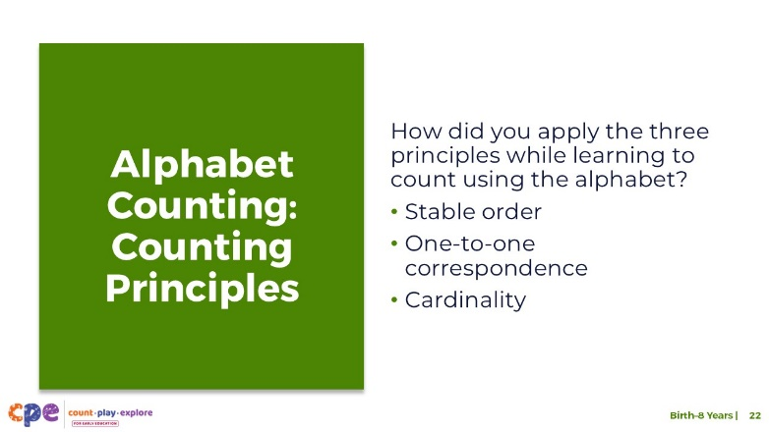

### Talking Points

* Think back to the alphabet counting activity we did at the beginning of this session. In table groups, discuss how you applied your understanding of the three principles of counting (stable order, one-to-one correspondence, and cardinality) while learning to count using the alphabet.
* [After some time for small group discussion, invite participants to share with the whole group. Then, summarize some key points. For example:]
  + Unlike young children when they first learn to recite the count list, you already knew the order of the alphabet, so you were able to apply the stable order principle to this new counting system.
  + From your experience with the number system, you also had some strategies to engage in one-to-one correspondence (for example, by lining up your items or pointing to each item as you count them). What may have been more challenging was to connect meaning to each letter in the alphabet.
  + From our experience with the number system, we understand how much “five” represents, but with the new alphabet counting system, we may not yet understand what “g” represents.

### Facilitator Notes

* Adjust the discussion method (for example, in pairs or at tables) based on group size, session length and format, and participant needs.

## SLIDE 23: Recognizing, Naming, and Recording Numerals

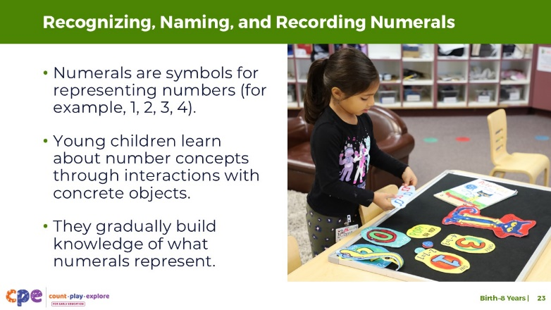

### Talking Points

* The last component in our suite of resources on number and counting describes children’s ability to recognize, name, and record numerals. Numerals are symbols that represent numbers. For example, the numeral “2” represents two objects.
* Most languages and countries use the Arabic numeral system (Hindu–Arabic numerals). These are the numerals we use in the United States.
* Young children learn about number concepts through interactions with concrete sets of objects. Gradually, they recognize that numerals represent numbers (for example, that “2” represents the value of two).
* Children first begin to recognize a few numerals under ten between ages three and four.
* Children can record numerals by writing, using an Augmentative and Alternative Communication (AAC) device, or using picture cards.

### Facilitator Notes

* Review PPT 2b: “Number and Counting: Preschool, Transitional Kindergarten, and Kindergarten” for more information on how children learn about numerals.

## SLIDE 24: Overview of Children’s Knowledge of Number and Counting

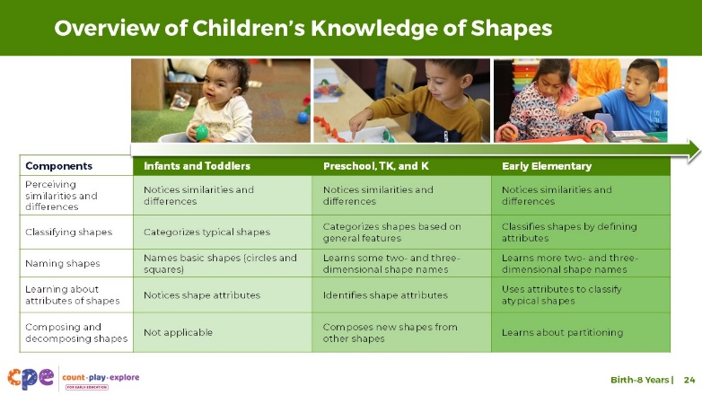

### Talking Points

* We have discussed four components related to understanding numbers and developing counting skills. Think about how children’s math learning develops and becomes more complex over time.
* This slide shows what children, at three points of development, know about number and counting across the four components.
  + Infants notice changes in the number of objects. With adult support, toddlers learn to communicate a few number words and use comparative words like “more” or “less.”
  + Children in preschool, transitional kindergarten, and kindergarten learn to recite the count list to 10, then to 20 and 30. They also learn to count using one-to-one correspondence and develop an understanding of cardinality. Once children know how to count with one-to-one correspondence, they can compare two small sets by counting. In preschool, children also learn to recognize a few numerals. By age five, they can recognize and record numerals up to 20.
  + Children learn to recite the count list to 1,000 in early elementary school. They can compare numbers larger than ten and express these comparisons using mathematical symbols such as <, >, and =. In addition, they can recognize and record numerals up to 1,000.

## SLIDE 25: Reflect: Exit Ticket

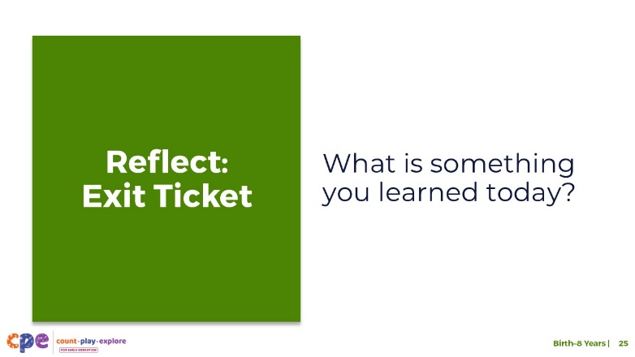

**Time:** 5–10 minutes

**Materials:** One note card per participant

### Talking Points

* We discussed four components of number and counting: attending to quantity; comparing numbers; counting and cardinality; and recognizing, naming, and recording numerals.
* We explored how these four components develop throughout early childhood. We also applied some of these number and counting skills in a playful, hands-on adult experience.
* Consider what you learned today. Then, record something you learned on a note card—your exit ticket.
* [Provide a few minutes for participants to record what they learned. Select a facilitation strategy for the debrief. Adjust talking points to match the strategy you chose.]
* This session described how children come to understand numbers and develop counting skills. When you return to your learning setting, you might notice ways children use numbers and counting. You also might pay attention to ways you support children to develop an understanding of number and counting skills. Noticing will help you be more intentional about the ways you support children’s learning in this math area.

### Facilitator Notes

* Adjust the way you organize the activity based on group size, session length and format, and participants’ needs.
  + Invite participants to share their reflections with their table groups.
  + If you prefer to keep participants’ reflections anonymous, invite participants to bring their cards to you to share. Collect the “exit tickets” to identify what participants learned and relate to topics for coaching or future professional learning.