Number and Counting: Infants and Toddlers (PPT 2a)

Use this facilitator guide with the slides “Number and Counting: Infants and Toddlers.” Facilitators can find talking points and guidance for activities and group discussions in this guide. The same text is also located in the notes portion of the slides. Adapt this facilitator guide based on your group size, session length and format, and participants’ needs.

## SLIDE 1: Number and Counting: Infants and Toddlers

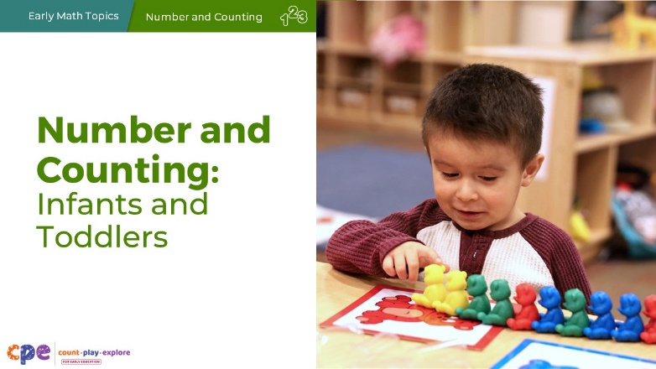

### Talking Points

* In this session, we will explore how infants and toddlers begin to understand number and counting. We will also focus on ways we can support infants and toddlers as they develop early number and counting skills.

### Facilitator Notes

* Adjust the talking points to reflect the session length and participant needs. If necessary, add introductory and “housekeeping” information.
* As you plan your professional learning session, consider the content in each of the PPTs in this suite:
  + PPT 1 “Introduction to Number and Counting” describes how children develop an understanding of number and counting from birth to age eight.
  + PPT 2a “Number and Counting: Infants and Toddlers” and PPT 2b “Number and Counting: Preschool, Transitional Kindergarten, and Kindergarten” describe in greater depth how children at different age levels develop an understanding of number and counting. These PPTs also include guidance on how to support children in specific age ranges to develop number and counting skills.
* We encourage you to offer the content in PPT 1 before, or in combination with, content in one of the age specific slide decks (PPT 2a or PPT 2b). Together PPT 1 and one of the age specific slide decks have been designed for a three-hour professional learning session. However, you might adjust slide decks to best meet participant needs and time allowances.

## SLIDE 2: Acknowledgments

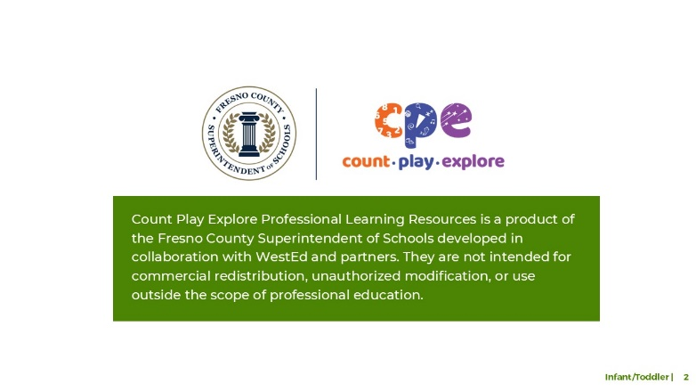

### Talking Points

The Count Play Explore Professional Learning Resources were made possible by Count Play Explore, an early math and science initiative led by the Fresno County Superintendent of Schools, Early Care and Education Department. This initiative is generously funded by the California Department of Education and the California State Board of Education. These resources, developed in collaboration by WestEd and partners, are intended to be used as a guide for implementing evidence-based strategies, promoting active learning, and encouraging developmentally appropriate practices in early education settings. They are not intended for commercial redistribution, unauthorized modification, or use outside the scope of professional education.

## SLIDE 3: Session Goals

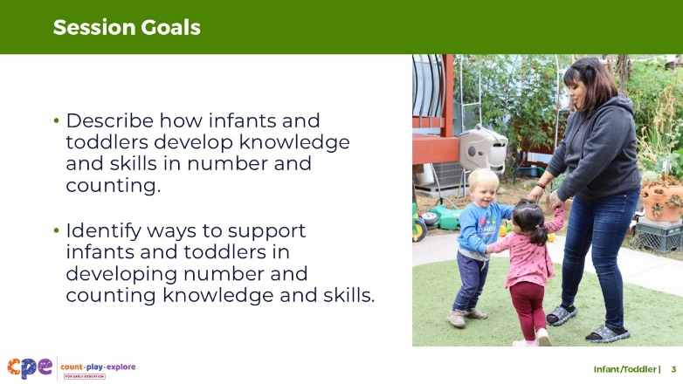

### Talking Points

* First, we will review how infants and toddlers develop knowledge and skills in number and counting.
* Then, we will explore ways educators can support infants and toddlers in developing knowledge and skills in number and counting.
* Throughout the session, we will reflect on our current practices. We will also think about how we might use information from this session in our work.

### Facilitator Notes

* Adjust slide content and talking points to reflect what you plan to address in your professional learning session.
* For longer sessions, start the session by engaging participants in the interactive **Alphabet Counting** activity described in PPT 1 “Introduction to Number and Counting: Birth–8 Years” and its corresponding handout. The purpose of this activity is to help participants become aware of the different skills involved in counting by inviting them to use a new counting system—the alphabet counting system.

## SLIDE 4: Play: Counting Fun

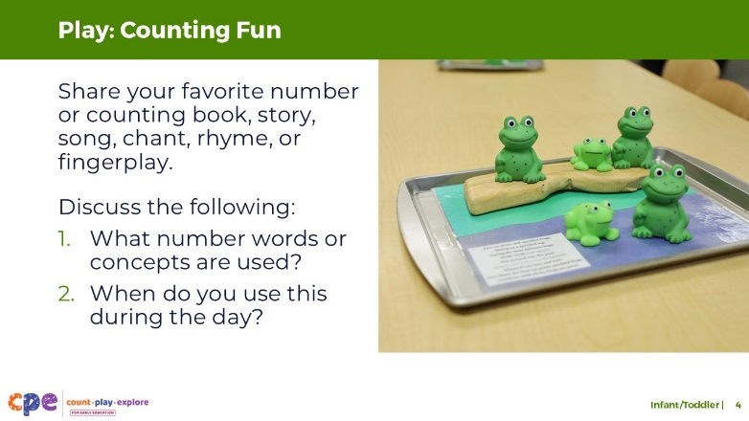

**Time:** 15–20 minutes

### Talking Points

* Infants and toddlers are exploring and learning about numbers every day. For example, they learn about numbers through stories, songs, chants, rhymes, and fingerplays.
* Think about some number and counting books or stories, songs, chants, rhymes, or fingerplays that you use in your learning setting—in English or any other language.
* Share with your table group one of your favorite number and counting books or stories, songs, chants, rhymes, or fingerplays to use with infants or toddlers. Then, discuss the following with your group:
  1. What number words or concepts are used?
  2. When might you use the book, story, song, chant, rhyme, or fingerplay (for example, during a specific daily routine)? Share why it’s used during that routine.

### Facilitator Notes

* Adjust how you organize the activity based on group size, session length and format, and participant needs.
  + For longer sessions, consider asking each table group to perform one or two songs, chants, rhymes, or fingerplays for the whole group.
  + For shorter sessions, consider inviting each table to focus on the first question.
* After participants share with their table group, consider having them share some of the following key takeaways:
  + How are children engaged in counting through books, stories, songs, chants, rhymes, or fingerplays?
  + How are number and counting included as part of children’s daily routines and play?
  + How are language, movement, and gestures used to engage infants and toddlers with number and counting?
  + How are language-based activities, including gestures and movements, used to offer children multiple ways to learn and express counting knowledge and skills?

## SLIDE 5: Learning About Number and Counting

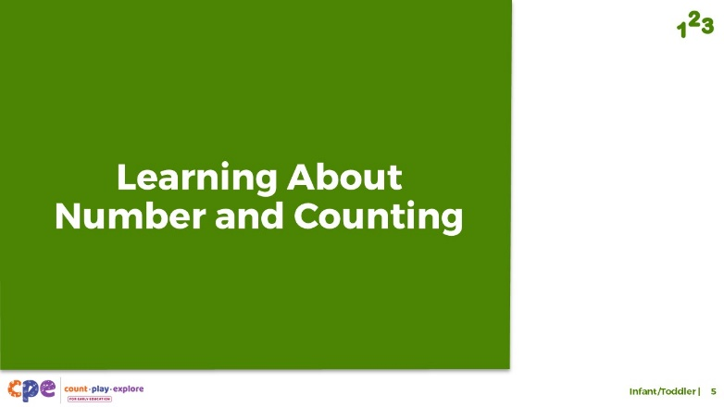

### Talking Points

* Now, we will explore how infants and toddlers develop an understanding of number.

## SLIDE 6: The California Infant/Toddler Learning and Development Foundations

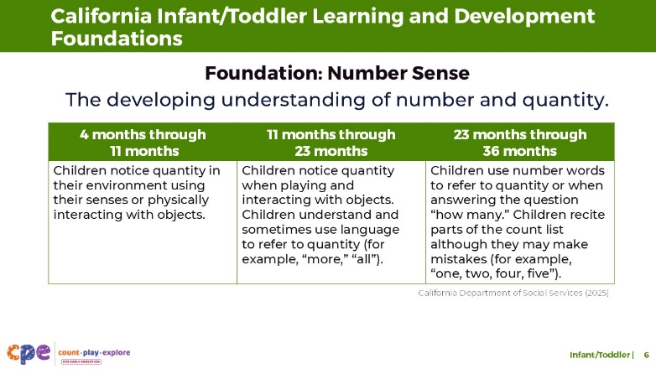

### Talking Points

* Let’s first review how the California Infant/Toddler Learning and Development Foundations describe infants’ and toddlers’ developing understanding of number and counting (California Department of Social Services, 2025).
* One foundation, Number Sense, includes concepts related to attending to quantity and counting. It describes how children understand that there are different amounts of things. It also shows that at about 36 months, children begin to understand and use a few number words.

### Facilitator Notes

* This slide makes connections between the components and relevant foundations.
* You may want to provide participants with copies of the relevant California Infant/Toddler Learning and Development Foundations. Consider whether electronic or printed copies will be more useful for your participants.

## SLIDE 7: Four Components of Number and Counting

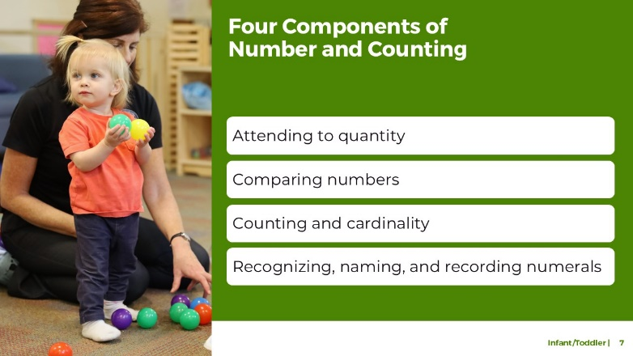

### Talking Points

* This suite addresses four components of number and counting:
  + attending to quantity
  + comparing numbers
  + counting and cardinality
  + recognizing, naming, and recording numerals
* For infants and toddlers, we focus on the first three components: attending to quantity, comparing numbers, and counting and cardinality. The last component describes skills that children typically begin to develop around age four.

## SLIDE 8: Attending to Quantity: Definition

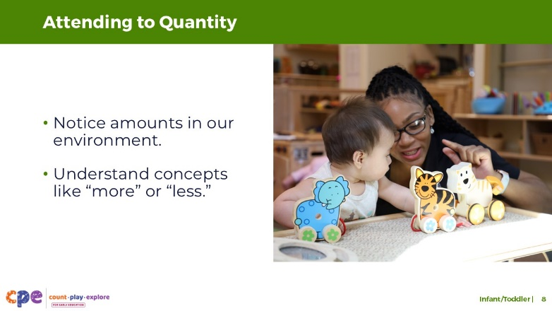

### Talking Points

* **Attending to quantity** describes infants’ and toddlers’ ability to notice the amount of things in the environment. This skill also includes noticing changes in quantity and understanding concepts like “more” or “less.” For example, toddlers might notice that the amount of apple slices on their plate changes as they eat.

## SLIDE 9: Attending to Quantity: Development

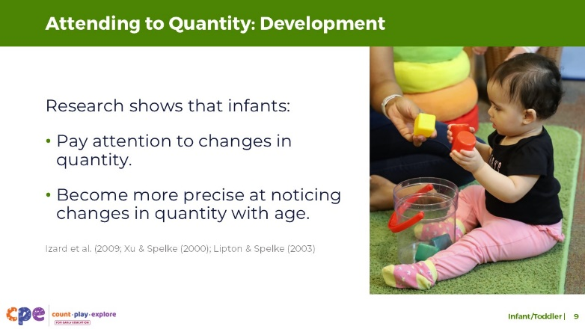

### Talking Points

* Infants, as early as a few weeks old, notice quantity.
  + Research on young infants measures how long they look at groups of objects. Researchers show infants a group of objects (for example, four objects) repeatedly and measure how long infants look at the group. When researchers then show infants a different quantity (for example, 12 objects), infants look longer at the set of objects with a different amount. The research suggests that infants notice a change in quantity (Xu & Spelke, 2000; Lipton & Spelke, 2003).
* Young infants also pay attention to quantity using other senses (Izard et al., 2009). For example, young infants notice if the number of faces they see matches the number of voices they hear.

## SLIDE 10: Which has more?

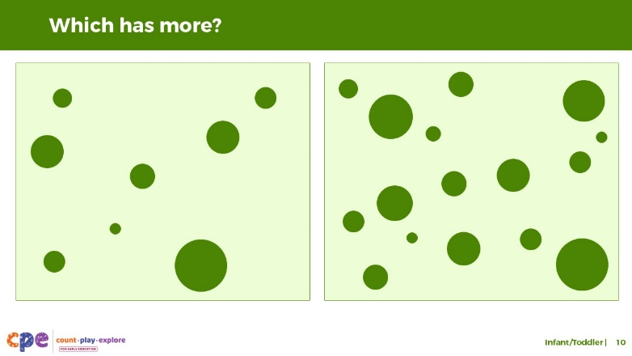

### Talking Points

* Let’s explore how researchers know what infants notice about large quantities. This slide shows two examples of pictures researchers used to measure the precision of infants’ understanding of large numbers.
  + Which of these pictures has more dots?
  + [Pause for participants to answer the question.] As you noticed, the picture on the right has more dots.
  + The difference between the number of dots is big, which makes it easy for adults to know which picture has more dots. In this example, we do not need to count the dots. We just know that one has more.
  + Six-month-olds also notice big changes in number, such as the change from eight to 16 objects. To measure this, researchers showed six-month-olds a few pictures of eight dots. Then, they showed the infants a picture of 16 dots. The researchers noticed that the infants looked at the picture with 16 dots much longer. This shows that infants noticed the change in the number of dots.

## SLIDE 11: Which has more? (continued)

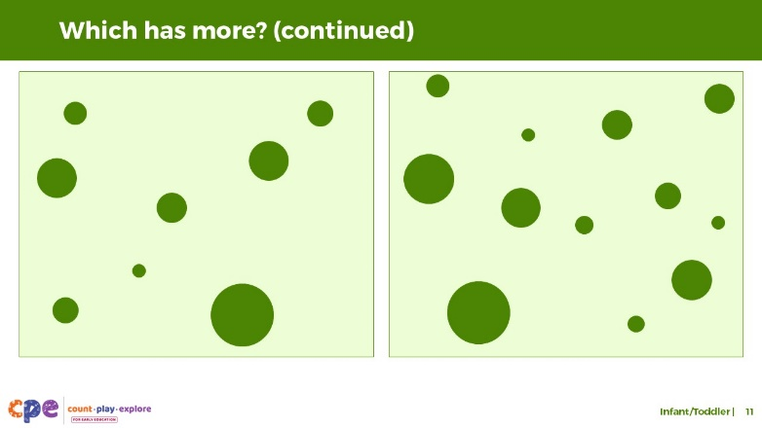

### Talking Points

* Infants’ sensitivity to, or understanding of, number is **approximate**; it is not precise. However, it becomes more precise as they get older.
* For example, as described on the prior slide, six-month-olds notice the change from eight to 16 objects. Nine-month-olds can notice a smaller change in number, such as the change from eight to 12 dots shown on this slide.
* As they get older, children notice even smaller changes in number without counting.
* Attending to quantity and different amounts of objects is important because it provides the foundation for later number and counting skills such as learning to label a set of objects with a number word or comparing two groups of objects to decide which one has more.

## SLIDE 12: Reflect: Attending to Quantity

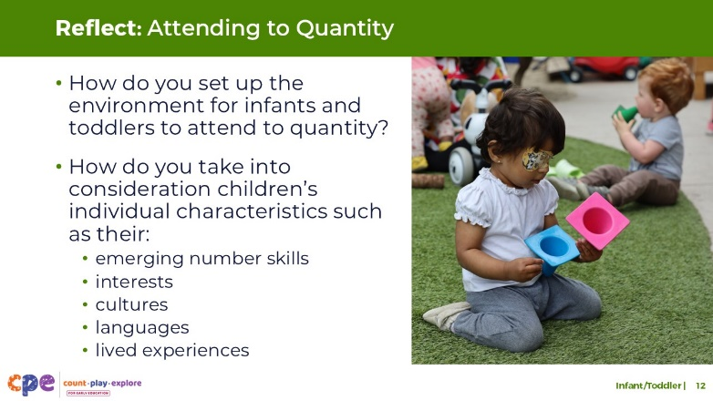

**Time:** 5–10 minutes

**Materials:** Paper and pens

### Talking Points

* Before exploring the next component, let’s consider how we expose infants to quantity in our environment.
* Take a piece of paper and divide it into three sections. Label the top of the first section, “Attending to Quantity.” We will use the other sections later in the session.
  + Think about your learning setting. How do you set up the environment for infants and toddlers to attend to quantity?
  + How do you take into consideration children’s individual characteristics such as their emerging number skills, interests, cultures, languages, or lived experiences when setting the environment?
  + Record some of your ideas under the heading “Attending to Quantity.”
* [Choose a debrief strategy from the facilitator notes.] From your examples, you may have noticed that children’s interests, cultures, languages, lived experiences, abilities, and emerging skills might affect how they notice and explore quantity. For example, children with visual impairments might gravitate toward materials they can touch or mouth to explore quantity.

### Facilitator Notes

* Adjust how you debrief the activity based on your group size, session length and format, and participants’ needs.
* Adaptations based on session length include the following:
  + For longer sessions, facilitators might invite tables to discuss and record their responses on chart paper. Each table can choose a recorder and reporter. Recorders will chart responses and reporters will share responses with the whole group.
  + For shorter sessions, invite a few participants to share their ideas with the whole group.

## SLIDE 13: Comparing Numbers: Definition

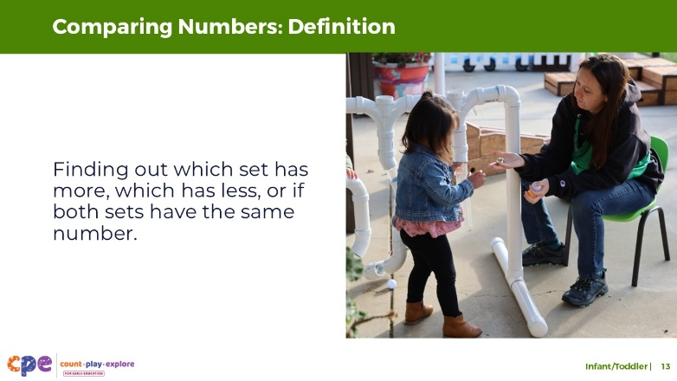

### Talking Points

* Earlier, we discussed how younger infants can attend to quantity. The ability to compare numbers is very closely related to the ability to attend to quantity.
* When comparing the number of objects in two sets, children find out which set has more, which has less, or if the sets are equal.

## SLIDE 14: Comparing Numbers: Visually Comparing Sets

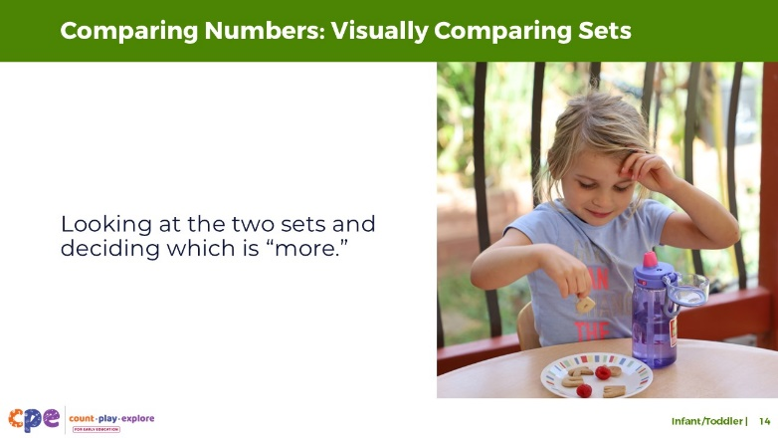

### Talking Points

* One of the first ways children learn to compare two sets of objects is by using visual strategies. This involves looking at the two sets and deciding which is more.
* Children and adults use this strategy when there are only a few objects.
* Children and adults can also use this visual comparison strategy when the difference between the two groups is very big.
* Although we call this a visual comparing strategy, this is not limited to the visual modality. Blind or visually impaired children and adults might compare sets by briefly touching the two sets to decide which one has more.

## SLIDE 15: Comparing Numbers: Matching

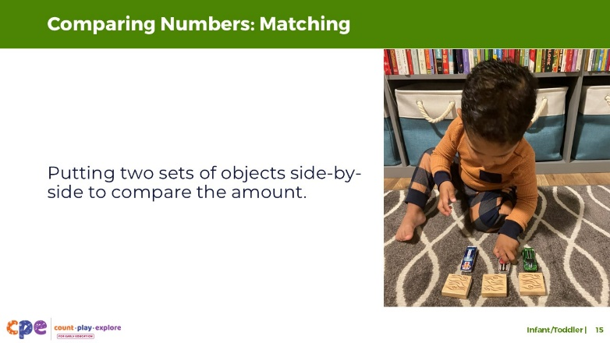

### Talking Points

* Around three years old, children learn to compare two sets of objects by matching. This involves lining up the two sets of next to another in one-to-one correspondence.
* At first, toddlers will need scaffolding from an adult to use the matching strategy to compare two sets.
  + For example, an adult might say, “Let’s make two lines to see which is more.” Then, the adult might make a line with the first set of objects and ask the child to put the second set of objects in one-to-one correspondence with the first. The adult might then point to each line and ask, “Which one has more?” or “Which one is longer?” to help the child make the comparison.
  + However, eventually, children will engage in the matching strategy independently when asked questions like “Which one is more? How can we find out?”
* Then, as children get older and learn to count, they transition to using counting to compare numbers.

## SLIDE 16: Comparing Numbers: Vocabulary

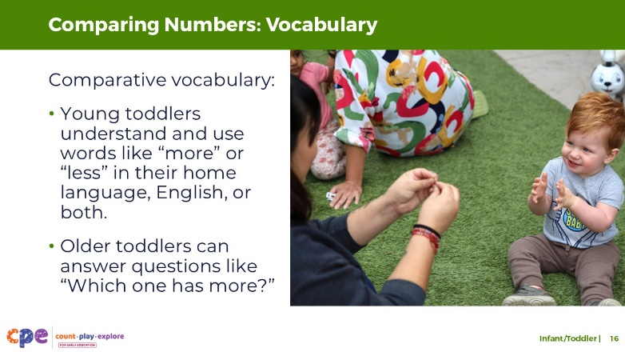

### Talking Points

* As part of learning to compare numbers, children learn comparative vocabulary.
* At around 12 months, children begin to **understand** comparative vocabulary in their home language, English, or both. This may include words like “more,” “less,” or “same.”
* Between 12 and 24 months, children may begin to **use** this type of comparative vocabulary in their home language, English, or both to express their wants or needs. For example, toddlers may ask for more tortillas at snack time or more crayons while drawing.
* Between 24 and 36 months, children begin to answer questions like “Which one has more?” using comparative vocabulary in their home language, English, or both, or using gestures. For example, when asked, “Who has more blocks, Diego or me?” a toddler might point to Diego or communicate, “Diego has more.”

## SLIDE 17: Counting: Definition

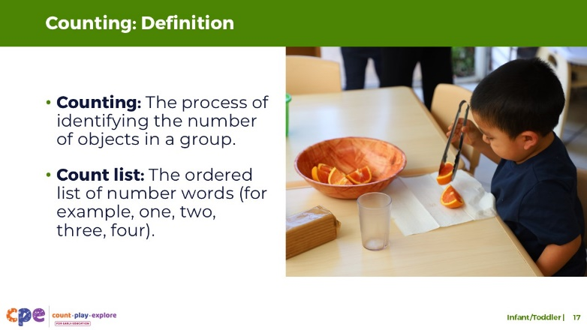

### Talking Points

* Next, we will discuss counting.
* Counting describes the process we use to identify the exact number of objects in a group. When counting, children use the count list.
  + The count list is the ordered list of number words. For example, the number words one, two, three, four, five.
* Children begin to develop an understanding of cardinality around age four or five. For infants and toddlers, we will focus on developing counting skills and not discuss cardinality.

### Facilitator Notes

* Review PPT 1: “Number and Counting: Preschool, Transitional Kindergarten, and Kindergarten” for more information on how children develop and understanding of cardinality.

## SLIDE 18: Counting: Beginning to Count

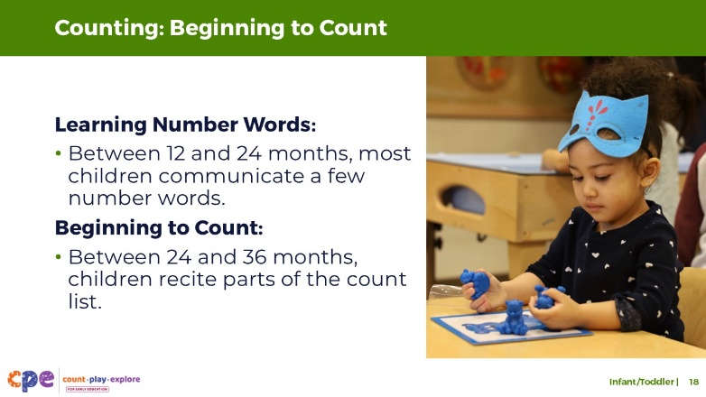

### Talking Points

* Most children begin recognizing and communicating one or two number words between 12 and 24 months.
  + For example, young toddlers may express how old they are using their fingers. They might say “two” in their home language, English, or both.
* Between 24 and 36 months, children begin to recite parts of the count list in their home language, English, or both. Reciting parts of the count list means children can communicate a few number words in order.
  + Toddlers are unlikely to know the meaning of the number words in their count list. When they begin to recite the count list, they tend to communicate it as a string of words with no separation between words, similar to how they recite the alphabet and think that “l, m, n, o, p” is one letter.
  + In addition, they are likely to make mistakes. For example, they may skip or repeat a number. These mistakes tend to be consistent. For example, a child may skip three and say, “One, two, four, five.” Adults can help toddlers fix these mistakes by modeling counting frequently.

## SLIDE 19: Reflect: Comparing Numbers and Counting

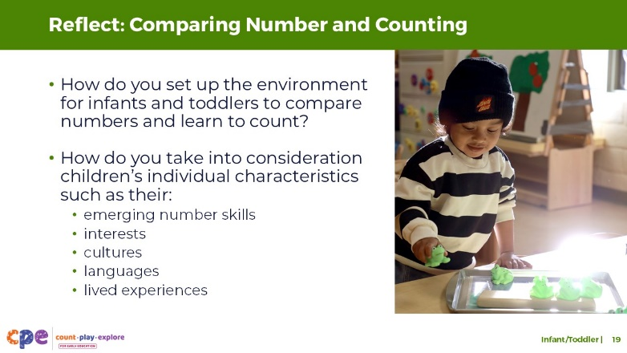

**Time:** 5–10 minutes

**Materials:** Paper and pens

### Talking Points

* Let’s return to the chart you created earlier in the session. Label the top of the second section, “Comparing Numbers” and the top of the third section, “Counting.”
  + Think about your learning setting. How do you set up the environment for infants and toddlers to compare numbers and learn to count?
  + How do you take into consideration children’s individual characteristics such as their emerging number skills, interests, cultures, languages, or lived experiences when setting the environment?
  + Record some of your ideas under the headings “Comparing” and “Counting.”
* [Choose a debrief strategy from the facilitator notes.] From your examples, you may have noticed that children’s interests, cultures and lived experiences, languages, abilities, and emerging skills might affect how they compare numbers and learn to count. For example, multilingual learners might use their home language and English when describing comparisons. Children may also count in their home language, on their fingers, or by using familiar objects.

### Facilitator Notes

* Adjust how you debrief the activity based on your group size, session length and format, and participants’ needs.
* Adaptations based on session length include the following:
  + For longer sessions, facilitators might invite tables to discuss and record their responses on chart paper. Each table can choose a recorder and reporter. Recorders will chart responses and reporters will share responses with the whole group.
  + For shorter sessions, invite a few participants to share their ideas with the whole group.

## SLIDE 20: Observe: Learning About Number and Counting

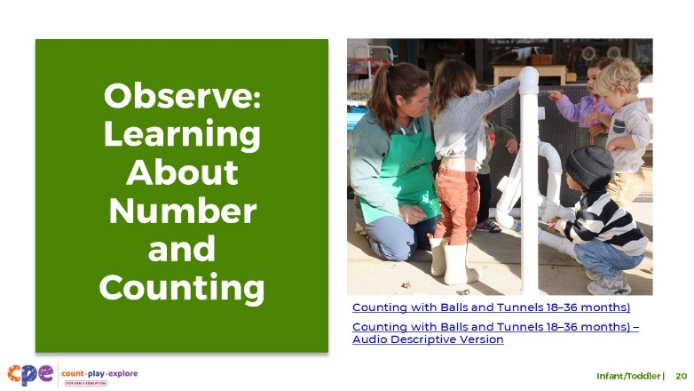

**Time:** 10–20 minutes (including a debrief on the next slide)

**Materials:** Infant or toddler number and counting video clip

### Talking Points

* Now, we will observe a video clip. As you observe, pay attention to the ways children:
  + attend to quantity
  + compare numbers
  + count
* After the clip, we will discuss what you noticed.

### Facilitator Notes

* Choose an infant or toddler video clip related to number and counting.
* We provide the following videos (you may use other videos):
  + [Using Math Language While Diapering (0–18 months)](https://youtu.be/sP53K3y0H3A)
  + [Using Math Language While Diapering (0–18 months) - Audio Descriptive Version](https://youtu.be/x4u_d80H67g)
  + [Counting with Balls and Tunnels (18–36 months)](https://youtu.be/fp3oLdHghdg)
  + [Counting with Balls and Tunnels (18–36 months) - Audio Descriptive Version](https://youtu.be/DOh6fbr6gDI)
* Note: Discussion points are provided for the video “[Counting with Balls and Tunnels (18–36 months)](https://youtu.be/fp3oLdHghdg)” in the Facilitator Notes on the next slide.
* If a component is not observed in the video, invite participants to:
  + Think about ways that children might develop knowledge and skills related to that component.
  + Explain how educators might support children to develop the knowledge and skills related to that component.
* Consider playing the video more than once. The first time, invite participants to become familiar with the clip. Then, invite participants to observe specific ways children show their understanding of the number and counting components.

## SLIDE 21: Discuss: Learning About Number and Counting

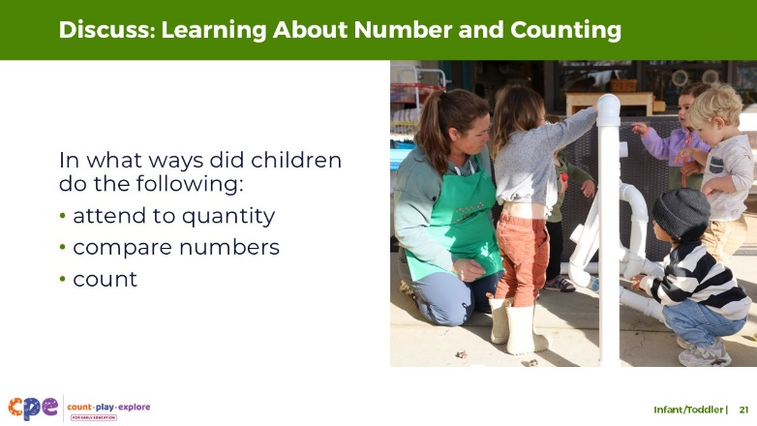

**Time:** 10–20 minutes (including the video observation on the previous slide)

### Talking Points

* Let’s discuss what you noticed. In what ways did children:
  + attend to quantity
  + compare numbers
  + count
* [After discussion:]. You noticed many ways children show that they are beginning to understand number and developing counting skills.

### Facilitator Notes

* Adjust the debrief based on your group size, session length and format, and participant needs. Consider charting participants’ observations to provide a visual of ways children understand number and develop counting skills.
* Consider using the following adaptations based on session length:
  + For shorter sessions, invite participants to share with the large group what they noticed about the ways infants and toddlers showed their knowledge and skills related to number and counting.
  + For longer sessions, offer time for participants to share their observations in pairs or at their tables. Then, invite each table to share some of their observations.
* Here are some examples of how children in the toddler video clip “[Counting with Balls and Tunnels (18–36 months)](https://youtu.be/fp3oLdHghdg)” attend to quantity, compare numbers, and count:
  + **Attending to quantity:** The child wearing the grey sweater showed an interest in quantity as they played with the balls. They were interested in adding one ball at a time into the tunnel until it filled up.
  + **Counting:** After the child with the grey sweater added the first ball to the tunnel, they started reciting the count list from one to nine. Since the numbers the child recited did not correspond to the number of balls they put in the tunnel, we can assume that the child had not yet developed an understanding of one-to-one correspondence or cardinality. However, the child understood that reciting the count list is an important part of counting. At the end when the educator modeled counting the balls in the tunnel, the child imitated the educator and pointed to each of the balls in the tunnel as the educator counted, an important step in developing an understanding of one-to-one correspondence.

## SLIDE 22: Supporting Number and Counting

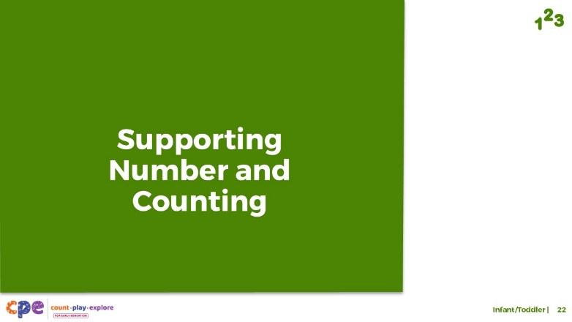

### Talking Points

* We explored how infants and toddlers develop an understanding of numbers. We also observed how infants and toddlers attend to quantity, compare numbers, and learn to count. Now, let’s discuss ways to support children in learning about number and counting—in our learning settings and at home.

## SLIDE 23: Explore: Daily Opportunities to Explore Number and Counting

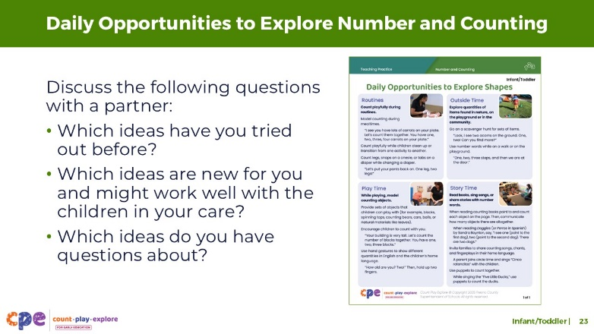

**Time:** 5–10 minutes

**Materials: Daily Opportunities to Explore Number and Counting** handout

### Talking Points

* Let’s review how we can help infants and toddlers develop their understanding of number and counting skills through daily routines at home, in their communities, and in early learning and care settings.
* Take out the **Daily Opportunities to Explore Number and Counting** handout. This handout offers some ideas on supporting infants’ and toddlers’ understanding of number and developing counting skills through daily routines.
* Review the handout on your own. Then, with a partner, discuss the following questions:
  + Which ideas have you tried out before?
  + Which ideas are new for you and might work well with the children in your care?
  + Which ideas do you have questions about?

### Facilitator Notes

* Provide 5–10 minutes for participants to review and discuss the handout.

## SLIDE 24: Explore: M5 Early Math Approach

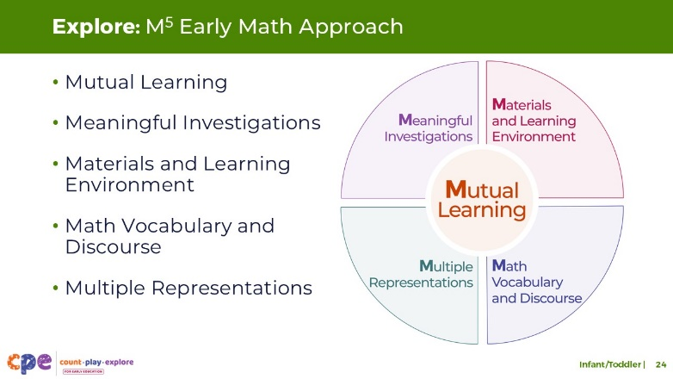

**Time:** 15 minutes

**Materials: M5 Overview** handout

### Talking Points

* We refer to five core early math teaching practices as the M5 (pronounced: M to the fifth) Early Math Approach. These practices include the following:
  + Mutual Learning
  + Meaningful Investigations
  + Materials and Learning Environment
  + Math Vocabulary and Discourse
  + Multiple Representations
* Let’s explore the M5 practices using the **M5 Overview** handout. Then, we will observe M5 in action.

### Facilitator Notes

* Consider your participants and their prior experiences with M5. Then, decide how to use the **M5 Overview** handout.
  + For groups with significant experience with M5, offer a few minutes for participants to review the handout and encourage them to share their strengths and the practices they are working on with a partner. You can also use this slide to revisit the M5 practices briefly and move to the next slide.
  + For groups with less experience with M5, offer more time for participants to independently explore each practice in the handout. Invite them to make a square over practices that they have “squared away” (practices they understand and use), a circle over “what’s still going around in their heads” (practices they still have questions about), and a triangle over three ideas that they will use in their settings.
* For ideas on how to provide a more comprehensive review, visit the **M5 Early Math Approach** suite.

## SLIDE 25: Explore: Using M5 to Support Learning About Number and Counting

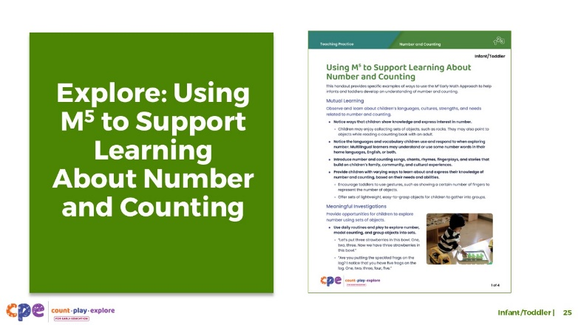

**Time:** 20–30 minutes (including debrief on next slide)

**Materials:** **Using M5 to Support Learning About Number and Counting** handout, paper, and markers

### Talking Points

* Let’s consider ways to use M5 teaching practices to support infants’ and toddlers’ understanding of number and counting.
* Take out the **Using M5 to Support Learning About Number and Counting** handout.
* Review the ideas on using M5 to support infants’ and toddlers’ understanding of number and counting; make notes, circle, or highlight as you review.
* [For shorter sessions:] consider the practices you reviewed. With a partner, discuss what you want to try and why. [If time permits, invite some participants to share with the large group what practices they will try and why.]
* [For longer sessions, use slide 26 to facilitate the discussion.]

### Facilitator Notes

* Provide seven to ten minutes for participants to review the handout independently.
* For shorter sessions, instead of using the next slide move on to slide 27.

## SLIDE 26: Discuss: Using M5 to Support Learning About Number and Counting

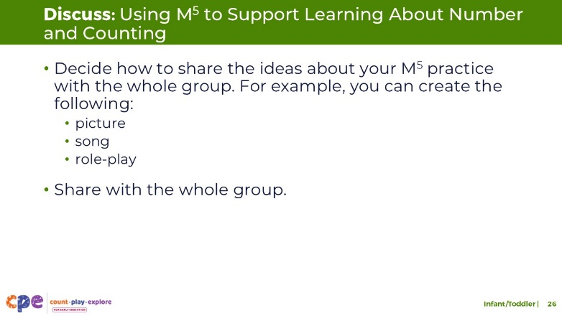

**Time:** 20–30 minutes (including a review of the document on the previous slide)

**Materials: Using M5 to Support Learning About Number and Counting** handout, paper, and markers

### Talking Points

* You reviewed some ideas on using the M5 Early Math Approach to support infants and toddlers in understanding number and counting. Next, let’s reflect on ways to continue supporting children’s understanding of number and counting.
* [Select a way to organize this activity from the facilitator notes. Then, adapt these talking points based on your selection.]
  + [Assign each group one M5 practice.] Briefly discuss the ideas described for your assigned practice. Then, decide how you will share these ideas with the whole group.
  + Be creative. For example, create a drawing, song, or role-play to share your learning.
  + Consider ways to represent the diversity of children’s interests, languages, cultures and lived experiences, abilities, and emerging skills.
  + Each group will have two to three minutes to share their M5 practice with the whole group.
* [Provide time for participants to prepare their presentations. Then, invite groups to share their assigned practices. Offer additional information about each practice as needed.]
* [After each group has shared:] You reviewed some ways to use the M5 Early Math Approach to support infants’ and toddlers’ understanding of number and developing counting skills. Hopefully, you will find these strategies helpful in your setting.

### Facilitator Notes

* Adjust the way you organize this activity based on group size:
  + For smaller sessions, divide participants into five groups. Assign each group one M5 practice. Each group will discuss their assigned practice briefly and identify a way to share the information with the whole group.
  + For larger groups, create groups of five to seven participants each. Assign each group an M5 practice. As necessary, assign more than one group to the same practice. Each group will discuss their assigned practice briefly and identify a way to share the information with the whole group.
* Move around the room while participants work in groups. Provide support as needed.

## SLIDE 27: Observe: Supporting Learning About Number and Counting

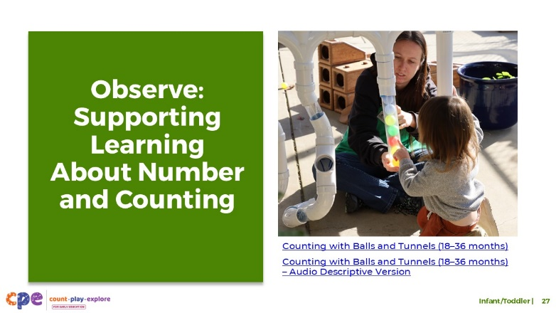

**Time:** 20–30 minutes (including a debrief on the next slide)

**Materials: Observing M5 in Action: Number and Counting** handout, infant or toddler number and counting video clip, chart paper, and markers

### Talking Points

* We observed how infants and toddlers develop an early understanding of number and counting skills. Then, we explored the M5 Early Math Approach. Now, we will observe a video showing how educators use M5 to help infants and toddlers develop number and counting skills.
* [Choose a strategy for facilitating this observation and debrief (on the next slide). Adapt the talking points to reflect this strategy.]

### Facilitator Notes

* Choose an infant and toddler video clip that shows children learning about number and counting. The same clip could be used from when participants observed children learning about number and counting.
* We provide the following videos (you might use other videos):
  + [Using Math Language While Diapering (0–18 months)](https://youtu.be/sP53K3y0H3A)
  + [Using Math Language While Diapering (0–18 months) - Audio Descriptive Version](https://youtu.be/x4u_d80H67g)
  + [Counting with Balls and Tunnels (18–36 months)](https://youtu.be/fp3oLdHghdg)
  + [Counting with Balls and Tunnels (18–36 months) - Audio Descriptive Version](https://youtu.be/DOh6fbr6gDI)
* Note: Sample answers are provided for the video “[Counting with Balls and Tunnels (18–36 months)](https://youtu.be/fp3oLdHghdg)” in the Facilitator Notes on the next slide.
* Invite participants to use the **Observing M5 in Action: Number and Counting** handout.
* For larger groups and longer sessions, use a jigsaw approach. Before playing the video clip, assign each table one practice to focus on during the video. [If there are more than five tables, assign more than one table to focus on each practice.]
* For smaller groups and shorter sessions, consider showing the video clip two to three times, inviting participants to focus on specific practices each time. Encourage them to record observations on the handout.

## SLIDE 28: Discuss: Supporting Learning About Number and Counting

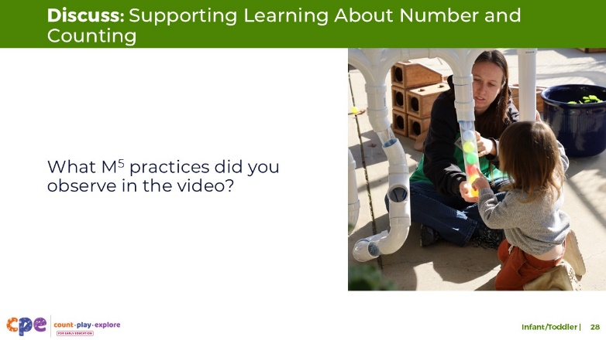

**Time:** 20–30 minutes (including the review of the video on previous slide)

### Talking Points

* Let’s unpack your observations of each M5 practice.

### Facilitator Notes

* Use the Answer Key for Observing M5 in Action Number and Counting handout for examples of ways M5 was used in the video, “[Counting with Balls and Tunnels (18–36 months)](https://youtu.be/fp3oLdHghdg)”
* For larger groups or longer sessions: After observing the video clip, ask each table group to discuss what they noticed about their assigned practice. Then, invite each group to share their observations with the whole group. As each group shares, paraphrase, affirm, and add to their responses as needed. Consider charting each group’s observations to make practices visible.
* For smaller groups or shorter sessions: Invite participants to share their observations with the whole group. Chart their observations to make the practices visible. As participants share, paraphrase, affirm, and add to their responses as needed. Consider inviting participants to share something they learned with someone from another table. For example, ask them to find someone with similar shoes, meet them, and share something they learned.

## SLIDE 29: Reflect: Three, Two, One

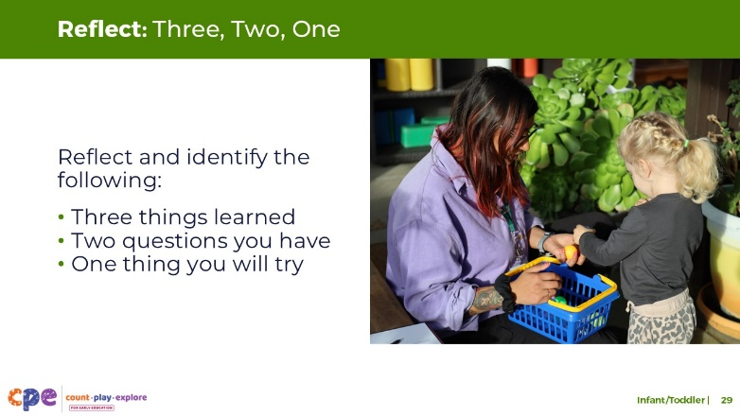

**Time:** 5–7 minutes

### Talking Points

* Take a few minutes to think about our session.
* Identify the following:
  + Three things you learned during this session
  + Two questions you have
  + One thing you will try in your learning setting next week
* [Allow three to four minutes for participants to think. Invite participants to share with a partner.]
* Thank you for your time, attention, and engagement. It has been wonderful working with you.

### Facilitator Notes

* For longer sessions, consider asking participants to share their questions with the whole group.
* As participants discuss their reflections, note the questions that they still have and what they would like to try. You might use this information to identify topics for future training, coaching, or communities of practice.