# The M5 Early Math Approach

## SLIDE 1: The M5 Early Math Approach

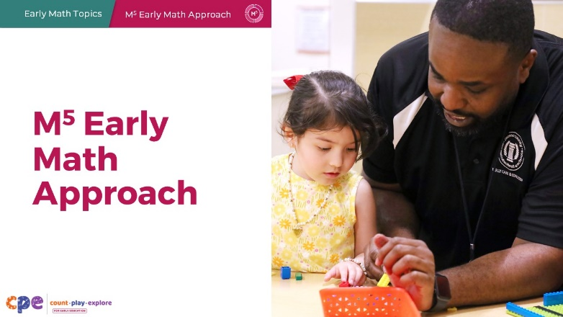

### Talking Points

Welcome everyone! I’m excited to explore with you the M5 [M to the fifth] Early Math Approach.

### Facilitator Notes

* The M5 Early Math Approach includes five key practices to support early math learning. This slide deck offers in-depth information on each of the five M5 teaching practices and activities to engage participants as they learn about the M5 Early Math Approach.
* M5 is integrated into all six of the math-focused educator suites, including
  + Geometry
  + Spatial Thinking
  + Number and Counting
  + Addition and Subtraction
  + Measurement
  + Data
* Use this slide deck as an introduction to the M5 Early Math Approach. Then, provide additional opportunities for educators to think about ways M5 can be used to support children’s knowledge and skills across the different math areas by using the math-focused educator suites.
* This slide deck has materials for about three hours of professional learning. However, you can adjust slides to meet participant needs and time allowances.
* For a more in-depth understanding of the M5 Early Math Approach, consider reviewing the **M5 Early Math Approach: Enhancing Math Learning in Early Childhood** research brief.

## SLIDE 2: Acknowledgments

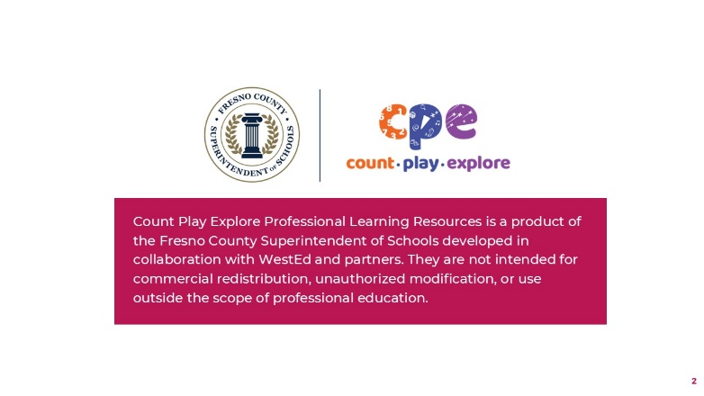

### Talking Points

The Count Play Explore Professional Learning Resources were made possible by Count Play Explore, an early math and science initiative led by the Fresno County Superintendent of Schools, Early Care and Education Department. This initiative is generously funded by the California Department of Education and the California State Board of Education. These resources, developed in collaboration by WestEd and partners, are intended to be used as a guide for implementing evidence-based strategies, promoting active learning, and encouraging developmentally appropriate practices in early education settings. They are not intended for commercial redistribution, unauthorized modification, or use outside the scope of professional education.

## SLIDE 3: Session Goals

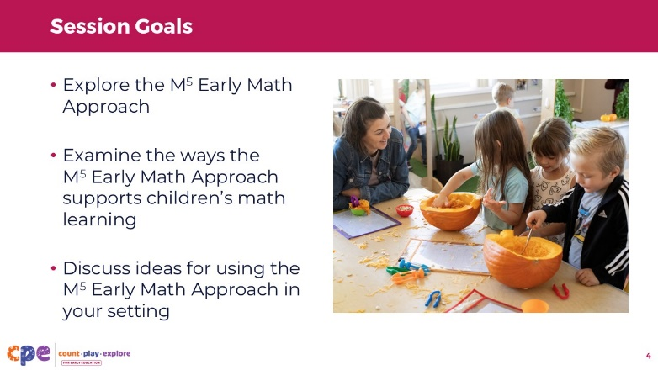

### Talking Points

* Today, we will discuss the **M5 Early Math Approach**, a comprehensive approach to supporting early math learning.
* We will start by learning about the approach as a whole.
* Then, we will examine each teaching practice. We will consider ways the approach supports math learning and discuss some ideas for using the approach in your setting.
* The ways we will learn together are like the ways children learn. We will play, observe, explore, discuss, and reflect.

## SLIDE 4: M5 Early Math Approach: Teaching Practices

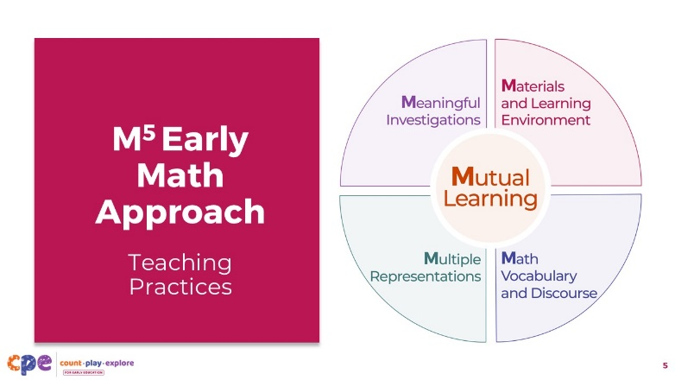

### Talking Points

* The M5 Early Math Approach includes five teaching practices to support young children’s math learning.
* We refer to this approach as “M5” [M to the fifth] because there are five practices, each starting with “M.”
* The five M5 early math practices are:
  + Mutual Learning
  + Meaningful Investigations
  + Materials and Learning Environment
  + Math Vocabulary and Discourse
  + Multiple Representations

## SLIDE 5: Explore: M5 Early Math Approach

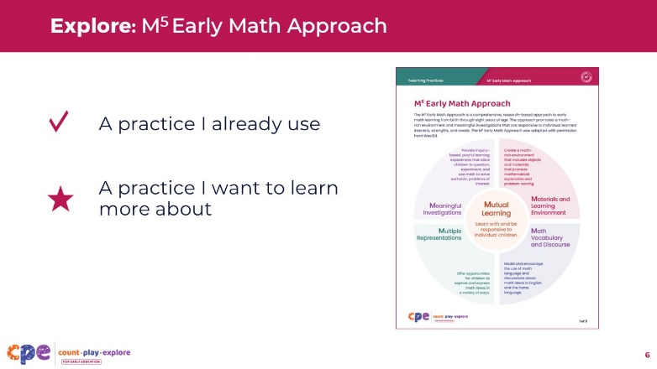

**Time:** 10 minutes

**Materials: M5 Early Math Approach** handout

### Talking Points

* We will start by briefly reviewing the M5 practices to give you a general idea of what this approach is about. Later in the session, we will discuss each practice in greater detail.
* Review the first page of the **The M5 Early Math Approach** handout.
* Place a checkmark next to a practice you already use and a star next to a teaching practice you are most interested in learning more about.
* [After participants review the handout, invite a few volunteers to share a teaching practice they already use and one they would like to learn more about.]
* Thank you for sharing your thoughts on the M5 practices.

## SLIDE 6: M5 Early Math Approach

This slide includes animation. See instructions in the Talking Points.

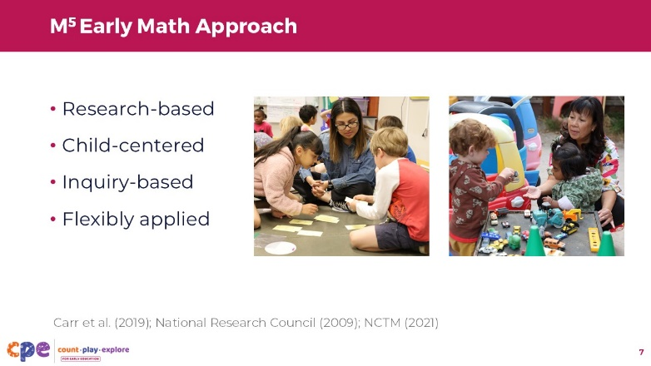

### Talking Points

* Let’s think about the approach as a whole.
* Taken together, these five practices are:
  + [Click] **Research-based:** Many studies show children learn more math and develop a deeper understanding of math concepts when educators intentionally use practices like the ones included in M5 (Carr et al., 2019; National Research Council, 2009; NCTM, 2021).
  + [Click] **Child-centered:** Children learn best when educators focus on individual interests, strengths, and needs. The M5 approach honors children’s unique ways of knowing and learning, including their languages, cultures and lived experiences, and abilities. Keeping the child at the center allows educators to offer learning experiences that support development and learning for all children of any background, race, culture, ethnicity, language, gender, ability, or socioeconomic status.
  + [Click] **Inquiry-based:** The M5 approach is also inquiry-based. Learning experiences come from questions children find interesting. The goal is not for children to memorize facts, like names of shapes or the count list (also called the “counting sequence”). Instead, inquiry-based learning allows children to solve real-world math problems, work with math ideas, and develop a deep understanding of math concepts.
  + [Click] **Flexibly applied:** Lastly, M5 can be used flexibly. It is not a curriculum or a checklist of specific strategies. M5 is an approach that can be used with any curriculum and supports math learning across the children’s day with all ages and abilities and across different learning settings.

## SLIDE 7: Paper Structures

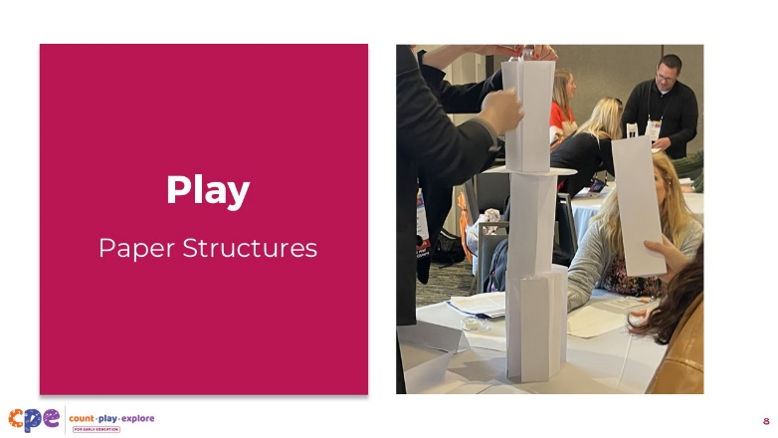

**Time:** 20–30 minutes (including the activity on the next slide)

**Materials: Paper Structures** handout, 10−20 sheets of any kind of paper, tape, paper clips, string, three feet of yarn per group

### Talking Points

* [Select a facilitation strategy from the facilitator notes. Adjust the talking points as necessary.]
* Math is playful! This principle is key to the Count Play Explore professional learning approach.
* Before we examine each M5 practice, let's engage in a playful math experience. The purpose of this activity is for you to experience the M5 Approach as a learner.
* Take out the **Paper Structures** handout. Follow the instructions to build a paper structure together. When you are finished, figure out a way to measure your structure and compare the height of your structure to the height of another group's structure.
* [You might use the following prompts to support participants while they build:]
  + Tell me about your structure.
  + How tall is your structure?
  + Do you think your structure is taller than another group? How do you know?
  + Tell me about the shapes you used to build.
  + How many pieces of paper did you use to build your structure?

### Facilitator Notes

* Math is playful! This principle is key to the Count Play Explore professional learning approach. This activity invites adults to experience the M5 Early Math Approach through a playful, hands-on experience.
* Before your session, carefully review the handout and prepare the necessary materials.
* Select a facilitation method that works best for your session's length, format, group size, and participant needs. For example:
  + Group the participants in a way that is meaningful to them (for example, create groups based on the ages of children in participants' learning settings).
  + Invite participants to build structures in pairs. Then, ask them to compare the structures built at their table.
  + Organize participants into larger groups by table. Then, compare structures around the room.
* As participants build their structures, move around the room and provide support as needed.

## SLIDE 8: Discuss: Paper Structures

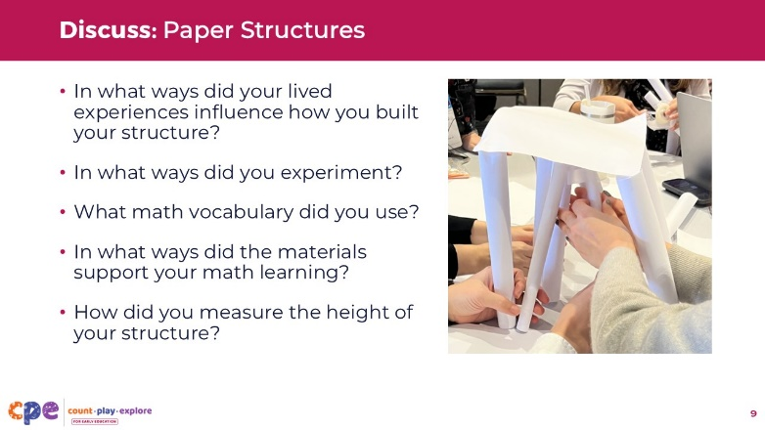

**Time:** 20–30 minutes (including the activity on the previous slide)

### Talking Points

* [After participants build their structures:] Let's discuss this experience.
* [You might use the following prompts to encourage discussions related to the M5 approach:]
  + In what ways did your lived experiences influence the ways you built your structure?
  + In what ways did you experiment?
  + What math vocabulary did you use?
  + In what ways did the materials support your math learning?
  + How did you measure the height of your structure?
* While you were building, I noticed a lot of connections to the M5 Early Math Approach. You used your lived experiences to design your structures, experimented with different ways to build and measure, and used math vocabulary such as "taller," "measure," and "on top of." The materials you used were open-ended, allowing you to use them in different ways. You also used different ways to measure and represent the height of your structures!
* Throughout our session, we will think more about how your experience building paper structures connects with the M5 Early Math Approach. We will also consider how using this approach can support early math learning.

### Facilitator Notes

* For shorter sessions, invite a few volunteers to respond to some or all of the reflection questions.
* For longer sessions, consider inviting groups to discuss some or all of the reflection questions. Then, encourage groups to share with the larger group.

## SLIDE 9: Mutual Learning

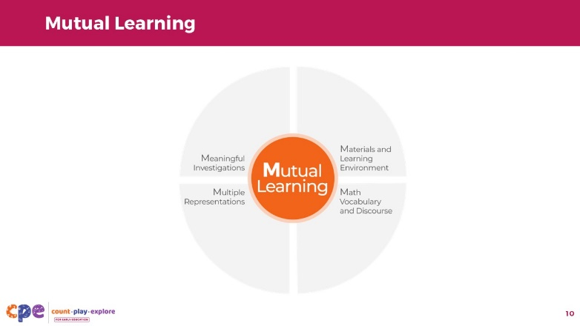.

### Talking Points

* Now that you have had an opportunity to experience the M5 Early Math Approach as a learner, let's discuss the five M5 practices in detail. We will start with the most central practice, Mutual Learning.

## SLIDE 10: Mutual Learning: Defined

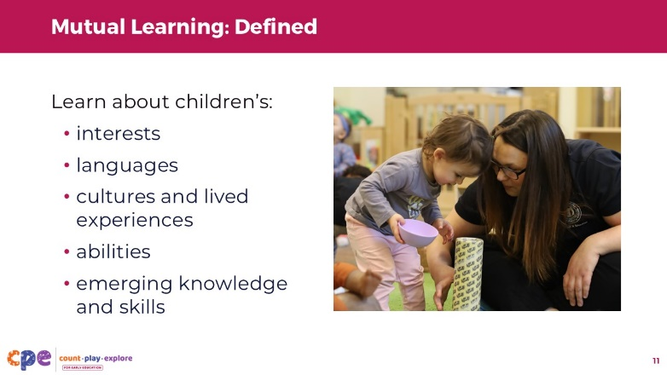

### Talking Points

* **Mutual learning** is when children and educators are learning together. Children are learning math and educators are learning about children. Educators learn about children's:
  + interests
  + languages
  + cultures and lived experiences
  + abilities
  + emerging knowledge and skills
* Educators use what they learn about children to plan an environment and a variety of early math learning experiences that are responsive to children’s diverse backgrounds, strengths, and needs.
* Mutual learning informs us of the ways we use other M5 practices.

## Slide 11: Why is mutual learning important?

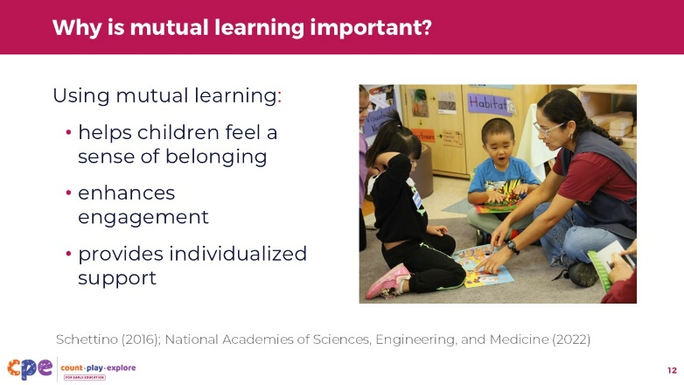

### Talking Points

* Using what we learn about children to support their early math development can increase children's engagement and math learning.
* When educators use mutual learning, they can help children feel a sense of belonging (National Academies of Science, Engineering, and Medicine, 2022; Schettino, 2016).
  + When children observe and experience their interests, languages, cultures, and lived experiences reflected in learning settings, they are more likely to feel part of the learning setting. They are also more likely to identify themselves as capable and competent math learners.
    - For example, you might display photographs of children's favorite places, such as their neighborhood parks or community center, in the block area to support children's geometry learning as they explore and build. These displays can help children feel personally included in the learning experience. Children also might begin to recognize that math is a part of their daily lives.
* Using mutual learning also enhances engagement. Children will maintain their interest and motivation to learn when the content is interesting and relevant to them (National Academies of Science, Engineering, and Medicine, 2022).
* Finally, mutual learning allows educators to provide individualized support. When educators pay attention to children’s abilities and emerging knowledge and skills, they can provide learning experiences and supports that meet children where they are.

### Facilitator Notes

* Consider inviting participants to revisit their experience building paper structures. You might encourage participants to share ways the activity is connected to their interests, languages, cultures and lived experiences, abilities, knowledge, and skills.

## SLIDE 12: Ways to Learn About Children

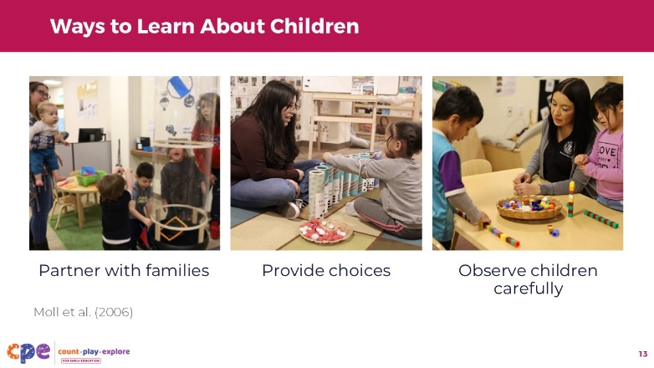

### Talking Points

* Educators learn about children in different ways. Here are three examples:
  + Educators can partner with families (Moll et al., 2006). They might have casual conversations with families during pick-up or drop-off, invite families to share information about their children's lived experiences outside the classroom or ask families to share items or photos from home. For example, this photo shows a family member exploring the wind tunnel with her children and their educator during pick-up time. The educator might invite the family member to share about children's math experiences at home. The educator might also learn about children by observing adult–child interactions during this experience.
  + Educators can learn about children by providing them with choices. Educators can invite children to choose where and how to play or how to approach and solve a problem. When children have choices, educators might notice their preferences, strengths, and abilities. For example, this photo shows a child choosing which tube to add the pom-pom balls.
  + Finally, educators can learn about children by carefully observing them throughout the day. Educators might notice what children communicate about, what language they prefer to use, or how they think about and understand math concepts. For example, this photo shows an educator observing children using connecting cubes. The educator might learn about children's knowledge of counting, measuring, or patterning.

## SLIDE 13: Explore: Mutual Learning

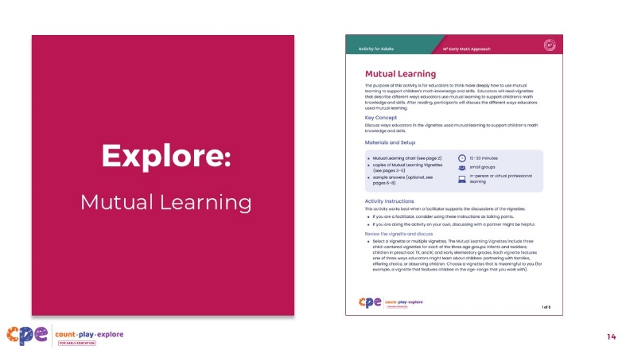

**Time:** 10–15 minutes

**Materials: Mutual Learning** handout, chart paper (optional)

### Talking Points

* Let's think more deeply about mutual learning.
* [Select a facilitation strategy from the facilitator notes. Provide copies of the **Mutual Learning** handout for participants. Distribute the vignettes in a way that works best for your session goals. Adjust talking points as necessary.]
* In this activity, we will examine ways educators learn about children and how they use what they learn to support children's math development and learning.
* The vignettes you were provided describe what an educator learned about a child, how they learned it, and at least one way they used what they learned to support that child's math development and learning.
* Use the Mutual Learning Chart (page 2 of the handout) to make notes on:
  + What the Educator Learned
  + How They Learned It
  + Ways They Used What They Learned
* [Provide 5−10 minutes for participants to review the vignettes and record their responses.]
* Let’s share your observations about what the educator learned, how they learned the information, and how they used what they learned to support children’s math development and learning.

### Facilitator Notes

* This activity invites participants to examine ways educators learn about children and how they might use what they learn to support children's math development and learning.
* The **Mutual Learning** handout provides three child-centered vignettes for each of the three age groups: infants and toddlers; children in preschool, TK, and K; and early elementary grades. Each vignette features one of three ways educators learn about children: partnering with families, offering choices, or observing children.
* Use vignettes that are most appropriate for your participants. For example, you could use only the preschool, TK, and K vignettes if you are working with educators who teach children within the three- to five-year-old age range. If your participants work with more than one age group, invite participants to choose an age group that is most relevant for them.
* Consider using the following adaptations based on session length:
  + For shorter sessions, you might provide one vignette per participant or group. Invite participants to review their vignettes individually and record notes on their charts. Then, invite a few volunteers to share their observations with the larger group.
  + For longer sessions, you might:
    - Provide multiple vignettes to each participant or small group. For example, one group might review all three infant and toddler vignettes.
    - Provide each group with chart paper and invite them to create a three-column chart with columns labeled, "What the Educator Learned," "How They Learned It," and "How They Used What They Learned."
    - Encourage groups to assign a recorder to write down responses and a reporter to share information with the larger group.
    - As necessary, support individuals to contribute while working in small groups.
    - When groups finish, invite reporters to share key points from their discussion with the larger group.
* Sample responses are included on pages 6–8 of the **Mutual Learning** handout. Use the sample responses to support a discussion.

## SLIDE 14: Mutual Learning in My Setting

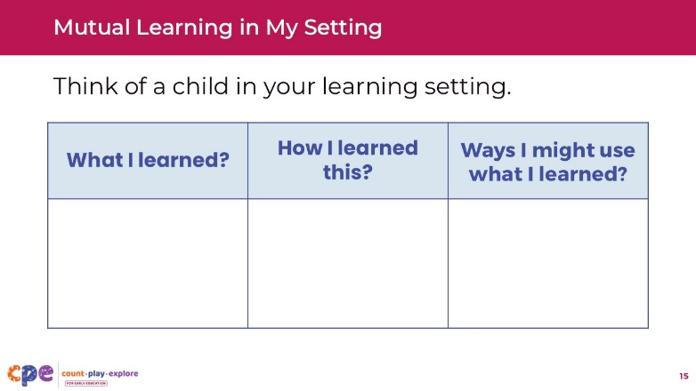

**Time:** 10–20 minutes (varies based on the session goals)

**Materials: Mutual Learning** chart from Mutual Learning handout

### Talking Points

* Now, we'll take a moment to reflect on mutual learning in our own learning settings.
* We will use the charts we used in the previous activity (page 2 of the **Mutual Learning** handout). Think of a child in your learning setting. Consider something you have learned about this child. In the first column of the chart, record what you learned about the child. In the second column, record how you learned this. In the third column, describe how you might use this information to support the child's math learning.
* You might record more than one thing you have learned about this child. Or you might record what you know about more than one child.
* [Allow time for participants to record their ideas. Then, offer time for participants to share. After sharing:] You shared many ways educators can learn about children. You also offered a variety of ways we might use this information to support children's math development and learning. We can enhance children's math learning by planning learning experiences that respond to children's interests, experiences, and abilities.

### Facilitator Notes

* Choose a facilitation strategy based on your session's length, format, group size, and participant needs. For example:
  + For shorter sessions, invite a few volunteers to share with the larger group.
  + For longer sessions, invite participants to share their responses with a partner or table group. Consider grouping participants in a meaningful way (for example, by the age groups they work with). Then, invite small groups to share with the larger group.
* As participants share with the larger group, paraphrase, affirm, and add to their responses as needed.

## SLIDE 15: Meaningful Investigations

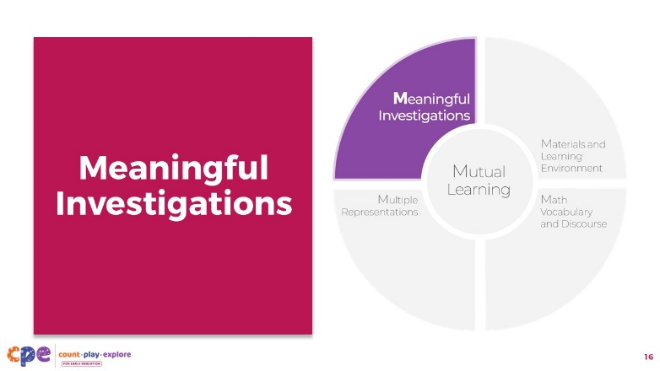

### Talking Points

* Next, we will describe Meaningful Investigations.

## SLIDE 16: Meaningful Investigations: Defined

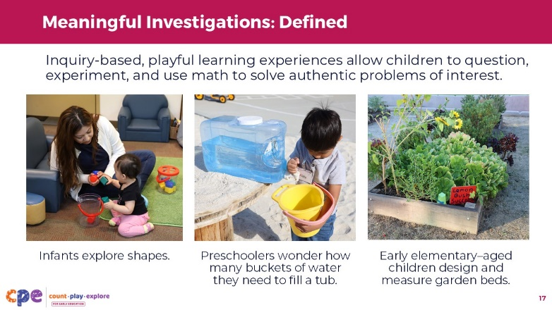

### Talking Points

* **Meaningful investigations** are inquiry-based, playful, open-ended learning experiences that allow children to question, experiment, and use math to solve authentic problems of interest.
  + Infants and toddlers might explore shapes. Preschoolers might wonder how many buckets of water are needed to fill a tub. Children in early elementary grades might design and measure garden beds. In these examples, children are able to use math in a way that is meaningful to them.

## SLIDE 17: Why are meaningful investigations important?

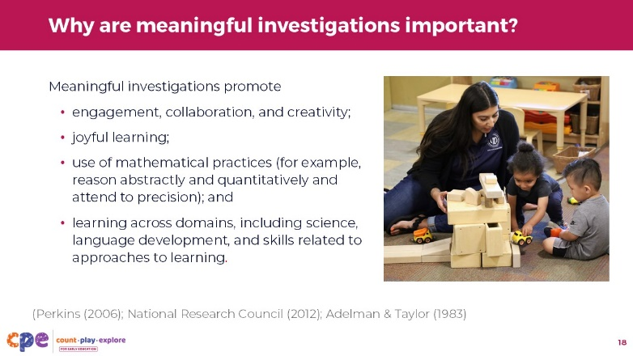

### Talking Points

* Meaningful investigations support children’s math development. They also provide opportunities for children to develop important learning skills such as engagement, collaboration, communication, and creativity (National Research Council, 2012; Perkins, 2006).
* When children participate in meaningful investigations, they are more likely to fully engage and experience joy in their learning. When children are engaged, they are motivated to keep trying and develop a deeper understanding of math concepts (Adelman & Taylor, 1983).
* Meaningful investigations also provide children opportunities to use mathematical practices such as making sense of problems, persevering to find solutions, and reasoning abstractly. They invite children to think critically and creatively about problems and ways they might solve them.
* Finally, meaningful investigations offer opportunities for children to practice skills from multiple learning domains, including science, language development, and skills related to approaches to learning such as attention, engagement, and persistence.

### Facilitator Notes

* Consider inviting participants to think about ways their experience building paper structures was a meaningful investigation. For example:
  + In what ways did you use mathematical practices like persistence and reasoning?
  + In what ways did you collaborate, communicate, think critically, and use creativity?

## SLIDE 18: Explore: Meaningful Investigations

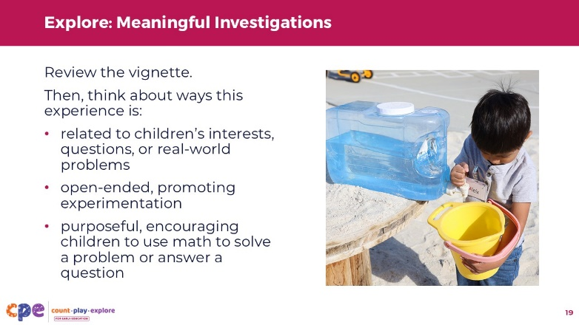

**Time:** 10–15 minutes

**Materials: Meaningful investigations** handout, blank paper

### Talking Points

* Now, we will think more deeply about what makes an experience a meaningful investigation.
* [Select a facilitation strategy from the facilitator notes. Adjust the talking points based on the strategy you choose.]
* [Provide printouts of the **Meaningful Investigations** handout to participants in a way that meets your session goals.]
* Review the vignette. Think about ways the experience is:
  + related to children's interests, questions, or real-world problems;
  + open-ended, promoting experimentation; and
  + purposeful, encouraging children to use math to solve a problem or answer a question.

### Facilitator Notes

* The Meaningful Investigation handout provides examples of meaningful investigations for three age groups: infants and toddlers; children in preschool, TK, and K; and children in the early elementary grades.
* Use vignettes that are the most appropriate for your participants. For example, you might use only the preschool, TK, and K vignettes if you are working with educators who teach children from three to five years old. If your participants work with more than one age group, you might invite participants to choose an age group most relevant for them.
* Select a facilitation strategy based on your session's length, format, group size, and participant needs.
  + For shorter sessions, you might do the following:
    - Provide one vignette per participant or group.
    - Invite participants to review vignettes individually and discuss in pairs or small groups.
  + For longer sessions, consider:
    - Providing multiple vignettes to each participant or small group (for example, one group might review the infant and toddler vignette and the preschool, TK, and K vignette).
    - Inviting small groups to discuss the vignettes.
* After participants review and discuss the vignettes, support a discussion with the larger group. Here are some sample answers for each vignette:
  + Gabriella Investigates Shapes
    - Gabriella notices how blocks of different shapes look and feel because she is interested in the objects.
    - The materials are open-ended, allowing Gabriella to experiment with different ways to use the blocks.
    - Gabriella is developing spatial thinking and shape knowledge through her desire to explore and manipulate shapes.
  + Filling the Tub
    - Children investigate an authentic, real-world question based on their interests.
    - Children experiment with different approaches to solving a problem.
    - Children use math for a purpose. They count and track data to find out how many buckets of water they use to fill the tub.
  + Garden Designs
    - Children investigate an authentic, real-world question.
    - Children experiment with different ways to design their garden beds and find the perimeter of shapes.
    - Children use their knowledge of geometry, measurement, and addition for a purpose-designing their garden beds.

## SLIDE 19: Observe: Mutual Learning, Meaningful Investigations

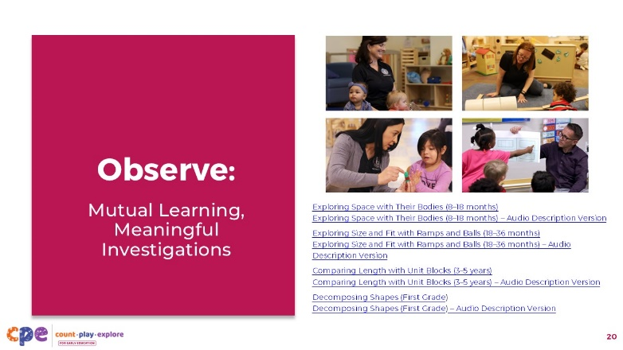

**Time:** 15–20 minutes (including the debrief on the next slide)

**Materials: Observing M5 in Action** handout, video clips

### Talking Points

* Now, we will observe a video. As you observe, focus on the first two M5 practices: Mutual Learning and Meaningful Investigations.
* Take out the **Observing M5 in Action** handout.
* Consider recording your observations on the handout. After we observe the clip, we will discuss what you noticed.

### Facilitator Notes

* Choose the video clip, or clips, that are most relevant for your participants.
* We provide the following videos (you may use different videos):
  + Infant video clip: "[Exploring Space with Their Bodies (8-18 months),"](https://youtu.be/9MjPYFUkqM4) "[Exploring Space with Their Bodies (8-18 months) - Audio Descriptive Version."](https://youtu.be/w9hJczYV_O8)
    - In this video, infants explore a variety of open-ended materials. The educator learns about individual children's interests and supports their growing understanding of numbers and spatial relationships.
  + Toddler video clip: "[Exploring Size and Fit with Ramps and Balls (18-36 months)](https://youtu.be/C3ksY_hbGaM)," "[Exploring Size and Fit with Ramps and Balls (18-36 months) - Audio Descriptive Version](https://youtu.be/0mFLcfPc-xo)."
    - In this video, an educator and child experiment with ramps and balls. Through meaningful investigations, the educator supports the child's early math learning in the areas of spatial thinking and measurement.
  + Preschool/TK/K video clip: "[Comparing Length with Unit Blocks (3-5 years)](https://youtu.be/RQigPvC0TOY)," "[Comparing Length with Unit Blocks (3-5 years) - Audio Descriptive Version](https://youtu.be/jX5aAtOaQL4)."
    - This two-part video shows ways an educator supports a preschooler's understanding of measurement concepts, mathematical reasoning, and problem-solving. In Part 1, the educator and child use connecting cubes to compare heights. In Part 2, they use the cubes to measure and compare the lengths of their hands.
  + Elementary video clip: "[Decomposing Shapes (first grade)](https://youtu.be/nVsELQ9_wuE)," "[Decomposing Shapes (first grade) - Audio Descriptive Version](https://youtu.be/GjT6CfSD89E)."
    - In this video, children identify and describe why they think one shape doesn't belong. The children and educator discuss concepts related to dividing shapes and directions, such as vertical and horizontal.
* Note: Sample answers for each of the four videos listed above are provided in the Facilitator Notes section of the next slide.
* Consider playing the video more than once. The first time, invite participants to observe to become familiar with the clip. Then, invite participants to notice examples of mutual learning and meaningful investigations.

## SLIDE 20: Discuss: M5 Teaching Practices (Part 1)

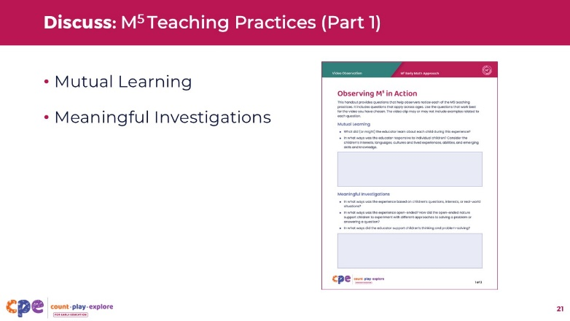

**Time:** 15–20 minutes (including observing the video clip on the prior slide)

**Materials: Observing M5 in Action** handout, chart paper (optional), markers (optional)

### Talking Points

* [Choose a strategy for facilitating this debrief. Adjust talking points to reflect this strategy.]
* Let’s discuss your observations of mutual learning and meaningful investigations.
* What did (or might) the educator learn about each child during this experience?
* In what ways, if any, was the educator responsive to individual children? Consider the children’s interests, languages, cultures and lived experiences, abilities, and emerging skills and knowledge.
* In what ways did this learning experience allow children to question, experiment, and use math to solve problems that they are interested in?
* In what ways, if any, did the educator support children’s thinking and problem-solving?
* [After participants discuss:] Thank you for sharing your observations of mutual learning and meaningful investigations.

### Facilitator Notes

* The **Answer Key for Observing M5 in Action** handout offers examples of M5 teaching practices used in video clips provided for this activity.
* Adjust the debrief based on your session's length, format, group size, and participant needs. For example:
  + For shorter sessions, invite participants to share their observations about mutual learning and meaningful investigations with the larger group.
  + For longer sessions, offer time for participants to discuss their observations in pairs or at their tables. Then, invite each table or pair to share their observations with the larger group.
  + Consider charting participants' observations to provide a visual of the ways mutual learning and meaningful investigations were observed in the clip.
* As participants share with the larger group, paraphrase, affirm, and add to their responses as needed.

## SLIDE 21: Materials and Learning Environment

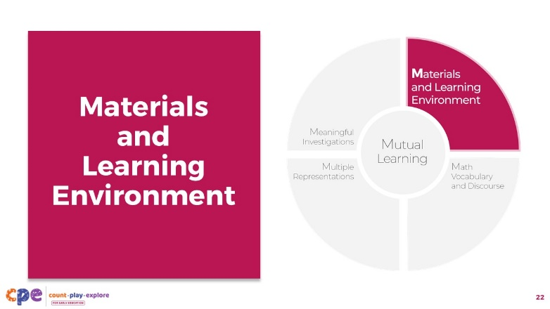

### Talking Points

* Next, we will explore three more M5 practices: Materials and the Learning Environment, Math Vocabulary and Discourse, and Multiple Representations. We will begin with Materials and Learning Environment.

### Facilitator Notes

* You might invite participants to discuss the materials they used to build their paper structures and the ways these materials supported math learning.

## SLIDE 22: Materials and Learning Environment: Defined

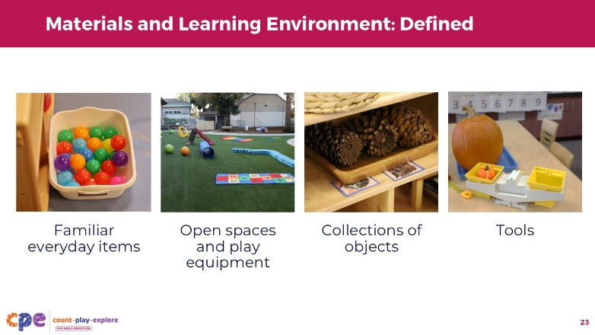

### Talking Points

* **Materials** are the tools and objects we offer children.
* The **learning environment** includes ways we arrange indoor and outdoor spaces that children use.
* Both materials and learning environments can promote math development and learning.
* Materials and learning environments that promote math learning include:
  + familiar materials that reflect children's cultures and lived experiences
  + collections of objects that vary in size, color, or shape—children can use objects such as shells, pinecones, buttons, cups, and toys to count, combine, sort, order, stack, and create patterns or geometric designs
  + open spaces and play equipment to support building and movement
  + tools such as balance scales, measuring cups, or rulers

## Slide 23: Materials and Learning Environment: Examples

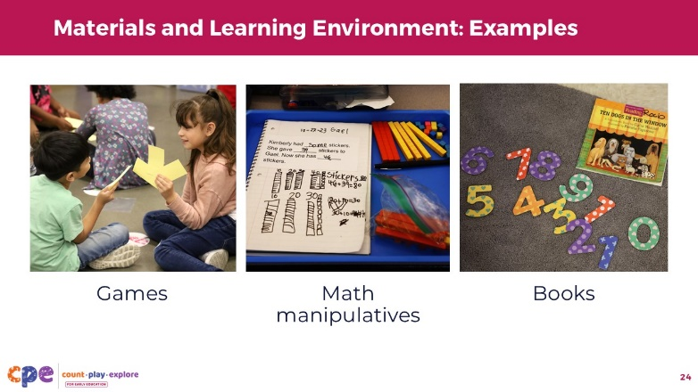

### Talking Points

* Here are some additional examples of materials and learning environments that promote math learning:
  + games such as shape sorters, puzzles, and matching games
  + math manipulatives such as base 10 blocks and counting chips
  + books that support math exploration

## Slide 24: Why are materials and learning environments important?

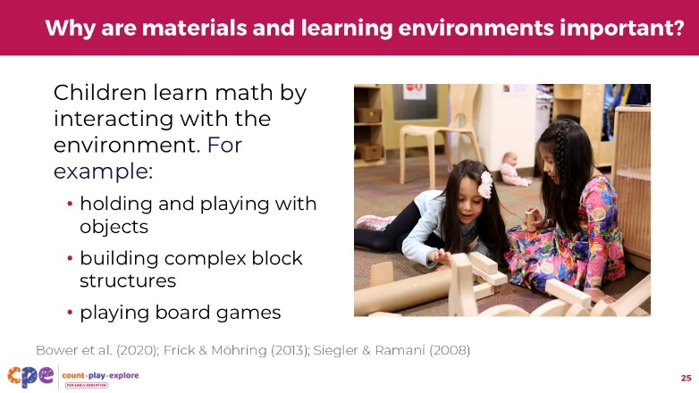

### Talking Points

* Research shows that children learn about math concepts by interacting with materials and the environment. For example:
  + Holding and playing with objects in infancy supports children to develop spatial thinking (Frick & Möhring).
  + Children who build more complex block structures perform better on math assessments (Bower et al., 2020).
  + Children who play board games show improvements in their number knowledge (Seigler & Ramani, 2008).

## SLIDE 25: Reflect: My Materials and Learning Environment

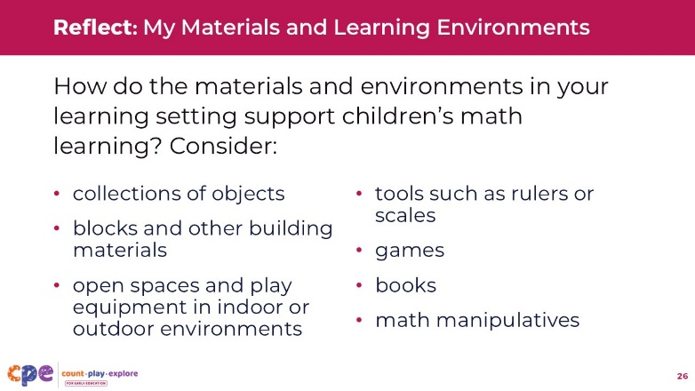

**Time:** 10 minutes

**Materials:** Blank paper

### Talking Points

* Let's pause for a moment to reflect on your learning setting.
* Record examples of the materials in your learning setting. Consider:
  + collections of objects
  + blocks and other building materials
  + open spaces and play equipment in the indoor or outdoor environment
  + tools such as rulers or scales
  + games
  + books
  + math manipulatives
* [After participants individually record examples:] Discuss with a partner how you might use these materials and environments to support math learning.
* [After participants discuss, you might invite a few volunteers to share with the larger group.]
* Thank you for sharing some examples of materials and environments you use to support math learning.

## SLIDE 26: Math Vocabulary and Discourse

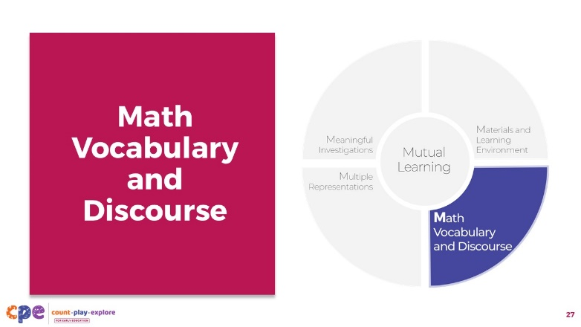

### Talking Points

* Next, we will explore Math Vocabulary and Discourse.

## SLIDE 27: Math Vocabulary: Defined

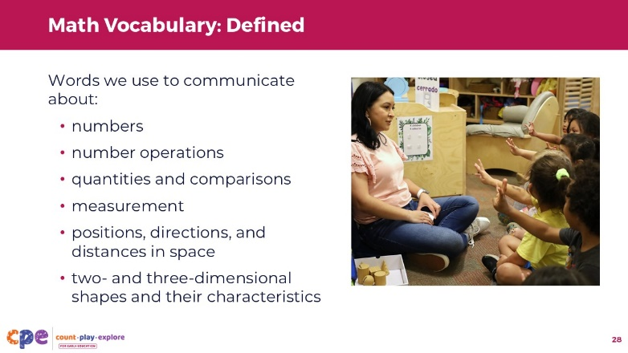

### Talking Points

* **Math** vocabulary refers to the words we use to describe math, in any language, to communicate about:
  + numbers (for example, one, two, three)
  + number operations (for example, add, combine, take away, subtract, group, divide)
  + quantities and comparisons (for example, more, less, same, full, empty)
  + measurement such as size, weight, or volume (for example, big, bigger, small, smaller, greater, heavy, heavier, tall, tallest, same)
  + positions, directions, and distances in space (for example, on, above, below, behind, far)
  + two- and three-dimensional shapes and their characteristics (for example, square, rectangle, cube, sphere, pyramid, face, edge, vertex)
* We might use formal and informal terms when discussing math. We might use "ball" instead of "sphere" or "a little bit" instead of "one spoonful." It is important to introduce children to formal math language to help build their vocabulary and understanding of math concepts.
* Math vocabulary might also be communicated nonverbally. For example, a child may reach their hands up high to communicate the idea that something is tall. Children might also use their fingers to communicate numbers, as we observe in this photo. Some children may use sign language to communicate.

### Facilitator Notes

* Consider inviting participants to share some of the math vocabulary they used while building their paper structures.

## SLIDE 28: Math Discourse: Defined

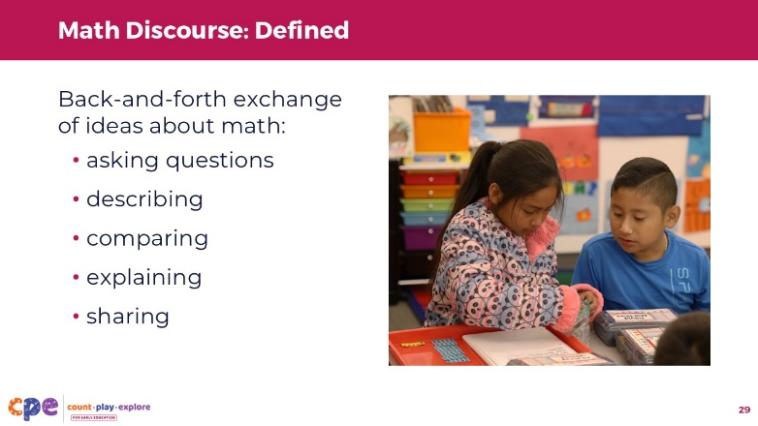

### Talking Points

* **Math discourse** is the back-and-forth exchange of ideas about math. This might be conversations between children or between children and adults.
* Children use math discourse when they ask questions, describe, compare, explain, or share their math solutions or thinking with others.

## SLIDE 29: Why are math vocabulary and discourse important?

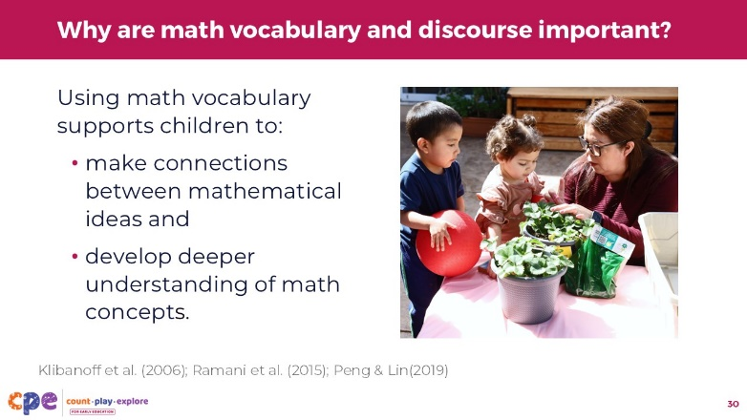

### Talking Points

* Using math vocabulary in learning settings and at home supports children's math learning.
* When educators and families use math vocabulary, they help children make connections between everyday experiences and mathematical ideas (Klibanoff et al., 2006; Ramani et al., 2015). For example, counting objects with educators or families help children learn the count list (also called the "counting sequence") and understand the meaning of number words. Similarly, educators or families communicating about the names of shapes during building activities help children connect the shape name to the object they are using.
* Children who are exposed to math vocabulary have a deeper understanding of math concepts (Peng & Li, 2019).
* Math vocabulary and discourse are appropriate for all ages! Even infants explore math concepts within their daily routines. Exposing infants to math vocabulary helps them notice math in their world and prepares them to use math language when they are ready.

## SLIDE 30: Math Vocabulary and Discourse: Multilingual Learners

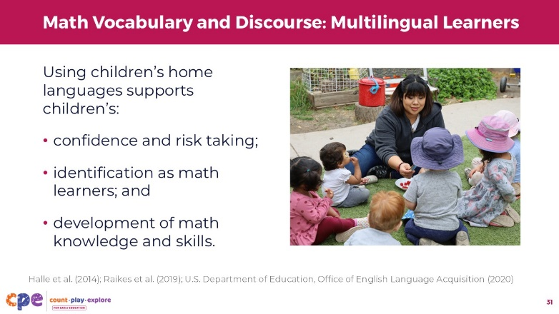

### Talking Points

* Math vocabulary and discourse can happen in any language, including varieties of English and sign language. It is important for educators to support math vocabulary and conversations in children’s home languages as well as English (Halle et al., 2014; Raikes et al., 2019; U.S. Department of Education, Office of English Language Acquisition, 2020). By supporting math vocabulary and conversations in children’s home languages as well as in English, educators acknowledge the rich linguistic and cultural backgrounds that children bring to the learning setting. Supporting all of the ways children might communicate is important because:
  + Children might feel more confident when their home language is used in the learning setting. When children feel confident, they are more willing to take risks and try new tasks.
  + When we use children's home languages in learning settings, children are more likely to feel a sense of belonging and identify themselves as capable and competent math learners.
  + Children may have learned math concepts in their home language. Math knowledge and skills are transferable across languages. Using children's home language helps them make connections and use all their knowledge and skills across their languages.

## SLIDE 31: Using Math Vocabulary and Discourse

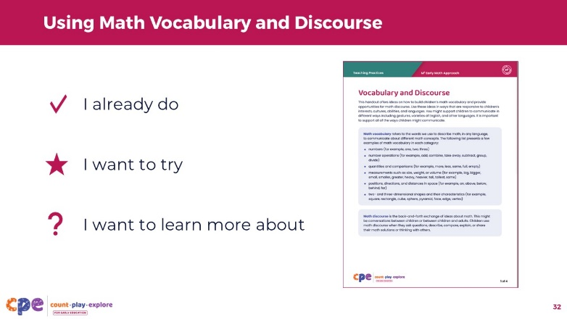

**Time:** 10–15 minutes

**Materials: Using Math Vocabulary and Discourse** handout

### Talking Points

* Now, let's examine some ideas on how to use math vocabulary and discourse in early learning settings. Take out the **Using Math Vocabulary and Discourse** handout.
* Review the handout on your own. Place a checkmark next to something you already do, a star next to something you want to try, and a question mark next to something you want to learn more about.

### Facilitator Notes

* For shorter sessions, invite a few participants to share what they want to try with the larger group.
* For longer sessions, consider inviting participants to share what they want to try with a partner or their table groups.

## SLIDE 32: Multiple Representations

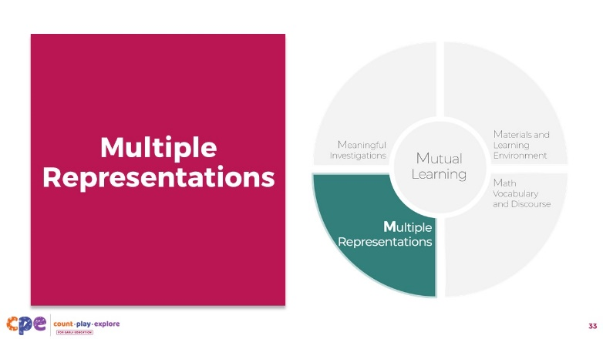

### Talking Points

* Lastly, let's discuss Multiple Representations.

## SLIDE 33: Explore: What concept is represented?

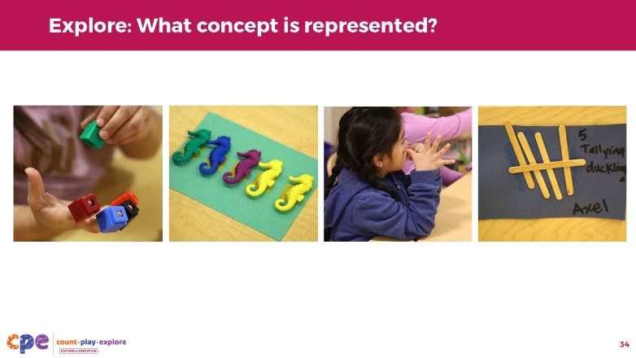

**Time:** 3 minutes

### Talking Points

* Observe these photos.
* What math concept is represented in these photos?
* [After participants respond:] These photos show different ways to represent the concept of "five." We can observe the use of:
  + concrete objects: five connecting cubes or five seahorses
  + movements or using the body: five fingers to count five
  + visual representations or drawings: five tally marks

## SLIDE 34: Multiple Representations: Defined

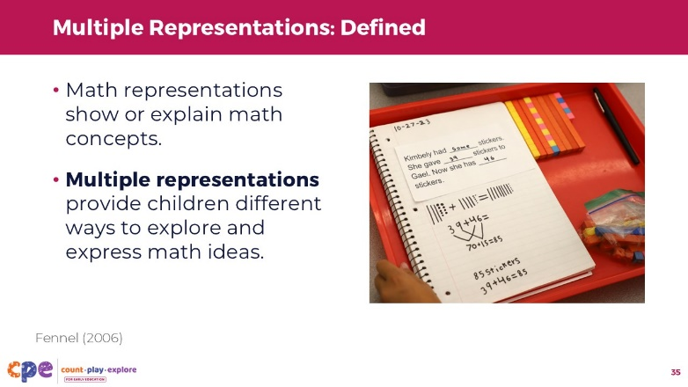

### Talking Points

* In math, representation is a way to show or explain a mathematical concept (Fennel, 2006). **Multiple representations** refer to providing different ways for children to explore and express math ideas.
* Educators might offer children opportunities to use a variety of materials to explore and express math ideas.
* This photo shows multiple representations. The child used an equation, base 10 blocks, and drawings to represent and solve the addition problem.

## SLIDE 35: Multiple Representations: Examples

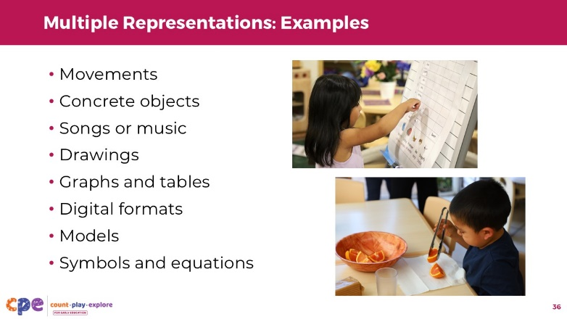

### Talking Points

* Some other representations children might use to explore and express math concepts include the following:
  + movements and using the body, like using fingers, hopping, jumping, and clapping
  + concrete objects, such as loose parts and counting chips
  + songs or music
  + drawings
  + graphs and tables, like bar graphs, charts, and pictographs
  + digital formats, such as computer applications
  + three-dimensional models
  + math symbols and equations

## SLIDE 36: Why are multiple representations important?

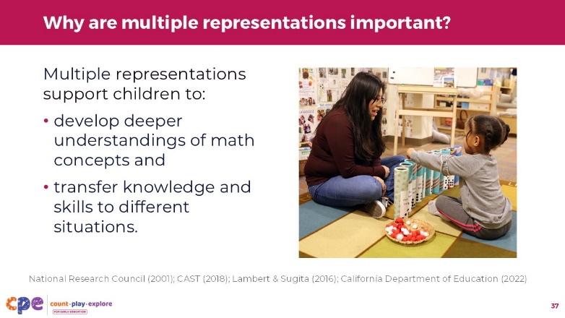

### Talking Points

* Multiple representations are important for children's math learning because they support children to understand that one concept can be represented in different ways (National Research Council, 2001). For example, the concept of five can be represented by five fingers, five tally marks, or five seahorses. This helps children develop a deeper understanding of math concepts and enhances flexible thinking—an important executive function skill.
* Using multiple representations also helps children transfer knowledge and skills learned in one context to different situations. This makes their knowledge and skills more useful. For example:
  + A child learns that adding one dinosaur to a group of two dinosaurs creates a group of three dinosaurs. Later, they might use this understanding in another context—adding one more cracker to a group of two crackers equals three crackers. Now, they have enough to share with three friends.

## SLIDE 37: Multiple Representations Support Diverse Ways of Knowing and Learning

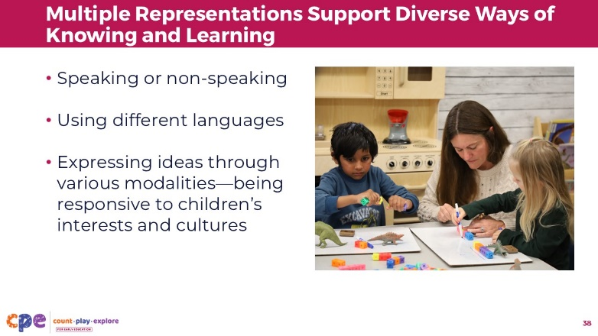

### Talking Points

* Multiple representations are also important because they provide opportunities for children to express their understanding in ways that work best for them. This practice supports children’s diverse ways of knowing and learning. For example:
  + Using concrete objects, gestures, drawings, and movements can support children to explore and express their understanding through speaking or non-speaking ways (CAST, 2018; Lambert & Sugita, 2016).
  + Using different languages, gestures, and visuals can support multilingual learners to communicate their ideas (CAST, 2018).
  + Multiple representations can also provide children from diverse cultural backgrounds opportunities to express their understandings in ways that are responsive to their cultures and lived experiences. For example, you might offer physical movements, such as rhythmic dance, as a way for children to explore and show their understanding of addition (California Department of Education, 2022).
* Children have different ways of knowing and learning (California Department of Education, 2022). Using mutual learning helps educators offer representations that are responsive to children’s interests, languages, cultures and lived experiences, abilities, and emerging knowledge and skills. Multiple representations can also create different entry points for children and ways for them to make meaning or communicate their knowledge in different ways.

## SLIDE 38: Explore: Multiple Representations

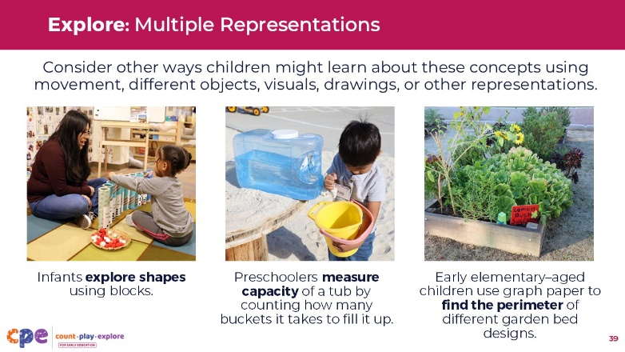

**Time:** 10 minutes

### Talking Points

* Let's think more about multiple representations. We will use examples of meaningful investigations that we discussed earlier.
* Observe the photos and math concepts children are exploring.
  + In an infant classroom, children explore shapes using blocks.
  + In a preschool setting, children measure the capacity of a tub by counting the number of buckets it takes to fill it up.
  + In an early elementary-grade setting, children use graph paper to find the perimeter of different garden bed designs.
* Choose a math concept from one of these examples-exploring shapes, measuring capacity, finding the perimeter-or choose another math concept you have investigated with children. What are some other ways children might explore or show their understanding of this concept? On your own, think about ways children might learn more about this concept using movement, different objects, visuals, drawings, or other representations.
* Consider the individual children in your learning setting. How might their languages, cultures and lived experiences, abilities, or emerging knowledge and skills inform the representations of math concepts that you offer them?

### Facilitator Notes

* Adjust the way participants engage in this experience based on your session's length, format, group size, and participant needs. For example:
  + For shorter sessions, encourage participants to reflect individually. Then, invite a few participants to share with the larger group.
  + For longer sessions, provide time for participants to think about the questions on their own. Then, invite participants to discuss and share their ideas in small groups. Encourage participants to form groups based on the ages of the children they work with.

## SLIDE 39: Observe: Materials and Learning Environment, Math Vocabulary and Discourse, and Multiple Representations

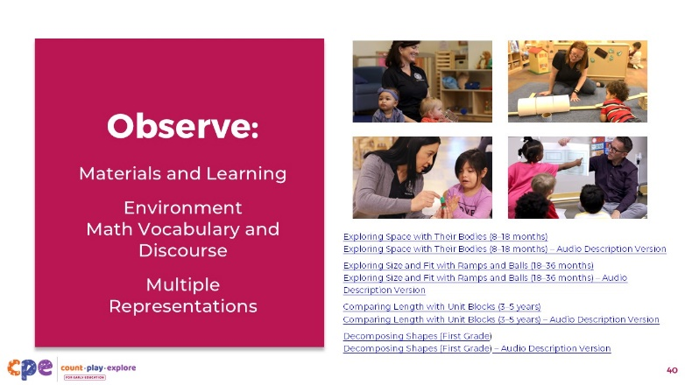

**Time:** 20−30 minutes (including the debrief on the next slide)

**Materials: Observing M5 in Action** handout, video clip

### Talking Points

* We are going to observe the video clip we observed earlier. This observation will focus on three of the M5 practices: Materials and Learning Environment, Math Vocabulary and Discourse, and Multiple Representations.
* [Choose a strategy for facilitating this observation. Adapt the talking points to reflect this strategy.] Take out the **Observing M5 in Action** handout.
* Consider recording your observations on the handout. After the clip, we will discuss what you noticed.

### Facilitator Notes

* Choose a video clip that is most relevant for your participants. We provide the following videos (you might use other videos):
  + Infant: "[Exploring Space with Their Bodies (8-18 months),"](https://youtu.be/9MjPYFUkqM4) "[Exploring Space with Their Bodies (8-18 months) - Audio Descriptive Version."](https://youtu.be/w9hJczYV_O8)
  + Toddler: "[Exploring Size and Fit with Ramps and Balls (18-36 months)](https://youtu.be/C3ksY_hbGaM)," "[Exploring Size and Fit with Ramps and Balls (18-36 months) - Audio Descriptive Version](https://youtu.be/0mFLcfPc-xo)."
  + Preschool/TK/K video clip: "[Comparing Length with Unit Blocks (3-5 years)](https://youtu.be/RQigPvC0TOY)," "[Comparing Length with Unit Blocks (3-5 years) - Audio Descriptive Version](https://youtu.be/jX5aAtOaQL4)."
  + Elementary video clip: "[Decomposing Shapes (first grade)](https://youtu.be/nVsELQ9_wuE)," "[Decomposing Shapes (first grade) - Audio Descriptive Version](https://youtu.be/GjT6CfSD89E)."
* Note: Answer Keys for Observing M5 in Action are provided in the Facilitator Notes section on the following slide.
* Adjust the video observation based on your session's length, format, group size, and participant needs. For example:
  + For shorter sessions and larger groups, invite participants to work in groups of three. Each member of the group can focus on a different M5 practice.
  + For longer sessions, consider using a jigsaw approach—assign each table an M5 practice to focus on.

## SLIDE 40: Discuss: M5 Teaching Practices (Part 2)

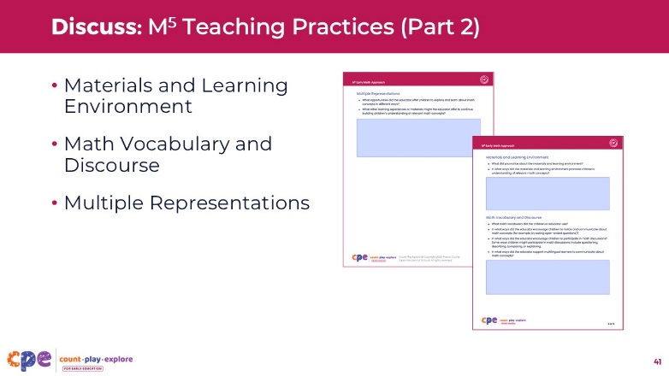

**Time:** 20−30 minutes (including observing the video clip on the prior slide)

**Materials: Observing M5 in Action** handout, chart paper (optional), markers (optional)

### Talking Points

* [Choose a strategy for facilitating this debrief. Adjust the talking points to reflect this strategy.] Let's discuss your observations of materials and learning environment, math vocabulary and discourse, and multiple representations.
* What did you notice about the materials and learning environment?
* How did the children and the educator use math vocabulary and discourse?
* What other ways might the educator invite children to explore and express math ideas?
* [After participants share with the larger group:] Thank you for sharing what you noticed. I hope that this observation and discussion added to your understanding of materials and learning environment, math language and discourse, and multiple representations.

### Facilitator Notes

* The **Answer Key for Observing M5 in Action** handout offers some ways M5 teaching practices can be observed in the video clips.
* Adjust the debrief based on your sessions' length, format, group size, and participant needs. For example:
  + For shorter sessions, invite participants to share their observations about materials and learning environment, math language and discourse, and multiple representations to the larger group.
  + For longer sessions, offer time for participants to share what they noticed in pairs or at their tables. Then, invite each table or pair to share their observations with the larger group.
  + Consider charting participants' observations to provide a visual of ways materials and learning environment, math language and discourse, and multiple representations were observed in the clip.
* As participants share with the larger group, paraphrase, affirm, and add to their responses as needed.

## SLIDE 41: Review: M5 Early Math Approach

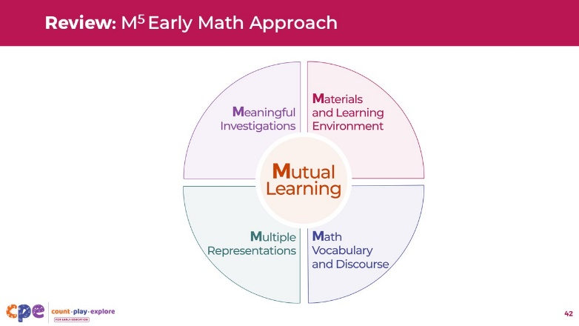

**Time:** 5–7 minutes

**Materials: M5 Early Math Approach** handout

### Talking Points

* We have explored all five of the M5 teaching practices. Let's take a moment to review them.
* Take out the **M5 Early Math Approach** handout. On your own, review each practice.
* Put a star next to a practice you might want to focus on in your learning setting.

## SLIDE 42: Using M5 In My Setting

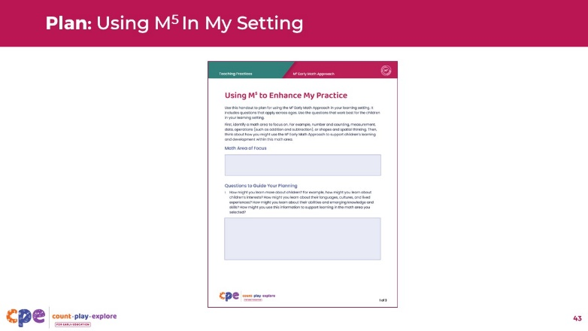

**Time:** 10–15 minutes

**Materials: M5 Early Math Approach** handout, **Enhance My Practice** handout

### Talking Points

* [Choose a strategy for facilitating planning. Adapt the talking points as needed.]
* Now, you will create a plan for using the M5 Early Math Approach.
* First, we will consider a math area to focus on. For example, number and counting, measurement and data, addition and subtraction, or shapes and spatial thinking.
* Use the **M5 Early Math Approach** handout to provide some ideas for how you might use the M5 practices to support children to learn and develop knowledge and skills for the math area you selected.
* Record your plan on the **Enhance My Practice** handout.
* Consider using these questions to guide your planning:
  + How might you learn more about children? For example:
    - How might you learn about children's interests?
    - How might you learn about their languages, cultures, and lived experiences?
    - How might you learn about their abilities and emerging knowledge and skills?
    - In what ways might you use this information to support math learning in the math area you selected?
  + What math investigations could you offer children to encourage them to explore the math area you selected and experiment with different approaches? How might you make these investigations meaningful to the children in your setting?
  + What materials could you introduce, or changes to the environment might you make, to support children's understanding of the math area you selected? How could you change the materials or environment based on individual children's interests, languages, cultures, or abilities?
  + What math vocabulary, related to this area, might you use with children? How could you use this vocabulary throughout the day?
  + Consider different ways children explore and represent their understanding of concepts within the math area you have selected. How might you promote children's use of different representations?
  + What additional support (for example, from a coach or co-worker) would be helpful to enhance your practice?
* [After participants plan and share:] You have identified ways to enhance your math teaching practices using the M5 Early Math Approach.

### Facilitator Notes

* Encourage participants to develop their plans independently.
* Adjust the debrief based on your session's length, format, group size, and participant needs. For example:
  + For shorter sessions, invite a few volunteers to share with the larger group.
  + For longer sessions, consider inviting participants to share with a partner or their table group. Then, invite a few participants to share with the larger group.
* As participants discuss their plans, make note of questions they still have and practices they plan to try. Use this information to identify topics for future training, coaching, or communities of practice.
* Review the Coaching Suite, part of the Count Play Explore Online Professional Learning Suites, for more information related to coaching.

## SLIDE 43: M5 Early Math Approach Supports All Math Learning

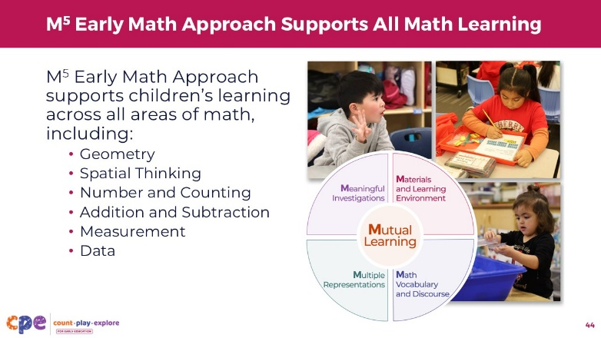

### Talking Points

* The M5 Early Math Approach supports all math learning.
* Count Play Explore Professional learning suites provide additional opportunities to think about ways to use M5 to support children’s knowledge and skills in:
  + Geometry
  + Spatial Thinking
  + Number and Counting
  + Addition and Subtraction
  + Measurement
  + Data
* Thank you for your time, attention, and engagement. It’s been wonderful working and learning with you.

## SLIDE 44: M5 Acknowledgment

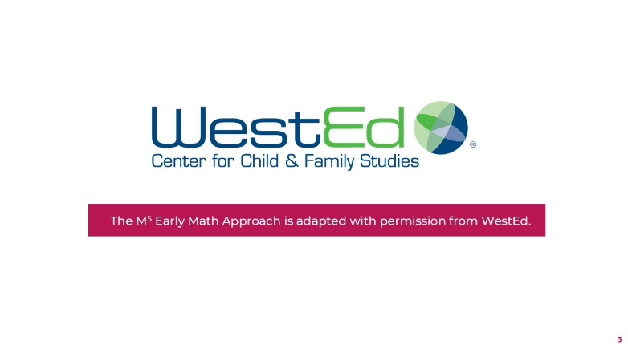

### Talking Points

The **M5 Early Math Approach** is adapted with permission from WestEd.