# Spatial Thinking: Preschool, Transitional Kindergarten, and Kindergarten (PPT 2b)

Use this facilitator guide with the slides “Spatial Thinking: Preschool, Transitional Kindergarten, and Kindergarten.” Facilitators can find talking points and guidance for activities and group discussions in this guide. The same text is also located in the notes portion of the slides. Adapt this facilitator guide based on your group size, session length and format, and participants’ needs.

## SLIDE 1: Spatial Thinking: Preschool, Transitional Kindergarten, and Kindergarten

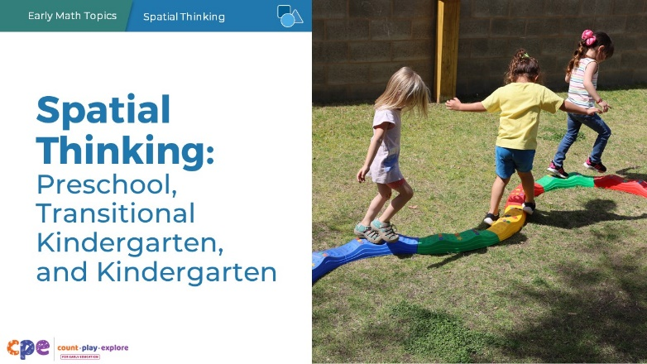

### Talking Points

* In this session, we will explore how children in preschool, transitional kindergarten, and kindergarten develop spatial thinking. We will also focus on ways we can support children in preschool, transitional kindergarten, and kindergarten to develop spatial thinking.
* Throughout the session, we will use TK to refer to transitional kindergarten and K for kindergarten.

### Facilitator Notes

* Adjust talking points to reflect your session length and participant needs. If necessary, add introductory and “housekeeping” information.
* As you plan your professional learning session, consider the content in each PPT in this suite of resources.
  + PPT 1 “Introduction to Spatial Thinking: Birth–8 Years” describes how children develop spatial thinking from birth to age eight. This introductory session also includes opportunities for participants to use spatial thinking in playful ways.
  + PPT 2a “Spatial Thinking: Infants and Toddlers”, and PPT 2b “Spatial Thinking: Preschool, Transitional Kindergarten, and Kindergarten” describe in greater depth how children at different age levels develop spatial thinking. These PPTs also include ideas on how to support children in specific age ranges to develop spatial thinking.
* We encourage you to offer the content in PPT 1 before or in combination with the content in PPT 2b. If your participants work with children in more than one age range, you might combine parts of PPT 2a and PPT 2b in one session or a series of sessions. Together, PPT 1 and one of the age-specific slide decks have been designed for up to three hours of professional learning. However, you might adjust slide decks to best meet participant needs and time allowances.

## SLIDE 2: Acknowledgments

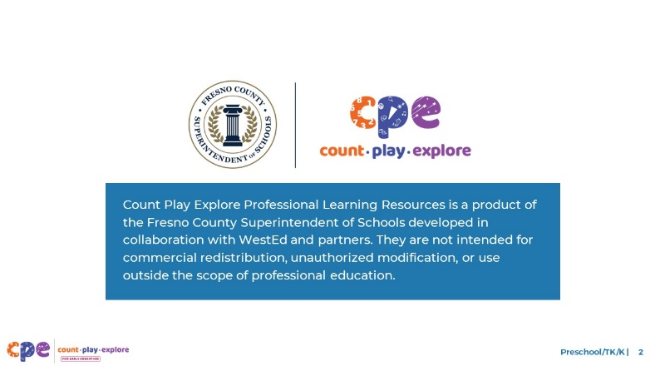

### Talking Points

The Count Play Explore Professional Learning Resources were made possible by Count Play Explore, an early math and science initiative led by the Fresno County Superintendent of Schools, Early Care and Education Department. This initiative is generously funded by the California Department of Education and the California State Board of Education. These resources are intended to be used as a guide for implementing evidence-based strategies, promoting active learning, and encouraging developmentally appropriate practices in early education settings. They are not intended for commercial redistribution, unauthorized modification, or use outside the scope of professional education.

## SLIDE 3: Session Goals

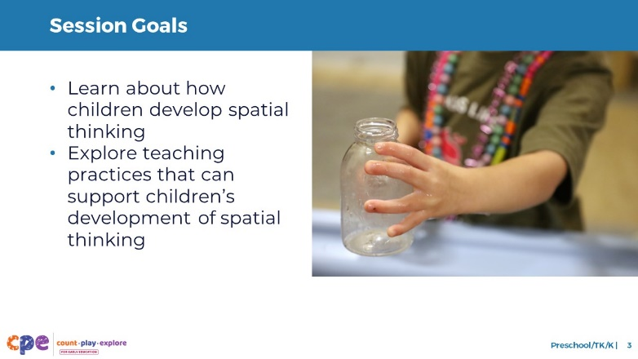

### Talking Points

* First, we will learn about how children in preschool, TK, and K develop spatial thinking.
* Then, we will explore teaching practices that can support children’s development of spatial thinking.
* Throughout our session, we will take time to reflect on our current practices. We will also consider how we might use information from this session in our work.

### Facilitator Notes

* Adjust talking points to reflect your session length and participant needs.

## SLIDE 4: Discuss: Using Spatial Thinking

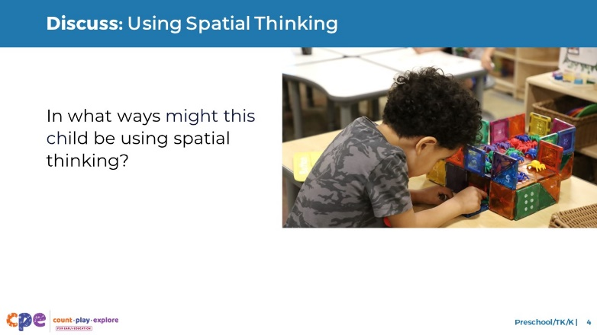

### Time

10 minutes

### Materials

Scratch paper, pens

### Talking Points

* Spatial thinking is understanding:
  + positions of objects and people in space,
  + how to get from one place to another, and
  + what objects will look like if rotated or moved to change their position in space.
* Children explore space and spatial relationships every day!
* Observe the photo on the screen. Consider some ways the child in this photo is using spatial thinking.
* [After providing time for participants to reflect and share with the larger group:] Thank you for sharing some ways this child is using spatial thinking. We will explore more examples like this throughout the session.

### Facilitator Notes

* Adjust the way you organize this activity based on group size, session length and format, and participants’ needs. For example:
  + For larger groups and longer sessions, consider inviting table groups to work together.
  + For shorter sessions, you might invite participants to reflect independently.
* Invite participants to share with the larger group.

## SLIDE 5: Developing Spatial Thinking

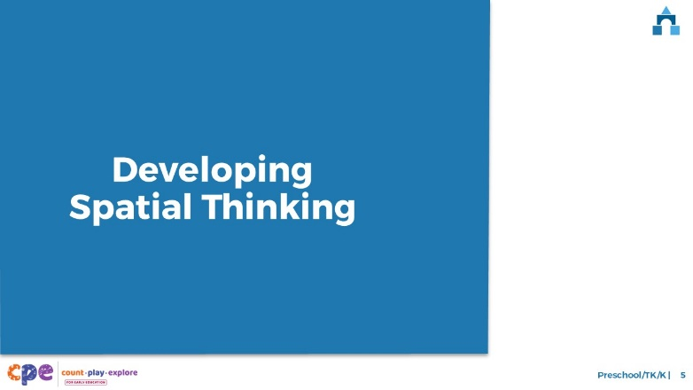

### Talking Points

* Now, we will examine how children develop and use spatial thinking

## SLIDE 6: The California Preschool/Transitional Kindergarten Learning Foundations and the California Common Core State Standards in Mathematics

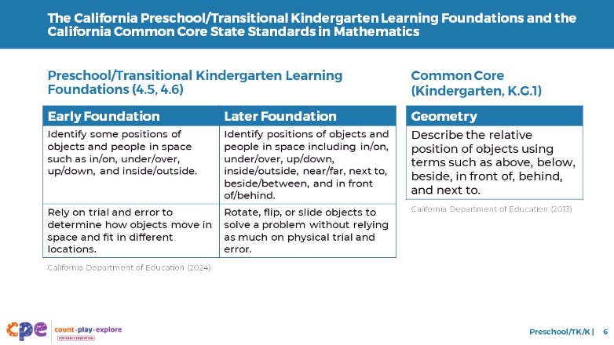

### Talking Points

* Let’s review how spatial thinking aligns with the California foundations and standards in mathematics.
* The California Preschool/Transitional Kindergarten Learning Foundations (PTKLF; California Department of Education, 2024) and the kindergarten California Common Core State Standards (California Department of Education, 2013) include standards related to spatial thinking.
* Both the Preschool/TK learning foundations and the Common Core State Standards in Kindergarten include expectations for how children identify the positions of objects and people in space.
* The PTKLF also includes a foundation on how children explore mental rotation as they experiment with how objects move and fit.

### Facilitator Notes

* This slide makes connections to foundations and standards for spatial thinking.
* The PTKLF addresses children aged 3–5, this includes both children in preschool and TK.
* The foundations and standards listed in some of the slides are condensed. You might consider providing participants with copies of the relevant foundations from the PTKLF or standards from the California Common Core State Standards. Consider whether electronic or printed copies will be more useful for your participants.

## SLIDE 7: Four Components of Spatial Thinking

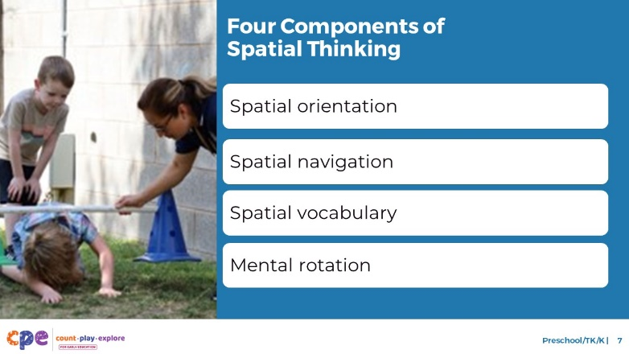

### Talking Points

* The development of spatial thinking in early childhood includes the following components:
  + Spatial orientation
  + Spatial navigation
  + Spatial vocabulary
  + Mental rotation
* Now, we will explore children’s development for each component of spatial thinking.

## SLIDE 8: Spatial Orientation: Definition

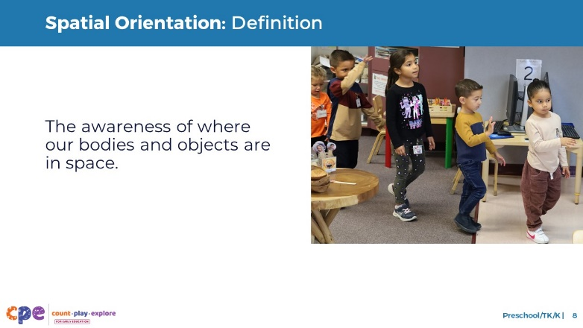

### Talking Points

* Spatial orientation is an awareness of where our bodies or objects are in space.

## SLIDE 9: Spatial Orientation: Development

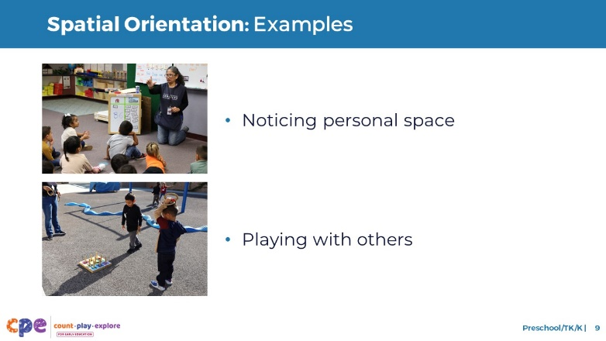

### Talking Points

* Here are a few examples of how children use spatial orientation.
  + You might notice children using spatial orientation when they pay attention to their own and others’ space—for example, when finding a spot on the carpet or in line. They might pay attention to who is next to them, how close they might be to another person, or where their feet are in relation to a neighbor.
  + Children also use spatial orientation when they play games or sports. For example, when playing soccer, basketball, a ring toss game, or other sports, children pay attention to where they are positioned in relation to the goal or another player.

## SLIDE 10: Spatial Orientation: Examples

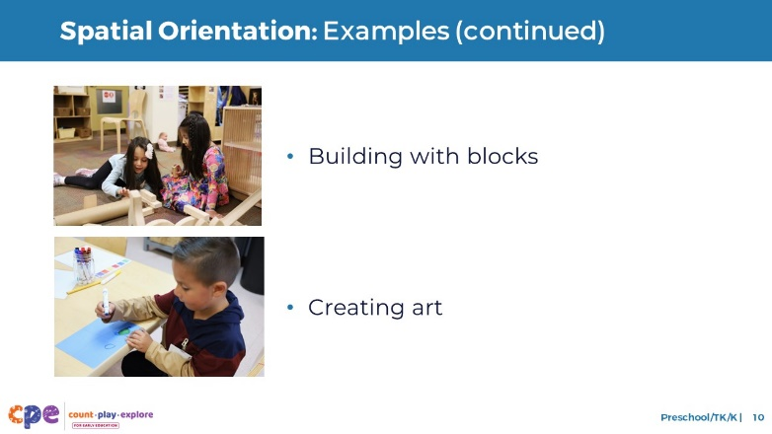

### Talking Points

* You might notice children paying attention to the position of blocks as they build. They may notice the orientation of different blocks, turning or moving them so their structure is stable.
* Children may also use spatial orientation when they pay attention to the position of images while drawing. For example, they might think about where they want to position the tree in relation to other elements of the picture. Do they want to place it in the middle? Behind the lake? In the corner?

## SLIDE 11: Spatial Orientation: Development

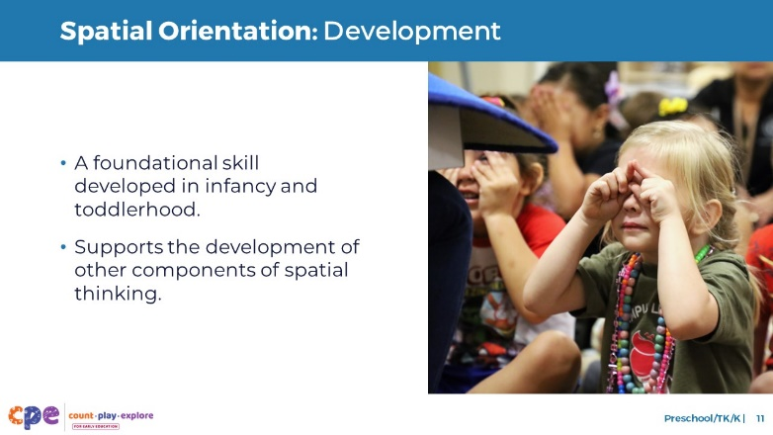

### Talking Points

* Spatial orientation is the foundation for children’s spatial thinking, including their development of spatial navigation, spatial vocabulary, and mental rotation skills.
* Spatial orientation begins to develop in infancy and toddlerhood.
* Infants and toddlers will notice the position of people and objects in relation to themselves.
* Preschool-aged children have a broader sense of their space and can notice where objects are positioned in relation to other objects or other people.

## SLIDE 12: Discuss: Spatial Orientation

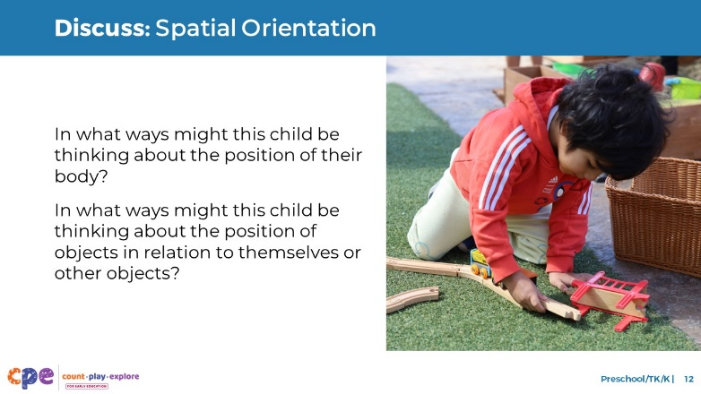

### Time

5–10 minutes

### Talking Points

* [Select a facilitation strategy. Adjust talking points as needed.] In what ways might this child be thinking about the position of their body? In what ways might the child be thinking about the position of objects in relation to themselves or other objects?
* [Provide time for participants to think. Invite them to record their responses.]
* [After participants share:] Thank you for sharing some ways this child might use spatial orientation.

### Facilitator Notes

* Adjust the way you organize this activity based on group size, session length and format, and participants’ needs. For example:
  + Encourage participants to work in groups or discuss with a partner.
* Invite participants to share responses with the larger group.
* Consider inviting participants to think about their own learning setting and share examples of how children might use spatial orientation. Encourage participants to think about children’s interests, languages, cultures, and lived experiences, abilities, and emerging skills.
* You might document ideas that are shared on chart paper. Label the chart paper “Spatial Orientation.”

## SLIDE 13: Spatial Navigation: Definition

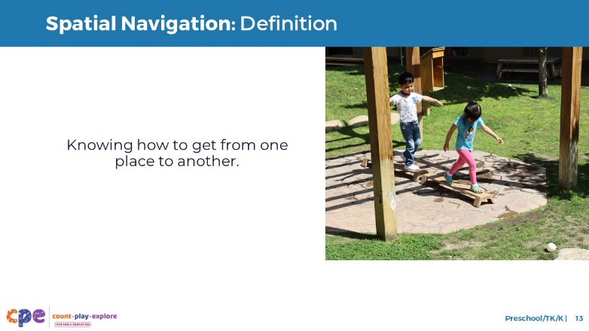

### Talking Points

* Spatial navigation is knowing how to get from one place to another.

## SLIDE 14: Spatial Navigation: Examples

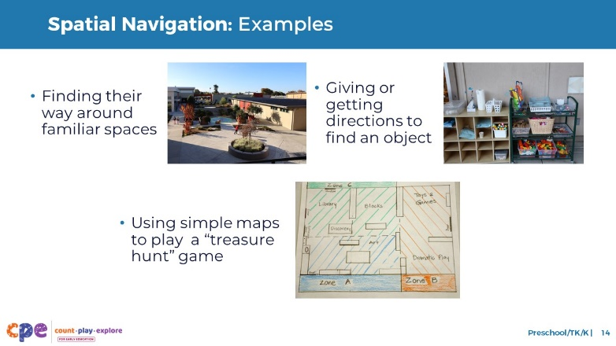

### Talking Points

* Here are some examples of how children might use spatial navigation.
  + Children might use landmarks to find their way around their learning setting (for example, going from indoor spaces to outside play spaces), or they might remember landmarks as they travel from their home to their learning setting.
  + Children use spatial navigation when they use directions to find objects. For example, an educator may tell a child to look “on the top of” the shelves “under” the paper to find the crayons.
  + Children might use maps when playing a treasure hunt game.
* Learning about children’s interests and abilities helps us better understand how they use spatial navigation. We can then incorporate what we learn about children into our early learning environments. For example:
  + Children showing an interest in pirates or adventurers might enjoy exploring spatial navigation through pretend treasure hunts.
  + Children with visual impairments might use their sense of touch to identify landmarks that help them navigate through a space.

## SLIDE 15: Spatial Navigation: Development

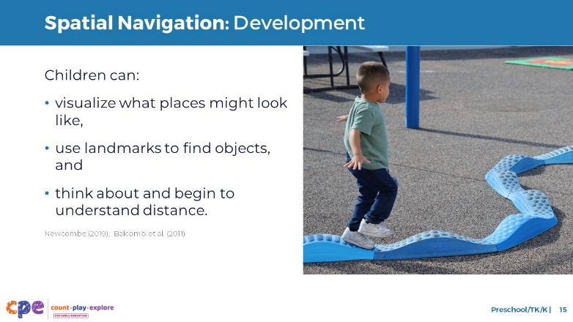

### Talking Points

* Children in preschool, TK, and K can visualize what places might look like from different perspectives and develop mental maps of spaces (Newcombe, 2019; Balcomb et al., 2011). For example:
  + Children might be able to imagine the layout of their living area and think about the specific location of their favorite toy inside that space.
* Children this age might use multiple landmarks to find an object. For example:
  + “My toy was under the window, next to the ball.”
* In addition, they begin to think about distance. For example:
  + “The bear is close to the window but far from the door.”

### Facilitator Notes

* Consider inviting participants to think about the way their learning environment is arranged. Then, offer time for them to describe to a partner what they might pass when they move from one side of the room to another.

## SLIDE 16: Discuss: Spatial Navigation

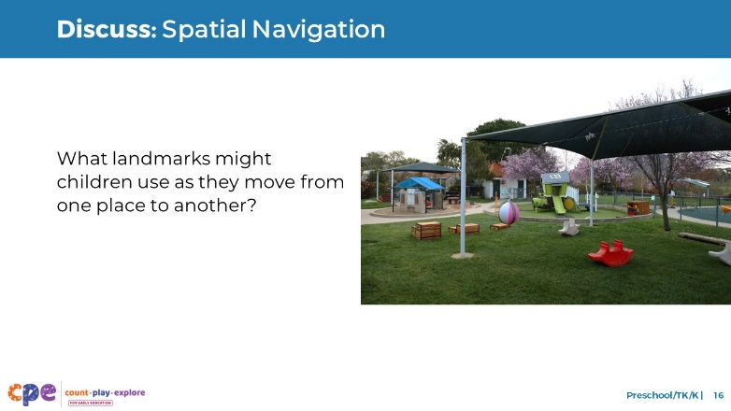

### Time

5–10 minutes

### Talking Points

* [Select a facilitation strategy. Adjust talking points as needed.] Let’s consider this photo.
* What landmarks might children use as they move from one place to another?
* [Provide time for participants to think. Invite them to record their responses.]
* [After participants share:] Thank you for sharing your ideas about how children might use spatial navigation.

### Facilitator Notes

* Adjust the way you organize this activity based on group size, session length and format, and participants’ needs. For example:
  + Encourage participants to work in groups or discuss with a partner.
  + Invite participants to share responses with the larger group.
  + Consider inviting participants to think about their own learning setting and share examples of how children might use spatial navigation. Encourage participants to consider children’s interests, languages, cultures and lived experiences, abilities, and emerging skills.
  + Document ideas that are shared on chart paper. Label the chart paper “Spatial Navigation.”

## SLIDE 17: Observe Video: Spatial Orientation and Spatial Navigation

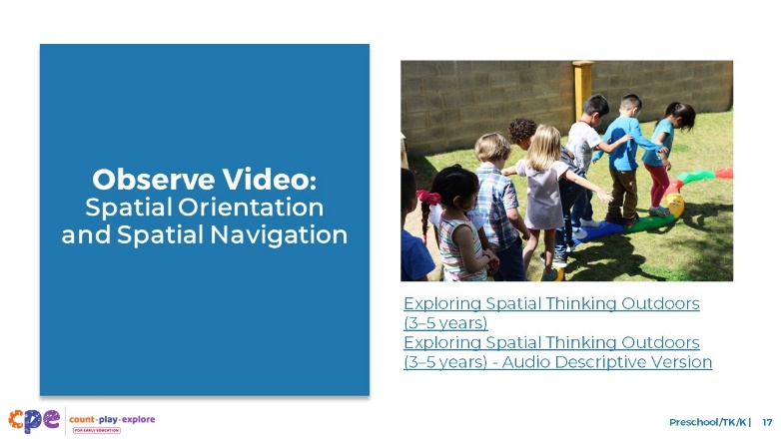

### Time

10–20 minutes (including debrief on the next slide)

### Materials

Preschool, TK, or K spatial thinking video clip

### Talking Points

* We have reviewed two components of spatial thinking. Now, we will observe a video clip. As you observe the video, think about the ways the children use spatial orientation and spatial navigation.
* You might record your observations. After the clip, we will discuss what you noticed.

### Facilitator Notes

* Choose a preschool, TK, or K video clip that shows children using spatial thinking.
* We provide the following videos (you might use another video):
  + [Exploring Spatial Thinking Outdoors (3–5 years).](https://youtu.be/PMTMu3itj2c) In this video, an educator explains how to move through an obstacle course. Then, children move through the obstacle course.
  + [Exploring Spatial Thinking Outdoors (3–5 years) - Audio Descriptive Version](https://youtu.be/Ug_VYdIH8yQ)
  + [Exploring Spatial Thinking While Building (3–5 years)](https://youtu.be/eSGEMd8KkdM). In this video, children and educators use spatial thinking to build a structure with blocks.
  + [Exploring Spatial Thinking While Building (3–5 years) - Audio Descriptive Version](https://youtu.be/iJhPGq90r-4)
* **Note:** Discussion points are provided for the video “Exploring Spatial Thinking Outdoors (3–5 years)” in the Facilitator Notes on the next slide.
* Consider playing the video more than once. The first time, invite participants to become familiar with the clip. Then, invite them to observe specific ways children show their understanding of the spatial thinking components.

## SLIDE 18: Discuss: Developing Spatial Thinking

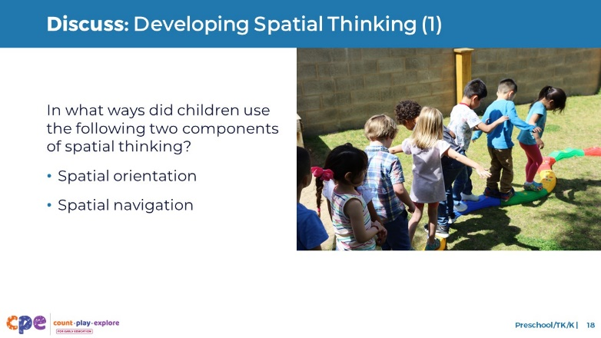

### Time

10–20 minutes (including video observation on previous slide)

### Talking Points

* [Use facilitator notes that best fit your group’s needs.] Let’s discuss what you noticed.
* In what ways did children in the video use the following two components of spatial thinking?
  + Spatial orientation
  + Spatial navigation

### Facilitator Notes

* Adjust the debrief based on your group size, session length and format, and participant needs.
* Consider charting participants’ observations to visually provide ways children develop and apply spatial thinking.
* Here are some examples of ways children in the video “Exploring Spatial Thinking Outdoors (3–5 years)” used spatial orientation and spatial navigation:
  + **Spatial orientation:** children were aware of their bodies in relation to others as they moved through the obstacle course. Children also noticed the position of objects in relation to their own bodies (for example, when children moved under the bar).
  + **Spatial navigation:** children paid attention to the directions the educator provided on how and where to move through the obstacle course (for example, “The red tunnel, between the hills”).
* Participants might notice children in the video learning about or using math concepts other than spatial thinking. Children’s learning is often integrated. They might use knowledge and skills from many domains. You might encourage discussions about other math concepts or other learning and development domains if it supports your session goals.
* If a skill is not observed in the video, invite participants to:
  + Think about ways children might use that skill.
  + Explain how educators might support children to use that skill.
* Consider using the following adaptations based on session length:
  + For shorter sessions, invite participants to share, with the larger group, what they noticed about ways children showed their knowledge and skills related to spatial thinking.
  + For longer sessions, offer time for participants to share their observations in pairs or at their tables. Then, invite each table to share their observations.

## SLIDE 19: Spatial Vocabulary: Definition

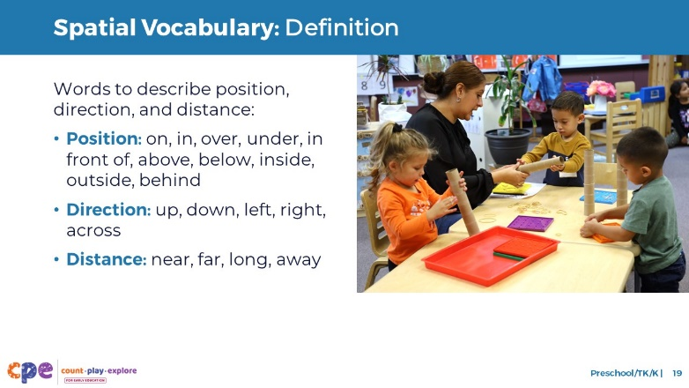

### Talking Points

* As children’s language continues to develop, their understanding and use of spatial vocabulary grows. Children in preschool, TK, and K use spatial vocabulary to describe:
  + Position—for example, “on,” “in,” “over,” “under,” “in front of,” “above,” “below,” “inside,” “outside,” and “behind”
  + Direction—for example, “up,” “down,” “left,” “right,” and “across”
  + Distance—for example, “near,” “far,” “long,” and “away”

## SLIDE 20: Spatial Vocabulary: Development

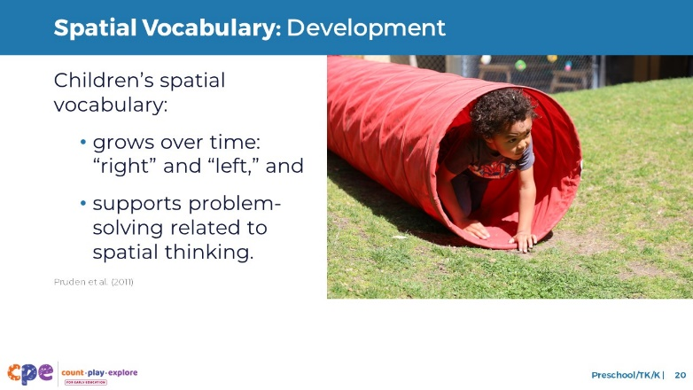

### Talking Points

* Children will continue to grow their spatial vocabulary over time. In preschool, TK, and K, children are ready to begin using more complex spatial language, like “left” and “right.”
* Studies show that children with greater spatial vocabulary have more advanced spatial thinking (Pruden et al., 2011). For example:
  + Children who used more spatial vocabulary as toddlers were more skilled at nonverbal spatial problem-solving tasks in preschool. Understanding spatial vocabulary goes beyond word knowledge—it supports problem-solving related to spatial thinking.

## SLIDE 21: Discuss: Spatial Vocabulary

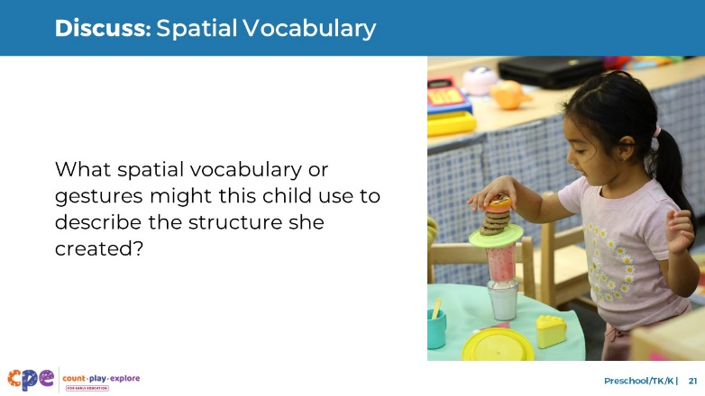

### Time

5–10 minutes

### Talking Points

* [Choose a facilitation strategy. Adjust talking points as needed.] Let’s consider the child in this photo with special attention to spatial vocabulary.
* What spatial vocabulary or gestures might this child use when describing the structure they created?
* [Provide time for participants to think. You might invite them to record their responses.]
* [After participants share:] Thank you for sharing your ideas about how this child might use spatial vocabulary.

### Facilitator Notes

* Adjust the way you organize this activity based on group size, session length and format, and participants’ needs. For example:
  + Encourage participants to work in groups or discuss with a partner.
* Invite participants to share responses with the larger group.
* Consider inviting participants to think about their own learning setting and share examples of how children might use spatial vocabulary. Encourage participants to consider children’s interests, languages, cultures and lived experiences, abilities, and emerging skills.
* You might document ideas that are shared on chart paper. Label the chart paper “Spatial Vocabulary.”

## SLIDE 22: Mental Rotation: Definition

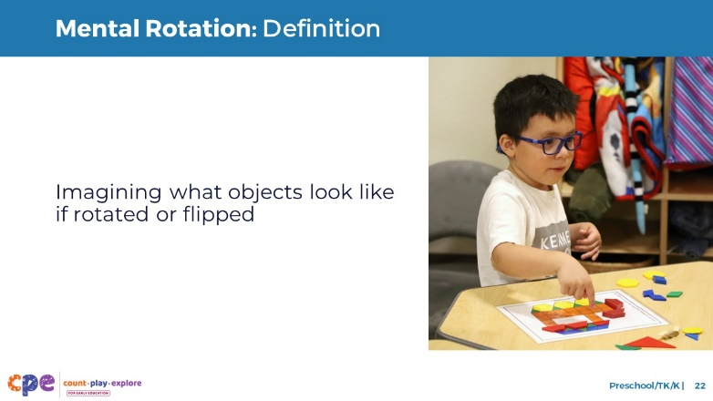

### Talking Points

* Mental rotation is the ability to imagine what an object might look like when rotated or flipped.

## SLIDE 23: Play: Mental Rotation

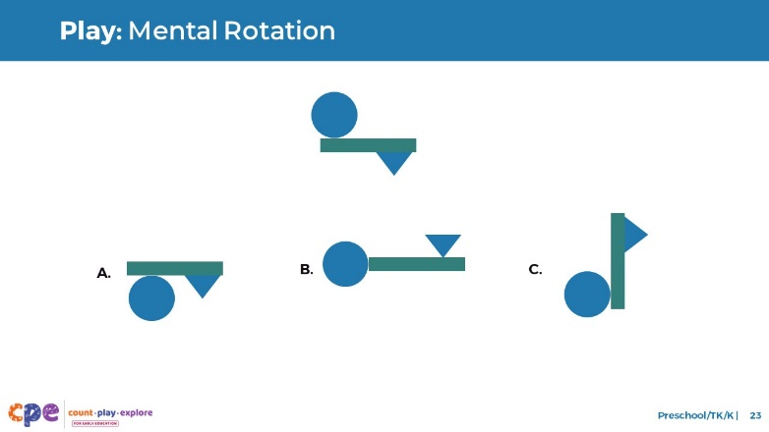

### Talking Points

* Let’s try mental rotation.
* Observe the image in the top row. Which of the images in the bottom row is the same as the image in the top row? [Pause to provide time for participants to think and respond. The correct answer is C.]
* To complete this task, you used mental rotation.

### Facilitator Notes

* **Note:** A similar experience is also provided in PPT 1: “Introduction to Spatial Thinking: Birth–8 Years.”

## SLIDE 24: Mental Rotation: Examples

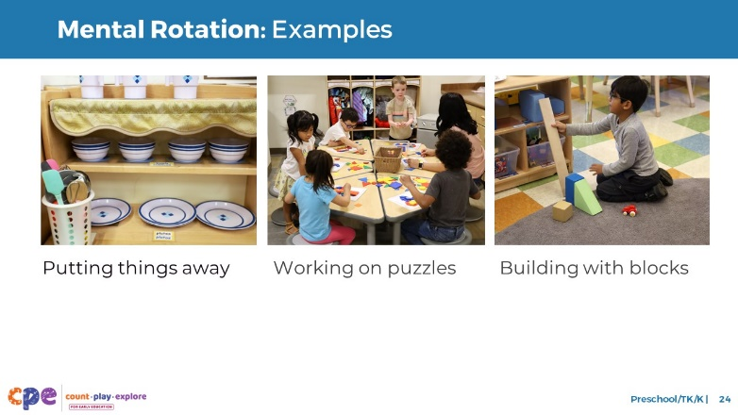

### Talking Points

* Here are someexamples of how children might use mental rotation.
  + Children mentally rotate toys or materials when putting them away on a shelf or in a container.
  + Children mentally rotate puzzle pieces to predict where a piece may fit.
  + Children use mental rotation when constructing with blocks or other building materials. They predict how to rotate or flip a piece, so it fits where they want it.
* Children’s lived experiences and cultures play roles in how they develop mental rotation. For example, children who play with nesting dolls might have a lot of experience with tasks that require mental rotation.

## SLIDE 25: Mental Rotation: Development

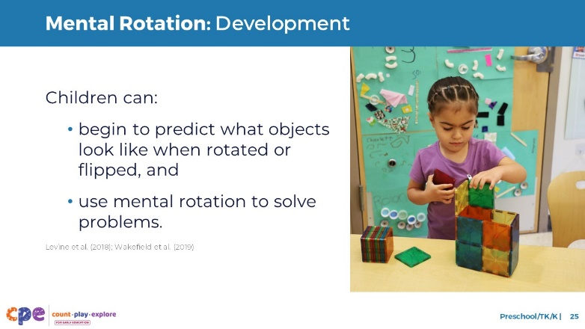

### Talking Points

* Children in preschool, TK, and K begin to mentally rotate objects. They don’t need to physically touch or move objects to know what they look like from different positions (Levine et al., 2018).
* Children in this age range can use mental rotation to solve problems (Wakefield et al., 2019). For example:
  + When working on a jigsaw puzzle, they can use mental rotation to imagine how to turn a piece, so it fits with the others.

## SLIDE 26: Mental Rotation: Development (continued)

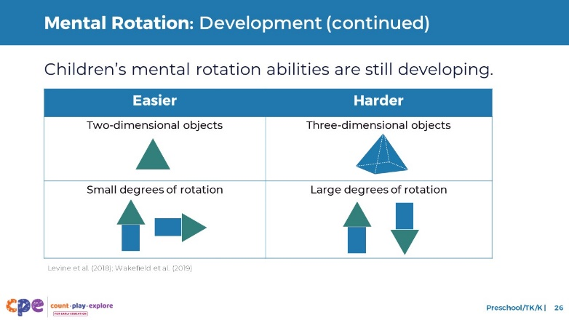

### Talking Points

* Children in this age range are still developing their mental rotation skills. For example:
  + Mentally rotating two-dimensional shapes might be easier than mentally rotating three-dimensional shapes.
  + Mentally rotating objects with a small change in rotation might be easier than mentally rotating objects with a big change in rotation. For example, turning an object on its side is easier for children to visualize than turning the same object completely upside down.

## SLIDE 27: Discuss: Mental Rotation

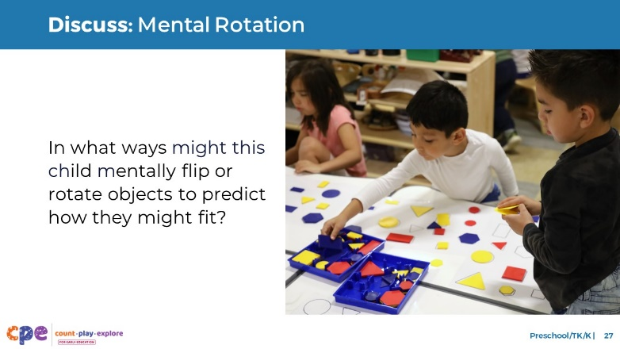

### Time

5–10 minutes

### Talking Points

* [Select a facilitation strategy. Adjust talking points as needed.] Let’s observe this photo. In what ways might this child mentally flip or rotate objects to predict how they might look or fit?
* [Provide time for participants to think. You might invite them to record their responses.]
* [After participants share:] Thank you for sharing your ideas about how this child might be using mental rotation.

### Facilitator Notes

* Adjust the way you organize this activity based on group size, session length and format, and participants’ needs. For example:
  + Encourage participants to work in groups or discuss with a partner.
  + Invite participants to share responses with the larger group.
* Consider inviting participants to think about their own learning setting and share examples of how children use mental rotation. Encourage participants to consider children’s interests, languages, cultures and lived experiences, abilities, and emerging skills.
* Consider documenting ideas that are shared on chart paper. Label the chart paper “Mental Rotation.”

## SLIDE 28: Observe Video: Spatial Vocabulary and Mental Rotation

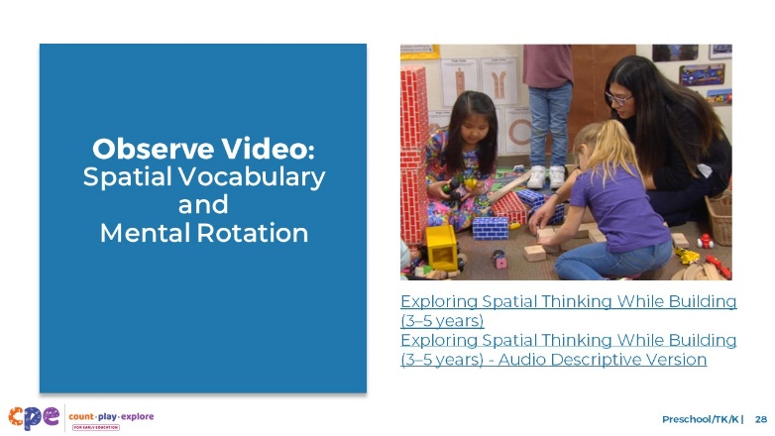

### Time

10–20 minutes (including debrief on the next slide)

### Materials

Preschool, TK, or K spatial thinking video clip

### Talking Points

* Now, we will observe a video clip. As you observe the video, think about ways the children use the following two components of spatial thinking:
  + Spatial vocabulary
  + Mental rotation
* You might record your observations. After the clip, we will discuss what you noticed.

### Facilitator Notes

* Choose a preschool, TK, or K video clip that shows children using spatial thinking.
* We provide the following videos (you might use another video):
  + [Exploring Spatial Thinking Outdoors (3–5 years)](https://youtu.be/PMTMu3itj2c). In this video, an educator explains how to move through an obstacle course. Then, children move through the obstacle course.
  + [Exploring Spatial Thinking Outdoors (3–5 years) - Audio Descriptive Version](https://youtu.be/Ug_VYdIH8yQ)
  + [Exploring Spatial Thinking While Building (3–5 years)](https://youtu.be/eSGEMd8KkdM). In this video, children and educators use spatial thinking to build a structure with blocks.
  + [Exploring Spatial Thinking While Building (3–5 years) - Audio Descriptive Version](https://youtu.be/iJhPGq90r-4)
* **Note:** Discussion points are provided for the video “[Exploring Spatial Thinking While Building (3–5 years)](https://youtu.be/eSGEMd8KkdM)” in the Facilitator Notes on the next slide.
* Consider playing the video more than once. The first time, invite the participants to become familiar with the clip. Then, invite participants to observe specific ways children show their understanding of the spatial thinking components.
* You might encourage participants to record their observations on sticky notes—using one sticky note for each observation. Then, invite participants to discuss and sort their observations into two groups: spatial vocabulary and mental rotation.

## SLIDE 29: Discuss: Developing Spatial Thinking

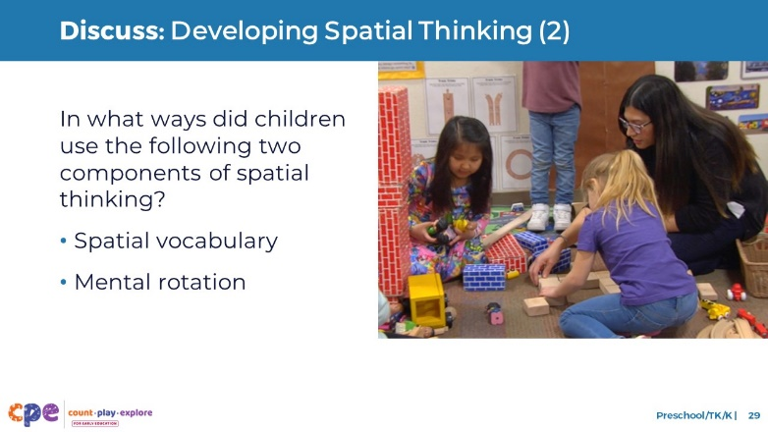

### Time

10–20 minutes (including video observation on the previous slide)

### Talking Points

* [Use facilitator notes that best fit your group’s needs.] Let’s discuss what you noticed.
* In what ways did you notice children in the video using the following two components of spatial thinking?
  + Spatial vocabulary
  + Mental rotation

### Facilitator Notes

* Adjust the debrief based on your group size, session length and format, and participant needs. Consider charting participants’ observations to visually provide ways children develop and apply spatial thinking.
* Here are some examples of ways children in the video, “Exploring Spatial Thinking While Building (3–5 years),” used spatial vocabulary and mental rotation:
  + Spatial vocabulary: The educator modeled spatial vocabulary. For example, “bottom,” “middle,” “around,” and “up.”
  + Mental rotation: Children might have visualized how the blocks will look as they build. For example, one child turned the blocks on the side so the “walls” of the structure were taller. She may have mentally rotated the blocks before placing them.
* Consider using the following adaptations based on session length:
  + For shorter sessions, invite participants to share with the larger group what they noticed about ways children showed their knowledge and skills related to spatial thinking.
  + For longer sessions, offer time for participants to share their observations in pairs or at their tables. Then, invite each table to share their observations.

## SLIDE 30: Supporting Spatial Thinking

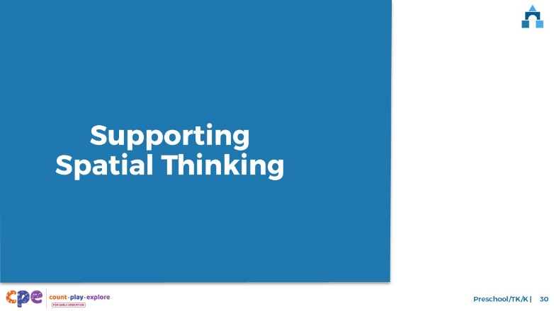

### Talking Points

* We explored four components of spatial thinking. We also observed how young children develop these concepts. Now, let’s discuss ways we can support children to develop spatial thinking in our learning settings and at home.

## SLIDE 31: Explore: M5 Early Math Approach

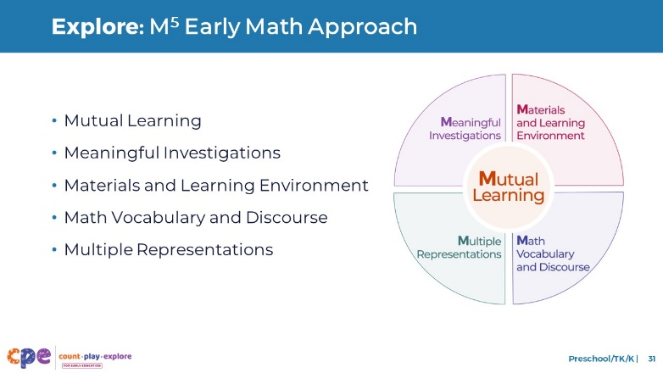

### Time

15 minutes

### Materials

**M5 Early Math Approach Overview** handout

### Talking Points

* Count Play Explore often uses M5 (pronounced: M to the fifth) Early Math Approach to refer to five core early math teaching practices. These practices include:
  + Mutual Learning
  + Meaningful Investigations
  + Materials and Learning Environment
  + Math Vocabulary and Discourse
  + Multiple Representations
* Let’s explore the M5 approach. Then, we will observe M5 in action.

### Facilitator Notes

* Consider your participants and their prior experiences with M5.
  + For groups that have significant experience with M5, you might offer a few minutes for participants to share with a partner their strengths and what practices they are working on. Or you might use this slide to briefly revisit the M5 practices and move to the next slide.
  + For groups that have less experience with M5, you might offer more time for participants to explore each practice. For example, allow time for them to review the practices on their own. Invite them to identify a word, phrase, and sentence that is meaningful to them. Then, invite participants to share with the larger group. For more ideas on how to provide a more comprehensive review, visit the **M5 Early Math Approach** suite of resources.

## SLIDE 32: Observe Video: Supporting Children’s Spatial Thinking

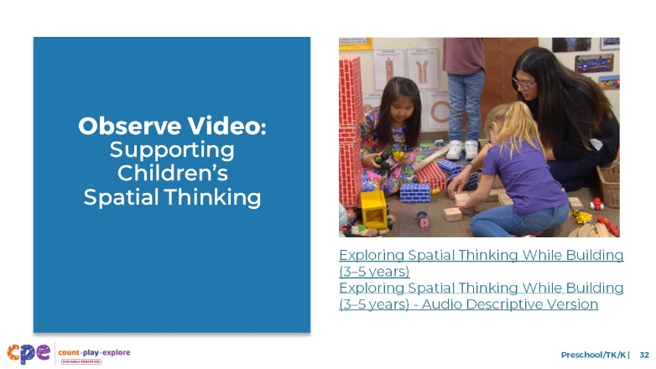

### Time

5–7 minutes (not including debrief)

### Materials

**Observing M5 in Action: Spatial Thinking** handout; preschool, TK, or K spatial thinking video clip; chart paper; markers

### Talking Points

* We observed how young children develop spatial thinking. Then, we explored the M5 Early Math Approach. Now, we are going to observe a video that shows how educators might use M5 to support children’s spatial thinking.
* [Choose a strategy for facilitating this observation and debrief. Adapt the talking points to reflect this strategy.]

### Facilitator Notes

* Choose a video clip that shows children using spatial thinking in preschool, TK, or K. This might be the same clip used for observing children using spatial thinking.
* We provide the following videos (you might use another video):
  + [Exploring Spatial Thinking Outdoors (3–5 years)](https://youtu.be/PMTMu3itj2c). In this video, an educator explains how to move through an obstacle course. Then, children move through the obstacle course.
  + [Exploring Spatial Thinking Outdoors (3–5 years) - Audio Descriptive Version](https://youtu.be/Ug_VYdIH8yQ)
  + [Exploring Spatial Thinking While Building (3–5 years)](https://youtu.be/eSGEMd8KkdM). In this video, children and educators use spatial thinking to build a structure with blocks.
  + [Exploring Spatial Thinking While Building (3–5 years) - Audio Descriptive Version](https://youtu.be/iJhPGq90r-4)
* **Note:** Sample answers are provided for the video “Exploring Spatial Thinking While Building (3–5 years)” in the Facilitator Notes on the next slide.
* Invite participants to take out the **Observing M5 in Action: Spatial Thinking** handout.
* For larger groups and longer sessions, use a jigsaw approach. Before playing the video clip, assign each table one practice to focus on during the video. [If there are more than five tables, assign more than one table to focus on each practice.]
* For smaller groups and shorter sessions, consider showing the video clip two to three times, inviting participants to focus on specific practices each time. Encourage them to record observations on the handout.

## SLIDE 33: Discuss: Supporting Children’s Spatial Thinking

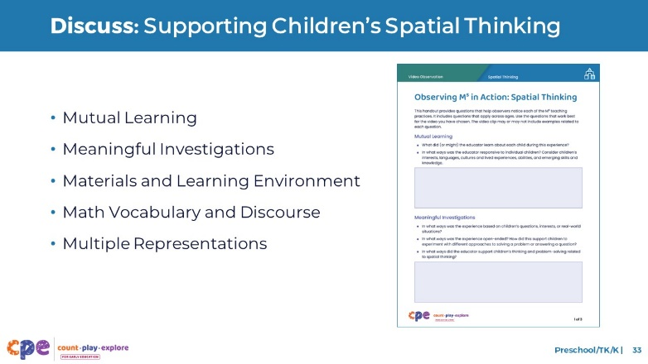

### Time

20–30 minutes (varies based on session goals)

### Materials

**Observing M5 in Action: Spatial Thinking** handout; preschool, TK, or K spatial thinking video clip; chart paper; markers

### Talking Points

* Let’s unpack your observations of each M5 practice. How did the educator use M5 to support children’s development of spatial thinking?

### Facilitator Notes

* Use the **Answer Key for Observing M5 in Action: Spatial Thinking** handout for examples of how M5 was used in the video clip.
* For larger groups or longer sessions: After observing the video clip, ask each table group to discuss what they noticed about their assigned practice. Then, invite each group to share their observations with the larger group. As each group shares, paraphrase, affirm, and add to their responses as needed. Consider charting each group’s observations to make practices visible.
* For smaller groups or shorter sessions: Invite participants to share their observations with the whole group. Chart their observations to make the practices visible. As participants share, paraphrase, affirm, and add to their responses as needed. Consider inviting participants to share something they learned with someone from another table. For example, ask them to find someone with similarly colored clothing, move to meet them, and share something they learned with that person.

## SLIDE 34: Explore: Using M5 to Support Spatial Thinking

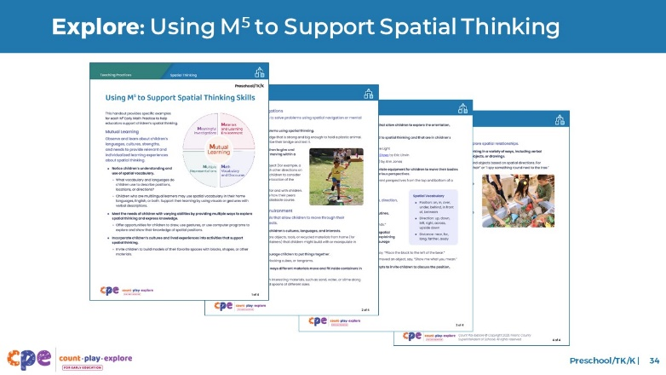

### Time

15–30 minutes (including debrief on next slide)

### Materials

**Using M5 to Support Spatial Thinking Skills** handout, chart paper, markers

### Talking Points

* We discussed the M5 Early Math Approach and observed some ways it might be used to support children’s spatial thinking. Let’s consider other ways to use M5 to support young children’s spatial thinking.
* Take out the handout, Using M5 to Support Spatial Thinking Skills.
* Review the ideas on how to use M5 to support young children’s spatial thinking. You might make notes, circle, or highlight as you review.

### Facilitator Notes

* Provide five to seven minutes for participants to review the handout independently.

## SLIDE 35: Discuss: Using M5 to Support Spatial Thinking

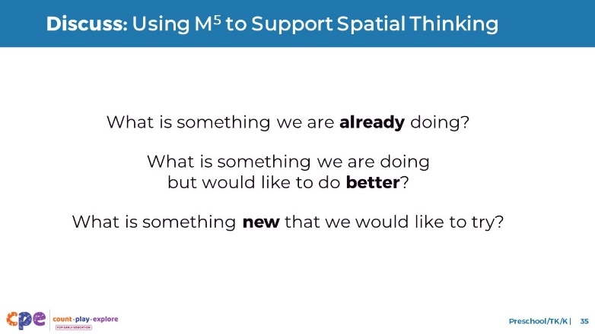

### Time

15–30 minutes (including review of document on previous slide)

### Materials

**Using M5 to Support Spatial Thinking Skills** handout; chart paper; markers

### Talking Points

* You reviewed some ideas on ways to use the M5 Early Math Approach to support children’s spatial thinking. Next, let’s reflect on ways we can continue to support children’s spatial learning.
* [Select a way to organize this activity from the facilitator notes. Then, adapt these talking points based on your selection.]
  + [Organize small groups.] In your groups, assign a recorder and a reporter. The recorder will document your group’s discussion. The reporter will share your group’s ideas with the large group.
  + Then, with your group, discuss what you are already doing, what you would like to do better, and something new you would like to try.
  + Reflect on the diversity of early learners in your setting. Consider children’s interests, languages, cultures and lived experiences, abilities, and emerging skills as you discuss.
* Consider the practices and ideas in “Using M5 to Support Spatial Thinking Skills.” You might also include ideas shared during our discussions.
* [Provide time for participants to reflect (or discuss) and record their responses.] Now, share with the larger group. [Invite participants to share based on the way you organized the activity.]
* [After participants share:] Thank you for sharing your ideas and reflections.

### Facilitator Notes

* Prior to the session, prepare charts for each table. Create and label three columns: “What we are already doing,” “What we would like to do better,” and “Something new we would like to try.” Or model the process and invite the recorders at each table to make their own charts.
* While participants work in small groups, move around the room. Provide support as needed.
* For shorter sessions, you might do one of the following:
  + Invite participants to do this activity independently, with or without sharing at their tables.
  + Invite participants to do this activity with their tables. Consider inviting tables to post their charts instead of sharing highlights with the larger group.

## SLIDE 36: Explore: Playful Activities to Support Spatial Thinking

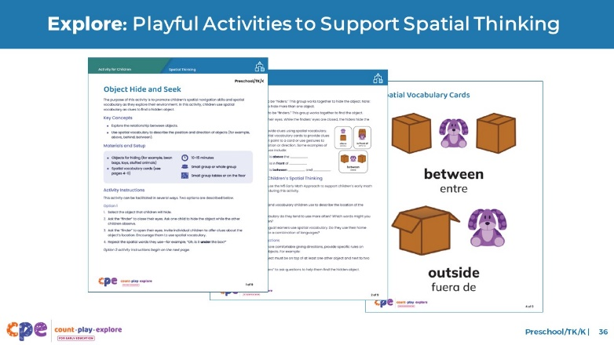

### Time

5–10 minutes

### Materials

“Object Hide and Seek” activity, chart paper, markers

### Talking Points

* We can support children’s spatial thinking by using the M5 Early Math Approach.
* The M5 approach can be used in the context of activities that encourage children to use and build their spatial thinking skills.
* Let’s try a playful activity that can help children develop spatial thinking.
* Take out and read the “Object Hide and Seek” activity.
* This handout includes instructions for setting up the activity, ideas on how to support children’s learning using the M5 Early Math Approach, and “Spatial Language Cards” to support children’s learning as needed.
* With a partner, review the handout. Then, discuss how you might use this activity in your settings. Consider the following questions:
  + Think about the children in your setting. In what ways might you modify this activity to respond to children’s interests, languages, cultures and lived experiences, abilities, and emerging skills and knowledge?
  + What vocabulary might be introduced throughout this activity?

### Facilitator Notes

* Provide 5–10 minutes for participants to review and discuss the handout.
* You might invite participants to share with the larger group.
* Here are some ways participants might modify this activity to respond to children’s interests, languages, cultures and lived experiences, abilities, and emerging skills.
  + For children with motor impairments, you might hide smaller objects on a desk or table where the child can easily reach them.
  + For children who speak languages other than English or Spanish, you might ask family members how to say certain spatial words in the child’s home language.
  + To be responsive to cultures and lived experiences, you might invite children to bring a special object from home to use in the game.
* For longer sessions, consider offering materials described in the handout and invite participants to engage in the learning experience. Encourage participants to discuss what they notice as they engage in the activity.
* Math is playful! This key principle is promoted by the Count Play Explore approach to professional learning.
  + Providing educators an opportunity to experience an activity gives them insight into the knowledge and skills children will use when they engage in the activity. This insight helps educators think about what support or extensions children might need.

## SLIDE 37: Reflect: Next Steps

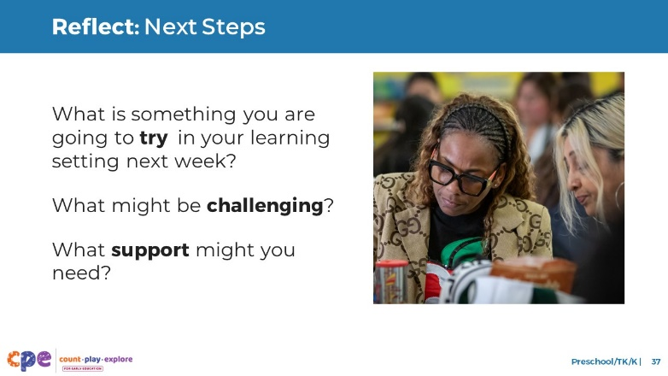

### Time

5 minutes

### Talking Points

* Take a few minutes to think about our session.
  + Make a plan for your next steps. Reflect on the diversity of early learners in your setting. Consider children’s interests, languages, cultures, and abilities as you plan.
* What is something you are going to try in your learning setting next week? What might be challenging? What support might you need? Consider recording your ideas.
* [Allow two to three minutes for participants to reflect and record.]
* Thank you for your time, attention, and engagement. It’s been wonderful working with you.

### Facilitator Notes

* For longer sessions, consider asking participants to share with the larger group.
* Make note of the questions that participants have and what they would like to try. You might use this information to identify topics for future training, coaching, or communities of practice.