# Spatial Thinking: Infants and Toddlers (PPT 2a)

Use this facilitator guide with the slides “Spatial Thinking: Infants and Toddlers.” Facilitators can find talking points and guidance for activities and group discussions in this guide. The text in the guide is also located in the notes portion of the slides. Adapt this facilitator guide based on your group size, session length and format, and participants’ needs.

## SLIDE 1: Spatial Thinking: Infants and Toddlers

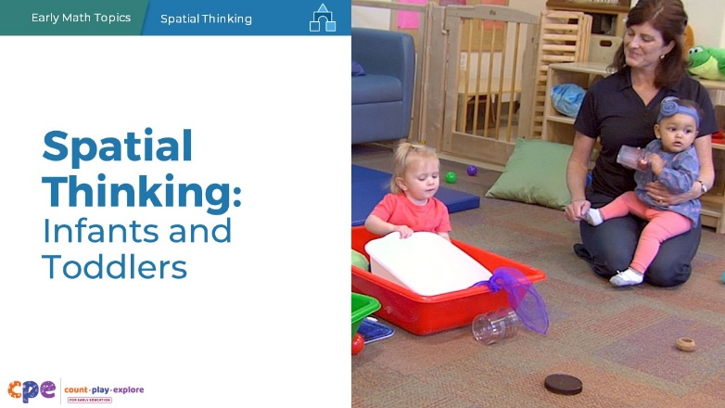

### Talking Points

* In this session, we will explore how infants and toddlers develop spatial thinking. We will also focus on ways we can support infants’ and toddlers’ spatial thinking.

### Facilitator Notes

* Adjust talking points to reflect your session length and participant needs. If necessary, add introductory and “housekeeping” information.
* As you plan your professional learning session, consider the content in each PPT in this suite of resources:
  + PPT 1 “Introduction to Spatial Thinking: Birth–8 Years” provides introductory information about children’s spatial thinking from birth to eight years old. This introductory session also includes opportunities for participants to use spatial thinking.
  + PPT 2a “Spatial Thinking: Infants and Toddlers” and PPT 2b “Spatial Thinking: Preschool, Transitional Kindergarten, and Kindergarten” describe in greater depth how children at different age levels develop spatial thinking. These PPTs also include ideas on how to support children in specific age ranges to develop spatial thinking knowledge and skills.
  + We encourage you to offer the content in PPT 1 before or in combination with the content in PPT 2a. If your participants work with children in more than one age range, you might combine parts of PPT 2a and PPT 2b in one session or a series of sessions.

## SLIDE 2: Acknowledgments

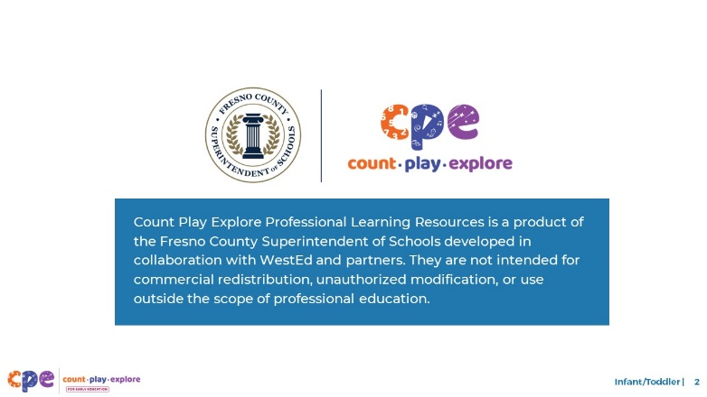

### Talking Points

The Count Play Explore Professional Learning Resources were made possible by Count Play Explore, an early math and science initiative led by the Fresno County Superintendent of Schools, Early Care and Education Department. This initiative is generously funded by the California Department of Education and the California State Board of Education. These resources are intended to be used as a guide for implementing evidence-based strategies, promoting active learning, and encouraging developmentally appropriate practices in early education settings. They are not intended for commercial redistribution, unauthorized modification, or use outside the scope of professional education.

## SLIDE 3: Session Goals

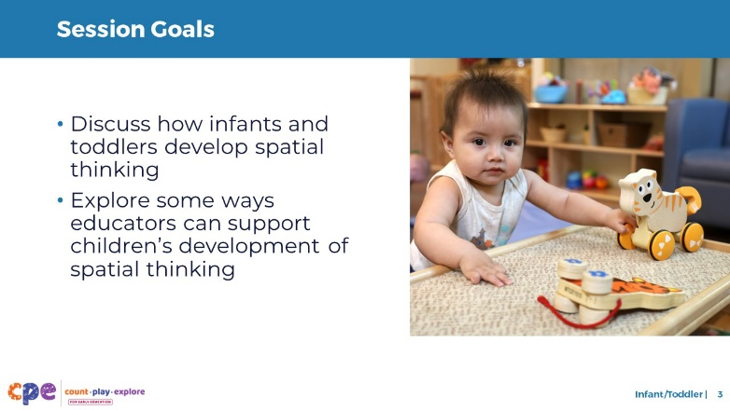

### Talking Points

* First, we will discuss how infants and toddlers develop spatial thinking.
* Then, we will explore some ways that educators can support infants’ and toddlers’ development of spatial thinking.
* Throughout our session, we will take time to reflect on our current practices. We will also consider how we might use information from this session in our work.

### Facilitator Notes

* Adjust talking points to reflect your session length and participant needs.

## SLIDE 4: Reflect: Infants and Toddlers Explore Space

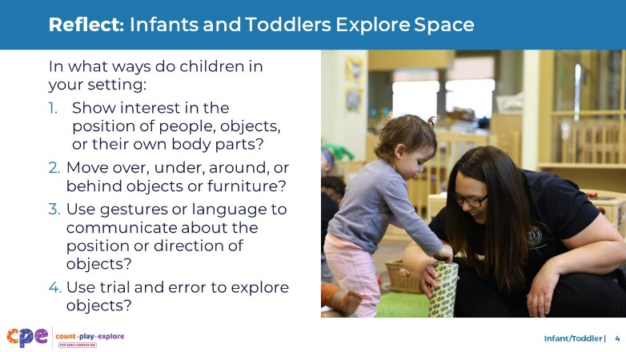

### Time

10 minutes

### Materials

Scratch paper, pens

### Talking Points

* Infants and toddlers explore space and spatial relationships every day!
* The ways infants and toddlers explore their space are affected by different factors, including their lived experiences, emerging developmental abilities, and interests. For example:
  + Children who crawl might experience space differently than children who do not crawl.
  + Children encouraged to explore their space might show more initiative to move in different ways.
  + Children’s lived experiences (for example, living in a home with stairs) might expose them to different concepts in different ways (for example, “up” and “down”).
* Think about your learning setting. What are some ways that children use spatial thinking? With your table group, discuss the ways children within your setting:
  + Show interest in the position of people, objects, or their own body parts.
  + Move “over,” “under,” “around,” or “behind” objects or furniture.
  + Use gestures or language to communicate about the position or direction of objects or the distance between objects or people.
  + Use trial and error to explore objects.
* [After participants record their responses:] You recorded some ways children use spatial thinking. We will revisit your ideas throughout the session.

### Facilitator Notes

* **Note:** Participants’ responses will be discussed later in the session.
* Adjust the way you organize this activity based on group size, session length and format, and participants’ needs. For example:
  + For larger groups and longer sessions, consider organizing participants into groups. You might create groups for specific age ranges of children (0–8 months, 9–18 months, 19–36 months).
  + For shorter sessions, consider inviting each table to focus on one of the numbered discussions above.
  + You might provide sticky notes on each table. Invite participants to take four sticky notes and label them 1, 2, 3, and 4. Then, ask them to respond to each question on a sticky note labeled with the question number. Participants will revisit their responses later in the session.

## SLIDE 5: Developing Spatial Thinking

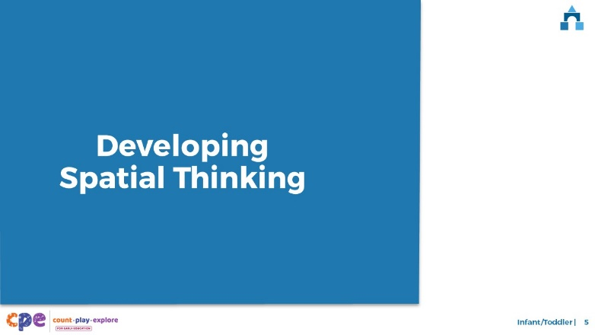

### Talking Points

* Now, we will explore how infants and toddlers develop and use spatial thinking.

## SLIDE 6: Four Components of Spatial Thinking

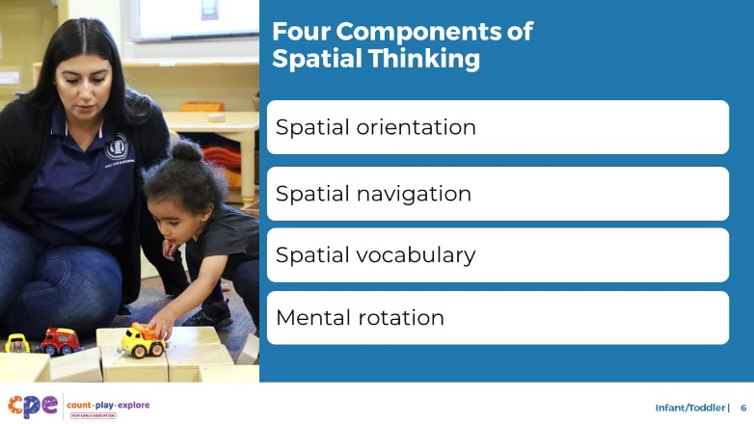

### Talking Points

* The development of spatial thinking in early childhood includes the following components:
  + Spatial orientation
  + Spatial navigation
  + Spatial vocabulary
  + Mental rotation

### Facilitator Notes

* More information on how children develop spatial thinking from birth to eight years old and ways to engage adults in using spatial thinking is featured in PPT 1, “Introduction to Spatial Thinking: Birth–8 Years.”

## SLIDE 7: The California Infant/Toddler Learning and Development Foundations

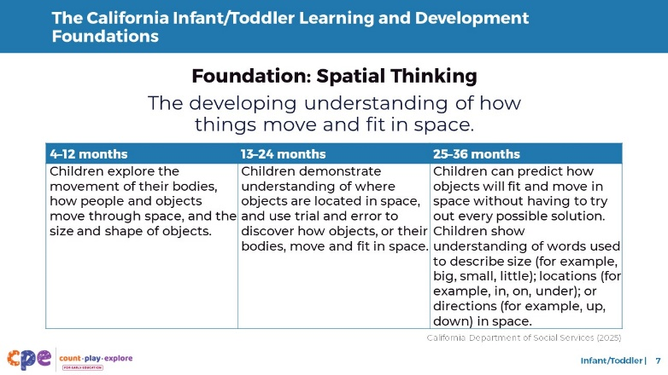

### Talking Points

* Let’s review how these four components align with the California Infant/Toddler Learning and Development Foundations (California Department of Social Services, 2025).
* Spatial Thinking is a foundation within Cognitive Development.
* You can identify elements of spatial orientation, spatial navigation, spatial vocabulary, and mental rotation reflected in this foundation.

### Facilitator Notes

* **Note:** This slide makes connections between the components and relevant foundations or standards. Place this slide where it works best for your participants’ needs.
* Consider providing participants with copies of the relevant California Infant/Toddler Learning and Development Foundations.

## SLIDE 8: Spatial Orientation: Definition

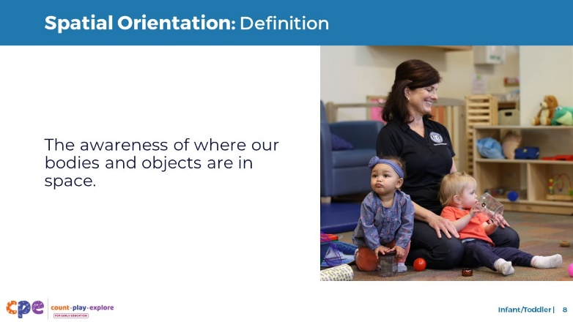

### Talking Points

* Spatial orientation is an awareness of where our bodies or objects are in space.

## SLIDE 9: Spatial Orientation: Development

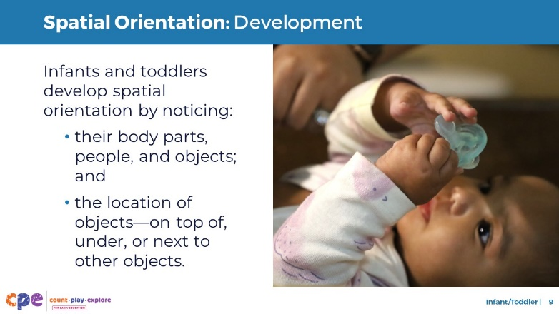

### Time

5–10 minutes

### Talking Points

* From birth, infants become aware of their bodies and how they move in space. This awareness increases as infants gain more motor skills. For example:
  + As infants gain control over their arms, legs, and head, they are more aware of how their body moves and is positioned in space.
* Infants also observe where important people in their lives are located. For example:
  + They become aware that their caregiver is by the door.
* In addition, infants and toddlers pay attention to how objects relate to one another in space. They start to notice that some objects can be “on top of,” “under,” or “next to” other objects. This understanding allows them to observe and remember meaningful landmarks in their environment. For example:
  + A toddler may notice that their doll is “next to” the chair or their cup is “on” the table.
* Earlier, we thought about some ways children in our learning settings show interest in the position of people, objects, or their own bodies—or how they explore spatial orientation. What are some of the ways that the children you work with explore spatial orientation?
* [After participants share:] Thank you for sharing ways that children in your learning setting explore spatial orientation.

### Facilitator Notes

* Encourage participants to share examples of how children in their early learning settings show interest in the position of people, objects, or their bodies.
* **Note:** Participants responded to a similar version of this question earlier in the session (slide 4, question 1).
* If participants documented their observations on sticky notes, you might invite them to add their sticky notes to a piece of chart paper labeled “Spatial Orientation.” Encourage participants to share some of their examples as they add their notes to the chart paper.
* Adjust the way you organize this activity based on group size, session length and format, and participants’ needs.
* **Note:** Slide 10 provides additional examples of spatial orientation. You might skip this slide if participants’ responses provide thorough examples.

## SLIDE 10: Spatial Orientation: Examples

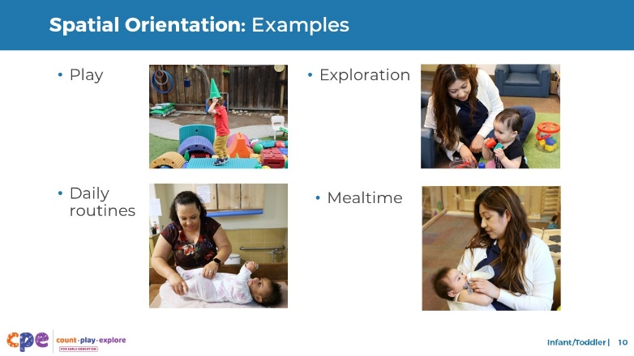

### Talking Points

* Here are some examples of how infants and toddlers might use spatial orientation.
  + Play: Children pay attention to the position of objects in relation to their bodies. For example, in the image, the child is aware that the cone is “on top” of his head.
  + Exploration: Children notice the position of objects in relation to other objects. For example, in the image, the child might notice the block is inside the container.
  + Daily routines: Children pay attention to the position of objects in relation to themselves. For example, as shown in the image, children might notice during diaper changing that their pants are on their legs.
  + Mealtime: Children might notice the position of their food in relation to their bodies. For example, in the image, the child is aware that the milk bottle is in their mouth.
* It is important to remember that children’s abilities might affect how they use spatial orientation. For example, children with visual impairments might use their sense of touch to identify where objects are in relation to their bodies.

### Facilitator Notes

* Acknowledge similarities between these examples and the examples participants shared during the discussion on the previous slide.

## SLIDE 11: Spatial Navigation: Definition

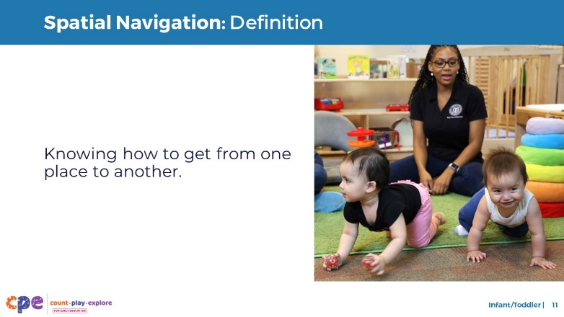

### Talking Points

* Spatial navigation is knowing how to get from one place to another.

## SLIDE 12: Spatial Navigation: Development

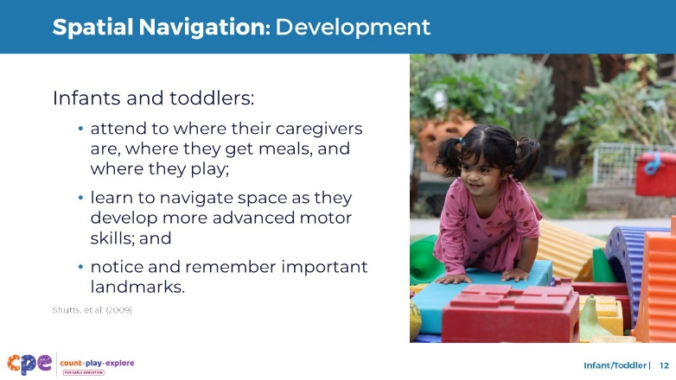

### Time

5–10 minutes

### Talking Points

* Spatial orientation and spatial navigation are closely related. As infants navigate spaces, they also learn more about their position in space.
* Infants’ and toddlers’ understanding of spatial navigation is related to what’s most important to them. They notice where their caregivers are, where they eat, and where they play. For example:
  + Infants begin to understand that being carried down the hallway and turning at the blue lamp is how to get to the kitchen.
* As infants and toddlers develop more advanced motor skills and learn to move on their own, they learn to navigate through their environment (Shutts et al., 2009). They also rely more on familiar landmarks to do so. For example:
  + Toddlers might remember that their favorite toy is always inside a big basket.
* Earlier, we thought about some ways children in our learning settings move “over,” “under,” “around,” or “behind” objects or furniture. These behaviors are a part of spatial navigation. What are some of the ways that the children you work with use spatial navigation?
* [After participants share:] Thank you for sharing the ways that children in your learning setting use spatial navigation.

### Facilitator Notes

* Encourage participants to share their examples of how children in their early learning settings move “over,” “under,” “around,” or “behind” objects or furniture.
* **Note:** Participants responded to a similar version of this question earlier in the session (slide 4, question 2).
* If participants documented their observations on sticky notes, you might invite them to add their sticky notes to a piece of chart paper labeled “Spatial Navigation.” Encourage participants to share some of their examples as they add their notes to the chart paper.
* **Note:** Slide 13 provides additional examples of spatial navigation. You might skip this slide if participants’ responses provide thorough examples.

## SLIDE 13: Spatial Navigation: Examples

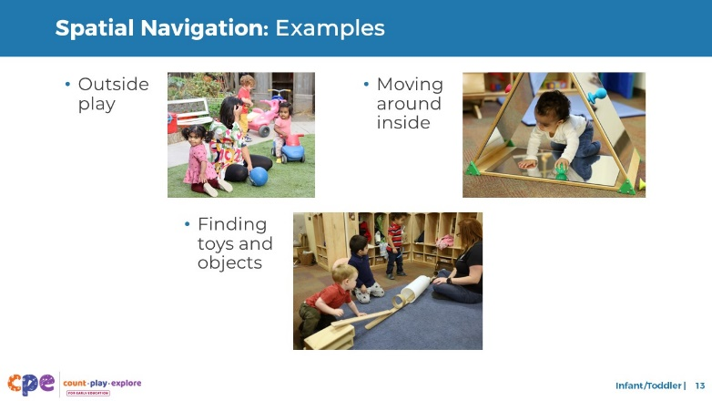

### Talking Points

* Here are some additional examples of how infants and toddlers might use spatial navigation.
  + Outside play: Children might use spatial navigation to move around their play space. For example, in the image, a child on a tricycle navigates around objects and other children.
  + Moving around inside: Children might use spatial navigation to move around their learning setting. For example, in the image, the child might move “over,” “under,” and “through” as they play and explore.
  + Finding toys and objects: Children might remember simple landmarks in familiar spaces to find toys or objects that interest them. For example, a child might find the ball at the end of the ramp.
  + Children’s abilities and lived experiences might affect how they use spatial navigation. For example, children with motor impairments might navigate space differently or need varied support from adults or assistive devices to support them to move from one place to another.
  + Different cultures support children to move and explore in different ways. For example, some cultures often carry their infants with them using slings or other “baby-wearing” approaches. Practices like these might expose infants to different opportunities to notice their surroundings and develop spatial navigation in different ways.

## SLIDE 14: Spatial Vocabulary: Definition

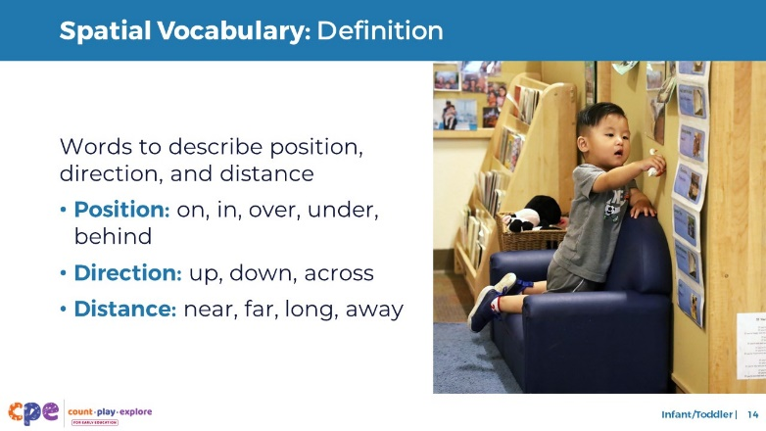

### Talking Points

* Now, we will discuss the last two components of spatial thinking.
* As children learn to navigate their world and pay attention to the position and orientation of their bodies and objects, they develop spatial vocabulary. This includes language to describe:
  + Position—for example, “on,” “in,” “over,” “under,” “behind”
  + Direction—for example, “up,” “down,” “across”
  + Distance—for example, “near,” “far,” “long,” “away”
* Children can learn and use spatial vocabulary in English and their home languages. The languages children use might affect how they learn and use spatial vocabulary. For example, Spanish uses “en” to describe locations that in English would be described as “in” or “on.”

## SLIDE 15: Spatial Vocabulary: Development

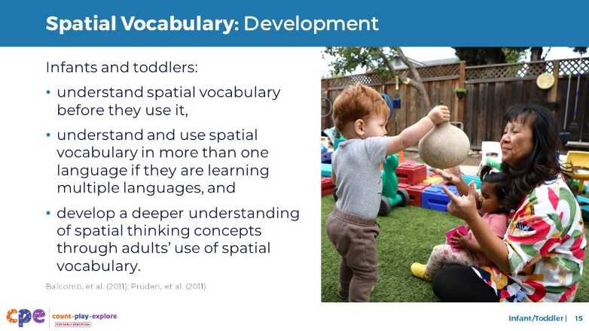

### Talking Points

* First, children develop an understanding of spatial words. Children know what the words mean, but they may not use the vocabulary (Balcomb et al., 2011). For example, if you tell a toddler that their favorite toy is under a basket, they may move the basket to look for it. This behavior shows that they understand the word “under.”
* As children develop their expressive vocabulary—or their ability to use spatial words—they begin to use words related to position, direction, and distance.
* Multilingual learners might learn spatial vocabulary in more than one language. Children might draw flexibly from their languages to communicate, such as using “abajo” (“down” in Spanish) and “up” in the same context.
* Studies show that children with greater spatial vocabulary have more advanced spatial thinking (Pruden et al., 2011). They think in this way because using spatial vocabulary draws children’s attention to the position and direction of objects and the distance between objects. So, modeling spatial vocabulary, even for infants, is a great way to support spatial thinking.
* Earlier, we thought about some ways children in our learning settings use gestures or language—English, their home languages, or both—to communicate about the position or direction of objects or the distance between objects or people. These behaviors are a part of spatial vocabulary. What are some of the ways that the children you work with use spatial vocabulary?
* [After participants share:] Thank you for sharing about the children in your learning setting and how they use and develop spatial vocabulary.

### Facilitator Notes

* Encourage participants to share their examples of how children in their early learning settings use gestures or language—English, their home languages, or both—to communicate about the position or direction of objects or the distance between objects or people. **Note:** Participants responded to a similar version of this question earlier in the session (slide 4, question 3).
* If participants documented their observations on sticky notes, you might invite them to add their sticky notes to a piece of chart paper labeled “Spatial Vocabulary.” Encourage participants to share some of their examples as they add their notes to the chart paper.
* Adjust the way you organize this experience based on group size, session length and format, and participants’ needs.

## SLIDE 16: Mental Rotation: Definition

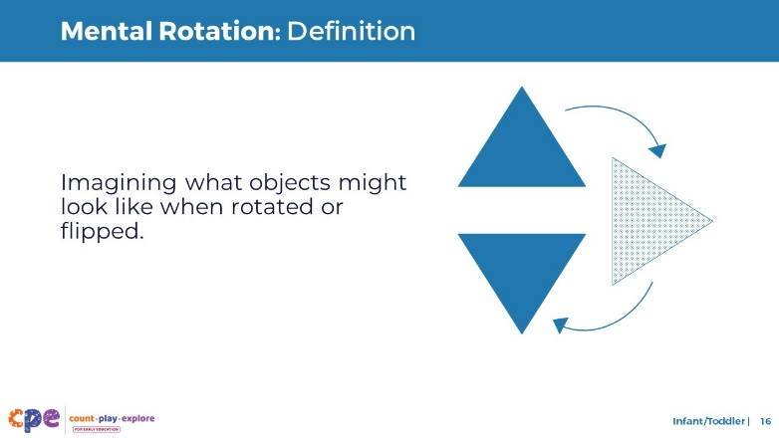

### Talking Points

* Mental rotation is the ability to imagine what an object might look like when rotated or flipped.
* For example, mental rotation would involve knowing what the triangle on the slide will look like if rotated.

## SLIDE 17: Mental Rotation: Development

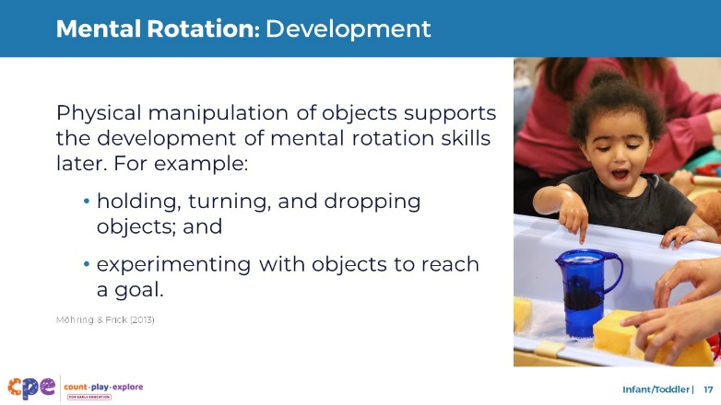

### Talking Points

* Infants’ and toddlers’ physical exploration of objects supports them to develop mental rotation skills later (Möhring & Frick, 2013).
* As children hold, turn, and drop objects, they notice what these objects look like from different angles. For example:
  + An infant learns that a toy car looks different when turned around or upside down.
* Toddlers continue to develop their mental rotation skills by experimenting with objects to reach a goal. For example:
  + You may notice toddlers rotating objects to try to fit them into containers.
* During the beginning of our session, we thought about ways children might use trial and error to explore objects. This exploration builds the foundation for mental rotation. What are some ways children use trial and error to explore objects?
* [After participants share:] Using trial and error to explore objects promotes foundational skills and knowledge that support children in using mental rotation as they get older.

### Facilitator Notes

* Encourage participants to share examples of how children in their early learning settings use trial and error to explore objects. **Note:** Participants responded to a similar version of this question earlier in the session (slide 4, question 4).
* You might invite participants to add their sticky notes to a piece of chart paper labeled “Foundations of Mental Rotation.” Encourage participants to share some of their examples as they add their notes to the chart paper.
* Adjust the way you organize this experience based on group size, session length and format, and participants’ needs.

## SLIDE 18: Observe Video

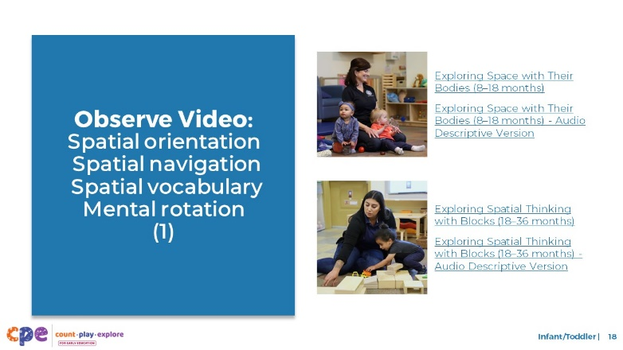

### Time

10–20 minutes (including debrief on the next slide)

### Materials

Infant or toddler spatial thinking video clip

### Talking Points

* Now, we will observe a video clip. As you observe, notice the ways children use:
  + Spatial orientation
  + Spatial navigation
  + Spatial vocabulary
  + Mental rotation
* You might record your observations. After the clip, we will discuss what you noticed.

### Facilitator Notes

* Choose an infant or toddler video clip that shows children using spatial thinking. Play both video clips or choose the clip that is most appropriate for participants.
* We provide the following video clips (you may use different video clips):
  + [[Exploring Space with Their Bodies (8–18 months)](https://youtu.be/kaWHHHgz_y8)](https://youtu.be/kaWHHHgz_y8). In this video, infants explore various containers. They experiment with putting their bodies and other objects inside containers.
    - [[Exploring Space with Their Bodies (8–18 months) - Audio Descriptive Version](https://youtu.be/Jw6kSYcssVw)](https://youtu.be/Jw6kSYcssVw)
  + [[Exploring Spatial Thinking with Blocks (18–36 months)](https://youtu.be/jfLjjJ1dlhw).](https://youtu.be/jfLjjJ1dlhw) In this video, an educator and child use wooden blocks to build a garage together. They use spatial thinking while exploring concepts related to size, how objects fit inside the garage, and ways to position blocks to build the garage.
    - [[Exploring Spatial Thinking with Blocks (18–36 months) - Audio Descriptive Version](https://youtu.be/8k_Z8Dkuf30)](https://youtu.be/8k_Z8Dkuf30).
* **Note**: Discussion points are provided for the videos “[[[Exploring Space with Their Bodies (8–18 months)](https://youtu.be/kaWHHHgz_y8)](https://youtu.be/jfLjjJ1dlhw)](https://youtu.be/kaWHHHgz_y8)” and “[[[Exploring Spatial Thinking with Blocks (18–36 months)](https://youtu.be/jfLjjJ1dlhw)](https://youtu.be/8k_Z8Dkuf30)](https://youtu.be/jfLjjJ1dlhw)” in the Facilitator Notes on the next slide.
* If a component is not observed in the video, you might invite participants to:
  + Think about ways that children might use that component.
  + Explain how educators might support children to use that component.

## SLIDE 19: Discuss: Developing Spatial Thinking

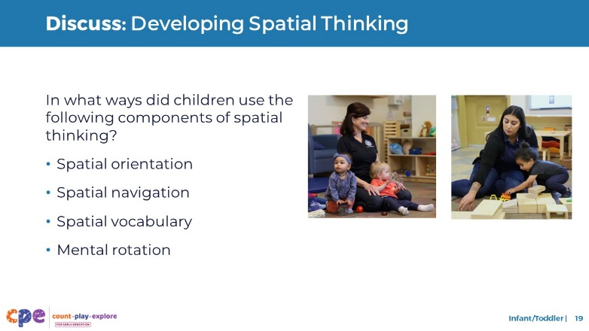

### Time

10–20 minutes (including the video observation on the previous slide)

### Talking Points

* Let’s discuss what you notice.
* In what ways did children use the following components of spatial thinking?
  + Spatial orientation
  + Spatial navigation
  + Spatial vocabulary
  + Mental rotation

### Facilitator Notes

* Adjust the debrief based on your group size, session length and format, and participant needs. Consider charting participants’ observations to visually provide the ways children develop and apply spatial thinking.
* If a component is not observed in the video, you might invite participants to:
  + Think about ways that children might use that component
  + Explain how educators might support children to use that component.
* Consider using the following adaptations based on session length:
  + For shorter sessions, invite participants to share, with the larger group, what they notice about the ways infants and toddlers show their knowledge and skills related to spatial thinking.
  + For longer sessions, offer time for participants to share their observations in pairs or at their tables. Then, invite each table to share their observations.
* Here are some examples of how children in the infant video clip used spatial orientation, spatial navigation, spatial vocabulary, and mental rotation:
  + Spatial orientation: The children explored how their bodies fit into different spaces, for example, “inside” the tubs.
  + Spatial navigation: The children moved around the learning setting. They moved around objects and stepped “up” and “over” the tub to get “in” and “out” of it.
  + Spatial vocabulary: The educator modeled spatial vocabulary such as “inside,” “on,” and “out.”
  + Mental rotation: The children held and rotated objects in their hands. They also observed how the balls fell. One child experimented with fitting a lid on a tube.
* Here are some examples of how children in the toddler video clip used spatial orientation, spatial navigation, spatial vocabulary, and mental rotation:
  + Spatial orientation: The child paid attention to the position of the blocks as he rebuilt with the educator.
  + Spatial navigation: The child noticed where the cars moved. For example, the educator said, “They went out the ‘back,’” and the child moved to the back of the structure to find the cars.
  + Spatial vocabulary: The educator modeled spatial vocabulary such as “in” and “down.”
  + Mental rotation: The child physically manipulated objects (the toy trucks) and moved around the structure. The child might have noticed how the trucks and the block structure looked from different angles.

## SLIDE 20: Supporting Spatial Thinking

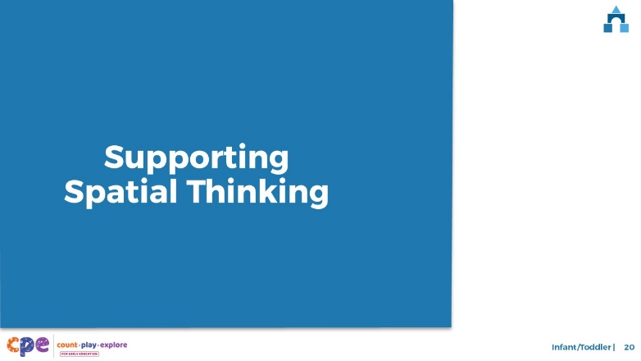

### Talking Points

* We explored four components of spatial thinking. We also observed how infants and toddlers develop these concepts. Now, let’s discuss ways we can support children to develop spatial thinking in our learning settings and at home.

## SLIDE 21: Explore: Daily Opportunities to Explore Spatial Thinking

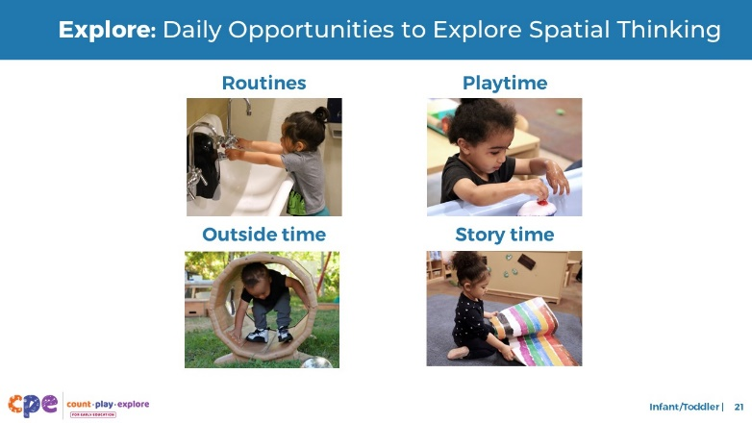

### Time

5–10 minutes

### Materials

**Daily Opportunities to Explore Spatial Thinking** handout

### Talking Points

* Let’s review some ways educators can support infants and toddlers’ spatial thinking through daily routines in early learning and care settings.
* Take out and review **Daily Opportunities to Explore Spatial Thinking**. This handout offers some ideas on how to support infants’ and toddlers’ spatial thinking through daily routines.
* With a partner, discuss ways you might use the ideas in this handout.

### Facilitator Notes

* Provide 5–10 minutes for participants to review and discuss the handout.

## SLIDE 22: Explore: M5 Early Math Approach

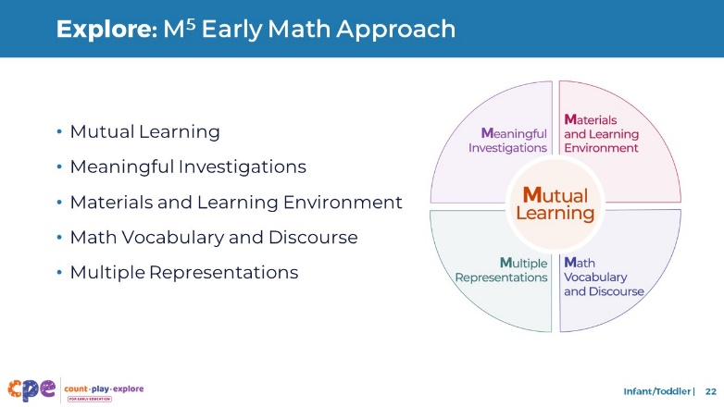

### Time

15 minutes

### Materials

**M5 Early Math Approach Overview** handout

### Talking Points

* We reviewed some ways educators might support children’s spatial thinking through daily routines. Now, we will think more deeply about teaching practices. Count Play Explore often uses M5 (pronounced: M to the fifth) Early Math Approach to refer to five core early math teaching practices. These practices include:
  + Mutual Learning
  + Meaningful Investigations
  + Materials and Learning Environment
  + Math Vocabulary and Discourse
  + Multiple Representations
* Let’s explore the M5 practices. Then, we will observe M5 in action.

### Facilitator Notes

* Consider your participants and their prior experiences with M5.
  + For groups that have significant experience with M5, you might offer a few minutes for participants to share with a partner their strengths and what practices they are working on. Or use this slide to briefly revisit the M5 practices and move to the next slide.
  + For groups that have less experience with M5, you might offer more time for participants to explore each practice. For example, allow time for them to review the practices on their own. Invite them to make a square over practices they have “squared away” (practices they understand and use), a circle over “what’s still going around in their heads” (practices they still have questions about), and a triangle over the ideas they will use in their settings. Visit the **M5 Early Math Approach** suite of resources for additional ideas and resources to support educators’ understanding of the M5 Early Math Approach.

## SLIDE 23: Observe Video: Supporting Children’s Spatial Thinking

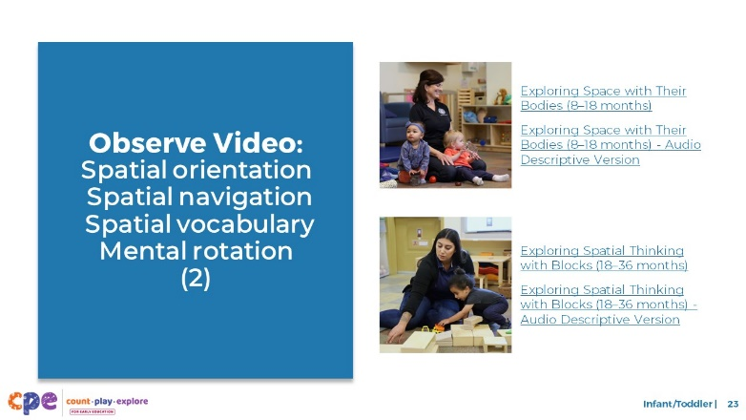

### Time

5–7 minutes (not including debrief)

### Materials

**Observing M5 in Action: Spatial Thinking** handout, infant and toddler spatial thinking video clip, chart paper, markers

### Talking Points

* We observed how infants and toddlers develop spatial thinking. Then, we explored the M5 Early Math Approach. Now, we are going to observe a video that shows how educators use M5 to support children’s spatial thinking.
* [Choose a strategy for facilitating this observation and debrief. Adapt the talking points to reflect this strategy.]

### Facilitator Notes

* Choose an infant and toddler video clip that shows children exploring and using spatial thinking. This may be the same clip used for observing children using spatial thinking.
* We provide the following videos (you may use other videos):
  + [Exploring Space with Their Bodies (8–18 months)](https://youtu.be/kaWHHHgz_y8)
  + [Exploring Space with Their Bodies (8–18 months) - Audio Descriptive Version](https://youtu.be/Jw6kSYcssVw)
  + [Exploring Spatial Thinking with Blocks (18–36 months)](https://youtu.be/jfLjjJ1dlhw)
  + [Exploring Spatial Thinking with Blocks (18–36 months) - Audio Descriptive Version](https://youtu.be/8k_Z8Dkuf30)
* **Note**: Samples answers are provided for the videos “Exploring Space with Their Bodies (8–18 months)” and “Exploring Spatial Thinking with Blocks (18–36 months)” in the Facilitator Notes on the next slide.
* Invite participants to take out the **Observing M5 in Action: Spatial Thinking** handout.
* For larger groups and longer sessions, use a jigsaw approach. Before playing the video clip, assign each table one practice to focus on during the video. [If there are more than five tables, assign more than one table to focus on each practice.]
* For smaller groups and shorter sessions, consider showing the video clip two to three times, inviting participants to focus on specific practices each time. Encourage them to record observations on the handout.

## SLIDE 24: Discuss: Supporting Children’s Spatial Thinking

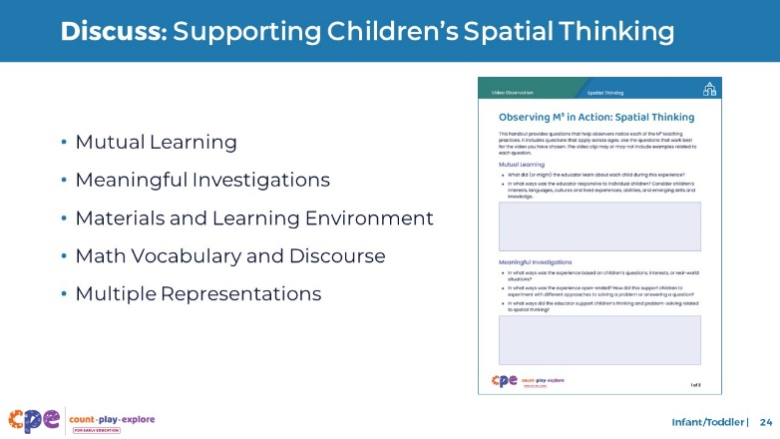

### Time

20–30 minutes (varies based on session goals)

### Materials

**Observing M5 in Action: Spatial Thinking** handout, chart paper, markers

### Talking Points

* Let’s unpack your observations of each M5 practice.

### Facilitator Notes

* Use the **Answer Key for Observing M5 in Action: Spatial Thinking** for examples of ways M5 was used in the video clips provided.
* For larger groups or longer sessions: After observing the video clip, ask each table group to discuss what they noticed about their assigned practice. Then, invite each group to share their observations with the larger group. As each group shares, paraphrase, affirm, and add to their responses as needed. Consider charting each group’s observations to make practices visible.
* For smaller groups or shorter sessions: Invite participants to share their observations with the whole group. Chart their observations to make the practices visible. As participants share, paraphrase, affirm, and add to their responses as needed. Consider inviting participants to share something they learned with someone from another table. For example, you might ask them to find someone with similar shoes, move to meet them, and share something they learned with that person.

## SLIDE 25: Explore: Using M5 to Support Spatial Thinking

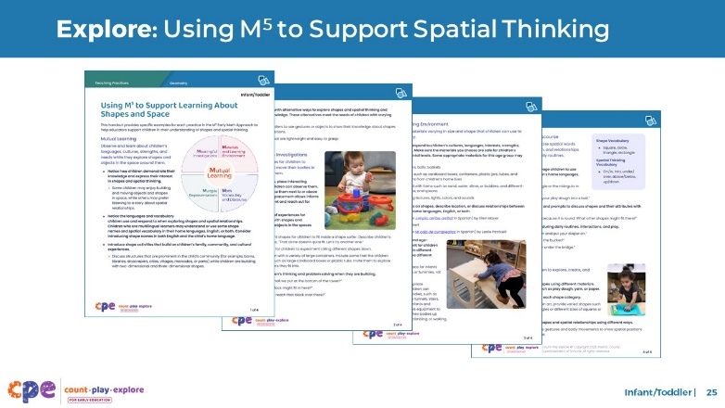

### Time

15–30 minutes (including debrief on next slide)

### Materials

**Using M5 to Support Learning About Shapes and Spatial Thinking Skills** handout, chart paper, markers

### Talking Points

* We discussed the M5 Early Math Approach and observed some ways it may be used to support infants’ and toddlers’ spatial thinking. Let’s consider other ways to use M5 to support infants’ and toddlers’ spatial thinking.
* Take out the Using M5 to Support Learning About Shapes and Spatial Thinking Skills handout.
* Review the ideas on how to use M5 to support infants’ and toddlers’ spatial thinking. You might make notes, circle, or highlight as you review.

### Facilitator Notes

* If you have used PPT 2a “Geometry: Infants and Toddlers” that is part of the **Geometry** suite of resources, participants may have already explored this document. This resource refers to a broader concept of geometry that includes both shapes and spatial thinking. Invite participants to explore the document again. Explain that they may have already used this resource. Let them know that today the focus is on spatial thinking.
* Provide five to seven minutes for participants to review the handout independently.

## SLIDE 26: Discuss: Using M5 to Support Spatial Thinking

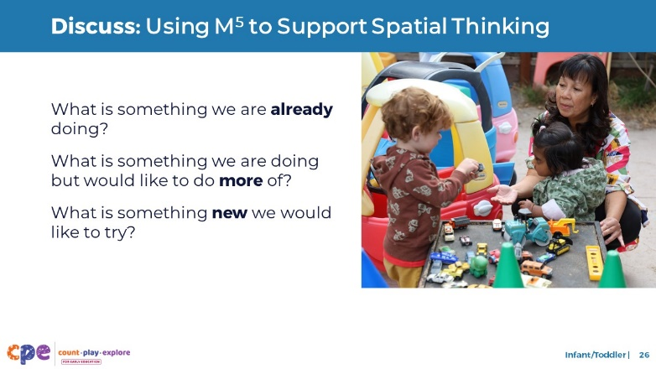

### Time

15–30 minutes (including review of document on previous slide)

### Materials

**Using M5 to Support Learning About Shapes and Spatial Thinking** handout, chart paper, markers

### Talking Points

* You reviewed some ideas on ways to use the M5 Early Math Approach to support infants’ and toddlers’ spatial thinking. Next, let’s reflect on ways we can continue to support children’s spatial learning.
* [Select a way to organize this activity from the facilitator notes. Then adapt these talking points based on your selection.]
  + [Organize small groups.] In your groups, assign a recorder and a reporter. The recorder will document your group’s discussion. The reporter will share your group’s ideas with the large group.
  + Then, with your group, discuss what you are already doing, what you would like to do more of, and something new you would like to try.
  + Reflect on the diversity of early learners in your setting. During your discussion, consider children’s interests, languages, cultures and lived experiences, abilities, and emerging skills.
* Consider the practices and ideas in **Using M5 to Support Learning About Shapes and Spatial Thinking**. You might also include ideas shared during the discussions.
* [Provide time for participants to reflect (or discuss) and record their responses.] Now, share with the larger group. [Invite participants to share based on the way you organized the activity.]

### Facilitator Notes

* Before the session, prepare charts for each table. Create and label three columns: “What we are already doing,” “What we would like to do more of,” and “Something new we would like to try.” Or you might model the process and invite the recorders at each table to make their own charts.
* While participants work in small groups, move around the room. Provide support as needed.
* For shorter sessions, you might do one of the following:
  + Invite participants to do this activity independently, with or without sharing at their tables.
  + Invite participants to do this activity with their tables. Consider inviting tables to post their charts instead of sharing highlights with the larger group.

## SLIDE 27: Reflect: Next Steps

### 

### Time

5–7 minutes

### Materials

Paper of any type

### Talking Points

* Take a few minutes to think about our session.
* Make a plan for your next steps. What is something you are going to try in your learning setting next week? What might be challenging? What support might you need? Consider recording your ideas.
* [Allow two to three minutes for participants to think and record. You might invite participants to share with a partner.]
* Thank you for your time, attention, and engagement. It’s been wonderful working with you.

### Facilitator Notes

* For longer sessions, consider asking participants to share with the larger group.
* As participants discuss their reflections, note the questions that they still have and what they would like to try. Use this information to identify topics for future training, coaching, or communities of practice.