# Geometry: Early Elementary (PPT 2c)

Use this facilitator guide with the slides “Geometry: Early Elementary.” It provides facilitators with talking points and guidance for activities and group discussions. The same text is also located in the notes portion of the slides. Adapt this facilitator guide based on your group size, session length and format, and participants’ needs.

## SLIDE 1: Geometry: Early Elementary

### 

### Talking Points

* In this session, we will explore how early elementary children deepen their understanding of shapes. We will also focus on ways we can support early elementary children to deepen their understanding of shapes.
* We will use “TK” to refer to transitional kindergarten and “K” for kindergarten.

### Facilitator Notes

* Adjust talking points to reflect your session length and participant needs. If necessary, add introductory and “housekeeping” information.
* As you plan your professional learning session, consider the content in each of the PPTs in this suite of resources:
  + PPT 1 “Introduction to Geometry: Birth–8 Years” describes foundational information about children’s geometry learning from birth to eight years old. This introductory session also includes opportunities for participants to use geometry skills.
  + PPT 2a “Geometry: Infants and Toddlers” describes infants’ and toddlers’ early geometry learning and ideas on how to support it.
  + PPT 2b “Geometry: Preschool, Transitional Kindergarten, and Kindergarten” describes the development of geometry learning for children in preschool, TK, and K and ideas on how to support it.
  + PPT 2c “Geometry: Early Elementary” describes the development of geometry learning for children in first, second, and third grade and ideas on how to support it.
* We encourage you to offer the content in PPT 1 before, or in combination with, content in PPT 2c. If your participants work with children in more than one age range, you might combine parts of PPT 1, PPT 2a, PPT 2b, and PPT 2c in one session or a series of sessions. Together, PPT 1 and one of the age-specific slide decks make up a three-hour professional learning session.

## SLIDE 2: Acknowledgments

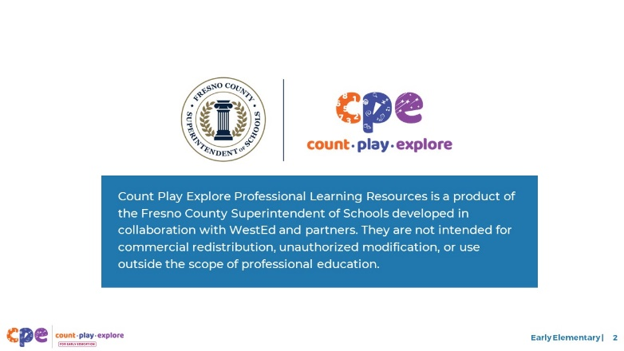

### Talking Points

The Count Play Explore Professional Learning Resources were made possible by Count Play Explore, an early math and science initiative led by the Fresno County Superintendent of Schools, Early Care and Education Department. This initiative is generously funded by the California Department of Education and the California State Board of Education. These resources, developed in collaboration by WestEd and partners, are intended to be used as a guide for implementing evidence-based strategies, promoting active learning, and encouraging developmentally appropriate practices in early education settings. They are not intended for commercial redistribution, unauthorized modification, or use outside the scope of professional education.

## SLIDE 3: Session Goals

### 

### Talking Points

* First, we will review how children in the early grades learn about shapes.
* Next, we will explore some ways that educators and families can support early elementary children to develop geometry knowledge and skills.
* Throughout our session, we will take time to reflect on our current practices. We will also think about how we might use information from this session in our work.

### Facilitator Notes

* Adjust talking points to reflect your session length and participant needs.

## SLIDE 4: Reflect: Learning About Shapes

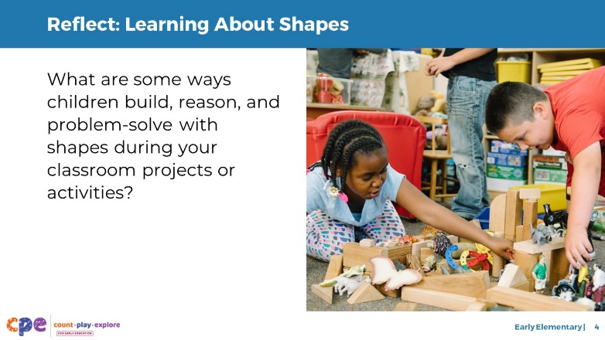

**Time:** 7–15 minutes (including debrief)

**Materials:** Three-column charts with columns labeled “first grade,” “second grade,” and “third grade”; markers

### Talking Points

* Early elementary children are learning about shapes every day!
* Take a couple minutes to think about your classroom projects or activities in which children create or build with shapes. Reflect on children’s opportunities to reason with shapes or solve a problem.
  + How might the influence of children’s home environments and cultural backgrounds impact the ways children explore and reason about shapes in your setting?
* [Allow participants a few minutes to reflect before inviting them to share their reflections.]

### Facilitator Notes

* Adjust the way you debrief participant reflections based on group size, session length and format, and participants’ needs. Charting reflections using a three-column chart will help participants connect their current practices to session content. You can use the following options for charting participant reflections:
  + Invite participants to share their reflections with the whole group. As they share, chart their reflections in the appropriate column.
  + Provide markers and a sheet of three-column chart paper to each table. Ask each table to choose a recorder and reporter. Allow time for participants to share their examples with their table group and for the recorder to chart their reflections in the appropriate column. Then, encourage the reporter from each table to share one or two reflections from their table’s chart.
* If you have not presented content from PPT 1 “Introduction to Geometry: Birth–8 Years” before engaging in this session, consider presenting the “Pull-Up Polyhedra” activity in slide 8 of PPT 1 at this point in your session. This will allow participant to engage in a playful, hands-on activity about two- and three-dimensional shapes.

## SLIDE 5: Learning About Shapes

### 

### Talking Points

* Wow! The children you work with are learning about shapes in a lot of different ways! Let’s examine how early elementary children deepen their understanding of shapes through these explorations.

## SLIDE 6: California Common Core State Standards

### 

### Talking Points

* Before we get started, let’s review some relevant standards from the California Common Core State Standards (California Common Core, 2011).
* The first grade standards build on what children know about shape identification and shape attributes. The standards also describe what children will learn about composing and decomposing shapes. By the end of first grade, children will be able to:
  + Determine if attributes are defining
  + Understand that closed shapes have the same start and end point, while open shapes do not
  + Compose two- and three-dimensional shapes
  + Partition circle and rectangles into halves and fourths
* The second and third grade standards continue to build on what children know about shape identification and shape attributes. In addition, children continue to develop their ability to analyze and reason with shapes. By the end of third grade, children will be able to:
  + Recognize, classify, and compose shapes with specific and similar attributes
  + Partition shapes into two, three, and four equal shares and begin to recognize the shares as fractions

### Facilitator Notes

* This slide makes connections between the components and relevant standards.
* The standards listed in the slides are condensed. You may want to provide participants with copies of the relevant California Common Core State Standards. Consider whether electronic or printed copies will be more useful for your participants.

## SLIDE 7: Learning About Shapes in Early Childhood

### 

### Talking Point:

* There are five components of learning about shapes in early childhood:
  + Perceiving similarities and differences
  + Classifying shapes
  + Naming shapes
  + Learning about the attributes of shapes
  + Composing and decomposing shapes
* Children in preschool, TK, and K develop considerable knowledge and understanding of shapes. They learn the names of common shapes, perceive similarities and differences in shapes, and can classify shapes.
* Now, we will focus on how elementary school children continue to develop their knowledge and understanding of shapes. We will examine how early elementary children learn the names of more two- and three-dimensional shapes, classify shapes by attributes, and compose and decompose shapes.

## SLIDE 8: Naming Shapes

### 

### Talking Points

* Children learn their first few shape names as toddlers. Then they expand their shape vocabulary in preschool and in kindergarten.
* As children move into early elementary years, they may learn the names of a greater variety of two-dimensional shapes, including trapezoids, rhombuses, hexagons, and octagons. They may also learn more formal names for three-dimensional shapes such as spheres, cones, cubes, cylinders, pyramids, and prisms.

### Facilitator Notes

* For more information about common two- and three-dimensional shapes and their names, review slide 16 and 18 of PPT 1 “Introduction to Geometry: Birth–8 Years.”

## SLIDE 9: Reasoning About Shape Attributes

### 

### Talking Points

* Children in preschool, TK, and K begin to understand that shapes have attributes such as number of “corners” or “sides.” They also recognize that attributes can help them decide how to classify a shape. For example, a child might recognize that a square has four sides.
* In first and second grade, children learn about the attributes of three-dimensional shapes and begin to use more formal vocabulary such as edges, vertices, and faces.
* First-graders and second-graders also begin to understand which attributes define a particular shape. This understanding helps children use shape attributes to identify shapes more consistently and accurately.
  + They understand that the number of edges or vertices is a defining attribute, but size, orientation, or color are not defining attributes of a shape.
  + They can explain how two shapes are different using what they know about shape attributes. For example, they may be able to explain that a triangle has three edges and three vertices, and a square has four edges and four vertices.
* By around third grade, children understand that multiple shapes can share the same attributes. For example, they recognize that rectangles, rhombuses, and squares all have four sides.
* Children in third grade also learn that shapes that share similar attributes are part of a larger category. For example, they learn that rectangles, rhombuses, and squares are all quadrilaterals.

## SLIDE 10: Composing and Decomposing Shapes

### 

### Talking Points

* In preschool, TK, and into K, children begin to compose and decompose shapes when building or making art. For example:
  + If a preschooler runs out of square blocks while building a tower, they might combine two triangles to make a square.
  + A kindergartner may put a triangle on top of a square to represent a house while drawing.
* Children in the early elementary grades compose and decompose a variety of two- and three-dimensional shapes to make more complex pictures and patterns. At this age, children can decompose two-dimensional shapes multiple times. For example:
  + They learn to cut a square diagonally to make two triangles. Then they cut each triangle to make more triangles.
* Children this age also learn to use three-dimensional shapes to compose complex structures, such as bridges, arches, and ceilings. Using mental rotation to solve problems, children can create complex pictures and structures. For example:
  + When building a roof of a house, children may try out several shape blocks, until they find one that balances on top of two-cylinder blocks standing upright.

## SLIDE 11: Partitioning Shapes

### 

### Talking Points

* Children in the early elementary grades begin to partition shapes into equal shares. For example:
  + Children can partition circles and rectangles into two, three, and four equal parts.
* By third grade, children understand that shapes can be divided into smaller equal parts. This understanding forms the basis for children’s understanding of geometric area and fractions. For example:
  + They use vocabulary like “halves, thirds, and quarters” to describe these parts.
  + At this age, children know that they can divide—or partition—rectangles into rows and columns of equal-sized units. They also understand that they can describe this rectangle’s area by counting the total number of units.

### Facilitator Notes

* For longer sessions, consider offering some time for hands-on exploration of partitioning shapes. Provide participants with shapes printed on paper. Invite participants to partition shapes into two, three, and then four equal shares. For example, you might challenge them to use a pencil to partition a square, rectangle, hexagon, and octagon into different equal shares.

## SLIDE 12: Observe: Learning About Shapes

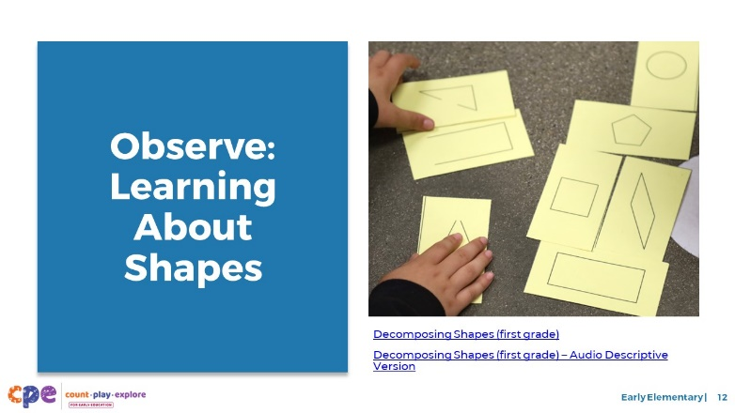

**Time:** 10–20 minutes (including debrief)

**Materials:** Early elementary shapes video [before your session, select a video to show]

* Now we will observe a video. As you observe the video, think about ways children are showing that they are:
  + Classifying shapes
  + Naming shapes
  + Learning about the attributes of shapes
  + Composing and decomposing shapes
* Consider how the interests, cultures and lived experiences, languages, abilities, and emerging skills of the children in this video might have affected how they learned about and explored shapes.
* You might record your observations. After the video, we will discuss what you noticed.

### Facilitator Notes

* Choose a video that shows children learning about shapes.
* We provide the following videos (you may use other videos):
  + [Decomposing Shapes (First Grade)](https://youtu.be/nVsELQ9_wuE)
  + [Decomposing Shapes (First Grade) – Audio Descriptive Version](https://youtu.be/GjT6CfSD89E)
  + [Learning About Shape Attributes (First Grade)](https://youtu.be/cYqNUw5GVVg)
  + [Learning About Shape Attributes (First Grade) – Audio Descriptive Version](https://youtu.be/U9cKMdq3Yu4)
  + [Classifying Shapes by Attribute (First Grade)](https://youtu.be/jAYY0yfIkRw)
  + [Classifying Shapes by Attribute (First Grade) – Audio Descriptive Version](https://youtu.be/XM2m049lWy4)
* **Note**: Discussion points are provided for the videos in the Facilitator Notes on the next slide.
* If a component is not observed in the video, you might invite participants to:
  + Think about ways that children might develop knowledge and skills related to that component
  + Explain how educators might support children to develop the knowledge and skills related to that component
* Consider playing the video more than once. The first time, invite the participants to just become familiar with the video. Then, invite the participants to observe specific ways children show their understanding of the components of shape learning.

## SLIDE 13: Discuss: Learning About Shapes

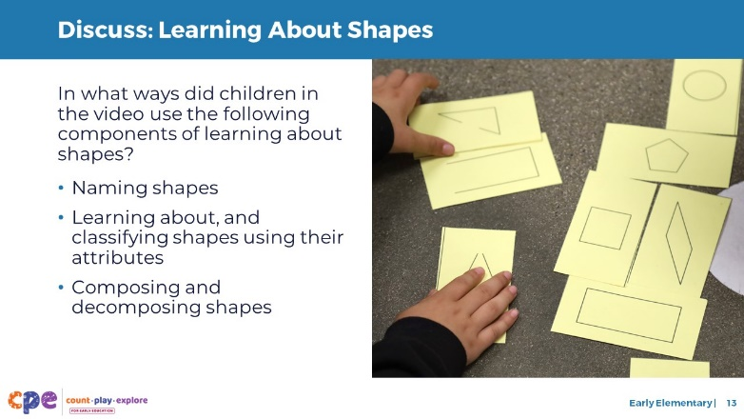

**Time:** 10–20 minutes (including video observation on previous slide)

### Talking Points

* Let’s discuss what you noticed.
* In what ways did children in the video demonstrate that they were:
  + Naming shapes
  + Learning about and classifying shapes using their attributes
  + Composing and decomposing shapes

### Facilitator Notes

* Adjust the debrief based on your group size, session length and format, and participant needs. Consider charting participants’ observations to visually provide ways children develop an understanding of shapes.
* Consider using the following adaptations based on session length:
  + For shorter sessions, invite participants to share, with the large group, what they noticed about ways children in early elementary showed their understanding of shapes.
  + For longer sessions, offer time for participants to share their observations in pairs or at their tables. Then, invite each table to share their observations.
* Here are some examples of how children in the video “[Learning About Shape Attributes (First Grade)](https://youtu.be/cYqNUw5GVVg)” learned about and classified shapes using their attributes and named shapes:
  + **Learning about and classifying shapes using their attributes:** As children were describing why shapes did not belong, they observed that most shapes were filled, and one was not. They also noticed which direction the points of the triangle were facing. One child explained that three shapes were part of the triangle family, while the other shape was part of the square family. Through these observations, children were noticing different attributes of a shape.
  + **Naming shapes:** Children named shapes like triangle and rectangle.
* Here are some examples of how children in the video “[Classifying Shapes by Attributes (First Grade)](https://youtu.be/jAYY0yfIkRw)” learned about and classified shapes using their attributes and named shapes:
  + **Learning about and classifying shapes using their attributes:** Children noticed that some shapes were open, and other were closed. Children classified shapes into groups based on whether they were open or closed. One child classified all rectangles together. She described that the two shapes looked the same even though one was tilted.
  + **Naming shapes:** Children named shapes like rectangle, diamond, oval, triangle.
* Here are some examples of how children in the video “[Decomposing Shapes (First Grade)](https://youtu.be/nVsELQ9_wuE)” explored decomposed shapes:
  + **Naming shapes:** In addition to naming the shapes (rectangle), one child learned the vocabulary “horizontal” and “vertical.”
  + **Composing and decomposing shapes:** One child described how three of the shapes had been decomposed in equal parts, while one shape was not decomposed in equal parts. One child then described the parts of the decomposed shapes as “halves.”

## SLIDE 14: Supporting Shape Learning

### 

### Talking Points

* We explored components of shape learning for children in early elementary grades. We also observed some ways early elementary children name two- and three-dimensional shapes, classify shapes by attributes, and compose and decompose shapes. Now, let’s discuss ways we can support children to learn about shapes—at school and at home.
* Historically, inequities in our educational system have impacted Children of Color, multilingual learners, and children with disabilities. For example, Children of Color, multilingual learners, and children with disabilities have had unequal access to rigorous learning opportunities. We must work to ensure that every child—of any background, race, culture, ethnicity, language, gender, ability, or socioeconomic status—has equitable opportunities to engage in high-quality geometry learning environments and experiences.

## SLIDE 15: Explore: M5 Early Math Approach

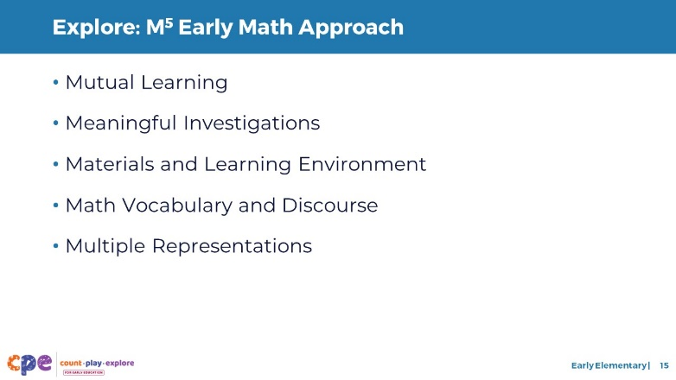

**Time:** 15 minutes

**Materials: M5 Overview** handout

### Talking Points

* We often refer to five core early math teaching practices as the M5 (pronounced: M to the fifth) Early Math Approach, or M5. These practices include:
  + Mutual Learning
  + Meaningful Investigations
  + Materials and Learning Environment
  + Math Vocabulary and Discourse
  + Multiple Representations
* Let’s explore the M5 practices. Then, we will observe M5 in action.

### Facilitator Notes

* Consider your participants and their prior experiences with M5.
  + For groups that have significant experience with M5, you might offer a few minutes for participants to share with a partner their strengths and what practices they are working on. Or you might use this slide to briefly revisit the M5 practices and move to the next slide.
  + For groups that have less experience with M5, you might offer more time for participants to explore each practice. For example, you might allow time for them to review the practices in the handout on their own. Invite them to make or imagine a square over practices that they have “squared away” (practices they understand and use), a circle over “what’s still going around in their heads” (practices they still have questions about), and a triangle over three ideas that they will use in their classrooms. For more ideas on how to provide a more comprehensive review, visit the **M5 Early Math Approach** suite of resources.

## SLIDE 16: Observe: M5 in Action

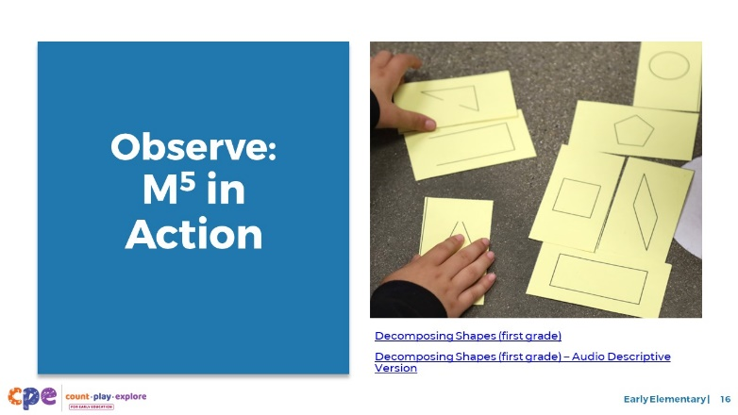

**Time:** 5–7 minutes (not including debrief)

**Materials: Observing M5 in Action: Shapes** handout, early elementary shapes video, chart paper, markers

### Talking Points

* We observed what early elementary children learn about shapes. Then, we explored the M5 Early Math Approach. Now, we are going to observe a video with M5 practices. [Choose a strategy for facilitating this observation and debrief. Adapt the talking points to reflect this strategy.]

### Facilitator Notes

* Choose a video that shows children learning about shapes. This video may be the same one you used for observing children learning about shapes.
* We provide the following videos (you may use other videos):
  + [Decomposing Shapes (First Grade)](https://youtu.be/nVsELQ9_wuE)
  + [Decomposing Shapes (First Grade) – Audio Descriptive Version](https://youtu.be/GjT6CfSD89E)
  + [Learning About Shape Attributes (First Grade)](https://youtu.be/cYqNUw5GVVg)
  + [Learning About Shape Attributes (First Grade) – Audio Descriptive Version](https://youtu.be/U9cKMdq3Yu4)
  + [Classifying Shapes by Attribute (First Grade)](https://youtu.be/jAYY0yfIkRw)
  + [Classifying Shapes by Attribute (First Grade) – Audio Descriptive Version](https://youtu.be/XM2m049lWy4)
* **Note**: An answer key is provided for the video “Decomposing Shapes (First Grade)” in the Facilitator Notes on the next slide.
* Invite participants to take out the **Observing M5 in Action: Shapes** handout.
* For larger groups and longer sessions, use a jigsaw approach. Before playing the video, assign each table one practice to focus on during the video. [If there are more than five tables, assign more than one table to focus on each practice.]
* For smaller groups and shorter sessions, consider showing the video two to three times, inviting participants to focus on specific practices each time. Encourage them to record observations on the handout.

## SLIDE 17: Discuss: M5 in Action

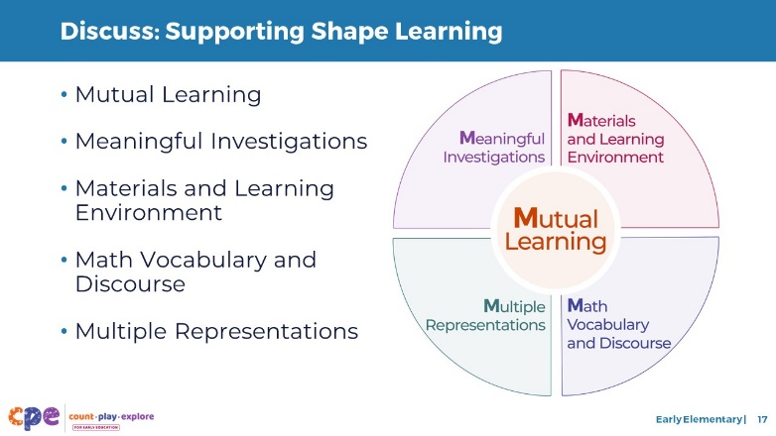

**Time:** 20–30 minutes (varies based on session goals)

**Materials: Observing M5 in Action: Shapes** handout, early elementary shapes video, chart paper, markers

### Talking Points

* Let’s unpack your observations of each M5 practice. How did the educator use M5 to support children’s learning about shapes?

### Facilitator Notes

* Use the **Answer Key for Observing M5 in Action: Shapes** handout for examples of ways M5 was used in the video “[Decomposing Shapes (First Grade)](https://youtu.be/nVsELQ9_wuE).”
* For larger groups or longer sessions: After observing the video, ask each table to discuss what they noticed about their assigned practice. Then, invite each table to share their observations with the larger group. As each table shares, paraphrase, affirm, and add to their responses as needed. Consider charting each group’s observations to make practices visible.
* For smaller groups or shorter sessions: Invite participants to share their observations with the whole group. Chart their observations to make the practices visible. As participants share, paraphrase, affirm, and add to their responses as needed. Consider inviting participants to share something they learned with someone from another table. For example, you might ask them to find someone with similar shoes, move to meet them, and share something they learned with that person.
* For additional ideas on how to facilitate debriefs, visit the **Facilitating Early STEAM Professional Learning** module.

## SLIDE 18: Explore: Using M5 to Support Learning About Shapes and Space

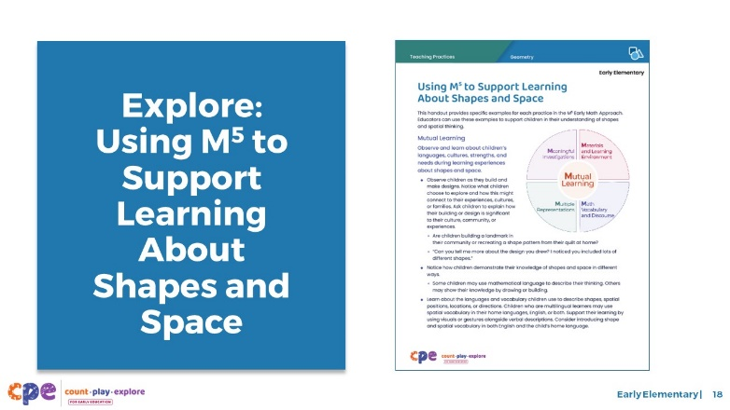

**Time:** 15–30 minutes (including debrief on next slide)

**Materials: Using M5 to Support Learning About Shapes and Space** handout, chart paper, markers

### Talking Points

* We discussed the M5 Early Math Approach and observed some ways the practices might be used to support early elementary children’s geometry learning. Let’s consider other ways for using M5 to support early elementary children’s geometry learning.
* Take out **Using M5 to Support Learning About Shapes and Space**. Review the ideas on how to use M5 to support early elementary children’s geometry learning.

### Facilitator Notes

* This document was also used in the suite of resources on Spatial Thinking. This resource refers to a broader concept of geometry that includes both shapes and spatial thinking.
* Provide five to seven minutes for participants to review the handout.
* While participants are reviewing the handout, post five charts around the room. Each chart will have one of the five M5 Early Math Practices as headers (Mutual Learning, Meaningful Investigations, Materials and Learning Environment, Math Vocabulary and Discourse, Multiple Representations) and one column each for first grade, second grade, and third grade. For larger groups, create and post a chart for each M5 practice at each grade level. Leave markers near each chart. Use the talking points and facilitator notes on the next slide to guide the debrief.

## SLIDE 19: Discuss: Using M5 to Support Learning About Shapes and Space

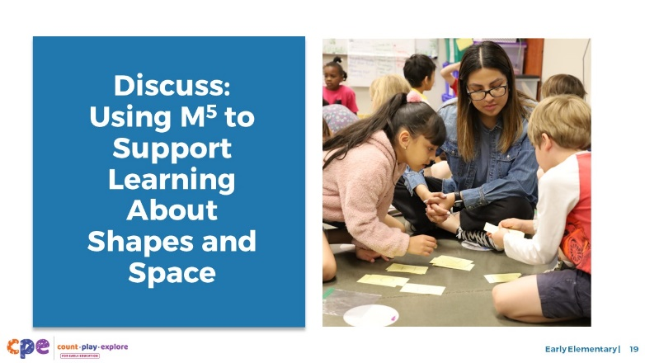

**Time:** 15–30 minutes (including review of document on the previous slide)

**Materials: Using M5 to Support Learning About Shapes and Space** handout, chart paper, markers

### Talking Points

* You reviewed some ideas on ways to support early elementary children’s shape learning using the M5 Early Math Approach. Next, let’s reflect on ways we can continue to support early elementary children’s shape learning. We might think about strategies we already use as well as strategies that we want to try.
  + We will form small groups that will travel from chart to chart together. [Provide directions on how to form groups. The facilitator notes offer some suggestions.]
  + When you arrive at the chart, identify and chart something you would like to try. For example, on the Math Vocabulary and Discourse chart, you might want to invite children to create definitions for different shapes based on what they know about their attributes.
  + I will signal groups when it’s time to move to the next chart. Leave the marker at the chart for the next group to use. Move clockwise to the next chart. When you arrive, review the ideas suggested by the previous groups. Identify and chart additional ideas.
  + The last group at each chart will share with the whole group two to three ideas that they found most interesting or valuable.
  + Reflect on the diversity of early learners in your setting. Consider children’s interests, languages, cultures and lived experiences, abilities, and emerging skills as you discuss.
* [After the activity concludes:] You might share the ideas you want to try with your coach and revisit this handout as you plan learning experiences throughout the year.

### Facilitator Notes

* Select a strategy for forming small groups. Some ideas include charting by grade level, numbering off at tables, numbering off in the whole group, or moving in table groups.
* Consider modeling what to do at charts.
* When considering the time allotted for this activity, leave at least five minutes at the end for the whole group to share. The remaining time should be divided into the number of charts. For example, if you have 25 minutes total, allow 20 minutes for the main activity and 5 minutes for the debrief. If there is one chart for each M5 Early Math Practice, the time allotted at each chart is four minutes (20/5 = 4).
* After the activity concludes, invite participants to return to their seats.

## SLIDE 20: Explore: Activities to Learn About Shapes

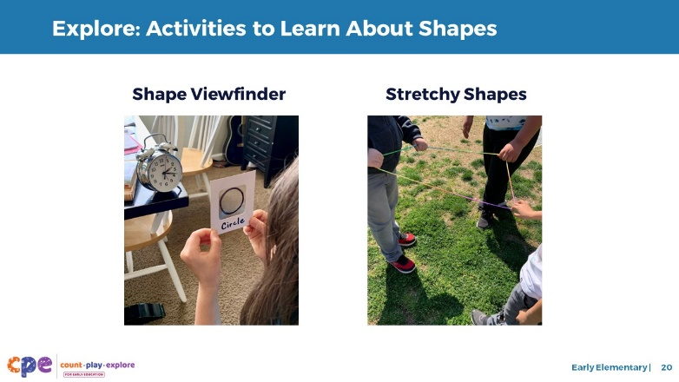

**Time:** 10–15 minutes

**Materials: Shape Viewfinder** handout, **Stretchy Shapes** handout

### Talking Points

* We reviewed a variety of ways that you can support children’s shape learning using M5. Next, we will read and discuss two activities that allow children to explore and learn about shapes in playful, hands-on ways.
* Take out the **Shape Viewfinder** and **Stretchy Shapes** activity handouts.
* These activity handouts include instructions for setting up the activities. They also include ideas on how to support children’s learning using the M5 Early Math Approach.
* With a partner choose one of the two handouts. Read the handout together. Then, discuss how you might use this activity in your classrooms. Consider the following questions:
  + Think about the children in your classroom. In what ways might you modify this activity to respond to their languages, cultures, strengths, and needs?
  + What vocabulary might you introduce through this activity?

### Facilitator Notes

* Provide 5–10 minutes for participants to review and discuss one handout with a partner.
* For longer sessions, offer time for participants to share, with their tables, how they might use the activity they reviewed.
* For longer sessions, consider offering time for participants to do the activity. Be sure to prepare and bring the necessary materials. Encourage participants to discuss what they notice as they engage in the activity.

## SLIDE 21: Reflect: Learn, Wonder, Do

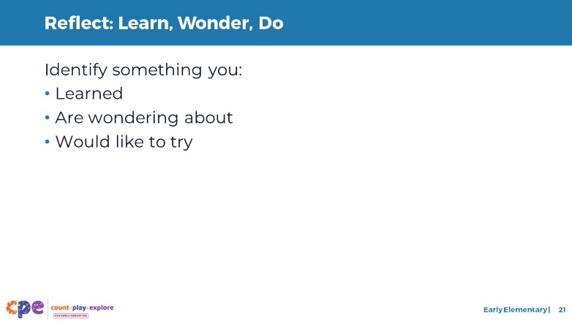

**Time:** 5 minutes

### Talking Points

* Take a few minutes to think about our session.
* Consider the following questions:
  + What is something you learned?
  + What is a wonder you still have?
  + What is something you want to try in your learning setting?
* [Allow two to three minutes for participants to think and record. You might invite participants to share with a partner.]
* Thank you for your time, attention, and engagement. It’s been wonderful working with you.

### Facilitator Notes

* For longer sessions, consider asking participants to share with the larger group.
* As participants discuss their reflections, note the questions that they still have and the things they would like to try. These reflections may inform the topics of future trainings, coaching, or communities of practice.